Drivers and Directions of Learning Styles among PG Student’s in a State Agricultural University (SAU) – An Explorative Study

Dr. K. Venkataranga Naika, Pooja, Dr. Shankara M.H, Shailesh and Dr. Murthy
University of Agricultural Sciences, Bengaluru

I. Introduction
Learning is the Process by which experience is transformed in to knowledge and knowledge is transformed in to action. It is a dynamic process of adoption and action in which we repeatedly interact with our social, biological and physical environment. People have their own styles of learning-they also have unique ways of looking at the world. While these techniques are based partly on a person preferred learning styles but also depends on values, beliefs, morals and tastes, cultural traditions, past experience language, attitude and personality type.
A person learning style is evident, not only when he/she takes learning style Inventory (LSI) questionnaire; but when that person tries to find out about and take action on a situation. Research also indicates that people career choices are associated with where they locate themselves by LSI along the prehension and transformation dimensions. The interaction of these two dimensions generates four primary learning styles (1) Divergent (2) Convergent (3) Accommodators and (4) Assimilators (Kathaleen Wilson and George. Morren 1990)
Students have different levels of motivation attitude and back ground. A thorough understanding of these differences by the teachers, (Drivers) better the chances they have in meeting the diverse learning needs of students. Students learn in many ways - by seeing, hearing, Reflecting, Acting and reasoning logically and intuitively memorizing, recalling and reciting besides drawing analogies.
No two students are alike they have different background, strengths and weakness, taste, preference and approach of studying.
Similarly, no teachers are alike in their teaching style/approach. Methods used to the tastes of students calls for learning styles inventory (LSI) which means a way or approach a student learns. But, the basic issues are (1) what kind of students are coming out of Agricultural Universities? who are accountable for triplicate functions of teaching, research and extension. (2) What are their qualities (3) What methods / Approaches they prefer or follow are the issues addressed in this paper.
Specifically, the objectives of this investigation are to explore the (l) Learning styles of Post Graduate Students Boys and Girls and to elicit their properties.

II. Brief Sketch of the concept of Learning Style
The idea of the term "learning style'" was first recognized as early as 334 BC by Aristotle, who believed that, "each child possessed specific talents and skills" (Reiff, 1992). The concept of learning style has evolved ever since. After Aristotle began to recognize that children had differences, many researchers began forming their own ideas regarding learning styles. The term “learning style” refers to the idea that each student learns in his or her own way. More specifically, a learning style is the preferential way that a student is able to learn, retain and apply the information that he/she is learning.
The Concept
Learning styles are "characteristic of cognitive, affective, and psychological behaviors that serve as relatively stable indicators of how learners perceive, interact with and respond to the learning environment" (Keefe, 1979).
Debellow (1990) defined the learning style as the way people absorb process and retain information.
Stewart and Felicity (1992) defined learning style as those “educational conditions under which a student is most likely to learn."
Sarasin (1998) describes learning style as some predispositions "learning style is the preference or predispositions of an individual to perceive and process information in a particular way or combination of ways".

Learning styles: types and measurement
Ravi babu (2014) has given two descriptions about the learning styles. The details are as follows:
Reproducing Learning Style: in this style, the learners prefers for imitation and practice, memorizing the content and reproducing the information through reading aloud or writing or telling to oneself silently or through listening to others, seeing many figures related to content and making the figure in mind for reproducing the requisite information. They prefer to actually experience the subject matter, rather than just gaining knowledge of the material. They retain the information given through repetition when they discuss or explain the material learned to others or themselves.
Instructive learning style: These learners gain understanding most thoroughly and efficiently when they follow the freedom to take time to reflect and construct on the information and instruction they have been given. These learners relate the subject matter to the other subjects, concepts or ideas of which they understand or confident.

According to Justin Ferriman, (2013) there are seven types of Learning Style they are:
Visual (Spatial): Prefer using pictures and images
Aural (Auditory-musical): Prefer using sound and music.
Verbal (Linguistic): Prefer using words in speech and writing
Physical (Kinesthetic): Prefer using body, hands, sense of touch
Logical (Mathematical): Prefer using logic, reasoning and systems
Social (Interpersonal): Prefer to learn in groups or with others.
Solitary (Interpersonal): Prefer to work alone and self-study.
Models/Inventories of Learning Style
There are numerous models/inventories available on learning styles. However, few of the models/inventories are; David Kolb's model, Henry and Mumford's model, Barbe, Swassing and Milone VAK learning Model, Fleming's VARK modalities, the Myers-Briggs model and Anthony Gregerc's model. Many models attempt to identify how individuals process information in terms of its input, memory and expression. One thought focuses on matching various approaches to reading instructions with a student's preferred ways of learning. While another attends to presentation preferences such as projects, discussion, games, independent study, lecture and so forth. Some models/approaches to style are comprehensive and include a wide range of factors that influence learning. Some are more influential than others and few are generally agreed facts, but no model/measurements of learning styles are universally accepted.
Coffield et al., (2004) were chronologically (1909-2000) documented 78 learning style modes, inventories, questionnaires and theories including 12 revised ones. Out of which, three learning style inventories are used to measure learning styles in the field of agricultural education. Kolb (1985) LSI is very popular and is presented below.

Kolb's Learning Styles Inventory (Kolb LSI)
Kolb (1985) describes the process of learning style as a four stage. This involves the tour adaptive learning nodes.
Concrete Experience (CE): it involves feeling. Here people learn from new and specific experiences. They are usually empathetic and prefer to treat each situation as a unique case.
Reflective Observation (RO): These individuals rely heavily on careful observation in making judgments and view issues from different prospective. They prefer learning situations such as lectures that allow the role of impartial objective observers. They want the teacher to provide expert interpretation.
Abstract Conceptualization (AC): It involves more of thinking. They analyse the ideas logically and act on in understanding of a situation. These individuals tend to be more oriented towards things and symbols, and less towards other people.
Active Experimentation (AE): They learn by doing things. These individuals learn best when they can engage in such things as projects, homework, or group discussion. In the four stages of leaning process, learners first involve themselves in a concrete learning experience and then, reflect on that experience from several perspectives. From this reflection they develop abstract conceptualization, creating generalizations or principles. Learners then test these general principles in new situations to active experimentation. In this way, learners arrived at four basic learning styles by combining two abilities under each style. The main characteristics of four learning styles are summarized as below:
Converging style (AC+AE): They have ability to think and act. They are good at problem solving, decision making and practical application of ideas. They prefer to deal with technical problems rather than interpersonal issues
Diverging style (CE+RO): They have ability to feel and watch. They are strong in innovative and imaginative abilities. They are good at generating ideas and view situations from different perspectives. They perform better by observing and listening to other opinions. They are interested in people, tends to be feeling oriented.
  - Assimilating style (AC+RO): They have ability to watch and think. They are able to assimilate observations and thought into an integrated whole. They prefer concise and logical frame approach of instruction. They are concerned with ideas and abstract concepts rather than people
  - Accommodating style (CE+AC): They have ability to act and feel. They like doing things, carrying out plans and getting involved in new experiences. They are more of risk takers, uses trial and error rather than thought and reflection. They solve the problems well when required to react immediate circumstances. Prefer to work in team to complete the tasks.

III. Methodology
This section throws light on the research methodology/ procedure adopted for the investigation.
  - Locale of the study
The study was conducted during Feb-2019 at University of Agricultural Sciences (UAS) Bangalore, Karnataka. The University of Agricultural Sciences Bangalore has five campuses namely Agriculture College, GKVK Campus, Bangalore, Agriculture College Mandya, Agriculture College, Hassan, Sericulture College, Chinthamani (Chikkaballapura district) and Agriculture College, Chamarajanagara.
Post-Graduate (PG) programme are being offered in two campuses (1) Agricultural College, GKVK Campus, Bangalore (2) Agricultural College Mandya. Agriculture College Bangalore was purposively selected because of the following reasons
    - It is offering M.Sc(Agri) degree in more than 15 disciplines
    - More number of students were available in one campus
    - Convenient to the researcher
    - Easy accessibility.
    - Heterogeneity of Students (Foreigners are Excluded)
- Sampling and Data Collection
Data were collected through distributed questionnaire from students of jr. M.sc (Agri) who were admitted to the GKVK campus of UAS Bangalore, during the Academic year 2019-20. A questionnaire was devised for the purpose. The questionnaire was pre-tested on a few students and then revised. The revised questionnaire was administered to all the 255 Post-Graduate students in the GKVK campus. Completed questionnaires could be obtained from only 124 students in spite of persistent follow up out of 124 students, 84 were girls and 40 were boys. Totally 124 students constitute the sample. Which accounts for 48.62%. The sampling method used was complete enumeration technique. Table-1 gives details of this fact.
Kolb's (1984) learning style inventory was given. It included 12 statements for each of the four learning styles viz., Accommodators, Assimilators, Converges and Diverges. Each student was asked to rank the learning styles from 1 to 4 for each statement. For each student, the ranks were added over the 12 statements for each learning style. Then the differences (AE-RO) and (AC-CE) were computed from the total ranks for each student. They were plotted in a two-dimensional graph. The scatterplot is given in the Fig.1-3
The Collected data was analyzed using simple percentages and Kolb's (1985) procedure was used to quantity the learning style inventory.

Table-1 number of M.Sc students admitted during 2019-20

Sl.No | Department | No of Students | Male | Female
1 | Agricultural Economics | 15 | 5 | 10
2 | Agricultural Entomology | 17 | 9 | 8
3 | Agricultural Extension | 15 | 5 | 10
4 | Marketing & Cooperation | 12 | 4 | 8
5 | Microbiology | 14 | 4 | 10
6 | Agricultural Statistics | 14 | 7 | 7
7 | Agronomy | 18 | 10 | 8
8 | Apiculture | 4 | 3 | 1
9 | Crop Physiology | 13 | 6 | 7
10 | Environmental Sciences | 10 | 8 | 2
11 | Food and Nutrition | 8 | 4 | 4
12 | Genetics and Plant breeding | 18 | 9 | 9
13 | Horticulture | 13 | 6 | 7
14 | Bio-Chemistry | 3 | 2 | 1
15 | Bio-Technology | 22 | 9 | 13
16 | Plant Pathology | 17 | 4 | 13
17 | Seed technology | 13 | 8 | 5
18 | Sericulture | 12 | 3 | 9
19 | Soil Science | 17 | 5 | 12
 | Total | 255 | 111 | 144
 | Percentage Total (%) | 100% | (43.53%) | (56.47%)

Source: Register Office, UAS, Bangalore

A cursory look at the data in table-1 high light the fact that, the number of students admitted to master's degree programme at University of Agricultural Sciences, Bangalore during 2019-20. It is interesting to note that girls students are more than boys (43.53%) meaning, girls number is in the increasing trend than boys. In the yester years, because agricultural courses were field oriented the trend used to be reverse. However, changing times, increasing trend can be noticed. Further, social sciences (Economics, Extension, Statistics and Marketing) accounted for 23.00% over, crop production and crop protection courses, Nevertheless, plant sciences attracting more number compared to other disciplines. Table-1 gives more details of this fact discipline wise.

IV. Results and discussion
Table-2 Distribution of PG Students according to learning Style
(n-124)
Category of Learning style | Girls |  | Boys |  | Total
 | Number | Percentage (%) | Number | Percentage (%) | Number | Percentage (%)
Assimilator | 21 | 25.00 | 13 | 32.50 | 34 | 27.41
Divergent | 28 | 33.34 | 11 | 27.50 | 39 | 31.46
Convergent | 10 | 11.90 | 11 | 27.50 | 21 | 16.94
Accommodator | 25 | 29.76 | 5 | 12.50 | 30 | 24.19
Total | 84 | 100.00 | 40 | 100.00 | 124 | 100.00

It is evident from the results of table-2 that boys and girls differ in their learning style. However, among girls one third of them belong to divergent and more than one forth of them belongs to Accommodators followed by Assimilators (25.00%) and convergers. Fig (1)

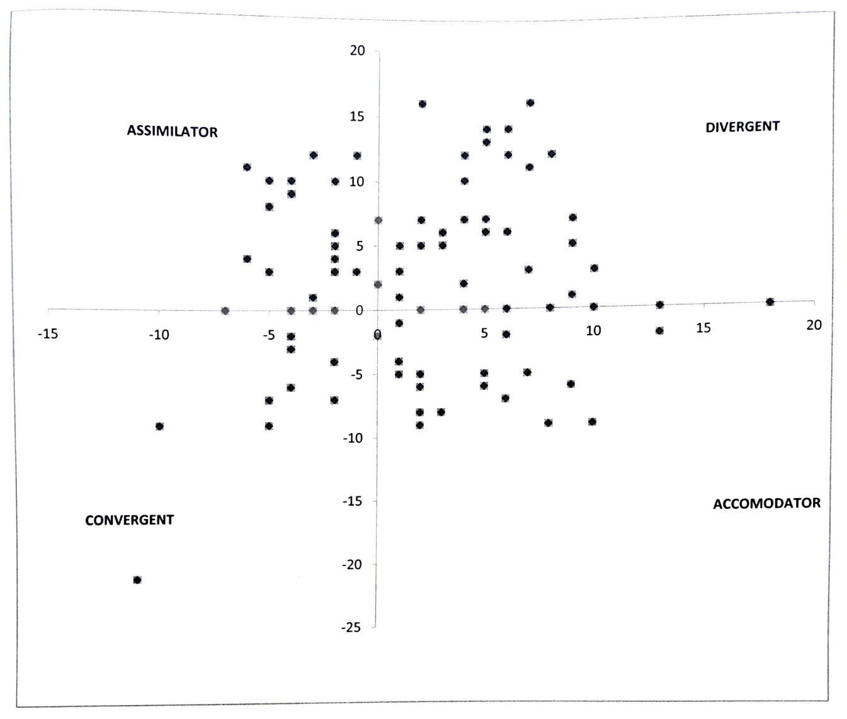
Figure-1: Learning Styles of Post Graduate Students (Girls)

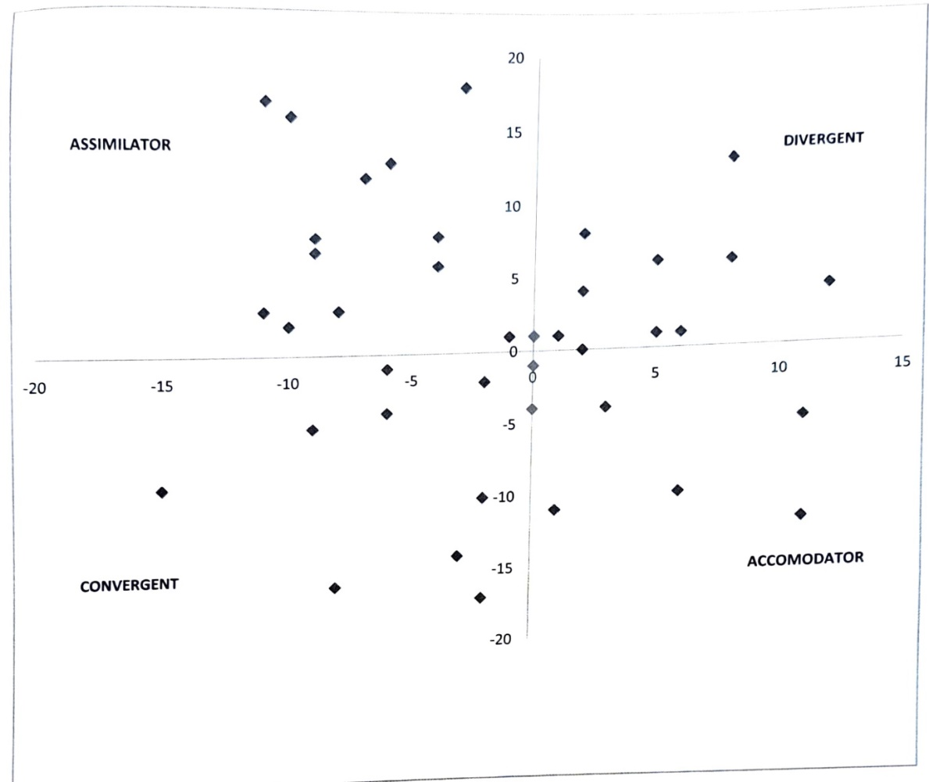
Figure-2: Learning Styles of Post Graduate Students (Boys)

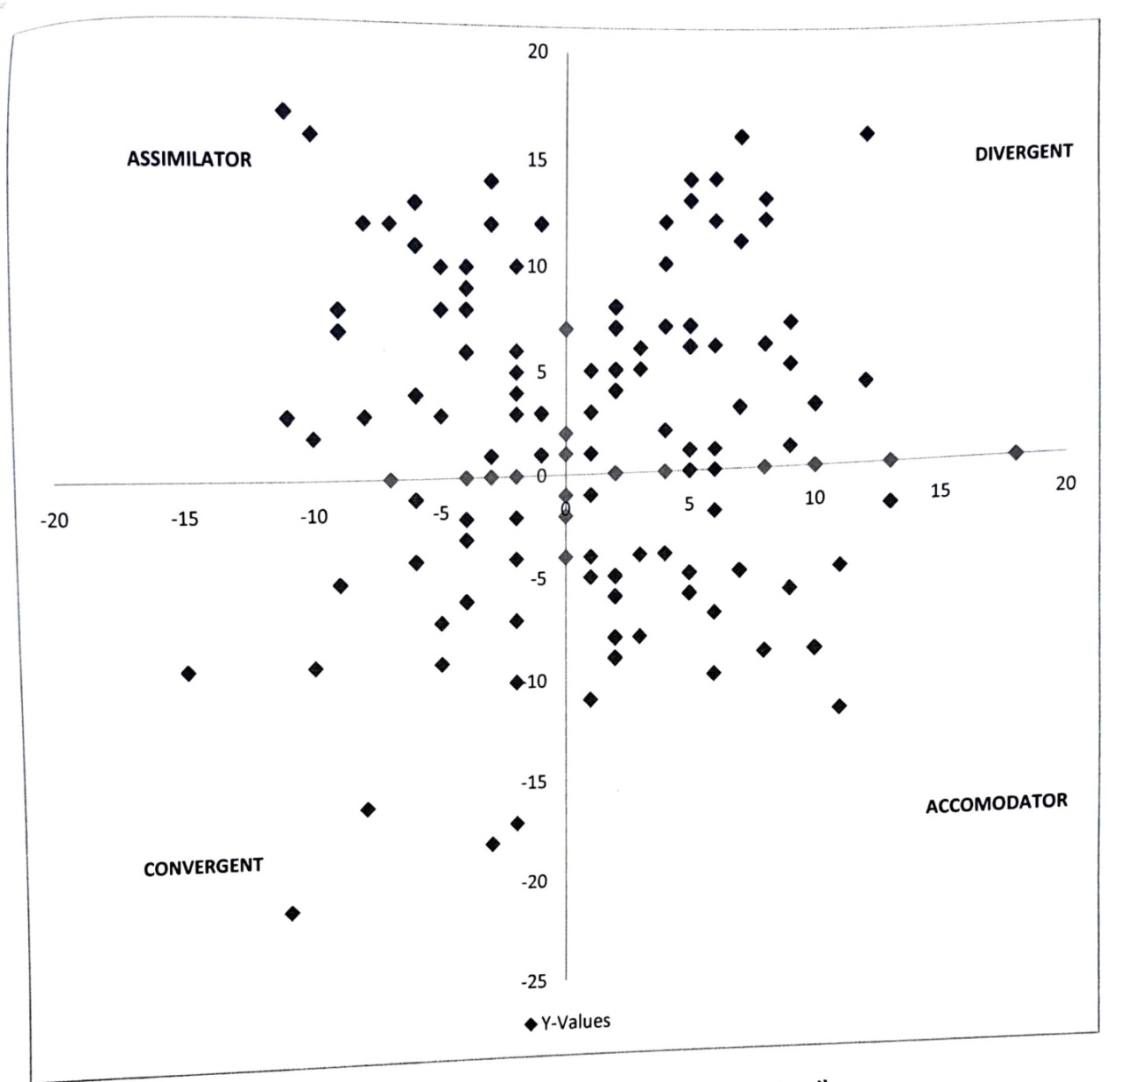

Figure-3: Learning Styles of Post Graduate Students (boys and girls combined)

With respect to boys, majority were belong to Assimilators (32.50%) and equal number of them (27.50) were belong to convergers and Divergent followed by accommodators Fig(2). Put together both boys and girls, it is interesting to note that majority were divergent (31.46) little more than one forth of them were assimilators followed by accommodators and convergers. This finding is in line with that of Raghavendra Muragad (2007) who citied in his study on learning styles of PD Students in the same university that majority were Divergents followed by convergents, Assimilators and accommodators contrary to this finding Madhuprasad (2016) have investigated the under graduate students learning style among sc/st students. He comes to different conclusion that majority of UG students belong to Convergents (33.05%) followed by accommodators (27.90%) assimilators (27.04%) and divergents (12.02%). He is of the opinion that teachers should emphasis problem solving approach to facilitate learning. Jaykumar et al (2016) have measured the learning styles of under graduate, Students of Agriculture, Horticulture and Engineering Degree programmes in vellur District of Tamil Nadu another state in South India. Using VAR Learning style model developed by Barbeetal (1975). He concluded that majority of the students are visual learners (52.69%) followed by auditory learners (32.14%) and Kinestatic (8.05%). The stream wise distribution of students showed that the highest percentage of visual learners were found in Engineering stream (66.66%). In Horticulture it was (62.509%) and Agriculture (61.11%) respectively. Futher, most of the students in agriculture were unimodal learners. As alluded, it was found that students of agriculture and horticulture stream being mostly auditory learners it is essential for teachers to incorporate discussions, brainstorming etc. In their teaching to make their teaching effective.
With respect to learning styles of PG students UAS, Bangalore. Being divergent (Table-2) and Fig(1), (2) & (3) they are strong in imaginative ability, good in generating ideas and seeing things in different perspective, interested in people and broad, cultural. Therefore, teachers should understand the methods that suits to teach these students, colour they like, pictures they wish to see in teaching. In order to make teaching interesting to the students in the class rooms. Kolb (1985) categories of learning style gives more details of this fact.
V. Conclusion
It is axiom to note that, the learning styles of PG students is varied among boys and girls. But, majority of Boys and Girls were divergent: added to these boys were assimilators where as girls are accommodators. Which means boys like inductive reasoning vis-à-vis girls who like hands on experience in learning. This trend calls for drivers (Teachers) to (1) identify the type of learning style of students and include appropriate method(s) of teaching (2) Motivate the students for better learning and (3) Make use of colour, pictures based on learning styles of students in teaching. So that, quality of teaching can be improved in the coming years to take this university to a greater height.
Vi. References
BARBE, WALTER BURKE, SWASSING, RAYMOND, H. AND MILONE MICHAEL,
N. 1979, Teaching through modality strengths concepts and practices. Columbus, Ohio: Zaner-Bloser.

COFFIELD, F. MOSELEY, D., HALL, E., & ECCLESTONE, K., 2004. Should we be
using learning styles?: What research has to say to practice. London, England: Learning & Skills Research Centre.

DEBELLOW, T. C., 1990, Comparison of eleven major learning style models: Variables,
appropriate populations, validity of instrumentation and the research behind them, Internatl. J. Reading, Writing and Learning disabilities, 6:203-222.

FLEMING, N., 2011, Teaching and Learning Styles. VARK Strategies. Christchurch: N.
D. Fleming. Pp.128.

GRASHA, A. F. AND REICHMANN, S. W., 1974, The Grasha-Reichmann student learning
style scales. In Handbook for faculty development, pp. 55-58.

JAYAKUMAR, N., ANU SURESH. SUNDARAMARL M. AND PUTHIRA PRATHAP,
D., 2016, Understanding Learning style variations among Undergraduate students. J. Extn. Edu., 28(4): 5727-5734.

KADAM, P. B. LAMBE, S. P. AND WAKLE. P. K.. 2015, Learning style of Agricultural
technology school students. Asian j. Extn. Edu., 33, pp.12-14.

KEEFE, J. W., 1979, Learning Styles: An overview. In J. W. Keefe (ed.), Student Learning
Styles: Diagnosing and prescribing Programs: National Association of Secondary School Principals. Reston, VA. Pp. 30-33.

KATHLEEN WILSON AND GEORGE MARREN., 1990, Systems approach
for improvement in agriculture and resource management. Macmillan publisher New York P:25-30.

KOLB, D. A., 1985, Experiential learning: Experience as the source of learning
and development. J. Mangt. Competencies, Englewood Cliffs, NJ: Prentice-Hall. 5(3): 13 24.

MADHU PRASAD, V. L, VENKATARANGA NAIKA, K., MANJUNATH, V. AND
USHA RAVINDRA, 2016, Learning Styles of Undergraduate SC/ST students at University of Agricultural Sciences, Bengaluru. Project Report, Directorate of Extension, Hebbal, UAS, Bangalore.

MADHU PRASAD, V. L., VENKATARANGA NAIKA, K., CHANDRASHEKARA,
S., AND USHA RAVINDRA, 2017, Learning Styles of Undergraduate SC/ST students at University of Agricultural Sciences, Bengaluru. Project Report, Directorate of Extension, Hebbal, UAS, Bangalore.

RAGHAVENDRA MURGOD, 2007, A study on learning styles of post graduate students
at University of Agricultural Science, Bangalore, M.Sc. Thesis, Univ. Agric. Sci., Bangalore.

RAVI BABU, M., 2014, A study on reproducing and constructive learning styles among
secondary School students. Internatl. J. Dev. Res. 4(12): 2798-2801.

REIFF, J. C., 1992. Learning styles. What research says to the Teacher series,
National Education Association, Washington, DC.

SARASIN, L. C., 1998, Learning style perspectives: impact in the classroom. Madison,
WI: Atwood. Pp. 4-5.

STEWART, K. L. AND FELICETTI, L. A., 1992, Learning styles of marketing majors. Educational Research Quarterly, 15 (2):15-23. -15

