DESIGN AND FABRICATION OF FERTILIZER SPREADER MACHINE

Supriya Upadhyay*, Hemant Kumar, Mohit Tiwari, Rajbhan Singh, Animesh K.Patel

Department of Mechanical Engineering

Madan Mohan Malaviya University of Technology

Gorakhpur, Uttar Pradesh, 273010, India

corresponding author:*[supriyaupadhyay.iitk@gmail.com](mailto:supriyaupadhyay.iitk@gmail.com)

ABSTRACT

A fertilizer spreader machine is a mechanical device that distributes fertilizer evenly across a field or garden. This machine is commonly used in agriculture to ensure that crops receive the nutrients for healthy growth and a high yield. The spreader typically consists of a hopper, a spinning disc, and a spreading mechanism that distributes the fertilizer as the machine moves across the field. Some fertilizer spreaders may also include advanced features such as GPS technology to improve accuracy and efficiency. Using a fertilizer spreader machine can help farmers and gardeners increase productivity and reduce costs associated with manual fertilization methods. This project report focuses on designing and developing a fertilizer spreader machine for agricultural applications. The machine is designed to distribute fertilizers evenly across a field or garden to ensure that crops receive the nutrients for healthy growth and a high yield. The report covers the various aspects of the machine, including its design, fabrication, and testing. The design phase involved developing the specifications for the machine, selecting the appropriate components, and creating a 3D model using computer-aided design software. The fabrication phase involved building the machine, including the hopper, spinning disc, and spreading mechanism. The testing phase involved evaluating the performance of the machine under various conditions, including different types of fertilizers, speeds, and terrains. The testing results demonstrated that the fertilizer spreader machine could distribute fertilizers evenly and efficiently and was a cost-effective alternative to manual fertilization methods. Overall, this project report provides a comprehensive overview of the design and development of a fertilizer spreader machine and its potential benefits for agricultural applications.

Keywords— Agriculture; Fertilizer spreader machine; Design and Fabrication

# INTRODUCTION

Fertilizer spreader machines have been developed over the ages to address the requirement for efficient and accurate spreading of fertilizers in agriculture. Using fertilizers is critical to confirming high crop yields and sustaining soil fertility, and proper application is necessary to achieve ideal results. The initial fertilizer spreaders were simple handheld devices consisting of a container with small holes at the bottom, which farmers would walk around their fields and shake to spread the fertilizer. However, this method could have been faster, imprecise, and labour-intensive, making it unsuitable for large-scale agricultural operations. The first mechanized fertilizer spreaders were invented in the late 19th century, introducing horse-drawn models that could quickly cover larger areas. These machines were fundamentally modified seed drills that used a rotating mechanism to spread the fertilizer. In the early 20th century, tractors became more widely accessible, and manufacturers began to develop fertilizer spreaders that could be attached to them. These early models were still comparatively basic and required a manual adjustment to control the application rate. With the commencement of modern technology, fertilizer spreader machines have become more sophisticated and efficient. Many modern spreaders now use GPS and computer-controlled systems to precisely control the application rate, ensuring that the correct amount of fertilizer is distributed evenly across the field. They also have variable rate technology, section control, and swath width control, which permit even greater precision and efficiency. Today, many different fertilizer spreaders exist, including broadcast, drop, and pneumatic spreaders, each designed to suit different agricultural needs and applications. The progress of the fertilizer spreader machine has transformed agriculture, making it easier and more efficient to dispense fertilizers and advance crop yields.

# LITERATURE REVIEW

Bhojane et al. [1] designed a manually operated fertilizer-spreading machine while considering the user group and their demands. The project design is separated into three levels: top, middle, and bottom. The top level is made up of a hopper. The intermediate level comprises the gear arrangement, chain drive, and spreader disc. A wheel can be seen on the bottom level. They have used this to learn how mechanization can help solve the problem and what else can be done to make it more accessible to all farmers. Laghari et al. [2] aim for valuable fertilizer uses in agriculture. Soil contains various micro and macronutrients vital for plant growth and yield. It is necessary to save essential nutrient constituents like nitrogen, phosphorus, and potassium by applying chemical nourishments. For constructive situations, broadcast applications can be inefficient because there is a much greater soil-to-fertilizer connection in more fixation or tie-up of nutrients. Shailesh Chaudhari et al. [3] have studied sugar plantations in Indian agriculture and what is the need for an alternative to the traditional tractor-operating fertilizer sprayer machine. The countries which are based on their agriculture, like India, have near about 71% farmers. Because of these reasons, the author has proposed to develop a machine that will have the least cost compared to traditional fertilizer requirements. Kishore et al. [4] described various types of machinery present in sugarcane farming, such as Mechanized land preparation in which animals, automobiles, or tractors are used. Narode and Sonawane [5] have studied a procedure to spread the fertilizer homogeneously over land, creating uniform distribution by dropping the fertilizer over the impeller disc. In this type of mechanical system, the mechanism consists of three wheels, of which two are mounted at the front and one at the back. The fronting two wheels are used to drive out the fertilizer. Here, two hoppers are used to store the fertilizer. These hoppers are placed at some height from the wheel axle so the fertilizer drops over the impeller. The hopper is based on a flow control mechanism. In fertilization, always flow maintenance is necessary. Vignesh et al. [6] have tried to focus on incredible changes in the best traditional methods of agriculture, like seed plantation, irrigation systems, pesticides, and spray. To evolve our monetary condition, increasing our agricultural production and superiority is obligatory.

## **Problem Statement**

Some issues exist when manually distributing fertilizers in the field, such as uneven fertilizer spreading (wrong material and wrong quantity), which may result in harvest damage. The old-fashioned method of distributing fertilizer by hand on a farm takes more time and demands more human energy. As a result, a fertilizer spreader machine is far more ideal for agricultural labour because it increases harvest productivity quickly and with no effort. Manual fertilizer spreading, which involves using hand-held tools to distribute fertilizer, also faces a few challenges and problems. One of the main issues with manual fertilizer spreading is the potential for uneven application. If the person spreading the fertilizer is skilled or experienced, they may apply less fertilizer, resulting in uneven crop growth and yield. Additionally, manual fertilizer spreading is typically less precise than using a machine, which can result in wasted fertilizer and environmental damage.

Another problem associated with manual fertilizer spreading is its physical strain on the person doing the work. Carrying heavy bags of fertilizer and repeatedly bending down to spread it can lead to back pain, fatigue, and other physical ailments. This can make finding workers willing to do the job difficult, especially in areas where labour is scarce or expensive. Moreover, manual fertilizer spreading can be time-consuming and inefficient, especially for large fields. It may require multiple passes over the same area to ensure even coverage, which can be tedious and costly. Finally, manual fertilizer spreading also poses risks to the health and safety of the person doing the work. Fertilizer dust can irritate the eyes and respiratory system, and exposure to certain chemicals in fertilizers can be toxic. Therefore, the problem statement for manual fertilizer spreading is to find ways to ensure the even distribution of fertilizer while minimizing physical strain and health risks for workers, reducing waste, increasing efficiency, and improving the overall productivity and sustainability of agriculture.

## **Project Objective**

To model and fabricate a mechanism to fulfill the need of economically weak farmers for fertilizers spreading in a single setup whenever needed. It also reduces the maximum effort required for spreading the fertilizer. The main objective of a fertilizer spreader machine is to distribute fertilizer or other granular materials onto agricultural land evenly. This is important to ensure that crops receive the appropriate amount of nutrients, which can improve their growth and yield. Fertilizer spreader machines come in different types and sizes. Still, they all generally work by spinning a disk or drum that throws the fertilizer or other material onto the ground. Some machines also have a control mechanism that allows the user to adjust the rate and direction of the fertilizer application depending on the needs of the crops and the condition of the soil. The main goals of a fertilizer spreader machine are to increase crop productivity and efficiency in farming, while minimizing waste and environmental impact. By ensuring that the right amount of fertilizer is applied correctly, farmers can improve their yields and reduce their costs, while also protecting the health of the soil and surrounding ecosystem.

# FERTILIZER

Fertilizer is a substance added to soil or plant tissues to provide essential nutrients for plant growth and development. Plants require nutrients like nitrogen, phosphorus, and potassium to grow and produce healthy crops. Fertilizers help to supplement these nutrients when they are deficient in the soil.

## **Types of Fertilizer**

*Organic Fertilizer*: Organic fertilizers are made from natural materials such as plant and animal waste, compost, and bone meal. They provide a slow release of nutrients to the plants and improve soil health by promoting microbial activity. Examples of organic fertilizers include manure, compost, blood meal, and bone meal.

*Inorganic or Synthetic Fertilizer*: Inorganic or synthetic fertilizers are manufactured chemically, immediately releasing plant nutrients. These fertilizers are often labelled with an NPK (nitrogen, phosphorus, potassium) ratio, which indicates the percentage of each nutrient in the fertilizer. Inorganic fertilizers are widely used in commercial agriculture, as they are highly concentrated and can be easily applied. Examples of inorganic fertilizers include ammonium nitrate, urea, superphosphate, and potash.

In addition to these two main types, speciality fertilizers are designed for specific crops or soil conditions. For example, sulfur-containing fertilizers are used to correct alkaline soil conditions. In contrast, micronutrient fertilizers contain trace elements such as zinc and boron, which are essential for plant growth in small amounts. It is important to note that while fertilizers can benefit plant growth, they can also be harmful if overused or used incorrectly. Over-application of fertilizers can lead to soil and water pollution, as excess nutrients can run into nearby waterways and cause eutrophication. Using fertilizers in moderation and following recommended application rates and timings is essential. These are:

1. Diammonium phosphate (DAP)

2. Nitro Phosphates

3. Ammonium Phosphates

4. Urea

5. Zinc Sulphate

6. Potassium Sulphate

7. Manganese Sulphate

## **Types of Spreader Systems Used**

Several types of fertilizer spreader systems are used in agriculture, each with advantages and disadvantages. Here are some of the most common types of fertilizer spreader systems:

1. Manual Handheld spreaders

2. Drop spreaders

3. Broadcast spreaders

4. Air-assisted spreaders

5. Spinner spreaders

6. Variable rate spinner

## **Methods of Fertilizer Application**

The different procedures for fertilizer application are as follows:



**Figure 1: Applications of solid Fertilizers**

*Broadcasting***:** This method involves spreading fertilizer evenly across the soil surface. This can be done manually or with a mechanical spreader.

*Side-dressing:* This method involves placing fertilizer in a band next to the plants, usually a few inches from the plant. This can be done manually or with a mechanical applicator.

*Top-dressing***:** This method involves applying fertilizer to the soil surface around the plants. This is typically done with a shovel or rake.

*Foliar feeding:* This method involves spraying a liquid fertilizer directly on the leaves of the plants. This is typically done with a backpack sprayer or other type of sprayer.

*Fertigation:* This method involves applying fertilizer through an irrigation system. The fertilizer is injected into the irrigation water and applied directly to the roots of the plants.

## **Advantages**

* Fertilizer spreader machines can cover large land areas quickly and efficiently, saving time and labor compared to manual methods.
* This allows farmers to apply fertilizer to their fields more quickly and accurately, reducing the risk of crop failure due to nutrient deficiencies.
* They can help to reduce labour costs and fertilizer waste, and the improved crop yields they promote can lead to higher profits for farmers.
* Fertilizer spreader machines can be used to apply a wide range of fertilizers, including organic and inorganic fertilizers, as well as herbicides and pesticides.
* Fertilizer spreader machines are a cost-effective solution for applying fertilizer to large areas of land
* This makes them a versatile tool for maintaining soil health and promoting plant growth.
* With the help of the machine operator, fatigue reduces during the operation.
* An adjustable nozzle helps to control the flow of fertilizer.
* Cost-effective as compared to tractor-operated spreaders.

## **Limitations**

* Fertilizer spreader machines may not be effective in windy or rainy conditions, as these conditions can cause the fertilizer to drift or wash away before it can be distributed appropriately.
* Fertilizer spreader machines may not be effective on uneven or steep terrain, as they require a flat surface to distribute fertilizer evenly.
* Fertilizer spreader machines may not be effective in compacted or poorly drained soils, as the fertilizer may not penetrate the soil surface and reach the plant roots.
* Fertilizer spreader machines can be expensive to purchase and maintain, especially for small-scale farmers who may not have the resources to invest in this technology.

## **Applications**

* Its major use in agriculture is to spread fertilizer.
* It is helpful in cases where the crops are in a row.
* It is useful for long farms as well as small farms.
* Use full in sugarcane crops and vegetable crops.
* For the herbicide’s application, to kill the weeds.
* It can be used for spraying germicide.

# COMPONENTS, MATERIAL AND WORKING PRINCIPLE

A fertilizer spreader is an agricultural machine that spreads fertilizers, seeds, and other agricultural inputs evenly over a large area of land. The machine consists of several components that work together to ensure the accurate and efficient distribution of the material.

## **Components**

*Hopper*: The hopper is the main component of a fertilizer spreader machine, where the material to be spread is stored. It is usually made of plastic or metal and is designed to hold a large quantity of material. The hopper is located at the top of the machine and is supported by a frame or chassis.

*Spreader Mechanism*: The spreader mechanism spreads the material evenly over the ground. It is typically made up of a spinner disc mounted beneath the hopper and rotates at high speed. The spinner disc throws the material outwards and distributes it over a wide area. A gearbox powers the spreader mechanism and is usually driven by the wheels of the machine.

*Adjustment Mechanism*: The adjustment mechanism controls the amount of material that is spread. It consists of a lever or knob that can be adjusted to change the size of the opening at the bottom of the hopper. By adjusting the opening size, the rate of material flow can be controlled, which allows for precise application of the material.

*Control System*: The control system is responsible for controlling the spreader mechanism and adjusting the material flow rate. It consists of a control box, which is usually located in the cab of the tractor, and a set of wires or cables that connect the control box to the spreader mechanism. The control system can be either manual or automated, depending on the type of machine.

*Wheels*: The wheels are an essential component of a fertilizer spreader machine, as they provide the necessary traction to move the machine over the ground. They are usually made of rubber or plastic and are mounted on an axle that is connected to the chassis of the machine. The wheels are typically adjustable, allowing the operator to change the width of the spread.

Overall, the components used in a fertilizer spreader machine work together to provide precise and efficient distribution of materials over a large land area. The machine can be adjusted to suit different materials and application rates, making it a versatile tool for agricultural applications.

## **Frame**

The frame of a fertilizer spreader machine serves as the structural foundation that supports the various components of the machine, including the hopper, agitator, spreader disc, and wheels. The frame is typically made of durable materials such as steel or aluminum, which provide strength and rigidity to the machine while also being resistant to corrosion and wear. The design of the frame can vary depending on the specific application and requirements of the machine. Some frames are designed with a fixed width and height, while others may have adjustable components to accommodate different sized hoppers or spreading widths. The frame may also be designed with additional features, such as folding or collapsing mechanisms to facilitate transport and storage when the machine is not in use. The frame of a fertilizer spreader machine must be designed to withstand the stresses and strains of the machine's operation, including the weight of the hopper and the forces generated by the agitator and spreader disc. The frame must also absorb shock and vibration to ensure smooth operation and reduce wear on the machine's components. Proper maintenance of the frame is important to ensure the longevity and safety of the fertilizer spreader machine. This may include regular inspection for signs of wear or damage, cleaning and lubricating moving parts, and repairing or replacing damaged components as necessary. The frame of a fertilizer spreader machine serves as the foundation that supports the machine's various components and must be designed to withstand the stresses and strains of operation. The design of the frame may vary depending on the specific application, and proper maintenance is essential for the longevity and safety of the machine.

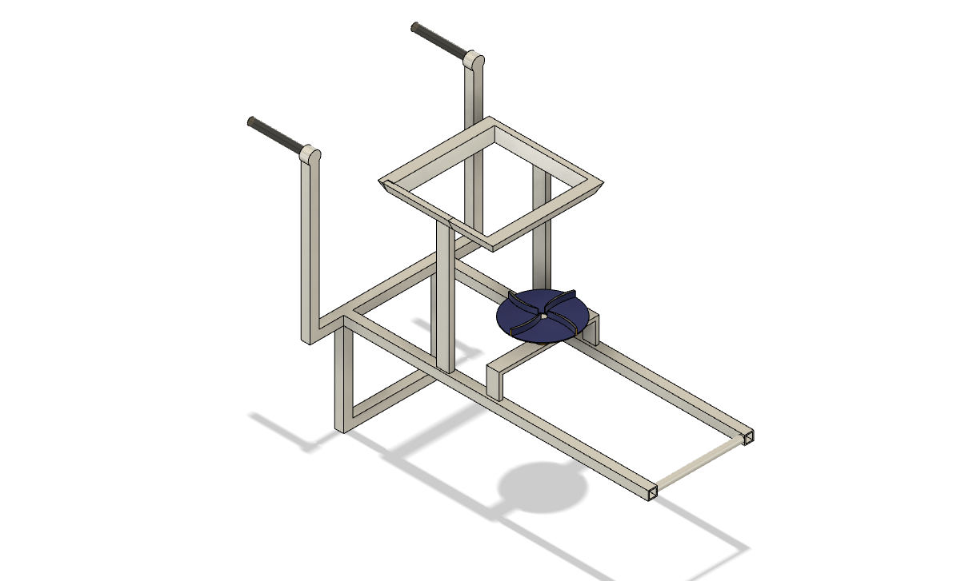

Figure 2: Mild Steel Cold Rolled Steel Frame

*Specifications:*

Length = 800,

Width = 480,

Height = 840

## **Hopper**

The hopper is an important component of a fertilizer spreader machine, as it is responsible for holding and dispensing the fertilizer or other granular material onto the ground. The hopper is typically located above the spinning disk or drum that distributes the material, and it may be made of various materials, such as plastic or metal. The design of the hopper is crucial for ensuring that the fertilizer is dispensed evenly and accurately. The hopper must be sized appropriately to hold the amount of fertilizer needed for a given area of land and be capable of dispensing the fertilizer at a consistent rate as the machine moves across the field. One important feature of the hopper is the opening at the bottom through which the fertilizer is dispensed. This opening may be adjustable, allowing the user to control the rate of application and the width of the spread pattern. Additionally, some hoppers may include agitators or other mechanisms to prevent clumping or bridging of the fertilizer, which can impede the flow and cause uneven distribution. The shape and orientation of the hopper can also affect the performance of the spreader machine. For example, a hopper with steep sides may help prevent bridging, while a hopper with a sloping bottom may facilitate fertiliser flow to the dispensing opening. The hopper is a critical component of a fertilizer spreader machine, as it determines the accuracy, efficiency, and consistency of the fertilizer application. The design and construction of the hopper must be carefully considered to ensure that it can hold and dispense the fertilizer effectively, while minimizing waste and environmental impact.

*Specifications:*

Empty weight – 2.15kg

Weight (filled) - 26 kg

Capacity - 23600000 mm3

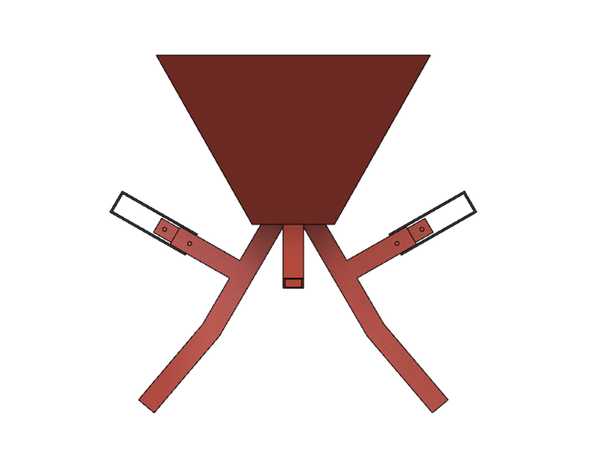

Figure 3: Mild Steel Sheet Hopper

## **Flow Pipe**

The flow pipe is an essential component of a fertilizer spreader machine, as it is responsible for transporting the fertilizer from the hopper to the spinning disk or drum that distributes the material onto the ground. The flow pipe may be made of various materials, such as plastic or metal, and it is typically located underneath the hopper, running the length of the machine. The design of the flow pipe is crucial for ensuring that the fertilizer is dispensed evenly and accurately. The flow pipe must be sized appropriately to handle the volume of fertilizer needed for a given application, and it must be capable of delivering the fertilizer at a consistent rate as the machine moves across the field. One important feature of the flow pipe is its shape and orientation. The flow pipe may be designed with curves or bends to help prevent clumping or bridging of the fertilizer, which can impede the flow and cause uneven distribution. Additionally, the flow pipe may be angled to help ensure the fertilizer is dispensed evenly and at the desired width. The flow pipe may also include mechanisms to control the rate of fertilizer flow. For example, a metering device or gate may be located at the bottom of the hopper or along the length of the flow pipe to regulate the amount of fertilizer that is dispensed. Additionally, the flow pipe may include sensors or other monitoring devices to ensure the flow rate is consistent and accurate. The flow pipe is a critical component of a fertilizer spreader machine, as it determines the accuracy, efficiency, and consistency of the fertilizer application. The design and construction of the flow pipe must be carefully considered to ensure that it can transport the fertilizer effectively while minimizing waste and environmental impact.

*Specifications:*

Outer cross section= 44*44 mm2

Inner cross section = 40*40 mm2

Length of Pipe=500 mm

## **Wheels**

The wheel is a key component of a fertilizer spreader machine, as it is responsible for supporting the weight of the machine and allowing it to move across the field. The design of the wheel is crucial for ensuring that the machine is stable and manoeuvrable, even in challenging terrain. The size and shape of the wheel can have a significant impact on the performance of the spreader machine. Larger wheels can provide more excellent stability and traction, especially in soft or uneven terrain, while smaller wheels may be more maneuverable in tight spaces. Additionally, the shape of the wheel may be designed to provide additional traction or to prevent slippage, depending on the conditions in which the machine will be used. One important consideration when designing the wheel is the weight of the machine and the load it will carry. The wheel must be strong enough to support the weight of the machine and the fertilizer, while also providing sufficient traction to move the machine across the field. The design and construction of the wheel is a critical aspect of a fertilizer spreader machine. The wheel must be carefully designed to provide stability, manoeuvrability, and traction while also being strong enough to support the weight of the machine and the load it will be carrying. A well-designed wheel can help to ensure that the machine is efficient, effective, and safe to operate in a variety of conditions.

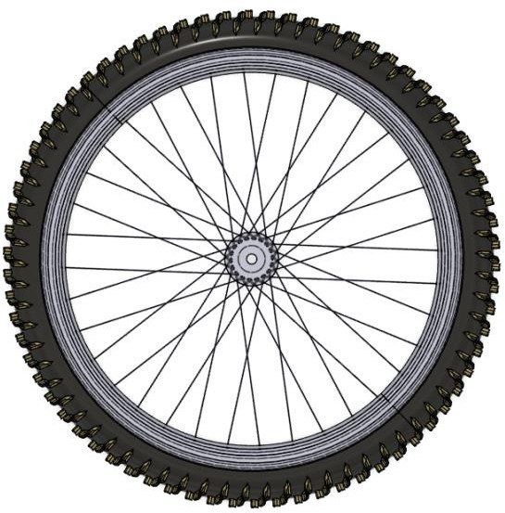

Figure 4: (29”/700c) Wheel

## **Flow Control Mechanism**

The flow control mechanism is an essential component of a fertilizer spreader machine, as it regulates the rate at which the fertilizer is dispensed onto the ground. The flow control mechanism may be located in various parts of the machine, such as the hopper, flow pipe, or dispensing mechanism. One common type of flow control mechanism is the metering gate, typically located at the bottom of the hopper or along the length of the flow pipe. The metering gate can be adjusted to control the rate at which the fertilizer is dispensed, allowing the user to customize the application rate based on the conditions of the field. Another type of flow control mechanism is the spinner disk, which is typically located at the bottom of the spreader machine and responsible for evenly distributing the fertiliser over a wide area. The spinner disk may be designed with adjustable vanes or fins, which can be used to control the width of the spread pattern and the density of the fertilizer application. Some spreader machines may also include sensors or other monitoring devices to ensure the flow rate is consistent and accurate. For example, a speed sensor may be used to adjust the flow rate based on the speed of the machine, or a load cell may be used to measure the weight of the fertilizer and adjust the flow rate accordingly. The flow control mechanism is a critical component of a fertilizer spreader machine, as it determines the accuracy and efficiency of the fertilizer application. The design and construction of the flow control mechanism must be carefully considered to ensure that it can regulate the flow of fertilizer effectively, while minimizing waste and environmental impact. A well-designed flow control mechanism can help ensure that the machine is efficient, effective, and safe to operate in various conditions.

* The brake wire length is 1500mm.
* It uses a helical spring to return the valve to its original position.
* Its specification is length=80 mm and diameter= 15mm

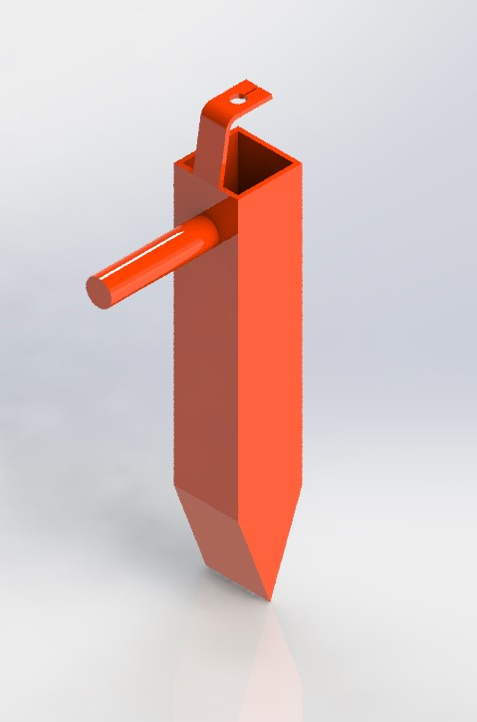

Figure 5: Mild Steel Flow Controller

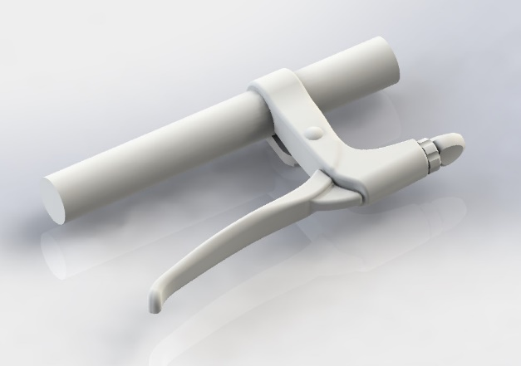

Figure 6: Bicycle Brake

## **Flow Control Valve Pipe**

* It is a square cross-section pie that is used for flow control.
* It is inserted in a flow pipe.
* It is attached to the brake wire and spring to control the flow by its up and down motion.
* It allows for an easy flow of fluids throughout a system.

## **Impeller**

The impeller is an essential component of a centrifugal fertilizer spreader machine, as it is responsible for spinning and distributing the fertilizer onto the ground. The impeller is typically located at the bottom of the machine, and it consists of a disk with vanes or fins that rotate at high speeds, creating a centrifugal force that propels the fertilizer outwards. The design of the impeller is critical for ensuring that the fertilizer is distributed evenly and accurately. The size, shape, and orientation of the vanes or fins can have a significant impact on the performance of the spreader machine. The vanes or fins may be designed to provide additional lift or turbulence, which can help to ensure that the fertilizer is distributed evenly over a wide area. The impeller may also be designed to be adjustable, allowing the user to customize the spread pattern based on the conditions of the field. For example, the impeller may be equipped with adjustable vanes or fins that can be used to control the width of the spread pattern and the density of the fertilizer application.

One important consideration when designing the impeller is the size and weight of the fertilizer particles. The impeller must be able to handle a wide range of particle sizes and densities, ensuring that the fertilizer is dispensed evenly regardless of the type of fertilizer being used. The design and construction of the impeller is a critical aspect of a fertilizer spreader machine. The impeller must be carefully designed to provide a consistent and accurate distribution of fertilizer, while also being strong and durable enough to withstand the demands of the application. A well-designed impeller can help ensure that the machine is efficient, effective, and safe to operate in various conditions.

*Specifications:*

Material= steel

Diameter = 18cm

Height = 3cm

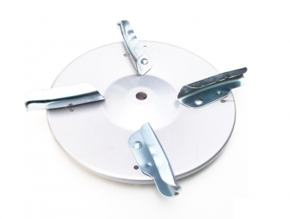

Figure 7: Fin Steel Impeller

## **DC Motor**

A DC motor is a type of electric motor that converts electrical energy into mechanical energy. It operates on the principle of the interaction between a magnetic field and an electric current, which causes the rotor to rotate. In the case of a fertilizer spreader machine, a DC motor is typically used to power the spreading mechanism. The DC motor used in a fertilizer spreader machine consists of two main components: the stator and the rotor. The stator is a stationary component that houses the magnets and the windings. The rotor, on the other hand, is the rotating part of the motor that is connected to the spreading mechanism. The stator of a DC motor typically consists of a series of permanent magnets that create a magnetic field. The windings, made of copper wire, are wound around the stator and connected to a power source.

When an electric current is passed through the windings, it creates a magnetic field that interacts with the permanent magnets in the stator, causing the rotor to rotate. The direction of rotation of the rotor is determined by the direction of the electric current flowing through the windings. To change the direction of rotation, the polarity of the power source must be reversed. The speed of a DC motor is determined by the voltage applied to the windings and the load on the rotor. Increasing the voltage will increase the speed of the motor while increasing the load will decrease the speed. To control the speed of a DC motor, a variable resistor or electronic speed controller can be used to regulate the voltage applied to the windings. In a fertilizer spreader machine, the DC motor is typically used to power the spreading mechanism, which consists of a rotating disk or impeller that distributes the fertilizer evenly over the ground. The speed of the motor is adjusted to control the rate at which the fertilizer is spread, ensuring that the correct amount is applied to the soil. DC motor is an essential component of a fertilizer spreader machine, providing the power to distribute the fertilizer evenly over the ground. By adjusting the voltage applied to the motor, the speed of the spreading mechanism can be controlled to achieve optimal results.

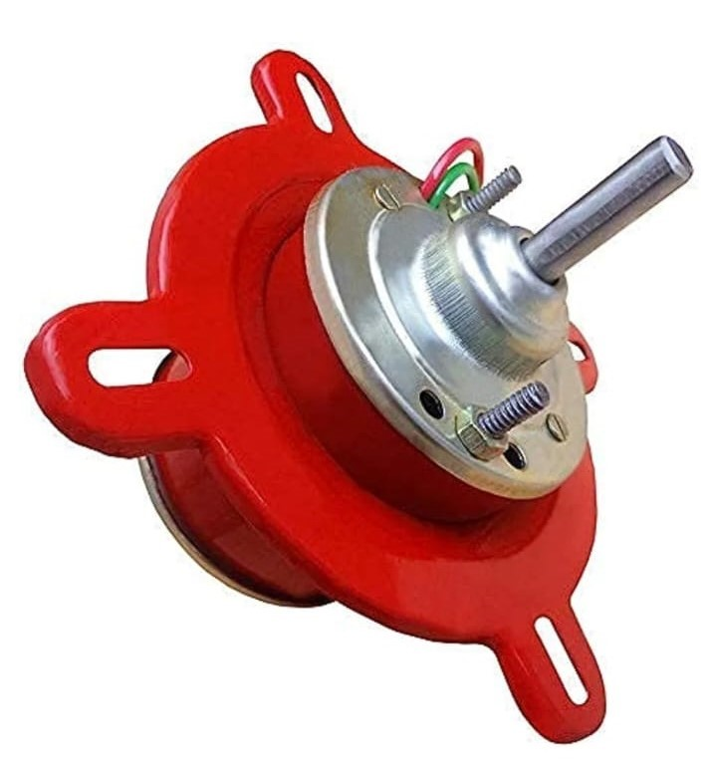

Figure 8: 12 volts Dc Motor

## **Battery**

A battery is an essential component of a fertilizer spreader machine, providing the power required to operate the machine's various electrical components. Several types of batteries are available for use in fertilizer spreader machines, including lead-acid batteries, lithium-ion batteries, and nickel-cadmium batteries. Lead-acid batteries are the most used batteries in fertilizer spreader machines. They are relatively inexpensive and have a high energy density, making them ideal for applications that require a lot of power. However, lead-acid batteries are also heavy and have a limited lifespan, which can be a drawback for some applications. Lithium-ion batteries are becoming increasingly popular in fertilizer spreader machines due to their high energy density, light lightweightlong lifespan. They are more expensive than lead-acid batteries, but their higher efficiency and longer lifespan can make them more cost-effective in the long run. Nickel-cadmium batteries are also used in some fertilizer spreader machines, but they are becoming less common due to their relatively low energy density and the environmental concerns associated with cadmium. Regardless of the type of battery used, it is important to maintain the battery to ensure optimal performance and lifespan properly. This includes regularly checking the battery's charge level, cleaning the terminals, and ensuring proper storage and usage conditions. The battery used in a fertilizer spreader machine is a crucial component that provides the power required to operate the machine's various electrical components. Several types of batteries are available, each with its advantages and disadvantages, and proper maintenance is important to ensure optimal performance and lifespan.

Table 1: Specifications of components

|  |  |  |  |
| --- | --- | --- | --- |
| **Name of the**  **component** | **Number of**  **items** | **Dimensions**  **(mm)** | **Material** |
| Frame | 1 | Length = 800, Width = 480  Height = 840 | Mild Steel |
| Hopper | 1 | Hight=250,  width=400,  Volume= 2360000mm3 | Medium Carbon Steel |
| Wheel | 1 | Diameter = 60 | Natural Rubber and  Steel |
| Hollow Square Pipe | 2 | Length = 500  Cross section= 44×44 | Steel |
| Brake arrangement | 2 |  | Plastic |
| Brake wire | 2 | length = 1500 | Plastic |
| Impeller | 1 | Dia = 180 | steel |
| Battery | 1 | 12 volts | Lithium-ion |
| DC Motor | 1 | 12-volt dc |  |
| Spring | 2 | Length=80, diameter=15 | Steel wire |
| Total Weight | 38 kg | | |

## **Working Principle**

The whole mechanism is mechanically and electrically operated. When the equipment is pushed forward by using handles, the front wheel rotates. The hopper contains fertilizer with three openings. It has a throttle valve mechanism that controls the flow of fertilizer. As fertilizer requirement, the operator can control the flow of the fertilizer. With the help of a side opening, we drop the fertilizer and control the volume by the flow control mechanism. Another opening is on the impeller. When the valve opens, the fertilizer drops on the impeller. By the action of the centrifugal force, the impeller spreads the fertilizer.

### **Table 2: Table Styles**

| Table Head | Table Column Head | | |
| --- | --- | --- | --- |
| Table column subhead | Subhead | Subhead |
| copy | More table copya |  |  |

# MODELLING AND CALCULATIONS

It consists of the frame on which the bicycle wheel is mounted with the help of an axle. The hopper is mounted on the frame with the help of two rods. Impeller is mounted below the hopper. Impeller is mounted on the motor which is mounted on the frame. The battery is mounted on the frame. It powers the motor to rotate the impeller. There is two side opening for dropping the fertilizer.

## **CAD Model of Fertilizer Spreader Machine**

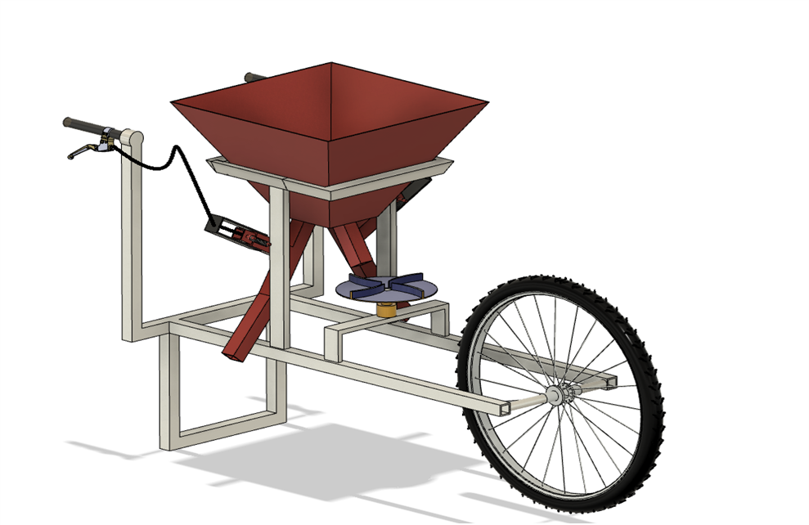

Figure 9: Isometric View

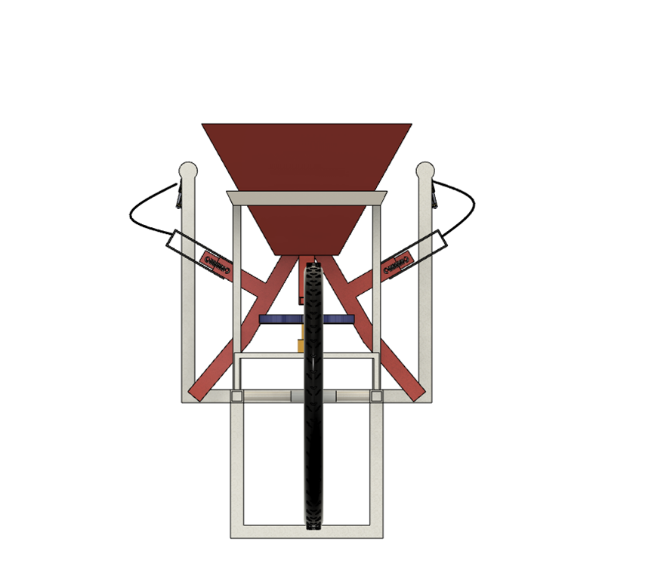

Figure 10: Front View

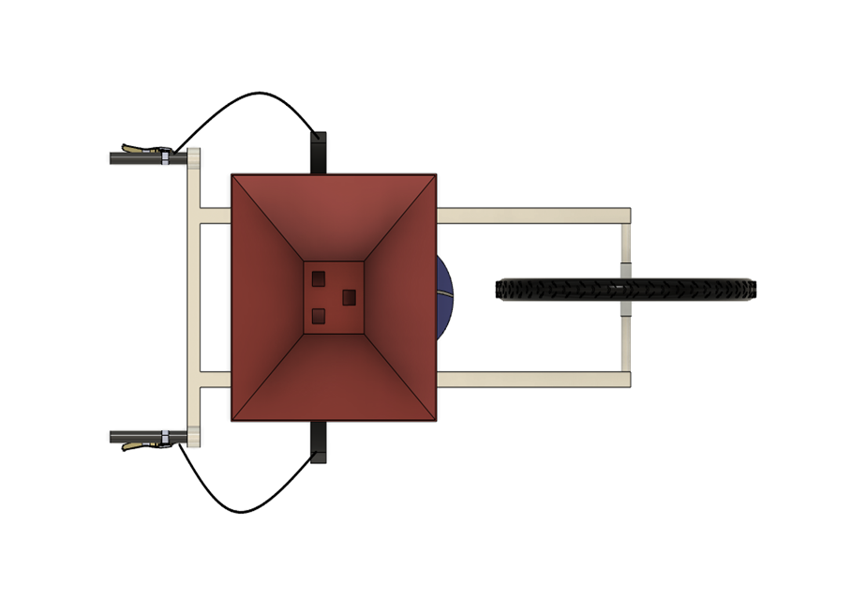

Figure 11: Top View

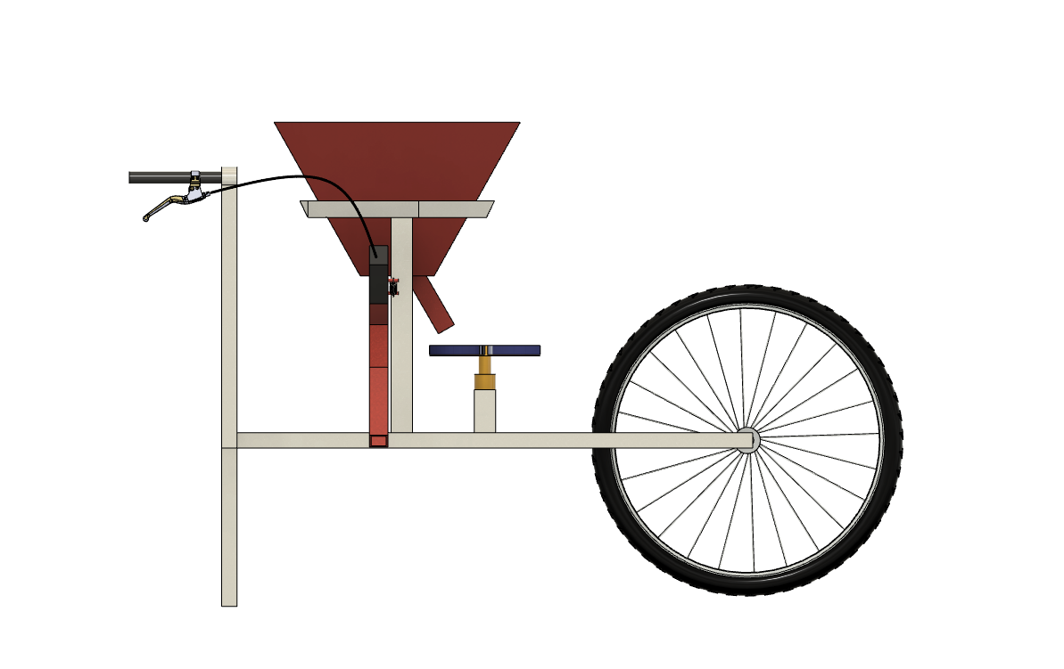

Figure 12: Side View

## **Design of Frame**

*Checking for column failure:*

In this project, two columns are used and fixed the critical buckling load at one column.

Euler’s Column Theory –

$$\text{Pe = π}\text{²}\text{ E}\frac{\text{I}\text{min}}{L_{e}\text{²}}$$

Where Pe = Buckling Load

E = Modulus of elasticity

Imin = Minimum moment of inertia

Le = Effective length

min =

Here both ends are fixed so

Le =

Pe  N

Buckling Load (Pe) = 17623 N

Here,

total load acting on one column = $\frac{weight of hopper with fertilizer}{2}$

$$=\frac{250.54}{2}N$$

$$=125.27 N$$

*Result:*

Here total load acting on column is less than the critical value of buckling load. So, column is safe and dimensions are correct.

*Checking for Frame failure: -*

Frame works like as a beam & it is subjected to point load.

$$Total load acting on one frame=\frac{weight of column +weight of hopper with fertilizer+weight of motor+weight}{2}=\frac{15.42+250.54+2.94+9.81}{2}$$

Total weight acting on one frame = 139.35 N

Consider total weight acting mid-point of the frame

Maximum bending moment acting on the frame

= $\frac{ wl}{4}= \frac{134.35×800}{4}=27870 N-m$ m

Moment of Inertia $I= \frac{{25}^{4}-{20}^{4}}{12}=19218.75 {mm}^{4}$

$$\frac{M}{I}=\frac{σ}{y}$$

$$σ= \frac{M}{I}×y$$

$$= \frac{27870×12.5}{19218.75}$$

Bending moment $\left(σ\right)=18.12 N/{mm}^{2}$

Allowable stress of mild steel = 250 MPa

*Result: -*

Maximum bending stress is less than the allowable stress of mild stress, so design.

## **Model of Hopper**

Length of frame = 800 mm

Width of frame = 480 mm

Height of frame = 840 mm

The total length of pipe used = 800×2+400×2+480+240+250=3610 mm

Cross section area of square pipe = (Outer cross-section area) – (Inner cross-section area) = (252) – (202) = 225 mm2

The volume of pipe = cross-section area ×length of square pipe

= 225 ×3610

= 812250 mm3

The total length of strip used = 460×2+270×4=2000 mm

Cross-sectional area of strip used = 20×5mm2 = 100mm2

Volume of strip used = 2000×100= 20000mm3

The total volume of mild steel used in the frame = 812250 + 20000

=1012250mm3

Density of mild steel material = 7.8 × 10-6 kg/mm2 = 7.8 × 10-8 kg/cm2

Density = Mass / Volume

Mass = Density × Volume

Total Mass of frame = 1012250×10-9m3×7860kg/m3

=7.95 kg ≈ 8kg

Total Mass = 5.38kg+30kg (completely filled hopper) +2kg(wheel)

= 37.38kg

Total weight = 37.38×9.81N=366.69N

## **Model of Frame**

Length of frame = 800 mm

Width of frame = 480 mm

Height of frame = 840 mm

The total length of pipe used = 800×2+400×2+480+240+250=3610 mm

Cross section area of square pipe = (Outer cross-section area) – (Inner cross-section area) = (252) – (202) = 225 mm2

The volume of pipe = cross-section area ×length of square pipe

= 225 ×3610

= 812250 mm3

The total length of strip used = 460×2+270×4=2000 mm

Cross-sectional area of strip used = 20×5mm2 = 100mm2

Volume of strip used = 2000×100= 20000mm3

Total volume of mild steel used in frame = 812250 + 20000

=1012250mm3

Density of mild steel material = 7.8 × 10-6 kg/mm2 = 7.8 × 10-8 kg/cm2

Density = Mass / Volume

Mass = Density × Volume

Total Mass of frame = 1012250×10-9m3×7860kg/m3

=7.95 kg ≈ 8kg

Total Mass = 5.38kg+30kg (completely filled hopper) +2kg(wheel)

= 37.38kg

Total weight= 37.38×9.81N=366.69N

## **Selection of Impeller**

Diameter of the impeller disc = 180mm

Speed of impeller, N1 = 2450, N2 = 2600, N3 = 2860

The velocity of fertilizer when leaving the impeller, v = r×ω

At the N1 speed,

ω 1 = (2πN1)/60 = 256.5rad/sec

V1 = 90×10-3×256.5

V1 = 23.09 m/s

At the N2 speed,

ω 2 = (2πN2)/60 = 272.27 rad/sec

V2 = 90×10-3×272.27

V2 = 24.5 m/s

At the N3 speed,

ω 3 = (2πN3)/60 = 293.2 rad/sec

V3 = r×w3

V3 = 90×10-3×293.2

V3 = 26.38 m/s

Height of the impeller from the base H = 550mm

The maximum displacement of fertilizer at different rpm,

X1 = √(2H/9) ×V1 = √ (2×0.55/9) ×23.09

X1 = 7.7 m

X2 = √(2H/9) ×V2 = 8.2 m

X2 = 8.2 m

X3 = √(2H/9) ×V2 = 8.8 m

X3 = 8.8 m

**Table 3: Crops specifications**

|  |  |  |
| --- | --- | --- |
| Name of plant | Spacing between  each row (cm) | Spacing between  each plant (cm) |
| Tomato | 45-60 | 45-60 |
| Corn | 75-90 | 15-25 |
| Cucumber | 30-35 | 30 |
| Eggplant | 45-60 | 45-60 |
| Cabbage | 45 | 45 |
| Broccoli | 45-60 | 45-60 |
| Cauliflower | 45-60 | 45-60 |
| Bell Pepper | 76-91 | 45 |
| Sugarcane | 90-182 | 45-60 |
| Potato | 30-35 | 25-30 |
| Chili | 45-60 | 45-60 |
| Carrot | 30-45 | 3-5 |

# FABRICATION

Figure 13: Fabricated model of fertilizer spreader machine

## **Cutting Operation**

Slitting is done with a pair of circular blades, and the rotary cutters slit the sheet along a straight line or a closed contour. The sheet is drawn through the blades, which are either turned by power or maintained idle. Trimming is a finishing procedure that involves shearing off the burr extra material from a previously manufactured item. Shaving is a fishing process that involves shearing burrs from cut edges in order to smooth them down and impart dimensional correctness. The cut off procedure comprises the sequential removal of a blank from a sheet metal by cutting on opposite sides.

## **Grinding Operation**

Grinding is a technique used to remove metal from a workpiece by using abrasive materials that are attached to a rotating wheel. As the abrasive particles move and meet the workpiece, they act as small cutting tools, each one removing a tiny chip of material. Contrary to popular belief, the process of grinding is not simply a rubbing action but rather a cutting action, much like drilling, milling, and lathe turning. The abrasive materials used in grinding are bonded together to form a wheel that rotates against the workpiece. As the wheel rotates, the abrasive particles remove small amounts of material from the workpiece, resulting in a smooth and precise finish. Grinding is commonly used in various industries, including metalworking, automotive, and construction, to achieve a variety of finishes, from rough to fine. Grinding is an essential technique that allows for precise and accurate removal of material, enabling manufacturers to produce high-quality products with tight tolerances and smooth finishes.

## **Welding**

One of the most frequent methods of arc welding is shielded metal arc welding (SMAW), also known as manual metal arc welding (MMAW) or stick welding. An electric current is employed in this procedure to create an arc between the base material being welded and a consumable electrode rod or stick. The electrode rod is made of a material suitable with the base material being welded and is flux-coated. The flux emits vapours, which function as a shielding gas and form a layer of slag. During the welding process, both the shielding gas and the slag protect the weld region from ambient contaminants. The electrode core also serves as filler material, removing the requirement for additional filler material. This makes the process more efficient and cost-effective. SMAW is a versatile welding process requiring minimal operator training and relatively inexpensive equipment. SMAW is a reliable and efficient welding process that can be used for various applications, making it a popular choice for novice and experienced welders.

**Table 4: Tools used in the fabrication process**

|  |  |
| --- | --- |
| Tools / Machine | Purpose |
| Cutting Blade | Cut pipes |
| Electric arc welding | For frame construction and assembly |
| Hand Grinder | Smoothen surface |
| Steel scale/ Steel tape | Linear measurement |
| Hammer | Striking the object/ Shaping |
| Round file | Smoothen edges |
| Spanner | Tighten nuts and bolts. |
| Screwdriver | Tightening Screws |
| Snip | Cut sheets |

**Table 5: Cost Analysis**

|  |  |  |  |
| --- | --- | --- | --- |
| Components | Price / Unit | Estimated Unit | Cost(Rs.) |
| Mild steel pipe | 90Rs/Kg | 6 kg | 540 |
| Wheel | 800Rs/Unit | 1 unit | 800 |
| Hopper | 300Rs/Unit | 1 unit | 300 |
| Helical spring | 50Rs/Unit | 2 unit | 100 |
| Flow pipe | 90Rs/kg | 3.5kg | 315 |
| Valve pipe | 90Rs/kg | 0.45kg | 40 |
| Bottom Pipe | 200Rs/Unit | 1 unit | 200 |
| Nozzle | 30Rs/Unit | 2 unit | 60 |
| Pipe | 50Rs/Unit | 1 unit | 50 |
| Battery | 700 Rs/Unit | 1 unit | 700 |
| DC Motor | 300 Rs/Unit | 1 unit | 300 |
| Speed Regulator | 100 Rs/Unit | 1 unit | 100 |
| Paint | 600Rs/Liter | 200ml | 120 |
| Filler Rod | 10Rs/Unit | 8 Unit | 80 |
| Cutting Blade | 180Rs/Unit | 1 Unit | 180 |

Total Cost = Rs. 3885

# CONCLUSION

Farmers have been using conventional methods for a long time. It is very time-consuming and tiring as it requires hard labor. Our model is a manual and electric-operated system, by using which we can reduce the maximum effort required for spreading fertilizer. In conclusion, developing a fertilizer spreader machine for agricultural applications has been a successful project, which has yielded a machine capable of accurately and efficiently distributing fertilizers across fields and gardens. The project has involved various stages, from the design phase to the fabrication and testing phase, and has demonstrated the importance of incorporating advanced features such as GPS technology to improve accuracy and efficiency. The fertilizer spreader machine developed in this project has the potential to significantly increase productivity and reduce costs associated with manual fertilization methods. Furthermore, the machine has been shown to be effective under various conditions, including different types of fertilizers, speeds, and terrains. Overall, this project has provided valuable insights into the design and development of agricultural machinery and its potential benefits for the farming community. Further improvements and modifications can be made to the machine to enhance its capabilities and make it even more efficient and effective in its fertilization tasks.

# FUTURE SCOPE

The future scope for fertilizer spreader machines is promising as the demand for sustainable agriculture practices and precision farming continues to rise. Here are some potential developments in this field:

*Smart technology integration*: Fertilizer spreaders may become equipped with sensors and artificial intelligence algorithms to optimize the application of fertilizers and reduce waste. Smart technology can analyze soil conditions, weather patterns, and crop growth to determine the exact amount and timing of fertilizer application.

Autonomous operation: Fertilizer spreaders may be integrated with autonomous vehicle technology, allowing them to operate without a human operator. This can improve efficiency, reduce labour costs, and minimize human error.

*Sustainable fertilization:* With increasing concerns over environmental impact and climate change, there may be a shift towards sustainable fertilization methods, such as the precision application of organic fertilizers and biofertilizers. Fertilizer spreader machines may be designed to accommodate these new materials and techniques.

*Improved accuracy and efficiency:* Advancements in engineering and materials science can lead to more accurate and efficient fertilizer spreader machines. This can result in reduced fertilizer use, increased crop yield, and better environmental outcomes.

*Integration with precision farming systems*: Fertilizer spreaders may be integrated with precision farming systems, which use data analytics and machine learning to optimize farming practices. This integration can give farmers real-time insights into fertilization, crop growth, and yield, allowing them to make informed decisions and improve their farming practices.

The future scope for fertilizer spreader machines is promising, and advancements in technology and sustainability practices can lead to better outcomes for both farmers and the environment.

##### REFERENCES

1. S. Bhojane, A. Inamdar, S. Somoshi, S. Yadav, and M. D. Dighe,” Fertilizer Spreading Machine”, Int. j. adv. eng. res. dev., Vol. 5 (04), pp. 1-3, 2018.
2. M. Laghari, N. Laghari, A. R. Shah and F. A. Chandio, “Calibration and Performance of Tractor Mounted Rotary Fertilizer Spreader”, Int. j. adv. res., Vol. 2 (4), pp. 839-846, 2014
3. S. Chaudhari, M. Naeem, P. Jigar, P. Preyash, “Design and development of fertilizer spreader machine”, Int. J. Eng. Res. Technol., Vol. 1(3), pp. 62-69, 2017.
4. N. Kishore, D. Gayathri, J. Venkatesh, V. Rajeshwari, B. Sageeta, and A. Chandrika, “Present mechanization status in Sugarcane – A review”, Int. J. Agric. Sci., Vol. 9 (22), pp. 4247-4253, 2017.
5. R. R. Narode, A. B. Sonawane, R. R. Mahale, S. S. Nisal, S. S. Chaudhari, A. B. Bhane, “Manually Operated Fertilizer Spreader”, Int. j. emerg. technol. adv. eng., Vol. 5(2), pp. 369-373, 2015.
6. B. Vignesh, M. Navaneethakrishnan, N. Sethuraman, “Design & Fabrication of Automatic Fertilizer Spreader”, Int. j. sci. dev. res., Vol. 5(4), 1133-1135, 2017.