Title of the Research Paper / Book Chapter:

“Use of Different Contraceptive methods among youths in India- A Study from the fourth Round of National Family Health Survey.”

Name of the Authors:
Sandipan Paul^{1 ⃰}, Dulumoni Das², Apyayee Sil³, Satyapriya Roy⁴

¹Research Scholars of Dept. of Statistics, Cotton University

²Associate Professor of Dept. of Statistics, Cotton University

³Research Scholars of International Institute of Population Sciences

⁴Assistant Professor, Department of Human Physiology, Government Degree College, Kamalpur, Dhalai Tripura, Pin: 799285, India. ORCID ID: 0000-0002-5277-2526

Email Address:
1. sandipanstat@gmail.com (Sandipan Paul)
2. dasdulumoni@gmail.com (Dulumoni Das)
3. silapyayee@gmail.com (Apyayee Sil)
4. satyapriya_roy123@yahoo.com (Satyapriya Roy)

⃰ Corresponding author

Abstract
Introduction: This study examines contraceptive usages of youth women (15-24 years) in India by using the fourth round of National family of Health Survey (NHFS-4) data (2015-16).
Methodology: The study usages bi-variate technique and multivariate regression method to find the distribution of modern and traditional method of contraception as well as potential determinants of using modern method over traditional method respectively.
Result: Among the youth women 80.02 % are modern contraceptive methods over total contraceptive usages. Among the modern contraceptive the most commonly usages are female sterilization (36%) followed by Condom (31%) and Pill (24.41%). The State wise distribution shows that in case of modern contraceptives, the percentage of usage is more among Dadra and Nagar Haveli (100 percent), followed by Mizoram (99.64 percent) and Puducherry (99.57 percent) and least in case of Lakshadweep (21.04 percent) followed by Manipur (37.61 percent and Uttar Pradesh (59.43 percent). From the logistic regression table shows that increasing the likelihood of modern contraception usage than the traditional methods in many variates.
Conclusions: women belonging to the age group 20-24 years (1.65, p<.001) are more likely to use modern contraception than the women in the age group 15-19 years when the other covariates are controlled. In case of wealth quintiles, women from richest wealth quintile (1.21, p<.05) are having more chances of using modern contraception method. This study also finds the others potential determinants of using modern contraceptive method over traditional method.

Keywords: Traditional Contraceptive Method, Modern Contraceptive Method, Logistic Regression & Odds Ratio

Introduction

Contraception is the intentional prevention of conception through the use of various devices, sexual practices, chemicals, drugs or surgical procedures. Thus, any device or act whose purpose is to prevent a woman from becoming pregnant can be considered as a contraceptive. In any social context effective contraception allows a couple to enjoy a physical relationship without fear of an unwanted pregnancy and ensures enough freedom to have children when desired.
There are mainly two types of contraceptive methods - Traditional Methods (includes Coitus Interrupts or Withdrawal, Lactational Amenorrhoea Method, Rhythm Method) and Modern Methods (includes Male Condom, Female Condom, Oral Contraceptive Pills, Injectables, Emergency Contraceptive Pill).
Among married young women aged 15-24 years in India, 16% used any contraceptive method in 1992-3; a little less than half were sterilized. By the year 2005-6, 27% of them had used contraceptives; nearly one third were sterilized. During this period (1992-06), use of modern spacing methods – predominantly condom use – has doubled, and there seems to be stagnation in the use of sterilization at early stage of life. At the same time, increase in the reliance on traditional methods (periodic abstinence and withdrawal) too have increased from less than 4% to nearly 7%, this is nothing but indicative of the demand for family planning and need for making program socially accessible to young women.
A growing number of women and men of reproductive age wish to regulate their fertility and have fewer children. Between the ages of 20 and 44, a fertile, sexually-active woman is potentially capable of giving birth about 12 times, even if she breastfeeds each baby for 1 year.
To avoid the need for an abortion, she has to successfully practice birth control for 16–20 of her roughly 25 childbearing years. Couples are faced with conflicting goals of achieving satisfying sex life and keeping a small family, failure to do so results in unwanted pregnancy and abortions. When abortion seeking is risky, late or in the hands of unsafe providers or unhygienic conditions, it can lead to both reproductive morbidity and maternal mortality. World over, if contraception is accessible and used consistently and correctly by women wanting to avoid pregnancy, maternal deaths would decline by an estimated 25–35%. In India, the surveys suggest that abortions are responsible for 10–20% of all maternal deaths. There is a need for awareness regarding effective contraceptive methods, their correct and consistent use.

Need for the study
Youth age Group TFR is maximum .So, there are several literature based on usages of contraceptive method among women in their reproductive age group (15-45 years).But, there are scanty of literature covers the reproductive behavior of youth women in their belonging to their age-group(15-24 years). Reproductive behavior in this age-group (22-24 years) is very much Crucial as fertility rate reaches its peak in that age group and also in India maternal mortality is high in this age group. So, this study examines “Use of Different contraceptive methods among Youth Women in India- A study from the Fourth Round of National Family Health Survey “

Objective of the study
- To find out the distribution of different contraceptive use among youth women (15-24 years) in India
- To find out the state wise variation of different contraceptive use among youth women in India
- To find out the potential determinants of usage of modern contraception over traditional methods among youth women in India

Sources of data: This study uses the women file of fourth round of National Family and Health survey data. This round of NFHS is conducted in 29 States and 7 Union Territories of India in 2015-16. Interviews for NFHS4 are conducted in all the 640 districts of India across different states and Union Territories. In the fourth round of NFHS is a two stage sampling design was used in case of both the urban and rural areas. In case of rural areas, in the first stage villages or group of villages were selected by the Probability Proportional to Size (PPS) scheme and in the second stage, systematic random sampling scheme was used for selecting 22 households from each selected village or group of villages. In case of urban areas, the Census Enumeration Blocks (CEBs) were selected in the first stage by PPS scheme and in the second stage; twenty-two households from each selected CEB were selected by systematic random sampling scheme.
The women file constituted of 699,686 women aged 15-49 years. The information regarding the contraceptive use was asked about the mode of contraceptive use (no use, traditional contraception, modern contraception etc.) and within the mode, the different methods of contraception. As the study focuses on women in the youth (15-24 years), the analysis is restricted to 23210 samples.

Methodology: Bi-variate and Multivariate analysis are used for analysis. In the multivariate analysis, binary logistic regression model is used for examining the potential determinants of modern method over traditional contraceptive method. In the logistic regression, dependent variable is using contraception (“modern method” is coded as “1”and “traditional method” as “0”). The characteristics such as age of women, place of residence, region of residence, caste, religion, wealth index, educational qualification (for women and their partner), occupational status (for women and their partner, number of members in the house, owning the decision regarding the contraception use is used as independent variables.
In case of region of residence, the 29 States and the 7 UTs of India were clubbed into 6 geographic regions. The ‘north’ region included Jammu & Kashmir, Himachal Pradesh, Punjab, Haryana, Chandigarh, Delhi, Uttarakhand and Rajasthan. The ‘central’ region included Uttar Pradesh, Madhya Pradesh and Chhattisgarh. Bihar, Jharkhand, West Bengal, Odisha, and Andaman & Nicobar comprised the ‘east’ region. The ‘northeast’ region included Assam, Arunachal Pradesh, Meghalaya, Manipur, Mizoram, Nagaland, and Tripura. Gujarat, Dadra & Nagar Haveli, Daman & Diu, Maharashtra, and Goa comprised the ‘west’ region. The ‘south’ region included Andhra Pradesh, Telangana, Karnataka, Kerala, Lakshadweep, Puducherry and Tamil Nadu.

Figure1: Distribution of Modern as well as Traditional Contraceptive method among youth women (15-24 years) in India in 2015-16
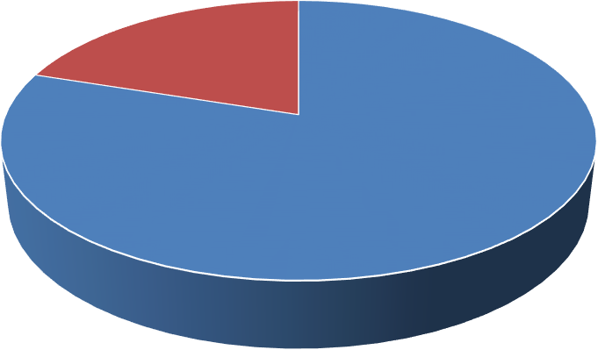
19.98%
80.02%
Using modern method
Using traditional method

Figure2: Distribution of different Modern contraceptive methods among youth women

(15-24 years) in India in 2015-16
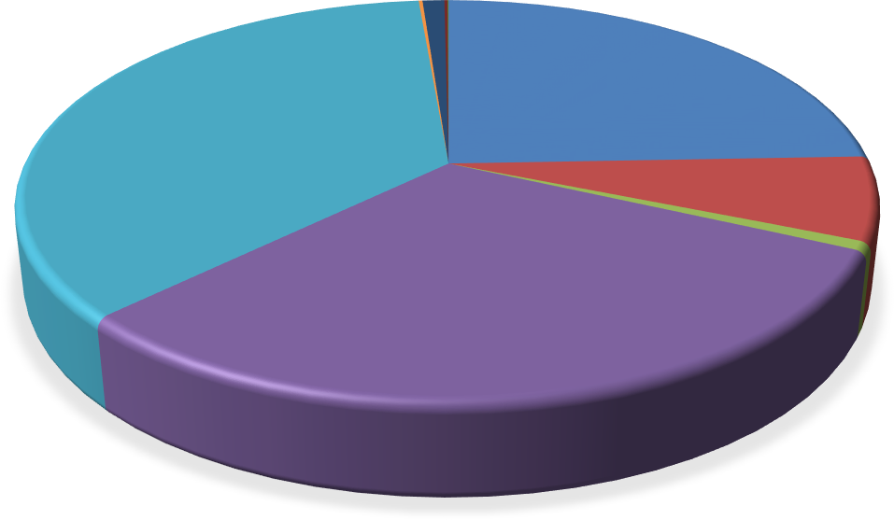
Lactational
Amenorrhea(lam), 0.98%,
Female
Male
Condom,0.14%, Sterilization,0.17%
Female
Sterilization, 35.90%
Iud, 6.74%,
Injections,0.70%
Condom, 30.92%
Pill, 24.41%
Standard Days, 0.05%

Figure3: Distribution of different Traditional contraceptive methods among youth women (15-24 years) in India in 2015-16

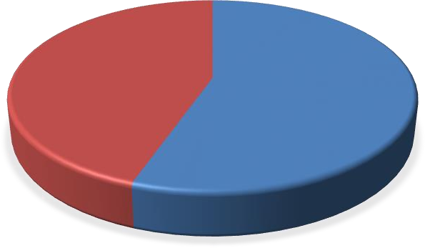
TRADITIONAL CONTRACEPTIVE METHODS

Withdrawal, 44.62%

Rhythm/Periodic Abstinence, 55.38%

Results:-

****Figure1*** depicts the distribution of Modern as well as Traditional method of contraceptive among youth women (15-24 years) in India in 2015-16. From the figure it can be seen that the usage of modern contraceptive is more (80.25 percent) than the traditional methods (19.98 percent).
***Figure 2*** depicts the distribution of different Modern contraceptive methods among youth women belonging to the age group 15-24 years in India in 2015-16. From the figure it can be seen that among the methods of modern contraceptives, the mostly used method is female sterilization (36 percent) followed by condom (31 percent) and Pill (24.41 percent) and the least used is standard days (0.05 percent) followed by female condom (0.14 percent) and male sterilization (0.17 percent).
****Figure 3*** depicts the distribution of different Traditional contraceptive methods among youth women belonging to the age group 15-24 years in India in 2015-16. From the figure it can be seen that among the methods of traditional contraceptives, the mostly used method is female sterilisation (36 percent) followed by condom (31 percent) and Pill (24.41 percent) and the least used is standard days (0.05 percent) followed by female condom (0.14 percent) and male sterilization (0.17 percent).
***Figure4*** shows state wise distribution of Modern as well as Traditional contraceptive methods among youth women (15-24 years) in India in 2015-16. From the figure it can be seen that in case of modern contraceptives, the percentage of usage is more among Dadra and Nagar Haveli (100 percent ), followed by Mizoram (99.64 percent ) and Puducherry (99.57 percent) and least in case of Lakshadweep (21.04 percent) followed by Manipur (37.61 percent and Uttar Pradesh (59.43 percent ).

Figure 4: State wise distribution of Modern as well as Traditional contraceptive methods among youth women (15-24 years) in India in 2015-16
Dadra and Nagar Havel 0
Andhra Pradesh0.36
Mizoram0.43 Telangana0.72 Puducherry1.05 Sikkim1.88 Karnataka 2.09
Tamil Nadu 5.62
Bihar 9.03
Maharashtra 9.59
Madhya Pradesh 10.04
Delhi Uttarakhand
Goa Andaman and Nicobar Island
Chhattisgarh Jharkhand Haryana Meghalaya Himachal Pradesh Daman and Diu
Punjab Jammu and Kashmir
West Bengal
Kerala Rajasthan Gujarat
Arunachal Pradesh
Chandigarh Nagaland Assam Odisha Tripura
Uttar Pradesh
Manipur
Lakshadweep
10.2
11.89
12.62
12.77
13.25
13.99
14.41
16.37
16.66
17.07
18.25
19.99
24.15
24.73
25.04
25.58
26.03
27.09
28.12
32.4
32.92
33.75
40.57
100
99.64
99.57
99.28
98.95
98.12
97.91
94.38
90.97
90.41
89.96
89.8
88.11
87.38
87.23
86.75
86.01
85.59
83.63
83.34
82.93
81.75
80.01
75.85
75.27
74.96
74.42
73.97
72.91
71.88
67.6
67.08
66.25
59.43
62.39 37.61
78.96
21.04
0%
20%
40%
60%
80% 100%
Using Traditional method
using Modern method

The Table1 shows Logistic regression for finding the potential determinants of using Modern method over Traditional method among young women (15-24 years) in India. The table depicted that women belonging to the age group 20-24 years (1.65, p<.001) are more likely to use modern contraception than the women in the age group 15-19 years when the other covariates are controlled. In case of wealth quintiles, women from richest wealth quintile (1.21, p<.05) are having more chances of using modern contraception method. The study results in increasing the likelihood of modern contraception usage than the traditional one who are residing with more family members (1.01, p<0.1). Women residing in Southern (3.88, p<0.001) and West (1.64, p<.001) region are more likely and belonging to Eastern (0.77,p<.001), Central (0.63,p<.001) or North Eastern region (0.46, p<.001) region are less likely to use modern contraception over traditional method. Women involved in any kind of job (1.53, p<.001)whose contraceptive decision taken by her husband or partner (1.27, p<.05) andfrom Christian (1.55, p<.001) and Buddhist religion (3.13, p<.001) are more likely to use modern contraceptive methods than the traditional one. On the other side, women from rural area (0.87, p<.05), husband or partner is having higher education (0.63 p<.0.5), belonging to and with OBC category (0.92, p<0.1) are less likely to use modern method than the traditional method.

Table1: Logistic regression for finding the potential determinants of using Modern method over Traditional method among young women (15-24 years) in India
Variables | Odds Ratio | 95%  Conf. Interval | P-value
Age (in 5 years )
20-24 | 1.65*** | [1.49,1.83] | 0
Type of place of residence
rural | 0.87** | [0.80,0.95] | 0.002
Highest educational level
primary | 1.04 | [0.92,1.18] | 0.51
secondary | 0.97 | [0.88,1.07] | 0.56
higher | 0.90 | [0.78,1.05] | 0.18
Wealth Index
poorer | 1.02 | [0.91,1.13] | 0.76
middle | 0.97 | [0.86,1.08] | 0.57

richer | 0.93 | [0.82,1.06] | 0.27
richest | 1.21** | [1.04,1.40] | 0.01
No. of household Members | 1.01* | [1.00,1.02] | 0.10
Decision maker for using contraception
mainly husband, partner | 1.27** | [1.08,1.50] | 0.01
joint decision | 1.08 | [0.96,1.23] | 0.21
other | 2.35 | [0.80,0.90] | 0.12
Highest Education level
primary | 1.14 | [0.79,1.65] | 0.49
secondary | 0.83 | [0.61,1.12] | 0.23
higher | 0.63** | [0.44,0.90] | 0.01
don’t know | 0.87 | [0.55,1.37] | 0.55
Occu_Women
yes | 1.53*** | [1.22,1.92] | 0
occu_Men
yes | 0.99 | [0.69,1.40] | 0.94
Region
South | 3.88*** | [4.67,7.41] | 0
East | 0.77*** | [0.69,0.86] | 0
West | 1.65*** | [1.40,1.94] | 0
Central | 0.64*** | [0.58,0.71] | 0
North east | 0.46*** | [0.41,0.52] | 0
Belong to a scheduled caste
schedule tribe | 1.09 | [0.97,1.23] | 0.14
obc | 0.92* | [0.84,1.01] | 0.08
none of them | 1.02 | [0.91,1.13] | 0.75
don’t know | 1.35 | [0.86,2.13] | 0.19
Religion
muslim | 0.92 | [0.82,1.02] | 1.02
christian | 1.55*** | [1.26,1.91] | 0
sikh | 0.98 | [0.79,1.22] | 0.85
9uddhist/neo-buddhist | 3.13*** | [1.95,5.04] | 0
jain | 0.60 | [0.19,1.97] | 0.41
no religion | 1
other | 1.57** | [1.08,2.29] | 0.19
_cons | 2.90*** | [1.78,4.75]
*** indicates p<0.001, ** indicates p<.05, * indicates p<0.1

Summary and Conclusion:
Among the youth women 80.02 % are modern contraceptive methods over total contraceptive usages. Among the modern contraceptive the most commonly usages are female sterilization (36%) followed by Condom(31%) and Pill (24.41%) .The State wise distribution shows that in case of modern contraceptives, the percentage of usage is more among Dadra and Nagar Haveli (100 percent ), followed by Mizoram (99.64 percent ) and Puducherry (99.57 percent) and least in case of Lakshadweep (21.04 percent) followed by Manipur (37.61 percent and Uttar Pradesh (59.43 percent ).From the logistic regression table shows that increasing the likelihood of modern contraception usage than the traditional one who are residing with more family members (1.01, p<0.1). Women residing in Southern (3.88, p<0.001) and West (1.64, p<.001) region are more likely and belonging to Eastern (0.77,p<.001), Central (0.63,p<.001) or North Eastern region (0.46, p<.001) region are less likely to use modern contraception over traditional method. Women involved in any kind of job (1.53, p<.001)whose contraceptive decision taken by her husband or partner (1.27, p<.05) and from Christian (1.55, p<.001) and Buddhist religion (3.13, p<.001) are more likely to use modern contraceptive methods than the traditional one. On the other side, women from rural area (0.87, p<.05), husband or partner is having higher education (0.63 p<.0.5), belonging to and with OBC category (0.92, p<0.1) are less likely to use modern method than the traditional method.

Declarations:-

Ethical Approval:- The analysis is based on the secondary dataset & there have no identification about the respondents on the survey participants.NHFS-4 Survey conducted by Ministry of Health and Family Welfare, coordinated by the International Institute for Population Sciences, Mumbai. In theNHFS-4 Survey, all the survey protocols were approved by the Institutional Ethical Review Board.
Competing Interest:- Authors have no Competing Interest.
Authors' contributions :- Sandipan Paul has conceived the idea, acquired the data, analysed it , prepared all figures and tables, and wrote the manuscript. Dulumoni Das, Apyayee Sil and Satyapriya Roy fine-tuned the project idea, co-wrote the manuscript and interpret finally.
Funding:- Not applicable.
Data Availability:- The data is available on the Institutional Website & can be easily downloaded for the research purpose by the students, faculty & other researchers in India.

References:
1. Basu Alaka, 1996. Female Schooling, Autonomy and Fertility Change: What Do These Words Mean In South Asia?, in Roger Jeffery and Alaka Basu, eds, Girls' Schooling, Women's Autonomy and Fertility Change in South Asia. Sage Publications.

2. Berelson Bernanrd, 1977. Path to fertility reduction: the policy cube. Family Planning Perspectives. Vol. 9. No. 5: 213-219

3. Donald J. Hernandez. 1985. Fertility Reduction Policies and Poverty in Third World Countries:Ethical Issues. Studies in Family Planning, Vol. 16, No. 2, pp. 76-87.

4. Gwatkin Davidson R. 1979. Political Will and Family Planning: The Implications of India's
Emergency Experience. Population and Development Review, Vol. 5, No. 1, pp. 29-59
International Institute for Population Sciences (IIPS). 1995. National family Health Survey (MCH andfamily Planning), India 1992-93. Bombay: IIPS.

5. International Institute for Population Sciences (IIPS) and ORC Macro. 2000. National family Health Survey (NFHS-2), 1998-99: India. Mumbai: IIPS.

6. Sen A. 1996. Fertility and Coercion. The University of Chicago Law Review, Vol. 63, No. 3, pp.1035-1061 Published by the University of Chicago Law Review

7. United Nations, 1994. Report of the International Conference on Population and Development, Cairo5-13 September 1994. (A/CONF.171/13).

8. Rakhi J, Sumathi M. Contraceptive method:needs,options and utilization.J Obstet Gynecol India. 2011;61(6):626-34

9. Alukal AT, George L, Raveendran RC.Awareness and practice of contraceptive methods among women in Kerala, India.Int J Reprod Contracept Obstet Gynecol2018;7:1501-4.

10. Renjhen P, Kumar A, Pattanshetty S, Sagir A, Samarasinghe CM. A study on knowledge, attitude and practice of Contraception among college students in Sikkim. India. J Turkish-German Gynecol Assoc. 2010;11:78-81.

11. Tuladhar H, Marahatta R. Awareness and practice of family planning methods in women attending gyne OPD at Nepal medical college teaching hospital. Nepal Med Coll J. 2008;10(3):184-91.

12.SantosoBI,SuryaR.Knowledge,attitude,and practice of contraception among pregnant women in Ende districet, east Nusa Tennaggara , Indonesia. J South Asian FederObstGynae.2017;9(2):110-8.

