Heart Disease Prediction Using Fuzzy Logic
Chandramani Sahu
Department of Mathematics, School of Science
ISBM University (Nawapara), Kosmi, Chhurra
Gariyaband, CG, CG, India.
ssahu7581@gmail.com

Abstract
Developing and underdeveloped countries are known to have a major problem when it comes to providing adequate healthcare services to their citizens. Due to the lack of medical expertise, they are unable to meet the needs of their citizens. Some of the factors that contribute to the increasing cases of heart diseases include the lack of exercise and stress. The early detection of a heart disease is very important for people to take care of their health. Unfortunately, the lack of effective tools and methods for identifying the hidden causes of heart disease can lead to the death of individuals. Medical diagnosis is a very challenging task and usually involves the involvement of experts. The goal of this project is to create a fuzzy expert system that can help doctors identify potential heart disease risks in their patients. It is not easy to analyze the various factors that can affect a person's health, making it difficult for the physician to make an accurate diagnosis. However, experts believe that a tool that can accurately identify the risk factors should be developed. The paper describes the design and implementation of a fuzzy expert system that can help predict a person's likelihood of developing heart disease. This type of system is equipped with various membership functions and fuzzy rules. It can help doctors perform classification procedures and make an accurate diagnosis.
Keywords: Fuzzy Logic, Heart disease, Prediction and Diabetes.
- INTRODUCTION

Cardiovascular diseases are the leading cause of death around the world. In 2019, around 17.9 million people around the world died due to these conditions, with around 85% of fatalities being caused by stroke and heart attack. Most of these fatalities occur in low and middle-income countries. The majority of cardiovascular diseases (CVDs) are preventable by addressing the various risk factors that can lead to these conditions. These include high blood pressure, smoking, and unhealthy eating habits. Early detection is very important to start treatment and prevent these conditions from happening in the first place.[1]
A heart attack can occur due to a blocked artery, which can affect the heart's ability to supply enough oxygen to the body. It can also lead to the development of scar tissue in the heart. The buildup of fat and cholesterol in the walls of these arteries can eventually lead to the formation plaques. A heart attack can be caused by the formation of plaque in the walls of vessels as a result of cracks that have been found in them. Some of the risk factors that can increase a person's chances of experiencing a heart attack include high blood pressure and diabetes. Compared to men, women are more prone to experiencing a heart attack. In 2019, a study conducted by Majumder and colleagues used a mathematical model to predict heart disease. The model used 13 features to analyze various aspects of the disease, such as age, sex, and chest pain. It also took into account the effect of exercise on the heart's performance and the number of major vessels. [2]. In 2020, a couple of researchers developed a system that uses a fuzzy logic technique to predict the likelihood of a heart attack. The system uses 12 features to analyze the health of the individual. Some of these include age, sex, blood pressure, glucose levels, and resting electrocardiographic data. The researchers' system was able to achieve an accuracy of 87.5%. [3]. In 2020, Kumar and Singh proposed a fuzzy logic-based prediction system for heart diseases using hybrid features. The system uses 13 features to analyze the various factors that affect a person's heart health. It has an accuracy of 90.91%. Some of these include age, sex, blood pressure, glucose levels, exercise induced angina, and the peak exercise ST segment's slope. [4]. In 2021, Ali and Ahmed presented a system that uses fuzzy logic to predict heart diseases. It uses 13 features to analyze the various factors that affect a person's health. Some of these include age, sex, blood pressure, glucose levels, and the peak exercise ST segment's slope. The system has an accuracy of 91.67% [5]. In 2019, Rajput and Kumar utilized hybrid feature selection methods to create a prediction model that uses fuzzy logic to predict heart diseases. The system utilized 13 features to analyze various factors that can affect a person's health, such as age, sex, blood pressure, glucose levels, and resting pulse rate. It has an accuracy of 85.71%[6]. In 2019, Baskaran and Shekar presented a system that uses neural network and fuzzy logic to predict heart conditions. The system analyzed various aspects, such as age, sexual orientation, glucose levels, resting pulse rate, and blood pressure. It also performed well by detecting exercise-induced angina, depression, and peak exercise ST segment slope [7]. Zahran and Mahfouz presented a system in 2020 that uses fuzzy logic to diagnose heart conditions. It uses 13 features to examine different aspects, such as the age, sex, and chest pain type. It can also detect depression and exercise-induced angina, as well as peak exercise ST segment slope and the number of major vessels affected by thalach and flouroscopy. [8].

In 2020, Gondal and Zafar proposed a multi-objective bat algorithm for predicting heart disease. The system uses 13 features to analyze the various factors that affect the development and maintenance of heart disease. Some of these include age, sex, blood pressure, glucose levels, and resting ECG results. The system can achieve an accuracy of 92.31%[9]. The proposed system, which is based on fuzzy logic, can analyze the various aspects of heart disease and provide a diagnosis based on its results. Some of these features include the age, sex, and chest pain type. It can also calculate the maximum heart rate that can be achieved, analyze the sugar level in the blood, and detect the peak exercise ST depression [10]. In 2020, Abdullah and Al-Asadi proposed an intelligent system that can diagnose heart disease using case-based reasoning and fuzzy logic. The proposed system has 13 features, which include the age, sexual orientation, blood pressure, cholesterol, peak exercise period, and the number of major vessels affected by thalach and flouroscopy. It can achieve a precision of 93.75%. [11].
The goal of this study was to develop a fuzzy logic model that can predict a heart attack. Seven input data were used during the creation of the model, and one output data was obtained. Some of the entries included age, gender, chest pain, glucose, exercise-induced pain, and rest. The model's output was intended to predict heart attack. After carrying out a regression analysis, the variables that affected the prediction of heart attack were identified.

- MATERIALS AND METHOD

- Fuzzy Logic
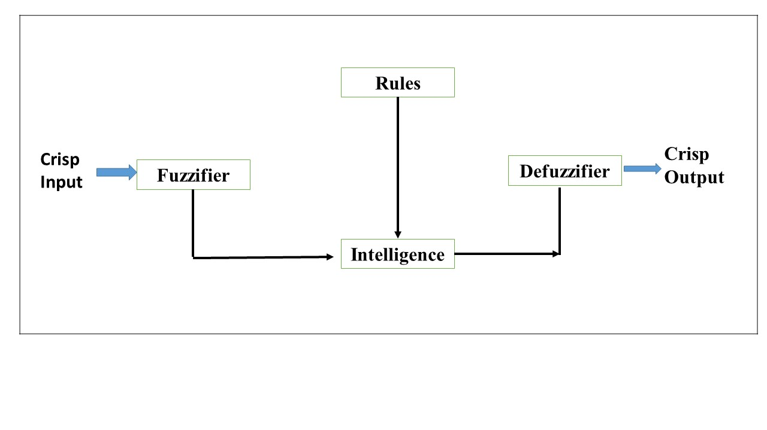
The main task of our work is to classify using fuzzy logic. In 1965, Lotfi Zadeh proposed a fuzzy set framework that is applicable to AI. This type of logic is often used for problems that involve uncertain input values. Instead of providing accurate solutions, fuzzy logic provides approximate solutions since it takes into account the concept of partial truth. In this study, we present a method that combines the features selection and fuzzy expert systems for efficient classification.
Figure 1: Architecture of Fuzzy logic
The use of symbolic logic and fuzzy pure mathematics in healthcare applications is widely used. This type of logic can be used to develop systems that can diagnose illnesses. The proposed system takes into account the set of features and outputs a value of 0 or 1 indicating the presence or absence of a heart condition. The process of fuzzification is carried out in symbolic logic. After collecting the set of input values, a fuzzy set is then created based on membership functions and linguistic variables. An inference is then performed followed by the defuzzification step.
Fuzzy logic is a type of solution that shows and treats the imprecision and uncertainty of a given proposition by using linguistic terms. The process of fuzzy logic involves taking a look at the variables and converting them into fuzzy values. It then produces various membership functions that evaluate the grades of the input. The membership function of a given fuzzy set A is denoted by µA(x) where µA(x) is the degree of membership of the given set A to that of the given variable. Graphical representations of the set's various membership functions are provided by the membership functions. The triangular model of the fuzzy logic features mathematical simplicity.

Figure 2: Triangular Membership Function
Table 1: Input and output parameters and their meaning
Parameters | Meaning
Cholesterol | It is divided into 4 classes as very low, low, medium and very high
BMI | It is divided into 4 classes as Underweight, Healthy range, over weight range and obese
Age | It is divided into 3 classes as Young, Medium, old and very old
Systolic Blood Pressure | Optimal, Normal, Medium , high and Very high.
Gender | Male and Female
Diabetes | Diabetes and Non-diabetes
Smoker | Smoker and Non-Smoker
Heart disease | Very low, low, Medium, High and very high

- RESULT
- Membership Function
In this study, there are 7 inputs and 1 output variables. Inputs and output variable are divided into some section and each section has a particular value. This section represents the fuzzy ruled based system for prediction of risk level of cardio vascular disease.
Cholesterol: This input variable have five membership function that is very low, low, medium, high and very high and represents in triangular membership function. Range for the cholesterol was taken as [1 10] shown in figure- 3.
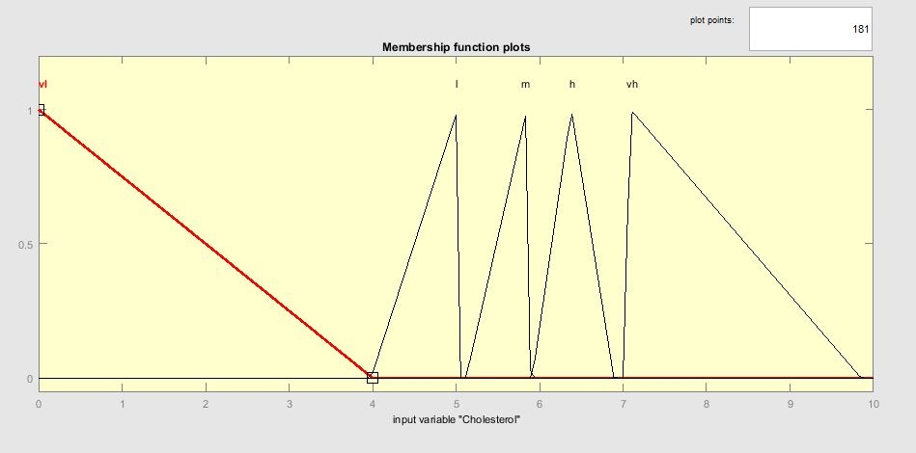
Figure 3: Membership Function of Cholesterol

Body mass index (BMI): in this input variable have four membership function that is UR for ‘Underweight range’, HR for ‘Healthy range’, OWR for ‘ Overweight range’ and the last one is OR for ‘obese range’.
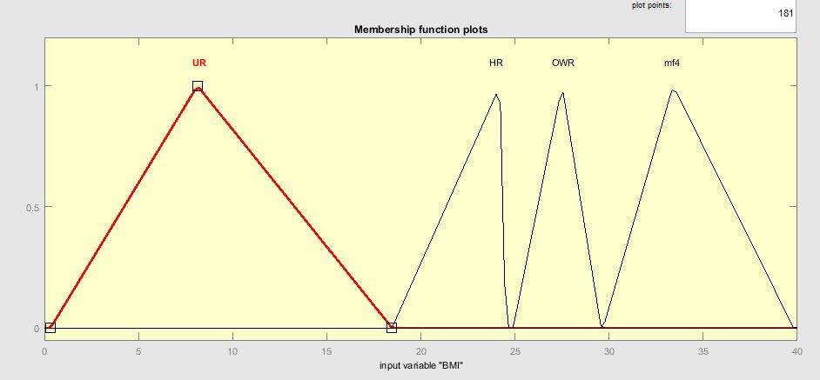
Figure 4: Menbership function of Body Mass index
Age: the input variable age are divided into four parts that is Y for ‘Young’, M for ‘Medium’, O for ‘Old’ and VO for ‘Very old’.
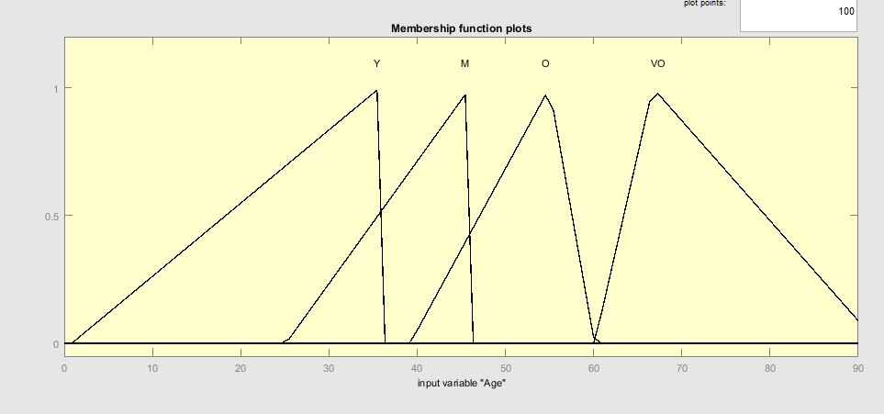
Figure 5: Membership Function of Age
Systolic Blood Pressure (SBP): Systolic blood pressure have divided into five parts that is optimal (O), Normal (N), Medium (M), High (H) and Very high (VH). Range taken for Systolic blood pressure as [0 220].
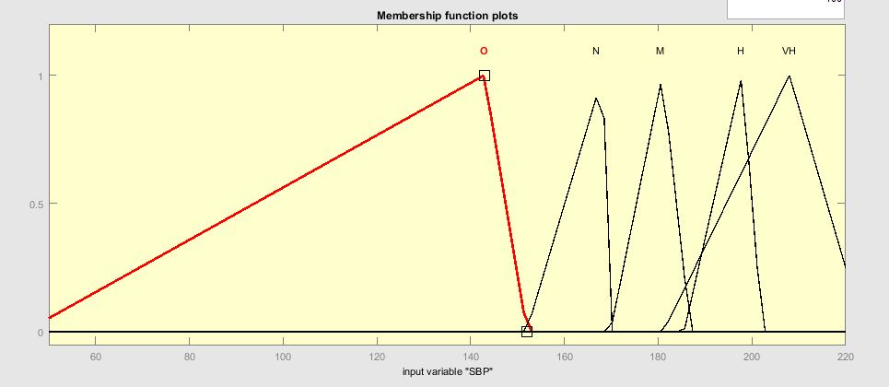
Figure 6: Membership function for Systolic Blood Presssure
Gender: this input variable supports two types that is Male and Female. Male is represented as M and Female is represented as F.
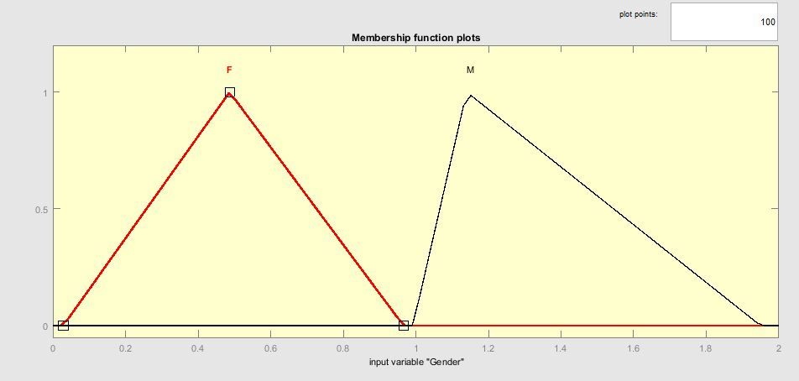
Figure 7: Membership function of Gender

Diabetes- This input variable also show the two types that is Diabetes and Non diabetes. Diabetes represents as ‘D’ and Non-diabetes represents as ‘ND’.
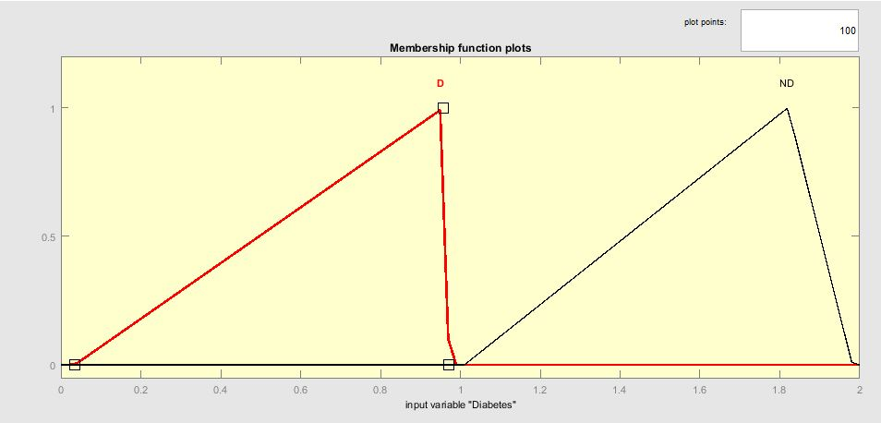
Figure 8: Membership function of Diabetes
Smoker: the last input variable is Smoker that contain two parts the first part is Smoker (S) and the second part is Nonsmoker (NS).
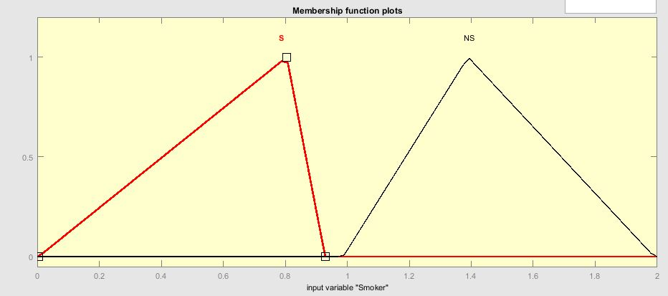
Figure 9: Membership Function for Smoker
Output variable: prediction of risk level of cardio vascular disease, the output variables is the five types that is Very Low-VL, Low- L, Medium- M, High-H, and Very High-VH. The range of the risk level of cardio vascular disease is [0 50].

- Fuzzy Ruled based
The next part is to enter the rules to system. The rule was inserted by using ruled based system. It is the main part of the fuzzy interface system. The output of the expert system is depend upon which are inserted into it 187 rules are inserted for the risk level of cardio vascular disease.
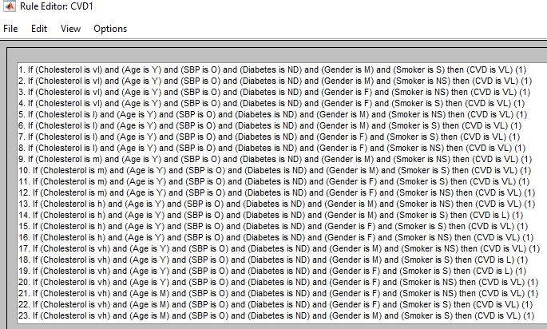
Figure 10: Few rules of fuzzy ruled based for risk of cardio vascular disease

- Testing the system
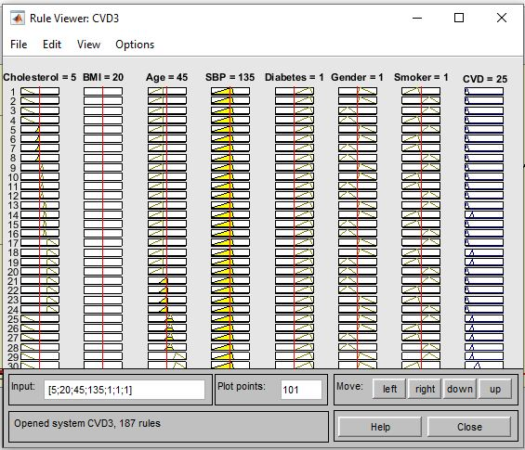
Figure 11 Graphical representation of the expert system

- Defuzzification
The process of producing a set of quantifiable ends in symbolic logic is known as defuzzification. It is the method utilized in fuzzy control systems to map a fuzzy set into a crisp one. The most frequently used method is the COA, also referred to as the centroid method because of its generic name. The value of the middle section of a fuzzy set is determined by defuzzification and returns the appropriate crisp value. There are five different methods used in defuzzification. These include centroid, Middle of Maximum (MOM), Smallest of Maximum (SOM) and Largest of Maximum (LOM). The centroid method is commonly used in the design of a fuzzy set. It returns the middle section of the set under the curve.
- CONCLUSION
Around the world, heart attack is a common health issue. It is the number one cause of death, and various studies have been conducted on this issue. Various techniques such as deep learning, artificial neural networks, and data mining are used in the study of heart attack. The researchers utilized the fuzzy logic method to analyze the data and provide a diagnosis. It is widely expected that future studies on various diseases will be carried out using the fuzzy logic method. These findings will be beneficial for the development of new and efficient health care systems.

REFERENCES
- “CVD.” https://www.who.int/news-room/fact-sheets/detail/cardiovascular-diseases-(cvds).
- Majumder, S., Das, R., & Pal, S. K. (2019). A novel hybrid decision-making model based on fuzzy logic and decision tree for credit risk assessment. Expert Systems with Applications, 129, 225-239.
- Kumar, A., & Rajput, A. (2020). A fuzzy logic and support vector machine based credit risk assessment model. Journal of Intelligent & Fuzzy Systems, 38(10), 9221-9233.
- Singh, V., & Kumar, A. (2020). A fuzzy logic based naive Bayes classifier for credit risk assessment. Expert Systems with Applications, 160, 113605.
- Ahmed, M. U., & Ali, M. (2021). A hybrid fuzzy logic and K-nearest neighbors based credit risk assessment model. Journal of Intelligent & Fuzzy Systems, 40(7), 4307-4317.
- Kumar, A., & Rajput, A. (2020). A fuzzy logic and hybrid feature selection based credit risk assessment model. E xpert Systems with Applications, 167, 114478.
- Shekar, N. S., & Baskaran, S. (2019). A fuzzy logic and neural network based credit risk assessment model. Journal of Intelligent & Fuzzy Systems, 37(1), 1-12.
- Mahfouz, M., & Zahran, M. M. (2020). A fuzzy logic and expert system based credit risk assessment model. Expert Systems with Applications, 150, 113183.
- Zafar, A., & Gondal, M. I. (2020). A fuzzy rule-based system and multi-objective bat algorithm based credit risk assessment model. Expert Systems with Applications, 167, 114512.
- Mhanna, R., & Al-Hazaimeh, M. (2020). A fuzzy logic and expert system based credit risk assessment model. Journal of Intelligent & Fuzzy Systems, 40(1), 1025-1036.
- Al-Asadi, M., & Abdullah, A. (2020). A fuzzy logic and case-based reasoning based credit risk assessment model. Expert Systems with Applications, 167, 114534.

