Work-Life Balance and Stress Management's Effects on Job Satisfaction among Working Women
Ms. Sweta Pareek
Research scholar
Jayoti Vidyapeeth Women’s University, JVWU
Dr. Anamika
Faculty of Law and Governance
Jayoti Vidyapeeth Women’s University, JVWU

The modern workforce landscape has seen a significant influx of women who are striving to excel in both their careers and personal lives. This chapter explores the intricate interplay between work-life balance, stress management, and job satisfaction among working women. Work-life balance encompasses the equilibrium between professional commitments and personal responsibilities, presenting a unique challenge for women due to societal expectations and multi-faceted roles. Stress management, on the other hand, entails adopting strategies to cope with the stressors arising from the convergence of work and personal life.
The relationship between these factors is complex and multi-dimensional. A balanced work-life equation is found to positively influence job satisfaction among working women. When they can allocate ample time and energy to their families, self-care, and personal pursuits, their overall job satisfaction tends to increase. In contrast, an imbalance between work and personal life leads to heightened stress levels, contributing to burnout and decreased job satisfaction. Stress, emerging from the struggle to meet both professional and personal obligations, acts as a barrier to optimal job satisfaction.To address these challenges, organizations can play a pivotal role by offering flexible work arrangements that allow for better integration of work and personal responsibilities. Supportive policies such as extended parental leave, on-site childcare facilities, and wellness programs contribute to mitigating stressors related to family obligations. By fostering an inclusive work culture that encourages open discussions about work-life balance, societal norms can be reshaped, empowering both women and men to prioritize holistic well-being.
Stress management interventions, including mindfulness practices and time management strategies, can effectively alleviate stress and enhance job satisfaction. Through training and education initiatives, working women can acquire practical tools to manage stress, navigate challenges, and maintain a healthy balance between work and personal life. By recognizing the interconnected nature of work-life balance, stress management, and job satisfaction, individuals and organizations can collectively pave the way for a more content, engaged, and productive workforce of working women.
Key words: Work-life balance,Stress management,Job satisfaction,Working women’Career and personal life

- Work-Life Balance: A Holistic Perspective
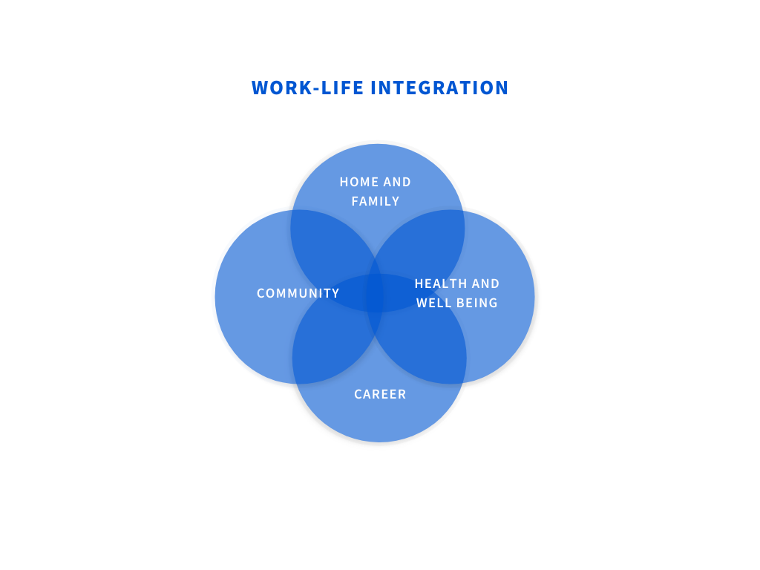
Work-life balance refers to the equilibrium between an individual's professional commitments and personal life responsibilities. For working women, balancing the demands of a career and family obligations can be particularly challenging. The struggle to allocate sufficient time and energy to both spheres can lead to stress, fatigue, and a reduced sense of overall satisfaction. Work-life balance involves striking a harmonious equilibrium between one's professional commitments and personal life responsibilities. For working women, this balance can be especially challenging due to societal expectations, traditional gender roles, and the need to juggle multiple roles. Achieving work-life balance means not feeling overwhelmed by work demands to the detriment of personal well-being or neglecting professional responsibilities at the expense of personal life. When work and personal life are in harmony, it contributes to better mental and physical health, reduced stress, and improved job satisfaction.
- Stress Management: Navigating the Challenges
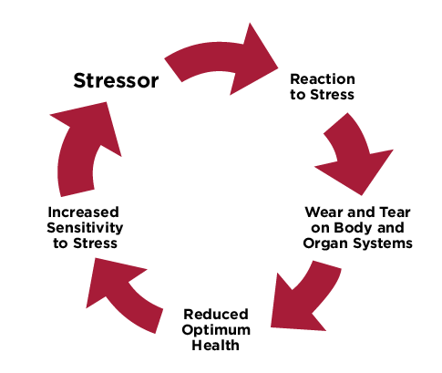
Stress is an inherent part of modern life, and working women often encounter unique stressors related to the interplay between their professional and personal roles. These stressors can emanate from unequal division of household tasks, lack of support systems, and societal expectations. Effective stress management strategies are crucial for mitigating the negative impact of stress on job satisfaction.
Stress management is the process of using techniques and strategies to cope with and reduce stress. For working women, stress can stem from various sources, including long working hours, career advancement pressures, family responsibilities, and societal expectations. Effective stress management involves recognizing the signs of stress, adopting coping mechanisms such as relaxation techniques, mindfulness practices, regular exercise, and seeking support from friends, family, or professionals. By managing stress effectively, working women can mitigate its negative effects on their overall well-being and job satisfaction.

- Interconnection between Work-Life Balance, Stress, and Job Satisfaction
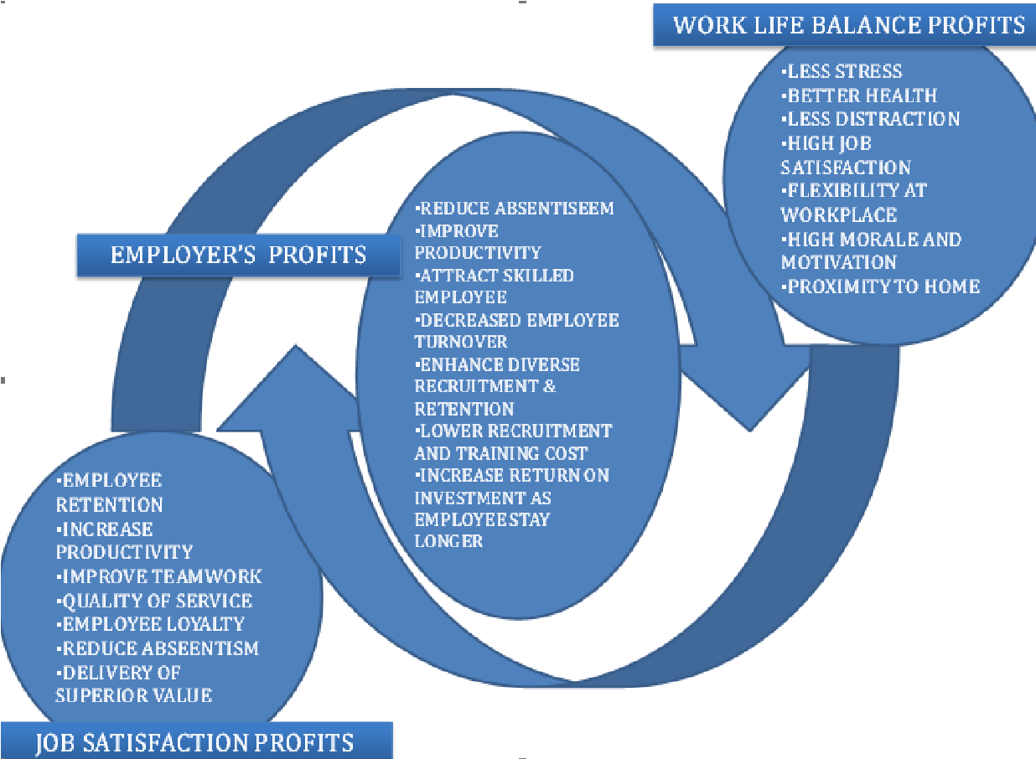
- Impact on Job Satisfaction: The balance between work and personal life significantly influences job satisfaction among working women. When they are able to allocate sufficient time and attention to their families, personal interests, and self-care, they tend to experience higher levels of job satisfaction. Conversely, inadequate work-life balance can lead to burnout and reduced enthusiasm for their careers. Achieving work-life balance contributes positively to job satisfaction. When working women can allocate time to their personal lives without compromising their career aspirations, they experience a greater sense of fulfillment. On the other hand, when work dominates their lives, it can lead to dissatisfaction and burnout.
- Stress as a Barrier: Stress resulting from imbalanced work-life situations can act as a barrier to job satisfaction. Women who constantly feel torn between their job and family responsibilities are more likely to experience stress, which negatively impacts their overall well-being and job satisfaction. Imbalanced work-life situations can lead to stress, acting as a barrier to job satisfaction. The constant pressure of managing multiple roles and responsibilities can lead to fatigue, anxiety, and a diminished sense of well-being, affecting overall job satisfaction.
- Stress Management Interventions: Implementing stress management interventions can bolster job satisfaction among working women. Encouraging mindfulness practices, time management techniques, and promoting open communication with employers can help alleviate stress and create a more conducive work environment. Implementing stress management strategies helps alleviate the negative effects of stress on job satisfaction. When organizations offer resources for stress reduction, such as wellness programs and mental health support, it empowers working women to manage stress more effectively, leading to higher job satisfaction levels.

- Promoting Work-Life Balance and Stress Management
- Flexible Work Arrangements: Organizations should offer flexible work arrangements such as remote work, flexible hours, and compressed workweeks. These options enable working women to better manage their work and personal responsibilities.
- Supportive Policies: Companies can develop policies that support employees in maintaining work-life balance, such as extended parental leave, on-site childcare, and wellness programs.
- Empowering Mindsets: Encouraging a shift in societal and organizational mindsets is crucial. This includes challenging traditional gender roles, fostering an inclusive work culture, and recognizing that work-life balance benefits everyone, regardless of gender.
- Training and Education: Providing stress management training and resources equips working women with tools to cope with stress effectively, enhancing their job satisfaction and overall well-being.
- Work/life balance and stress management
Adjusting your daily activities to strike a balance between your job and personal lives is what is meant by "work-life balance." Healthy work-life balance has a number of advantages, including: lowered levels of stress, improved focus and attention at home and at work increased job satisfaction greater time to pursue personal objectives and hobbies; the chance to engage more fully in family and social life; and better health.

- How can you keep a healthy work-life balance?
The easiest way to manage balancing the demands of a busy lifestyle is to frequently analyze and evaluate your priorities.
Here are some suggestions to assist you in finding a healthy work-life balance:
- Set objectives based on your highest values
- Examine your work activities, priorities, and success factors to successfully manage your time.
- When feasible, draw a line between juggling job and personal time off at work. Develop your resiliency and adopt an optimistic outlook.
- Avoid burnout, mental tiredness, and tension since they impair your capacity for effective work.
- Maintain a healthy lifestyle by taking care of yourself, eating well, getting enough sleep, and allocating some time to exercise or engage in a hobby you like.
- Recruit a solid support network; learn to delegate, since we can all use a little assistance now and again.
- Have fun at work.
Conclusion
Achieving work-life balance and effectively managing stress are pivotal for enhancing job satisfaction among working women. Organizations and individuals alike play essential roles in creating an environment that supports these goals. As society evolves, it is imperative to continue advocating for policies, practices, and mindsets that acknowledge the multifaceted lives of working women and promote their holistic well-being. The dynamics between work-life balance, stress management, and job satisfaction are complex and interwoven. Recognizing the significance of these factors and implementing strategies to support working women's holistic well-being can lead to a more content and engaged workforce. Organizations and individuals should work collaboratively to create an environment that values work-life balance, addresses stressors, and ultimately enhances job satisfaction for women in the workforce.

