An Overview of Internet of Vehicles (IoV)
Dr. R. Jeevitha
Assistant Professor, Department of Information Technology, PSGR Krishnammal College for Women, Coimbatore, India.
Abstract
The network which interconnects the cars, pedestrians and parts of urban infrastructure by using various sensors, built-in hardware and software to provide continuous communication is referred as the Internet of Vehicles (IoV). IoV is the major application of the Internet of Things (IoT) in the transportation field. The Internet of Vehicles is important for safer and efficient smart transportation. Internet of Vehicles (IoV) enables communication between vehicles and public networks using vehicle-to-vehicle (V2V), V2R Vehicle-to-Road (V2R), Vehicle-to-Human (V2H) and vehicle-to-sensor (V2S) interactions where the participants are intelligent objects. This chapter focuses on network architecture of IoV, features, benefits, applications, advantages of vehicle networking, new challenges in research and future of IoT in transportation. As IoV provides safe driving experience to the passengers, this chapter focuses on the importance of IoV, how vehicle connects to Internet and future scope of connected cars. Each entity in the network acts as an intelligent object. As IoV is evolved from the Vehicular Adhoc Network (VANET), there exist security and privacy issues which should be overcome by the connected intelligent objects.
Keywords: IoV, VANET, ITS, SIoT, GPS, RSU
I Introduction
The Internet of things (IoT) connects smart objects and allow them to communicate with each other. When the smart objects are connected over Internet are exclusively vehicles, then IoT becomes Internet of Vehicles (IoV). IoV is considered to be an extended application of IoT in the field of intelligent transportation. This IoV serves as an important data sensing and processing platform for Intelligent Transportation Systems (ITS). Smart objects share important information such as ID, location, speed, messages, and traffic information that are required for the network operation. IoV components contains many types of sensors including global positioning system (GPS), light detection and ranging (LIDAR), cameras, radar, and electronic control units (ECUs) [7]. The features that are exhibited by the Smart vehicles are self-driving, safety driving, social driving, electric vehicles, and mobile applications. The Internet of Vehicles (IoV) consists of nodes/objects (vehicles) which can communicate with each other as well as with handheld devices carried by pedestrians, Road side units (RSUs), and the public networks using V2V (vehicle-to-vehicle), V2I (vehicle-to-infrastructure), V2R (vehicle-to-road), V2H (vehicle-to-human)/ V2P (vehicle-to-pedestrian) and V2S (vehicle-to-server) interconnectivity. A social network is established where the participants are smart objects rather than the human beings. This social network is called Social Internet of Vehicles (SIoV). SIoV is a vehicular instance of SIoT. IOV is the advanced version of Vehicular Ad-hoc Network (VANET) which originated from Mobile Ad-hoc Network (MANET). It extends VANET’s scale, structure and applications [3].

II Network architecture of IoV
According to Ishita Seth et al [1]., the IoV communication has seven layered architecture. The role of User Interaction layer is to collect the data from a user. After collecting the data, it can communicate with the user directly and manage the notifications. Acquisition layer collects data from different sources. The collected data is filtered and pre-processed in the pre-processing layer. Communication layer selects the best network available 3G,4G,5G for communication. Management layer manages the network providers and offers interoperability. Business layer builds business models, analyse and process the data. The security layer provides authentication, confidentiality, privacy and no-repudiation of the data [4].
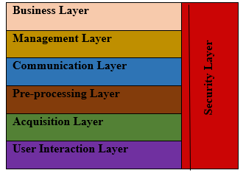
Fig 1. Architecture of Internet of Vehicles (IoV) communication (Ishita Seth et al.,2022)

Vehicle-to-Vehicle (V2V) communication supports Safety alerts, transmission of data and video sharing. Each vehicle is considered as a node where one node can connect to the other moving vehicles within the vehicular network. Vehicle to- Infrastructure (V2I) supports the communication with the building and smart cities. The availability of the parking space in the malls (smart parking) and availability of tables for food in some restaurants can be obtained using V2I communication. Vehicle-to- Roadside unit (V2R) is essential for communicating with roadside units like traffic signals and warning signs for the road walk. In V2P, the personal devices are connected to the infotainment unit of the vehicle using Android and iOS platform and communicate with the personal devices. Picking a phone call, listening to music, navigating the locations, SIRI, and Google assistant can be made available for the driver to use without taking phones in the hands. V2S-based network communication is used for the communication from the servers and any automatic update of software [1].

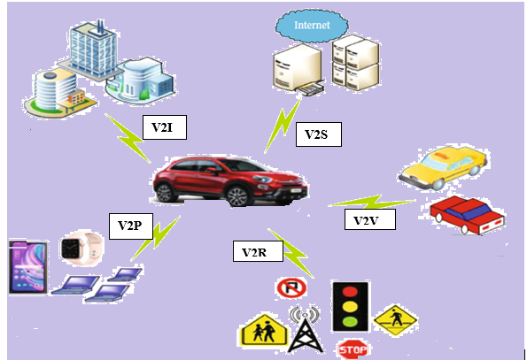
Fig 2 IoV communications (Ishita Seth et al., 2022)

III Features of IoV
- Faster travel - optimizing traffic flows and preventing traffic jams
- Efficient vehicle maintenance
- Less energy consumption
- 5G network suited for V2I communication
- Better vehicular movement and traffic management
- For making predictive analytics, and to initiate the corrective actions
- Reduced traffic congestion
- Smart parking
- Energy saving - Fuel and electricity resources are optimized using smart lights and smart signals.
- Reduced carbon emissions

IV Applications of IoV
Safety application: In public safety, IoV is used for emergency rescue, emergency message dissemination, emergency vehicle priority and emergency vehicle avoidance warning. Highway management, high precision map, vehicle tracking and automatic collection of highway tolls come under Intelligent traffic management. In case of road information warning, speed warning, collision warning, s-bend and U-turn warning can be suggested.
Service application: The daily services like online news, games, infotainment, entertainment, navigation can be disseminated. Business service and diagnostic services can be categorized under service-based application.
Other applications include automatic parking, mobile payment, fleet management, vehicle monitoring, transport efficiency and logistics [6].

V Advantages of vehicle networking
Vehicle networking connects the internal components of vehicles to aid the vehicles to securely communicate their locations and obtain the real-time information to avoid crashes and accidents. Different vehicular networks are interconnected to enhance the road safety, driving efficiency, security and passenger experience in addition to faster travel, reduced energy consumption, and better vehicle maintenance. AI-powered driving assistance, predictive maintenance, and direct car-to-car interaction are enabled in IoV. Most of the smart cars run on electricity, reduces the harmful greenhouse gas emissions. The data gathered by the IoV system helps the companies to conduct preventive maintenance of car parts, reduce the cases of thefts and better-quality products are delivered based on the customers’ behaviours and driving preferences.
VI New challenges in research and future of IoT in transportation.
Even though the intelligent transportation systems have benefited the society, there exist security issues and challenges. In blockchain-based IoV, the data transfer between the common nodes are not fully secured. There occurs end to end delay in vehicular communication and during the peak hours. Minimizing the delay is a major problem to be taken into account. Saving fuel and emission leading to environmental pollution can be optimized using AI techniques [5]. Data are transferred between smart entities for various system operations may contain value-added services and security applications. New communication protocols for autonomous vehicles can enhance the performance of IoV networks in terms of security and privacy [2]. Light weight and secured encryption standards can be developed. Large amount of data is generated by SIoV needs the requirement of the collected data, transmitted data, storage, classification, and decision making. Data mining and classification techniques can be used for securing big data analytics [6] [7].

Discussion
In this chapter, the need for Internet of Vehicles (IoV) is addressed. Internet of Vehicles is the blend of VANET with IoT. Internet of vehicle is the revolutionary technology that provides innumerous openings to automotive manufactures and it also provides a safe driving experience to the passengers. In the competitive world, IoV is considered to play an important part in the automotive industry. As the number of vehicles increases every day, it poses a challenge for every developing technology within the area of the automobile. Connected vehicles improves the overall environment by reducing the carbon footprint. With the invent of smart cars and arising communication technologies among vehicles, IoV has become the important field of research as it is attracting the several vehicle industries and researchers.

REFERENCES
[1] Ishita Seth, Kalpna Guleria, Surya Narayan Panda, Divya Anand, Khalid Alsubhi, Hani Moaiteq Aljahdali, and Aman Singh,” A Taxonomy and Analysis on Internet of Vehicles: Architectures, Protocols, and Challenges”, Hindawi Wireless Communications and Mobile Computing Volume 2022, pp:1-26, https://doi.org/10.1155/2022/9232784
[2] Jawaher Abdulwahab Fadhil, Qusay Idrees Sarhan, “Internet of Vehicles (IoV): A Survey of Challenges and Solutions”,2021 21st International Arab Conference on Information Technology, 2021
[3] Matthew N. O. Sadiku, Mahamadou Tembely, and Sarhan M. Musa, “Internet of Vehicles: An Introduction”, International Journals of Advanced Research in Computer Science and Software Engineering, Volume-8, Issue-1, 2018, pp:11-13.
[4] Murtaza Rashid Wani, Jasdeep Singh,” Internet of Vehicle (IOV) Security Issues and Their Solutions”, International Journal for Research in Applied Science & Engineering Technology (IJRASET), Volume 10 Issue III Mar 2022
[5] Priyankkumar Sharma, Meet Shitalkumar Patel, Apoorva Rajesh Prasad, “A Systematic Literature Review on Internet of Vehicles Security” https://arxiv.org/pdf/2212.08754, 2022
[6] Sedeng Danba, Jingjing Bao, Guorong Han, Siri Guleng and Celimuge Wu,” Toward Collaborative Intelligence in IoV Systems: Recent Advances and Open Issues”, Sensors 2022, 22, 6995, pp:1-38. https://doi.org/10.3390/s22186995
[7] SulaimanM.Karim, AdibHabbal, ShehzadAshrafChaudhry and AzeemIrshad, “Architecture, Protocols, and Security in IoV: Taxonomy, Analysis, challenges, and Solutions”, Hindawi Security and Communication Networks, 2022, pp. 1-19 ,https://doi.org/10.1155/2022/1131479

