FUTURISTIC TRENDS IN DENTISTRY
Artificial Intelligence --- A New Diagnostic Software in Dentistry
- Dr.Karthik Shunmugavelu
BDS, MDS OMFP, MSC LONDON, MFDSRCS ENGLAND, MFDSRCPS GLASGOW, FACULTY AFFILIATE RCS IRELAND, MCIP, FIBMS USA, MASID AUSTRALIA
Senior Resident / Consultant Dental Surgeon / Consultant Oral and Maxillofacial Pathologist
Department of Dentistry/Oral and Maxillofacial Pathology
PSP medical college hospital and research institute Tambaram Kanchipuram main road Oragadam Panruti Kanchipuram district Tamilnadu 631604
Mobile 0091-9789885622/9840023697
https://orcid.org/0000-0001-7562-8802
- Dr Evangeline Cynthia Dhinakaran
MBBS DMCH FUS OBG (MD PATHOLOGY)
Sree Balaji Medical College and Hospital, Chrompet, Chennai-600044, Tamilnadu, India
Mobile – 9952054096
Email – drevangelinedhinakaran@gmail.com
0000-0003-2194-6455

Abstract:
Artificial intelligence (AI) is taking hold in public health, especially in dentistry because everyone are looking to make a diagnosis using technology that allows them to work faster and accurately, reducing the costs, less time consuming and the less count in number of medical errors. Artificial Intelligence has proved to be a boon in the field of health care and in dentistry. In the future, AI-based comprehensive care systems are expected to have high-quality patient care and help researchers know and treat more about diseases. Even though there are some misconceptions and limitations about Artificial Intelligence, it continues to be successful due to its advantages in providing exact and accurate results. Along with AI, certain trends are in use, like 3D printing, Teledentistry, Machine Learning, and Smart Dental Devices. These are just a few of the many ways that technology is changing dentistry. As technology continues to advance, there will be more innovative and ground breaking developments in this field in the coming years. Albert Einstein said, “Imagination is the highest form of research.” so one needs to be National Dental Thinker providing innovative Dental Solutions¹. Nanotechnology, stem cells, and gene therapy are also innovative methods that are used in dentistry ². This review describes few present and future applications of all the above trends in dentistry.
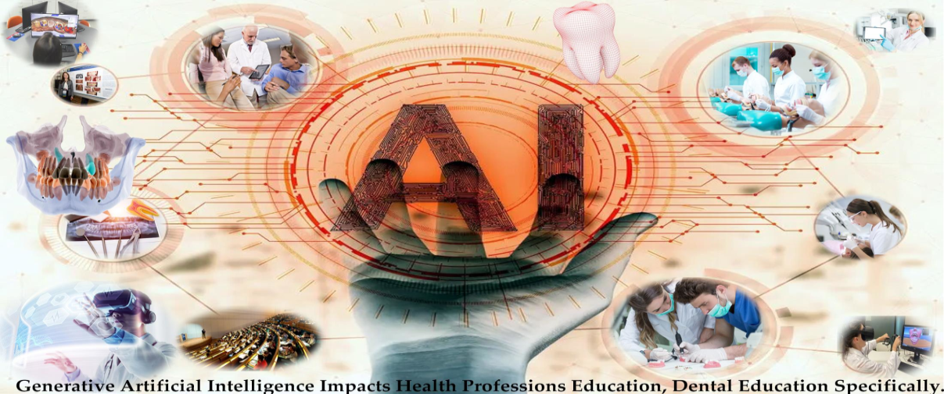
Figure1: Graphical Abstract
Courtesy: Thurzo A, Strunga M, Urban R, Surovková J, Afrashtehfar KI. Impact of Artificial Intelligence on Dental Education: A Review and Guide for Curriculum Update. Education Sciences. 2023; 13(2):150. https://doi.org/10.3390/educsci13020150³

Introduction:
Artificial Intelligence:
Tooth loss or tooth pain or any gum disease is very common and it can be due to disease or trauma and thus dental implants are widely used to provide a replacement for missing teeth or preventing tooth pain and gum disease. The healthcare sector is involving more and more technologies like artificial intelligence and machine learning from the past 5 years. The main objective is to analyse the accuracy of artificial intelligence and machine learning in the diagnosis of different dental diseases or conditions. Artificial intelligence (AI) is a fast-moving technology that enables machines to perform tasks exclusively when compared to human-beings⁴. Advances in Artificial Intelligence offer benefits such as increase in the quality of life, improve in decision-making, and decrease in the number of unnecessary procedures⁵. In 1956, “John McCarthy”, a mathematician from Dartmouth University, introduced the concept of Artificial Intelligence at a workshop which credited him as the “Father of Artificial Intelligence”⁶ and he defined the term “artificial intelligence” (AI), as “computerized synthetic human cognitive function”⁷. In 1978, “Richard Bellman”, defined Artificial Intelligence as “The automation of activities associated with human thinking abilities, that includes learning, decision making and problem-solving”⁸. AI can be regarded as a valuable tool to help dentists reduce their workload along with diagnosing diseases using a single information source on a specified disease. AI can diagnose the disease or the abnormalities by learning from multiple information sources beyond human capabilities. AI also enables early diagnosis through the search and detection of pre-symptoms of contracting a given disease⁹. AI allows machines to learn to adapt to new processes, and perform tasks like a human being. Based on various advantages of Artificial Intelligence based technologies, health care and dentistry have gained many benefits¹⁰. Back in 2020, dated Jan 8, there was a very harmful virus called coronavirus, which was referred and designated as a severe acute respiratory syndrome (SARS)-CoV-2, and was the latest pandemic that was affecting human health across the world¹¹. At that time, healthcare providers and especially all the dental care personnels were at an increased risk of contracting the infection and becoming carriers of the disease. According to Occupational Safety and Health Administration (OSHA), dental health care personnel (DHCP) were placed in the very high risk category as dentists work close to the patient’s oral cavity¹². AI has been demonstrated to increase accuracy, efficiency, and give exact results on par with medical experts more quickly and affordably¹³. The main component of artificial intelligence technology is a neural network that is designed like the human brains, which can simulate human thoughts. The neurons which are strongly interconnected make up this sort of brain architecture, that primarily functions as a data processing system to address a particular disease¹⁴. AI solutions have not, entered routine dental practice, mainly due to limited data availability, structure, and comprehensiveness, lacking methodological standards in their development, and practical questions and usefulness of these solutions¹⁵. AI is a platform to make dental care better, and time-saving for the professionals. AI helps dentistry professionals to fulfil the demands of patients provides better oral health care and quality treatment. AI can also help in predicting failures of clinical cases and gives precise and accurate solutions. In this way, it helps in increasing the quality of treatment of dental problems¹⁶. Artificial intelligence appeared as a reliable mode to enhance future implications in the various fields of dentistry like diagnostic dentistry, restorative dentistry, head and neck cancer, orthodontics, radiology, endodontics and periodontics¹⁷. In dental radiology, AI has been used to improve image interpretation. The process of machine learning is significantly improving with the help of deep learning, that enables the computer to process numerous algorithms with graphic processing units¹⁸. Most of the work is focused on AI models that rely on convolutional neural networks (CNNs) and artificial neural networks (ANNs). These AI models are used in the detection and diagnosis of various abnormalities like vertical root fractures, dental caries, apical lesions, salivary gland diseases, sinusitis, disorder of the jaw, cancerous lesions, alveolar bone loss, and orthodontic treatments¹⁹. AI enables in the creation of a virtual database to assist the professionals in the treatment and also helps in follow-up and emergencies²⁰. The results showed that the accuracy and precision of the disease is about 90%–96% when the above CNN and ANN algorithms are used²¹. AI can be involved in the process of locating canals during control trials and radiographic images which shows damaged or decayed tooth²². AI also has the potential to transform many features of dentistry, from diagnosis to treatment planning.

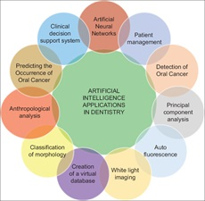
Figure 2: Different applications of artificial intelligence in dentistry
Courtesy: Lingam, Amara Swapna; Koppolu, Pradeep1; Akhter, Fatema; Afroz, Mohammed Malik; Tabassum, Nafeesa; Arshed, Maheen; Khan, Tahseen; ElHaddad, Sally. Future Trends of Artificial Intelligence in Dentistry. Journal of Nature and Science of Medicine 5(3):p 221-224, Jul–Sep 2022. | DOI: 10.4103/jnsm.jnsm_2_22²³

The future of Artificial Intelligence:
Artificial intelligence in health care may involve activities from simple to very advanced activities which may include medical record review, population health analytics, radiological image interpretation, and clinical diagnosis and treatments²⁴. Artificial Intelligence is the new evolution of dentistry which may involve in any aspects like for example it may evolve the manual dental chairs to an electrical ones that has voice recognition centres to facilitate command operations by the dentists²⁵. In the future, AI will be used by all dental practitioners and with the use of machine learning the patient records and diagnostic data can be saved virtually. This will help patients maintain health track records and also help practitioners share the data for consultation and discuss the case with the fellow practitioner in a hassle-free way. In the future, the cutting-edge technologies will serve as great assistant to the practitioner by increasing their precision and their valuable time will not be wasted²⁶. Improved Diagnostic Accuracy, Predictive Analytics, Personalized Treatment Planning, Dental Robotics, Augmented Reality, Digital Impression Scanning, and Improved Patient Communication are included, which can be done by the AI models in the coming future.
Challenges of Artificial Intelligence:
AI systems are associated with safety issues and also mechanisms must be created to control the quality in AI algorithms. To improve this situation, the United States Food and Drug Administration(USFDA) have created a new drug category, “Software as Medical Device,” through which it regulates patient safety and safe innovation. In the use of AI systems, the other concern is Ambiguous accountability which is very challenging for AI to get into day to day life²⁷.

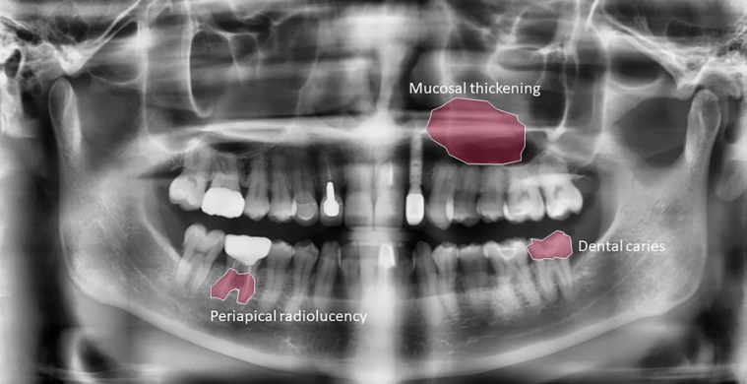
Figure 3: AI dental image analysis
Courtesy: Lee, S, Kim, D, Jeong, HG, (2022) Detecting 17 fine-grained dental anomalies from panoramic dental radiography using artificial intelligence. Research Outreach. Scientific Reports, 12, 5172. doi.org/10.1038/s41598-022-09083-2 DOI: 10.32907/RO-130-2773295876²⁸

Clinical Application of AI in Dentistry:
Osteoarthritis classification: AI has demonstrated the ability to classify 3D images of the mandibular condyle into structural degenerative changes, achieving 91% close agreement with clinician consensus and an established classification system²⁹.
Cancer Detection: In a recent study, an AI model was able to achieve an F1 score (which includes precision and recall) of 87% for the identification of images containing lesions³⁰.
Radiology: In Dental radiography, intraoral radiographs, advanced imaging techniques, and cone beam computed tomography (CBCT), are collected for diagnosis and treatment planning. AI can be used as an effective tool to help dentists make more reproducible assessments of radiological images³¹.
Orthodontics: It is the branch of dentistry that focuses on diagnosing and treating the placement irregularities of the teeth and the development and position disorders of the jaws³².
Periodontics: It is the branch of dentistry that focuses on health of gums and jawbone. Periodontitis is the most common oral disease that can cause alveolar bone loss, tooth mobility, damage gums, destroy jawbone and also lead to tooth loss³³. The diagnosis of periodontitis can be made by radiographic and clinical examination of periodontal tissues³⁴.

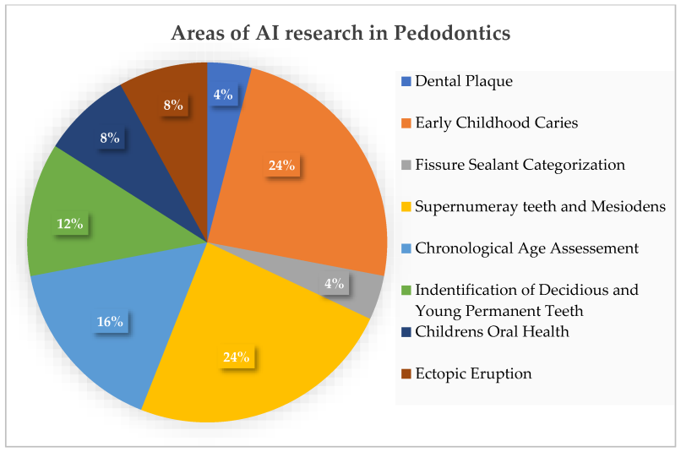
Figure 4: Areas of AI research in Pedodontics
Courtesy: Vishwanathaiah S, Fageeh HN, Khanagar SB, Maganur PC. Artificial Intelligence Its Uses and Application in Pediatric Dentistry: A Review. Biomedicines. 2023; 11(3):788. https://doi.org/10.3390/biomedicines11030788³⁵

Endodontics: It is a branch of dentistry concerned with all components of pulpal and periapical pathologies from their accurate accessment to their treatment. Anatomical variations of root canals, canal shaping techniques are some of the topics that are researched and continue to be developed in endodontics³⁶.

Oral pathology³⁷: Artificial intelligence models and networks can learn and process dense information in a short time, leading to an efficient, objective, and accurate clinical and histopathological analysis, which can be useful in improving treatment modalities and prognostic outcomes³⁸.
Machine Learning: It is a branch of AI in which systems learn to perform intelligent tasks without prior knowledge. The system also identifies patterns in samples from large data patterns and sets without human help. Deep learning (DL) which is the sub-branch of ML involves the systems that attempt to learn both patterns and compostable hierarchies of patterns³⁹.

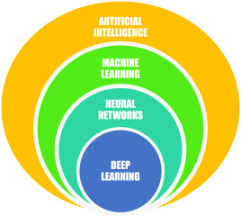
Figure 5: Key Aspects of Artificial Intelligence
Courtesy: Sanjeev B. Khanagar, Ali Al-ehaideb, Prabhadevi C. Maganur, Satish Vishwanathaiah, Shankargouda Patil, Hosam A. Baeshen, Sachin C. Sarode, Shilpa Bhandi, Developments, application, and performance of artificial intelligence in dentistry – A systematic review, Journal of Dental Sciences, Volume 16, Issue 1, 2021, Pages 508-522, ISSN 1991-7902, https://doi.org/10.1016/j.jds.2020.06.019⁴⁰.
3D printing: It is being used to create custom dental restorations such as crowns, bridges, and dentures; well, it allows dentists to create these restorations quickly and accurately. With accurate 3D scans and virtual models, it is easy to take the 3D print of the aligners with treatment plans. As the whole data get computed, it creates an algorithm that decides how a patient’s teeth should be moved, with how much pressure to be applied and even identifying pressure points for that particular teeth⁴¹.
Teledentistry: Teledentistry is a combination of telecommunications and dentistry which involves the exchange of clinical information over remote and far distances for dental consultation and treatment planning⁴². Teledentistry which is defined as the use of health information technology and telecommunications for oral care has the potential to identify high-risk population without any contact, facilitate patient access to dental care, and reduce waiting lists, unnecessary travel⁴³. Teledentistry has also the potential to address the oral care needs of those who have limited access to care⁴⁴. Teledentistry demonstrated that dental professionals could consult each other as well as with the patients even at large distances. Teledentistry was able to reduce total patient care costs, extending dental care to distant, remote and rural areas and offering complete information required for tooth analyses⁴⁵.
Smart Dental Devices: These are being developed that can track a patient's oral health and provide feedback to the dentist. These devices can be used to monitor a patient's brushing habits, track the progress of gum diseases and identify potential problems earlier. Artificial neural networks (ANNs) can be more helpful for the diagnosis of the dental conditions, and assisting dental professional in timely treatment of the patient. This is very prominent in the identification of risk groups who are more susceptible to oral cancers. It also helps in the prediction of erupted canine sizes or premolars as well as tooth surface loss.
Computer-aided design (CAD) technologies: Computer-aided design (CAD) technologies introduced in the last decade into the dental industry have signiﬁcantly facilitated achievements in dentistry⁴⁶.
Robotics in dentistry: The role of intelligent robots in oral implantation mainly includes pre-operative digital 3D scanning of the implant site, imaging data collection, diagnosis analysis, digital implant surgery plan design, and real-time navigation to improve the accuracy of dental implant surgery and shorten the operation time⁴⁷. In 1920, the Czech writer “Karel Čapek” published the science fiction script “Rossum’s Omnipotent Robots”, in which the word “robot” was first coined from the Czech word “Robota,” with a meaning which is similar to “labour”⁴⁸. Masticatory robots are robots or devices that can simulate human chewing motion. It can be used in dentistry, food science and biomechanics⁴⁹. A six-axis robot was programmed with clinical tooth brushing programs and it performed tooth brushing on artificial teeth, which were covered with a plaque simulation⁵⁰. The robotic technology in dentistry has the ability to provide improved and accurate treatment in a very short time and has a good quality of work.
Applications of AI in the various fields of dentistry:
Today, Artificial Intelligence-based virtual dental assistants are available in the market and these softwares can perform a number of simple tasks in the dental clinic with greater accuracy , less man-power and fewer errors than human assistants.
Some of these tasks include:
Booking and co-ordinating regular appointments according to the convenience of the dentists and the patients, alerting the patients and dentists about check-ups whenever any genetic or lifestyle information indicates increased susceptibility to dental diseases like diabetes and oral cancer, and managing paperworks⁵¹.

Conclusion:
The above overview depicts that artificial intelligence has emerged a lot in current times and might emerge as a common tool in ultramodern dentistry in the upcoming future. The benefits of this system are effectiveness, delicacy, bettered perfection, bettered monitoring, and time savings⁵². As per researchers, AI is the future of helping dentists and the other professionals to integrate different fields of knowledge for better patient care⁵³. Dental practitioners can identify AI as a tool to reduce their workload and also can improve accuracy in diagnosis, treatment planning, and prediction of treatment outcomes. The benefits of the digital applications will help professionals to achieve improved and cost-efficient healthcare for patients⁵⁴. Teledentistry will help dentists to assist patients without any contact and that too in remote areas and also without adding the risks of infections⁵⁵. These are just a few of the many ways that technology is changing dentistry. In coming future, as technology continues to advance, AI will be the best view as an intelligent assistant in therapeutic and diagnostic care, providing reliable data to inform clinical decision-making and ultimately this could help in translate to improved protocols and health outcomes for patients. With AI, dentists can provide more effective and efficient care, leading to better patient outcomes and improved oral health of the patients. To have the full benefit of the technology, one should have a clear understanding of the concepts and models of AI. Dentists and clinicians also should ensure the collection and providing authentic data in their database to have accurate results from the models. In addition, AI also plays a very important role in augmented reality (AR) and virtual reality(VR), which will be very useful to us in the coming future.
References:
1. Tandon, Shobha; Venkiteswaran, Annapurny; Baliga, Sudhindra M1; Nayak, Ullal Anand2. Recent research trends in dentistry. Journal of Indian Society of Pedodontics and Preventive Dentistry 35(2):p 102-105, Apr–Jun 2017. | DOI: 10.4103/0970-4388.206038
2. Venugopal, Chaitra; K, Shobha; Rai, Kiranmai S.; Pinnelli, Venkata B.; Kutty, Bindu M.; Dhanushkodi, Anandh. Current Gene Therapy, Volume 18, Number 5, 2018, pp. 307-323(17)Doi: https://doi.org/10.2174/1566523218666180913152615
3. Thurzo A, Strunga M, Urban R, Surovková J, Afrashtehfar KI. Impact of Artificial Intelligence on Dental Education: A Review and Guide for Curriculum Update. Education Sciences. 2023; 13(2):150. https://doi.org/10.3390/educsci13020150
4. Yu KH, Beam AL, Kohane IS. Artificial intelligence in healthcare. Nat Biomed Eng. 2018 Oct;2(10):719-731. doi: 10.1038/s41551-018-0305-z. Epub 2018 Oct 10. PMID: 31015651.
5. Topol EJ. Deep medicine: how artificial intelligence can make healthcare human again. 1st ed. New York: Basic Books; 2019.
6. Bijo Alexander and Sunil John. (2018); ARTIFICIAL INTELLIGENCE IN DENTISTRY: CURRENT CONCEPTS AND A PEEP INTO THE FUTURE. Int. J. of Adv. Res. 6 (Dec). 1105-1108] (ISSN 2320-5407). www.journalijar.com
7. Obermeyer Z, Emanuel EJ. Predicting the Future - Big Data, Machine Learning, and Clinical Medicine. N Engl J Med. 2016 Sep 29;375(13):1216-9. doi: 10.1056/NEJMp1606181. PMID: 27682033; PMCID: PMC5070532.

8. Khanagar SB, Al-Ehaideb A, Maganur PC, Vishwanathaiah S, Patil S, Baeshen HA, Sarode SC, Bhandi S. Developments, application, and performance of artificial intelligence in dentistry - A systematic review. J Dent Sci. 2021 Jan;16(1):508-522. doi: 10.1016/j.jds.2020.06.019. Epub 2020 Jun 30. PMID: 33384840; PMCID: PMC7770297.
9. Hao Ding, Jiamin Wu, Wuyuan Zhao, Jukka P. Matinlinna, Michael F. Burrow, and James K. H. Tsoi Frontier Dental Medicine, 20 February 2023.Sec. Dental Materials Volume 4 - 2023 | https://doi.org/10.3389/fdmed.2023.1085251
10. Wulff A, Montag S, Steiner B, et al CADDIE2—evaluation of a clinical decision-support system for early detection of systemic inflammatory response syndrome in paediatric intensive care: study protocol for a diagnostic study BMJOpen 2019;9:e028953. doi: 10.1136/bmjopen-2019-028953
11. Prasad S, Potdar V, Cherian S, Abraham P, Basu A; ICMR-NIV NIC Team. Transmission electron microscopy imaging of SARS-CoV-2. Indian J Med Res. 2020 Feb & Mar;151(2 & 3):241-243. doi: 10.4103/ijmr.IJMR_577_20. PMID: 32362648; PMCID: PMC7224615.
12. Centers for Disease Control and Prevention, Interim Infection Prevention and Control Guidance for Dental Settings during the COVID-19 Response, Centers for Disease Control and Prevention, Atlanta, GA, USA, 2019, https://www.cdc.gov/coronavirus/2019-ncov/hcp/dental-settings.html.
13. Aminoshariae A, Kulild J, Nagendrababu V. Artificial Intelligence in Endodontics: Current Applications and Future Directions. J Endod. 2021 Sep;47(9):1352-1357. doi: 10.1016/j.joen.2021.06.003. Epub 2021 Jun 10. PMID: 34119562.Artificial intelligence in endodontics: Current applications and future directions.
14. Bhanushali, Parin & Katge, Farhin & Deshpande, Shantanu & Chimata, Vamsi & Shetty, Shilpa & Pradhan, Debapriya. (2020). COVID-19: Changing Trends and Its Impact on Future of Dentistry. International Journal of Dentistry. 2020. 1-6. 10.1155/2020/8817424. https://doi.org/10.1155/2020/8817424
15. Manne, Ravi and Kantheti, Sneha C., Application of Artificial Intelligence in Healthcare: Chances and Challenges (April 24, 2021). Current Journal of Applied Science and Technology, 40(6): 78-89, 2021, Available at SSRN: https://ssrn.com/abstract=4393347
16. Talpur S, Azim F, Rashid M, Syed SA, Talpur BA, Khan SJ. Uses of Different Machine Learning Algorithms for Diagnosis of Dental Caries. J Healthc Eng. 2022 Mar 31;2022:5032435. doi: 10.1155/2022/5032435. PMID: 35399834; PMCID: PMC8989613. J Healthc Eng.2022 Mar 31;2022:5032435. doi: 10.1155/2022/5032435. eCollection 2022.
17. Ahmed N, Abbasi MS, Zuberi F, Qamar W, Halim MSB, Maqsood A, Alam MK. Artificial Intelligence Techniques: Analysis, Application, and Outcome in Dentistry-A Systematic Review. Biomed Res Int. 2021 Jun 22;2021:9751564. doi: 10.1155/2021/9751564. PMID: 34258283; PMCID: PMC8245240.
18. Yo-Wei chen, Kyle Stanley, Dr Med Dent, Wael Att. Current applications and future perspectives quintessens international volume 51 number 3 march 2020
19. SanjeevB. Khanagar , Ali Al-ehaideb , Prabhadevi C. Maganur , Satish Vishwanathaiah , Shankargouda Patil , Hosam A. Baeshen , Sachin C. Sarode , Shilpa Bhandi .Journal of dental sciences Volume 16 issue1 Jan 2021 pages 508-522 https://doi.org/10.1016/j.jds.2020.06.019
20. Bas B, Ozgonenel O, Ozden B, Bekcioglu B, Bulut E, Kurt M. Use of artificial neural network in differentiation of subgroups of temporomandibular internal derangements: a preliminary study. J Oral Maxillofac Surg. 2012 Jan;70(1):51-9. doi: 10.1016/j.joms.2011.03.069. Epub 2011 Jul 29. PMID: 21802818.
21. Lim K, Moles DR, Downer MC, Speight PM. Opportunistic screening for oral cancer and precancer in general dental practice: results of a demonstration study. Br Dent J. 2003 May 10;194(9):497-502; discussion 493. doi: 10.1038/sj.bdj.4810069. PMID: 12835785.
22. Lingam, Amara Swapna; Koppolu, Pradeep1; Akhter, Fatema; Afroz, Mohammed Malik; Tabassum, Nafeesa; Arshed, Maheen; Khan, Tahseen; ElHaddad, Sally. Future Trends of Artificial Intelligence in Dentistry. Journal of Nature and Science of Medicine 5(3):p 221-224, Jul–Sep 2022. | DOI: 10.4103/jnsm.jnsm_2_22
23. https://chestnutdental.com/blog/the-future-of-dentistry-how-artificial-intelligence-is-changing-oral-healthcare/
24. Agrawal P, Nikhade P (July 28, 2022) Artificial Intelligence in Dentistry: Past, Present, and Future. Cureus 14(7): e27405. doi:10.7759/cureus.27405
25. Da Costa CB, Peralta FDS, Ferreira de Mello ALS. How Has Teledentistry Been Applied in Public Dental Health Services? An Integrative Review. Telemed J E Health. 2020 Jul;26(7):945-954. doi: 10.1089/tmj.2019.0122. Epub 2019 Oct 1. PMID: 31573410
26. Mann DL. Artificial Intelligence Discusses the Role of Artificial Intelligence in Translational Medicine: A JACC: Basic to Translational Science Interview With ChatGPT. JACC Basic Transl Sci. 2023 Jan 18;8(2):221-223. doi: 10.1016/j.jacbts.2023.01.001. PMID: 36908674; PMCID: PMC9998448.July 2022 Journal of Nature and Science of Medicine 5(3):221 DOI:10.4103/jnsm.jnsm_2_22LicenseCC BY-NC-SA 4.0
27. Thomas Nguyen, Naomie Larrivée, Alicia Lee, Olexa Bilaniuk, and Robert Durand J Canadian Dental Association 2021;87:L7
28. Lee, S, Kim, D, Jeong, HG, (2022) Detecting 17 fine-grained dental anomalies from panoramic dental radiography using artificial intelligence. Research Outreach. Scientific Reports, 12, 5172. doi.org/10.1038/s41598-022-09083-2 DOI: 10.32907/RO-130-2773295876
29,30. Strunga M, Urban R, Surovková J, Thurzo A. Artificial Intelligence Systems Assisting in the Assessment of the Course and Retention of Orthodontic Treatment. Healthcare. 2023; 11(5):683. https://doi.org/10.3390/healthcare11050683
31. Hosny A, Parmar C, Quackenbush J, Schwartz LH, Aerts HJWL. Artificial intelligence in radiology. Nature Reviews. Cancer. 2018 Aug;18(8):500-510. doi: 10.1038/s41568-018-0016-5. PMID: 29777175; PMCID: PMC6268174.

32. Tugce Gokdeniz S, Buyuksungur A, Eray Kolsuz M. Artificial Intelligence in Dentistry [Internet]. Dentistry. IntechOpen; 2023. Available from:Artificial Intelligence in Dentistry May 2023 DOI:10.5772/intechopen.111532 License CC BY 3.0 In book: Human Teeth - From Function to Esthetics [Working Title] Seyide Tugce Gokdeniz,Arda Buyuksungur and Mehmet Eray Kolsuz

33. Tonetti MS, Jepsen S, Jin L, Otomo-Corgel J. Impact of the global burden of periodontal diseases on health, nutrition and wellbeing of mankind: A call for global action. Journal of Clinical Periodontology. 2017 May;44(5):456-462. doi: 10.1111/jcpe.12732. Epub 2017 May 8. PMID: 28419559
34. Lin PL, Huang PY, Huang PW. Automatic methods for alveolar bone loss degree measurement in periodontitis periapical radiographs. Comput Methods Programs in Biomedicine. 2017 Sep;148:1-11. doi: 10.1016/j.cmpb.2017.06.012. Epub 2017 Jun 24. PMID: 28774432.
35. Vishwanathaiah S, Fageeh HN, Khanagar SB, Maganur PC. Artificial Intelligence Its Uses and Application in Pediatric Dentistry: A Review. Biomedicines. 2023; 11(3):788. https://doi.org/10.3390/biomedicines11030788
36. Joda T, Yeung AWK, Hung K, Zitzmann NU, Bornstein MM. Disruptive Innovation in Dentistry: What It Is and What Could Be Next. Journal of Dental Research. 2021 May;100(5):448-453. doi: 10.1177/0022034520978774. Epub 2020 Dec 16. PMID: 33322997.
37. Thomas T. Nguyen, Naomie Larrivée; Alicia Lee; Olexa Bilaniuk; Robert Durand, J Canadian Dental Association 2021;87:l7
38. Araújo ALD, da Silva VM, Kudo MS, de Souza ESC, Saldivia-Siracusa C, Giraldo-Roldán D, Lopes MA, Vargas PA, Khurram SA, Pearson AT, Kowalski LP, de Carvalho ACPLF, Santos-Silva AR, Moraes MC. Machine learning concepts applied to oral pathology and oral medicine: A convolutional neural networks' approach. J Oral Pathol Med. 2023 Feb;52(2):109-118. doi: 10.1111/jop.13397. Epub 2023 Jan 4. PMID: 36599081.58 Journal of oral pathology and Medicine , 04 January 2023. https://doi.org/10.1111/jop.13397
39. Nguyen TT, Larrivée N, Lee A, Bilaniuk O, Durand R. Use of Artificial Intelligence in Dentistry: Current Clinical Trends and Research Advances. J Can Dent Assoc. 2021 May;87:l7. PMID: 34343070
40. Sanjeev B. Khanagar, Ali Al-ehaideb, Prabhadevi C. Maganur, Satish Vishwanathaiah, Shankargouda Patil, Hosam A. Baeshen, Sachin C. Sarode, Shilpa Bhandi, Developments, application, and performance of artificial intelligence in dentistry – A systematic review, Journal of Dental Sciences, Volume 16, Issue 1, 2021, Pages 508-522, ISSN 1991-7902, https://doi.org/10.1016/j.jds.2020.06.019.
41. Deshmukh, SonaliVijay. (2018). Artificial intelligence in dentistry. Journal of the International Clinical Dental Research Organization. 10(2): 47. 10.4103/jicdro.jicdro_17_18. January 2018 LicenseCC BY-NC-SA
42. Yoshinaga L. The use of teledentistry for remote learning applications. Pract Proced Aesthet Dent. 2001 May;13(4):327-8. PMID: 11402774.
43. Daniel SJ, Kumar S. Teledentistry: a key component in access to care. J Evid Based Dent Pract. 2014 Jun;14 Suppl:201-208. doi: 10.1016/j.jebdp.2014.02.008. Epub 2014 Mar 5. PMID: 24929605.
44. Susan J. Daniel, Sajeesh Kumar,Teledentistry: A Key Component in Access to Care, Journal of Evidence Based Dental Practice, Volume 14, Supplement, 2014, Pages 201-208, ISSN 1532-3382, https://doi.org/10.1016/j.jebdp.2014.02.008.
45. Duka M, Mihailović B, Miladinović M, Janković A, Vujicić B. [Evaluation of telemedicine systems for impacted third molars diagnosis]. Vojnosanit Pregl. 2009 Dec;66(12):985-91. Serbian. doi: 10.2298/vsp0912985d. PMID: 20095519.
46. Shu-Xian Zheng, Jia Li, and Qing-Feng Sun. 2011. A novel 3D morphing approach for tooth occlusal surface reconstruction. Comput. Aided Des. 43, 3 (March, 2011), 293–302. https://doi.org/10.1016/j.cad.2010.11.003
47. Liu L, Watanabe M, Ichikawa T. Robotics in Dentistry: A Narrative Review. Dent J (Basel). 2023 Feb 24;11(3):62. doi: 10.3390/dj11030062. PMID: 36975559; PMCID: PMC10047128.
48. Almurib Haider , Al-Qrimli Haidar & Thulasiraman Nandha. (2012). A review of application industrial robotic design. Proceedings of the 2011 Ninth International Conference on ICT and Knowledge Engineering, Bangkok, Thailand. 12–13 January 2012; pp. 105–112 ,10.1109/ICTKE.2012.6152387.
49. Liu L, Watanabe M, Ichikawa T. Robotics in Dentistry: A Narrative Review. Dent J (Basel). 2023 Feb 24;11(3):62. doi: 10.3390/dj11030062. PMID: 36975559; PMCID: PMC10047128.
50. Lang T, Staufer S, Jennes B, Gaengler P. Clinical validation of robot simulation of toothbrushing--comparative plaque removal efficacy. BMC Oral Health. 2014 Jul 4;14:82. doi: 10.1186/1472-6831-14-82. PMID: 24996973; PMCID: PMC4094541.
51. Khanna, Sunali & Dhaimade, Prita. (2018). Artificial Intelligence: Transforming Dentistry Today. Indian Journal of Basic and Applied Medical Research; June 2017: Vol.-6, Issue- 3, P. 161-167 .www.ijbamr.com P ISSN: 2250-284X , E ISSN : 2250-285
52. Amisha, Malik P, Pathania M, Rathaur VK. Overview of artificial intelligence in medicine. J Family Med Prim Care. 2019 Jul;8(7):2328-2331. doi: 10.4103/jfmpc.jfmpc_440_19. PMID: 31463251; PMCID: PMC6691444.

53. Priyankar Roy , Lalith Vivekanand and Gurman Preet Singh GSC Advanced Research and Reviews, 2021, 07(01), 082–086. ,10.30574/gscarr.2021.7.1.0078. https://doi.org/10.30574/gscarr.2021.7.1.0078
54. Ossowska A, Kusiak A, Świetlik D. Artificial Intelligence in Dentistry—Narrative Review. International Journal of Environmental Research and Public Health. 2022; 19(6):3449. https://doi.org/10.3390/ijerph19063449
55. Bhanushali, Parin & Katge, Farhin & Deshpande, Shantanu & Chimata, Vamsi & Shetty, Shilpa & Pradhan, Debapriya. (2020). COVID-19: Changing Trends and Its Impact on Future of Dentistry. International Journal of Dentistry. 2020. 1-6. 10.1155/2020/8817424 https://doi.org/10.1155/2020/8817424

