Nanotechnology to mitigate abiotic stress in horticulture crops
Swati Rani
Department of Bio & Nano Technology, Guru Jambheshwar University of science and Technology, Hisar, Haryana, India

Anuja
Department of Molecular Biology & Biotechnology, CCS HAU, Hisar, Haryana, India

Randeep Singh
Department of Vegetable Science, Maharana Pratap Horticultural University, Karnal, Haryana, India

Vikalp
Department of Horticulture, Maharana Pratap Horticultural University, Karnal, Haryana, India

Abstract

Horticultural crops have multiple uses, including providing food and aesthetic value. These plants are a significant source of carbohydrates, proteins, organic acids, vitamins, and minerals for human nutrition. Abiotic factors, including drought, flooding, inadequate nutrition levels, heat, light, and metal stress, restrict crop plant growth and output. Tolerance to abiotic stress can be increased through various strategies, such as creating genetically altered cultivars with added genes that enhance their resilience to stress. Nanotechnology is a broad discipline with potential applications in all areas of study, including business, agriculture, and medicine. There needs to be more understanding of the effects of nanoparticle interaction with plants, considering the rapid progress in using nanoparticles in many applications. With an emphasis on modern research, this chapter discusses the role of nanomaterials in horticultural crops under abiotic stress. This chapter additionally defines how various nanoparticles can improve horticultural plants’ ability to withstand abiotic stress.
Keywords: Nanotechnology, abiotic, horticultural, nutrition
Introduction
Nanotechnology is an emerging field that has influenced all life facets and sparked a new scientific revolution. Particles synthesised at the nanoscale with at least a one-dimension size of less than 100 nm form the building block of nanotechnology [1]. Productivity as well as offers protection against biotic and abiotic stress factors. Nanotechnology provides a novel platform to balance agricultural production and environmental sustainability. It can improve the agriculture and food industries by developing innovative nanotools to improve crop stress tolerance and uplift plants’ nutritional absorption. These nanotools are nanoparticles in nano fertilisers, nano pesticides, and nanosensors to track nutrient levels to increase productivity and protect against biotic and abiotic stress. Nanofertilizers increase crop yield and quality by proliferating the uptake of nutrients while lowering production costs, contributing to agricultural perseverance [1].
Nanoparticles are commonly used as a pesticide against biotic stress in agriculture and as a saviour of water and energy since they are utilised in lesser amounts and more infrequently than conventional pesticides. The scale of demand for input materials is always prominent in contrast with industrial nanoproducts, with the absence of control over the input of the nanomaterials in contrast with industrial nanoproducts [2]. Nanotechnology applications are being tested in food technology and agriculture. The applications of nanomaterials in agriculture aim to reduce the spraying of plant protection products and to increase plant yields. Nanotechnology means nanocapsules, and nanoparticles are examples of uses for detecting and treating diseases. The potential of nanotechnology in agriculture is significant, but a few issues are still to be addressed as the risk assessment.
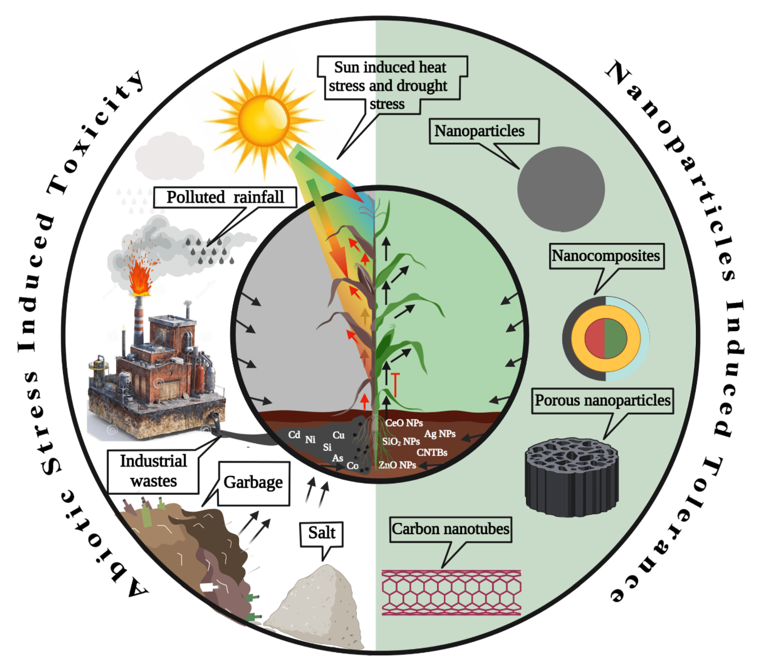
Different types of abiotic stress on plants is mitigated by nanoparticles

Abiotic Stresses and Crop Plants
Stress is stimuli that prevent plants’ growth and development and their metabolism during both abiotic and biotic stress [1]. Many plant species protect themselves against adverse environmental conditions. Generally, various stresses act simultaneously, such as combined water, heat, salt, heavy metals, and other light stresses. As a result, these changes interfere with the regular plant metabolism function and the source–sink interaction, which lowers plant growth, metabolism, and production [3]. Moreover, these stresses alter the expression sequence of several plant genes and significantly affect crop production worldwide, reducing the usual yields of important crops such as wheat and rice [4].

Salt Stress
Soil salinity is a considerable risk for agriculture in areas where water shortage and poor drainage systems of irrigated farms lower the productivity of crops significantly [5]. According to the Food and Agricultural Organization (FAO, 2016) [6], more than 6% of total global land and 19.5% of total irrigated land is already affected by salt conditions. Both human and natural factors can cause soil salinity. Of 932.2 Mha salt-affected soils globally, 76.6 Mha soil salinisation has been caused by humans [5]. The salt-affected lands have higher amounts of exchangeable sodium or soluble salts, perhaps due to insufficient leaching of cations that form the base. The chief soluble salts that act as anions are sulfate (SO2−4SO4−), carbonate (CO2−3CO3−), chloride (Cl−) and nitrate (NO−3NO3−) salts, and the cations are potassium, calcium, magnesium, and sodium. Many metals, such as selenium, lithium, boron, strontium, silica, fluorine, rubidium, manganese, aluminium and molybdenum are present in hyper-saline soil water, some of which can be harmful to animals, humans, and plant health [MELO] Salt accumulation slows down the growth of plants and lowers plants’ absorption capacity for nutrients and water, a consequence of osmotic stress.
ZnO is known as zinc-oxide, which is considered one of the valuable materials applied in fetchers; known for its non-toxic, photo activity, inexpensive and long-term appearances. Zinc oxide nanoparticles (ZnO-NPs) have many benefits on the fertility of the soil, plant production and zinc source, which is an essential microelement for enhancing plant development and protection. Okra [7] is one of the heats loving plants in the field of vegetable crops and is widely grownup in tropics, sub-tropics, and temperature areas involving Africa, Asia and North America. It is an annually renewable crop, herbaceous, day neutral, shrub-like dicotyledonous and erect plant that can grow from 1 to 3 m, and it has alternate broad and polymorphous leaves. Okra flowers have five yellow or white petals with a red or purple centre. The entire plant’s organs are edible, and this plant is a powerhouse of valuable nutrients [7].

Drought Stress
Rainfall distribution is unequal due to climate change, responsible for the significant stress reported: drought, the most prevalent abiotic stress globally, reducing grain output drastically. Drought stress is linked to a lack of water and cellular dehydration. Decreased water potential, stomatal closure, and turgor pressure result in poor plant growth and development [8]. Low water stress affects biochemical and physiological functions, including ion acquisition and chlorophyll synthesis, photosynthesis, respiration, and carbohydrate and nutrient metabolism reducing plant growth [9]. Plant adaptation to low-water stress is a process that involves physiological and biochemical alterations in the plant system. Under drought conditions, plants limit their shoot development and metabolic demands. In maize, yield reduction is observed up to 40%, and in wheat, 21%, with around 40% water shortage or reduction [9]. A yield decline ranging from 34 to 68% was reported in cowpea during drought stress [8]. Drought is a primary environmental factor with a negative effect on agriculture. Climate change will be one of the essential forces in determining agricultural plant yields, performance and stability [10]. Low water availability is one of the leading environmental factors influence the plant growth and yield in many world regions [10]. Therefore, raising environmental awareness and improving plant drought tolerance is increasingly important to sustain crop quality. Several engineered nanomaterials are being investigated in agriculture to increase crop productivity and protection [11]. Among these, carbon-based nanomaterials (CBNMs) have been the focus of several studies in recent years and have been helpful in agriculture and biotechnology [10]. The most researched CBNMs are fullerene (C60 and C70), fullerene C60(OH)x, x = 18–36 and CNTs. .
For biological applications, the main drawback of native fullerene is its insolubility in water. To overcome this, water-soluble fullerene derivatives are designed and synthesised, which have unique properties of native fullerene; because of their solubility in water. FNPs were introduced into various plant tissues of bitter melon (Monodica charantiai) [12] by the technique of seed priming. This experiment resulted in increased biomass, fruit yield and phytomedicine content. It has been found that fullerenol can pass through various cell membranes and compartments [12]. Polyanion nanoparticles are formed when fullerenol is dissolved in water. Their size and charge depend on the experimental conditions (concentration, pH, temperature, and presence of co-solvents). Nanoparticles can bind water molecules. Therefore, they can be used as a potent intracellular depot when osmotic stress occurs. Our hypothesis is that FNPs can pass through different plant leaves and root tissues, where they bind water molecules into cell components, providing an additional water source that can be used when facing drought stress. This hygroscopic activity suggests that FNPs may be uniquely beneficial in plants.

Cold Stress

This stress has been identified as the principal abiotic stress, which reduces agricultural crop productivity by decreasing crop quality and postharvest life. Cold stress consists of chilling from 0–15 °C and freezing at 0 °C, negatively affecting plant growth and agriculture production [13]. During the comparison of freezing and chilling stress, it has been found that freezing stress is far more harmful to plants. Typically, freezing’s harmful effects start with forming ice nucleation within the cells, then progressively growing and forming ice crystals, causing water leakage and cell dehydration [14]. Several major crops are still unable to cope with cold acclimation. For example, tomato (Solanum lycopersicum), maise (Zea mays), rice (Oryza sativa), cotton (Gossypium hirsutism), and soybean (Glycine max) cannot withstand lower temperatures. It can grow and survive only in tropical and subtropical areas [15]. Hence, cold stress harms plant growth along with plant metabolism and development, resulting in the reduction of crop yields globally [14].

Heat Stress
During heat stress, plants are susceptible; at extremely high temperatures, plants die. Generally, plants perform better at their optimum temperature; below and above the optimum temperature, plant growth and development are severely affected [16]. Most biochemical and enzymatic reactions double at 20 °C to 30 °C and change with every ten °C. Temperatures above and below the optimum range reduce the reaction rate because enzymes are denatured and inactivated progressively. One or two degrees of temperature change significantly impact plant growth and development, particularly reproduction, harming the early stages of male gametophyte formation in various crops, including wheat, rice, sorghum, barley, maize, and chickpea [16]. Heat stress causes male sterility and spikelet production abnormalities in rice and wheat [11]. In wheat and rice, cold and heat stress results in tapetum breakdown and changes in the callose walls of microspores, exine formation and metabolism of carbohydrates, ultimately ensuing in male sterility. However, temperature stress shows no adverse effects on female gametophyte development [11].

Heavy Metals Stress

Metal poisoning is one of the leading environmental risks that impairs plants’ ability to operate and engage in normal metabolic activities. Heavy metals (HMs) are a group of non-biodegradable, persistent inorganic substances having an atomic weight of more than 20 and a density of more than 5 g cm−3, which affect and pollute the food chains, irrigation, soils, aquifers, and nearby atmosphere before having mutagenic, cytotoxic, and genotoxic effects on human, plant, and animal health [17]. Toxic metals accumulate in the agricultural soils due to excessive use of fertilisers and increasing industrialisation, showing harmful consequences to the soil–plant interaction system [18]. These metals concentrate and enter the plant system at a slow rate via water and air and enter the food chains over a specific time. That considerably threatens the natural food web and biogeochemical cycle [19]. The unprecedented in vivo heavy metals accumulation and bioaccumulation in the environment presents a dilemma for all plants and organisms. Toxic concentrations of HM can interact with various important cellular molecules, including nucleoproteins and DNA, causing excessive production of ROS. This will result in profound plant changes, e.g., proteolysis, shoot chlorosis, and lipid peroxidation [19]. Under abiotic stress, it was thought that using osmolytes, nanoparticles, mineral nutrients, hydrogels, antioxidants, protectants, potassium, and plant growth hormones such as uniconazole and salicylic acid would boost plant production [20]. Additionally, plants may adapt to the negative impacts of droughts by applying plant hormones such as brassinolide (BR), gibberellic acid (GA), auxins, ABA, cytokinins, JA and ethylene, which govern several beneficial reactions in plants [20].
Influence of nanoparticles on abiotic stress resistance of plants:-
Stress is stimuli that prevent plants’ growth and development and their metabolism during both abiotic and biotic stress. Many plant species protect themselves against adverse environmental conditions. However, in most cases, these protective responses initiate late, and damage may be irreversible. Therefore, in plant production systems, plants must be assisted using stimulators. Recently, many studies have been conducted on plants using nano-stimulators, which can be natural plant extracts, chemicals or a combination of both. They can also be nano-metals or nanocomposites [21]. Nanocomposites consisting of macronutrients (N, P, K) and micronutrients that are fabricated through nanotechnological methods and are based on biomaterials that have beneficial properties during their uptake by roots and can prevent undesirable nutrient losses to soil, water and air. Calcite [calcium carbonate, CaCO3 (40%), silicon dioxide, SiO2 (4%), magnesium oxide, MgO (1%), and iron(III) oxide, Fe2O3 (1%)] NFs at 0.5 g.L−1 reduced the period of three development stages (full bloom, véraison and maturity) of grapes cultivar Narince growing in calcareous orchards. For example, véraison and maturity dates in vines that received NF were four days earlier than in untreated control vines (véraison: 30.07 in control versus 26.07 in NF treatment; maturity: 29.08 in control versus 25.08 in NF treatment) while other factors were increased by spraying this compound under alkaline stress: berry weight (control: 223.6 g; NF treatment: 234.7 g), cluster number (control: 16.3; NF treatment: 17.6), cluster weight (control: 310.8 g; NF treatment: 341.9 g) and pruning weight (control: 505.4 g; NF treatment: 547.4 g). [22] Due to vineyard management controls, Pruning weight is essential for measuring vine vegetative growth and changes in vine canopy size. [23]. Increases in berry weight, cluster number and weight, and pruning weight might be due to the positive effects of Zn, which affected the synthesis of tryptophan, an auxin precursor to indole-3-acetic acid (IAA) synthesis, contributed to the production and maturation of pollen, and improved berry production and unification in grape bunches and shoots. Any factor which can increase the concentration of endogenous Zn in plants, such as spraying NFs, can increase the synthesis of IAA and therefore shoots, berries and pollen growth and decrease undeveloped shoot berries [24]. showed that a foliar spray of Se-NPs (10 and 20 mg L−1) on strawberry plants improved their tolerance to salinity, and subsequently yield, which was accredited to their ability to protect photosynthetic pigments (12.19% increase in chlorophyll a and 40.47% increase in chlorophyll b contents) and 13.63% increase in the free proline level relative to the non-NP treatment. Fruit cracking caused by drought stress was reduced by a spray of Se-NPs (1 and 2 μM) in pomegranate compared to the non-NF treatment (8.03%), although two μM (4.0%) was better than one μM (7.2%).

References:
- Abdelsalam, I. M., Ghosh, S., AlKafaas, S. S., Bedair, H., Malloum, A., ElKafas, S. S., & Saad-Allah, K. M. (2023). Nanotechnology as a tool for abiotic stress mitigation in horticultural crops. Biologia, 78(1), 163-178.
- Sekhon, B. S. (2014). Nanotechnology in agri-food production: an overview. Nanotechnology, science and applications, 31-53.
- Abhinandan, K., Skori, L., Stanic, M., Hickerson, N. M., Jamshed, M., & Samuel, M. A. (2018). Abiotic stress signaling in wheat–an inclusive overview of hormonal interactions during abiotic stress responses in wheat. Frontiers in plant science, 9, 734.
- Melo, F. V., Oliveira, M. M., Saibo, N. J., & Lourenço, T. F. (2021). Modulation of abiotic stress responses in rice by E3-ubiquitin ligases: a promising way to develop stress-tolerant crops. Frontiers in Plant Science, 12, 640193.
- Kumar, P., & Sharma, P. K. (2020). Soil salinity and food security in India. Frontiers in Sustainable Food Systems, 4, 533781.
- FAO. The State of Food and Agriculture—Climate Change, Agriculture and Food Security; Food and Agricultural Organization of the United Nations: Rome, Italy, 2016.
- Alabdallah, N. M., & Alzahrani, H. S. (2020). The potential mitigation effect of ZnO nanoparticles on [Abelmoschus esculentus L. Moench] metabolism under salt stress conditions. Saudi Journal of Biological Sciences, 27(11), 3132-3137.
- Farooq, M., Gogoi, N., Barthakur, S., Baroowa, B., Bharadwaj, N., Alghamdi, S. S., & Siddique, K. H. (2017). Drought stress in grain legumes during reproduction and grain filling. Journal of Agronomy and Crop Science, 203(2), 81-102.
- Li, X., Pu, H., Liu, F., Zhou, Q., Cai, J., Dai, T., ... & Jiang, D. (2015). Winter wheat photosynthesis and grain yield responses to spring freeze. Agronomy Journal, 107(3), 1002-1010.
- Sihag, S., Brar, B., & Joshi, U. N. (2019). Salicylic acid induces amelioration of chromium toxicity and affects antioxidant enzyme activity in Sorghum bicolor L. International journal of phytoremediation, 21(4), 293-304.
- Fahad, S., Bajwa, A. A., Nazir, U., Anjum, S. A., Farooq, A., Zohaib, A., ... & Huang, J. (2017). Crop production under drought and heat stress: plant responses and management options. Frontiers in plant science, 1147.
- Zhang, Y., Min, H., Shi, C., Xia, G., & Lai, Z. (2021). Transcriptome analysis of the role of autophagy in plant response to heat stress. Plos one, 16(2), e0247783.
- Liu, H., Yu, C., Li, H., Ouyang, B., Wang, T., Zhang, J., ... & Ye, Z. (2015). Overexpression of ShDHN, a dehydrin gene from Solanum habrochaites enhances tolerance to multiple abiotic stresses in tomato. Plant Science, 231, 198-211.
- Pearce, R. S. (2001). Plant freezing and damage. Annals of botany, 87(4), 417-424.
- Chinnusamy, V., Zhu, J., & Zhu, J. K. (2007). Cold stress regulation of gene expression in plants. Trends in plant science, 12(10), 444-451.
- Liliane, T. N., & Charles, M. S. (2020). Factors affecting yield of crops. Agronomy-climate change & food security, 9.
- Ali, H., Khan, E., & Sajad, M. A. (2013). Phytoremediation of heavy metals—concepts and applications. Chemosphere, 91(7), 869-881.
- Nievola, C. C., Carvalho, C. P., Carvalho, V., & Rodrigues, E. (2017). Rapid responses of plants to temperature changes. Temperature, 4(4), 371-405.
- Haider, F. U., Liqun, C., Coulter, J. A., Cheema, S. A., Wu, J., Zhang, R., ... & Farooq, M. (2021). Cadmium toxicity in plants: Impacts and remediation strategies. Ecotoxicology and Environmental Safety, 211, 111887.
- Lamaoui, M., Jemo, M., Datla, R., & Bekkaoui, F. (2018). Heat and drought stresses in crops and approaches for their mitigation. Frontiers in chemistry, 6, 26.
- Brown, P., & Saa, S. (2015). Biostimulants in agriculture. Frontiers in plant science, 6, 671.
- Sabir, A., Yazar, K., Sabir, F., Kara, Z., Yazici, M. A., & Goksu, N. (2014). Vine growth, yield, berry quality attributes and leaf nutrient content of grapevines as influenced by seaweed extract (Ascophyllum nodosum) and nanosize fertilizer pulverizations. Scientia Horticulturae, 175, 1-8.
- Reeve, J. R., Carpenter-Boggs, L., Reganold, J. P., York, A. L., McGourty, G., & McCloskey, L. P. (2005). Soil and winegrape quality in biodynamically and organically managed vineyards. American journal of enology and viticulture, 56(4), 367-376
- Zahedi, S. M., Karimi, M., & Teixeira da Silva, J. A. (2020). The use of nanotechnology to increase quality and yield of fruit crops. Journal of the Science of Food and Agriculture, 100(1), 25-31.

