Seizure detection and Classification with EEG Signals

Sateesh Kumar Reddy C,
Assistant Professor,
Advanced CSE,
School of Computing & Informatics,
Vignan's Fondation for Science, Technology and Research, Vadlamudi, Guntur.
Email: drcs@vignan.ac.in

Dr.Poornaiah Billa
Professor-ECE,Lakireddy Bali Reddy College of Engineering
Mylavaram, Krishna- district
Email: poornaiah@gmail.com

- Introduction

A seizure is a surprising change in the electrical movement of the cerebrum.This change in electrical activity will alter the normal behavior of a person for a short time. The various causes for seizures include changes in glucose levels in the blood, head injuries, brain tumors, drug abuse, and fever. The recurrent seizures in a short period will lead to a brain disorder called epilepsy. It is an uncertain neurological disorder. This brain disorder is affecting around 60 million of the world population [1]. These epileptic patients usually will undergo the treatment with antiepileptic drugs (AEDs) to control the seizures. In some extreme cases, the seizures can't be controlled after multiple antiepileptic drug treatments. In such cases, the physicians will suggest surgical intervention as the only option to control the seizures activity in the brain [2]. The doctors need a novel technique for extracting more information, to diagnose these abnormal changes in brain by electrical activity.
Electroencephalography (EEG) is a non-intrusive scheme, which is utilize and to record and store electrical activities in the brain. EEG is a signal from the brain nervous system which will differ according to various activities, and furthermore, it contains more significant information. Hence it is a potential apparatus for perceiving the abnormalities of brain functions which are associated with certain brain disorders. The EEG signals are recorded by employing the standard 10-20 Electrode system on the scalp surface [3]. Recorded EEG can be used in various applications such as brain-computer interface [4], diagnosing schizophrenia patients [5] and transient event detection [6]. It is also used to observe the changes in the brainwave, due to smoking and mobile phone usages [7]. The process of identifying epileptic seizures and its variations in EEG signals is much significant in diagnosing epilepsy. In comparison with a visual inspection of EEG signals by doctors, machine learning techniques are more consistent [8]. Using these techniques the training and testing were done with feature values to classify the healthy and seizure subjects. The recital of the Machine Learning Algorithms [MLA]be contingent on the feature values. Thus the EEG signal has to be processed with a more desirable technique to extract the features. Earlier techniques based on Short-Time Fourier transform [9], Wavelet transforms [10]provided successful results, but unlikely they do not perform the multi-resolution analysis of the signals [11]. The said techniques are best in analyzing static signals, but as the EEG signals are non-static, hence suitable schemes for processing such signals are preferred. Later these non-stationary signals are processed by Empirical Mode Decomposition [EMD] [12]. It is an adaptive spell space exploration scheme and is more suitable for processing non-static signals. The EMD technique festers the sign to a gathering of recurrence modules, known as Intrinsic Mode Functions (IMF) short of leaving the spell space. For nonlinear and non-static information examination, the momentary recurrence and neighborhood vitality highlights got from the IMF of EMD through the hilbert change are untainted [13].This characteristic of EMD has motivated the researchers to use it for the analysis of EEG signals.

The recent studies were set an ultimate objective on seizure detection of designing automated EEG analysis system to forecast epilepsy before it occurs. To design this automated seizure detection system, various decomposition and wavelet-based techniques are used because of their time-frequency features. Previously, seizure detection in EEG signals will be done by utilizing wavelet-based techniques. Discrete wavelet transform (DWT) [14] based EEG signal analysis is proposed in seizure detection. The average power, standard deviations and mean total value are the statistical structures which are derivate from DWT coefficients. The classification was performed using K-nearest neighbors (KNN) and Naive bayes (NB) classifiers. The Naive bayes classifier provided better accuracy with less computation time. Recently empirical wavelet transform [15] was utilized to detect seizure patterns from EEG signals. The highlights, for example, the mean of joint quick adequacy, mean and difference of monotonic absolute AM change were mined from the joint moment amplitudes of multivariate Electroencephalography signals. These species were distinguished by using six different classifiers and achieved an average precision of 99.41%. The automated seizure detection system requires an update to real-time monitoring to improve the diagnosing process of epileptic patients.SinaKhanmohammadiet.al. [16] Proposed a new adaptive framework for seizure detection where the features dynamically selected from enhanced EEG signals. In this method, for improving the SNR of EEG signals, the blind signal parting algorithms like foremost element exploration and common spatial arrays have been used. The authors say that this method is more suitable to monitor epileptic patients in real-time. Most of the research papers used EMD as the best method to decompose non-stationary EEG signals. The Ictal and Interictal EEG patterns are classified using SVM classifier after empirical mode decomposition [17] of epileptic EEG signals. This experimental analysis accomplished 97% of sensitivity and 96.25% of specificity. Farhan Riaz et.al. [12] Proposed an EMD based seizure classification system. Here first three IMF levels of EMD are deliberated for feature extraction. Further, these features are classified using SVM and good classification results are achieved. More recently an automatic seizure detection system using Local mean decomposition (LMD) method [18] was proposed. The authors used LMD to molder the underdone EEG signal into multiple product utilities. Then they considered the first five products functions for feature extraction. Further, these features are classified into five different cases and achieved an average accuracy of 98.10%. It has been found from the deep literature survey that EMD gives better performance. Here, we proposed a novel technique of feature extraction from the IMF levels of empirical mode decomposition.

This experimental study focused on two novel features extracted from EEG signal to diagnose brain disorders like seizures and epilepsy. The significant contribution of this work is summarized as follows:

- We proposed two novel features of EEG signal known as dynamic bandwidth and relaxation time. These features effectively discriminate variations of seizure and non-seizure subjects of principal signal.
- We have collected a real-time EEG signal using RMS 24-channel EEG data acquisition module and evaluated the ability of the proposed features with two different datasets for identifying seizure activity in the EEG signal.
- The performance of these features was obtained and compared with four different classifiers. The SVM with marginal sampling approach gives the best performance among all other classifiers. In SVM-marginal sampling approach, the samples which are very closer to decision boundary were examined and are correctly placed in respective classes to develop the concert of the classifier.

The remainder of this examination composed as pursues: Section 2 talks about out materials and strategy. Results and execution assessment are introduced in Section 3. The discourse dependent on the result and essentialness of the investigation is depicted in Section 4. At long last, the work has been closed in Section 5.

- Materials and methodology
The primary goal of the proposed work is to extract more pertinent features from the EEG segments so that the divergence can be identified clearly between healthy and seizure subjects. Fig.1 exhibits the various stages of proposed work, consists of feature extraction and classification as the significant steps to classify EEG as healthy and seizure subjects.
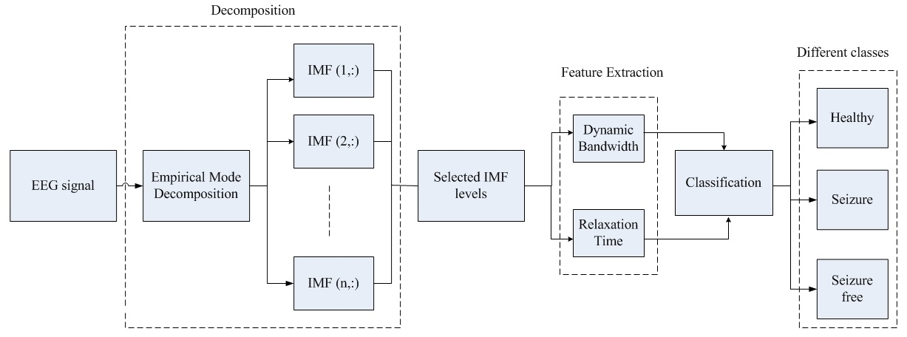
Fig.1 Stages involved in the proposed methodology

2.1. Data collection and preparation

In this investigational study, two EEG informational collections which are recorded utilizing the standard 10-20 electrode arrangement plans are utilized. One is the freely accessible online database of Bonn University, Germany and another is from the Ramesh emergency clinic, India. The Bonn college [17], [18], [21]–[24] information comprises of five gatherings, implied as A to E datasets. The datasets A and B are recorded by giving alert and eyes open and relaxed with eyes are closed, individually utilizing the scalp electrodes. Solid eye development ancient rarities were not considered in these two datasets. Sets C, D, and E comprise of EEG ages recorded utilizing profundity electrodes. The datasets C and D are recorded during without seizure interims (interictal) from the hippocampal arrangement of the contrary side of the equator and epileptogenic zone separately. Set E comprises of EEG sign detailedthroughout the seizure assault (ictal). Each of these datasets contains 100 single-channel antiques free EEG ages with a span of 23.6s, and an examining recurrence of 173.61Hz. In this manner the length of every EEG fragment is 173.61×23.6, which is comparable to 4097 examples. Every age is separated into four sections with a comparative length of 1024 examples and sent out to MATLAB for examination.

2.1.1 Data pre-processing

The primary step involved in quantifying the obtained EEG signal is the pre-processing stage and, in this stage, the artifacts are removed in underdone EEG signals using clarifying schemes. Here, we applied the independent component analysis(ICA) on the raw EEG signal to eliminate artifacts included due to eye blinks and muscular events. The frequencies higher than 60 Hz are considered as noise because the frequency as sortment of EEG signals extents up to 60 Hz [1]. The noise is eliminated by executing every signal through sixth-order Butterworth filter with an end point frequency of 60 Hz.

2.2.Signal decomposition using EMD

Empirical Mode Decomposition (EMD) is used to represent the non-static signals as entireties of zero-mean amplitude modulation and frequency modulation are of non-linear techniques [19]. EMD is a subordinate information strategy which disintegrates a signal into various intrinsic mode functions. The goal of EMD is to putrefy the acquired non-static signal $s(t)$ into various intrinsic mode functions. Every IMF of EMD must fulfill two conditions. They are 1) The number of extrema or zero crossings must be the same, or it can differ by at least one; 2) the average value of the envelope at any point is defined by local maxima, and the envelope at the zero points is defined by local minima. The algorithmic flow of Empirical mode decomposition for the signal $s(t)$ is shown in Fig.3.

Once the first IMF is obtained, the temporal scale$k_{1}\left(t\right)=f_{1}(t)$ with the smallest value in a signal $s(t)$ was defined. The first residual was determined as$r_{1}\left(t\right)=s\left(t\right)-k_{1}\left(t\right)$, and the same was utilized as a new input signal. The entire process is repeated until a constant or a monotonic function of residue value is obtained. Now the original signal $s(t)$ is rearranged in terms of intrinsic mode functions and is expressed as

$$s\left(t\right)=\sum_{m=1}^{M}{\left(k_{m}\left(t\right)+r_{m}(t)\right)} (1)$$

Where $r_{m}(t)$ is the residue, $k_{m}(t)$ are the IMFs, and M represents the total number of IMF levels. Every IMF level of$s(t)$ will contain meaningful information of local frequency, but all the IMF's do not exhibit similar frequencies at the same time. So, $s(t)$ can be re-written as

$$s\left(t\right)≈\sum_{m=1}^{M}{A_{m}\left(t\right)\cos\left[∅_{m}\left(t\right)\right]} (2)$$

Fig.3. Flow chart for EMD algorithm.

2.2.1 Hilbert transform

Hilbert transform is very useful to detect the envelope of a signal. The signal envelope will contain more valuable information about the signal. By applying the Hilbert transform to the signal, the rapid oscillations are removed, and a direct representation of a signal envelope is produced. Therefore Hilbert transform is used to the IMF levels of EMD. It also eliminates the DC offsets from the spectral component of each signal, which is an important aspect to compensate for the non-stationary of the signals [20]. Hilbert transform for the selected set of IMFs [$k_{m}(t)$] in the time-frequency domain can be analytically written as

$${y\left(t\right)=k}_{m}\left(t\right)+iHk_{m}\left(t\right) (3)$$

Where $Hk_{m}(t)$ is the Hilbert transform of $m^{th}$ IMF extracted from the signal $s(t)$which is given by $Hk_{m}\left(t\right)=\left[k_{m}\left(t\right)*1/{πt}\right]$ Where $*$ is the convolution, operating the inverse Fourier transform of$1/{πt}$ gives $jsgn()$ which has a phase of $π/2$, the analytic associate form of the mono-component signal is represented as follows
$$z\left(t\right)=a\left(t\right)e^{jφt} (4)$$
Where$πt$ is the instantaneous phase, and $a(t)$ is the instantaneous amplitude. It is represented as
$$a\left(t\right)=\sqrt{k_{m}^{2}(t)+H^{2}\left[k_{m}(t)\right]} (5)$$
$$φ\left(t\right)=arctan\left[\frac{H\left[k_{m}(t)\right]}{k_{m}(t)}\right] (6)$$

The instantaneous frequency is the derivative of the instantaneous phase and can be denoted as
$$f_{i}\left(t\right)=\frac{1}{2π}\frac{dφ(t)}{dt} (7)$$

Where $f_{i}\left(t\right)$ and $φ\left(t\right)$represents the instantaneous frequency and phase of the signal respectively. Then the time delay (TD) which is dual of instantaneous frequency (IF) is obtained. Further, these IF and TD is used to extract the proposed features such as relaxation time and dynamic bandwidth respectively.

2.3. Feature extraction

Since the seizure is as an intermittent event, the EEG signals evoked from epilepsy patients are subjected to vary instantaneously, and the EEG waveform becomes dynamic as a result of the patient's abnormal behavior. These instantaneous variations can be easily trapped using our novel dynamic features, relaxation time and dynamic bandwidth. For extracting these features, we have selected the sum of the first five IMF levels. The proposed features are briefed as follows:

2.3.1 Relaxation time
The relaxation time RT is the period over which the deviation of the instantaneous phase is not more than $\frac{π}{4}$from its linearity. The instantaneous phase $φ(t)$ can be represented as an expansion of the Taylor series about $t=t_{0}:$
$$φ\left(t\right)=φ\left(t_{0}\right)+φ^{'}\left(t_{0}\right)\left(t-t_{0}\right)+\frac{1}{2}φ^{''}\left(t_{0}\right){\left(t-t_{0}\right)}^{2}$$

$$=φ\left(t_{0}\right)+\frac{d}{dt}φ\left(t_{0}\right)\left(t-t_{0}\right)+\frac{1}{2}\frac{d^{2}}{{dt}^{2}}φ\left(t_{0}\right){\left(t-t_{0}\right)}^{2} (8)$$

The relation between instantaneous frequency and the instantaneous phase is
$$\frac{d}{dt}φ\left(t_{0}\right)=2πf_{i}\left(t_{0}\right) (9)$$

Thus from equation (8) and (9), the instantaneous phase$φ(t)$, can be derived as
$$φ\left(t\right)=φ\left(t_{0}\right)+2π{\left(t-t_{0}\right)f}_{i}\left(t_{0}\right)+\frac{1}{2} 2π{\left(t-t_{0}\right)}^{2}f_{i}^{'}\left(t_{0}\right) (10)$$

From the above equation, the deviation of the instantaneous phase from linearity can be written as
$$\left|\frac{\frac{1}{2}2πf_{i}\left(t_{0}\right)R_{T}^{2}}{4}\right|=\frac{π}{4} (11)$$
Solving the equation (11), the relaxation time can be expressed as
$$R_{T}\left(t\right)={\left|\frac{df_{i}(t)}{dt}\right|}^{\frac{-1}{2}} (12)$$
Where $f_{i}(t)$ and $R_{T}(t)$ are the instantaneous frequency and relaxation time of the signal respectively.

2.3.2 Dynamic bandwidth

The dual of relaxation time is called as dynamic bandwidth and is defined as the bandwidth over which the phase spectrum deviates no more than $\frac{π}{4}$ from linearity. It can be denoted as
$$D_{B}\left(f\right)={\left|\frac{dT_{d}(f)}{df}\right|}^{\frac{-1}{2}} (13)$$
Where $T_{d}(f)$is the time delay which can be representedas$T_{d}\left(f\right)=-\frac{1}{2}\frac{dθ(f)}{df}$ and $θ(f)$is the phase of an input EEG signal.

Thus the equation (12) represents the relaxation time, which is measured from the significant time variations of IF. The equation (13) represents the dynamic bandwidth, which is measured from the significant changes in time delay. Since these features are calculated from the time domain of the EEG signal itself, these novel features could project the dynamic variation in the signal. Then these two features which are obtained from the IMF levels of EMD are used for the classification process.

2.4. Classification

The feature extraction is followed by the classification process. The extracted features $x_{i}=\left[x_{1},x_{2}, ….x_{n}\right]$are givento the SVM classifier to classify normal and seizure subjects.In the case of non-linear data, the kernel function of SVM will givebetter classification results than the other functions of SVM.Thus the dot product $\left(a_{i}, a_{j}\right)$is replaced with the function $X\left(a_{i}, a_{j}\right)=∅\left(a_{i}\right) . ∅\left(a_{j}\right)$ to carry out the transformation. Now the standard form of SVM is obtained as
$$f\left(x\right)=sign\left(\sum_{l=1}^{N}{α_{l}}y_{l}X\left(a_{i}, a_{j}\right)+b\right) (14)$$
Where $y_{l}$ indicates output label and $α$ is a Lagrange multiplier. The kernel function used in the SVM classifier is a Gaussianfunction and is represented as
$$X\left(a_{i}, a_{j}\right)=e^{\frac{-\left({\left\|a_{i}-a_{j}\right\|}^{2}\right)}{2σ^{2}}} (15)$$
Where $σ$is a parameter that sets the “spread” of the kernel, and it controls the width of the Radial basis function(RBF).
Support vector machines are binary classifiers. In this work, more than two classes are considered, so a multiclass classification methodology is adopted. The One-Against-All (OAA) and One-Against-One (OAO) are the two most popular strategies for multi-class SVM. As the One-Against-All approach requires only a few binary decompositions, it is selected as the preferred method for classification. The basic procedure for this approach is as follows. Let $Z=\left(z_{1, }z_{2, }z_{3, }…..z_{N, }\right)$ be the set of N possible labels corresponding to the EEG spikes to be classified. First, training is done for an ensemble of ‘N' SVM classifiers. The role of each classifier is to solve the binary classification problem, which is defined by the difference of characteristic of one class $Z_{i}\left(i=1,2,…N\right)$from all other classes. Then, in the classification stage, the “victor takes all” standard is applied for determining the ‘make’ to be assigned to each weary. The main class is the one that relates to the SVM classifier of the outfit with the most extreme estimation of the yield.

2.4.1. Marginal Sampling Technique

It is an effective learning technique that enhances the performance of SVM. For a linear SVM classification problem, the samples of the exercise sets which are nearer to the hyper plane, defines the verdictfrontier which are selected as backing vectors. The illustrations in learning set which are closer to the decision frontier have more chances to become support vectors in the updated training set [25]. Therefore, in marginal sampling approach, the samples with the base outright estimations of the discriminant capacity are to be picked. The same procedure is also applicable to nonlinear classification problems. The discriminant capacity of every double SVM is assessed, and the greatest estimation of the discriminant capacity is chosen as an example marker for select least showed qualities. Further, these are marked and added to the preparation set for the new preparing set. The algorithmic flow of the marginal sampling technique is explained below.
Algorithm 1 Marginal Sampling Approach
Steps
1: Consider ‘x’ different classes of training data with ‘n’ labeled samples.
2: Initialize $L=\left(x_{1, }x_{2,}x_{3,}….x_{n}\right)$ learning data with ‘m’ un-labeled samples.
3: Consider ‘N’ be the number of samples to be added to the training data after every iteration.
4: Now train SVM classifier with training data.
5: Evaluate the discriminant function of each binary SVM, V_max in every sample of learning data.
6: Now select and label ‘Y’ samples which are exhibiting V_max minimum values.
7: Remove ‘Y’ selected samples from learning data and add them to the training data.
End

- Results
The performance of the proposed methodology with twonovel features such as relaxation time and dynamic bandwidthhas been evaluated. The relaxation time is a measure of time ininstantaneous frequency, and it depends on instantaneous phasefrom its linearity, whereas the dynamic bandwidth is a measureof bandwidth in time delay and it depends on phase spectrumfrom its linearity. These two features have predominantvariation in healthy and epileptic EEG signals. In this way the exhibition assessment of the proposed procedure was examined with standard estimates, for example, precision and Receiver Operating Characteristic (ROC).ROC gives a complete report oversensitivity and specificity with a graphical representation and it is a fundamentaltool for test evaluation,.The territory under the ROC bend is a measure to determine how well a parameter can separate between two symptomatic cases.

3.1. Classification Tasks
This experimental study is carried out to classify healthy and seizure subjects of two datasets. One is publicly available EEG data of Bonn University, Germany [12] and second is the real-time data collected in Ramesh hospitals, India. The subsets of two EEG datasets are described in Section 2, and these subsets are considered as three classes such as healthy, seizure-free (inter-ictal) and seizure (ictal) to form differentcases for classification purpose. Finally, from these subsets, we have introduced five separate cases for classification andare listed in Table 1. These cases were formulated in viewof clinical relevance as well as their wide usage by variousresearches for seizure classification [12] [19].

Table 1
Different cases considered based on datasets.
Cases | Grouping of datasets |  | Classes
 | Bonn database
Case I | Set D |  | Seizure free
 | Set E |  | Seizure
Case II | Set A |  | Healthy
 | Set E |  | Seizure
Case III | Set A, B ,C ,D |  | Healthy
 | Set E |  | Seizure
Case IV | Set A |  | Healthy
 | Set D |  | Seizure free
Case V | Set A |  | Healthy
 | Set D |  | Seizure free
 | Set E |  | Seizure

The Case I is formulated with set D & E in such away to classify the seizure subjects and seizure free subjects respectively. In Case II, Set A is considered as a healthy class, where Set B is seizure class. In Case III, four sets from A to D were assembled and considered as a solid class and Set E has picked as the seizure class. Case IV was figured with sets A and D to identify sound and seizure free subjects. Case V was planned as multi-class with three sets A, D and E to recognize as 'solid', 'seizure free' and 'seizure' signals. All these datasets are used to extract the features for analysis, and from the experimental analysis, it is observed that there is an impressive variation in the relaxation time and dynamic bandwidth features of ‘healthy’ and ‘seizure’ subjects. In this paper, we have utilized help vector machine with peripheral examining approach for characterization.
3.2. Performance evaluation

The presentation of the classifier was assessed by computing diverse execution measures, for example, affectability (sensitivity), particularity (specificity), exactness (accuracy), accuracy and F-measure. Exactness estimates the proportion of genuinely grouped examples to the complete number of arranged examples. The affectability and explicitness are characterized as the level of really anticipated positive examples (sound examples) and genuinely anticipated negative examples (seizure tests) separately. Exactness characterizes the proportion of really arranged positive examples to the absolute number of anticipated positive examples. The F-measure estimation is done dependent on review and accuracy esteems. It is utilized to know the limit of the framework, and it fluctuates between zero to one. At that point the exhibition parameters can be characterized as pursues:
$$ACC=\frac{T_{P}+T_{N}}{T_{P}+T_{N}+F_{P}+F_{N}}×100\left(\%\right) (16)$$
$$SEN=\frac{T_{P}}{T_{P}+F_{N}} (17)$$
$$SPE=\frac{T_{N}}{T_{N}+F_{P}} (18)$$
$$P=\frac{T_{P}}{T_{P}+F_{P}} (19)$$
$$F=\frac{\left(2×P×SEN\right)}{P+SEN} (20)$$

Where P is precision,${ T}_{P}$ and${ T}_{N}$, are the precise affirmative and precise destructive of the samples correspondingly. $F_{P}$and${ F}_{N}$, are the unseemly affirmative & unseemly destructive of the samples correspondingly. The receiver operating characteristics curve is also used to estimate the concert of the proposed scheme.

The feature extraction process is implemented on two different at sets to extract the proposed novel features such as relaxation time and dynamic bandwidth. Empirical Mode Decomposition [EMD] shows great potential at managing the non-linear and non-static gestures. Here, the non-static EEG signal was processed by EMD algorithm, decomposes the multi scale EEG signal into various IMF levels. Each IMF level represents the repeating operation of the signal at an isolated time scale. The first five IMF levels are selected to excerpt the sorts. Then, the obtained sorts are distinguished by four different classifiers, such as Decision Tree, NB, KNN, and SVM based classifiers for rich performance analysis. The classification process was performed for all the cases with four different classifiers, and their five performance parameters were evaluated and compared in Table 2.

It has been seen that independent of datasets our proposed strategy achieved best arrangement execution by appraisal of classifier with k-overlap (fold) cross-approval. Here the first examples are isolated to k equivalent component of subsets. From the k subsets, an independent subset is locked in as the testing information for approval, and the rest of the k-1 for preparing in each overlap. At that point the outcomes got from every k fold are arrived at the midpoint of to create a solitary estimation. The proficiency of grouping depends on the extricated highlights. Here we can see that the acquired presentation estimations of exactness, affectability, explicitness, F-measure and accuracy nearing to one indicates the viability of the highlights extricated and the characterization technique.

For Case I, the best accuracy was achieved with the proposed classifier, where the specificity of this case is 100%. In case II, Proposed SVM with marginal sampling obtained 100% result in all the parameters, among all other classifiers. In this case, our proposed classifier achieved perfect classification in the uncovering of epilepsy seizure activity is present in EEG signals. In Case III, our proposed method obtained almost similar results as in case II. In Case IV, the proposed classifier gives the best results with a sensitivity of 100%. Case V is a multi-class where the three classes, for example, solid, seizure free and seizure class is utilized in order. The classification of this case is complex because of three different classes. In this case, the proposed classifier achieved 100% sensitivity, which represents the precise identification of true positive instances. The objective of evaluating the discrimination power between healthy and epilepsy patients and also, the best seizure detection is achieved with the consideration of Case II and III as classification experiments. Case V is the most challenging task where three different classes are considered. The experimental results of the proposed feature set have outperformed the pre-existed features. The classification results obtained from the proposed technique is appreciably different when compared to other methods. Apart from the other classifiers, the highest classification accuracy was achieved with SVM classifier. Fig.4. gives the performance comparison of various classifiers. Therefore we can observe that the SVM classifier outperforms with proposed features.
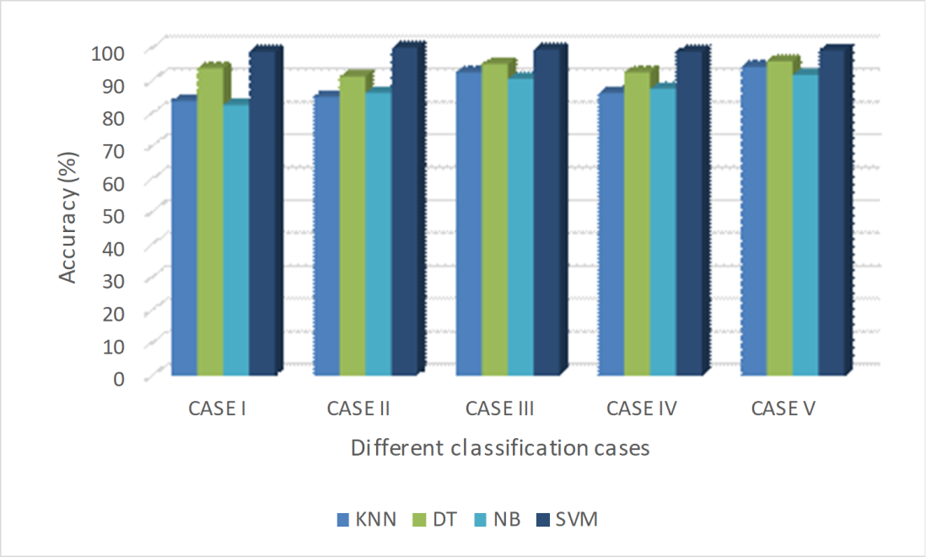
Fig. 4: Accuracy comparison of different classifiers withproposed novel features

The classification parameters in average were compared with different classifiers in Table.3 to signify the potential of marginal sampling SVM classifier.
Table 3.
Performance in average of different classifiers with proposedfeatures.
Performance Parameters | KNN | DT | NB | Proposed
Accuracy (%) | 88.33 | 93.67 | 87.68 | 99.23
Sensitivity | 0.931 | 0.9353 | 0.8999 | 0.994
Specificity | 0.8225 | 0.9335 | 0.851 | 0.9902
Precision | 0.8721 | 0.9531 | 0.8697 | 0.9926
F-measure | 0.8992 | 0.944 | 0.8821 | 0.9932

The presentation of the classifier is likewise approved utilizing the recipient working qualities, which gives us a clever perspective on the whole range of sensitivities and specificities. Fig.5 shows the area under the curve of three different classes.

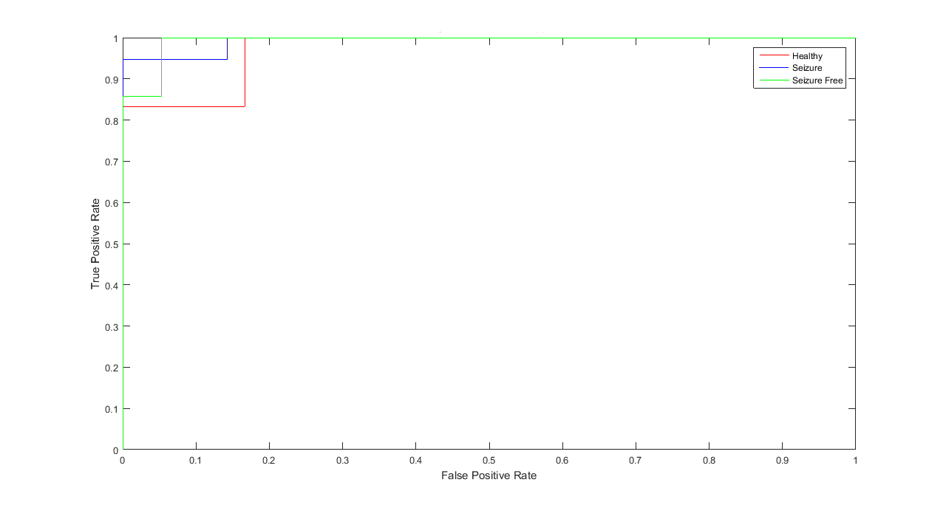
Fig. 5: ROC curve
The larger ROC area indicates the highest classification accuracy. We have achieved the ROC curve for three classes with the area under the curves of 0.9925, 0.9883 and 0.9725 for seizure, seizure free and healthy respectively. The ROC curve represents a decent order of execution for SVM classifier.

- Discussion
In this study, two novel features are introduced for the detection of seizures. These features quantified efficiently with their dynamic changes in identifying the abnormal changes of EEG. The extracted features are potent, which led to outperforming most of the existing studies. Further, in terms of accuracy of this work with existing studies as listed in Table 4 is compared with performance. When comparing to [12, 17, 18, 24], this work has achieved better accuracy in all the cases. Lee et al. [22] for arranging seizure and non-seizure EEG signals, proposed new consolidated strategies dependent on a Neural Network with Weighted Fuzzy Membership functions (NNWFM), They utilized wavelet transform (WT), Euclidean Distance (ED) and phase-space reconstruction (PSR) to extricate a lot of 24 highlights. Further, a non-cover region circulation estimation strategy bolstered by the NNWFM is utilized to choose 4 best highlights among 24 introductory highlights. These authors achieved the performance accuracy of 98.17% using the 4 selected features. A.Tzallas. et al. [26] proposed a strategy dependent on time-frequency examination to classify epileptic EEG subjects. STFT and several time-frequency disseminations are used to obtain the feature, power spectral density (PSD) of each section. The Classification was done using an artificial neural network (ANN) and achieved qualitative and quantitative results. Comparing with previous and existing studies our proposed method outperforms in seizure detection. We used four different classification mechanisms and two different datasets to evaluate the ability of proposed features. The performance parameters are calculated with four different classifiers and compared with each other, and observed that our proposed methodology gives the best outcomes among all others.
Table 4.
Performance comparison between proposed and existing
Author | Method | Cases | Accuracy (%)
A.Tzallas. et al. [26] | Features based on ICA and STFT + BPNN | A E | 100
 |  | A B C D E | 96.2
 |  | A C E | 100
Li et al. [17] | Fluctuation index and coefficient of variation of IMFs + SVM | A E | 98.70
 |  | D E | 96.63
Lee et al. [22] | WT, phase-space reconstruction and ED + NEWFM | A E | 98.17
Murugavel et al. [24] | WT based features + H-MSVM | A E | 99
 |  | A B C D E | 94
 |  | AB CD E | 95
 |  | ABCD E | 99
 |  | A D E | 96
F.Riaz et al. [12] | Time-Frequency features in EMD + SVM | A E | 99
 |  | D E | 93
 |  | ABCD E | 96
 |  | A D E | 85
 |  | AB CD E | 83
Guangyiet al. [23] | Nonsubset Wavelet–Fourier features + SVM | ABCD E | 93.6
T. Zhang.et.al [18] | (LMD) based features + GA-SVM | A E | 100
 |  | D E | 98.10
 |  | ABCD E | 98.87
 |  | AB CDE | 98.40
 |  | A D E | 98.47
Jaiswalet al. [21] | One-dimensional local ternary pattern(1D-LTP) +ANN | A D E | 98.33
Proposed method | Relaxation time and dynamic bandwidth features from EMD + MSVM | A D E | 99.16
 |  | ABCD E | 99.5
 |  | A E | 100
 |  | A D | 98.75
 |  | D E | 98.75
The results illustrate that the proposed features and classification technique exhibits the best outcomes in terms of accuracy and computational time than other existing methods.
- Conclusion

In the present investigation, another technique for seizure location utilizing the EEG signal varieties, such as relaxation time and dynamic bandwidth as features were proposed. The analysis was carried out by decomposing the input EEG signal into various frequency bands through the EMD algorithm to check the ability of these features in distinguishing the healthy and seizure activity in EEG signals. Further classification was done with these features using SVM with marginal sampling. The characteristics of the proposed scheme was deliberate on two different datasets (openly available Bonn database and real-time data collected from Ramesh hospital) with different classification cases and compared with recent methods. It has been uncovered that our proposed technique can give the best execution in every one of the cases, especially in segregating seizure occasions from the non-seizure ones. In the future, we intend to extend this study by researching the options to select the optimal time-frequency based features to distinguish healthy and seizure subjects from EEG signals.

Acknowledgment
The authors sincerely thank all the volunteers and medical team of Ramesh hospital, Vijayawada for their valuable time and support for our research work. We want to thank Bonn University, Germany for providing seizure database.
This work did not get any financial support from any government agencies, or commercial party.

References:

- Adeli, H., Ghosh-Dastidar, S. and Dadmehr, N., 2007. A wavelet-chaos methodology for analysis of EEGs and EEG subbands to detect seizure and epilepsy. IEEE Transactions on Biomedical Engineering, 54(2), pp.205-211.
- Lu, Y., Worrell, G.A., Zhang, H.C., Yang, L., Brinkmann, B., Nelson, C. and He, B., 2014. Noninvasive imaging of the high frequency brain activity in focal epilepsy patients. IEEE Transactions on Biomedical Engineering, 61(6), pp.1660-1667.
- Bhardwaj, A., Tiwari, A., Krishna, R. and Varma, V., 2016. A novel genetic programming approach for epileptic seizure detection. Computer methods and programs in biomedicine, 124, pp.2-18.
- Edelman, B.J., Baxter, B. and He, B., 2016. EEG source imaging enhances the decoding of complex right-hand motor imagery tasks. IEEE Transactions on Biomedical Engineering, 63(1), pp.4-14.
- Sun, J., Tang, Y., Lim, K.O., Wang, J., Tong, S., Li, H. and He, B., 2014. Abnormal dynamics of EEG oscillations in schizophrenia patients on multiple time scales. IEEE transactions on biomedical engineering, 61(6), pp.1756-1764.
- Exarchos, T.P., Tzallas, A.T., Fotiadis, D.I., Konitsiotis, S. and Giannopoulos, S., 2006. EEG transient event detection and classification using association rules. IEEE Transactions on Information Technology in Biomedicine, 10(3), pp.451-457.
- Parvez, M.Z. and Paul, M., 2015. Epileptic seizure detection by exploiting temporal correlation of electroencephalogram signals. IET Signal Processing, 9(6), pp.467-475.
- Jiang, Y., Wu, D., Deng, Z., Qian, P., Wang, J., Wang, G., Chung, F.L., Choi, K.S. and Wang, S., 2017. Seizure classification from EEG signals using transfer learning, semi-supervised learning and TSK fuzzy system. IEEE Transactions on Neural Systems and Rehabilitation Engineering, 25(12), pp.2270-2284.
- Pinnegar, C.R., Khosravani, H. and Federico, P., 2009. Time–frequency phase analysis of Ictal EEG recordings with the S-transform. IEEE Transactions on Biomedical Engineering, 56(11), pp.2583-2593.
- Liu, Y., Zhou, W., Yuan, Q. and Chen, S., 2012. Automatic seizure detection using wavelet transform and SVM in long-term intracranial EEG. IEEE transactions on neural systems and rehabilitation engineering, 20(6), pp.749-755.
- Hyvärinen, A., Ramkumar, P., Parkkonen, L. and Hari, R., 2010. Independent component analysis of short-time Fourier transforms for spontaneous EEG/MEG analysis. NeuroImage, 49(1), pp.257-271.
- Riaz, F., Hassan, A., Rehman, S., Niazi, I.K. and Dremstrup, K., 2016. EMD-based temporal and spectral features for the classification of EEG signals using supervised learning. IEEE Transactions on Neural Systems and Rehabilitation Engineering, 24(1), pp.28-35.
- Huang, N.E., Shen, Z., Long, S.R., Wu, M.C., Shih, H.H., Zheng, Q., Yen, N.C., Tung, C.C. and Liu, H.H., 1998. The empirical mode decomposition and the Hilbert spectrum for nonlinear and non-stationary time series analysis. Proceedings of the Royal Society of London. Series A: Mathematical, Physical and Engineering Sciences, 454(1971), pp.903-995.
- Conradsen, I., Beniczky, S., Wolf, P., Kjaer, T.W., Sams, T. and Sorensen, H.B., 2012. Automatic multi-modal intelligent seizure acquisition (MISA) system for detection of motor seizures from electromyographic data and motion data. Computer methods and programs in biomedicine, 107(2), pp.97-110.
- Bhattacharyya, A. and Pachori, R.B., 2017. A multivariate approach for patient-specific EEG seizure detection using empirical wavelet transform. IEEE Transactions on Biomedical Engineering, 64(9), pp.2003-2015.
- Khanmohammadi, S. and Chou, C.A., 2018. Adaptive Seizure Onset Detection Framework Using a Hybrid PCA–CSP Approach. IEEE journal of biomedical and health informatics, 22(1), pp.154-160.
- Li, S., Zhou, W., Yuan, Q., Geng, S. and Cai, D., 2013. Feature extraction and recognition of ictal EEG using EMD and SVM. Computers in biology and medicine, 43(7), pp.807-816.
- Zhang, T. and Chen, W., 2017. LMD based features for the automatic seizure detection of EEG signals using SVM. IEEE Transactions on Neural Systems and Rehabilitation Engineering, 25(8), pp.1100-1108.
- Bajaj, V. and Pachori, R.B., 2012. Classification of seizure and nonseizure EEG signals using empirical mode decomposition. IEEE Transactions on Information Technology in Biomedicine, 16(6), pp.1135-1142.
- Netoff, T.I. and Schiff, S.J., 2002. Decreased neuronal synchronization during experimental seizures. Journal of Neuroscience, 22(16), pp.7297-7307.
- Jaiswal, A.K. and Banka, H., 2018. Local transformed features for epileptic seizure detection in EEG signal. Journal of Medical and Biological Engineering, 38(2), pp.222-235.
- Lee, S.H., Lim, J.S., Kim, J.K., Yang, J. and Lee, Y., 2014. Classification of normal and epileptic seizure EEG signals using wavelet transform, phase-space reconstruction, and Euclidean distance. Computer methods and programs in biomedicine, 116(1), pp.10-25.
- Chen, G., Xie, W., Bui, T.D. and Krzyżak, A., 2017. Automatic epileptic seizure detection in EEG using nonsubsampled wavelet–fourier features. Journal of Medical and Biological Engineering, 37(1), pp.123-131.
- Murugavel, A.M. and Ramakrishnan, S., 2016. Hierarchical multi-class SVM with ELM kernel for epileptic EEG signal classification. Medical & biological engineering & computing, 54(1), pp.149-161.
- Suchetha, M. and Kumaravel, N., 2013. Classification of arrhythmia in electrocardiogram using EMD based features and support vector machine with margin sampling. International Journal of Computational Intelligence and Applications, 12(03), p.1350015.
- Tzallas, A.T., Tsipouras, M.G. and Fotiadis, D.I., 2009. Epileptic seizure detection in EEGs using time–frequency analysis. IEEE transactions on information technology in biomedicine, 13(5), pp.703-710.

