BREASTFEEDING: - ALTERNATIVES FOR PRE-TERM BABIES

By:-
MEGHA B. KAWALE
(PhD scholar)
Sadhu vaswani college of nursing
BREASTFEEDING:- ALTERNATIVES FOR PRE-TERM BABIES

Aim:-
The aim of the chapter is to find the alternative methods of feeding breast milk to the pre-term babies.
Objectives:-
- To find out the prevalence of pre-term births.
- To assess the feeding problems of the pre-term babies.
- To explain the importance of breast milk for growth and development of pre-term babies.
- To find the alternative methods of feeding breast milk to pre-term babies.
- To compare the two methods of feeding breast milk to pre-term babies i.e. wati spoon and NIFTY cup.

Introduction:
Behera JR, Behera G, Sahu SK (2020), India faces a significant challenge concerning infants with very low birth weight (VLBW), defined as those weighing less than 1500 grams. While they make up only approximately 5% of all live births, they occupy a substantial portion of neonatal intensive care unit (NICU) beds and incur the majority of neonatal care expenses. VLBW infants typically experience extended NICU stays due to specific issues such as respiratory distress, apnea, intraventricular hemorrhage, the necessity for mechanical ventilation, total parenteral nutrition, and the time needed to initiate enteral feeding.
The provision of extended neonatal intensive care places a strain on both financial resources and medical infrastructure. It also heightens the risk of hospital-acquired infections, disruptions in the biological rhythms of infants, challenges in establishing strong parent-infant bonds, and potential difficulties in thriving after being discharged. Currently, the number of available NICU beds in India falls significantly short of the actual demand. Consequently, there is a growing inclination toward discharging neonates from NICUs at an earlier stage to address this issue.

Prevalence
Low birth weight remains a notable public health challenge worldwide and is linked to various short- and long-term repercussions. Among neonatal deaths, preterm birth stands out as the primary direct cause, leading to complications for approximately 1.1 million infants annually. Besides being a significant factor in prenatal mortality and morbidity, recent research has uncovered that low birth weight is also a contributing factor to non-communicable diseases like diabetes and cardiovascular conditions in adulthood.^{23]}
UNICEF data (December 2021) In India the neonatal mortality rate was 24.8 per 1000 births (2016), 23.7 per 1000 births (2017), 22.6 per 1000 births (2018), 21.4 per 1000 births (2019), 20.3 per 1000 births(2020).^{[10]}

Definition of pre-term
Low birth weight is defined by the World Health Organization (WHO) as weight at birth less than 2500 g (5.5 lb).

Feeding problems of pre-term
Approximately 80% of premature infants are expected to encounter difficulties with oral feeding while receiving care in the neonatal intensive care unit (NICU). These feeding challenges can arise due to factors such as the immaturity of the central nervous system, medical complications, and potential cerebral injuries. Immaturity often leads to insufficient readiness cues, suboptimal state regulation, and underdeveloped oral motor reflexes necessary for feeding. However, it's worth noting that most infants tend to progress towards achieving complete oral feedings either before reaching or around term equivalent age, typically occurring at 38-40 weeks postmenstrual age (PMA). While a considerable number of preterm infants can attain full oral feedings before leaving the NICU, some may continue to face feeding difficulties even at term equivalent age. In the NICU setting, the introduction of oral feeding is usually initiated when the infant displays signs of readiness for oral feeding, a milestone typically observed around 34 weeks PMA.
- Although oral feeding is frequently the final milestone that preterm infants need to achieve before being discharged from the NICU, it is crucial to give special consideration to the feeding process during this critical neonatal period. Neonatal therapists, primarily consisting of occupational therapists and speech-language pathologists, can play a vital role by conducting assessments and providing interventions to enhance the early feeding process and establish favorable feeding experiences that can extend into childhood. While the ultimate objective may be to achieve successful oral feeding, it is equally important to emphasize the quality of feeding experiences, especially when dealing with feeding difficulties. These early therapies can offer guidance in achieving positive feeding experiences even in the presence of feeding impairments.
Following are some feeding problems of pre-term:-
- Poor arousal
- Poor rooting and grasp
- Lack of sucking initiation
- Poor tongue positioning
- Suck–swallow–breathe discoordination
- Inadequate sucking bursts
- Inadequate suction
- Disco-ordination of the jaw and tongue during sucking
- Lack of positive engagement and/or comfort during feeding
- Signs of aspiration
- Difficulty regulating breathing
- Inability to finish feeding

Methods of feeding to pre-term babies:-
Feeding premature infants can be accomplished using three methods: intravenously, via a feeding tube, or directly through oral feeding. These infants can receive various types of nutrition, including total parenteral nutrition (TPN), breast milk, or specialized infant formula tailored for premature babies. The choice of feeding method and nutritional content depends on the gestational age of the premature baby and the presence of any gastrointestinal tract complications.
Intravenous feeding and parenteral nutrition
Even though the digestive system of a premature baby is capable of processing milk, there are instances when the baby's health may be too fragile to be fed through this route. In such situations, premature infants receive nutrition through a different method that bypasses the digestive system entirely. This involves delivering essential nutrients directly into the baby's bloodstream via an intravenous line (IV) or catheter. Initially, the premature baby is provided with sugar water containing essential electrolytes for several days through this line, followed by a solution known as total parenteral nutrition (TPN). TPN consists of proteins, vitamins, minerals, sugar, fat, and water, and the duration of TPN feeding can vary from days to weeks depending on the baby's maturity and ability to adopt an alternative feeding method.

Gavage feeding
Once the premature infant's condition has improved to the point where they can receive enteral feedings, gavage or nasogastric (NG) feedings can be initiated. This involves the insertion of a small tube through the nose or mouth, which is then threaded directly into the baby's stomach. Subsequently, small quantities of expressed breast milk or formula are carefully introduced into the stomach through this tube. If the baby tolerates these feedings well, the volume of feedings is gradually increased.

Breastfeeding and bottle feeding
After the infant has acquired the necessary coordination for sucking and swallowing, the medical team will work to assist the parents with breastfeeding. Typically, mothers are advised to start pumping their breast milk early to stimulate milk production and maintain a consistent milk supply. The expressed breast milk can then be provided to the baby when they are prepared for gavage feeding, breastfeeding, or bottle feeding. This approach allows many parents to actively participate in feeding their child, fostering their parental role and contributing to the bonding process.

Importance of breast milk
Supplying breast milk for a premature infant can present challenges, but it is typically feasible and represents an effective means to improve the baby's health, growth, and overall development. Even if the baby cannot initially breastfeed, it is possible to provide them with expressed breast milk right after birth. Once the baby's condition stabilizes, they can receive the milk through a tube or by allowing them to sip it from a small cup or bottle. Regardless of the method of delivery, breast milk offers the most optimal nourishment during a critical period, and its benefits can be substantial.
Mothers of premature infants naturally produce breast milk with a slightly distinct composition, particularly during the initial weeks. This unique composition is tailored to fulfill the specific requirements of premature babies. Premature breast milk exhibits elevated levels of protein and minerals, including salt, and contains varying types of fats that are easier for the baby to digest and assimilate.
An infant's brain and neurologic tissues are developed to a greater extent by the fat in human milk, which is particularly significant for premature babies. They can digest human milk more easily than formula. Also, it keeps the cow's milk proteins—found in baby formula meant for premature babies—away from their developing intestinal lining. Compared to formula-fed newborns, breastfed premature babies have a lower risk of intestinal infections. In order to aid the infant in fending off infection, a mother's first few days' worth of breast milk has high amounts of antibodies. Expressing breast milk from the start will guarantee that the mother's milk supply is maintained until the baby is able to nurse, even if the infant is not yet ready to be breastfed.
It has been demonstrated that rooming in and maintaining skin-to-skin contact (also known as "kangaroo care") are advantageous for the stability and best possible growth and development of premature infants, which is why many NICUs advise parents to do this. Increased milk supply can be achieved by breast milk pumping or expressing as soon as the infant is held skin-to-skin.

Methods of feeding breast milk to pre-term baby
- Wati spoon feeding:-
Bottle feeding has been completely discontinued in the Neonatal Division of several Indian hospitals as a policy to promote breastfeeding due to the long-term advantages of lowering infection, particularly gastroenteritis. Instead of being bottle-fed, babies whose gestations exceed 32 to 34 weeks are fed extracted breast milk via spoon.
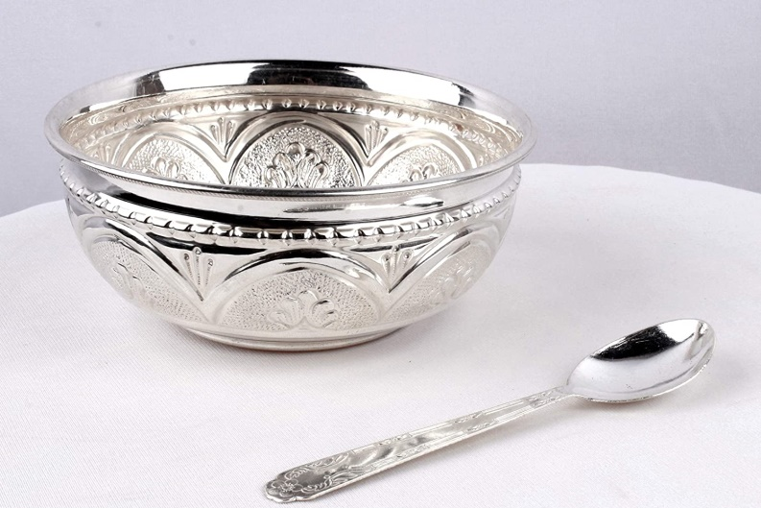

Indications to give milk by wati and spoon:-
- newborns with low birth weight or preterm newborns with at least 32 to 34 weeks of gestation.
- Spoon feeding of expressed breast milk is given to babies who are unable to develop a good suckling reflex, gradually transitioning to exclusive breastfeeding.
- The mother is ill, suffering from a breast abscess, or has a cesarean section and is unable to nurse her child right away.
- Birth abnormalities in children, such as hypoxia at birth and cleft palate.

Procedure of wati spoon feeding: -
- Cover your infant with a bib in case any breast milk spills.
- A sterile disposable plastic syringe should be used to measure expressed breast milk, which should be placed in a stainless steel basin.
- Support your baby's neck and upper back by sitting them up on your lap and holding them with one hand.
- Once the infant is correctly positioned, a 3/4-full spoon of milk is inserted into the spoon.
- The spoon is put against the baby's bottom lip without being tilted.
- Hold the spoon up to your baby's mouth and tilt it so that the breast milk just reaches their lips. Your baby shouldn't have it put in their mouth.
- Your infant will forward his tongue to lap up the breast milk.
- The spoon is left in place until the infant has consumed the milk that is being supplied.
- Give your infant some time to swallow before reloading the spoon and providing additional breast milk. Your infant will be able to regulate the feeding's pace thanks to this.
• After the baby has eaten about half of the meal, it is time to burp him. An additional 2-3 milliliters of milk should be consumed in addition to the recommended amount to make up for any minor milk spills during feeding.
• When used with great effectiveness, steel or silver "Paladas" with a capacity of 5 ml or more are especially useful for babies who have impaired sucking reflexes, such as those who have septicemia, cleft palates, or birth asphyxia.

The advantages of spoon feeding as opposed to bottle-feed
- It is socially acceptable because it is an ancient custom.
- A new mother can pick it up with ease.
- It is easier to sterilize and more hygienic than the bottle.
- It promotes early weight gain and the early release of preterm or low birth weight newborns from the hospital. The practice can be carried out at home until the baby reaches a healthy weight and a good sucking reflex.
5) When preterm babies are first breastfed, they have difficulty sucking and become fatigued easily, which prevents them from gaining weight and causes worry in the family. Using alternate spoon feeds of expressed breast milk in such a scenario can facilitate weight gain swiftly.
- NIFTY cup:
A reusable solution for giving breast milk to babies who have trouble nursing is the Nifty Feeding Cup. With this easy-to-use, easily cleaned, and culturally suitable feeding solution, the baby may regulate how quickly they eat.
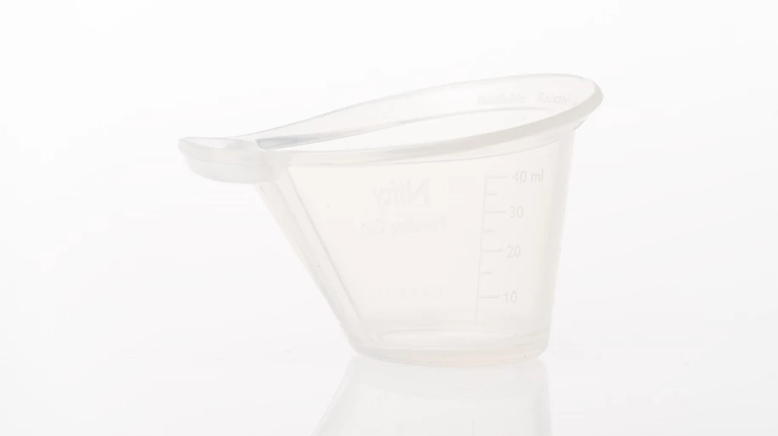

Features:-
• Boilable, autoclavable, and reusable.
Keep an eye on your feeding with the millimeter feeding measurements on the cup's side.
• The baby's mouth is gently touched by the soft silicone substance.
• A milk reserve that the baby can lap at to regulate the feeding's speed.
• Mother can communicate with Nifty directly.

Material:-
- Made with silicone rubber
- Safe for food contact according to regulation 1935/2004
- Operating Temperature:-18 °C to +50 °C
- Storage temperature: -40 °C to +60 °C
- Not made with natural rubber latex

Dimensions
- Mass: Approx. 23.5 g
- Volume: 5 to 40 ml

Disinfection
- reusable so that other infants can utilize it
- Adaptable to reprocessing using the subsequent techniques:
- Steam autoclaving for 10–20 minutes at 136 °C

- Chemical disinfection for 20 minutes using a 0.5% chlorine solution, followed by three clean water rinses
- Boiling for ten minutes in water
Procedure of NIFTY cup feeding

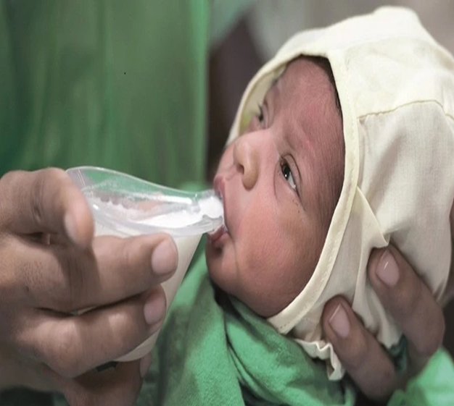
- The mother hand expresses breastmilk into the NIFTY cup.
- The mother then pours the milk into the reservoir and the infants takes in the milk at his or her own pace.
- The cup shape makes this intuitive, hence the NIFTY name: the Neonatal Intuitive Feeding TechnologY (NIFTY).
Advantages of NIFTY cup feeding
- The NIFTY feeding cup optimizes infant feeding. The innovation is in the cup shape and material.
- The NIFTY is large enough for direct hand expression of breastmilk.
- The unique reservoir allows for easy control of the milk flow by the feeder and enables the infant to control the feeding.
- The soft silicone material prevents oral cavity injury and can be boiled or autoclaved.
Comparison between wati spoon feeding and NIFTY cup feeding
Advantage of using NIFTY cup over wati spoon is less spillage, no wastage of breast milk and exact amount of feed taken by the baby can be measured and lastly ease of handling cup than wati spoon.

Conclusion:-
In India the prevalence of pre term births is high and it causes the burden on health care system of India. The main problem of pre- term babies is nutrition which is responsible for their growth and development. To provide them the required nutrition the breast milk is the best feed. Now how to give them i.e method of feeding is already discussed in the above paragraph. To feed breast milk to pre-term babies there are two methods wati spoon and NIFTY cup out of which NIFTY cup has more advantage over wati spoon method.

Research studies related to NIFTY cup are as follows:
  - Mckinney C, Balakrishnan U, Ninan B, Glass R, Cunningham M, Murthy J. A Comparative Study of Two Infant Feeding Tools: The NIFTY Cup and ThePaladai. Indian J Pediatr. 2020 Jul 1;87(7):505–11.
  - Mckinney CM, Plange-Rhule G, Ansong D, Cunningham ML, Agyeman I, Coffey PS. A randomized crossover trial comparing the NIFTY cup to a medicine cup in preterm infants who have difficulty breastfeeding at KomfoAnokye Teaching Hospital (KATH) in Kumasi, Ghana. Plos One. 2019 Oct 17;14(10):e0223951.
Doi: 10.1371/journal.pone.0223951. PMID: 31622421; PMCID: PMC6797128.
References:-
- Behera J R, Behera G, Sahu S , Factors Influencing the Age at Discharge of Very Low Birth Weight Preterm Neonates From a Neonatal Intensive Care Unit in Eastern India: A Cohort Study. Cureus. 2020 march;12, 12(12): e11889.
DOI 10.7759/cureus.11889
- https://data.unicef.org/topic/child-survival/neonatal-mortality/
- https://www.parentinginottawa.ca/en/breastfeeding/Spoon--Cup-and-Paced-Bottle-Feeding.aspx#:~:text=Bring%20spoon%20to%20your%20baby's,and%20offering%2 0more%20breast%20milk
- https://www.sangopan.com/why-spoon-feeding-should-be-preferred-than-bottle-feeding/
- https://laerdal.com/in/products/skills-proficiency/neonatal-skill-trainers/NIFTY-feeding-cup/
- New Mother's Guide to Breastfeeding, 3rd Edition (Copyright © 2017 American Academy of Pediatrics)
- Roberta Pineda, Danielle Prince, Jenny Reynolds, Molly Grabill and Joan Smith, Preterm infant feeding performance at term equivalent age differs from that of full-term infants. Springer Nature America, Inc. 2020 Received: 4 November 2019 / Revised: 21 January 2020 / Accepted: 4 February 2020 / Published online: 17 February 2020
https://doi.org/10.1038/s41372-020-0616-2
- WHO Global nutrition targets 2025: low birth weight policy brief :WHO/NMH/NHD/14.5)

