Brachytherapy in Breast Cancer
Antara Bagchi ¹, Isha Jaiswal²
¹Junior Resident ²Assistant Professor
Department of Radiotherapy and Radiation Medicine, Institute of Medical Sciences, Banaras Hindu University, Varanasi
The incidence of breast cancer has been showing a continuously rising trend, not just in India but also across the globe. The treatment of breast cancer encompasses multiple disciplines, i.e., surgery, radiotherapy, chemotherapy, hormonal therapy and targeted therapy. These modalities play an integral role in the course of treatment, and have a distinct role and mechanism of action and work in conjunction. This also has direct implications on the psychosocial state of the patient. Owing to this, Breast Conserving Surgery has gained recognition and acceptance as the preferred surgical modality in majority of patients. Radiotherapy is an essential element of management of these patients (BCS with RT together known as BCT or Breast Conserving Therapy); and brachytherapy has been established as a highly precise and effective modality of delivering radiation.
Brachytherapy can be given in patients of breast cancer in the following settings:
- Tumor Bed Boost
Rationale:
A very large percentage of local recurrence arises in the immediate vicinity of original location of the tumor.

Figure-1: Diagrammatic representation of recurrence post-BCS

Many prospective randomized studies were carried out and published, to examine the percentage of local recurrence after RT to the whole breast. It was observed that 69 to 90% of these recurrences occur within or close to the index tumor location.
Table-1: Trials showing patterns of Ipsilateral breast tumor recurrence (IBTR) after BCS ^{[1]}
These data provide a strong rationale for tumor bed boost.

The role of Tumor bed boost was established by Bartelink et al ^{[2]} in the landmark EORTC Randomized Boost vs No Boost Trial in 1989, which included patients of breast cancer (cT1-2, N0-1), who received whole-breast EBRT 50 Gy in 25# over 5 weeks. This was followed by randomization of margin negative patients to receive a boost or exclude it. The results showed a significant improvement in patients with boost, in terms of reduction in ipsilateral breast tumor recurrence (IBTR).
And of all available modalities, brachytherapy has shown to have a high degree of conformity and therapeutic ratio. ^{[3]}

- Accelerated Partial Breast Irradiation (APBI):
This involves delivery of high dose of radiation to the tissue surrounding the lumpectomy cavity, which us the area at highest risk for recurrence.
It involves decreased size of radiation field, decreased number of radiation fractions and shortened treatment duration.
Table-2: ASTRO recommendations for APBI are as follows: ^{[4, 5]}
Criteria | SUITABLE | CAUTIONARY | UNSUITABLE
Age | ≥50 yrs | 40-49 | ≤ 40 yrs
Tumor stage | Tis or T1 | To/T2 | T3/T4
Tumor size | ≤ 2 cm | 2-3 cm | >3cm
Margins | ≥ 2 mm | Close ≤ 2 mm | Positive
Grade | Any | NA | NA
LVI | No | Limited/ Focal | Extensive
ER status | Positive | Negative | NA
Multicentricity | Unifocal | NA | Present
Histology | IDC/ favourable | Invasive Lobular
EIC/ Pure DCIS | Not allowed | ≤ 3 cm | >3cm
Nodes | pNo | NA | Positive
NACT | Not allowed | NA | Used

- Retreatment in relapsed patients

Techniques:
a) Balloon catheter brachytherapy: After BCS, the lumpectomy cavity is assessed with a Cavity Evaluation Device (CED). This is followed by insertion of specialized brachytherapy device that aims to confirm to the shake of the patient’s cavity. ^{[6]}

•Mammosite:
It is a multilumen device which consists of a balloon of variable diameter, a multilumen silicon catheter, radiation source port pathways and a separate port for inflation/deflation of the balloon. The balloon can be spherical in shape (of diameter 4-5 cm & 5-6 cm) or elliptical (of size 4x6 cm).
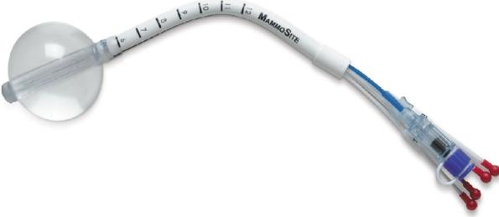
Figure-2: The MammoSite Multilumen System (courtesy of Hologic, Marlborough®)
• Contura:
It us similar to Mammosite with the advantage of having 5 lumens, which confers greater dose flexibility due to additional source positions. It also has vacuum ports to enable the aspiration of seroma fluid and air, thus providing better tissue-balloon conformance.
Figure-3: The Contura balloon applicator (courtesy of SenoRx®).

•Strut Adjusted Volume Implant (SAVI):
It is an expandable catheter system that consists of a bundle of soft tiny catheters that can be custom fitted to the excision cavity. It consists of 1 central lumen and variable number of outer lumens (6-1, 8-1, 10-1). Since it doesn’t involve any water-filled balloon, the catheters are in closer proximity to the breast tissue.
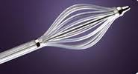
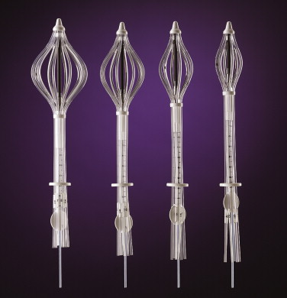

Figure-4: Different sizes of SAVI with peripheral struts expanded (courtesy of Cianna Medical®)
• Clearpath:
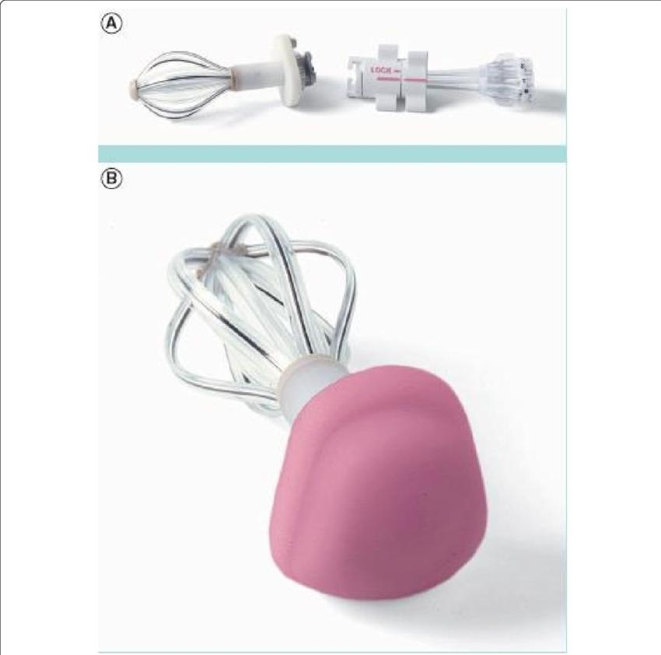
It is a device similar to SAVI, consisting of a central catheter, surrounded by 6 expandable outer plastic catheters. The main difference is that the radiation source is not in direct contact with the skin, due to the presence of a cap placed over the HDR channels.

Figure-5: ClearPath device (a) the base detached (b) a cap placed over the HDR channels (courtesy of North America Scientific®).

•Axxent Electronic Brachytherapy system:
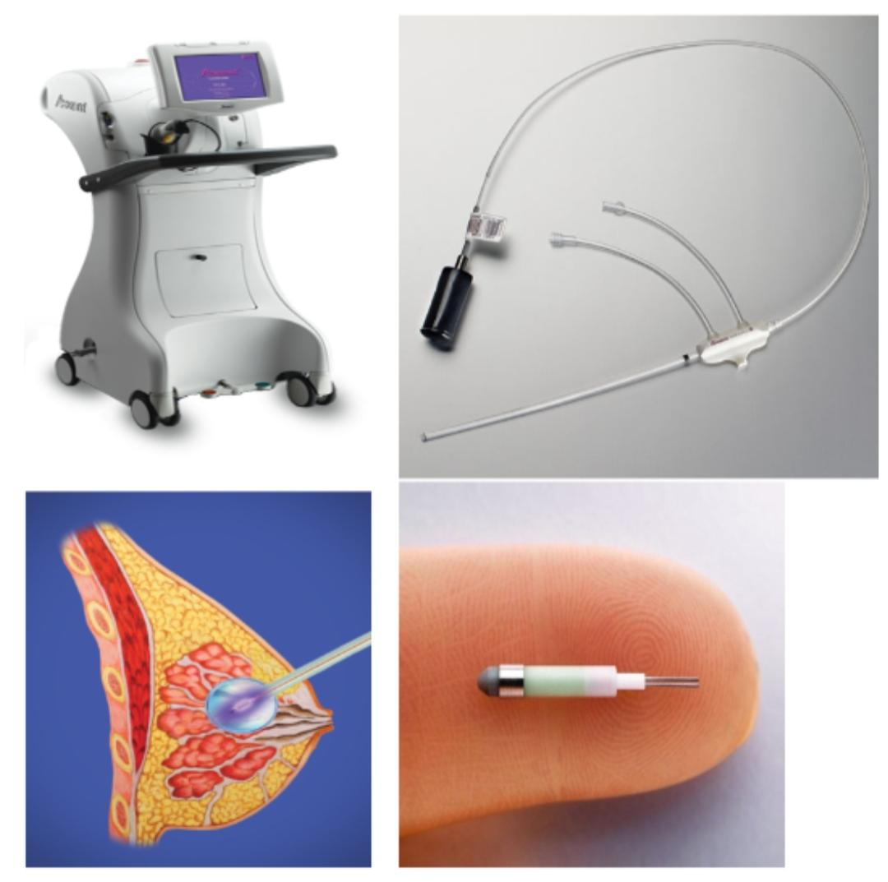
Figure-6: Axxent electronic brachytherapy (courtesy of Xoft®)

It is a unique modality wherein no radio-isotope is used. Instead, it utilizes a miniaturized high dose rate x-ray source of 50 kV, which is disposable and intended for use upto 10 fractions. It is a portable unit, and doesn’t need any shielded room for radiation protection. The applicator consists of a single-lumen radiolucent balloon, that utilizes multiple dwell positions.

- Seed implant:
Palladium-103 seeds are used for insertion in the cavity, which is done after a thorough pre-planning CT scan and subsequent surface marking of the representative points for seed insertion. The procedure is done under general anaesthesia and USG guidance, with a template. The size of the target volume should be restricted to 125 cc. The seed activity is 2.5 U/seed, and the prescribed Minimum Peripheral Dose is around 90 Gy.

- Accuboost (NIBB):
Non-invasive image-guided breast brachytherapy. It consists of initial immobilization of breast between two mammography paddles. This is followed by image-guided delineation of target using 30 kVp x-rays. The treatment is subsequently done with collinated photon emission using Iridium-192 HDR brachytherapy from two orthogonal angles.

- Multicatheter interstitial brachytherapy:
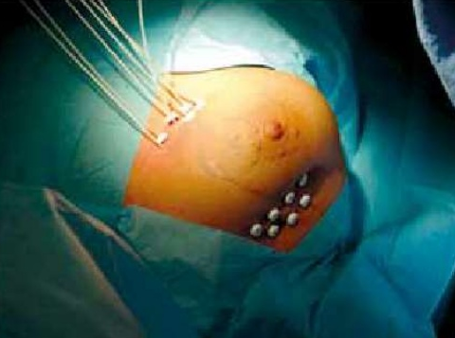
It was initially given as Low dose rate or LDR brachytherapy. The technique involves flexible afterloading catheters placed in and around the lumpectomy bed either during or after surgery.
Figure-7: Interstitial brachytherapy for breast cancer : Postoperative and Intra-operative implantation procedure ^{[7]}
Dose:
•For Tumor bed boost:
A biologicaly equivalent total dose in the range of 10-20 Gy in 1-4 fractions ahould be selected as per current recommendations; preferably 2x4-6 Gy, or 3x3-5 Gy scheduled twice per day, with minimum 6 hours internal between the fractions, or a single fraction of 7-10 Gy. ^{[8]}

•For APBI:
-LDR brachytherapy: 50 Gy to tumor bed over a duration of 96 hours
-HDR brachytherapy: 34-38 Gy in 10 fractions (two fractions per day)

-For balloon brachytherapy, dose prescription is done at 1 cm from the edge of balloon.

Institutional protocol

The technique for Breast brachytherapy employed in Sir Sunderlal Hospital, Banaras Hindu University, a tertiary care cancer center with a high turnover of patients, is Multicatheter interstitial brachytherapy. This is performed with either templates or by freehand insertion.
Cavity delineation:
Table-3: Possible modalities for delineation of post-op cavity ^{[9]}

Procedure and Practical Considerations:

-In accordance with Paris system of Brachytherapy implantation, afterloading catheters are inserted transcutaneously, as per ESTRO-ACROP guidelines.

-Insertion of needles is done in and around the tumor bed in a single plane or multiple planes, which depends on the individual patient’s tumor bed location and anatomy.

-Distance between the needles is kept uniform, at 1-1.5 cm intervals.

-It should cover the tumor bed with an adequate margin of 1-2 cm.

-It can be performed in 2 methods:
- Post operative: Implant procedure is done after wound healing and receiving final histopathology report. However, image guidance is required for placing the adequate number of catheters in the right geometry relative to the cavity

- Intra-operative: Direct visualization of tumor bed makes implantation much simpler. It requires coordination between surgeon, pathologist and radiation oncologist.

-Needles are later replaced with flexible plastic catheters and secured with buttons.

-After the implant procedure, patient is taken for CT simulation, where images are taken with a slice thickness of 1 mm.

Target delineation:
The clinical target volume (CTV) is delineated with a non-isotropic expansion, taking into account the index size and location of tumor, as well as the distances of resection margins from the tumor. Apart from CTV, organs at risk like heart, ipsilateral lung, ribs and skin are also contoured.

Treatment Planning:
The next step is catheter reconstruction by cross-sectional imaging, which is done on the Oncentra Brachytherapy Treatment Planning System.
Figure-8: Virtual reconstruction of catheters (Courtesy: Oncentra TPS, Department of Radiotherapy and Radiation Medicine, IMS-BHU)
This is followed by inverse planning and optimization using IPSA (Inverse planning simulated annealing) or HIPO (Hybrid inverse planning and optimization). This is followed by Graphical optimization, where isodose curves are manually adjusted as per coverage and doses to CTV and organs at risk.
Figure-9: Planning followed by evaluation by isodose curves and Dose Volume Histogram (DVH) (Courtesy: Oncentra TPS, Department of Radiotherapy and Radiation Medicine, IMS-BHU)
The plan is evaluated with the help of Dose-Volume histogram, and other dose parameters like D90, V90, V100, V150 and V200. D0.1cc and D2cc is seen for organs at risk.

After dose prescription, the plan is exported to the treatment console and tubes are connected to the remote afterloader (Iridium-192 Nucletron microselectron).

Prerequisites for Brachytherapy:
•Accessible site
•Well-localized cavity
•Relatively small size of cavity
•Good expertise
•Thorough clinical and radiological localization

Advantages:
•Highly conformal technique
•High dose can be safely delivered
•Sharp dose falloff
•Reduced toxicity

Possible disadvantages:
•Invasive procedure
•Anaesthesia complications
•Not feasible for every site

Brachytherapy delivers a very high dose to a precise, strictly limited volume within the breast. By virtue of the Inverse square law, it ensures sharp dose falloff, thus avoiding exposure of adjacent sensitive organs at risk to the highest possible extent. This results in excellent local control with lower rates of side effects. Therefore, it is considered to be a highly effective modality, and its use should be encouraged in the clinical setting for patients post-BCS. ^{[10]}

References:
- Mannino M, Yarnold J. Accelerated partial breast irradiation trials: Diversity in rationale and design. Radiother Oncol. 2009;91:16–22.

- Bartelink H, Maingon P, Poortmans P et al; EORTC Radiation Oncology and Breast Cancer Groups. Whole-breast irradiation with or without a boost for patients treated with breast-conserving surgery for early breast cancer: 20-year follow-up of a randomised phase 3 trial. Lancet Oncol. 2015 Jan;16(1):47-56.

- Skowronek J, Chicheł A. Brachytherapy in breast cancer: an effective alternative. Menopause Review/Przegląd Menopauzalny. 2014;13(1):48-55. Doi:10.5114/pm.

- Smith BD, Arthur DW, Buchholz TA, et al. Accelerated partial breast irradiation consensus statement from the American Society for Radiation Oncology (ASTRO). Int J Radiat Oncol Biol Phys 2009;74:987-1001.

- Correa C, Harris EE, Leonardi MC, et al. Accelerated Partial Breast Irradiation: Executive summary for the update of an ASTRO Evidence-Based Consensus Statement. Pract Radiat Oncol 2017;7:73-9.

- Njeh et al.: Accelerated Partial Breast Irradiation (APBI): A review of available techniques. Radiation Oncology 2010 5:90.

- Skowronek J, Wawrzyniak-Hojczyk M, Ambrochowicz K. Brachytherapy in accelerated partial breast irradiation (APBI) – review of treatment methods. Journal of Contemporary Brachytherapy. 2012 Sep;4(3):152-164.

- Strnad V, Major T, Polgar C, et al. ESTRO-ACROP guideline: Interstitial multi-catheter breast brachytherapy as Accelerated Partial Breast Irradiation alone or as boost – GEC-ESTRO Breast Cancer Working Group practical recommendations. Radiother Oncol. 2018 Sep;128(3):411-420.

- Rakesh Jalali, Suruchi Singh & Ashwini Budrukkar (2007) Techniques of tumour bed boost irradiation in breast conserving therapy: Current evidence and suggested guidelines, Acta Oncologica, 46:7, 879-892.

- Daniela Kauer-Dorner, Daniel Berger; The Role of Brachytherapy in the Treatment of Breast Cancer. Breast Care 2 July 2018; 13 (3): 157–161.

