AI-POWERED HEALTHCARE TECHNOLOGY: A POST PANDEMIC CRITICAL REVIEW

DR. S. SAROJINI M.Com., M.Phil., Ph.D.
Assistant Professor, Commerce, Dr. G.R. Damodaran College of Science, CBE-14
DR. J. NITHYA M.Com., M.Phil., M.B.A., Ph.D.
Associate Professor, Commerce, Dr. N.G. P Arts and Science College, CBE-48
MS. SWATHY S
B. Com BPS, Dr. N.G. P Arts and Science College, Coimbatore-48
MR. SARAN R
B. Com BPS, Dr. N.G. P Arts and Science College, Coimbatore-48

ABSTRACT:

The complication and rise of information in healthcare means that (Artificial intelligence) will increasingly be tried within the field. Several types of AI are already being empowered by payers and providers of care, and life sciences companies. The key areas includes applications involved in diagnosis and treatment, patient information, official activities in hospital. Although there are many instances in which AI can perform healthcare job as well or better than humans, execution element will prevent large-scale automation of healthcare professional jobs for a considerable period. ChatGPT help reducing efforts to understand patients’ symptoms by providing alternative ways solving their problems. Ethical issues while using the application of AI in health care sector is also discussed. AI is being used to improve the accuracy of cancer diagnosis, to create new drugs and treatments. AI chatbots are being used to provide information related to patient support and education. As AI technology continues to develop, we can expect to see even more widespread adoption of AI in healthcare in the years to come.
Key Words: Artificial intelligence, life sciences, diagnosis, automation, ChatGPT

INTRODUCTION:

Artificial intelligence (AI) and equivalent technologies are rising in prevalent business and society, and are beginning to be adopted to healthcare. These technologies have the capacity to transform many aspects of patient care, as well as administrative processes within provider, payer and pharmaceutical organizations. There are already a number of research studies suggesting that AI can execute as well as or better than humans at key healthcare jobs, such as diagnosing disease. Today, structured programs are already performing radiologists at noticing malignant tumors, and guiding researchers in how to build cohorts for costly clinical trials. Humankind believes that AI replaces humans or doctors in wider medical process domains. In this paper, we discuss both the potential that AI offers to automate aspects of care that is provided to the patients.
- AI-POWERED CHATBOTS IN HEALTHCARE
AI chatbots are being used to provide information related to patient support and education. For example, Babylon Health's chatbot has been used by over 2 million patients in the UK, and it has been shown to be effective in reducing wait times and improving patient sat
- AI IN DRUG DISCOVERY
AI is being used to create new drugs and treatments. For example, Insilico Medicine uses AI to predict the effects of new drug candidates on human cells, and it has already identified several promising new drug targets.
- AI IN CANCER DIAGNOSIS
AI is being used to improve the accuracy of cancer diagnosis. For example, Google AI has developed an AI system that can detect breast cancer with 99% accuracy, and it is currently being used in clinical trials.
- AI IN PERSONALIZED MEDICINE
AI is being used to personalize medicine. For example, IBM Watson Health's Oncology Suite uses AI to analyze patient data and recommend the best treatment plan for each individual patient.
These are lot of peculiar examples that AI is being used in hospital industries. As AI technology continues to develop, we can expect to see even more innovative and effective applications of AI in the healthcare industry.
Here are some additional figures and facts about AI in healthcare:
- According to a report by Grand View Research, the global market for AI in healthcare is expected to reach $6.6 billion by 2026.
- In 2020, there were over 1,000 AI-powered healthcare startups.
- AI is being used in over 200 different healthcare applications.
- AI is being used to improve patient care in over 50 countries.
These figures and facts show that AI is rapidly becoming a mainstream technology in the healthcare industry. As AI technology continues to develop, we can expect to see even more widespread adoption of AI in healthcare in the years to come.
There are a few real-world examples of AI in healthcare:
- Babylon Health chatbot
Babylon Health's chatbot has been used by over 2 million patients in the UK. The chatbot can answer patient questions, provide education on health topics, and even help patients book appointments. It has been shown to be effective in reducing wait times and improving patient satisfaction.
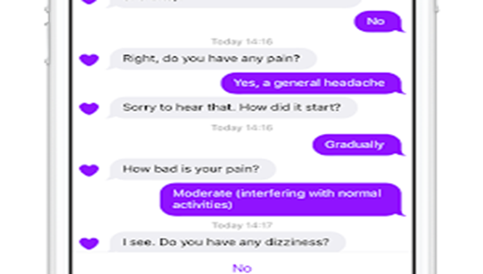
Fig 1: source: techcrunch.com
- Google AI DeepVariant:
Google AI has developed an AI system that can detect breast cancer with 99% accuracy. The system, called DeepVariant, analyzes medical images to identify cancer cells. It is currently being used in clinical trials, and it has the potential to revolutionize the early detection of breast cancer.
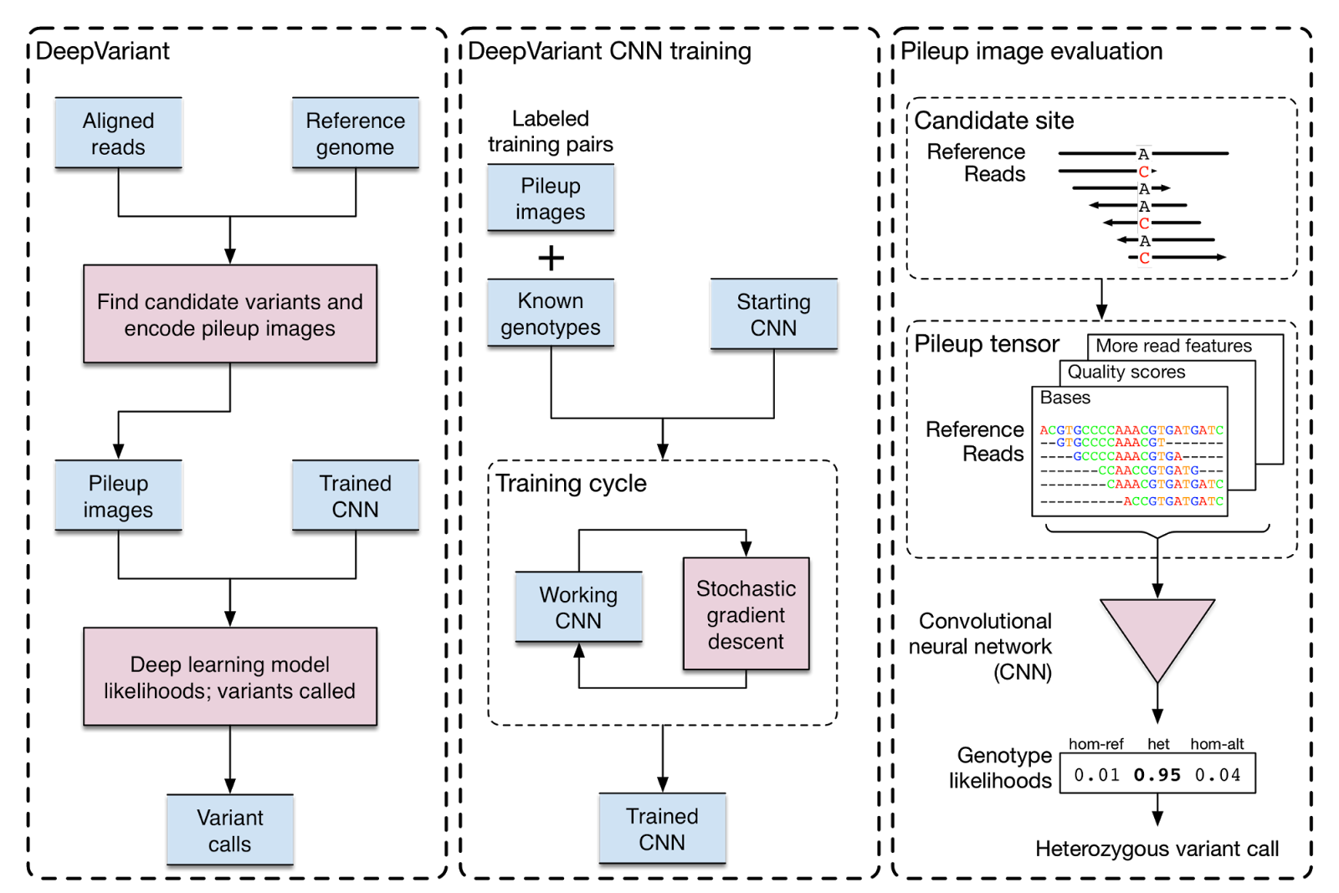
Fig 2 : Source:ai.googleblog.com
- IBM Watson Health Oncology Suite
IBM Watson Health's Oncology Suite uses AI to analyze patient data and recommend the best treatment plan for each individual patient. The system takes into account a patient's medical history, genetic information, and other factors to create a personalized treatment plan. It is currently being used in hospitals around the world, and it has the potential to improve the outcomes of cancer treatment.
- Insilico Medicine Uses AI to Predict the Effects of New Drug Candidates on Human Cells:
The company's AI platform, called Genotype-Tissue Expression (GTEx), analyzes large datasets of medical data to identify new drug targets and develop new treatments.
.
Fig 3: Source: Insilico Medicine Uses
It has already identified several promising new drug targets, and it is currently working with pharmaceutical companies to develop new drugs.
These are lot of examples that provide live witnesses about the AI usage in healthcare today. As AI technology continues to develop, we can expect to see even more innovative and effective applications of AI in the healthcare industry in the years to come.

TYPES OF AI OF RELEVANCE TO HEALTHCARE

Artificial intelligence is not one technology, but a group. Most of these technologies have immediate significance to the healthcare field, but the particular processes and tasks they support vary widely. Some weird AI technologies of extraordinary importance to healthcare are also defined and described as below.

MACHINE LEARNING – PECULIAR NETWORKS AND DEEP LEARNING

Machine learning is a statistical technique for attaching models to data and to ‘learn’ by teaching models with data. Machine learning is one among the supreme usual forms of AI. According to Deloitte survey in 2018 by 1,100 US managers whose establishments were already handling with AI, 63% of companies surveyed were engaging machine learning in their businesses. It is a wider technique at the core of many approaches to AI and there has many versions of it.

PHYSICAL ROBOTS

Physical robots are known by this point, given that more than 2 lakhs industrial robots are installed each year around the world. They perform pre-programed tasks like lifting, keeping back in the previous positions, welding or assembling objects in places like working place and warehouses, and delivery in hospitals. More recently, robots have become engaged with humans and are more conveniently trained by moving them through a desired task. They are also becoming more knowledgeable, as other AI capabilities are being used in their ‘brains’ (really their operating systems).

Over time, it seems likely that the same improvements in innovation that we've seen in other areas of AI would be included into physical robots, which could be the future so the robots could easily viewed on the nook and corner of the world. Many companies started to invest billions of dolor into the installation process of the robots. But we cannot say the result of the robots will be 100 percent.

THE FUTURE OF AI IN HEALTHCARE

We believe that AI has a main role to play in the healthcare offerings of the future. In the form of machine learning, it is the initial capability behind the development of precision medicine, widely agreed to be a sorely needed advance in care. Although early efforts at providing diagnosis and treatment endorse have proven challenging, we expect that AI will eventually master that domain as well. Given the rapid advances in AI for imaging analysis, it seems likely that most radiology and pathology images will be checked at some point by a machine. Speech and text recognition are already put in place for tasks like patient communication and capture of clinical notes, and their usage will increase.

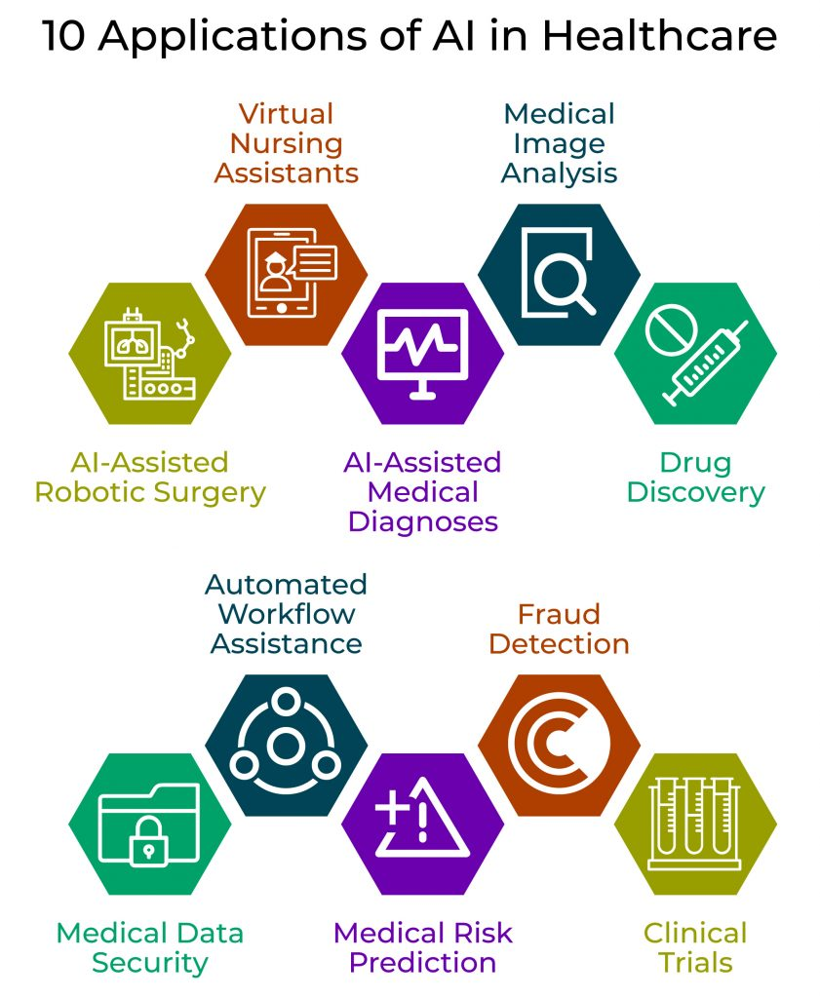

Fig 4: Applications of AI in Healthcare

ChatGPT

Our research is also based on the Chat-GPT. For example, we are working to improve feedback to people who use our decision aid on antidepressants (http://MeAgainMeds.com). Today, when ChatGPT gives antidepressants, it relates very universal advice. We need to type it very specific to be specific. Google Brain has prepared ChatGPT more specific by keeping fit further. The specific version of Google Brain also passed the U.S. Medical Licensing Exam. Thus, it has more knowledge and is more specific to the exam. The system we are planning will be trained o do so.

CONCLUSION:

It also seems clear that AI systems will not replace human doctors on a large scale, but rather will increase their efforts to care for patients. Over time, human doctors may move toward tasks and job designs that draw on distinctive human skills like empathy, faith and big-picture integration. Although there are many instances in which AI can perform healthcare job as well or better than humans, execution element will prevent large-scale automation of healthcare professional jobs for a considerable period. ChatGPT help reducing efforts to understand patients’ symptoms by providing alternative ways solving their problems.

REFERENCES:

Deloitte Insights State of AI in the enterprise. Deloitte, 2018
Lee SI, Celik S, Logsdon BA, et al. A machine learning approach to integrate big data for precision medicine in acute myeloid leukemia. Nat Commun 2018;9:42.
Ross C, Swetlitz I. IBM pitched its Watson supercomputer as a revolution in cancer care. It's nowhere close. Stat 2017.
www.statnews.com/2017/09/05/watson-ibm-cancer.

