RAMJET ENGINES
S. P. Gairolaª ,
Department of Mechanical Engineering, Uttaranchal University, Dehradun Uttarakhand, India,
Suryapg07@gmail.com , https://orcid.org/0000-0001-7135-4269
Abhay Dashmana^{b} ,
Department of Mechanical Engineering, Uttaranchal University, Dehradun Uttarakhand, India,
abhaydhasmana735@gmail.com
Sanjeev Kumar Joshi^{c},
Department of Mechanical Engineering, Uttaranchal University, Dehradun Uttarakhand, India,
ersanjeevjioshi@gmail.com
Sanjeev Dhama^{d} ,
Department of Mechanical Engineering, Uttaranchal University, Dehradun Uttarakhand, India,
Sanjeev.dhama@gmail.coms

Introduction
Air-breathing ramjet engines are at the cutting edge of high-speed propulsion technology, working effectively at hypersonic speeds (3-6 Mach), and are essential in a variety of aerospace applications [1]. This extensive chapter explores the fundamentals, working principles, design considerations, uses, and difficulties of ramjet engines. This investigation provides a thorough grasp of this innovative and interesting technology, from its historical origins to the thrilling future of hypersonic flight.
Sound Barrier
We must first comprehend the idea of shock waves in order to understand ramjet technology. Everyone is aware of the waves that are made when anything is tossed into the water. The resulting waves have the shape of concentric circles and move equally in all directions. A similar effect occurs when sound waves go through an aircraft, but we can see that the waves created as the aircraft travels ahead are not symmetrical. The speed of sound is the movement of these waves. These waves create a sort of intangible wall in front of the moving aircraft when it is traveling at the speed of sound. The sound barrier is this imperceptible barrier [2].
The sound barrier breaks and creates a disputed wave pattern whenever an aircraft flies faster than the speed of sound. The aircraft encounters both high pressure and considerable drag in this disputed area. To overcome this drag, the aero plane must use greater thrust. The dispersed pattern resembles a cone. The intriguing aspect is the formation of a conical-shaped chamber with a thickness of 200 nanometers, a high temperature, and a pressure that is nearly 29 times more than atmospheric pressure. A shock wave is the name for this area.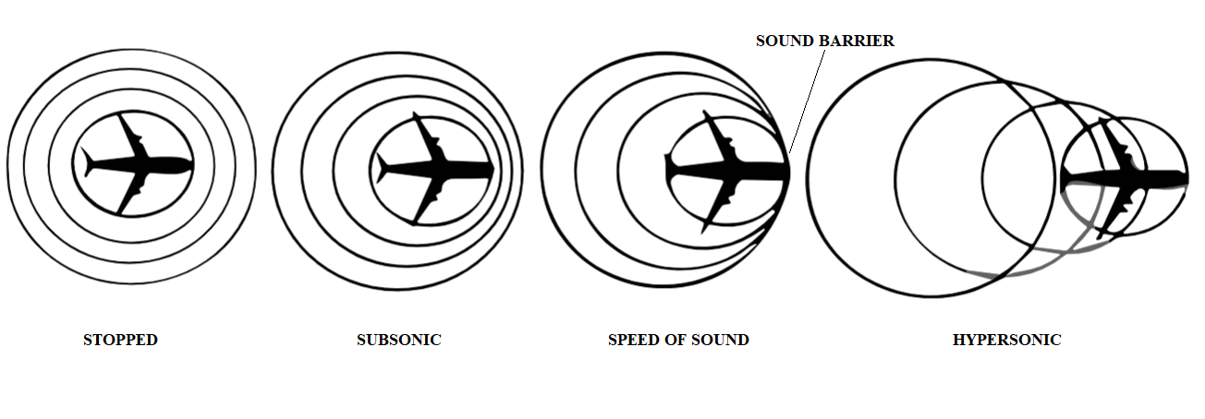

Figure 1. Pressure waves of air flowing off an airplane

1. The Operation of Ramjet Engines
There are three sections :
1.1 Compression from Subsonic to Supersonic:
The core idea behind a ramjet engine is to capture and accelerate incoming air to supersonic speeds. The entry has a diffuser, which raises the temperature and pressure of incoming air. Only supersonic conditions allow the ramjet engine to function. The shock wave created by the engine's inlet at supersonic conditions creates a cone of thick volume, raising the pressure and temperature of incoming air. The Ram Effect is the name given to this phenomenon. However, it had one flaw: the compressed air leaks out around the tube's inlet, limiting the ramjet engines' top speed to 1.2 Mach.
Scientists came up with the idea of creating an inner body that is aerodynamically stable and connected to the outer body to enhance the ram effect. We can observe that the area set aside for air is contracting together with the flow for supersonic flow and leading to a rise in pressure by attaching the component with an aerodynamic design. When air strikes the inner body's nose and is forced in a specific direction, it produces an oblique shock wave. This wave is deflected multiple times, resulting in a conventional shock wave. The spill-out is thereby greatly reduced, and the engine's overall efficiency is raised.
1.2 Thrust Generation and Combustion
Let's find out more about the ramjet engines' combustion chamber layout. Fuel is introduced and ignited in the high-speed airflow once compressed air has been directed into the combustion chamber. The ramjet's airflow is moving through it at such a rapid rate that the fuel is thoroughly mixed in two to five milliseconds. The ramjet engine's air-to-fuel ratio is 50:1. An enormous amount of heat energy is released quickly during burning, raising. the gases' pressure and temperature. An air flame holder is used to completely mix the fuel, which aids in maintaining continuous combustion and prevents the flame from blowing out by sheltering it. A strong exhaust jet is created at the back of the engine as a result of the combustion gases' subsequent expansion, which creates a forward push.
The ramjet engine, as we all know, only operates at supersonic speeds. The stand-alone ramjet engine is not practical at low speeds because the thrust is insufficient to overcome the drag; instead, it requires a strong booster to accelerate it to supersonic speeds.
1.3 Outlet Design for Efficient Exhaust:
A convergent-divergent nozzle serves as the ramjet engine's outlet design. A crucial part of producing thrust is the nozzle, which transforms thermal energy into kinetic energy. It is a convergent-divergent nozzle that efficiently converts thermal energy into velocity by accelerating high-pressure exhaust gases. The required forward push is produced when this high-velocity exhaust jet is shoved in the opposite directionn.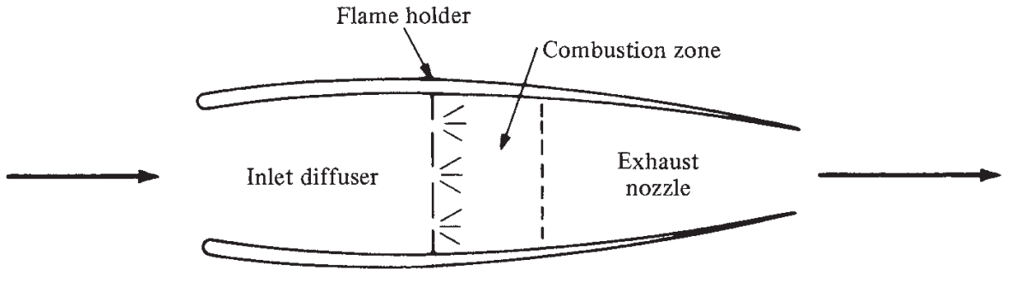
Figure 2. Ramjet Engine
(Source: John D. Anderson, Jr., Introduction to Flight, Eighth Edition)

2. Considerations for Ramjet Design and Operation
Ramjet engines are specially made to run effectively at hypersonic speeds when the engine's forward motion at supersonic speed compresses the air for combustion. The design and operating elements of these engines are crucial to their effectiveness [3-5]. The following are a few of the most crucial factors to take into account while constructing ramjet engines for hypersonic travel, choosing fuel, and launching criteria.
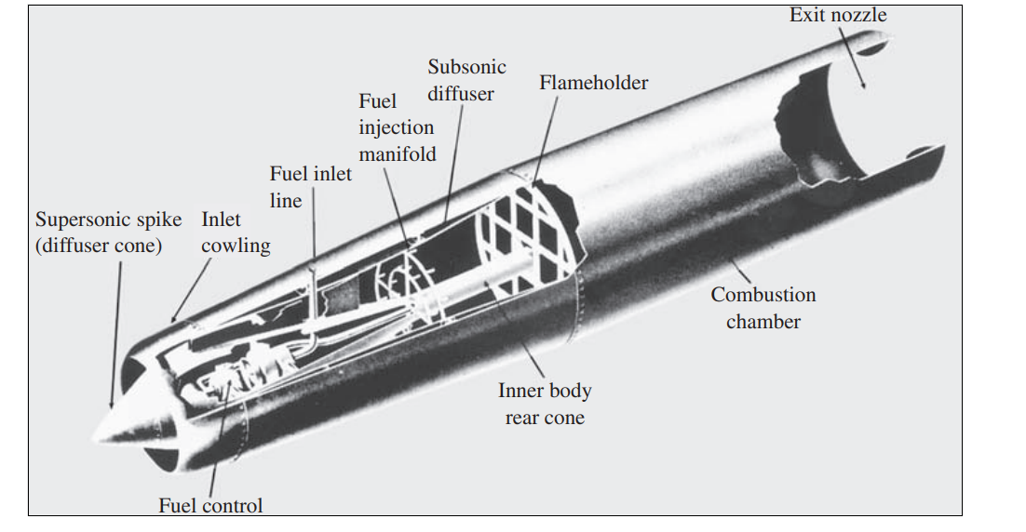

Figure 3. A typical ramjet engine.
(Source: Marquardt Aircraft Co.)

2.1 Hypersonic Speed Design
2.1.1Aerodynamic effectiveness:
The ramjet engine's most crucial criterion is aerodynamic efficiency [3]. For the engine to operate at its best at hypersonic speeds, where airflows around it are extremely compressed, aerodynamic efficiency must be maximized. Engineers and scientists are continually working to improve the geometry of the air intake so that it can efficiently compress and slow down incoming air, creating the perfect airflow pattern in the combustion chamber. The standard intake design has a converging-diverging form that allows the air to be deflected several times, slowing it down in the converging part and compressing it further in the diverging region. The efficiency of combustion is improved by this process, which helps raise air pressure and temperature before it enters the combustion chamber [4]. Additionally, the spill-out is significantly decreased, and the engine's overall efficiency is increased.
To avoid needless energy losses during flight, aerodynamic drag must be kept to a minimum. The engine can attain and maintain greater speeds more effectively by reducing drag by streamlining the engine's exterior and incorporating a smooth design.

2.1.2 Structural Integrity and Thermal Stresses:
Ramjet engines frequently run at hypersonic speeds, subjecting them to powerful thermal and aerodynamic forces. The engine's structure is put under a lot of pressure by these forces over time. The longevity and performance of the engine depend heavily on maintaining structural integrity and controlling thermal and aerodynamic loads.
Engineers typically use cutting-edge materials with excellent heat resistance, mechanical strength, and the ability to easily handle high thermal stresses to withstand these extreme conditions.
Critical engine components frequently use materials such as super alloys, ceramics, and carbon composites. These materials are able to withstand the high temperatures produced by fast flight without losing structural integrity.
To regulate heat dissipation and shield the structure from high thermal loads, thermal protection systems, such as heat-resistant coatings and cooling systems [5], are frequently incorporated into the engine's design. A multidisciplinary approach, encompassing consideration of aerodynamic efficiency, structural integrity, thermal management, fuel choice, and launch requirements, is necessary for designing and operating ramjet engines for hypersonic speeds. To obtain optimum engine performance, there should be a balance between aerodynamic performance, structural robustness, and thermal resistance.
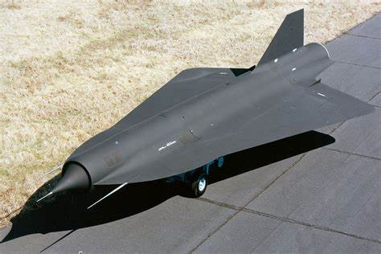

Figure 3. Lockheed D-21.
(Source: Lockheed Martin)

2.2Fuel Choice and High-Temperature Capabilities
2.2.1 Hydrogen Fuel
Due to their high energy density and simplicity of handling, hydrocarbon fuels, such as Jet-A and JP-7, are frequently utilized in ramjet engines. These fuels provide the necessary energy for prolonged hypersonic flight thanks to their favorable combustion characteristics at high temperatures.
A ramjet engine's exothermic combustion process generates a substantial quantity of thermal energy, which raises the temperature and pressure of the gases in the combustion chamber. Hydrocarbon fuels allow effective combustion and steady engine operation during hypersonic flight thanks to their high energy content.
Utilizing hydrocarbon fuels has many benefits, one of which is their ability to be deployed quickly in real-world scenarios due to their compatibility with existing infrastructure and storage facilities. The management of hydrocarbon fuels, however, becomes more and more difficult as speeds and thermal stress rise.
2.2.2 Hydrogen as a High-Energy Fuel:
One of the most potential alternative fuels for ramjet engines is hydrogen, especially in the context of space travel and high-speed flight. It is ideal for flights at hypersonic and even orbital velocities since it has the highest specific impulse of any fuel. Hydrogen is a desirable option for cutting-edge propulsion systems due to its clean combustion characteristics and high energy content. However, because of its incredibly low density, handling and storage can be difficult. To keep hydrogen liquid at the low temperatures required for storage on the vehicle, advanced cryogenic storage methods are needed. In addition, careful design and optimization of the combustion process are necessary due to hydrogen's high combustion rates and explosive nature in order to produce stable and effective combustion at hypersonic speeds [6-7].
Ramjets powered by hydrogen are an innovative technology with great potential for the aerospace industry. They are a great option for a variety of applications due to their ability to travel at hypersonic speeds and have a minimal environmental impact. To fully realize their potential, it will be important to solve the technical issues and make sure that the implementation is feasible. High-speed flight, space travel, and military aviation will all benefit from the ongoing research and development in this area.
2.2.3Use of Solid Propellant
Alternatively, to the conventional liquid or gaseous fuels used in ordinary ramjets, the solid propellant in the form of powder is utilized in powder-fueled ramjets, sometimes referred to as solid-fuel ramjets or simply powder ramjets.
Typically, a fuel and oxidizer mixture is compressed into the ramjet's combustion chamber to create the powder propellant [8–9]. The following statement summarises how powder-fueled ramjets work:
Air intake: Powder-fueled ramjets, like all ramjets, suck air into their engines through an inlet when they are moving. Fast air is compressed as it approaches the engine.
Combustion: The solid powder propellant is encountered as the compressed air enters the combustion chamber. The gases expand quickly as a result of the heat produced by the powder's combustion.
Thrust generation: The fast-moving gases that emerge from the engine's exhaust nozzle at the back provide a forward thrust that moves the ship or missile onward.
Advantages: When compared to liquid-fueled systems, powder-fueled ramjets are simpler and more compact. Additionally, they do away with the requirement for a separate fuel system, lowering weight and raising total propulsion system efficiency.
Limitation: Due to the limited supply of solid propellant, they may only have a little operational time, making them unsuitable for lengthy flights. Furthermore, the engine cannot be restarted while in flight once the solid propellant has been used up. Powder-fueled ramjets, like any other sophisticated propulsion technology, have their own unique uses and are still undergoing study and development in the field of aeronautical engineering.
2.3 Requirements for Launch and Acceleration

2.3.1 Techniques for Aided Takeoff and Launch:

As ramjet engines can only operate at supersonic airflow, one of their operational constraints is their dependency on high-speed airflow for effective combustion. They require additional propulsion systems for takeoff and initial acceleration because of this property. These extra systems provide the ramjet engine the starting velocity it needs to start running at its lowest speed. Rocket boosters and catapult technologies are frequently used in assisted takeoff techniques.
The vehicle is equipped with rocket boosters, which are additional solid fuel-powered engines that are lit up during takeoff to speed it up to the appropriate speed. While using a ground-based mechanism, catapult systems instantly propel the vehicle into the air at high speeds.

2.3 Requirements for Launch and Acceleration

2.3.1 Techniques for Aided Takeoff and Launch:

As ramjet engines can only operate at supersonic airflow, one of its operational constraints is their dependency on high-speed airflow for effective combustion. They require additional propulsion systems for takeoff and initial acceleration because of this property. These extra systems provide the ramjet engine the starting velocity it needs to start running at its lowest speed. Rocket boosters and catapult technologies are frequently used in assisted takeoff techniques.
The vehicle is equipped with rocket boosters, which are additional solid fuel-powered engines that are lit up during takeoff to speed it up to the appropriate speed. While using a ground-based mechanism, catapult systems instantly propel the vehicle into the air at high speeds.
A scramjet engine may be used to create supersonic combustion at even higher speeds. In hybrid configurations, the seamless integration of several propulsion systems presents engineering issues that call for careful attention in order to ensure seamless transitions and maximize total vehicle performance.
2.3.3 System for Ram-Air Turbines (RAT):
A Ram-Air Turbine (RAT) system is used by some aircraft, especially military jets, to generate emergency power. When the main engines of the aircraft are not producing enough power, the RAT is a little wind turbine that automatically deploys. The turbine, which functions as a ramjet and generates emergency electrical or hydraulic power, is propelled by the aircraft's forward speed.

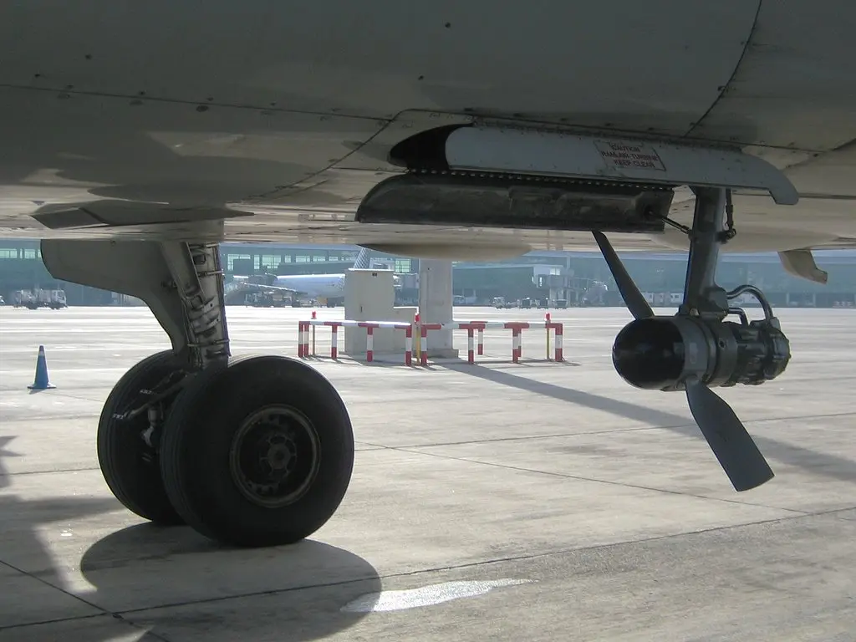
Figure 4. RAT system in Airbus A-320
(Source: Airbus)

2.3.4 Ramjet Engine for Orbital Missions:
Due to a number of drawbacks, using ramjet engines only for orbital missions is not a viable option. Ramjets are air-breathing engines, and the Earth's atmosphere is the only place in which they can function effectively. They lack the thrust needed to reach orbital velocity or perform useful functions in the vacuum of space.
A combination of various propulsion systems and stages, such as the Rocket Based Combined Cycle (RBCC), is required to carry out orbital missions [10–13]. This is how it can be done:
1. Hypersonic Air-Breathing Propulsion: Ramjets can only be used for orbital missions if the vehicle is capable of air-breathing propulsion up to hypersonic speeds while still inside the Earth's atmosphere. This calls for an initial propulsion system to propel the vehicle to the required speed range for ramjet operation, such as rockets or other air-breathing engines (such as scramjets or turbojets).
2. Switch to rocket propulsion: The efficiency of air-breathing engines declines as the vehicle ascends and the atmosphere gets thinner. The ramjet-powered vehicle needs to seamlessly switch to rocket propulsion in order to keep speeding up and attain orbital velocity. This might entail a dual-mode engine that can switch between an air-breathing and a rocket-powered mode, or a staged propulsion system that jettisons the air-breathing components after they are no longer effective.
3. Adequate Thrust-to-Weight Ratio: To overcome the Earth's gravity and air drag, orbital ascent requires a high thrust-to-weight ratio. In order to overcome these forces and move the vehicle at the necessary speeds for orbital insertion, ramjet engines must produce enough thrust.
4. Selecting the Best Propellant Combination: A successful orbital flight depends on selecting the best propellant combination. To maximize the vehicle's overall performance, the fuel, and oxidizer utilized in both the air-breathing and rocket propulsion stages should have a high specific impulse (efficiency).
5. Thermal Control: The quick acceleration and change from air-breathing to rocket propulsion can produce a lot of heat. To avoid engine damage and maintain steady performance during the mission, proper thermal control is essential.
6. Guidance, Navigation, and Control (GNC):
During the acceleration and transition stages, the vehicle must be steered and stabilised using precise GNC systems. The GNC system must adjust as the vehicle undergoes various flight regimes to guarantee accurate trajectory and orientation.

3. Ramjet Engine Benefits and Drawback
Ramjet engines have several distinctive and significant advantages, but they also have certain drawbacks because of how they are built and how they work. This section examines the main benefits of ramjet engines, such as their simplicity and effective functioning at hypersonic speeds, as well as the drawbacks they experience at slower speeds and while switching to the Scramjet Regime.
3.1 Benefits
The effectiveness of ramjet engines at hypersonic speeds, their simplicity, and their lightweight design due to the absence of moving parts are only a few of its many noteworthy benefits. These characteristics make them ideal for high-speed applications, including research aircraft, UAVs, and hypersonic missiles.
3.1.1 Effective Hypersonic Operations
Ramjet engines' effective operation at hypersonic speeds is one of its most important features. The engine's intake system accelerates the entering air to supersonic velocities as the vehicle accelerates through the atmosphere. Due to the vehicle's high-speed motion and specialized aerodynamic shape, this compression process happens passively without the need for complicated moving parts.
Ramjet engines generate high specific impulse and thrust-to-weight ratios by using the vehicle's forward momentum to compress the air, which makes them perfect for high-speed flying. Their effectiveness and dependability in hypersonic flight regimes are facilitated by the simplicity of their design.
Ramjet engines are useful for applications like hypersonic cruise missiles, unmanned aerial vehicles (UAVs), and high-speed research aircraft because they excel at providing sustained propulsion at hypersonic speeds.
3.1.2 Ease of Use and No Moving Parts
Comparing ramjet engines to other propulsion systems like turbojet and turboprop engines, they are noted for their simplicity and lack of moving parts. This quality adds to its lightweight construction, lower maintenance needs, and higher reliability.
The risk of mechanical failures is reduced by the absence of intricate mechanical parts like turbines and compressors, which is useful in high-speed and high-altitude flying conditions when preserving engine integrity is crucial.
Ramjet engines are an appealing option for different aerospace applications due to their simplicity and ease of manufacture, which also makes them reasonably cost-effective when compared to other high-speed propulsion systems.
3.2 Negative aspects
Ramjet engines can only operate at certain speeds, hence other propulsion systems must be used to help with takeoff and acceleration. Additionally, the switch to scramjet regimes adds significant complexity to combustion and flow management as speeds exceed their capabilities.
3.2.1 Difficulties at Slower Rates
The inefficiency of ramjet engines at lower speeds is one of their main drawbacks. Ramjet engines fail to operate effectively at speeds below their intended operating range since they depend on the forward momentum of the vehicle to compress air. Ramjet engines have difficulty collecting and compressing enough air for efficient combustion at subsonic and low supersonic speeds. They therefore need additional propulsion systems, like rockets or turbojet engines, for initial takeoff and acceleration before reaching their range of working speeds. For ramjet engines, the phase change from subsonic to supersonic speeds can be a crucial one, and smooth management of this phase requires careful design considerations.

3.3 Transition to Scramjet Regimes
As speeds rise beyond the capability of ramjet engines, they enter the scramjet domain, a region of supersonic combustion. Airflow velocities increase considerably more in the scramjet domain, necessitating specialized design elements and combustion techniques.
Scramjet engines come with additional difficulties to operate even if they promise greater effectiveness and performance at very high speeds. It becomes more difficult to achieve stable combustion in supersonic airflow, and sustaining engine stability depends on controlling flow conditions.
Research on the shift from ramjet to scramjet operation is ongoing, and it is still technically difficult to create efficient combined-cycle engines that can move between ramjet and scramjet modes without losing performance [14].
Despite these obstacles, continued research and improvements in hypersonic propulsion technology continue to push the limits of ramjet engine performance and broaden their aerospace uses. Ramjet engines are essential for high-speed flying, military applications, and the quest for hypersonic travel and exploration due to the benefits they provide.

4. Applications of Ramjet Engines

In the fields of aerospace and defense, ramjet engines are used in a variety of vital applications. They are excellent for a variety of high-speed flight scenarios due to their effective performance at hypersonic speeds. The most suggested propulsion solution for increasing the velocity and range of ramjet-powered missiles is the solid-fuel ramjet (SFRJ). This section describes in detail the numerous uses for ramjet engines, emphasizing their benefits to the aerospace sector.

4.1 Hypersonic Cruise Missiles
Hypersonic cruise missiles driven by ramjets are one of the main uses for this propulsion system. These missiles are built to travel at incredibly high speeds, making it possible to quickly engage targets over great distances. Ramjet-powered hypersonic cruise missiles are particularly effective in modern warfare due to a number of critical benefits, including their fast speed, which allows them to avoid detection by surveillance systems [15].
4.1.1 Capabilities for Long-Range Strikes:
Ramjet-powered hypersonic cruise missiles provide long-range striking capabilities, enabling them to go great distances quickly. Compared to conventional subsonic or supersonic missiles, their ability to maintain high speeds makes them challenging to intercept. This long-range attack capability improves strategic reach and response capabilities by allowing military forces to engage far-off targets rapidly and efficiently.
4.1.2 Stealth and Maneuverability:
Ramjet-powered hypersonic cruise missiles may achieve excellent maneuverability due to their constant high-speed flight, which also enhances stealth. They are difficult to identify and intercept due to their agility, which enables them to dodge hostile defenses. Additionally, their quickness reduces the amount of time that adversaries have to respond, thus improving their stealth qualities.
Ramjet-powered hypersonic cruise missiles are an essential part of contemporary military arsenals due to their qualities that make them perfect weapons for precision strikes and time-sensitive missions.
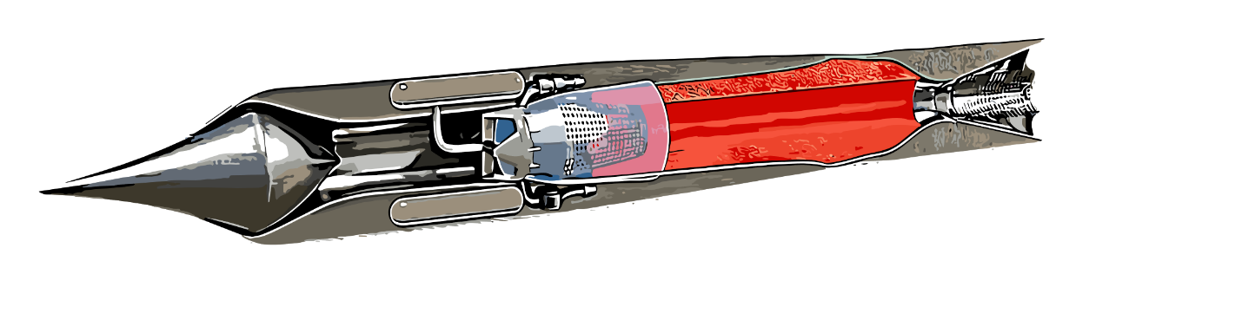

Figure 5. Brahmos- A ramjet supersonic cruise missile

4.2 Unmanned Aerial Vehicles (UAVs):
Ramjet engines are widely used in unmanned aerial vehicles (UAVs) that are built for high-speed operations and specialized mission profiles. They are valuable assets in a variety of military and civilian applications because of their distinctive characteristics.

4.2.1 High-Speed Reconnaissance and Surveillance:
UAVs using ramjet propulsion are excellent for swift surveillance and reconnaissance missions. They provide real-time data collecting over huge territories since they can swiftly cover large areas. This skill is especially useful for environmental monitoring, border surveillance, disaster relief, and military intelligence.
Ramjet-powered UAVs can stay on the station for long periods of time thanks to their high-speed flight and long endurance, which makes it easier to continuously collect data and have better situational awareness.
4.2.2; Target drones for military training
Drones used as targets are crucial equipment for military training and missile system testing. Ramjet-powered target drones may simulate fast aerial threats, including hostile aircraft or missiles, and offer lifelike scenarios for air defense training and weapon testing.
Armed forces can practice engagement and interception drills using these remotely operated drones, which also act as fictitious targets. They can effectively simulate threats from the actual world thanks to their high-speed capabilities, which improves training and readiness for air defense operations.
4.3 High-Speed Flight Research:
Research into hypersonic propulsion and high-speed flight is advanced significantly by ramjet engines. the capability of numerous experimental vehicles and planes built to push the limits of aerospace engineering.
4.3.1Hypersonic research planes
Research aircraft using ramjet propulsion, like the X-43A and X-51, have been essential for performing tests at hypersonic speeds. These aircraft have tested improved aerodynamics, materials, and propulsion systems while setting records for continuous hypersonic flight. The data collected from these experiments help refine our understanding of hypersonic flight and contribute to the development of future hypersonic vehicles and technologies.

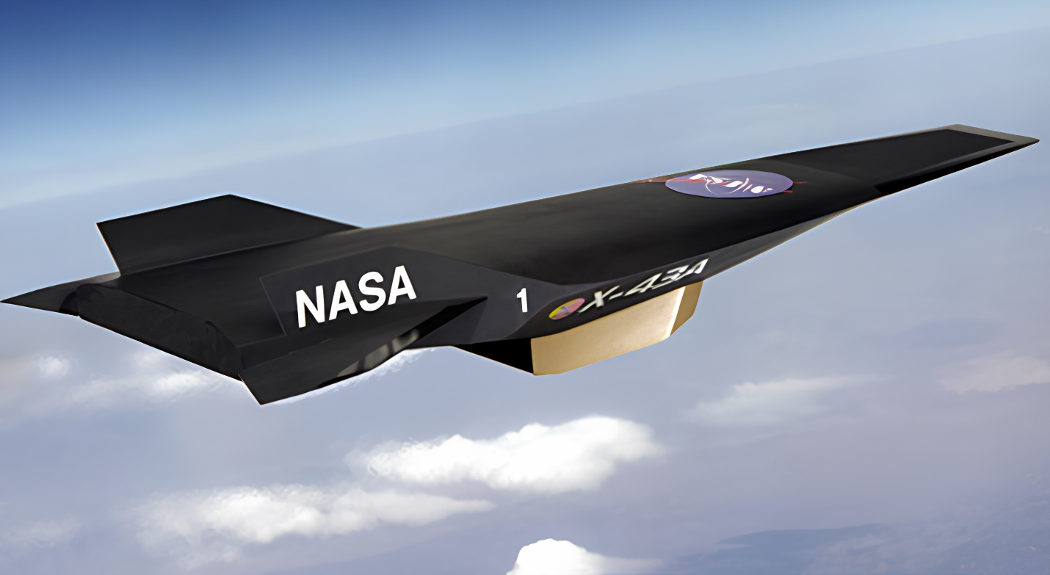

Figure 6. NASA X 43A – An unmanned hypersonic aircraft
(Source: NASA)

4.3.2 Contribution to Future Aerospace Technologies:
Ramjet engine research goes beyond its immediate use in hypersonic flight, making a contribution to future aerospace technologies. Future aerospace technologies, including spaceplanes, reusable launch vehicles, and potentially space access alternatives, are developed using the knowledge gleaned from these tests.

Ramjet-powered research vehicles provide knowledge that spurs innovation and helps to define the future of aerospace exploration and transportation as scientists and engineers continue to test the limits of hypersonic flight.

Ramjet engines are essential for a variety of high-speed aerospace applications because they provide benefits like long-range strike capability, stealth, and maneuverability for hypersonic cruise missiles. Ramjet engines help unmanned aerial vehicles perform fast surveillance and reconnaissance missions and act as vital target drones for military training and experimentation.
Additionally, ramjet-powered research aircraft make a substantial contribution to expanding our knowledge of hypersonic flight and the creation of new aerospace technology.
Ramjet engines are essential components of contemporary aerospace due to their adaptability and efficiency, which fosters innovation and determines the direction of future high-speed flight and exploration.
5. Difficulties and Future Prospects
Ramjet engines are currently at the cutting edge of hypersonic propulsion technology, but there are still a number of obstacles preventing them from reaching their full potential. Expanding the potential of ramjet engines requires improvements in thermal management, combustion efficiency, and seamless integration with hypersonic vehicles. The difficulties and prospects for ramjet engines are discussed in more detail in this section.
5.1 Material Science and Thermal Management
5.1.1 Materials and Coatings That Resist Heat:
Ramjet engines operate at extremely high temperatures at hypersonic speeds as a result of rapid combustion and airflow. Researchers concentrate on creating enhanced heat-resistant materials and coatings as well as advanced cooling systems to endure these circumstances [5]. To withstand the severe climate, these materials must have high melting points, great thermal conductivity, and mechanical strength.
Due to their outstanding thermal qualities, super alloys are frequently used in vital engine components including the combustion chamber and exhaust nozzle. For their high-temperature capabilities, new ceramic materials and carbon composites are also investigated.
Engineers can now modify a material's qualities to match the unique requirements of ramjet engines, leading to improved durability and efficiency.
5.1.2 Thermal protection systems:
In order to control the heat produced during hypersonic flight, thermal protection systems (TPS) are essential. To dissipate heat and shield the engine construction from thermal stresses, these systems employ a variety of methods.
The internal engine parts are shielded from the strong heat by ablative materials, which char and degrade at high temperatures. Additionally, before combustion, hot surfaces can be cooled using some of the incoming air thanks to regenerative cooling channels built into the engine walls.
To improve thermal management and guarantee the safe and effective functioning of ramjet engines, research into TPS design optimization is still ongoing. Future hypersonic vehicles must successfully develop lightweight and reliable thermal protection technologies.
5.2 Efficiency of Hypersonic Combustion
5.2.1 Holding and Stabilizing the Flame:
Ramjet engines running at hypersonic speeds face a substantial problem in achieving efficient combustion in supersonic airflow. The erratic and turbulent airflow may stifle the flame, resulting in unstable combustion and poor engine performance.
Designing efficient flame holders that stabilize the flame in the combustion chamber is one of the main challenges. To sustain stable combustion in the presence of high-speed airflow, engineers and scientists employ a variety of flame holder geometries, including strut-based designs, cavity-based flame holders, and porous materials.
Optimization of flame holder designs and stable flame holding in hypersonic conditions are achieved by computational fluid dynamics (CFD) models and experimental testing.
5.2.2 Novel Combustion Techniques:
In order to enhance the performance of ramjet engines even more, researchers are investigating novel combustion techniques Pulsed detonation combustion (PDC), in which fuel is ignited through quick, repeated detonations, is one such method. In comparison to steady-state combustion, PDC has the potential for greater combustion efficiency and thrust. Another method for improving mixing and combustion efficiency in supersonic flow is transverse injection, which involves injecting fuel perpendicular to the airflow.
Alternative fuels are also being researched since they have better combustion properties and contain more energy, like hydrogen. Hydrogen is a desirable choice for future ramjet engines due to its benefits in terms of high specific impulse and clean combustion [4].
5.3 Integrating with Hypersonic Vehicles
5.3.1 Spaceplanes and Reusable Launch Vehicles.
Integrating ramjet engines with spaceplanes and reusable launch vehicles is a multidisciplinary task. These spacecraft must be able to switch between different propulsion systems smoothly as they soar to great heights and accelerate to hypersonic speeds.
To maximize vehicle performance, reduce weight, and assure reliable propulsion throughout the mission profile, the integration procedure carefully coordinates the various propulsion systems. To avoid flow interruptions and provide a seamless changeover between a ramjet and other propulsion systems, proper synchronization is crucial [10–13].
5.3.2 Scramjet and Ramjet Technology Coupling:
Dual-Mode Ramjet (DMRJ) or Dual-Mode Scramjet (DMSJ) propulsion is a concept that combines ramjet and scramjet technologies. It is a hybrid strategy that tries to take advantage of the strengths of both ramjets and scramjets to achieve effective and fast air-breathing propulsion under various flying circumstances [14].
Scramjet Technology: A scramjet (supersonic combustion ramjet) is a type of air-breathing engine that is made to travel at speeds even faster than those of a conventional ramjet, specifically in the hypersonic range. It produces supersonic airflow combustion without slowing the air down to subsonic speeds, as in a conventional ramjet [1].
Ramjet/Scramjet Dual-Mode (DMRJ/DMSJ): Ramjet and scramjet technologies are combined in the DMRJ or DMSJ engine to enable effective operation over a wider range of flight speeds [14]. Typically, it operates in three modes:
Subsonic Mode: The engine uses its subsonic combustion capability to operate as a ramjet at subsonic speeds.
Supersonic Mode: The engine switches to scramjet mode when the vehicle accelerates to supersonic speeds, enabling combustion while the airflow is still moving at supersonic speeds.
Hypersonic Mode: The engine continues to run in scramjet mode at hypersonic speeds, taking advantage of its effective handling of high-speed airflow.
Advantages of DMRJ/DMSJ:
Efficiency Across Speed Range: The primary benefit of DMRJ/DMSJ is its capacity to maintain effective combustion over a broad speed range, from subsonic to hypersonic. This adaptability enables greater performance during various flying phases.
Streamlined Design: A DMRJ/DMSJ engine can result in a simpler design, lighter weight, and perhaps lower cost than employing separate ramjet and scramjet engines.

Challenges:
Engine Transition: It can be difficult to accomplish smooth transitions between subsonic, supersonic, and hypersonic combustion modes, and calls for careful coordination and management.
Thermal Control: The engine must manage the high temperatures and thermal loads brought on by hypersonic combustion, which can affect the materials and structural integrity.
The engine must be built with structural integrity to survive the stresses and forces present during transitions and at hypersonic speeds.
Even though the idea of combining ramjet and scramjet technologies is intriguing, it is still a challenging technical problem that necessitates research in advanced materials, aerodynamics, and propulsion. To fully realize the potential advantages of DMRJ/DMSJ engines for upcoming hypersonic flight and space access applications, continued research and testing are needed.
6. International Research and Collaboration Efforts
Technologies for hypersonic propulsion have advanced significantly as a result of international research cooperation. A number of nations and organizations are working together to push the limits of supersonic flight as part of a worldwide movement to achieve hypersonic flight. This section examines efforts being made worldwide to develop hypersonic propulsion, projects, information exchange, and the participation of both the public and corporate sectors.
6.1 International Search for Hypersonic Propulsion
As a new frontier in aeronautical engineering and exploration, hypersonic flight has prompted governments and businesses all over the world to spend money on research and development. The United States, Russia, China, India, and European nations have all started specific programmers to create hypersonic propulsion systems. These nations are aware of the strategic value of hypersonic flight for military purposes, as well as its potential for high-speed travel and space exploration. As a result, a significant amount of experience and resources are focused on comprehending hypersonic flight and creating cutting-edge propulsion systems.
6.2 Group projects and knowledge exchange
In the field of hypersonic propulsion, international cooperation is becoming more frequent. Universities, research institutions, and aerospace organizations from several nations work together on shared projects to pool resources, spread information, and quicken development.
Sharing data from experimental flights, working together on research projects, and attending joint seminars and conferences are all common components of collaborative endeavors. By sharing knowledge, researchers can better comprehend hypersonic flight and benefit from one another's experiences and knowledge.
6.3 Participation of the Public and Private Sectors
Governments and the corporate sector are both significantly interested in the study and development of hypersonic propulsion. Government organizations oversee national hypersonic programmers and carry out fundamental research, including NASA in the United States, Roscommon in Russia, ESA in Europe, and ISRO in India.
In addition to government funding, the private sector—including aerospace firms and start-ups—is essential to the development of hypersonic technologies. These businesses make significant investments in cutting-edge R&D, developing cutting-edge propulsion technologies, materials, and vehicle designs.
Public-private partnerships, which leverage the strengths of both sectors to hasten technological developments and commercial applications, further promote the development of hypersonic propulsion.

7. Hypersonic Flight's Future
The future of high-speed flight and space travel is filled with exciting possibilities thanks to the development of hypersonic propulsion systems. This section examines prospective economic uses, technological breakthroughs related to hypersonic propulsion, and their effects on space. exploration.

7.1 Business Uses and High-Speed Transportation
Hypersonic flying has the ability to drastically cut the amount of time it takes to travel great distances, revolutionizing commercial aviation. Hypersonic passenger aircraft is one example of a high-speed transportation technology that promises to reach remote regions faster than regular aero planes can. Hypersonic travel can revolutionize international trade and tourism by reducing travel times, allowing travelers to get to their destinations in a matter of hours rather than days.
Commercial hypersonic flying, however, has obstacles in terms of infrastructural needs, environmental impact, and safety. To overcome these obstacles and make commercial hypersonic transportation a reality, ongoing research and cooperation between governments, regulators, and aerospace businesses are required.

Figure 6. Concorde – A supersonic Ram Jet (Scram Jet)
(Source: Aerospatiale - BAC)

7.2 Access to Space and Space Exploration
For space travel and exploration, hypersonic propulsion also shows promise. Advanced hypersonic engines can be used to build reusable spacecraft that offer quick and affordable access to low Earth orbit and beyond.
In order to enable single-stage-to-orbit (SSTO) capabilities, spaceplanes with combined-cycle engines could be built. This would lower launch costs and increase cargo capacity.
Furthermore, the development of hypersonic propulsion technology is essential for planetary and astrophysical exploration missions. On worlds like Mars, safe and effective entry and landing could be made possible by hypersonic entry devices, such as inflatable heat shields.
7.3 Technological Advances in Hypersonic Propulsion
Propulsion technology will continue to progress in the future of hypersonic flight. Ramjet and scramjet engines will run more efficiently and reliably thanks to ongoing work in the fields of flame-holding, material science, and combustion efficiency.
Vehicle performance will be optimized throughout a wide speed range, from subsonic to hypersonic, thanks to the development of combined-cycle engines [10–13], which smoothly integrate ramjet and scramjet technology.
The design and optimization of hypersonic propulsion systems will also proceed more quickly because of developments in computational approaches including high-fidelity numerical simulations and machine learning technologies.
Conclusion
In terms of hypersonic propulsion, ramjet engines are a good technology since they provide high-speed flight capabilities without the complexity of moving parts. We have examined the fundamentals, workings, design factors, uses, and difficulties of ramjet engines throughout this chapter. The pursuit of hypersonic flight, research aircraft, and military systems all depend on these engines in various ways.
Looking ahead, the continued development of ramjet technology depends on the synergy of ongoing research initiatives and global partnerships. We are getting closer to realizing the full potential of ramjet engines with every passing day thanks to inventive discoveries and advancements in material science, combustion efficiency, and integration with hypersonic vehicles.
The efficiency and maneuverability provided by ramjet engines continue to be advantageous for military applications, such as hypersonic cruise missiles and unmanned aerial vehicles. Ramjet-powered research aircraft also advance aerospace technologies and exploration by pushing the limits of supersonic flight. Hypersonic flight offers tremendous commercial opportunities for space research and affordable global connection, from high-speed travel to access to space.
The difficulties associated with thermal management, combustion efficiency, and integration with hypersonic vehicles will be resolved as research advances, opening the path for real-world and environmentally friendly hypersonic transportation options.
Additionally, global partnerships and knowledge exchange between governments and the commercial sector spur innovation and quicken the speed of developments in hypersonic propulsion. We can overcome obstacles more successfully and open up new vistas for space travel by pooling our knowledge and resources.
As this chapter comes to a close, ramjet engines have a promising future, altering the landscape of hypersonic flight and advancing aerospace technology. The quest for knowledge and the desire to further human exploration and achievement will lead us on the path to faster, more effective, and environmentally friendly aerospace technologies.

References

- Bernard Petit (2003), Ramjets and Scramjets, Encyclopedia of Physical Science and Technology (Third Edition), Pages 867-884 (Ramjets and Scramjets - ScienceDirect)
- Peter Bailey (1996), Breaking the Sound Barrier: A Historian Listens to Noise, Body & Society 2: 49 (https://journals.sagepub.com/doi/abs/10.1177/1357034x96002002003)
- Min Ou, Li Yan, Jing-feng Tang, Wei Huang, Xiao-Qian Chen (2017), Thermodynamic performance analysis of ramjet engine at wide working conditions, Acta Astronautica, Volume 132, March 2017, Pages 1-12 (Thermodynamic performance analysis of ramjet engine at wide working conditions - ScienceDirect)
- Dan Zhao (2023), Chapter 11 - Ramjet combustion instability and thermodynamic performances, Thermoacoustic Combustion Instability Control, Engineering Applications and Computer Codes, Pages 831-905 (Ramjet combustion instability and thermodynamic performances - ScienceDirect)
- Jing Xu, Kunlin Cheng, Chaolei Dang, Yilin Wang, Zekuan Liu, Jiang Qin, Xiaoyong Liu (2023), Performance comparison of liquid metal cooling system and regenerative cooling system in supersonic combustion ramjet engines, Energy, Volume 275, 127488 (Performance comparison of liquid metal cooling system and regenerative cooling system in supersonic combustion ramjet engines - ScienceDirect)
- Bhupendra Khandelwal, Adam Karakurt, Paulas R. Sekaran, Vishal Sethi, Riti Singh (2013), Hydrogen powered aircraft: the future of air transport, Progress in Aerospace Sciences, Volume 60, Pages 45-59 (Hydrogen powered aircraft : The future of air transport - ScienceDirect)
- Yasin Şöhret, Selcuk Ekici, T. Hikmet Karakoc (2018), Using exergy for performance evaluation of a conceptual ramjet engine burning hydrogen fuel, International Journal of Hydrogen Energy, Volume 43, Issue 23, Pages 10842-10847 (Using exergy for performance evaluation of a conceptual ramjet engine burning hydrogen fuel - ScienceDirect)
- Shibin Luo, Yanbin Feng, Jiawen Song, Dequan Xu, Kunxiong Xia (2022), Progress and challenges in exploration of powder fueled ramjets, Applied Thermal Engineering Volume 213,118776 (Progress and challenges in exploration of powder fueled ramjets - ScienceDirect)
- Omer Musa, Guoping Huang, Zonghan Yu (2021), Effects of new solid propellant configurations on the combustion characteristics of a ramjet, Aerospace Science and Technology, Volume 119, 107192 (Effects of new solid propellant configurations on the combustion characteristics of a ramjet - ScienceDirect)
- Tiantian Zhang, Zhenguo Wang, Wei Huang, Derek Ingham, Lin Ma, Mohamed Porkashanian (2020), An analysis tool of the rocket-based combined cycle engine and its application in the two-stage-to-orbit mission, Energy, Volume 193, 116709 (An analysis tool of the rocket-based combined cycle engine and its application in the two-stage-to-orbit mission - ScienceDirect)
- Lei Shi, Guojun Zhao, Yiyan Yang, Da Gao, Fei Qin, Xianggeng Wei, Guoqiang He (2019), Research progress on ejector mode of rocket-based combined-cycle engines, Progress in Aerospace Sciences, Volume 107, Pages 30-62 (Research progress on ejector mode of rocket-based combined-cycle engines - ScienceDirect)
- Yuan-Shu Liu, Rui Xue, Jun-Li Liu, Chao-Qi Xu, Shao-Hua Zhu, Bing Liu (2023), Numerical study on the dynamic process of ramjet/scramjet mode transition in the integrated RBCC full flow path through multistage fuel injection strategies, International Communications in Heat and Mass Transfer, Volume 146, 106857 (Numerical study on the dynamic process of ramjet/scramjet mode transition in the integrated RBCC full flow path through multistage fuel injection strategies - ScienceDirect)
- Wei Huang, Li Yan, Jian-guo Tan (2014), Survey on the mode transition technique in combined cycle propulsion systems, Aerospace Science and Technology, Volume 39, Pages 685-691 (Survey on the mode transition technique in combined cycle propulsion systems - ScienceDirect)
- Nishanth Thillai, Amit Thakur, Srikrishnateja K., Dharani J. (2021), Analysis of flow-field in a dual mode ramjet combustor with boundary layer bleed in isolator, Propulsion and Power Research, Volume 10, Issue 1, Pages 37-47 (Analysis of flow-field in a dual mode ramjet combustor with boundary layer bleed in isolator - ScienceDirect)
- Roy J. Hartfield, Rhonald M. Jenkins, John E. Burkhalter (2006), Optimizing a solid rocket motor boosted ramjet powered missile using a genetic algorithm, Applied Mathematics and Computation, Volume 181, Issue 2, Pages 1720-1736 (Optimizing a solid rocket motor boosted ramjet powered missile using a genetic algorithm - ScienceDirect)

