A Chapter on:

Understanding Wound Infections, Biofilm Formation, and Methods for Detection and Prevention

Author information:
Prachi S. Patel*1,
* 1 CAM Institute of Allied Health Sciences & Technology,
Bhaikaka University,
Karamsad, Gujarat, India.
Email: jaanp0293@gmail.com
ORCID: 0000-0001-9327-9423
Contact number: + 91 8849253013

Disclaimer: The author(s) ensure that no contractual relations or proprietary considerations exist that would affect the publication of information in the submitted manuscript. There is no conflict of interest of any sort. Neither has the membership nor one with substantially similar content under my authorship been published in any language, in any journal nor is being considered for publication elsewhere.
Number of Figure: 00
Number of Table: 00

Understanding Wound Infections, Biofilm Formation, and Methods for Detection and Prevention
I. ABSTRACT
Wound infection is growing challenge in healthcare settings, considering causes like microorganism resistance, chronic wound complexities, from contamination to systemic infection stages, influenced by wound traits, microbial species and patient factors. ^{[1, 2, 3]} Biofilms, microbial communities surrounded by a matrix, are central to infections. Stages of adhesion, co-adhesion, maturation, and detachment define biofilm formation. ^{[4]} Detection methods encompass microscopy and indirect assays. Preventive strategies, including disinfection and antimicrobial coatings, are essential. Overall, this work highlights wound infection understanding, biofilm roles, and their detection and prevention for effective healthcare management. ^{[5, 6, 7]}
II. INTRODUCTION
Wounds in hospitals often result from accidental injuries, heat exposure, animal bites, and accidents with sharp tools. These wounds can be infected by microorganisms from the outside environment, especially during hospital stays. ^{[1]} The rate of infected wounds is increasing as microorganisms become more resistant to anti-microbial agents. ^{[2, 3]} The signs of infected wounds include redness, swelling, tenderness, increasing pain, edema, purulent discharge, odor, localized fever or contact bleeding, and secondary signs like lack of healthy granulation, excessive exudate, and degraded wound. ^{[4, 5, 6]}
The most common pathogens associated with wound infections include Staphylococcus aureus (20-40%) and Pseudomonas aeruginosa (5-15%). Other pathogens include Enterococci and members of Enterobacteriaceae, especially in immune compromised patients and surgery. Up to 80% of wound infections are biofilm-associated, with Pseudomonas aeruginosa (12-25%), Staphylococcus aureus (50-63%), and Enterobacteriaceae bacteria like Escherichia coli. ^{[5]}
Wounds can be open or closed, and their condition can be interpreted based on wound characteristics such as slough, exudates, maceration, wound edges, infection, complications, and host factors. Wound infections are also related to patient comorbidities, such as diabetes, hypertension, old age, diminished immune function, obesity, and multiple chronic diseases, which can lead to wound chronicity and make treatment difficult. ^{[7, 8, 9]}
III. WOUND INFECTION
Robert Koch was a pioneer in isolating pure cultures to identify infection causes. Infections can occur at any time, from community acquired infections within 48 hours of admission, and to hospital acquired infections or nosocomial infections. Infected wounds are localized defects or excavations of skin or soft tissue, with signs like erythema, swelling, pain, heat, and color. Secondary signs, such as lack of healthy granulation tissue, unhealthy color, excessive exudates, degraded wound bed, and a stalled healing trajectory, can also be detected. ^{[10, 11, 12]}
Wound infection is a major cause of wound chronicity, which takes more than 4 weeks to heal. Wound infection occurs in three stages: contamination, colonization, local infection, and systemic infection. Contamination occurs when an infectious microorganism is accidentally introduced to a wound, and if the environment, nutrition, and physical conditions are favorable, it will not multiply or cause damage. Colonization occurs when the microorganism grows and divides without causing damage. Local infection occurs when the microorganism only affects the wound area, with signs like erythema, swelling, and pain. Systemic infection occurs when the infection spreads throughout the entire system. Factors influencing wound infection include wound etiology, dimensions, tissues, host factors, structural composition of poly-microbial species, and state of infection, such as planktonic or biofilm. Wound infections can be nosocomial and caused by common or opportunist pathogens. ^{[14, 15, 16, 17]}
IV. BIOFILM
Biofilms are microbial cells attached to surfaces and enclosed in a polysaccharide matrix. They are common in microbial infections, with 80% of infections resulting from biofilm formation. Biofilms form when microorganisms adhere to surfaces in a moist environment and reproduce. They can form on metals, plastics, natural materials, medical implants, and more. Biofilms can be formed by single or mixed species of bacteria, fungi, algae, yeasts, and other microorganisms. ^{[19, 20]}
Biofilm, produced by microorganisms, contains extracellular polymeric substances like proteins, DNA, polysaccharides, and RNA, and water for nutrient transport. It consists of a water channel and densely packed region. Biofilm-forming bacteria exchange genes, activating stress genes, leading to resistant phenotypes due to changes in cell density, temperature, pH, and osmolality. ^{[21]}
V. BIOFILM FORMATION
Biofilm formation involves three stages: adhesion, co-adhesion, and maturation and detachment. Adhesion occurs when bacteria reach a surface, while co-adhesion involves colonization and matrix synthesis. Maturation and detachment occur when microorganisms grow further, forming a mature biofilm. Potential biofilms include failure of antibiotic treatment, delayed wound healing, increased exudate/moisture, low-level chronic inflammation, erythema, poor granulation, and secondary signs of infection. Biofilms cause chronic infections through genetic changes, surface and excreted molecular messengers, physical barriers, and escape behaviors. ^{[22, 23]} Pathogenicity is retained and sometimes increased as bacterial concentration increases, and individuals tend to leave the biofilm. Biofilm formation depends on virulence factors, survival mechanisms, and the host immune response.
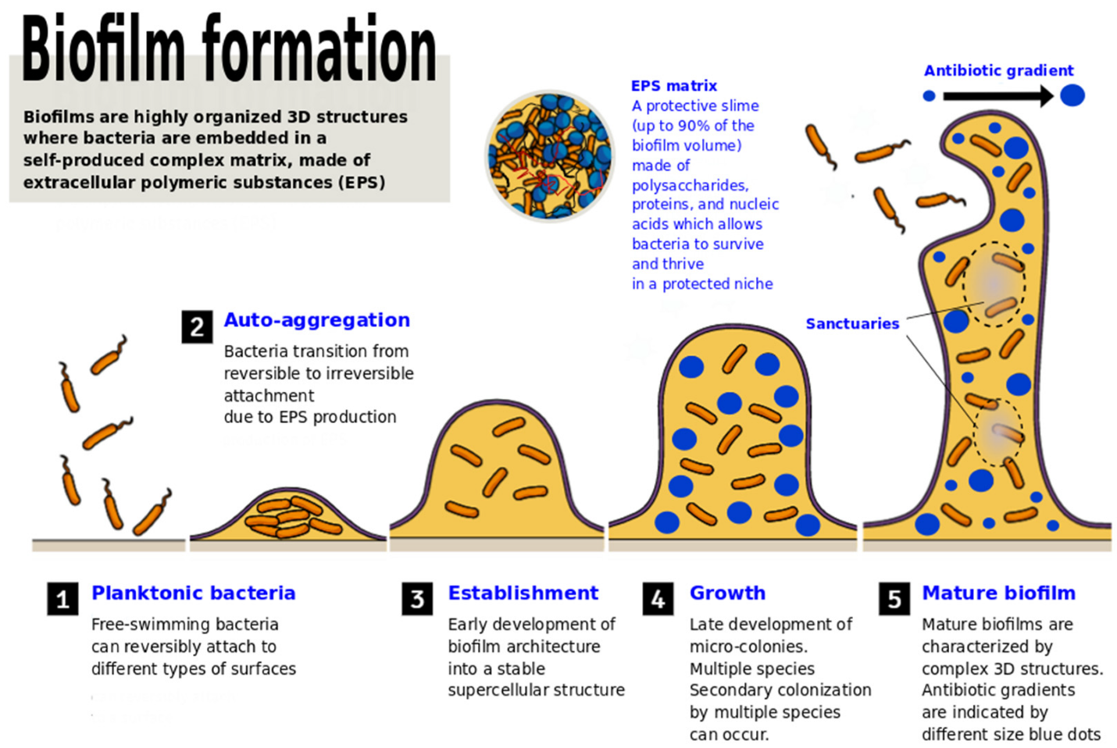
Figure 1. Biofilm formation ^{[24]}
Wounds are poly-microbial, with bacteria from both exogenous and endogenous sources. Bacteria that multiply are not considered infectious unless they cause harm. Studies show that 75% of macroscopic wounds contain biofilm when antiseptic wound dressing is not used. In a pediatric hospital in India, 44% Pseudomonas aeruginosa produce biofilm, with half of Acinetobacter isolates producing multi-drug resistant biofilm. ^{[25]}
Detection of Biofilm can be done by different methods:-
Detection of biofilms can be accomplished through various methods, both direct and indirect, depending on the desired level of detail and accuracy.
A. Direct Observation Methods:
1. Light Microscopy: This involves using visible light to observe biofilms. It can provide valuable information about biofilm structure and morphology but might not provide very high resolution.
2. Scanning Electron Microscopy (SEM): SEM allows for detailed imaging of the biofilm's surface structure by using focused electron beams. It provides high-resolution images and can reveal the three-dimensional architecture of the biofilm.
3. Transmission Electron Microscopy (TEM): TEM provides even higher resolution than SEM. It involves transmitting electrons through a thin section of the biofilm, enabling visualization of internal structures and details.
4. Confocal Laser Scanning Microscopy (CLSM): CLSM uses laser light to create detailed 3D images of biofilms. It can also be used to visualize specific components of biofilms, like different types of cells or EPS.
B. Indirect Methods:
1. Microtiter Plate Method: This is a quantitative method where biofilms are grown in microtiter plates. After growth, various assays can be performed to assess biofilm formation, including crystal violet staining and biomass quantification.
2. Congo Red Agar Method: This method utilizes Congo red dye to stain and visualize biofilm matrix components. Biofilm-producing colonies on Congo red agar appear as black or dark colonies due to the interaction of the dye with the EPS.
3. Tube Method: In this qualitative method, test tubes are filled with liquid medium, allowing biofilms to form at the air-liquid interface. Biofilm formation can be observed by changes in turbidity, adherence to the tube's sides, or the formation of a pellicle at the air-liquid interface. ^{[26, 27]}
Some of the direct methods are very expensive which cannot be used routinely. So indirect methods are preferred over them. Among the indirect methods Congo red agar method and tube methods are qualitative methods while microtiter method is quantitative method. These methods play a crucial role in understanding biofilm formation, structure, and characteristics. Choosing the appropriate method depends on the specific research goals, the nature of the biofilm, and the available resources. Combining multiple methods can provide a comprehensive view of biofilm properties. ^{[26, 28]}

VI. PREVENTIONS FOR WOUNDS INFECTIONS
Wound infection prevention involves disinfecting skin with alcohol, chlorhexidine, or iodine, applying antiseptic agents, and applying a protective dressing. In acute traumatic wounds, cleaning and using antiseptic agents reduce infection risk. Tetanus prevention is recommended, and antibiotic prophylaxis is provided for high-risk wounds. Burn wounds should be cleaned and treated with antiseptic agents. In infected or heavily colonized chronic ulcers and wounds, systemic antibiotics and antiseptic agents are used, followed by wound cleaning and treatment of underlying causes. ^{[29, 30]}
VII. PREVENTION OF BIOFILM
Biofilm prevention involves preventing microbe growth, using antibiotics for prophylaxis, empirical treatment based on clinical diagnosis, definitive treatment based on clinical diagnosis, and preoperative antibiotics for surgical-related biofilm formation. Antimicrobial coatings, such as biocides and ion coatings, can prevent biofilm formation by interfering with immature biofilm attachment. Silver's antimicrobial property is limitedly used. To prevent microbial surface attachment, antibiotic agents and polymer chains are applied, and ozone is used as an oxidizing agent. Nontoxic agents like imidazole, indole, and sulfide peptides also inhibit biofilm formation. ^{[31, 32, 33]}
VIII. CONCLUSION
Understanding wound infections in healthcare is crucial, as biofilms exacerbate them. Innovative detection and prevention strategies are needed, focusing on wound attributes, microbial elements, and patient variables. Effective detection techniques and preventive measures are essential for healthcare providers.

REFERENCES
- P. G. Bowler, B. I. Duerden, and D. G. Armstrong ‘Wound Microbiology and Associated Approaches to Wound Management’ Clinical Microbiology Reviews, 0893-8512/01/04.0010 DOI: 10.1128/CMR.14.2.244–269.2001 Apr. 2001, p. 244–269
- Swanson T, Grothier L, Schultz G ‘wound infection made easy’ wound international 2014. Available from: www.woundsinternational.com2014.
- Wolcott RD, Rhoads DD. A study of bioflim based wound management in subjects with critical limb ischemia. J Wound Care 2008; 17(4):145–55.
- Phillips PL, Wolcott RD, Fletcher J, Schultz GS. Biofilms Made Easy. Wounds International 2010. Available at: http://www.woundsinternational.com/made-easys/bioflms-made-easy
- Bien, Justyna; Sokolova, Olga; Bozko Przemyslaw "Characterization of Virulence Factors of Staphylococcus aureus: Novel Function of Known Virulence Factors That Are Implicated in Activation of Airway Epithelial Pro-inflammatory Response”. Journal of Pathogens. 2011: 601905. doi:10.4061/2011/601905. PMC 3335658 .PMID 22567334.
- Jamal, Muhsina,; Ahmad, Wisala; Andleeb, Saadiac; Jalil, Fazalb; Imran, Muhammade; Nawaz, Muhammad Asifd; Hussain, Tahira; Ali, Muhammadd; Rafiq, Muhammada; Kamil, Muhammad Atifb. Bacterial biofilm and associated infections. Journal of the Chinese Medical Association 81(1):p 7-11, January 2018. Available: http://doi.org/10.1016/j.jcma.2017.07.012
- Stevens, D.L., Bisno, A.L., Chambers, H.F., Everett, E.D., Dellinger, P.E., Goldstein, E.J., Gorbach, S.L., Hirschmann, J.V., Kaplan, E.L., Montoya, J.G., & Wade, J.C. (2005). Practice guidelines for the diagnosis and management of skin and soft-tissue infections. Clinical infectious diseases : an official publication of the Infectious Diseases Society of America, 41 10, 1373-406 .
- Beth A Barnes ‘ negligence, medical malpractice, vicarious , liability, or paitient responsibility: who should pay when a paitient contracts MRSA from a healthcare facility’ 2009,7:335-337
- Arora A, Bharadwaj P, Chaturvedi H, Chowbey P, et al ‘A review of prevention of surgical site infections in Indian hospitals based on global guidelines for the prevention of surgical site infection’, 2016.Journal of Patient Safety Infect Control 2018;6:1-12
- Romling U, Balsalobre C, ‘Biofilm infections, their resilience to therapy and innovative treatment strategies (Review)’. Journal of International Medicine 2012; 272: 541–561.
- Wolcott RD, Hanson JD, Rees EJ, Koenig LD, Phillips CD, Wolcott RA, Cox SB, White JS. Analysis of the chronic wound microbiota of 2,963 patients by 16S rDNA pyrosequencing. Wound Repair Regen. 2016 Jan-Feb;24(1):163-74. doi: 10.1111/wrr.12370. Epub 2015 Dec 10. PMID: 26463872.
- Kamat US, Fereirra AM, Kulkarni MS, Motghare DD. ‘A prospective study of surgical site infections in a teaching hospital in Goa.’ Indian Journal of Surgery 2008; 70:120-4.
- Sharma K, Thanbuana B T, Gupta A K, Rajkumari N, Mathur P, Gunjiyal J, Misra M C. A prospective study of wound infection among post-discharge patients at a level 1 trauma centre of India. Indian J Med Microbiol [serial online] 2016 [cited 2021 Mar 18];34:198-201 Available from: https://www.ijmm.org/text.asp?2016/34/2/198/180299
- Collier M. Recognition and management of wound infections. World Wide Wounds. Updated January 2004. Available at: http://www.worldwidewounds.com/2004/january/Collier/Management-of-Wound
- Vanessa Ngan ‘wound infection’ Derm Net New Zealand all about the skin. 2005
- Sarabahi, Sujata "Recent advances in topical wound care”. Indian Journal of Plastic Surgery. 45 (2): 379–87. doi:10.4103/0970-0358.101321.
- Randall D. Wolcott, Keith F. Cutting Scott Dowd, and Steven L. Percival ‘types of wound and infections’ Microbiology of wound 2010; 11 DOI: 10.1201/9781420079944-c7
- Wolcott R, ‘Economic aspects of biofilm-based wound care in diabetic foot ulcers.’ Journal of Wound Care 2015; 24(5):189–94.
- Rhoads DD, Wolcott RD, and Percival S, ‘Biofilms in wounds: management strategies.’ J Wound Care 2008; 17(11):502–8.
- Bianchi, T., Wolcott, R. D., Peghetti, A., Leaper, D., Cutting, K., Polignano, R., Rosa Rita, Z., Moscatelli, A., Greco, A., Romanelli, M., Pancani, S., Bellingeri, A., Ruggeri, V., Postacchini, L., Tedesco, S., Manfredi, L., Camerlingo, M., Rowan, S., Gabrielli, A., & Pomponio, G. (2016). Recommendations for the management of biofilm: a consensus document. Journal of wound care, 25(6), 305–317. https://doi.org/10.12968/jowc.2016.25.6.305
- Sandra G Gompf, ‘Community Acquried infections’ Medscape, 2020; Available at:- https://reference.medscape.com/slideshow/community-acquried-disease-6007100
- Uppuluri P and Lopez-Ribot JL. ‘Go forth and colonize: Dispersal from clinically important microbial biofilms.’ Pathology 2016; 12(2):e1005397.
- Ling ML, Apisarnthnarak A, Madriaga G, ‘The Burden of health care associated infections in Southeast Asia: A systematic literature review and meta-analysis.’ Clinical infectious Diseases; 2015;60(11)1690-1699
- Meroni G, Panelli S, Zuccotti G, Bandi C, Drago L, Pistone D. Probiotics as Therapeutic Tools against Pathogenic Biofilms: Have We Found the Perfect Weapon? Microbiology Research. 2021; 12(4):916-937. https://doi.org/10.3390/microbiolres12040068
- Khyati Jain et al studied “Bacteriological profile of post-surgical wound infection along with special reference to MRSA in central India, Indore” International journal of Integrative medical Sciences,2014;1(1); 9-13
- Nouraldin AAM, Baddour MM, Harfoush RAH, and Essa SAM. ‘Bacteriophage-antibiotic synergism to control planktonic and biofilm producing clinical isolates of Pseudomonas aeruginosa.’ Alexandria Journal of Medicine 2016; 52(2):99–105.
- Hassan A , Usman J, Kaleem F, Omair M, Khalid A , Iqbal M. Evaluation of different detection methods of biofilm formation in clinical isolates. Brazil Journal of Infectious Diseases; 2011; 15:305-11.
- Metcalf DG, Bowler PG, and Hurlow J. ‘A clinical algorithm for wound biofilm identification.’ Journal of Wound Care 2014; 23(3):137–42.
- Boev C, Kiss E, ‘Hospital Acquired infections: A current trends and Prevention. Critical Care nursing clinical North America’. 2017;29(1) 51-65
- Ducel G, Fabry J, Nicolle L. Prevention of hospital-acquired infections - A practical guide. 2nd ed. Geneva, Switzerland: WHO; 2002 2. Centers for Disease Control and Prevention – Healthcare associated infections – HAI. Available from: www.cdc.gov/hai/
- Hurlow J and Bowler PG. ‘Clinical experience with wound biofilm and management: A case series.’ Ostomy Wound Manage 2009; 55(4):38–49.
- Rodney M. Donlan ‘Biofilms: Microbial Life on Surfaces’ CDC emerging infectious diseases 2002;2(8)
- Clinton A and Carter T. ‘Chronic wound biofilms: Pathogenesis and potential therapies.’ Lab Med 2015; 46(4):277–84.

