NUCLEAR PHYSICS EXPLORING THE ATOM'S MYSTERIES
Modernizations in Nuclear Physics, Investigating the Basics of Energy and Matter
Aasir Ayoub
Department of Mathematics, Jammu And Kashmir Institute Of Mathematical Sciences, Gojgibagh Srinagar, Jammu And Kashmir
Email: aasirayoub@gmail.com
Abstract
A subfield of physics called nuclear physics studies the behaviour, structure, and characteristics of atomic nuclei. This research article seeks to present a thorough review of nuclear physics, taking into account its foundation in history, underlying theories, contemporary developments, and practical applications. It explores cutting-edge research being done in this area and dives into ideas like nuclear decay, nuclear processes, and nuclear energy. Our understanding of the cosmos has benefited greatly from advances in nuclear physics, which have also produced innovations in the fields of medicine, energy production, and elemental composition. This essay emphasizes the importance of nuclear physics and how it affects numerous scientific fields.
Keywords: Branch, ‎explores, ‎comprehensive, ‎overview, ‎advancements, ‎practical, ‎applications, ‎delves, and ‎concepts
^{Introduction}
In our quest to comprehend the fundamental constituents of matter and the forces that control their interactions, nuclear physics plays a significant role. The behaviour of protons, neutrons, and other subatomic particles within an atom's nucleus, which contains more than 99.9% of its mass, is analysed. Our understanding of nuclear physics has greatly improved recently as a result of advancements in experimental methods and theoretical models. The significant developments in this field and how they increase our understanding of matter and energy are discussed in this paper.
Nuclear Structure: Overview of nuclear physics: The composition of nuclei, their production, and their equilibrium are studied in nuclear physics, a branch of science. It largely concentrates on comprehending nature's fundamental nuclear forces and the complex interactions between neutrons and protons.
The branch of physics known as nuclear physics is concerned with how atomic nuclei are structured and how they interact.
Historical development of nuclear physics
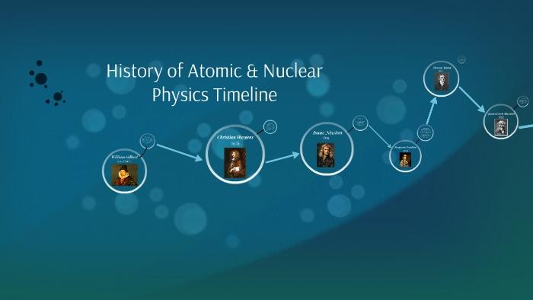
The history of radioactivity as a field of study apart from atomic physics dates back to Henri Becquerel's discovery of it in 1896 while he was looking into the phosphorescence of uranium salts. Ernest Rutherford was the first to engineer an artificial nuclear reaction in the University of Manchester's labs around 1917. A British physicist named Rutherford used alpha particles to explore atoms. The "father of nuclear physics" is what he is referred to as. For his work on the atomic structure, he received the Nobel Prize in 1908.
Importance of nuclear physics in different scientific domain
Nuclear physics discoveries have sparked interest across numerous disciplines. Included in this are nuclear energy, nuclear weapons, nuclear medicine, magnetic resonance imaging, the industrial and agricultural sectors, particle engineering's ion implantation, and radiocarbon dating in geology and archaeology. Our daily lives are surrounded by nuclear physics, Identifying pollutants in our homes, diagnosing and treating cancer, and keeping an eye out for illegal cargo in shipments. Nuclear physics and the techniques it has produced have a significant impact on our safety, health, and security. The cornerstone of fundamental nuclear physics research and advancement is where many among the most important advancements in today's domains of climatology, materials, energy, security, and numerous other fields..
Fundamental theory of nuclear physics
The nucleus of an atom is where the majority of the mass is concentrated, and it is composed of the atomic nucleus and its elements. We learned that the nucleus of an atom holds a more significant portion of the atom's mass through the Rutherford-examined dispersion of alpha particles. In terms of numbers, an atom's nucleus has a volume that is nearly 10–14 times larger than its actual size but still retains 99.99% of the atomic mass. A modern atom's nucleus would be little larger than a pinhead if it were extended to fill a room. This is due to how small atoms are in their cores. The atomic nucleus, a very small centre portion of the atom that contains all of an atom's mass, is what gives an atom its name. Protons with positive electric charges and neutrons with no electric charges make up the atomic nucleus. The weights and charges of these three basic atom components, as well as the electrically negative electrons, surround the atomic nucleus.
Particle Charge Mass
Electron -1 0
Proton +1 1
Neutron 0 1

The quantity of protons in the nucleus determines the chemical makeup of an atom, or the chemical characteristics of a particular element. The atomic number refers to this quantity of protons. Remember that because the mass of an electron is so little, it is completely disregarded for determining the atomic mass, hence the mass of an atom depends on both the quantity of protons and neutrons present in the nucleus. There are a number of recognized isotopes for a large number of chemical elements. Atoms with the same atomic number but varying atomic masses are known as isotopes. The only difference between the isotopes of the same chemical element's atoms is the number of neutrons in their nuclei.
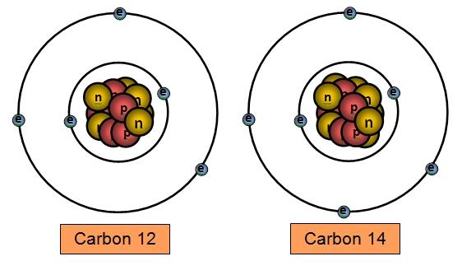
Physicists occasionally feel the need mentioning an isotope's atomic mass. To do this, write superscripting the atomic mass before the atomic letter symbol, such as carbon [14C].
Even while all atoms of the same chemical element have the same number of protons in their nucleus, they do not all have the same number of neutrons, therefore while they all have roughly the same chemical characteristics and reactivity, their mass varies. Only if the atom ionizes can the number of electrons change, and in any case, an electron's relative mass is significantly lower than that of a proton or neutron. Electron gain or loss is frequently disregarded. The mass of the neutron is sufficient, though, for any material to noticeably change with a single neutron variation. The molar masses of an element's many isotopes differ dramatically as a result. On Earth, the majority of elements are mixes of different isotopes.
Strong Forces And Nuclear Stability

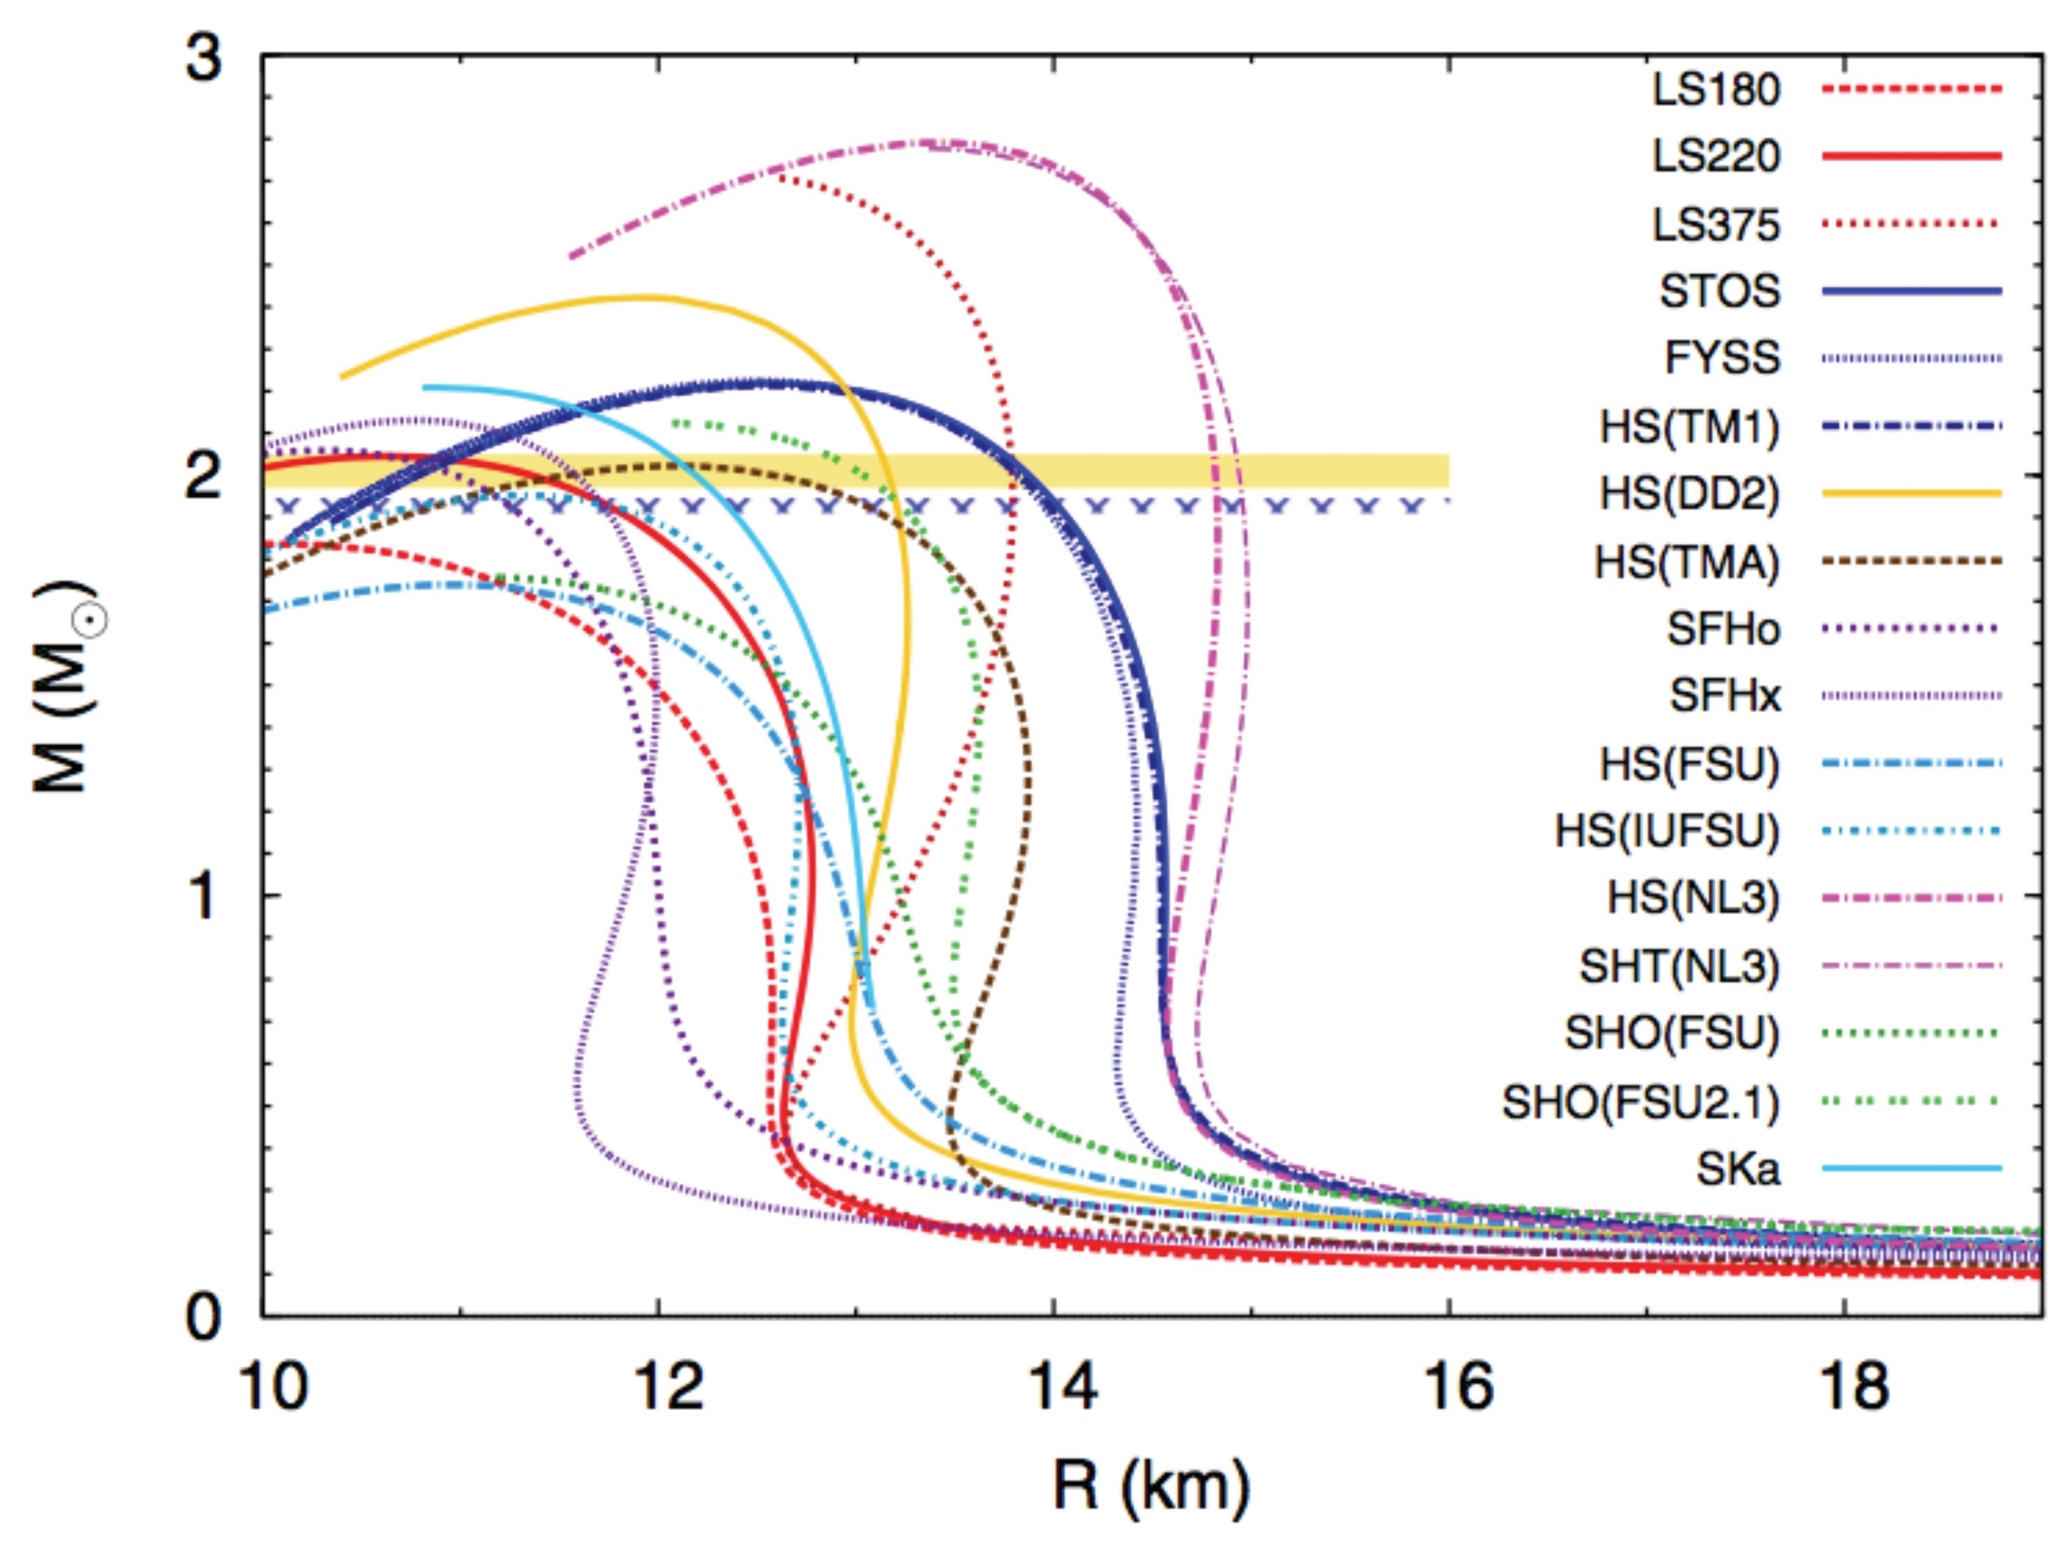
The strong nuclear force binds each nucleon to its neighbours. Neutron-to-proton ratios of at least 1:1 and even quantities of protons and neutrons are typical characteristics of stable nuclei. Particularly common are nuclei with magical proton and neutron counts. For the nucleus to be stabilized, neutrons are essential. The nucleus becomes unstable and decays if the attractive force between the nucleons is smaller than the electrostatic repulsion. It describes an element's isotope's equilibrium. High binding energy nucleons are more stable. When the strong nuclear force pulls together positively and negatively charged quarks, protons and neutrons are produced that are both positively and neutrally charged. Strong nuclear force is also responsible for keeping protons and neutrons together in the atomic nucleus. The weak nuclear force enables the fusing of simple atoms to produce complex ones.
^{Nuclear Decay}
An unstable atomic nucleus produces radiation during nuclear decay to lose energy. A good example of this is the decay chain that starts with uranium-238 and finishes with lead-206 after producing intermediates like uranium-234, thorium-230, radium-226, and radon 222. Deterioration is another name for the series. Each series has its own unique decay cycle, which is always radioactive and results from the chain's decay.
^{Formula}
^{A=- dN/dt}

^{A} ⁼ ^{total activity}
^{N} ⁼ ^{number of particles}
^{t} ⁼ ^{time}
Depending on the particle emitted and the change in mass and atomic number, the decay is called alpha, beta, and gamma decay.
^{Alpha Decay:}
In nuclear decay, an unstable nucleus converts to another element by ejecting an alpha particle, which is made up of two protons and two neutrons. It is just a helium nucleus, and it is referred to as an alpha particle. Both the mass and the charge of alpha particles are positive
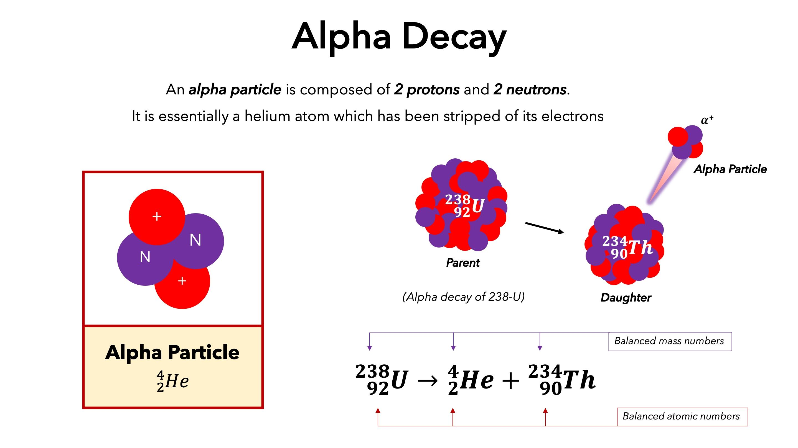
.

^{Beta Decay}
A radioactive process known as beta decay occurs when an atomic nucleus emits a beta ray. The proton in the nucleus is changed into a neutron during beta decay, and vice versa. It is referred to as "+ decay" when a proton transforms into a neutron. Similar to this, a neutron's conversion to a proton is referred to as "- decay.".
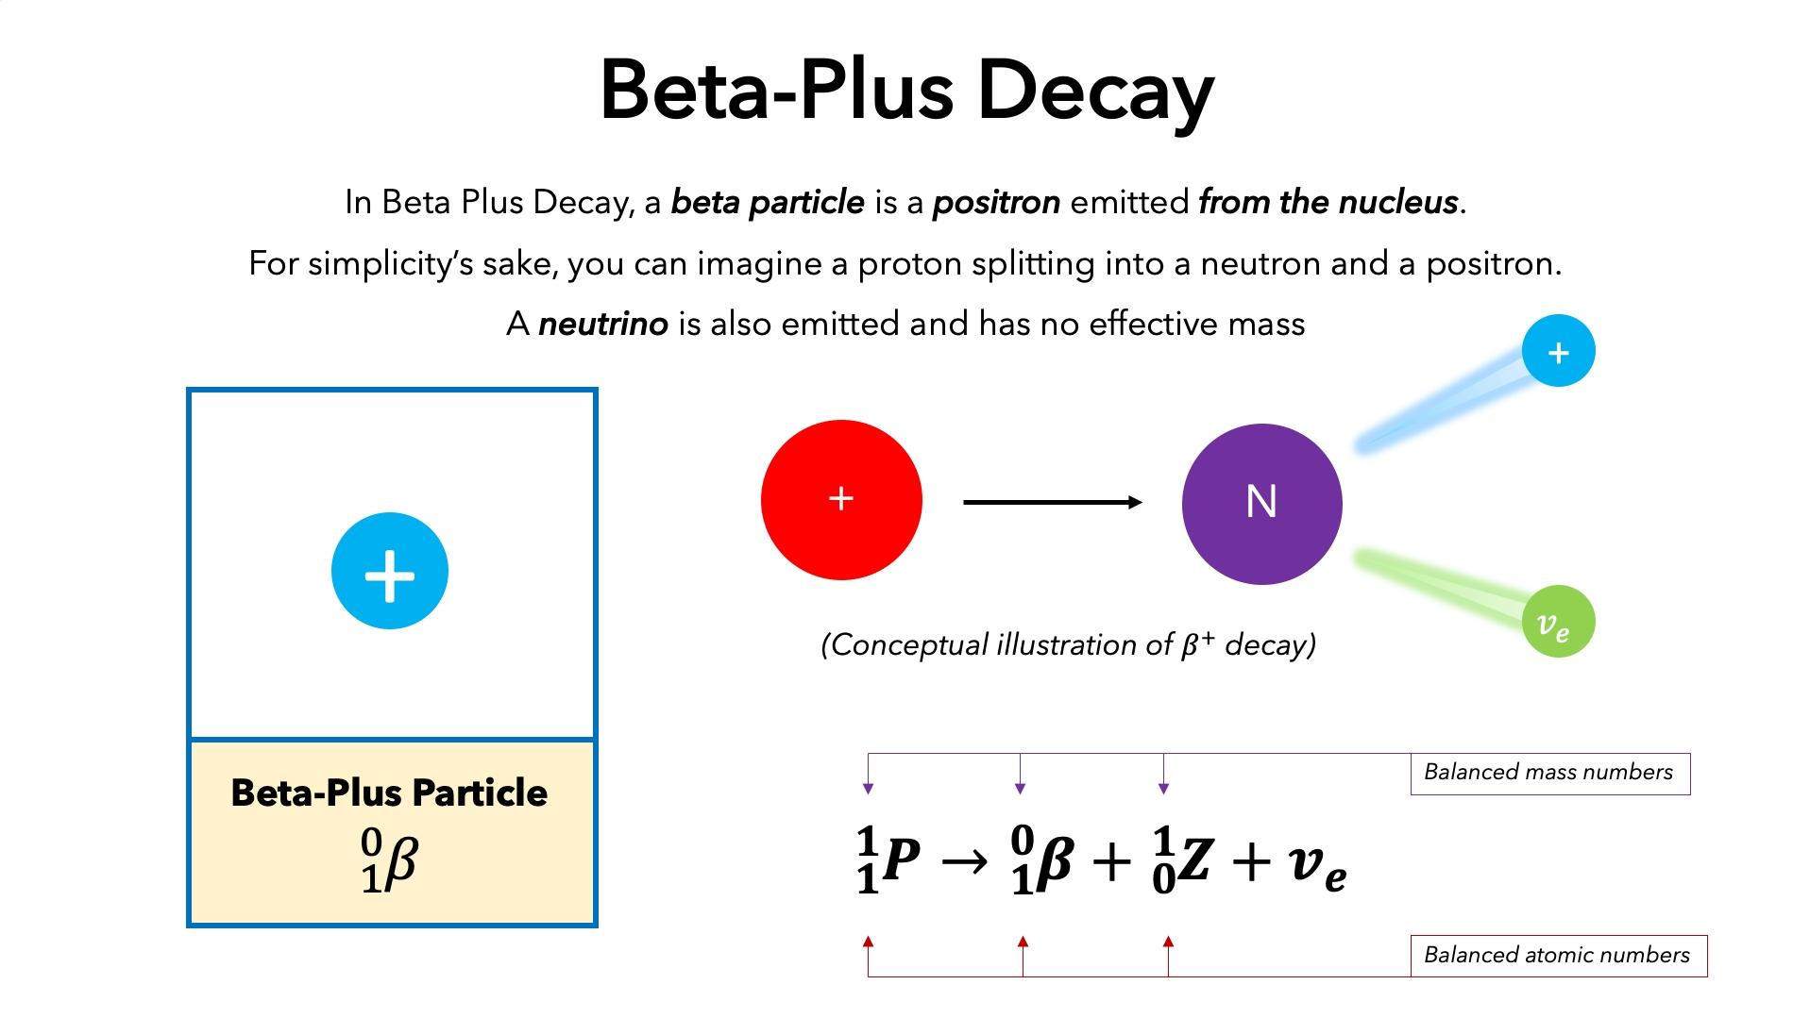
^{Gamma Decay}
Through the emission of electromagnetic radiation (photons), a nucleus undergoes gamma decay, transitioning from a higher energy state to a lower energy state. The process does not modify the number of protons (and neutrons) in the nucleus, hence the parent and daughter atoms are the same chemical element..

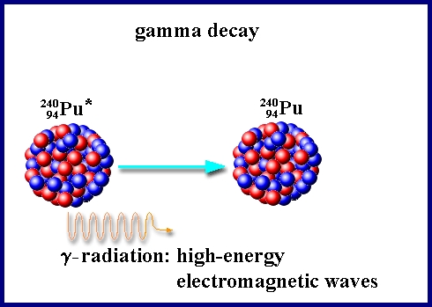

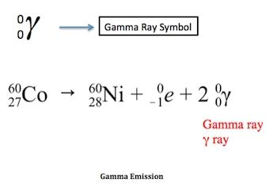
Nuclear Reactions and Cross-sections
The interaction of two atomic nuclei or subatomic particles that results in the production of both or any additional nuclear reaction, which can produce particles or gamma rays. Consequently, a nuclear reaction requires the transformation of at least one nuclide. If a nucleus interacts with another nucleus or particle without changing the nature of any nuclides, the event is occasionally referred to as a nuclear scattering rather than a nuclear reaction.. The light-related nuclear fusion processes are arguably the most notable nuclear reactions. Natural nuclear reactions also happen when cosmic rays and matter interact, to give another example. Fission, which takes place in nuclear reactors, is the most significant man-controlled nuclear reaction..
When describing the likelihood that a nuclear reaction will occur, the term "nuclear cross-section" is employed. Physically, the "characteristic area" of the nuclear cross section can be used to quantify it, where a bigger area corresponds to a higher probability of contact.. The likelihood that a certain atomic nucleus or subatomic particle will display a particular reaction (such as absorption, scattering, or fission) in relation to a specific species of incident particle in nuclear or subatomic particle physics. The cross-section is expressed in terms of area, and its numerical value is selected such that the reaction is expressed as either occurring or not occurring depending on whether the bombarding particle hits a circular area of this size that is perpendicular to its path and centred at the target nucleus or particleTypically, the geometric cross-sectional area of the target nucleus or particle is different from the reaction cross-section. The barn (1024 square cm) is used as the unit of measurement for reaction cross sections. The energy of the blasting particle and the type of reaction affect the cross section values. For instance, boron has a cross-section for the neutron-capture reaction of around 120 barns when hit by neutrons travelling at 1,000,000 cm/s (22,500 miles/h), and this cross-section increases to about 1,200 barns for neutrons moving at 100,000 cm/s.
Nuclear Shell Model and Quantum Mechanics
The shell model explains how the quantum numbers fluctuate and how much energy is needed to shift nucleons from one orbit to another. The shell model is one of the most effective and easily understood. In this scenario, protons and neutrons reside in different systems of shells that are comparable to the shells that electrons inhabit outside of the nucleus. Each of the models is based on an analogy that makes sense and connects a wealth of data, allowing for the reveal of nuclei's features.
^{Nuclear Energy}
A sort of energy called nuclear energy is released from the nucleus, the central region of atoms made of protons and neutrons. The two processes through which this kind of energy can be produced are fusion and fission, in which the nuclei of atoms combine to form a single larger nucleus.
There are more applications for nuclear energy than only producing carbon-free electricity. Desalination of water, sterilization of medical equipment, and the provision of radioisotopes for cancer treatment are all made possible by the nuclear energy that propels space exploration.
Astrophysical Nuclear Reactions
Nuclear reactions reorganize the remaining nuclear particles over from the Big Bang (as hydrogen and helium isotopes, as well as traces of lithium, beryllium, and boron) to other isotopes and elements as we know them today. This is how stars functioned during cosmic times. Nuclear astrophysics is the study of how chemical elements are formed, how stars glow, develop, and eventually perish.
^{Fission and fusion reactions}
Atomic energy is extracted from matter through the physical processes of fusion and fission.
^{Fission}
When a neutron impacts a larger atom, it becomes excited and splits into two smaller atoms known as fission products. This process is known as fission. Other neutrons that are released at the same time could initiate a chain reaction.
Each atom's division generates a huge amount of energy.
Uranium and plutonium are most frequently used for fission processes in nuclear power reactors because they are easy to start and regulate..
The energy generated by fission in nuclear reactors heats water, turning it into steam. A turbine is spun by steam to provide carbon-free energy.
^{Fusion}
When two atoms collide to create a heavier atom, such as when two hydrogen atoms combine to create one helium atom, this process is known as fusion.
Similar mechanisms that create energy many times greater than that produced by fission are used to power the sun. Additionally, no radioactive fission products are produced..
The intense pressure and temperature needed to fuse the nuclei together are being studied by scientists, but they are difficult to maintain for long periods of time.
Advanced Research and Technology
When producing rare isotopes, radioactive ion beams can offer analysis options that aren't possible with regular ion beams. In particular, radioactive beams make it possible to study nuclear events that are crucial to stellar burning and nucleosynthesis, which take place in high-temperature and/or stable settings in stars. Each isotope in this mixture possesses unique qualities. They have distinct lifetimes that range from a fraction of a second to several billion years, and they emit various radiation kinds and quantities of energy.
Nuclear Astrophysics and Stellar Evolution
The arrangement of protons and neutrons, as well as their corresponding energies, define the process of atomic nuclei. The nuclear shell model, which is founded on the ideas of quantum mechanics, offers a thorough framework for explaining the patterns of nuclear properties that have been noticed. Recent research has concentrated on the creation of novel theoretical frameworks and experimental methods to investigate the characteristics of exotic nuclei that exist outside of stable isotopes. Our conventional understanding of nuclear structure has been put to the test by the identification of new occult volumes and the appearance of new nuclear forms.
Applications of Nuclear Physics
Medical imaging and radiation therapy
Radiation therapy's objective is to give a high dosage of radiation to the tumour or other target area to enhance local disease control while administering a modest dose to healthy soft tissues to minimize adverse effects. Ionizing radiation therapy for the treatment of cancer has advanced significantly during the past century. The advancement of medical imaging has been largely responsible for this transformation. The development of computed tomography (CT) significantly contributed in the improvement of treatment planning. Despite these limitations, CT remains the only three-dimensional imaging modality used for dosage computation. Modern image modalities including positron emission tomography (PET) and magnetic resonance imaging (MR) imaging are sporadically used in the treatment-planning process. Radiation therapy was developed thanks to three ionising radiation discoveries made in the late nineteenth century.
1. On November 8, 1895, Wilhelm Conrad Roentgen (1845–1923) made the discovery of X-rays.
2. Henri Becquerel (1852–1908) discovered radioactivity on March 1;
3. Madame Curie (Maria Sktodowska) (1867–1934) discovered radium on December 26, 1898.
Radiocarbon Dating And Archaeology
The first set of radiocarbon dates were released in 1949 by American chemist Willard Libby, who was involved in the creation of the atomic bomb. His use of radiocarbon dating is still the primary method for dating the last 50,000 years and is the most significant advancement in absolute dating in archaeology.
An isotopic or nuclear decay technique for determining the age of organic materials is radiocarbon (14C) dating. The method offers a standard chronometric time scale with routine global applicability in the age range of around 300 calendar years to between 40,000 and 50,000 years. Ages up to 75,000 years have been measured using isotopic enrichment and greater sample sizes (Taylor 1987, 2001).
Numerous types of carbon can be measured for radiocarbon.
Nuclear forensics and non-proliferation
Nuclear security strives to stop, detect, and respond to nuclear material theft, sabotage, unauthorized access, unlawful transfer, and other nefarious acts. A crucial component of nuclear security is nuclear forensics. A process known as "nuclear forensics" seeks to reconstruct the past of radioactive material with an ambiguous origin. It is founded on signs that come from established connections between material properties and past processing histories. As a result, the characterization of the material and its relationship to manufacturing history are included in the nuclear forensics investigation. In order to offer information on pre- and post-detonation events (i.e., the range of nuclear security events under inquiry), nuclear forensics, a critical technical skill, uses signatures inherent to nuclear and radioactive materials.
Materials science and nuclear waste management
Nuclear waste management entails minimizing all radioactive waste, classifying it, and choosing the best ways of disposal in accordance with Best Available Techniques (BAT). According to its amount of radioactivity, radioactive waste is often categorized as low-level (LLW), intermediate-level (ILW), or high-level (HLW).
Challenges and Future Perspectives
Limitations and safety concerns
Nuclear reactions, such as radioactive decay, nuclear capture, and particle-induced reactions, modify atomic nuclei in various ways. For a number of uses, such as the creation of energy, the synthesis of materials, and medical treatments, it is essential to comprehend these interactions. The mechanisms and dynamics of nuclear reactions at both low and high energy have recently been studied. Precision measurements and in-depth analyses of reaction cross-sections and resonance phenomena have been made possible by the development of sophisticated detectors and accelerators.
Fusion Energy Development and Sustainability
Nuclear processes called fission and fusion, which involve splitting or joining atomic nuclei, respectively, release enormous amounts of energy. Understanding the intricate dynamics and possibilities for energy release in nuclear fission has advanced significantly in recent years. Our understanding of this subject has improved as a result of the study of spontaneous fission and the identification of novel isotopes with distinctive fission characteristics. Additionally, research into nuclear fusion has yielded encouraging results, with experimental improvements in fusion-controlled devices like tokamaks and stellarators opening the door to the creation of sustainable energy.
Nuclear physics in the context of quantum computing
Our knowledge of matter and energy has undergone a revolutionary change because to developments in nuclear physics. The investigation of nuclear structure, reactions, and fission/fusion processes has deepened our comprehension of the complex nature of the atomic nucleus. These developments have produced useful applications in fields including energy production, medicine, and astrophysics in addition to adding to theoretical knowledge. We can look forward to new discoveries that will help us to better understand the atomic nucleus and the phenomena that it is connected to. The advancements in nuclear physics have a wide range of applications. Despite its difficulties, nuclear energy is nevertheless a substantial source of electricity generation worldwide. The synthesis of isotopes for medical diagnostics and cancer treatment has been made easier because to developments in accelerator technology.By using laboratory data and theoretical models, nuclear physics is also essential for understanding astrophysical phenomena like nucleosynthesis and stellar evolution.
Recap of key findings and contributions of nuclear physics
High-energy electron scattering experiments in nuclear physics can reveal details about the structure of nuclei. According to the findings of these tests, the density of nuclear matter at the center of every nucleus is essentially the same. Nuclear physics is the study of the structure of nuclei as well as how they arise, remain stable, and degrade. It strives to comprehend the underlying nuclear forces in nature, their symmetries, and the intricate interactions between protons and neutrons in nuclei and between quarks inside hadrons, including the proton, that result from these interactions.
Future Directions and Potential Applications
If you want to offer new questions, theories, or areas for additional research in nuclear physics, theoretical or exploratory study is typically more appropriate.
Importance of continued research in nuclear physics
This research study intends to provide a broader understanding of the theoretical underpinnings, technological developments, and applications of nuclear physics by providing a thorough assessment of the field. It explores the ethical and safety issues related to nuclear energy and armament while also highlighting the significance of nuclear physics in forming our understanding of the universe. This study anticipates future developments and discoveries that will continue to influence the area of nuclear physics in the years to come by examining the difficulties and opportunities.
_{References}
- R. E. Pollock and D. L. Morton, “Principles of surgical oncology,” in Cancer Medicine, D. W. Kufe and R. E. Pollock, Eds., B. C. Decker, Hamilton, Ontario, Canada, 2000.
- V. T. De Vita Jr. And E. Chu, “A history of cancer chemotherapy,” Cancer Research, vol. 68, no. 21, pp. 8643–8653, 2008.
- F. M. Khan, “Clinical radiation generators,” in The Physics of Radiation Therapy, Lippincott Williams & Wilkins, Philadelphia, Pa, USA, 2010.
- K. U. Hunter and A. Eisbruch, “Advances in imaging: target delineation,” Cancer Journal, vol. 17, no. 3, pp. 151–154, 2011.
- CURRIE, L.A. 2004. The remarkable metrological history of radiocarbon dating. Journal of Research of the National Institute of Standards and Technology 109: 185-217.
- Anspaugh, L. R., Catlin, R. J., Goldman, M., The Global Impact of the Chernobyl Reactor Accident, Science 242, Dec 16, 1988, p1513
- Becker, Edwin D., High Resolution NMR, Academic Press, 1969.
- Beiser, Perspectives of Modern Physics, Sec 5.3. Reference for alpha scattering geometry
- Blatt, Frank J, Modern Physics, McGraw Hill, 1992. Mossbauer effect, Ch 15. Rutherford scattering, Ch 14.
- Booth, C. N. And Combley, F. H., Nuclear Physics 303, http://www.shef.ac.uk/uni/academic/N-Q/phys/teaching/phy303/phy303-3.html External link
- Cowan, George A., A Natural Fission Reactor, Scientific American 235, July 1976, p 36.
- Dalrymple, G. Brent, The Age of the Earth, Stanford University Press, 1991.
- Das, Ashok and Ferbel, Thomas, Introduction to Nuclear and Particle Physics, Wiley, 1994.
- Evans, Robley D., The Atomic Nucleus, McGraw-Hill, 1955.
- Jelley, N. A., Fundamentals of Nuclear Physics, Cambridge University Press, 1990.
- Krane, Kenneth S., Introductory Nuclear Physics, Wiley, 1987.
- Levin,Harold L., The Earth Through Time, 2nd Ed,, Philadelphia:Saunders College Publishing, 1983. Discussion of radioactive dating processes.
- Mulligan, Joseph F., Practical Physics: The Production and Conservation of Energy, McGraw-Hill, 1980.
- Nave, C. R. And Nave, B. C., Physics for the Health Sciences, 3rd Ed, W. B. Saunders, 1985.

