Balloon Blowing Exercises: Effective for respiratory parameters

A systematic review & Meta Analysis
Corresponding Author: Rajni Thapa, Asstt. Professor, SMVDCoN, Katra
Co-Author: Supriya, Nursing Tutor, SMVDCoN,Katra
Background:
In India, the children younger than 15 years old involve around 35 percent of total population. This special group of the society ought to be secured as prime concern in all nations. A Meta Analysis manifested that 1.9 million children expired from acute respiratory infections in 2009 worldwide and a normal death rate is 4.3 million consistently are alluded to intense respiratory infections.¹
Breathing techniques are critical in reducing the severity of symptoms in respiratory disorders and infections. Breathing exercises seems to be effective in clearing the airways and can improve gas exchange.²
Numerous types of breathing exercises to improve respiratory function and health‐related quality of life in people with lower respiratory tract disorders have been reported in the literature. One of the breathing exercise i.e, balloon blow exercise has come with the evidence in clinical trials to reduce the severity of symptoms in children with respiratory disorders & infections.³
Modified breathing exercises (Balloon Blowing Exercises) could be effective in children because it doesn’t cause any anxiety and fear to devices and it is easy to administer in children as compared with other respiratory exercises. As well, they might not cooperate like adults. Balloon Blowing exercises works as a play way therapy along with other treatment regimen.¹
Balloon blowing exercises involve a group of muscles interacting to adapt thoracic dimensions to certain breathing stages. Basic respiratory muscles are the diaphragm, the internal costal and external costal. Accessory muscles, or muscles that contribute to lift the ribcage, so that lungs can expand and take in air, are frequently used during vigorous physical activities, like weight training, stressful situations or when someone suffers from an asthma attack. Steadily blowing up several balloons, one after another, effectively exercises these muscles, builds lung capacity and stamina⁴.
But in practice, incentive spirometry is on use as breathing exercises to children (patients) with lower respiratory tract disorders irrespective of the children’s interest and cognition of the ability to understand the procedure. To recommend balloon blowing exercises as a therapeutic play based on a principle to attract children not to create boredom; therefore we identified and reviewed the evidence on efficacy of balloon blowing exercises to improve respiratory status among children population with lower respiratory tract disorders.
Besides, it has been proved in trials that balloon therapy was more acceptable among children as it is a part of their normal routines play activity and excitement to explore blowing balloons and few expressed anxiety and fear towards spirometry.
Objectives:
- To undertake a systematic review of randomized and quasi-randomized studies that assessed the effects of balloon blowing exercise as therapeutic play on the recovery in respiratory status of children with lower respiratory tract infections.
We focused on studies investigating changes in the respiratory parameters related to balloon blowing exercise trials in children. The respiratory parameters taken into account in this systematic review are Respiratory rate, Breath sounds, and Oxygen saturation. The primary outcome were reduction in mean respiratory rate and distress whilst the secondary outcomes included oxygen saturation, pulse rate and breathe sounds. To develop an effective search strategy, we adopted the Population, Intervention, Comparison, Outcomes and Study Design (PICOS) worksheet in a Table 1.

Methodology
Search strategy: we searched the MEDLINE/Pubmed, Scopus, CENTRAL Cochrane, Google scholar, electronic database searches and hand searches of relevant journals and abstract book of conference proceedings for RCTs on the effects of balloon blowing exercise compared with usual care or any active control intervention. The keywords used in search strategy were Balloon, or balloon blowing, breathing exercises, respiratory disorders, respiratory function or pulmonary function, children.
This systematic review followed the Preferred Reporting Items for Systematic Reviews and Meta-Analyses (PRISMA) guidelines. PRISMA comprises a 27-item checklist that has to be completed in order to improve quality of systematic reviews. The check-list is reported in Supplementary Table 2
Date of most recent search: September 2019
Selection Criteria: We included Randomized controlled trials and quasi experimental and Pre Experimental studies comparing balloon blowing exercise with a control group in children with Lower respiratory tract disorders.
Inclusion Criteria

Children up to the age of 18 years with a clinical diagnosis of lower respiratory tract infections were eligible for inclusion.

Breathing exercise comprise of balloon blowing only.
- Effect of exercise on respiratory status/parameters.
- Case control, quasi experimental, pre-experimental, true experimental design studies.
Exclusion criteria
- Adult as a participant
- Children with other diagnosis except lower respiratory tract infections.
- Adult with lower respiratory tract infections, smokers and chest intubation.
- Breathing exercise comprise of blow bottle, balloon and ball together.
- Effect of balloon blowing seen in chest complications, laprotomy, posture stability and pain.
- Case reports.
- Any intervention without balloon exercises or where balloon exercises were not key to the intervention were excluded.
Data Collection and analysis:

Review authors independently selected articles for inclusion, evaluated the methodological quality of the studies, and extracted data. Data were pooled in random effect meta-analysis whenever possible. Data extraction comprises of:
- Study name
- Year of publication
- Sampling technique
- Outcome measured
- Study group Mean
- Study group Standard difference
- Comparison group Mean
- Comparison group standard difference
- Difference between two means

Risk of bias in individual studies:
Risk of bias was assessed by 2 authors independently using the Cochrane risk of bias tool. This tool assesses risk of bias using 7 criteria (rating: low, unclear, or high risk of bias): random sequence generation, allocation concealment, blinding of participants and personnel, blinding of outcome assessment, incomplete outcome data, selective reporting, and other bias. Discrepancies were rechecked with a third reviewer and consensus achieved by discussion. The risk of bias for included study is presented in Fig.C.
Main results:
Authors identified 25 studies, of which 06 studies with 320 participants met the review’s inclusion criteria. There was wide variation in the methodological and written quality of the included studies. One study included in the review did not specify the technique of balloon blowing exercise used. The control groups received different interventions: one received bubble training, one on incentive spirometry and other four was not treated with any placebo..
Balloon blowing training interventions varied dramatically, with age of participants ranging from 3 to 18 years and with frequency, intensity and duration of exercise ranging from 3 to 6 days and 10 to 30 minutes respectively. Participant numbers ranged from 40 to 60 in the included studies; all studies were in children only.
Finally, six with a total of 320 patients were included. Compared with usual care and other intervention group (bubble therapy, spirometry), good quality evidence was found for effects of balloon blowing on Respiratory status resulted in statistically significant Respiratory rate and respiratory distress reduction (Standardized Mean difference: 1.733 breaths/min 95% CI 0.486 to 2.980). Reductions were seen in oxygen saturation, breath sounds and heart rate/pulse rate compared with the controls. Trials durations ranged from 10 times per session for 3 to 16 days.
Discussion
- Included studies measured the effect of specific balloon exercise on primary outcomes of reduction in respiratory rate with the help of statistical test of difference between two means.
- Four studies compare with no intervention control group. Hence they used unpaired “t”
test which was highly significant at 95% CI.
- One study compare with bubble therapy. In the paired “t” test both are equally effective in controlling the respiratory parameters.
- Moreover another study compare with incentive spirometry. It was statistically proved that balloon blowing is more effective than incentive spirometry.
- Therefore, all the included studies proved that balloon blowing exercise is effective in reducing the respiratory rate,along with other respiratory parameters like breath sounds, oxygen saturation, nasal flaring, use of accessory muscle.

Author’s Conclusion:
- Z Value for this test is -3.9 & p value <0.001; conclude that mean effect is not zero. Effect size is similar across the studies. On an average, balloon therapy reduces the respiratory distress.
Respiratory infections account for the majority of acute illness in children. Balloon blowing exercise along with routine care is one of the non pharmacological method and easy to perform and found to be an effective method in treating the children with lower respiratory tract infection.
Healthcare practitioners should consider the use of respiratory muscle training on a case‐by‐case basis.
Further research of reputable methodological quality is needed to determine the effectiveness of balloon blowing exercise on following clinical outcomes in future studies; respiratory muscle function, pulmonary function, exercise capacity, hospital admissions, and health‐related quality of life.

Additional records identified through other sources (n=02)
Records identified through database searching (n= 25)
IDENTIFICATION

Studies included in qualitative synthesis n=6
Full text articles excluded n=12
Mixed deep breathing exercises
Effect assessed on Cardiac disorders
Effect on Physiological Parameter alone
Age group <18 years

Records after duplicates removed (n=25)
Records screened (n=25)
Records excluded (n=7)
Full text articles assessed for eligibility (n= 18)
ELIGIBILITY
SCREENING

s

FIGURE 1: PRISMA CHECKLIST
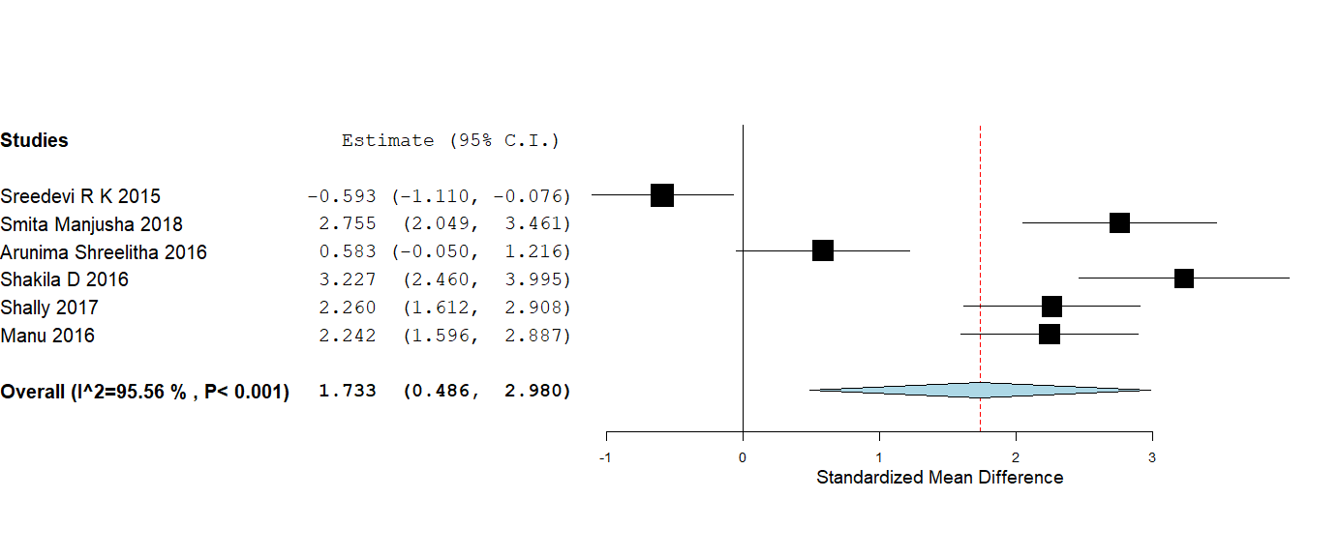
FIG.3 FOSTER PLOT

Parameter | Inclusion criteria | Exclusion criteria
Population | - Children of age ranges from 2-18 years  - Children with acute lower respiratory tract infections. | - Children of age less than 2 year  - Children with chronic and acute exacerbations conditions.
Intervention | Balloon blowing exercise only that control the respiratory parameters i.e, Respiratory Rate & Oxygen saturation in a condition of respiratory distress. | Deep breathing exercises which does not specify the techniques and blow bottle exercise in respiratory distress.
Comparison | Spirometry, Bubble exercise, Nebulization, and Control group
Outcomes | Primary Outcome: reduction in Respiratory rate | Physiological Parameters is of no interest (Heart rate, Temperature,) Effect on respiratory signs symptom.
Study Design | Randomized Controlled trial and Quazi experimental design, Pre experimental design | Case Report, Lack of rigorous description of the methodology and experimental set up impeding replicability.
 | FIG: 2 PICOS CRITREIA.

Bibliography

- Sreedevi,R. Effectiveness of balloon blowing on respiratory parameters. International journal of nursing trendz.2016;7(3):18-22.
- Das SM et al. Effect of balloon therapy vs bubble therapy on LRTI among 3-12 years children. International journal of health sciences and research .2018; 8(1): 144-147. (www.ijhsr.org).
- Sreeletha. Effect of balloon therapy vs spirometry in promotion of respiratory function in children. International journal of nursing research.2016; 2(1): 123-132.
- Rick R. Lung exercises with balloon. Livestrong.2013. www.livestrong.com
- Shakila D, Kokilavani N. Effectiveness of balloon blowing exercise on improvement of respiratory patterns among children with bronchial asthma. International journal of recent scientific research. 2016; 7(11): 14371-14374. ( http://www.recentscientific.com)
- Shally, Yogesh Kumar et al. Effectiveness of breathing exercises as therapeutic play among children with lower respiratory tract infections. International journal of applied research. 2017; 3(11): 101-107.
- Manu Mehra. Balloon blowing exercises for children with acute respiratory infections. Nightingale nursing times.2016;11(12):30-32.

