LiDAR TECHNOLOGY
S. P. Gairola ,
Department of Mechanical Engineering, Uttaranchal University, Dehradun Uttarakhand, India,
Suryapg07@gmail.com , https://orcid.org/0000-0001-7135-4269
Karunaesh Dhiman,
Karuneshdhiman@gmail.com
Department of Mechanical Engineering, Uttaranchal University, Dehradun Uttarakhand, India,
abhaydhasmana735@gmail.com
Sanjeev Kumar Joshi,
Department of Mechanical Engineering, Uttaranchal University, Dehradun Uttarakhand, India,
ersanjeevjioshi@gmail.com
Sanjeev Dhama ,
Department of Mechanical Engineering, Uttaranchal University, Dehradun Uttarakhand, India,
Sanjeev.dhama@gmail.coms

INTRODUCTION
Both autonomous systems and advanced driver assistance systems (ADAS) rely heavily on LiDAR technology. Along with cameras, radars, and ultrasonic sensors, it is a sensor that autonomous cars use to navigate without the assistance of a human. LiDAR creates high-resolution point clouds that are used for accurate object recognition, tracking, and environment mapping. In order for the vehicle to understand its location in relation to the environment, Simultaneous Localization and Mapping (SLAM) is aided. LiDAR real-time data helps autonomous systems avoid obstacles and adds redundancy, increasing their dependability and safety. By identifying potential hazards and making emergency braking possible, LiDAR with ADAS helps to avoid crashes. It improves safety and convenience for human drivers by helping with adaptive cruise control, lane-keeping assistance, blind-spot recognition, and parking assistance.
Understanding LiDAR Technology
LiDAR Fundamentals:
A remote sensing technique known as LiDAR, or light detection and ranging, uses laser pulses to measure distances and then analyses the reflections of those pulses. The sensor and the target's distance are calculated using the time-of-flight principle. Map-making, surveying, forestry, environmental monitoring, autonomous cars, and other fields all use LiDAR extensively.
LiDAR's operating principles:
LiDAR works by sending laser pulses out from the sensor that are focused on the desired location. These pulses reflect back to the LiDAR sensor when they make contact with objects or surfaces. The LiDAR system determines the distance to the target by precisely measuring the amount of time it takes for the laser pulse to complete its circuit. This distance calculation is achieved by utilizing the constant speed of light as a reference. By scanning the laser in different directions and combining the collected data, LiDAR creates detailed 3D representations of the environment. (1)
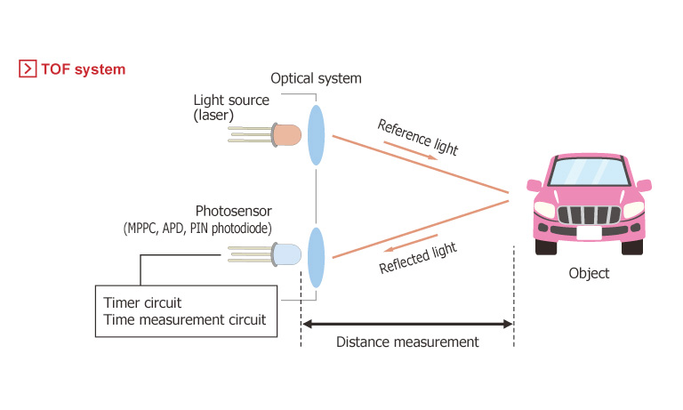
https://www.microcontrollertips.com/lidar-and-time-of-flight-part-2-operation/
LiDAR sensor types:
1. Airborne LiDAR: Airborne LiDAR sensors are attached to planes or unmanned aerial vehicles. They are frequently used for topographic mapping, forest inventory, and catastrophe assessment and swiftly cover enormous areas.
2. Terrestrial LiDAR: Fixed or mobile ground-based terrestrial LiDAR sensors. They are employed for precise close-range scanning of items or buildings, such as those on building facades, archaeological sites, or in industrial settings.
3. Mobile LiDAR: Sensors for mobile LiDAR are attached to moving vehicles, usually cars or trucks. They are useful for autonomous vehicles and city planning since they enable 3D mapping of streets, highways, and metropolitan areas.
4. Satellite LiDAR: Satellite-based LiDAR systems are placed in orbit and used to scan and track the Earth's surface on a broad scale, including vegetation, oceanography, and ice sheet measurements. (2)
Range and Resolution Considerations:
1. Range: The maximum detection range of LiDAR sensors establishes the greatest distance that may be precisely measured. While long-range LiDARs are better suited for aerial and satellite applications covering large areas, short-range LiDARs are employed for close-range tasks like indoor mapping.
2. Resolution: The capacity to detect minute details in the scanned data is referred to as LiDAR resolution. Denser point clouds are produced by higher resolution LiDARs, which offer more accurate depictions of the environment. Applications demanding accurate measurements and object recognition require higher- resolution.
3. Pulse Repetition Frequency (PRF): The number of laser pulses the LiDAR emits each second is known as the PRF. In fast-moving situations, such as those involving autonomous vehicles, a greater PRF enables more frequent data collecting and improved performance.
4.Field of View (FOV): A LiDAR sensor's FOV determines the range of angles that can be covered by a single measurement. Narrower FOV sensors are more accurate at focusing on specific targets while wider FOV sensors cover a bigger region with each pulse. When it comes to picking the best LiDAR system for certain applications and maximising its effectiveness in varied settings, having a thorough understanding of the fundamentals, working principles, and numerous types of sensors is crucial. Additionally, taking range and resolution into account is crucial for ensuring the LiDAR system operates at its best in various settings. (3)
LiDAR Components and Configurations
- Key Components of a LiDAR Sensor:

- Laser Source | Initial Laser Source Short light pulses, often in the infrared range, are emitted by the laser source. The target is illuminated by the laser, which also tracks how long it takes for the light to come back.
- Scanner | The scanner controls the direction of the laser beam. It can be either a mechanical scanner (using rotating mirrors) or a solid-state scanner (using micro-electro-mechanical systems, MEMS).
- Photodetector | The laser light is reflected, and the photodetector captures it and turns it into an electrical signal. It tracks the duration of the laser pulse's return, which enables the system to determine the distance. (4)
- GPS Receiver | To precisely geolocate the data acquired, many LiDAR systems are fitted with a Global Positioning System (GPS) receiver. (5)
- Inertial Measurement Unit (IMU) | LiDAR systems frequently include an IMU to measure the orientation and motion of the sensor, which helps with data registration and georeferencing. (6)
- Data Storage and Processing Unit | LiDAR sensors have built-in data processing and storage to handle the massive amount of point cloud data produced during scanning.(7)
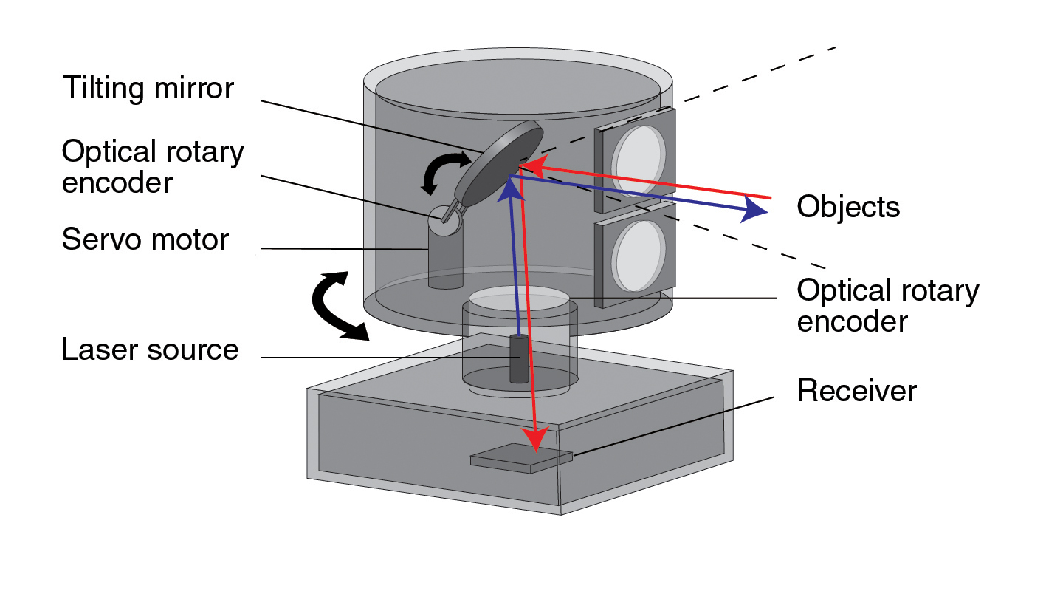
- Overview of LiDAR Configurations:
- Topographic LiDAR | Application areas for topographic LiDAR sensors include mapping and surveying. They examine the ground from above while mounted on drones or aircraft. These sensors are useful for producing digital elevation models (DEMs) and digital surface models (DSMs) because they provide high-resolution elevation data.
- Bathymetric LiDAR | LiDAR that measures the depth of water bodies is called bathymetric LiDAR, and it can be used for coastal and hydrographic surveys. These submergible sensors track how long it takes the laser to return from the seafloor and water's surface.(8)
- Mobile LiDAR | On moving platforms, such as vehicles, trains, or boats, mobile LiDAR sensors are mounted. They are the perfect tool for building 3D maps of streets, highways, and cities because they scan their surroundings while moving. (9)
- Terrestrial LiDAR | Ground-based terrestrial LiDAR systems are employed for scanning structures or objects at close range. They are extensively employed in industrial, construction, and historical preservation projects. (9)

- Differences Between Scanning Methods:

- Mechanical Scanning | Mechanical inspection Rotating mirrors are used in LiDAR systems to steer the laser beam over the scene. Compared to other approaches, these devices often acquire data more slowly and have a smaller range of vision. However, they frequently measure with greater accuracy.(10)
- Solid-State Scanning (MEMS) | Micro-electro-mechanical systems (MEMS) are used in solid-state LiDAR systems to electrically steer the laser beam. MEMS-based scanners are more robust, compact, and quick. They also have a larger field of vision.(11)
- Flash LiDAR | Geiger-mode flash LiDAR is another name for LiDAR uses a single laser pulse to illuminate the entire area and an array of detectors to collect the returned data. This technique is frequently utilised in applications like driverless vehicles since it enables very quick data collecting.(12)

Due to differences in accuracy requirements, survey area, and financial restrictions, each LiDAR setup and scanning technique has strengths and disadvantages that make them suited for particular applications. Understanding these variations is essential when choosing the right LiDAR system for a certain task.
Obstacle Detection and Localization:
Numerous applications, such as autonomous cars, robotics, and industrial automation, depend on accurate obstacle detection and localisation. LiDAR is essential to these jobs because it provides precise 3D point clouds of the surrounding area. To ensure safe and effective navigation, the point cloud data is analysed to identify and locate barriers like pedestrians, automobiles, or other objects.
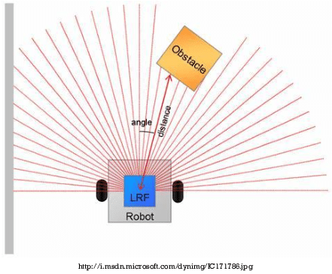
https://www.researchgate.net/publication/268257659/figure/fig7/AS:669333038592025@1536592840717/An-example-of-the-LIDAR-as-an-obstacle-detection-system.png

- LiDAR Data Processing:
In order to extract valuable information from the raw point cloud data that the LiDAR sensor has acquired, many steps must be taken during the processing of the data. The primary procedures involve the creation of point clouds, pre-processing methods, segmentation, and object recognition. (13)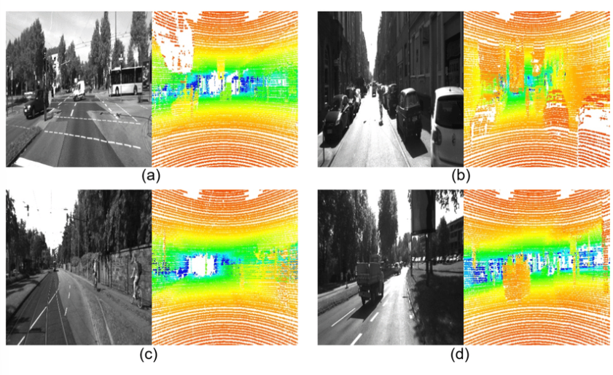
https://www.researchgate.net/figure/Camera-images-left-image-in-a-d-and-LiDAR-depth-maps-generated-from-LiDAR-raw-data_fig1_352260835
- Point Cloud Generation:
The creation of a point cloud is the initial step in the collection of LiDAR data. The LiDAR sensor fires laser pulses during this operation and records the reflections from the surrounding objects. The resulting information is stored as a set of 3D points, where each point corresponds to a specific position in space and the distance between that location and the LiDAR sensor. (14)
- Pre-processing Techniques:
Filtering | In order to assure the accuracy of the point cloud data, noise filtering procedures eliminate outliers and points of low reliability.
Ground Segmentation | For the purpose of detecting obstacles on road surfaces, ground segmentation divides the point cloud into ground and non-ground points.
Normalization | By aligning the point cloud with a standard reference frame through normalisation, reliable comparison and sensor data fusion are made possible.
Registration | LiDAR data is registered with data from other sensors, such as cameras or radar, in multi-sensor setups to produce a complete and synchronised representation of the environment.
(15)
• Segmentation and Object Recognition:
Segmentation is the process of separating the point cloud data into various clusters or regions depending on their spatial properties. These groups stand in for various environmental objects or barriers. Then, object identification algorithms evaluate these segments to pinpoint certain items like people, cars, or stationary obstructions.
- Clustering | In the point cloud, neigh boring points that are probably part of the same item are grouped together by clustering algorithms. Different impediments can be distinguished from the background using this approach.
- Object Classification | The segmented clusters are categorised into several classes by object identification algorithms using machine learning approaches, such as pedestrians, cars, or trees. Understanding the kinds of impediments present in the environment requires taking this step.
- Localization | The locations and orientations of objects are established in relation to the LiDAR sensor or a global reference frame once they have been identified and categorised. For autonomous vehicles' navigation and collision-avoidance systems, this information is essential. (16)

Obstacle Localization and Tracking
The objective of obstacle localization and tracking is to continually track and forecast the positions and motions of objects that have been discovered over time. For autonomous systems, ADAS, robots, and other applications, this procedure is essential to ensuring secure and straightforward navigation while preventing potential collisions with obstructions.
Object Tracking Algorithms:
- Kalman Filter | A well-liked recursive algorithm for tracking moving objects is the Kalman filter. The object's status is predicted using a probabilistic model at each time step, and the predictions are then updated in light of the most recent measurements from the LiDAR sensor. The Kalman filter offers reliable tracking performance and is effective. (17)
- Particle Filter (Monte Carlo Localization) | For non-linear and non-Gaussian tracking issues, particle filters are used. They use a collection of particles to represent the object's state, with each particle standing for a potential state hypothesis. The likelihood that these particles match LiDAR readings is used to resample and update the particles, which enables the filter to zero in on the real position of the item.
- Joint Probabilistic Data Association Filter (JPDAF) | The JPDAF works well in situations where there are numerous objects or occlusions. LiDAR readings are linked to numerous potential tracks, and joint probabilities are kept for each linkage. This method deals with circumstances when the measurement-to-object relationship may be unclear.
- Multiple Hypothesis Tracking (MHT) | The data-driven algorithm MHT handles complex tracking scenarios where the number of objects is unknown and can change over time by taking into account numerous hypotheses for object tracks.
(17)(18) 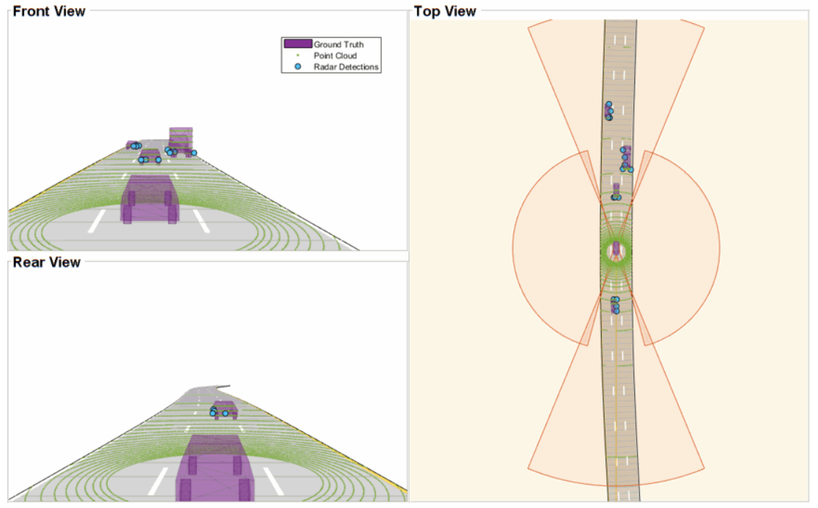
https://www.mathworks.com/help/driving/ug/track-level-fusion-of-radar-and-lidar-data.html
- Predictive modelling: Predictive modelling forecasts future positions and trajectories of observed objects by using past object motion data. This predictive ability is crucial for allowing autonomous systems to foresee prospective impediments or dynamic changes in the environment and respond accordingly.
- Constant Velocity Model: This model makes the assumption that an object's velocity stays constant across time. For objects travelling at roughly constant velocities, this model offers reasonably accurate predictions.
The constant velocity model can be written mathematically as:
Position (x, y) at time t = Position (x0, y0) + Velocity (Vx, Vy) * (t - t0)

where:
(x0, y0) represents the initial position of the object at time t0.
(Vx, Vy) represents the constant velocity vector of the object in the x and y directions.
(t - t0) represents the time elapsed since the initial position was recorded.

Constant Acceleration Model: This model takes into account both the object's acceleration and its present velocity. For things that might be accelerating or decelerating over time, this model is more accurate. The following equations can be used to explain an object's position, velocity, and acceleration in this model:
Position (x, y) at time t = (x0, y0) + (Vx0, Vy0) * (t - t0) + (1/2) * (ax, ay) * (t - t0)^2
Velocity (Vx, Vy) at time t = (Vx0, Vy0) + (ax, ay) * (t - t0)

where:
The initial position of the object at time t0 is represented by (x0, y0).
The initial velocity of the object in the x and y directions at time t0 is represented by (Vx0, Vy0).
The continuous acceleration of the object in the x and y directions is represented by (axe, ay).
The amount of time that has passed since the first position was noted is denoted by (t - t0). (19)
- Sensor Fusion: By combining data from many sensors, including LiDAR, cameras, and radar, predictive modelling can be enhanced even more. The system can have a more complete understanding of the environment and predict the behaviour of objects more accurately thanks to sensor fusion.

- LiDAR for Collision Avoidance and Braking
In a variety of applications, including autonomous vehicles, advanced driver assistance systems (ADAS), and industrial automation, LiDAR is essential for braking and accident avoidance systems. LiDAR assists in recognising potential collisions, sending timely warnings to the driver, or initiating autonomous brakes to prevent accidents by providing real-time and exact 3D perception of the surroundings. Collision Detection and Warning Systems:
LiDAR data is used by collision detection and warning systems to locate risks and barriers in a vehicle's route. To identify any objects that can cause a collision, these systems continuously scan the environment and examine the incoming LiDAR point cloud data. For improved performance and redundancy, collision detection systems can cooperate with various sensors like cameras and radars, depending on the application and implementation.
Real-time Collision Detection:
Real-time collision detection is a crucial component of these systems because it enables quick responses to suddenly appearing impediments and shifting road conditions. LiDAR is a good choice for real-time collision detection applications since it can deliver frequent updates and precise 3D data.
- Object Tracking: As was already indicated, object tracking algorithms constantly track the positions and motions of obstacles that have been discovered. The technology is able to foresee impending collisions by applying predictive modelling approaches to estimate their future paths.
- Mapping of the environment: LiDAR produces precise 3D maps of the surroundings, including the locations and contours of obstructions and road features. These maps provide the system a thorough picture of the environment, enabling more accurate collision detection.
3. Visual Warnings: To warn the driver of a potential accident, visual warnings are shown on the instrument panel or Heads-Up Display (HUD) of the vehicle. Flashing lights or visual representations of the detected impediments are frequent features of these alerts.
4. Auditory Warnings: To alert the motorist to an impending risk, auditory warnings like alarms or beeps are frequently used.
5. Haptic Feedback: In some systems, haptic feedback can be utilised to inform the driver without forcing them to take their eyes off the road, such as seat vibrations or pulses from the steering wheel.
6. Autonomous brake: In autonomous vehicles, if the driver ignores the warnings, the collision avoidance system can take control of the brake system and start emergency braking to avoid the crash.

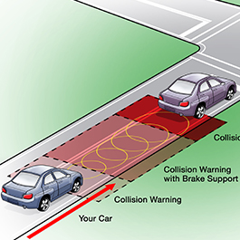
https://mycardoeswhat.org/deeper-learning/forward-collision-warning/
Vehicle safety is improved and the possibility of accidents brought on by human mistake or environmental factors is decreased thanks to the integration of real-time collision detection utilising LiDAR data and efficient warning and notification methods. LiDAR technology is anticipated to play a bigger part in collision avoidance systems as it develops, making transportation safer and more dependable. (20)

Emergency Stopping Devices
A safety feature known as automatic emergency braking (AEB) was developed to assist drivers in avoiding or minimising collisions with objects or pedestrians. LiDAR, cameras, radars, and ultrasonic sensors are used in combination to continuously scan the area around the vehicle and identify potential crash dangers.
When the system detects an impending collision, it can automatically apply the brakes in an effort to lessen the force of the crash or, ideally, avoid one altogether.
• Automatic Emergency Braking Principle:
The three primary phases of automatic emergency braking are as follows:
1. Sensing and Detection: The AEB system uses sensors like LiDAR to continuously analyse its surroundings. Real-time information on the proximity and relative speed of objects in the path of the vehicle is provided by these sensors. This data is examined by the system to identify potential collision risks.
2. Collision Warning: The AEB system will alert the driver if it detects an impending collision. The motorist is alerted to take evasive action by this notification, which may be visual, audio, or tactile. The intention is to get the driver to act and either manually apply the brakes or swerve clear of the collision.
3. Autonomous Braking: The AEB system takes control and applies the brakes on its own if the driver does not react to the warning or does not move quickly enough to prevent the crash. In order to lessen the collision or completely stop the car, the system determines the required braking power based on the severity of the predicted impact and the vehicle's speed.
• Brake Actuation and Control:
The effective and smooth application of the brakes is made possible by the AEB system's brake actuation and control. To prevent abrupt stops or sliding, the system must guarantee that the brake force is appropriate for the situation at hand.
1. Electronic brake control: Modern vehicles come with electronic brake control systems like the Electronic Stability Control (ESC) and Anti-lock Braking System (ABS). These systems minimise skidding and enhance braking performance by modulating the braking force applied to each individual wheel using sensors and actuators.
2.Brake-by-Wire: Some high-tech automobiles use brake-by-wire systems, which electronically regulate the braking pressure and eliminate any mechanical links between the brake pedal and the brakes. These solutions make it easier to integrate AEB and other safety systems while enabling more accurate control.
3.Collision Avoidance Manoeuvres: Some AEB systems may also start collision avoidance manoeuvres, such as turning the car away from the obstruction, in addition to applying the brakes. These manoeuvres are intended to supplement braking efforts and add another layer of protection.
Emergency braking technologies, such as AEB, have shown tremendous promise in lowering crash severity and averting accidents. It's important to remember that AEB does not replace careful driving. Although it is designed to help drivers and improve safety, drivers should constantly be aware of their surroundings and prepared to take control of the vehicle when necessary. (21)

LiDAR-based Autonomous Vehicles
LiDAR is an essential component of the perception system used by autonomous vehicles to comprehend and interpret their environment. For the purpose of producing a thorough and dynamic picture of the environment, LiDAR offers rich and precise 3D point cloud data. The ability to perceive the environment is essential for autonomous cars to navigate safely and accurately.
• The Sensor Suite and LiDAR:
A wide variety of sensors, each of which offers specific information about the environment, are included in autonomous vehicles. LiDAR improves the vehicle's overall perception skills by working in conjunction with other sensors like cameras, radars, and ultrasonic sensors.
- Complementary Information | 1. Additional Information In addition to the 2D visual data from cameras and the relative speed information from radars, LiDAR provides exact distance measurements and 3D geometry of objects. Object detection and tracking are more accurate and reliable when data from many sensors are combined..
- Robustness in Adverse Conditions | LiDAR is less impacted by difficult environmental factors including dim lighting, rain, fog, and dust, which can occasionally make cameras less effective. The perception system of the vehicle is strengthened by the addition of LiDAR to the sensor array and can continue to function well in a variety of weather situations.
- Redundancy | For safety-critical systems like autonomous vehicles, redundancy is essential. LiDAR can compensate and preserve the vehicle's perception abilities in the event that one sensor malfunctions or delivers incorrect data, helping to maintain a greater level of safety.

Environmental Mapping:
Mapping the surroundings is one of the primary uses of LiDAR in autonomous vehicles. As the vehicle moves, LiDAR sensors create updated, detailed 3D maps of the immediate area.
These maps offer a thorough and current picture of the surrounding area, allowing the vehicle to drive successfully and make wise decisions.
- High-Definition Mapping: LiDAR technology is essential for producing high-definition maps, which provide accurate details about road geometry, lane markings, curbs, and other infrastructure components. In order for a vehicle to accurately localise itself and create safe routes for navigation, these maps are essential for localization and path planning.
- Dynamic Object Mapping: LiDAR data contains real-time details about moving things, such as bicycles, cars, and pedestrians. The vehicle develops the ability to predict their movements and modify its driving strategy by continuously updating the maps with the most recent positions and trajectories of these dynamic objects. The vehicle's awareness and response are improved by this feature, resulting in safer and more effective navigation in challenging terrain.

- SLAM (Simultaneous Localization and Mapping): LiDAR's capacity to simultaneously map the surroundings and localise the vehicle is a key component in enabling autonomous navigation. The point cloud data collected from LiDAR is used by SLAM (Simultaneous Localization and Mapping) algorithms to create and continually update the map of the surroundings. These algorithms simultaneously calculate the vehicle's position on the map. Autonomous vehicles can navigate efficiently because to this fusion of mapping and localization, making decisions in the moment based on their precise location inside the surroundings. (22,23)

Path Planning and Navigation Using LiDAR
Navigation and path planning are crucial parts of autonomous driving systems. LiDAR is essential in these areas because it gives the vehicle a precise 3D vision of its surroundings, allowing it to plan safe and effective routes and precisely localise itself inside the mapped environment.

• Path Planning Algorithms: Path planning algorithms calculate the optimal path for the autonomous vehicle to travel while avoiding obstacles and abiding by traffic regulations using data from LiDAR and other sensors. In autonomous cars, a number of path planning algorithms are frequently used:
- Potential Fields | Potential fields create a virtual potential field around the vehicle, which has repellent forces from barriers and attracting forces moving in the direction of the goal. In this field, the vehicle then travels the route with the fewest impediments until it reaches its target.
- Rapidly-Exploring Random Trees (RRT) | By randomly selecting points from the environment and connecting them to construct a path, RRT algorithms build a tree structure. The vehicle takes the path with the lowest cost, taking obstacle avoidance into account, as the tree expands quickly in the direction of the objective.
- A* (A-Star) | Popular graph-searching algorithm A* determines the shortest path between two points while taking into account the costs of travelling through various parts of the environment. The environment is represented as a grid using LiDAR data, with prices given to each grid cell based on obstacles and other factors.
- Model Predictive Control (MPC) | A performance criterion is optimised using the control-based MPC technique, which plans a series of control inputs over a limited time frame. LiDAR data is used to forecast the positions of obstacles in the future and adjust the vehicle's trajectory as necessary.
(24)

- LiDAR-based Localization and Mapping:

- SLAM (Simultaneous Localization and Mapping) | SLAM is a method for creating maps of the environment and estimating a vehicle's position inside those maps. LiDAR is a crucial sensor for SLAM because of its capacity to produce accurate distance measurements and produce detailed 3D maps of the surroundings.
- Point Cloud Matching | Point cloud matching algorithms estimate the vehicle's present location by comparing the real-time LiDAR data with the built-in map. For point cloud matching, the Iterative Closest Point (ICP) algorithm is frequently employed.
- Feature-based Localization | In feature-based localization, distinguishing elements in the LiDAR data, such as corners or landmarks, are found and compared to features on the existing map to determine the location.
- Particle Filters | Based on the likelihood of various particle hypotheses, particle filters determine the position of the vehicle using probabilistic methods. LiDAR data is used to update the particle weights and improve localization accuracy.
Autonomous cars may operate safely and effectively in complex and dynamic situations by integrating path planning algorithms with precise LiDAR-based localization and mapping. LiDAR is a key technology for autonomous driving systems since it can produce comprehensive maps and perceive the environment in real-time. LiDAR technology is anticipated to contribute to even more complex and dependable path planning and navigation tactics for autonomous cars as it continues to evolve. (25)

Various Obstacles and Future Directions
• High Cost and Complex Integration

Despite tremendous advancements in LiDAR technology, there are still a number of issues that must be resolved before its full potential in ADAS and other autonomous driving applications can be realised

- Resolution and Range: Improving the LiDAR sensors' resolution and range is essential for obtaining more accurate and detailed environmental perception. Longer range enables obstacle detection from further away, giving cars more response time, while improved resolution enables better object detection and tracking.
- Sensor Size and Weight: For smooth integration into automobiles and other platforms, developing compact and lightweight LiDAR sensors is crucial. The challenge for manufacturers is to reduce sensor weight and size while maintaining optimal performance.
- Cost-Effectiveness: Compared to other sensor technologies like cameras and radars, the price of LiDAR sensors continues to be quite high. Making LiDAR systems more affordable is crucial to fostering widespread use, especially for consumer vehicles and mass-market applications.
- Reliability and Durability: LiDAR sensors need to be durable and dependable to withstand challenging operating circumstances, such as high or low humidity levels and vibrations. In particular for automotive applications with strict dependability requirements, ensuring long-term endurance is essential.
- Interference and Crosstalk: In multi-sensor configurations, interference and crosstalk between LiDAR sensors can affect the precision and efficiency of the system. In order to achieve proper sensor fusion and trustworthy perception, effective interference reduction strategies are required.
• LiDAR Performance Limitations and Adverse Weather Conditions:

LiDAR's performance limitations in bad weather are one of the difficulties it encounters. Heavy precipitation, snow, fog, or dust can all degrade the quality of the LiDAR data and make object tracking and detection more difficult. Several restrictions include:
- Reduced Range and precision: LiDAR readings may have a reduced range and precision due to adverse weather conditions that scatter and absorb laser light.
- Occlusion and Reflections: Occlusion and reflections can make it challenging for LiDAR to distinguish between objects and the background due to fog, rain, and snow.
- False Positives and Negatives: Weather-induced artefacts can cause false positives, which can result in the system missing actual barriers, and false negatives, which can result in the system recognising non-existent obstacles.

To increase the robustness of LiDAR in difficult situations, strategies like adaptive scanning patterns, wavelength selection, and post-processing algorithms are being investigated.
• High Cost and Complex Integration:
The following are a few causes of the high cost and complexity:
1. Components utilised in LiDAR, such as lasers, detectors, and scanning mechanisms, can be pricey, which affects the sensor's overall cost.
2.Calibration and Synchronisation: Adding to the complexity, integrating LiDAR with additional sensors and making sure precise calibration and synchronisation call for specialised knowledge.
3. Redundancy and Safety: For safety-critical systems like driverless vehicles, redundancy is crucial. For redundancy, using additional LiDAR sensors can raise the overall cost.

To overcome these obstacles, work is being done to provide LiDAR solutions that are affordable without sacrificing performance and security. Costs are anticipated to decrease over time as a result of improvements in semiconductor technology, manufacturing techniques, and economies of scale.

• Future Prospects:

Despite these difficulties, LiDAR appears to have a bright future. Some possible directions for the future include:
- Solid-State LiDAR: LiDAR systems may become smaller, lighter, and more reasonably priced as a result of developments in solid-state LiDAR technology, including flash LiDAR and MEMS-based scanners.
2. Integration with Other Sensors: Sensor fusion, which combines information from LiDAR, cameras, radars, and other sensors, can help autonomous systems perceive their environment better.
3. Industry-wide standardisation and standards will aid in the development of a framework for LiDAR technology that will ensure interoperability and safety.
4. Improvements in AI and Algorithms Object identification, tracking, and path planning will continue to be enhanced by machine learning and AI algorithms, improving the overall performance of LiDAR-based systems.
5. Wider Uses: LiDAR technology will find uses outside of the automotive industry, such as in robotics, forestry, agriculture, and environmental monitoring, which will promote innovation and uptake.
These difficulties are anticipated to be resolved as LiDAR technology research and development progresses, and LiDAR will then be a crucial technology for enabling safer, more effective, and autonomous transportation as well as other uses in the future.
Improvements and the Future
• LiDAR Sensor Miniaturisation and Cost Reduction:
Smaller, lighter LiDAR sensors have been made possible by developments in semiconductor manufacturing, laser diodes, and micro-electro-mechanical systems (MEMS). LiDAR's application will increase as further miniaturisation efforts make it simpler to integrate into vehicles, robotics, drones, and other platforms. Additionally, as the LiDAR industry experiences increased demand and competition, economies of scale will eventually result in lower costs. LiDAR technology is becoming more affordable as manufacturers work to streamline production processes and reduce component costs. (26)
- Fusion of Additional Sensor Modalities:

A prospective application for LiDAR technology is sensor fusion, which involves combining data from various sensor modalities. Autonomous systems can take advantage of each sensor's advantages and make up for its weaknesses by combining LiDAR with others such as cameras, radars, ultrasonic sensors, and inertial measurement units (IMUs).

- LiDAR-Camera Fusion: LiDAR's precise 3D point cloud data and cameras' detailed colour and texture data can be combined to enhance item recognition and categorization. Additionally, it improves the perception of low-reflectivity items like bikes and pedestrians, which may be difficult for LiDAR alone.
- LiDAR-Radar Fusion: Radar can sense over a great distance and is less susceptible to weather-related errors. Autonomous systems can perform better at detection and tracking when radar and LiDAR data are combined, particularly in conditions where LiDAR visibility is limited.
- Sensor Redundancy: By providing redundancy, sensor fusion improves the security and dependability of autonomous systems. Other sensors can make up for a failing or problematic sensor and keep up essential perception functions.

• Machine Learning and AI:
The future of LiDAR technology is anticipated to be significantly influenced by developments in machine learning and artificial intelligence (AI). Based on extensive datasets and practical experiences, machine learning algorithms can enhance object detection, segmentation, and tracking capabilities. AI-powered algorithms can also improve the feature extraction, classification, and processing of LiDAR data., leading to more efficient and accurate perception systems. (27)
- Beyond Automotive Applications:
Although LiDAR has become popular in the automotive sector, its potential goes beyond driverless vehicles. Due to its adaptability, LiDAR is useful in a variety of fields, including archaeology, robotics, agriculture, mining, urban planning, forestry, and environmental monitoring. It is anticipated that the usage of LiDAR technology will rise as it develops and becomes more accessible, spurring innovation and broadening its reach across a range of industries.
With continual improvements in miniaturisation, cost reduction, sensor fusion, and AI-powered algorithms, the future of LiDAR is generally bright. LiDAR will continue to be a game-changing force in the development of robotics, environmental monitoring, and transportation as these technologies merge, enabling safer, more effective, and sustainable solutions.
Conclusion
LiDAR technology's ability to provide precise and real-time 3D awareness of the environment has revolutionised road safety and autonomous driving. By giving autonomous vehicles and ADAS greater vision and decision-making capabilities, it has dramatically improved safety and efficiency on roadways. By identifying and localising barriers in real-time, LiDAR-based collision detection and warning systems contribute to accident prevention and minimise collision severity. LiDAR-integrated emergency braking systems guarantee quick and precise responses to probable collisions, improving safety for passengers and pedestrians. LiDAR is essential for perception, localization, and mapping in autonomous driving, enabling safe navigation and well-informed decision-making in challenging situations.
With continued efforts to miniaturise and lower the cost of LiDAR, making it more broadly accessible, the technology's future appears bright. By fusing LiDAR with additional senses, sensor fusion will further advance our capacity for perception. The processing of LiDAR data and object detection will be optimised using machine learning and AI algorithms, increasing the effectiveness and dependability of autonomous systems. LiDAR will also be used in a variety of industries, including urban planning, robotics, agriculture, and environmental monitoring, spurring innovation and promoting sustainability. As technological hurdles are surmounted, LiDAR will advance, changing the face of transportation and paving the way for safer, more effective, and autonomous transportation systems.

References:

Qinghua Guo, Yanjun Su, Tianyu Hu(2023), Working Principles of LiDAR, LiDAR Principles, Processing and Applications in Forest Ecology, Pages 23-61 (https://www.sciencedirect.com/science/article/abs/pii/B9780128238943000025)

Zeyu Li ª, Changhui Jiang ^{b}, Xiaobo Gu ^{c}, Ying Xu ª, Feng zhou ª, Jianhui Cui ª (2023), Collaborative positioning for swarms: A brief survey of vision, LiDAR and wireless sensors based methods, Defence Technology (https://www.sciencedirect.com/science/article/pii/S2214914723001368)

Lucas K. Johnson ª, Michael J. Mahoney ª, Eddie Bevilacqua ^{b}, Stephen V. Stehman ^{b}, Grant M. Domke ^{c}, Colin M. Beier ^{b}(2022), Fine-resolution landscape-scale biomass mapping using a spatiotemporal patchwork of LiDAR coverages, International Journal of Applied Earth Observation and Geoinformation, Volume 114 , 103059 , (https://www.sciencedirect.com/science/article/pii/S1569843222002473)

Ji-Hwan You, Seontaek Oh, Jae-Eun Park, Hyeongseok Song, Young-Keun Kim(2021),

A novel LiDAR sensor alignment inspection system for automobile productions using 1-D photodetector arrays, Measurement, Volume 183, 109817 (https://www.sciencedirect.com/science/article/abs/pii/S0263224121007661)

Stefano Tavani ª ^{b}, Andrea Billi ^{b}, Amerigo Corradetti ^{c}, Marco Mercuri ^{d}, Alessandro Bosman ^{b} ^{e}, Marco Cuffaro ^{b}, Thomas Seers ^{f}, Eugenio Carminati ^{d}(2022), Smartphone assisted fieldwork: Towards the digital transition of geoscience fieldwork using LiDAR-equipped iPhones, Earth-Science Reviews, Volume 227, 103969(https://www.sciencedirect.com/science/article/abs/pii/S0012825222000538)

Vetle O. Jonassen ª ^{b}, Narve S. Kjørsvik ^{b}, Jon Glenn Omholt Gjevestad ª(2023), Scalable hybrid adjustment of images and LiDAR point clouds, ISPRS Journal of Photogrammetry and Remote Sensing, Volume 202, Pages 652-662(https://www.sciencedirect.com/science/article/pii/S0924271623001880)

Vetle O. Jonassen ª ^{b}, Narve S. Kjørsvik ^{b}, Jon Glenn Omholt Gjevestad ª(2023), Scalable hybrid adjustment of images and LiDAR point clouds, ISPRS Journal of Photogrammetry and Remote Sensing, Volume 202, Pages 652-662(https://www.sciencedirect.com/science/article/pii/S0924271623001880)

Kai Guo ª, Qingquan Li ª, Chisheng Wang ª, Qingzhou Mao ^{b}, Yanxiong Liu ^{c}, Jiasong Zhu ª, Anlei Wu ^{b}(2022), Development of a single-wavelength airborne bathymetric LiDAR: System design and data processing, ISPRS Journal of Photogrammetry and Remote Sensing, Volume 185, Pages 62-84 (https://www.sciencedirect.com/science/article/abs/pii/S0924271622000156)

Rebeca Cordero,Montoya ª, Anthony,W. D'Amato ^{b}, Christian Messier ª, Philippe Nolet ª (2023), Mapping temperate forest stands using mobile terrestrial LiDAR shows the influence of forest management regimes on tree mortality, Forest Ecology and Management,

Evan S. Cameron , Ronald P. Szumski(1992), Lidar scanning system, EP0448111A2(https://patents.google.com/patent/EP0448111A2/en)

Nanxi Li, Chong Pei Ho, Jin Xue, Leh Woon Lim, Guanyu Chen, Yuan Hsing Fu, Lennon Yao Ting Lee(2022), A Progress Review on Solid-State LiDAR and Nanophotonics-Based LiDAR Sensors (https://onlinelibrary.wiley.com/doi/full/10.1002/lpor.202100511)

Hyung-Chul Lim ª, Daniel Kucharski ^{b}, Simon Kim ª, Chul-Sung Choi ª, Ki-Pyoung Sung ª, Jong-Uk Park ª, Mansoo Choi ª, Eunseo Park ª, Sung-Yeol Yu ª, Byoungsoo Kim ^{c} (2019) , Evaluation of a Geiger-mode imaging flash lidar in the approach phase for autonomous safe landing on the Moon, Advances in Space Research, Volume 63, Issue 3, Pages 1122-1132(https://www.sciencedirect.com/science/article/abs/pii/S027311771830797X)

Michael J. Behrenfeld ª, Yongxiang Hu ^{b}, Kelsey M. Bisson ª, Xiaomei Lu ^{b}, Toby K. Westberry ª(2022), Retrieval of ocean optical and plankton properties with the satellite Cloud-Aerosol Lidar with Orthogonal Polarization (CALIOP) sensor: Background, data processing, and validation status, Remote Sensing of Environment, Volume 281, 113235(https://www.sciencedirect.com/science/article/pii/S0034425722003418)

Mehul Arora ª, Louis Wiesmann ª, Xieyuanli Chen ª, Cyrill Stachniss ª ^{b} ^{c}(2023), Robotics and Autonomous Systems, Volume 159, 104287(https://www.sciencedirect.com/science/article/abs/pii/S0921889022001762)

Shanglian Zhou ª, Hao Xu ^{b}, Guohui Zhang ª, Tianwei Ma ^{c}, Yin Yang ^{d}(2023), Deep learning-based pedestrian trajectory prediction and risk assessment at signalized intersections using trajectory data captured through roadside LiDAR,
Journal of Intelligent Transportation Systems(https://www.sciencedirect.com/org/science/article/abs/pii/S1547245023000828)

Jing Li ª, Rui Li ª ^{b}, Jiehao Li ª ^{c}, Junzheng Wang ª, Qingbin Wu ª, Xu Liu ª (2022), Dual-view 3D object recognition and detection via Lidar point cloud and camera image, Robotics and Autonomous SystemsVolume 150, 103999 (https://www.sciencedirect.com/science/article/abs/pii/S0921889021002542)

Wai Hou Lio, Gunner Chr. Larsen, Gunhild R. Thorsen(2021), Dynamic wake tracking using a cost-effective LiDAR and Kalman filtering: Design, simulation and full-scale validation, Renewable Energy, Volume 172, Pages 1073-1086 (https://www.sciencedirect.com/science/article/abs/pii/S0960148121004377)

Janusz Marian Bedkowski, Timo Röhling(2017), Online 3D LIDAR Monte Carlo localization with GPU acceleration(https://www.emerald.com/insight/content/doi/10.1108/IR-11-2016-0309/full/html)

Zhiting Yao, Xiyuan Chen, Ninghui Xu, Ning Gao, Mingming Ge(2023), LiDAR-based simultaneous multi-object tracking and static mapping in nearshore scenario, Ocean Engineering, Volume 272, 113939(https://www.sciencedirect.com/science/article/abs/pii/S0029801823003232)

Mohamed Abdel-Aty, Qing Cai, Yina Wu, Ou Zheng(2022), Evaluation of automated emergency braking system's avoidance of pedestrian crashes at intersections under occluded conditions within a virtual simulator, Accident Analysis & Prevention, Volume 176, 106797(https://www.sciencedirect.com/science/article/abs/pii/S0001457522002329)

Yasuhiro Mimura ª, Ryosuke Ando ª, Keiichi Higuchi ^{b}, Jia Yang ª(2020), Recognition on trigger condition of autonomous emergency braking system, Journal of Safety Research, Volume 72, Pages 239-247(https://www.sciencedirect.com/science/article/abs/pii/S0022437519306760)

Georgios Zamanakos ª, Lazaros Tsochatzidis ª, Angelos Amanatiadis ^{b}, Ioannis Pratikakis ª(2021), A comprehensive survey of LIDAR-based 3D object detection methods with deep learning for autonomous driving, Computers & Graphics, Volume 99, Pages 153-181(https://www.sciencedirect.com/science/article/pii/S0097849321001321)

Kshitij Tiwari, Nak Young Chong(2020), Simultaneous Localization and Mapping (SLAM): Where is the robot?, Multi-robot Exploration for Environmental Monitoring, Pages 31-38 (https://www.sciencedirect.com/science/article/abs/pii/B9780128176078000162)

Zhiheng Yu ª, Jian Yuan ª, Yongsheng Li ^{b}, Changan Yuan ^{c}, Song Deng ^{d} (2023), A path planning algorithm for mobile robot based on water flow potential field method and beetle antennae search algorithm, Computers and Electrical Engineering Volume 109, Part B, 108730 (https://www.sciencedirect.com/science/article/abs/pii/S0045790623001544)

Ilya Belkin ª ^{b}, Alexander Abramenko ^{c}, Dmitry Yudin ª(2021), Real-Time Lidar-based Localization of Mobile Ground Robot, Procedia Computer Science, Volume 186, Pages 440-448(https://www.sciencedirect.com/science/article/pii/S1877050921009996)

Anshuman Bhardwaj ª ^{b}, Lydia Sam ^{b} ^{c}, Akanksha Bhardwaj ^{d}, F. Javier Martín-Torres ª ^{e} (2016), LiDAR remote sensing of the cryosphere: Present applications and future prospects, Remote Sensing of Environment, Volume 177, Pages 125-143(https://www.sciencedirect.com/science/article/abs/pii/S0034425716300591)

Yohei Okada ª ^{b}, Mayli Mertens ^{c} ^{d}, Nan Liu ª, Sean Shao Wei Lam ª, Marcus Eng Hock Ong ª ^{e}(2023), AI and machine learning in resuscitation: Ongoing research, new concepts, and key challenges, Resuscitation Plus, Volume 15, 100435(https://www.sciencedirect.com/science/article/pii/S2666520423000784)

