Nanosensors: Fundamentals and recent applications
Nazia Asghar,
Rawalpindi women university,, Rawalpindi.
Abstract
In this era, nanoscience discoveries in practically every sector of science and nanotechnologies make life easier. Nanotechnology and emerging fields in different fields including devices, systems and technologies having innovative characteristics and functions because of arrangements of their atoms in the range of 1-100nm. At the start of 2000, this field got enhanced public awareness and controversies resulting in the first commercial applications of nanosensors. Nanosensors almost play a crucial role in every field of life such as engineering, computer sciences, biology, physics, chemistry and material science etc. Additionally, nanotechnology also has many applications in human health with favorable outcomes, specially in the cancer detecion and tretment. To comprehened study of nanotechnology, the overview of different applications of nanotechnology is very important. This book chapter democnstrates the explanation of nanosensors, principle of nanotechnology and nanoscience, also covers the pre-moderns and and modern historical eras of achievements and milestones in these demains.
Key words:
Nanomaterials, sensitivity, nanoparticles, nanomedicines, nanosensors and nanotechnology etc.

- Introduction
The word “nanosensor” is made by combining two words “nano” and “sensors’. The word nano is originated from nanotechnology which is the study of constituents (e.g. atoms or molecules) in nano meter (10⁻⁹) range which is an emerging and innovative field in the arena of science and technology. Whereas, the word sensors related to the measurement in physical quantity followed by transmitting signals which are recorded and read by recording devices or operators as well. Within the extent of nanoscience, the nanosensors are devices enable to:
- Administrate physical and chemical components especially in remote areas
- Diagnose biochemical in cellular tissues
- Measure nanoparticles in the vicinity of industries
Compared to conventional sensing systems, nanosensors demonstrate substantial improvement in sensitivity, speed and selectivity [1]. Nanosensors serve as channels to deliver information from nano to macro range. These devices are efficient or precise enough to detect up-to the range of parts per billion (ppb). As per the findings of Wiesendanger [2], sensors are deliberated as nanosensors only in the case if fulfill the following standards:
- The size must be in nanometer range.
- The sensitivity must be in nanoscale (nano-Watt and nano-Newton etc.).
- The spatial captivity of sensor’s interaction with entity must be in nanometer scale.
In principle, this special and distinctive category of nanomaterials must have anticipated mechanical, chemical and physical properties for their effective implementation in nanosensors [3]. Refractive index, fluorescence, luminescence, adsorbance, absorbance, capacitance and resistance are some major physical quantities measured by nanosensors. Nanosensors are auspicious and emerging devices for sensing, thus have extensively be used in the field of aerospace, chemical, medical, defense, security, textile and integrated circuits. Conclusively, nanosensors are sensitive materials having application to transmit physical, biological or chemical information related to recognition molecules and nanomaterials. In other words, the molecular devices that have a recognition element linked to a transduction system that allows signal processing through the interaction of the sensor component with the analyte. That is the reason to detect biological, physical, chemical and quantum sensations at nanoscale (1×10 ⁻⁹ m) [4].
The parameters including cost, portability, selectivity, sensitivity, recyclability, detection and response time are considered to evaluate and characterize a nanosensor. High stability, selectivity, sensitivity, long life, quick response time, small hysteresis, good linearity and lower value of detection limit are associated to an ideal or perfect sensor. Various types of nanosensors have been recommended in literature with aim to fulfill some anticipated properties [5].
A nanosensor has capability to transmit information and data related to the features and performance of nanoparticles at macroscopic level. Nanoparticles for being used in nanosensors have specific optical, mechanical and chemical properties [6]. Nanomaterials (nanoparticles, nanowires, nanotubes, nanometals etc.) or biomolecules might be employed as recognition components [7-8], directly linked to physical transducer (mechanical, electrochemical, and optical). The contact of recognition elements and sample (pesticide, heavy metal, disruptor, endocrine, toxin, and hydrocarbon) resulted in a signal that can be processed and intensified [9]. Nanosensor having recognition element (sensitive layer) when combines to environmental stimuli (mechanical, chemical, thermal, volume, concentration, electrical, gravitational and magnetic forces,), produce a physicochemical change which ultimately changed into an electrical response by transducer [10, 11].
2. Types of nanosensors
Lim and Ramakrishna [12] classified nanosensors into three categories such as optical, electrochemical, and vibrational/mechanical.
2.1 Optical nanosensors
Optical nanosensors relates to the class of chemical sensors which produce analytical signal by using electromagnetic radiations in transduction element. The sample interaction along with radiation causes a change into an optical parameter that can be linked to analyte concentration. The working mechanism is based upon the modification in optical properties (emission, transmission and absorption etc.), due to attachment of immobilized indicator with the concentration of analyte. Chemical sensors made of nanomaterials may experience changes in their optical properties due to target-induced accumulation and separation as well as changes to the surface of nanomaterials. Furthermore, the task is based upon the choice of suitable functionalization, applicable solid matrix, immobilization technique and morphology.
The classification of optical sensors can be attributed as surface plasmon resonance (SPR), surface-enhanced Raman scattering (SERS) and fluorescent [13].
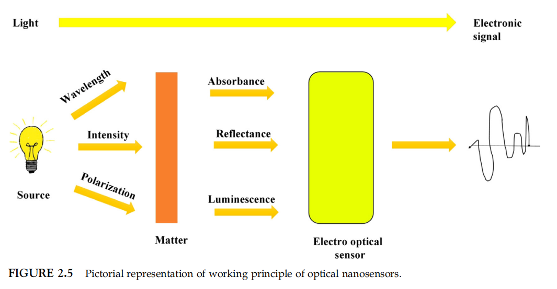
According to latest literature, optical nanosensors hold a unique niche in different industrial processes. Among them, leakage detection, healthcare, toxin detection, food industry, environmental protection including monitoring of pollution level and air quality etc. are significant [14]. Based upon the working principle, various analytical methodologies are adopted for detection. Because many toxins, flammable gases (H₂S, CO₂, HCl, O₃, CH₄, etc), respiratory irritant and greenhouse gas etc. absorb radiations in ultraviolet/infrared range.
2.2 Nanobiosensors
Nanobisensors have attracted researchers due to their detection sensitivity at various level starting from pico-, then femto-, atto- or even zepto (10⁻¹² -10⁻²¹) which make them able to detect diseases (DNA detection and cancer) at early stage. The device nanobiosensors are made of various components including biological element, a transducer and a detector as exhibited in Fig. 2.6. The title role and selection of biological element are important because it is the place where targeted molecules are attached. The biological elements include, antigens, antibodies, microorganisms, tissues, cells and enzymes. At the place of reaction, the calorimetric, electrochemical and optical changes are responsible to sensitize transducer and convert this modification to a meaningful response. Whereas, the response from transducer is converted into final upshot through detector [15].
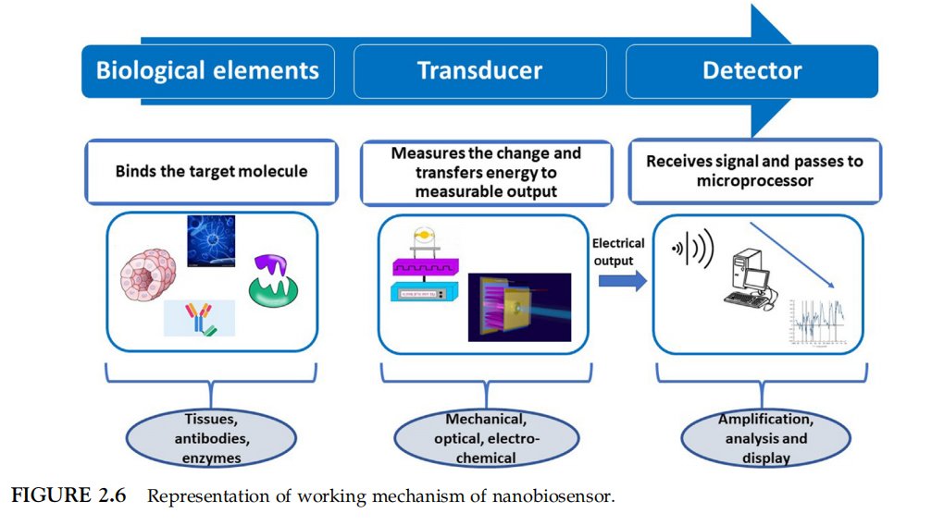
Nanomaterials used for the manufacturing of nanosurface plasmon resonance (nano-SPR) biosensors are synthesized by Nath and Chilkoti [16]. Valuable efforts were conducted to determine the optical features of adsorbed gold and parameters affecting them. Field-effect transistors (FETs) made of nanotubes have been designed, where the presence of electrostatic charge on the surface of nanotubes is responsible for biosensing applications [17].
2.3 Chemical nanosensors
According to the definition of the International Union of Pure and Applied Chemistry (IUPAC), a device that transmits chemical information into significantly measured signal is called as chemical sensor [18]. In other words, the addition of nanocomponent in a typical chemical sensor is referred as chemical nanosensor. The components having physicochemical transducer and a receptor (i.e., chemical molecule) are used to fabricate these devices. In this type of nanosensor, receptor interlinked to analyte and with changes in properties, an electrical signal is received by transducer [11]. After absorbing analyte (such as gas molecule), receptor alter its electrical characteristics including capacitance and resistance. Only trivial amount of gas molecules are enough to modify electrical properties associated to sensing elements to make them highly selective and sensitive. For example, the properties of gaseous molecules are detected by carbon nanotubes (CNTs) based nanosensors.
The ionization of gas molecules as well as their presence in environment and near industrial plant can be organized and monitored using chemical nanosensors. According to few reports, nanosensors made of CNTs have potential to detect NO₂ even in ppb concentration with high reversibility and selectivity [19]. In this context, the concentration of NO₂ in 100 ppb can be detected where CNTs and hexagonal-WO3 composites were used. It is claimed that, these nanosensors are significant for environmental applications due to their detection limit nearly close to the standards of ambient air quality [20]. Change in other environmental conditions including pressure and temperature can also be detected by these nanosensors. Besides this, type and concentration of chemical in various fields (e.g. chemical industries, food handling and storage, agriculture and food sector, beverage and alcohol industry, ventilation monitoring in transport sector) can also be detected by using chemical nanosensors [21].
Being human being, we can taste, smell, hear, feel and see using our sensory organs. Taste buds tingling and smelling involve the chemical alaysis of liquid/solid contact with tongue and ambient air, respectively. Due to this, chemical sensors can be anticipated as fake tongue/nose for their use in food industry to improve aroma other than quality control. Volatile compounds can also be identified using electronic/artificial nose, hence having effective applications in evaluating the quality of seafood, coffee bean grading and controlled cheese ripening.
2.4 Electrochemical nanosensors
Electrochemical nanosensors usually measure the conductance, potential, electrical current at electrode as well as sample-matrix interface [22]. It is based upon chemical reaction which involved the acceptance, consumption and release of ions by electrons.
An analyte of interest and a ligand undergo this chemical response, which measurably affects the transduced indicator, such as potential or an electric current [23]. In the existence of an analyte/interest marker, this electrochemical signal is immediately enumerated and linked to the sample solution. There are various subtypes of electrochemical detection methods depending on the signal, including voltammetry, potentiometry and electrochemical impedance spectroscopy [24]. The electrode-solution interface (either static or dynamic) is the place where signal detects in electrochemical nanosensors. In the dynamic technique, an electron transmission in voltammetric nanosensor follows a redox process that involves the interaction of analyte and electrode. Whereas, in static approach, the charged species concentration (as electrochemical potential) is observed by potentiometric nanosensor [25-26].

2.5 Mechanical nanosensors
Extremely small mass changes, forces and displacements can be easily measured by mechanical nanosensors where these changes are detected at molecular level. For instance, cantilevers are made up of a component that functions as a sensor for biological, chemical or physical changes in vibrational or deflection frequency [27]. They are made up of flexible and thin rods [28] that can be used to sense various specific substances [29–30].
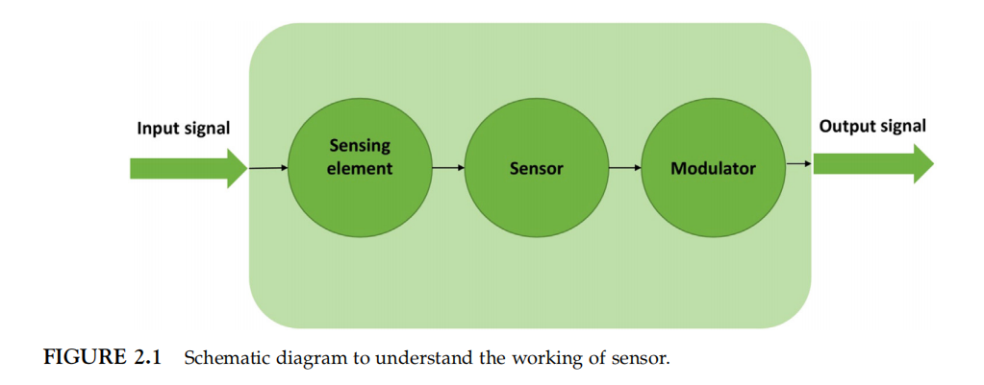3. Working mechanism
Sensors are employed in different fields for analysis of different analytes. Sensors detect the change in chemical composition of receptors and transducers transform this change into signals, these signals were changed into detectable sensor response. Figure 2.1 depicts the working principle of sensors. The sensors work exactly in the same manner like how a human sense the world; sensing components are like the body's sensory receptors, circuits are like nerves, and computers are like the brain. Functioning is comparable in both situations. In fig. 2.2, represents the similarity between the sensors and human sensing system.
3.1. Fabrication of nanosensors
For the fabrication of nanosensors, there are two different methods:
- Bottom-up approach
- Top-down approach
- Self-assembly
Other methods are also used for fabrication purpose but these three the most common in literature [31].

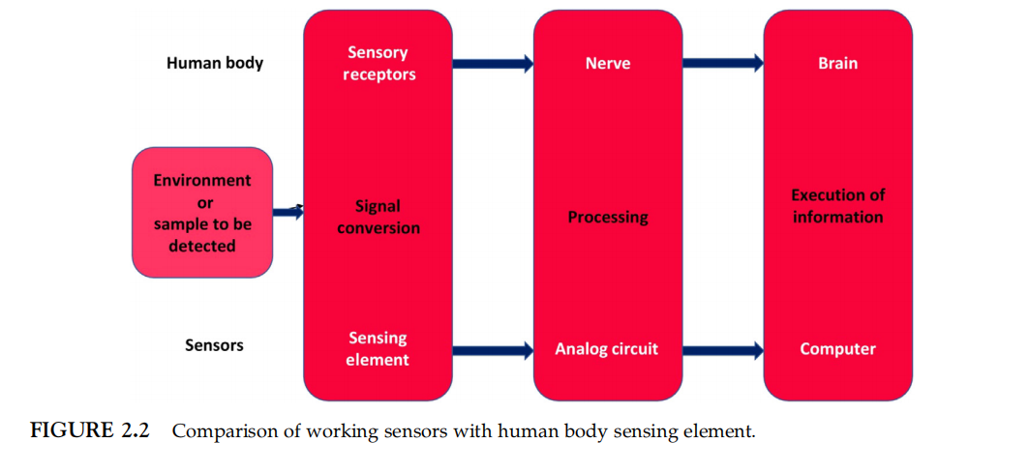
3.2 Top-down approach
In a simple way, top-down approach means it changes the size into smaller units as shown in figure 2.3. It is comparable to carving an idol out of stone, which ultimately involves chipping away some of the stone. By etching out a fraction of the original micro- or macro-sized particles, similarly nanosized particles for the manufacture of nanosensors are created. In lithographic method, to obtain the required size of particles, material is continuously separate from the starting material. For the continuation of these methods, vacuum and inert atmosphere is important to prevent agglomeration of newly synthesized and highly reactive particles. Different methods e.g. milling, laser ablation, electroexplosion, etching, sputtering, lithography and mechanochemical method are in this category, lithography and etching are the most commonly used approaches. For instance, using the lithographic approach, components for nanosensors are made from integrated circuits [32].
3.3. Bottom-up approach
Bottom-up approach is completely opposite to top-down method, in this method atoms and molecules are assembled to synthesize particles of nanodimensions. This technique is comparable to making an idol out of clay, when clay granules are gathered together to form an idol. However, the final structure for nanosensors is nanoscale [33]. In this approach, starting material is atomic sized particles and assembled together. This mechanism is depicted in figure 2.4. Solution phase technique, e.g. sol-gel, plasma, and flame spray method are the mostly used methods instead of chemical vapor condensation and chemical vapor deposition of bottom-up approach. Two important steps of this technique are growth and nucleation. This method has a key advantage over all top-down approaches in that it allows for the customization of sensing element properties. Customized characteristics increase the sensor's detecting range and increase sensitivity. Nanosensors designed through this method are more quick and sensitive also have minimum shortcomings. Some methods are high priced show uniform composition and are lazy in processing [34].
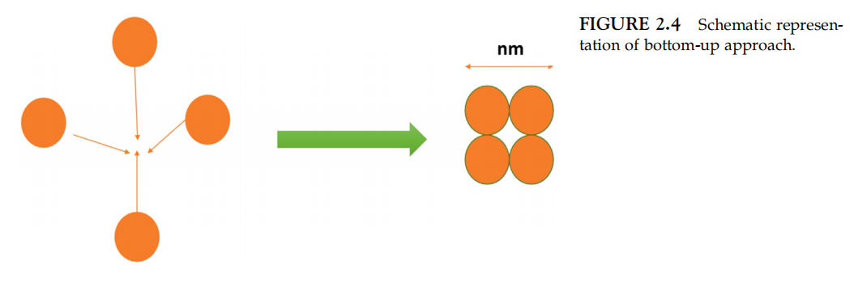
3.4 Self-assembly approach
This technique falls within the bottom-up strategy but the only distinction is that no external sources are employed during the process. Atoms and molecules are spontanuously self-assembled through a specific arrangement proves to be a quick and cost-effective process [35]. This strategy has basic two steps. The already synthesized material is considered as the precusors. These atoms are again agglomerated on its surface and generate fresh, higher sized naoparticles and then used as the part of nanosensors. The already generated particles are dipped into a collection of same atoms which helps them to stick into eachother [36].
- Characteristics of nanosensors
There are some main characteristics of nanosensors as follows:
• Nanosensors are highly efficient devices capable of measuring changes in particular
property.
• They can be fabricated as small and light weight devices.
• Once nanosensors are fabricated, very less set up conditions, are required for making them functional.
• Very small sample size is required for nanosensors to interact the material under investigation [37].
• Nanosensors are highly sensitivity and selective.
• They are very convenient to use with less response time and cost.
• They are highly suitable for real-time analysis.
• In comparison to other devices, very less power consumption is required.
• They provide useful, accurate, and precise information.
• These devices can be utilized for multitasking operations.
• They are stable under normal storage condition.
• Sensor should be specific in nature so that it can easily differentiate between analyte and other materials [38].
- Applications of nanosensors
The widespead uses of nanosensors help society to function efficiently. These devices can be employed to improve the everyday activities to rocket sciences. Sensors have important applications such as how much water should be added into wasing machine to prevent overflow. Sensors have multiple applications in daily life such as sensors in the doors at retail mall, sensor in the cars , sensors in the fields used to detect the quality of crops and also used in motors to monitor the the water and air flow [39]. sensors are also have extensive uses in textile and medical industries.
6.1. Applications in food industry
Modern research in the nascent subject of nanosensors facilitates to develop efficient, inexpensive and selective devices for analysis in food industry. Due to the availabilty ofnanosensors, food waste has been reduced and food safety is also ensured. Nanosensors changes into technologies with enormous benifits for agriculture and food industries. these miniaturised sized devices follow a simple principle to detect gaeses , contiamination, flavors, viruses, diseases, aromas, pckaging etc., however they offer greater accuracy and precision. There are some special sensors employed for food contamination and safety are nanocantilevers, electronic noses, electronic tongues, nanoparticle-based sensors, array-based sensors, and other types of sensors are used to monitor the safety of food. For food samples analysis, these sensors look for chemicals, toxins, spoilage, composition, diseases, bacteria, pathogens, etc. in the food samples.With the use of liposome-based biosensors, Vamvakaki and Chaniotakis [40] had monitored dichlorvos, paraoxon, etc. at very low levels. Escherichia coli detection has also reportedly been accomplished using GCE modified with bismuth nanofilm [41]. A biochip sensor system with two Ti contact pads and a Ti nanowell device on a LiNbO₃ substrate has been built. When the bacteria were resistant to the phages, a slight difference in voltage was noticed. According to Seo et al., it is measured in terms of power spectral density [42].
Similar to this, Rai et al. [43] provided a succinct summary of the uses of nanosized biosensors as a tool for testing multiple food items, including multivitamin evaluation, antibacterial identification, degradation of food, contamination by microbes, etc. Packing and delivery analysis of food, such nanosensors are particularly helpful. It is common knowledge during the fresh preparation of products, synthetic foods, packaging of semi-processed and sent to traders, the increased potential that during fresh during the process of fresh produce, the potential will be increased due to changed storage conditions which will reduce the food spoilage. Luechinger et al. [44] described that nanosensors designed using nanomaterials detects the presensce of moisture during food packing after production at retail locations. These small devices are also very helpful during the packing and delivery of food items. When the food is produced freshly,during packing of processing and semi-processing food, delivery to the retail locations, change in storage conditions may cause the contamination and food spoilage.
Mycotoxins are toxic compounds present in food articles synthesized by fungi. These toxic metabolites are not healthy may be a major cause of carcinogenic or even more toxic can cause severe damage to central nervous system [45]. Gaag et al. [46] described that the synthesis of SPR-based technique for the detection and quantification of mycotoxcins at very dilute concentration. For the analysis of various toxic metabolites e.g. aflatoxin B1, zearalenone, ochratoxin A, and fumarotoxin B1were also the advanced form of it. Similarly, the available miniaturised size devices, SPREETA was converted into highly cost-effective device for analysis. Yotova et al. [47] had written a lot related to the uses of sensors for the analysis of harmful molecules. Nanosensors are also used for the identification of huge toxic targets protein molecules to biggest microorganisms [48]. Nanosensors also have useful applications in food contamination and packaging. These small devices has the ability to detect the pathogens growth and alteration in colors when threshold limit is reached. Specially designed sensors are also very helpful to prevent from food poisoning through online control process [49].
Sharma et al. [50] described that apta-sensors, a modification in nanocensor bahves as a tool for the assessment of food quality. Apta-sensors are made up of aptamers (the target recognition component) and nanomaterials (the signal transducers and/or signal boosters). These are generated using the exponential enrichment of ligands and connect to the to the desired receptor. Metal nanoparticles, metal oxide nanoparticles metal and quantum dots (QDs), graphene,canbon nanotubes (CNTs) nanoclusters are commonly used for the synthesis of apta-sensors. Various forms of nanomaterials such as metal nanoparticles, metal oxide nanoparticles, metal and carbon quantum dots metal nanoclusters, graphene, CNTs, and nanocomposites are used to make apta-sensors. Apta-sensors may be superior to traditional methods in the future [51].
6.2. Applications in biomedical field
Nanobiotechnology play an important role in drug discovery, drug delivery, molecular diagnostics [52]. For the detection of lower limit biomarkers, optical, mechanical, electrical and magnetic characteristics are used for the synthesis of highly sensitive and selective nanosensors. These characteristics of nanomaterials have commonly employed applications. The US Food and Drug Administration has developed many rules for different doisorders and also helped through funding for nanomedicnes throughout the world [53]. Biotechnology has also improved the identification of desired molcules and biomolecules which are necessary for diagnosis purpose, this process is nanodiagnostics. Nanodiagnostics enhances the applications of nanotechnology for the identification and detection of analyte that are useful in diagnosis purpose. Due to the naturally low magnetic susceptibility of biological material, magnetic nanoparticles (NPs) (labelled with molecular targets) can be detected in unprocessed clinical samples. The prognosis is vastly improving as a result of the rising application of nanotechnology in cancer detection and treatment. Early detection and cancer genomics are increasingly important in the development of more specialized, tailored therapies for the majority of human tumors [54]. Nanosensors synthesized using Gold nanoprticles play important role in improving sensor response, east operation and portability application in diagnosis analysis [55]. Nanomedicines are large-surface-area nanomaterials with a submicrometer size that can be used to treat and diagnose illnesses [56]. Nanotechnology has demonstrated its ability to bridge the gap between biological and physical sciences by using nanostructures and nanophases in a range of sectors, such as nanomedicine and nano-based drug delivery systems.
6.2.1 Diagnosis of Diabetes Milletus
By the selection of suitable analytes, it is possible to reduce the chances of diabetes milletus for those people who are at great risk. There are following risks such as family history, age, race and obesity/ overweight etc [12]. The pathopysiological sources of D.M. are chronic inflammation and insulin resistance, and these may be detected using diagnostics and prognotics analysis [57]. Numerous differentially expressed biomarkers have been studied in D.M. and GDM investigations, offering a more in-depth understanding of the nuances of D.M. and GDM pathophysiology and potentially functioning as diagnostic indicators. Adipokines (leptin, tumor necrosis factor (TNF), interleukin 6 (IL-6), and others), glycoproteins (afamin, CD59, sex-hormone binding protein (SHBG), pregnancy-associated plasma protein-A (PAPP-A), C-reactive protein (CRP), and retinol-binding protein 4 (RBP4) are essential biomarkers for GDM detection (Fig. 1) [58-59]. Several ongoing research efforts will continue to develop more efficient and precise biomarkers to help update the detection and diagnosis of D.M. sickness. Nanotechnology can also help with earlier D.M. diagnosis and a better knowledge of its pathophysiology. Because D.M. is a glucose intolerance illness, a blood test is needed to diagnose it at its early stages. Diabetes mellitus can occur as a result of insulin resistance or decreased insulin production. According to the study, the most important factors influencing diabetes fetuses are mitochondrial damage and oxidative stress [60].
6.2.2. Nanosensors for acetone gas detection in human breath
Excessive acetone levels found in breath of humans are a major indicator of noninvasive diagnosis of diabetes [61]. Exhaled acetone concentrations in patients of diabetes milletus in individuals exceed 1.8 ppm, whereas healthy people have amounts of 0.3-0.9 ppm. Diabetes is currently detected using chemiresistive sensors that detect acetone in human breathe. Some of the semiconductor metal oxides that have long been employed in chemi-resistive gas sensing include In₂O₃ (Indium (III) oxide), CeO₂ (Cerium oxide), WO₃ (Tungsten oxide), SnO₂ (Tin oxide), and ZnO (Zinc oxide). Changes in electrical conductivity in the presence of gases and oxygen result in catalytic reduction/oxidation reactions at the metal oxide surface, which activates the sensing mechanism [62].
CH₃COCH_{3(gas)}+2O⁻ _{(ads)} = CH₃O⁻ + C + H₃ + CO₂ (gas)+2e⁻
CH₃O⁻ + C + H₃+ CO₂ (gas) + 2e⁻ = CH₃O⁻ + C + H₃ + CO_{2(gas)} + 2e⁻
CH₃O⁻ + C+H₃+CO_{2 (gas)} + 2e⁻ = CH₃O⁻+ C + H3 + CO₂ (gas)
Miniaturization, low power consumption, and low-cost mass production are all advantages of chemoresistive gas sensors for portable devices [67].
7. Benefits
- Sensitivity: Due to the increased surface to volume ratio of nanoparticles and nanoclusters, nanosensors showed more sensitivity by detecting alterations in receptors from their surroundings. these nanoreceptors make them ideal for detection and quantifiction of small amounts of analytes / signals [68].
- Selectivity: The addition of specific compounds or coatings to nanoparticles and nanoclusters helps for exceptional selectivity in sensing certain chemicals or target analytes. This allows for the exact detection and differentiation of diverse substances, biomarkers, and contaminants [69].
2.Miniaturization:Nanosensors may be reduced to incredibly tiny sizes, allowing them to be integrated into a wide range of devices and systems. This functionality is especially useful for applications with restricted area, such as wearable devices, medical implants, or environmental monitoring in small spaces [70].
4. Versatility: Nanoparticles and nanoclusters can be designed with a variety of materials and topologies, allowing for greater flexibility in sensor design and functioning. They may be programmed for responding to specific stimuli such as light, temperature, pressure, or chemical interactions, allowing them to be used in a wide range of sensing settings [71].
5. Real-time monitoring: Nanosensors are ideal for real-time monitoring applications due to their small dimensions and quick reaction. They can capture data continuously and instantly, enabling for the quick detection of changes or events [72].
10. Limitations of nanosensors
Nanosensors offer a variety of benefits over traditional sensors, but they also have several drawbacks [73], which are listed below. For example, the total process of development and implementation might be rather costly in certain cases. The creation of nanosensors is a time-consuming procedure as well [74-75]. When it comes to human tissues and cell cultures, nanomaterials may be toxic depending on their composition and concentration. A further limitation of genetically encoded FRET Nanosensors in the presence of background signal is that the emission wavelength coincides with chlorophyll autofluorescence as well as fluorescent signals from cell wall components [76]. Due to gene silencing, it is possible that genetically encoded FRET Nanosensors will be challenging to integrate. Another drawback of FRET Nanosensors is the absence of statistical tools for assessing large amounts of data in real time. Nanosensors for temperature and ionic strength that use electrochemical reactions are intrusive, and they need on-site power supply [78-79]. The manufacture of piezoelectric Nanosensors, on the other hand, may be time-consuming and costly.
Conclusion and future perspectives
Nanotechnology is revolving around us since many decades. Nanostructured materials have changed research studies all over the world and nanosensors also brought revolution in every field of life. Several approaches has been devised and development of nanosensors has become simpler as synthetic pprocedures. We have developed a deep knowledge of developing nanosensors through characterization and and assessment methods. Various kinds of nanosensors have been synthesized such biosensors, chemical and optical sensors demonstrating their adaptability. All these advancements have resulted a diverse range of nanosensors in different fields of science. These nanosensors have found widespread application in fields such as health, food, military, agriculture, and safety.
Certain nanosensors have hit the market, a big fraction of their applications have yet received commercial viability. The goal should be to transition the success obtained in the research stage to the commercial level as quickly as possible so that the beneficial features of these sensors can enrich our daily life. Nanosensors designed by metals, metal oxides, graphene, graphene oxide, carbon nanotubes (CNTs) are extremely attractive candidates in future for textile industries due to their greater mechanical strength, high flexibility, electrical and thermal conductivities, also improved the corossion and exidation resistance. Furthermore, increased fitness consciousness in people, breakthrough in medicine industry, growing global focus on energy sustainability thoughtout the world is to promote research importance for medical and energy harvesting- based smart uses. Overall, the benefits of nanotechnology are enormous, and the ever-expanding reach of these nanosensors in numerous disciplines bodes well for their eventual implementation in everyday life.
References
[1] Kumar N, Kumbhat S. Nano materials: general synthetic approach in essentials. Nanoscience and nanotechnology. 1st ed New Jersey: John Wiley and Sons; 2016.
[2] Dahman Y, Radwan A, Nesic B, Isbister J. Nanosensors. In: Dahman Y, editor. Nanotechnology and functional materials for engineers. 1st ed The Netherland: Elsevier Inc.; 2017.
[3] He T, Shi Q, Wang H, Wen F, Chen T, Ouyang J, et al. Beyond energy harvesting - multi-functional triboelectric nanosensors on a textile. Nano Energy 2019;57:338 52.
[4] Liao X, Liao Q, Zhang Z, Yan X, Liang Q, Wang Q, et al. A highly stretchable ZnO@fiber-based multifunctional nanosensor for strain/temperature/UV detection. Adv Funct Mater 2016;26:3074 81.
[5] Lee T, Lee W, Kim SW, Kim JJ, Kim BS. Flexible textile strain wireless sensor functionalized with hybrid carbon nanomaterials supported ZnO nanowires with controlled aspect ratio. Adv Funct Mater 2016;26:620614.
[6] Mao Y, Shen M, Liu B, Xing L, Chen S, Xue X. Self-powered piezoelectric- biosensing textiles for the physiological monitoring and time-motion analysis of individual sports. Sensors 2019;19:3310.
[7] N. Ullah, M. Mansha, I. Khan, A. Qurashi, Nanomaterial-based optical chemical sensors for the detection of heavy metals in water: recent advances and challenges, TrAC Trends Anal. Chem. 100 (2018) 155–166.
[8] Y. Wang, T.V. Duncan, Nanoscale sensors for assuring the safety of food products, Curr. Opin. Biotechnol. 44 (2017) 74–86.
[9] S. Hameed, A. Munawar, W.S. Khan, A. Mujahid, A. Ihsan, A. Rehman, I. Ahmed, S. Z. Bajwa, Assessing manganese nanostructures based carbon nanotubes composite for the highly sensitive determination of vitamin C in pharmaceutical formulation, Biosens. Bioelectron. 89 (2017) 822–828.
[10] A. Munawar, Y. Ong, R. Schirhagl, M.A. Tahir, W.S. Khan, S.Z. Bajwa, Nanosensors for diagnosis with optical, electric and mechanical transducers, RSC Adv. 9 (2019) 6793–6803.
[11] P. Singh, S.K. Pandey, J. Singh, S. Srivastava, S. Sachan, S.K. Singh, Biomedical perspective of electrochemical nanobiosensor, Nano Micro Lett. 8 (2016) 193–203.
[12] Q. Lang, L. Han, C. Hou, F. Wang, A. Liu, A sensitive acetylcholinesterase biosensor based on gold nanorods modified electrode for detection of organophosphate pesticide, Talanta 156–157 (2016) 34–41.
[13] Q. Liu, H. Yang, Application of atomic force microscopy in food microorganisms, Trends Food Sci. Technol. 87 (2019) 73–83.
[14] S. Ca´rdenas-Perez, J.J. Chanona-Perez, J.V. Mendez-Mendez, I. Arzate- Va´zquez, J.D. Herna´ndez-Varela, N.G. Vera, Recent advances in atomic force microscopy for assessing the nanomechanical properties of food materials, Trends Food Sci. Technol. 87 (2019) 59–72.
[15] J. Wang, S. Nie, Application of atomic force microscopy in microscopic analysis of polysaccharide, Trends Food Sci. Technol. 87 (2019) 35–46.
[16] Dahman Y, Radwan A, Nesic B, Isbister J. Nanosensors. In: Dahman Y, editor. Nanotechnology and functional materials for engineers. 1st ed The Netherland: Elsevier Inc.; 2017.
[17] Kumar N, Kumbhat S. Nano materials: general synthetic approach in essentials. Nanoscience and nanotechnology. 1st ed New Jersey: John Wiley and Sons; 2016.
[18] Dahman Y, Radwan A, Nesic B, Isbister J. Nanosensors. In: Dahman Y, editor. Nanotechnology and functional materials for engineers. 1st ed The Netherland: Elsevier Inc.; 2017.
[19] Rai V, Acharya S, Dey N. Implications of nanobiosensors in agriculture. J Biomater Nanobiotechnol 2012;3: 315-24.
[20] Luechinger NA, Loher S, Athanassiou EK, Grass RN, Stark WJ. Highly sensitive optical detection of humidity on polymer/metal nanoparticle hybrid films. Langmuir 2007; 23(6):3473-7.
[21] Gaag B, Spath S, Dietrich H, Stigter E, Boonzaaijer G, Osenbruggen T, et al. Biosensors and multiple mycotoxin analysis. Food Control 2003;14:251-4.
[22] Sharma R, Ragavan KV, Thakur MS, Raghavarao KS. Recent advances in nanoparticle based aptasensors for food contaminants. Biosens Bioelectron 2015;74:612-27.
[23] Rai M, Ribeiro C, Mattoso L, Duran N. Nanotechnologies in agriculture and food. Switzerland: Springer International Publishing; 2015.
[24] Omanovi´c-Mikliˇcanina E, Maksimovi´c M. Nanosensors applications in agriculture and food industry. Bull Chem Technol Bosnia Herzeg 2016;47:59 70.
[24] Ditta A. How helpful is nanotechnology in agriculture? Adv Nat Sci Nanosci Nanotechnol 2012;3 (3):033002-12.
[25] Shyamkumar P, Rai P, Oh S, Ramasamy M, Harbaugh RE, Varadan V. Wearable wireless cardiovascular monitoring using textile-based nanosensor and nanomaterial systems. Electronics 2014;3(3):504-20.
[26] Lai YC, Deng J, Zhang SL, Niu S, Guo H, Wang ZL. Single-thread-based wearable and highly stretchable triboelectric nanogenerators and their applications in cloth-based self-powered human-interactive and biomedical sensing Adv Funct Mater 2017;271604462.
[27] Chen J, Huang Y, Zhang N, Zou H, Liu R, Tao C, et al. Micro-cable structured textile for simultaneously harvesting solar and mechanical energy. Nat Energy 2016;1:16138.
[28] Xu J, Wang D, Yuan Y, Wei W, Duan L, Wang L, et al. Polypyrrole/reduced graphene oxide coated fabric electrodes for supercapacitor application. Org Electron 2015;24:153- 9.
[29] Yan S, Dong K, Lu J, Song W, Xiao R. Amphiphobic triboelectric nanogenerators based on silica enhanced thermoplastic polymeric nanofiber membranes. Nanoscale 2020;12:4527-36.
[30] Liu S, Wang H, He T, Dong S, Lee C. Switchable textile-triboelectric nanogenerators (S-TENGs) for continuous profile sensing application without environmental interferences Nano Energy 2020;69Accepted Manuscript.
[31] Xiong J, Lee PS. Progress on wearable triboelectric nanogenerators in shapes of fiber, yarn and textile. Sci Technol Adv Mater 2019;20:837-57.
[32] Tseghai GB, Malengier B, Fante KA, Langenhove LV. The status of textile- based dry EEG electrodes Autex Res J. 2020; (published online ahead of print).
[33] Sharon M. Smart nanofabrics for defense. In: Sharon M, Rodriguez ASL, Sharon C, Gallardo SP, editors. Nanotechnology in the defense industry: advances, innovation, and practical applications. Scrivener Publishing LLC; 2019. p. 235 73.
[34] Kim M, Kim H, Park J, Jee KK, Lim JA, Park MC. Real-time sitting posture correction system based on highly durable and washable electronic textile pressure sensors. Sens Actuators A Phys 2018;269:394-400.
[35] Souri H, Bhattacharyya D. Highly stretchable multifunctional wearable devices based on conductive cotton and wool fabrics. ACS Appl Mater Interfaces 2018;10:20845-53.
[36] Li X, Koh KH, Farhan M, Lai KWC. Ultraflexible polyurethane yarn-based wearable strain sensor with poly dimethylsiloxane infiltrated multilayer sheath for smart textiles. Nanoscale 2020;12:4110-18.
[37] Skrzetuska E, Puchalski M, Kruci´nska I. Chemically driven printed textile sensors based on graphene and carbon nanotubes. Sens (Switz) 2014;14:16816-28.
[37] Chan KL, Fawcett D, Poinern GEJ. Gold nanoparticle treated textile-based materials for potential use as wearable sensors. Int J Sci 2016;2:829.
[38] J.A. Kemp, Y.J. Kwon, Cancer nanotechnology: current status and perspectives,
Nano Converg. 8 (1) (2021).
[39] USFDA, Nanotechnology: Over a Decade of Progress and Innovation at FDA, 2020, pp. 1-24.
[40] C. Jin, K. Wang, A. Oppong-Gyebi, J. Hu, Application of nanotechnology in cancer diagnosis and therapy – a mini-review, Int. J. Med. Sci. 117 (18) (2020) 2964–2973.
[41] Javier Lou-Franco, et al., Gold nanozymes: from concept to biomedical applications, Nano-Micro Lett, 13(1), 2020, p. 10.
[42] J.K. Patra, et al., Nano based drug delivery systems: recent developments and future prospects, J. Nanobiotechnol. (2018) 1–33.
[43] R. Soni, A. Kumar, P. Pooja, J.A. Lal, K. Kesari, V. Tripathi, An overview ofnanoscale materials on the removal of wastewater contaminants, Appl. Water Sci. 10 (8) (2020) 1–9.
[44] H. Sadegh, et al., The role of nanomaterials as effective adsorbents and their applications in wastewater treatment, J. Nanostruct. Chem. 7 (1) (2017) 1-14,
[45] S. De Gisi, G. Lofrano, M. Grassi, M. Notarnicola, Characteristics and adsorption capacities of low-cost sorbents for wastewater treatment: a review, Sustain. Mater. Technol. 9 (2016) 10–40.
[47] J. Yang, et al., Nanomaterials for the removal of heavy metals from wastewater,
Nanomaterials 9 (3) (2019).
[48] M.F. Ahmed, et al., Hybrid beads of zero valent iron oxide nanoparticles and chitosan for removal of arsenic in contaminated water, Water 13 (20) (2021) 2876.
[49] E. Weidner, F. Ciesielczyk, Removal of hazardous oxyanions from the environment using metal-oxide-based materials, Materials 16 (6) (2019).
[50] M. Anjum, R. Miandad, M. Waqas, F. Gehany, M.A. Barakat, Remediation of wastewater using various nano-materials, Arab. J. Chem. 12 (8) (2019) 4897– 4919.
[51] N.R. Nicomel, K. Leus, K. Folens, P. Van Der Voort, G. Du Laing, Technologies for arsenic removal from water: current status and future perspectives, Int. J. Environ. Res. Public Health 13 (1) (2015) 1–24.
[52] V.K. Yadav, et al., Synthesis and characterization of amorphous iron oxide
nanoparticles by the sonochemical method and their application for the remediation of heavy metals from wastewater, Nanomaterials 10 (8) (2020) 1– 17.
[53] H. Ali, E. Khan, I. Ilahi, Environmental chemistry and ecotoxicology of hazardous heavy metals: environmental persistence, toxicity, and bioaccumulation, J. Chem. 2019 (2019).
[54] M. Jalilzadeh, D. Çimen, E. ¨ Ozgür, C. Esen, A. Denizli, Design and preparation of imprinted surface plasmon resonance (SPR) nanosensor for detection of Zn(II) ions, J. Macromol. Sci. Part A Pure Appl. Chem. 56 (9) (2019) 877–886.
[55] P. Sharma, et al., A review on biosensors and nanosensors application in agroecosystems, Nanoscale Res. Lett. 16 (1) (2021).
[56] S. Behzadi, et al., HHS Public Access, 46(14), 2018, pp. 4218–4244.
[57] Z.-H. Zhou, C.-L. Zou, Y. Chen, Z. Shen, G.-C. Guo, C.-H. Dong, Broadband tuning of the optical and mechanical modes in hollow bottle-like microresonators, Opt. Express 25 (4) (2017) 4046.
[58] I.A. Lakhiar, G. Jianmin, T.N. Syed, F.A. Chandio, N.A. Buttar, W.A. Qureshi,
Monitoring and control systems in agriculture using intelligent sensor techniques: a review of the aeroponic system, J. Sens. 2018 (2018).
[59] C. Sharma, R. Dhiman, N. Rokana, H. Panwar, Nanotechnology: an untapped resource for food packaging, Front. Microbiol. 8 (2017).
[60] M. Soltani Firouz, K. Mohi-Alden, M. Omid, A critical review on intelligent and active packaging in the food industry: research and development, Food Res. Int., 141(2020), 2021, p. 110113.
[61] A. Oukhatar, M. Bakhouya, D. El Ouadghiri, Electromagnetic-based wireless nano-sensors network: architectures and applications, J. Commun., 16(1), 2021, pp. 8–19.
[62] E. Lallas, Key roles of plasmonics in wireless THz nanocommunications-a survey, Appl. Sci. 9 (24) (2019).
[63] Z. Ullah, G. Witjaksono, I. Nawi, N. Tansu, M.I. Khattak, M. Junaid, A review on the development of tunable graphene nanoantennas for terahertz optoelectronic and plasmonic applications, Sensors 20 (5) (2020).
[67] H. Sohrabi, et al., Recent advances on portable sensing and biosensing assays applied for detection of main chemical and biological pollutant agents in water samples: a critical review, TrAC Trends Anal. Chem. 143 (2021), 116344.
[68] S.A. Walper, et al., Detecting biothreat agents: from current diagnostics to developing sensor technologies, ACS Sens. 3 (10) (2018) 1894–2024.
[69] V.B. Juska, M.E. Pemble, A critical review of electrochemical glucose sensing:
evolution of biosensor platforms based on advanced nanosystems, Sensors 20 (21) (2020) 1–28.
[70] R.M. Lu, et al., Development of therapeutic antibodies for the treatment of diseases, J. Biomed. Sci. 27 (1) (2020) 1–30.
[71] J. Zhou, J. Rossi, Aptamers as targeted therapeutics: current potential and challenges, Nat. Rev. Drug Discov., 16(3), 2017, pp. 181–202.
[72] G. Perret, E. Boschetti, Aptamer affinity ligands in protein chromatography, Biochimie 145 (2018) 98–112.
[73] G. Faccio, From protein features to sensing surfaces, Sensors 18 (4) (2018),
[74] P.A. Nazarov, D.N. Baleev, M.I. Ivanova, L.M. Sokolova, M.V. Karakozova, Infectious plant diseases: etiology, current status, problems and prospects in plant protection, Acta Nat. 12 (3) (2020) 46–59.
[75] R.K. Saini, L.P. Bagri, A.K. Bajpai, Smart Nanosensors for Pesticide Detection,
2019, Elsevier Inc., 2017.
[76] S. Sahani, Y.C Sharma, Advancements in applications of nanotechnology in global food industry, Food Chem 342 (2021) 128318.
[77] Y. Durmaz, M. Kilicli, O.S. Toker, N. Konar, I. Palabiyik, F. Tamturk, Using spray– dried microalgae in ice scream formulation as a natural colorant: effect on physicochemical and functional properties, Algae Res 47 (2020) 101811.
[78] M. Venkatachalam, M. Zelena, F. Cacciola, L. Ceslova, E. Girard-Valenciennes, P. Clerc, P. Dugo, L. Mondello, M. Fouillaud, A. Rotondo, D. Giuffruda, L. Dufossé, Partial characterization of the pigments produced by the marine- derived fungus Talaromyces albobiverticillius 30548. Towards a new fungal red colorant for the food industry, J Food Compos Anal 67 (2018) 38.
[79] M. Filgueiras Rebelo de Matos, P. Quênia Muniz Bezerra, L. Conceição Argôlo Correia, D. Nunes Viola, A. de Oliveira Rios, J. Izabel Druzian, I. Larroza Nunes, Innovative methodological approach using CIELab and dye screening for chemometric classification and HPLC for the confirmation of dyes in cassava flour: a contribution to product quality control, Food Chem 365 (2021) 130446,

