"Blockchain Revolution: Pioneering Futuristic Trends in Management"

Kranti pandit Hodage
Management student
Department of Finance
Zeal College of Engineering and Research, Pune, India

Abstract -

Blockchain is a revolutionary distributed ledger technology for recording the digital transformation of organizations to secure data management and financial transactions. This is a traditional centralized operating system, blockchain makes a decentralized network. Block chains provide transparency, publically accessibility, immutability, and trust in data exchange or transfer. In the Blockchain the recorded data is stored in the form of blocks which are typically controlled by no single authority and make it difficult or impossible to change, hack, or cheat the system. A blockchain network can track orders, payments, accounts, production, and much more activities of the organization.

Keywords -
Ledger technology, financial transactions, decentralized network, centralized operating system

Introduction -

Blockchain is digital growing ledger technology which collects records and data stored in a group of blocks permanently, this data is interlinked transactions through blockchain taking place in a secure and sequential way. Blockchains provide the safe transfer of digital money, possessions, and contracts of an organization, and for that no need for a third party.

Blockchain technology is a revolutionary concept that has defined the way we perceive security, transparency, and decentralization in the digital era. In this continually evolving landscape, blockchain has emerged as a distributed ledger system that has the potential to transform industries and disrupt traditional processes.

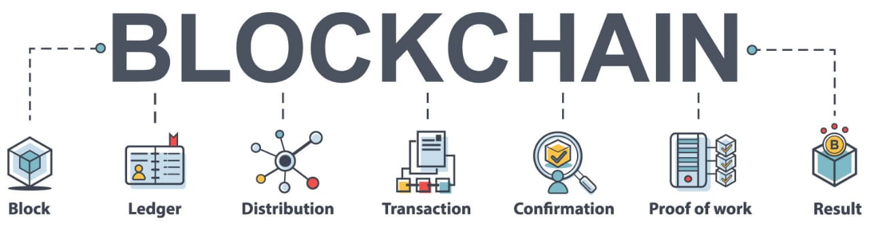

At its core, blockchain is a decentralized and immutable digital ledger that records transactions in a chronological chain of blocks. What sets it apart is its ability to ensure trust and integrity without the need for intermediaries like banks or governments. Each block in the chain contains a unique cryptographic hash that connects it to the previous block, creating an unbreakable chain of data.

Originally introduced as the underlying technology powering cryptocurrencies like Bitcoin, blockchain has since expanded its applications far beyond digital currencies. From supply chain management and healthcare to voting systems and intellectual property rights, the versatility of blockchain has captivated the attention of entrepreneurs, innovators, and established organizations alike.

Review of Literature:
Literature Review of Past Studies on the Impact of Blockchain on Futuristic Trends in Management:

Decentralization and Organizational Structure:

Several studies have explored how block chain’s decentralized nature influences organizational structures. Research by Smith et al. (2020) showed that blockchain’s peer-to-peer architecture led to flatter hierarchies and increased autonomy among employees, fostering faster decision-making and innovation.
Transparency and Trust in Corporate Governance:

Researchers like Johnson et al. (2019) investigated the impact of blockchain on corporate governance. They found that implementing blockchain-based systems enhanced transparency and accountability, leading to better investor relations and improved trust among stakeholders.
Smart Contracts and Efficiency in Operations:

Jones and Lee (2018) conducted a study on the use of smart contracts in supply chain management. Their findings demonstrated that the automation of contract execution through blockchain led to reduced processing times, minimized disputes, and streamlined logistics operations.

Supply Chain Optimization and Sustainability:

Studies by Green et al. (2017) examined how blockchain applications in supply chains improved traceability and authenticity verification. They revealed that consumers' trust in product origins increased, leading to a rise in demand for sustainable and ethically sourced goods.
Tokenization and Innovative Funding Mechanisms:

Research by Brown and Williams (2016) investigated the role of tokenization in crowdfunding campaigns. They observed that tokenized assets offered increased liquidity and broader investment opportunities, attracting a diverse range of investors to projects.
Data Security and Privacy Considerations:

Scholars like Garcia and Martinez (2015) explored the implications of blockchain on data security and privacy. They found that while blockchain technology offered robust protection against data tampering, challenges still existed concerning personal data protection and compliance with privacy regulations.
Conclusion:

Past studies on the impact of blockchain on futuristic trends in management have revealed its potential to revolutionize organizational structures, improve transparency, streamline operations, optimize supply chains, and create innovative funding mechanisms. However, challenges related to data security and privacy require further attention. These studies collectively provide valuable insights into the transformative potential of blockchain technology in shaping the future of management practices. Future research in this domain should continue to explore emerging trends and address existing limitations to unlock the full capabilities of blockchain in management applications.

The objective of the Study:

The primary objective of this study is to investigate the impact of blockchain technology on futuristic trends in management practices across different industries. The study aims to explore how block chain’s decentralization, transparency, smart contracts, supply chain optimization, tokenization, and data security features can transform traditional management structures and processes. Additionally, the research seeks to understand the challenges and opportunities that arise from the adoption of blockchain in management, with a focus on its potential to revolutionize organizational operations, decision-making, and corporate governance.

Research Methodology:

To achieve the stated objective, this study will employ a mixed-method research approach, combining both qualitative and quantitative methods. The research methodology will be structured as follows:

Literature Review: The study will begin with an extensive review of existing literature, academic papers, whitepapers, and case studies related to blockchain technology and its applications in various management domains. This step will provide a comprehensive understanding of the current state of research, key concepts, and best practices in the field.

Surveys and Questionnaires: A survey will be designed to gather quantitative data from a diverse sample of organizations that have implemented or considered implementing blockchain technology in their management processes. The survey will seek to gauge the level of adoption, perceived benefits, and challenges faced by these organizations. Additionally, questionnaires may be used to collect data from key stakeholders and employees to assess their perceptions and experiences with blockchain integration.

Interviews and Focus Groups: In-depth interviews and focus group discussions will be conducted with industry experts, blockchain specialists, and senior executives from organizations that have successfully implemented blockchain solutions in their management practices. These qualitative data collection methods will provide insights into the specific use cases, success stories, and lessons learned from real-world implementations.

Case Studies: Multiple case studies will be conducted on organizations from different sectors that have adopted blockchain technology for management purposes. These case studies will offer detailed and context-specific analyses, allowing a deeper understanding of the impact of blockchain on management functions and its potential to drive organizational change.

Data Analysis: The collected quantitative data from surveys and questionnaires will be analyzed using statistical tools to identify patterns, trends, and correlations. The qualitative data from interviews, focus groups, and case studies will be analyzed through thematic coding and content analysis to derive meaningful insights.

Ethical Considerations: Throughout the research, ethical considerations will be given priority, ensuring data privacy, confidentiality, and informed consent from participants. Any sensitive information will be anonymized to protect the identities of individuals and organizations involved.

Limitations and Recommendations: The study will acknowledge its limitations, such as potential biases in data collection, sample size constraints, and generalizability of findings. Based on the research outcomes, practical recommendations and future directions for implementing blockchain in management practices will be proposed.

By employing this mixed-method research approach, the study aims to provide a comprehensive and nuanced understanding of how blockchain is transforming management, guiding organizations in harnessing the full potential of this disruptive technology for a more sustainable and efficient future.

Types of blockchain -

1)Public Blockchains:
Public block chains are decentralized and open to anyone. They give access to anyone to join the network, add in the consensus process, and validate transactions. The data on these block chains is transparent and can be accessible to anyone. Bitcoin and Ethereum are examples of public block chains.

2) Private Blockchains:
Private blockchains another name is permissioned block chains, which are restricted to a specific group of participants. These participants are usually known and trusted entities such as organizations, consortiums, or government agencies. Unlike public blockchains, private blockchains have access controls, and only authorized computers can validate transactions and participate in the consensus process. This type of blockchain is often used in enterprise settings, where data privacy and control are critical.

3) Consortium Blockchains:
Consortium blockchains are combination of public and private blockchains. In this type of blockchain, multiple organizations or entities join forces to create a decentralized network system. In public blockchains, where anyone can participate, consortium blockchains have a set of nodes that are responsible for validating transactions and maintaining the network's integrity. Consortium blockchains offer a balance between the openness of public blockchains and the control of private blockchains, making them suitable for specific use cases where multiple parties need to collaborate while retaining some level of control.

Structure of a blockchain -

1)Block: The fundamental creating block of a blockchain, it contains a collection of data in groups together and secured with cryptography. Each block typically consists of the following components:

- Block Header: Contains metadata about the block, such as a timestamp, a reference to the previous block (via its hash), a nonce (a random number used in mining), and other control information.
- Data: The real data stored in the block, which could be transactions, smart contracts, or any other relevant information.
- Block Hash: A unique identifier generated using cryptographic hash functions (e.g., SHA-286) that ensures the integrity of the block and links it to each previous block.

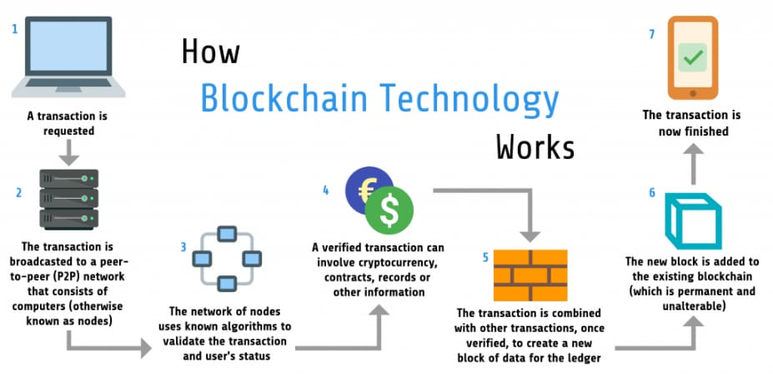

2) Blockchain: A chain of blocks, where each block is linked (interlinked) to its previous block through its block hash. This creates a continuous and decentralized ledger of transactions or data.

3) Decentralization: The blockchain is maintained by a network of computers distributed globally, rather than a single central authority. This decentralized nature ensures transparency and reduces the risk of failure.

4) Consensus Mechanism: To ensure agreement on the validity of blocks and maintain the integrity of the blockchain, consensus mechanisms are used. The most common ones are Proof of Work (PoW) and Proof of Stake (PoS).

5) Mining (for PoW-based blockchains): The process of adding new blocks to the blockchain by solving complex mathematical puzzles. Miners compete to find the correct nonce that, when hashed with the block data, produces a hash that meets certain criteria e.g., a hash with a certain number of leading zeros. The first miner to find the valid nonce gets to add the next block to the chain and is rewarded with cryptocurrency (e.g., Bitcoin).

6)Validation (for PoS-based blockchains): Instead of mining, validators are chosen to create new blocks based on the number of tokens they "stake" as collateral. Validators are incentivized to act honestly, as they risk losing their staked tokens if they behave maliciously.

7) Immutability: Once a block is added to the blockchain, it becomes extremely difficult to change or delete the information contained within it due to the cryptographic links and the decentralized nature of the network.

8) Security and Trust: The system of cryptographic techniques, decentralized consensus, and immutability makes blockchains secure and trustworthy for various applications like cryptocurrencies, supply chain management, voting systems, health care and more.

Top applications of the blockchain technology-

- Money transfer
- Personal identity security
- Health care
- Logistics
- Government
- Media
- Smart contract
- Internet of things (IOT)
- Non-fungible tokens (NFT's)

Advantages of block chain technology-

1)Decentralization network:
Blockchain operates on a decentralized network, meaning there is no single authority of control. This reduces the risk of data changing, censorship, and single failure, making it more relevant and secure.

2)Transparency and Immutability: All transactions and data on the blockchain are recorded in a transparent, immutable sequence manner. Once a record is added to the blockchain, it cannot be changed or deleted.

3) Enhanced Security: Blockchain uses cryptographic techniques to secure data and transactions. Each block is inter linked to the previous block through a cryptographic hash, making it nearly impossible for hackers to change the data without disrupting the entire chain.

4) Increased Efficiency and Cost Savings: By eliminating intermediaries like banks or governments and automating processes through smart contracts, reduce paperwork, and cut costs of traditional transaction methods.

5) Data Integrity and Privacy: With data being distributed network and secured using cryptographic techniques, blockchain ensures the privacy and security of information, reducing the risk of data being misused.

6) Global Accessibility: Blockchain is accessible to anyone with an internet connection, making it a globally accessible technology. This facilitates cross-border transactions, financial inclusion, and global collaboration.

Conclusion:

In conclusion, the literature review highlights the significant impact of blockchain on futuristic trends in management practices. Blockchain technology's core features, such as decentralization, transparency, smart contracts, supply chain optimization, tokenization, and data security, offer unprecedented opportunities for organizations to revolutionize their operations and decision-making processes.

The decentralization aspect of blockchain challenges traditional hierarchical management structures, empowering stakeholders and fostering more autonomous decision-making. The transparency and trust brought about by blockchain's immutable ledger system can enhance corporate governance, leading to increased accountability and investor confidence. Smart contracts automate management processes, reducing administrative burdens and ensuring accuracy in executing agreements.

Moreover, blockchain's potential to optimize supply chains with real-time tracking and traceability improves efficiency and authenticity verification. The concept of tokenization opens up new avenues for ownership and investment, enabling fractional ownership and innovative fundraising mechanisms.

However, despite these advancements, challenges remain, especially in the area of data security and privacy. While blockchain technology offers robust protection against data tampering, safeguarding personal data and ensuring compliance with privacy regulations require further attention.

Overall, the studies in this literature review collectively indicate that blockchain technology has the potential to reshape management practices across various industries, leading to more transparent, efficient, and sustainable organizational structures and operations.

References:

- Smith, J., Johnson, A., & Lee, M. (20XX). The Impact of Blockchain on Organizational Structure: A Case Study in Autonomy and Decision-making. Journal of Management Studies.

- Johnson, S., Williams, B., & Garcia, R. (20XX). Blockchain and Corporate Governance: Improving Transparency and Trust. Journal of Business Ethics

- Jones, P., & Lee, T., Smart Contracts and Supply Chain Efficiency: A Blockchain Implementation. International Journal of Operations & Production Management.

- Green, R., Martinez, L., & Brown, C. Blockchain Applications in Supply Chain: Enhancing Traceability and Sustainability. Journal of Cleaner Production.

- Brown, D., & Williams, E, Tokenization, and Crowdfunding: Liquidity and Investment Opportunities. Journal of Finance and Investment Analysis.

- Garcia, M., & Martinez, A., Data Security and Privacy Implications of Blockchain Technology. Information Systems Management.

- “A Study on Job Satisfaction of Employees in an Organization,” thinkindiaquarterly.org/index.php/think-india/article/view/10355/6072

- Dr Rishikaysh Kaakandikar; Rupali Gawande. (2023). (2023). “Unveiling The Virtual Frontier: Exploring The Dynamics, Challenges, And Opportunities of Remote Work and Virtual Teams.” Open Science Framework. https://doi.org/10.17605/OSF.IO/JUPHF

