INSILICO SYNTHESIS AND BIOLOGICAL EVALUATION OF
SOME NOVEL QUINOLINE DERIVATIVES
TEJAS SHI MALIPATIL¹, N.SHRINIVASULULU²

1. Department of Pharmaceutical chemistry V.L. College of Pharmacy
Raichur, Karnataka India.
Corresponding Email ID- tejasmuttu19521@gmail.com

ABSTRACT

The purpose of this research is to functionalize to synthesise 4,7- disubstituted quinoline.Intially quinoline derivatives was docked using 3U2D DNA Gyrase as a target for anti-bacterial activity by using schrodinger software, from the results obtained from docking only those compounds which shown potent activity were subjected for synthesis using facile method. The synthesized compounds was characterized by IR, NMR and Mass spectrometry,The synthesized compounds (TM1-TM8) were screened for antibacterial activity studies at various concentrations of 5, 10, 25, 50 and 75g/ml using DMF as a control against Staphylococcus aureus, Enterococcus faecalis, Escherichia coli and Klebsiella pneumonia, by agar-well diffusion method. Ciprofloxacin was used as standard drug. Among the synthesized compounds TM4 shown moderate activity when compared with the standard, rest of the derivatives possesses weak antibacterial activity.

KEYWORDS:

Quinolines, DNA Gyrase, p-Hydroxy benzaldehyde, Sodium acetate, Potassium hydroxide, Choroacetyl chloride, Choropropionyl chloride, Antimicrobial activity.

INTRODUCTION
Quinoline ¹ nucleus is exist in many naturally compounds and having diverse biological activities. Quinoline moiety is of great importance to chemists as well as biologists as it is chemically useful molecules having diverse biological activities such as anti- inflammatory, anti HIV, antibiotic, antimalarial, anticancer, antihypertensive. A large variety of quinoline derivatives have been used as antimalarial agents. The antimalarial agents are quinine, quinidine, mefloquine, chloroquine, amodiaquinine and primaquine. Quinolines displayed potent antibacterial activities. There is a growing interest in the synthesis of quinolines bearing various substituents such as alkenyl, akynyl, aryl or primary amino groups on the 3- and 4-positions of quinoline moiety. The quinoline derivatives bearing alkynyl or amine group at position 4 of the quinoline ring were synthesized and tested for selectivity in binding to the estrogen receptor β (ER β), which plays an important role in the development, maintenance, and function of the mammalian reproductive system, as well as non-sexual tissues ².
The Antibacterial agent ³ continuous development of pharmaceutical, it is becoming increasingly difficult to find new structures to make antibacterial drugs from natural sources. Moreover, because these drugs play important roles in clinics, their widespread use and even abuse have led to the evolution of drug-resistant bacteria that pose a threat to human health and survival. This has prompted the development of chemical synthetic drugs. Synthetic chemical drugs still occupy a large proportion compared to biopharmaceuticals and traditional Chinese medicines, and chemical synthetic drugs play a major role in bacterial infections.
Drug discovery and developing a new medicine is a long, complex, costly and highly risky process that has few peers in the commercial world. This is why computer aided drug design (CADD) approaches are being widely used in the pharmaceutical industry to accelerate the process. Use of computational ability to streamline drug discovery and development process. Advantage of chemical and biological information about Ligands and/or targets to discover and optimize novel drugs⁴.
The molecular manipulation of a promising lead compound is still a major line of approach for the discovery of new drugs. Molecular manipulation involves the efforts to combine the separate groups having similar activity in one compound by eliminating, substituting or adding new moiety to a parent lead compound thus by making gradual

changes in the structure of the compounds resulting in gradual change in the physicochemical properties of the drug and the biological activity of the compound.
Due to wide range of pharmacological activities of quinoline derivatives Hence the present attempt was made to lead optimize using docking studies. By the results of docking attempt was made to synthesize, characterized, and biologiacal evaluation of optimized lead compounds or quinoline derivatives
.

MATERIALS AND METHOD
All the chemicals are purchased sigma Aldrich the melting point was determined by using open capillary tubr method.Characterization of synthesized compound were done by FTIR, NMR by Brooker and Mass analysis by ESMS.

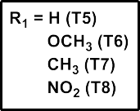
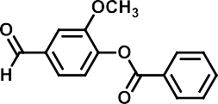
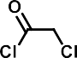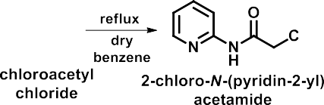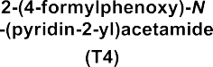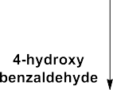METHODOLOGY SCHEME-1

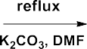

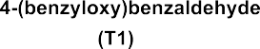
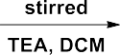
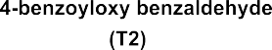
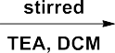

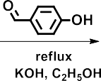

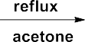
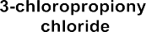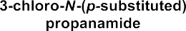

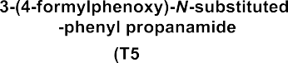

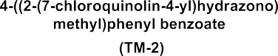
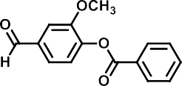
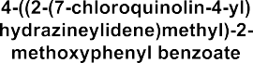
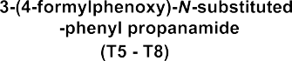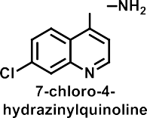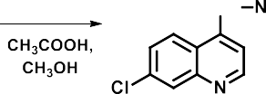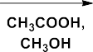SCHEME-2
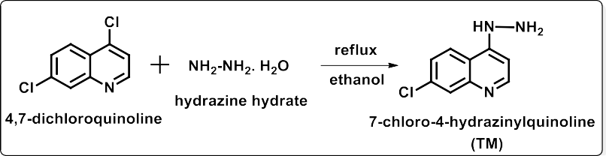
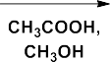

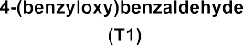

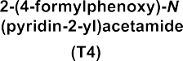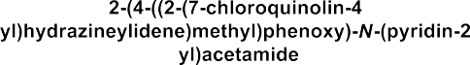
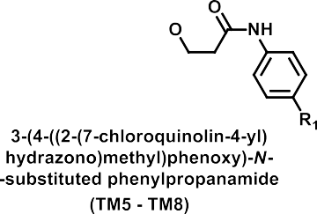

Procedure for the preparation of 4-(benzyloxy) benzaldehyde (T1):
In a round bottom flask dissolve p-hydroxybenzaldehyde (10 G, 8 mmol), pottassium carbonate (11 G, 7 mmol) in dimethylformamide (10 ml, 12 mmol). The mixture was refluxed for 60-90 minutes. Then add benzylchloride (1.4 ml, 1 mmol). Then this mixture was kept reflux for overnight. Then mixture is added to water and cooled in ice bath, the obtained solid is filtered and dried. (70% yield, m.p. 71-75 ºC).

Procedure for the preparation of 4-benzoyloxy benzaldehyde/4-benzoyloxy-3-methoxy benzaldehyde (T2 and T3):
In a round bottom flask p-hydroxybenzaldehyde (1.080 g, 8.85 mmol) and triethylamine (1.5 ml, 10.78 mmol) were dissolved in 25-30 ml of dichloromethane. The mixture was stirred for 30-45 minutes at room temperature. To this reaction mixture benzoyl chloride (1 ml, 8.85 mmol) was added drop by drop and the resulting solution was stirred at room temperature for 1-3 hours. To the above mixture a saturated aqueous solution of sodium carbonate (20 ml) was added three times. The organic phase was dried over magnesium sulphate and the solvent was removed under reduced pressure, thus affording 75 % yield, m.p. 90-92 ºC and 72 % yield, m.p. 70-72 ºC respectively.

Procedure for the preparation of 2-(4-formylphenoxy)-N-(pyridine-2-yl) acetamide (T4):
Chloroacetyl chloride (0.02 mol, 1.6 ml) was slowly added to a solution of 2-aminopyridine (0.01 mol, 0.94 g) in dry benzene, maintaining the temperature 0-5 ºC. The reaction mixture was refluxed for 4-5 h (TLC monitored), and the excess of solvent was removed under vacuum. The residue was washed with 5% aqueous solution of sodium bicarbonate (20 ml) and then with water (20 ml). The crude product was recrystallized from ethanol to give pink crystals of 2-chloro-N- (pyridin-2-yl) acetamide. Yield 60 %, m.p. 128-130 ºC.
To a suspension of 2-chloro-N-(pyridin-2-yl) acetamide (1.70 g, 0.01 mol), p- hydroxybenzaldehyde (1.22 g, 0.01 mol) in sufficient alcohol and anhydrous potassium hydroxide (1.38 g, 0.01 mol) was added. The reaction mixture was refluxed overnight (TLC monitored). The precipitate was collected on evaporation of solvent, dried and recrystallized from ethyl alcohol. Crystals of 2-(4-formylphenoxy)-N-(pyridine-2-yl) acetamide were collected. Yield 60 %, m.p. 250-254 ºC

Procedure for the preparation of 3-(4-formylphenoxy)-N-substituted-phenylpropanamide (T5- T8):

A mixture of 3-chloropropionyl chloride (3.0 ml) and acetone (6 ml) is added drop wise to a refluxing mixture of substituted aniline (5.75 ml) and acetone (10 ml). The reaction mixture is refluxed for 1-2 h. The progress of reaction was monitored by TLC ethyl acetate and n-hexane (1:1). The reaction mixture was cooled in an ice bath, and poured into a mixture of 6N HCl (5.0 ml) and water (35 ml). The resulting solid is filtered, washed with water, dried. The physical characterization data of synthesized compounds 3-chloro-N-(p-substituted phenyl) propanamide was given in the Table No-1
To a suspension of 3-chloro-N-(p-substituted phenyl) propanamide (0.01 mol), p- hydroxybenzaldehyde (0.01 mol) in sufficient alcohol and anhydrous potassium hydroxide (0.01 mol) was added. The reaction mixture was refluxed overnight (TLC monitored). The precipitate was collected on evaporation of solvent, dried and recrystallized from ethyl alcohol. Crystals of 3-(4-formylphenoxy)-N-substituted-phenylpropanamide (T5-T8) were collected. The physical characterization data of synthesized compounds (T5-T8)

Procedure for the preparation of 7-chloro-4-hydrazinylquinoline (TM):
In to a clean dry round bottomed flask containing 4,7-dichloroquinoline (10 g, 5 mmol) absolute ethanol (30 ml), hydrazine hydrate (100%, 25 ml, 50 mmol) was added drop wise with stirring. The mixture was refluxed for 2-3 h (TLC monitored). After 30 minutes a golden yellow color begins to precipitate. The mixture was allowed to cool, and the golden yellow precipitate was collected by filtration, washed with absolute ethanol and recrystallized from ethanol to give 7- chloro-4-hydrazinoquinoline. Yield 80 %, m.p. 223-225 ºC.

Characterization

4-(2-(4-(Benzoyloxy)-3-methoxybenzylidene)hydrazinyl)-7-chloroquinoline (TM3)

FTIR : 3250cm⁻¹ NH, 3050 cm⁻¹ Ar-CH, 2800 cm⁻¹ OCH3 1580 cm⁻¹ C=O, 1420 cm⁻¹ C=N, 1150 cm-1 C-O-C, 800 cm-1 C-Cl.

TABLE NO-1

¹HNMR Spectra (DMSO-d6, δ ppm):

Value (δ ppm) | Nature of segment | No of protons | Types of protons
12.8-13.2 | Broad singlet | 1H | 1H of NH of NH-N
7.4-8.4 | Multiplet | 14H | 13H of Ar-H and
 |  |  | 1H of CH of N=CH
3.8-3.9 | Singlet | 3H | 3H of CH3 of OCH3

Mass spectrometry M/Z Molecular ion peak 431, Base peak 280.

4-(2-(4-(Benzoyloxy)benzylidene)hydrazinyl)-7-chloroquinoline (TM2)

FTIR : 3400cm-1 NH, 3100 cm-1 , Ar-CH, 1620 cm-1 C=O, 1430 cm-1 C=N, 1180 cm-1 C-O-C, 760 cm-1 C-Cl.

TABLE NO-2
¹HNMR Spectra (DMSO-d6, δ ppm):

Value (δ ppm) | Nature of segment | No of protons | Types of protons
11.2-11.4 | Broad singlet | 1H | 1H of NH of NH-N
7.3-8.5 | Multiplet | 15H | 14H of Ar-H and
 |  |  | 1H of CH of N=CH
Mass spectrometry M/Z Molecular ion peak 404, Base peak 370

RESULTS AND DISCUSSION TABLE NO-3
MOLECULAR DOCKING:

S.No | Compound  Code | Docking  Score | Glide Energy  (kcal/mole) | Aminoacid  Interaction | Type of  Interaction
1 | TM1 | -6.091 | -42.33 | Arg-144  Val-79 | Pi-cation  Halogen-Bond
2 | TM2 | -6.188 | -45.96 | R-84  T-173 D-81 | Pi-cation H-Bond
3 | TM3 | -3.588 | -32.01 | Arg-144 | Pi-cation
4 | TM4 | -6.735 | -49.29 | Arg-144  Lys-93 | Pi-cation  Halogen-Bond
5 | TM5 | -5.806 | -49.31 | R-144  T-173 | Pi-cation  H-Bond
6 | TM6 | -5.526 | -43.71 | Thr-173 | H-Bond
7 | TM7 | -5.955 | -48.26 | Arg-84 | Pi-cation  Halogen-Bond H-Bond
8 | TM8 | -4.877 | -40.93 | Arg-144  Val-79 | H-Bond  Halogen-Bond

All the synthesized 8 compounds (TM1-TM8) were subjected for docking studies with gyrase B ATP-binding domain of DNA gyrase (PDBID 3U2D). Total 8 synthesized compounds were docked into the newly generated grid of DNA gyrase enzyme (3U2D). The 3D structures of the synthesized compounds were docked into three dimensional structure of target DNA gyrase enzyme. The dock score of the docked compounds was in the range of -6.73 to -3.58. Molecular docking study of compounds TM1-TM8 suggested that the docked compounds found to interact with enzyme by several Van der Waals, covalent, H-bond, π-π and π-cation interactions, among these the

π-cation bond interactions are the key force for binding of compounds TM1-TM8 with 3U2D protein which was clearly observed from the Table No 5 the interaction map of enzyme and docked compounds. However the affinity towards the enzyme was not strong as expected which was also reflected in the biological activity screening data of synthesised compounds.

Antibacterial activity data of newly synthesized compounds (TM1-TM8) against
Staphylococcus aureus

TABLE NO-4

Compound  Conc | *Inhibition zone diameter in mm
 | 75µg | 50 µg | 25 µg | 10 µg | 5 µg
TM-1 | 13 | 11 | 8 | R | R
TM-2 | 10 | R | R | R | R
TM-3 | 11 | R | R | R | R
TM-4 | 12 | 11 | 10 | R | R
TM-5 | 11 | 10 | R | R | R
TM-6 | 12 | 10 | R | R | R
TM-7 | 12 | R | R | R | R
TM-8 | 18 | 16 | 15 | R | R
Ciprofloxacin  (10 µg) | -- | -- | -- | 26 | R
The synthesized compounds (TM1-TM8) were screened for antibacterial activity studies at a concentration of 5, 10, 25, 50 and 75g/ml using DMF as a control against Staphylococcus aureus, Enterococcus faecalis, Escherichia coli and Klebsiella pneumonia, by agar-well diffusion method. Ciprofloxacin was used as standard drug for the comparison at the concentration 10 µg/ml and 5 µg/ml against Gram positive and Gram negative organism
The results obtained from Table no-4 indicates that the compounds were found to possess moderate and weak activity. The synthesized compounds TM1-TM8 showed moderate activity

against Staphylococcus aureus, Enterococcus faecalis, Escherichia coli, and Staphylococcus aureus, Enterococcus faecalis, Escherichia coli and Klebsiella pneumonia.

CONCLUSION
The present work, which has undertaken is bonafide, for the synthesis of new 4-(2-benzylidene hydrazinyl)-7-chloroquinolines as possible potent inhibitors of the DNA gyrase of antibacterial.In this view we have made an attempt in reviewing the literature on substituted quinoline and its derivatives for their medicinal significance with the help of chemical abstract, journals and internet sites.The literature review and survey was carried out from 1960 to 2022 related to quinoline derivatives as antibacterial agents and as as potent inhibitors of the DNA gyrase.In the light of above, for the synthesis of 4-(2-benzylidene hydrazinyl)-7-chloroquinolines were established on literature survey.All the structures of the synthesized compounds were subjected for molecular docking studies.Around 8 new compounds were synthesized, with the standard chemicals and procedures.The synthesized compounds were tested for their preliminary tests, physical constants and TLC.The structure of the final compounds was confirmed by ¹H NMR, IR analysis.The selected 8 synthesized compounds were screened for their anti-bacterial activity against different bacterial strains.

Acknowldgement: The authors are thankful V.L. College of Pharmacy for providing necessary facilities to carry out this work.

References:
- Eissa SI, Farrag AM, Abbas SY, El-Shehry MF, Ragab A, Fayed EA et al. Novel structural hybrids of quinoline and thiazole moieties: Synthesis and evaluation of antibacterial and antifungal activities with molecular modeling studies. Bioorg Chem 2021; 110: 104803.
- Basak SC. Chemobioinformatics: the advancing frontier of computer aided drug design in the post genomic era. Curr Comput Aided Drug Des 2012; 8: 1-2.
- Jina G, Lib Z, Xiaoa F, Qib X, Sun X. Optimization of activity localization of quinoline derivatives: Design, synthesis, and dual evaluation of biological activity for potential antitumor and antibacterial agents. Bioorg Chem 2020; 103837.

- Akasaka T, Takase H, Tanaka M, Sato K. First detection of the plasmid-mediated quinolone resistance determinant qnrA in Enterobacteriaceae clinical isolates in Japan. Int J Antimicrob Agents 2007; 29: 738-9.
- Vu AT, Cohn ST, Manas ES, Harris HA, Mewshaw RE. ER β-ligands part 4: Synthesis and structure-activity relationships of a series of 2-phenyl quinoline derivatives. Bioorg Med Chem 2005; 15: 4520-5.
- Kumar ST, Kanti BT, Liaquat A, Biswapati M. Anti-inflammatory and anti-platelet aggregation activity of human placental extract. Acta Pharmacol Sin 2003; 24: 187-92.
- Kaschula CH, Egan TE, Hunter, Basilico N, Parapini S, Taramelli D et al. Structure-activity relationships in 4-aminoquinoline antiplasmodials. Trole of the group at the 7-position. J Med Chem 2002; 45: 3531-9.
- Pozzan A. Molecular descriptors and methods for ligand based virtual high throughput screening in drug discovery. Curr Pharm Des 2006; 12: 2099-110.
- Green DV. Virtual screening of virtual libraries. Prog Med Chem 2003; 41: 61-97.
- Michael JP. Quinoline, quinazoline and acridone alkaloids. Nat Prod Rep 2005; 22: 627-46.

METHODOLOGY SCHEME-1

SCHEME-2

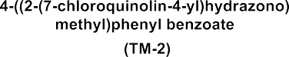
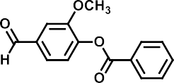
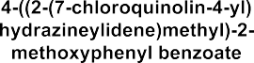
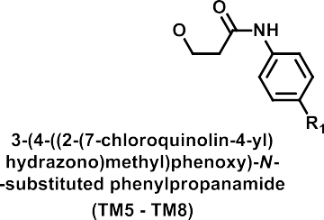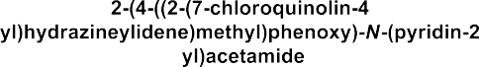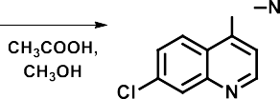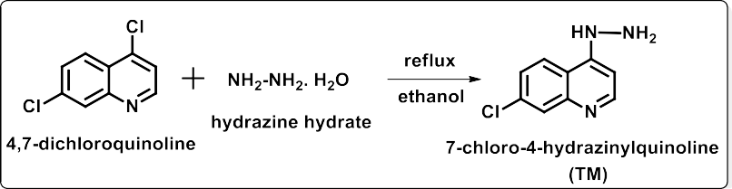
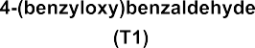

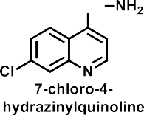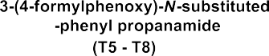

4-(2-(4-(Benzoyloxy)-3-methoxybenzylidene)hydrazinyl)-7-chloroquinoline (TM3)

FTIR : 3250cm⁻¹ NH, 3050 cm⁻¹ Ar-CH, 2800 cm⁻¹ OCH3 1580 cm⁻¹ C=O, 1420 cm⁻¹ C=N, 1150 cm-1 C-O-C, 800 cm-1 C-Cl.

TABLE NO-1
¹HNMR Spectra (DMSO-d6, δ ppm):

Value (δ ppm) | Nature of segment | No of protons | Types of protons
12.8-13.2 | Broad singlet | 1H | 1H of NH of NH-N
7.4-8.4 | Multiplet | 14H | 13H of Ar-H and
 |  |  | 1H of CH of N=CH
3.8-3.9 | Singlet | 3H | 3H of CH3 of OCH3

Mass spectrometry M/Z Molecular ion peak 431, Base peak 280.

4-(2-(4-(Benzoyloxy)benzylidene)hydrazinyl)-7-chloroquinoline (TM2)

FTIR : 3400cm-1 NH, 3100 cm-1 , Ar-CH, 1620 cm-1 C=O, 1430 cm-1 C=N, 1180 cm-1 C-O-C, 760 cm-1 C-Cl.

TABLE NO-2
¹HNMR Spectra (DMSO-d6, δ ppm):

Value (δ ppm) | Nature of segment | No of protons | Types of protons
11.2-11.4 | Broad singlet | 1H | 1H of NH of NH-N
7.3-8.5 | Multiplet | 15H | 14H of Ar-H and
 |  |  | 1H of CH of N=CH
Mass spectrometry M/Z Molecular ion peak 404, Base peak 370

RESULTS AND DISCUSSION TABLE NO-3
MOLECULAR DOCKING:

S.No | Compound  Code | Docking  Score | Glide Energy  (kcal/mole) | Aminoacid  Interaction | Type of  Interaction
1 | TM1 | -6.091 | -42.33 | Arg-144  Val-79 | Pi-cation  Halogen-Bond
2 | TM2 | -6.188 | -45.96 | R-84  T-173 D-81 | Pi-cation H-Bond
3 | TM3 | -3.588 | -32.01 | Arg-144 | Pi-cation
4 | TM4 | -6.735 | -49.29 | Arg-144  Lys-93 | Pi-cation  Halogen-Bond
5 | TM5 | -5.806 | -49.31 | R-144  T-173 | Pi-cation  H-Bond
6 | TM6 | -5.526 | -43.71 | Thr-173 | H-Bond
7 | TM7 | -5.955 | -48.26 | Arg-84 | Pi-cation  Halogen-Bond H-Bond
8 | TM8 | -4.877 | -40.93 | Arg-144  Val-79 | H-Bond  Halogen-Bond

Antibacterial activity data of newly synthesized compounds (TM1-TM8) against
Staphylococcus aureus

TABLE NO-4

Compound  Conc | *Inhibition zone diameter in mm
 | 75µg | 50 µg | 25 µg | 10 µg | 5 µg
TM-1 | 13 | 11 | 8 | R | R
TM-2 | 10 | R | R | R | R
TM-3 | 11 | R | R | R | R
TM-4 | 12 | 11 | 10 | R | R
TM-5 | 11 | 10 | R | R | R
TM-6 | 12 | 10 | R | R | R
TM-7 | 12 | R | R | R | R
TM-8 | 18 | 16 | 15 | R | R
Ciprofloxacin  (10 µg) | -- | -- | -- | 26 | R

