**Isolation of Plant growth promoting bacteria and their characterization from Goa**

Gaitonde Sapna S.

Department of Microbiology

Government College of Arts, Science & Commerce

Khandola-Marcela, India

[sapna.gaitonde@khandolacollege.edu.in](mailto:sapna.gaitonde@khandolacollege.edu.in)

M.Naik, K. Phadte, G. Chari, G. Gopinath, P. Gaunkar, A. Bista, D. Kunhi, P. Bhomkar, P. Salgaonkar

Department of Microbiology;

Government College of Arts, Science & Commerce,

Khandola-Marcela, Goa, India

**Abstract**

Goa is bestowed with agro-climatic conditions that are best suited for tropical vegetables and therefore solanaceous crops are being widely cultivated widely. However Crop disease remains a major problem to global food production. It is a well known fact that Chilli is one of the commercial crop of Goa but its cultivation is hampered by severe incidence of bacterial wilt. Excess use of pesticides through chemical disease control measures is a serious problem for sustainable agriculture as we struggle for higher crop productivity. There is well established evidence that the use of plant growth promoting rhizobacteria (PGPR) would overcome these problems and in turn improve plant growth and crop yield. It is possible to identify and develop PGPR that both suppress plant disease and more directly stimulate plant growth, bringing dual benefit. A number of PGPR have been registered for commercial use under greenhouse and field conditions and a large number of strains have been identified and proved as effective biocontrol agents (BCAs) under environmentally controlled conditions. In this research study a total of 17 bacterial strains were isolated from the rhizosphere region of leguminous plants and were tested for their ability to produce siderophore, HCN, indole acetic acid, nitrogen fixation and potassium solubilization. Based on the results of biochemical characterization four bacteria were selected namely A1, T1, T2 and Pb1 for invivo plant studies.The result of this study revealed that 2 bacteria amongst the 4 showed striking results of plant growth promotion and was further sent for sequencing.

Keywords: Solanaceous, rhizobacteria,siderophore, nitrogen fixation

I. INTRODUCTION

The term “plant growth promoting bacteria” refers to bacteria that colonize the roots of plants (rhizosphere) that enhance plant growth. The term PGPR was proposed by Kloepper *et al.,* 1980 and has been used for a long time, especially for fluorescent Pseudomonas involved in the pathogens biological control and enhancing plant growth. Later, Kapulnik *et al*. (1981) extended this term to the rhizobacteria capable to directly promote plant growth. Today, the term of PGPR is used to refer to all bacteria living in the rhizosphere and improve plant growth through one or more mechanisms. Agriculture is essential for the food security of humans and animals that live on the planet. It has been predicted that by 2050, the human population could reach 8 billion, which will present a significant challenge for agricultural systems to produce enough food to feed this global population, especially given the fact that there are a wide range of biotic and abiotic factors that have a significant negative impact on agricultural productivity. Among the limiting biotic factors, there are a multiplicity of pathogens such as bacteria, fungi, viruses, insects and nematodes. The successful management of these pests is essential to avoid losses during production. PGPR has the ability to increase the availability of nutrient concentration in the rhizosphere by fixing nutrients, thus preventing them from leaching out. As an example, nitrogen, which is needed for the synthesis of amino acids and proteins, is the most limiting nutrient for plants. Therefore, understanding rhizosphere colonization mechanisms by PGPR is essential for generating inoculants able to compete and efficiently colonize the rhizosphere of plant crops, and having a great impact on crop production and more consistent results.

Goa, located on the western coast of India, has a tropical climate that is suitable for growing chili plants. Chili plants require warm temperatures, plenty of sunlight, and well-draining soil to grow well. Some popular chill varieties that can be grown in Goa include Bhavnagar, Guntur, Wala and Kashmiri chilies. These varieties are used in a variety of Indian dishes and are known for their unique flavours and heat levels. In Goa, chili plants are often used in local cuisine, and you can find them in dishes such as a spicy meat curry, and xacuti, a curry made with coconut and spices. They are an integral part of the state's identity and contribute significantly to its livelihoods and economic growth.

The growth rate of chili plants in Goa can vary depending on various factors such as the variety of chill climate sail fertility, and farming practices. However, on average chili plants in Goa can take anywhere from 70 to 120 days to reach maturity depending on the variety and growing conditions. It's worth noting that the growth rate of chili plants can also be affected by pests and diseases. Common pests that affect chili plants in Goa include aphids, whiteflies, and thrips, while common diseases include powdery mildew and bacterial wilt. Farmers need to take proper measures to control these pests and diseases to ensure optimal growth and yield of their chilli plants. If not managed properly, the cultivation of chilli plants can deplete the soil of its nutrients, leading to soil erosion and decreased fertility. However, proper management practices such as crop rotation intercropping and the use of organic fertilizers can help maintain soil health.

Therefore, a study of PGPR bacteria is based on the rationale that these bacteria have the ability to help the plant significantly in increasing germination, seedling growth and yield in different agricultural crops. An array of microbes including *Pseudomonas, Azospirillum, Azotobacter, Klebsiella, Enterobacter, Alcaligenes, Arthrobacter, Burkholderia, Bacillus*, and *Serratia* enhance plant growth as per literature thereby reducing the need for chemical fertilizers that are harmful to the environment. The use of PGPR bacteria can therefore benefit both farmers and the environment by promoting sustainable agriculture practice.

**II. MATERIALS AND METHODS**

1. **Sample selection:** The plant growth promoting rhizobacteria were isolated from the rhizosphere of following plants from different regions of Tiswadi, Bicholim and Ponda taluka of Goa in August & September 2022.
2. *Senna obtusifolia* (Sicklepod)
3. *Vigna unguicuata* (Cowpea)
4. *Terminalia catappa* (Sea almond)
5. *Artocarpus heterophyllus* (Jackfruit)
6. *Tamarindus indica* (Tamarind).
7. *Ocimum tenuiflorum* (Tulsi)
8. *Carica papaya* (papaya)
9. **Collection of rhizospheric soil:** Soil samples were collected from rhizospheric region of plants and were brought to the laboratory for isolation of bacteria. Loosely attached soil was removed from the roots. The roots were shaken gently to remove extra soil and the soil adhering firmly to the root of each plant was collected in the tube containing sterile saline to carry out serial dilution (Khalid *et al*., 2004; Kumar *et al*., 2012).

***Serial Dilution Method:*** The plant was taken from different locations as shown in map (Fig.1). The plant was pulled out by gently twisting it and stored in a plastic bag and the soil was used to carry out serial dilutions. Soil adhering to the root was taken and mixed with 4.5 mL saline in the test tube of 100 and was allowed to stand still so that the soil settles down. 0.5mL was transferred from test tube 100 to 101, from 101 to 102 and so on till 106. 0.1mL of suspension was spread plated from last 3 dilutions on CRYEMA agar and incubated at room temperature for 24 – 48 h. From the isolated colonies obtained on CRYEMA plate, 17 colonies were selected. The selected colonies were then sub-cultured and stored to carry out characterization tests.

1. **Subculturing and maintainence of the bacterial culture:** The selected bacterial colonies were re-streaked on CRYEMA media and sub-cultured on Nutrient Agar Media. Petriplates were incubated at room temperature for 24 h.
2. **Physical characterization of bacterial isolates:** Colony characteristics of each isolate were studied and their Gram character and motility was determined. The colony characters like size, shape, margin, colour, surface texture, consistency, motility, pigmentation, Gram character etc. were studied.
3. **Biochemical characterization of bacterial isolates:** Following tests were performed according to Himedia Manual (1998).
4. ***Fermentation of sugars* -** Ability of bacteria to form organic compounds by metabolizing sugars such as glucose, sucrose, fructose and lactose was used to detect acid and gas production with the help of inverted Durham’s tube immersed in the test tube containing sugar and indicator dye.
5. ***Catalase test***- For this a drop of 3% hydrogen peroxide was placed on a clean glass slide. Isolated colony was picked up with sterile nichrome loop and slowly immersed into the drop of hydrogen peroxide (Taylor and Achanzar, 1972). Rapid bubbling indicated positive result.
6. ***Citrate test* -** The test organism is cultured on Simmon’s Citrate agar medium which contains sodium citrate, an ammonium salt and the indicator bromothymol blue. After 24 h of incubation growth in the medium is shown by a change in colour of the indicator from light green to blue.
7. **PGPR tests**
8. ***Siderophore Production*:** Siderophore production was estimated qualitatively using Chrome Azurol S (CAS) Agar medium (Schwyn and Neilands, 1987). For the detection of siderophores, each isolate was grown in synthetic medium containing 0.5 μM of iron and culture supernatant was added to the wells made on the CAS agar plates. Plates were incubated for 24 h on a rotary shaker at room temperature. Formation of yellow to orange coloured zone around the well indicated siderophore production.
9. ***Nitrogen Fixation*:** The nitrogen fixation ability of bacteria was tested by spot inoculation on Burk medium (Hossain *et.al*. 2019). The cultures which had the nitrogen fixation ability showed the appearance of bacterial growth which was considered as a positive result.
10. ***Phosphate Solubilization*:** For this test sterilized Pikovskaya’s agar was poured as a thin layer on to the sterilized petriplates and incubated for 24 h. After incubation the Pikovskaya’s plates were spot inoculated with isolates and incubated at 28±1°C for 4-5 days. Formation of a clear zone around the colonies was considered as positive result for phosphate solubilization.
11. ***HCN Test*:** All the isolates were screened for the production of HCN by using the method of Lorck (1948). Nutrient broth was amended with 4.4 g glycine/L and isolates were streaked on modified agar plate. A Whatman filter paper No. 1 soaked in 2% sodium carbonate in 0.5% picric acid solution was placed in the top of the plate. Plates were sealed with parafilm and incubated at 28 ± 2°C for 4 days. Development of orange to red colour indicated HCN production.
12. ***Indole Acetic Acid*:** 24-hour old culture was inoculated in tryptophan broth containing 0.1% filter sterilized tryptophan and was kept for kept for incubation at 28o C for 48 hours. Test sample was centrifuged at 5000 rpm for 10 minutes and the supernatant was collected and 2ml of Salkowski reagent (2% 0.5M FeCl3 in 35% HClO4 solution) was added. The sample was incubated in dark for 30 min. Pink colouration was observed showing positive result.
13. **Plant growth promotion assessment:** Based on the above mentioned PGPR tests, a few isolates were shortlisted for plant growth promotion studies. Chilly seeds were sown in pot filled with garden soil. After the growth for 30 days, the selected cultures were grown for 24 h (Fig. 2) followed by centrifugation. The pellet obtained was mixed in 30mL of saline. Seedlings were inoculated with 5 mL of selected bacterial suspension. Bacterial population was estimated by serial dilution method before inoculation. Sterile water was used as control. Each treatment had 2 repeats with 5 seedlings per repeat.

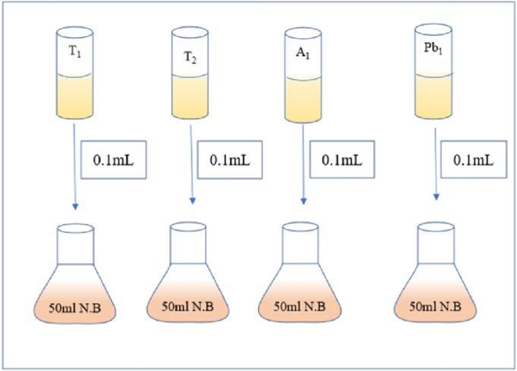

**Fig. 1. Mass cultivation of 4 bacterial cultures for plant inoculation**

After every seven days interval, growth parameters of seedlings were analyzed. The height of the stem and area of leaf were measured by a ruler and thread. For the in-vivo testing of the cultures sterile and unsterile soil was used for each culture and two control samples were kept of sterile and unsterile soil in pots. The size of the pots was kept same and the amount of soil was taken constant for all the cultures. For each culture two replica of sterile and unsterile soil was maintained. Each pot previously grown one month old chilly seedlings were replanted. Each pot had around five seedlings of similar size. After replanting they were allowed to set in the pot for around 2-3 days. After setting, 5mL of the culture suspended in saline was poured into each pot of sterile and unsterile soil except for control (Fig. 1 & Fig. 2). After inoculation of the cultures the plants were regularly watered and their growth was observed after 7, 14, 21 and 28 days.

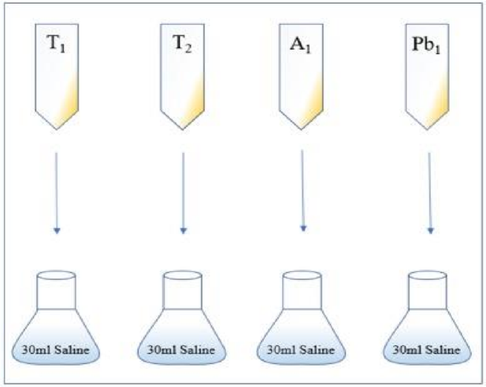

**Fig. 2. Preparation of inoculums for soil drenching**

**III. RESULTS**

1. **Sample selection:** Plant samples were collected from different regions of Tiswadi, Bicholim and Ponda talukas of Goa in August & September 2022.
2. **Collection of rhizospheric soil:** Rhizospheric soil was collected and was serially diluted to isolate the pure bacterial cultures.

**Table 1**: List of bacterial isolates used in this study.

|  |  |  |
| --- | --- | --- |
| **Name of the isolate** | **Host Plant** | **Location of isolation** |
| Sp1 | Sicklepod | Tiswadi |
| Sp2 | Sicklepod | Tiswadi |
| PG1 | Cowpea | Corlim |
| PG2 | Cowpea | Corlim |
| S1 | Sea almond | Khandola |
| S2 | Sea almond | Khandola |
| J1 | Jackfruit | Bicholim |
| J2 | Jackfruit | Bicholim |
| Pb1 | Tamarind | Carambolim |
| T1 | Tulsi | Ponda |
| T2 | Tulsi | Ponda |
| P1 | Papaya | Ponda |
| P2 | Papaya | Ponda |
| PS1 | Tamarind | Chodna |
| PS2 | Tamarind | Chodna |
| A1 | Cowpea | Bicholim |
| A2 | Cowpea | Bicholim |

1. **Purification of bacterial colony and sub-culturing:** A total of 17 colonies were purified and sub-cultured on CRYMA agar.
2. **Physical characterization of bacterial isolates:** Bacteria grow in the form of colonies on solid media and the colony characteristics were studied (Table 2).

**Table 2**: Colony Characteristics of bacterial isolates on CRYEMA



1. **Biochemical characterization of bacterial isolates:** Biochemical tests were used to differentiate between bacterial species based on their biochemical activities (table 3).

**Table 3:** Biochemical characterization of the bacterial isolates



**Key: + =** Acid production only; (+) = Acid and gas production; - = No acid, no gas production

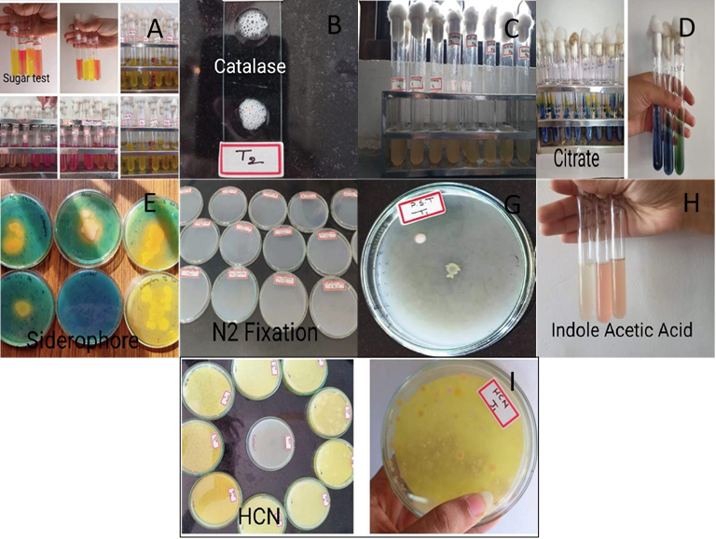

**Fig.3. (**A) Carbohydrate tests, (B) Catalase Test, (C) Gelatinase Test, (D) Citrate Test, (E) Siderophore Production, (F) Nitrogen Fixation Test, (G) Phosphate solubilization, (H) IAA Test, (I) HCN Production.

1. **PGPR tests (**Fig. 3; Table 3)
2. *Siderophore production*- The siderophore production was checked on CAS media. 6 bacterial isolates (A1, Sp1, Sp2, T1, T2, and Pb1) showed a clear orange halo zone around the colonies after 72 h in CAS media
3. *Nitrogen fixation*- All the 17 bacterial isolates were able to grow on Burk’s medium and confirmed their nitrogen fixation ability.
4. *Phosphate solubilization*- Inorganic phosphate solubilization activity was checked on Pikovskaya’s agar plates containing tricalcium phosphate and 3 isolates (T1, T2, and Pb1) formed a clear halo zone around them after 48 hours.
5. *HCN production* - Qualitative assay of HCN production was shown by 5 isolates (T1, T2, J1, J2, and Ps1).
6. *Indole acetic acid* – Qualitative analysis of IAA showed that it was produced by only 2 bacterial isolates (T1, A1).
7. **Plant growth promotion assessment:** Chilly seedlings were planted for plant growth promotion studies (Fig. 4).

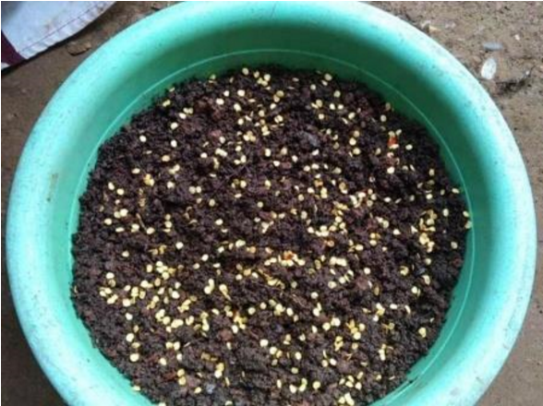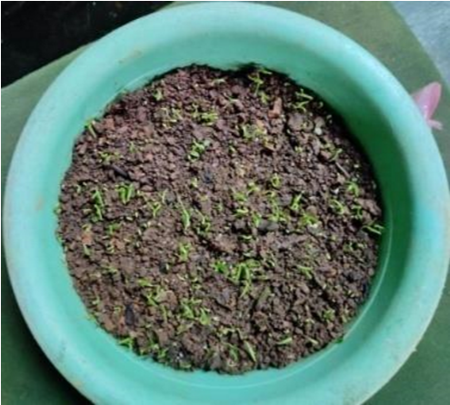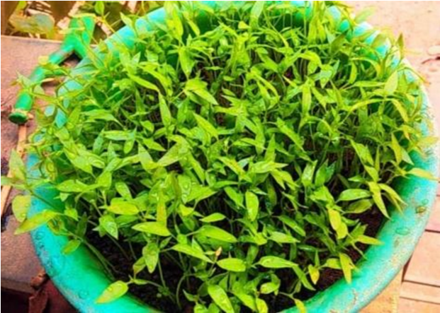

**Fig. 4.Chilly seedlings**

Analysis of growth promotion by bacterial isolates depicted improvement in growth parameters compared to the control plants for most of the strains. Percentage height increase after culture inoculation was highest for strains T2 and Pb1 in unsterile and sterile environment. Treatment with Pb1 showed best increment in height of 90.4% followed by T2 treated plant having 48.4% height increase (Table 4; Fig. 5) on day 28 of inoculation.

**Table 4:** Data showing average percentage of increase in plant height for each bacterial isolate after inoculation (U- depicts unsterile soil; S- depicts sterile soil; DAI – days after inoculation).

|  |  |  |  |  |
| --- | --- | --- | --- | --- |
| **Isolate name** | **7 DAI** | **14 DAI** | **21 DAI** | **28 DAI** |
| T1-S | 2.0 | 22.4 | 25.2 | 36.1 |
| T1-U | 4.3 | 23.5 | 30.4 | 35.7 |
| T2-S | 2.2 | 20 | 29.6 | 31.1 |
| T2-U | 4.4 | 35.2 | 39.6 | 48.4 |
| A1-S | 1.7 | 14.0 | 16.9 | 23.3 |
| A1-U | 2.4 | 19.8 | 32.5 | 40.5 |
| Pb1-S | 4.3 | 50.0 | 59.6 | 90.4 |
| Pb1-U | 2.2 | 19.3 | 21.5 | 31.9 |
| CONTROL -S | 2.4 | 20.5 | 24.1 | 28.9 |
| CONTROL -U | 4.0 | 44.0 | 32.0 | 36.0 |

Also, other strains showed moderate increase in height. Significant differences in vigour index were also exhibited in plants inoculated with Pb1 and T2 showing maximum increase, whereas, A1 treated plant had low vigour index compared to control. Nevertheless, all plants treated with different isolates had appreciable vigour value above the control (Fig. 5).

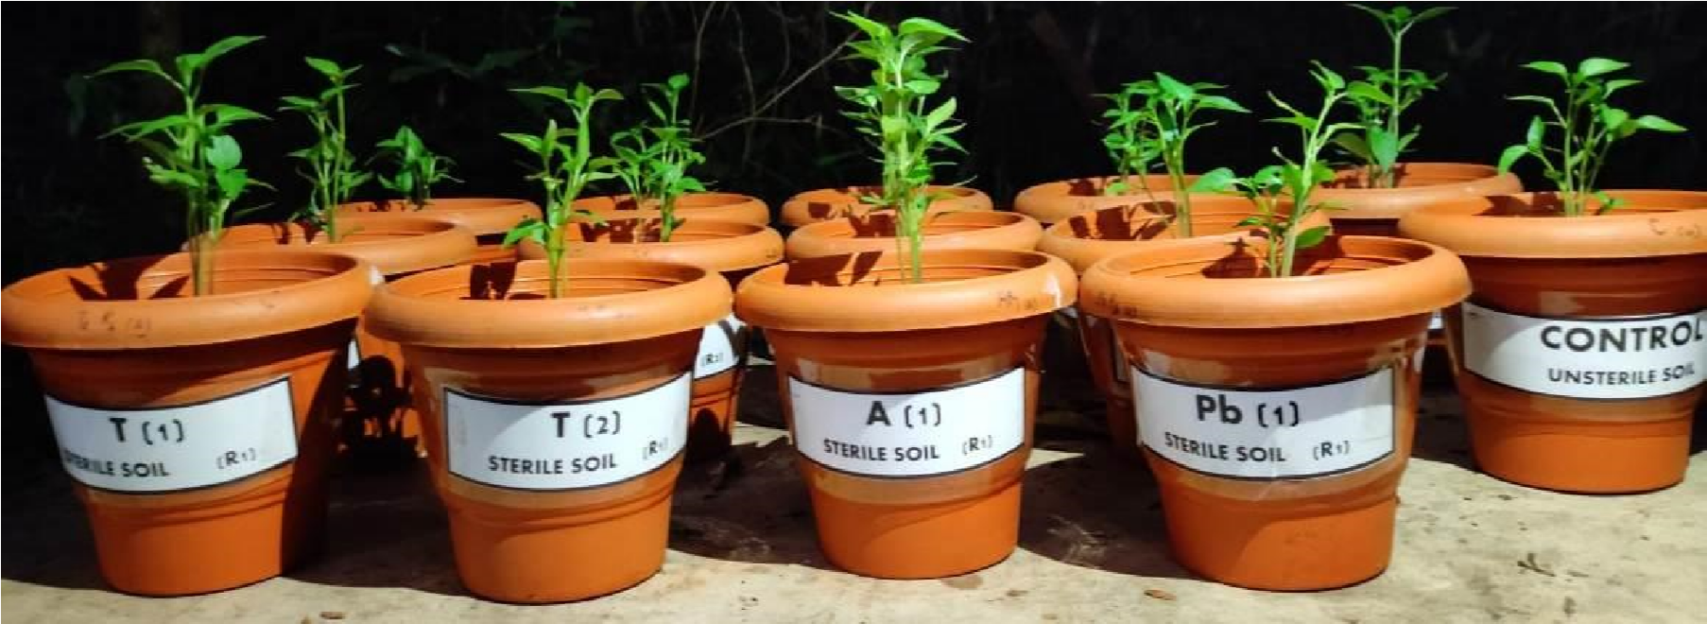

**Fig. 5. Plant growth assessment studies.**

**IV. DISCUSSION**

Soil microbial communities play pivotal roles in various biogeochemical cycles and influence the fertility of soils. In addition, the soil microflora influences above-ground ecosystems by providing nutrients to plants; improve soil structures and consequently, affect soil health (Ahemad*et al.*, 2009). Rhizosphere microflora is also involved in many other soil processes e.g., decomposition of organic matter, nutrient mobilization, mineralization, mineral phosphate solubilization, denitrification, bioremediation of pollutants and suppression of soil borne phytopathogens (Rameshkumar and Nair, 2009; Khan *et al*., 2010; Ahemad and Khan, 2011b). Thus, the plant rhizosphere is a versatile and dynamic ecological environment of intense microbes–plant interactions for harnessing essential micro- and macro-nutrients from a limited nutrient pool (Jeffries *et al.*, 2003).

The widespread application of chemical fertilizers, herbicides, and pesticides in modern agriculture is severely modifying and polluting the natural environment (Punja, 1997). The potential negative effects of chemical fertilizers on the global environment Together with its increased cost have promoted the research and application of microbial inoculants which offer an environment-friendly means to increasing crop productivity and soil health in an integrated plant nutrient management. In the present investigation, 17bacterial isolates were evaluated for their plant growth promoting activities. Serial dilution of the rhizospheric soil from Tulsi, Papaya, Jackfruit, Tamarind, Tamarind, Almond, Cowpea, Sicklepod plants was carried out. This rhizosphere effect is thought to be caused by root exudate-dependent growth of rhizosphere microorganisms due to which microbial biomass activity increases. (Bashan and de-Bashan, 2005).

The isolated bacterial strains A1, SP1, SP2, T1, T2, Pb1 were positive for siderophore production. Ajilogba and Babalola (2013), reported that the PGPR make use of mechanisms such as siderophore production, systemic resistance induction and antifungal volatile production to control or inhibit the growth of plant pathogens e.g., inhibition of *Fusarium sp*. Further, siderophore released by PGPR could be involved in plant growth promotion, since siderophore released increases Fe availability (Van Loon *et al*., 1999, 2007). Plants assimilate iron from bacterial siderophores by means of different mechanisms, for instance, chelate and release of iron, the direct uptake of siderophore-Fe complexes, or by a ligand exchange reaction (Schmidt, 1999; Crowley and Kraemer, 2007). Similarly, the Fepyoverdine complex synthesized by *P. fluorescens* C7 was taken up by *Arabidopsis thaliana* plant, leading to an increase of iron inside plant tissues and to improve plant growth (Vansuyt *et al.*, 2007). Several studies have demonstrated that production of siderophores, other secondary metabolites and lytic enzymes by *Pseudomonas* strains was most effective in controlling the plant root pathogens including *F. oxysporum* and *R. solani* (Ahmad *et al.*, 2008). *B. cereus* strain UW85, *P. fluorescens* strains CHA0 and Pf5 produce numerous antibiotics with different degrees of action against specific pathogenic fungi (Raaijmakers *et al.*, 2002).

The fixation of atmospheric N2 and ammonia production was observed in all the bacterial isolates. These findings are quite similar with N2 fixing bacteria such as *Rhizobium* and *Bradyrhizobium* which were reported to form nodules on roots of leguminous plants such as soybean, pea, peanut, and alfalfa, in which they convert N2 into ammonia, which in contrast to N2 can be used by the plant as a nitrogen source (Van and Vanderleyden, 1995). Ammonification, an important step in the transformation of organic nitrogen to ammoniacal form, would enhance soil nitrogen content by the ammonifying character of the PGPR isolates (Dey *et al*., 2004). Hence, involvement of ammonification trait of isolated strains might be significant.

In soil, despite of large reservoir of P, the amount of available forms to plants is generally low. This low availability of phosphorous to plants is because the majority of soil P is found in insoluble forms, while the plants absorb it only in two soluble forms, the monobasic (H2PO4-1) and the dibasic (HPO4-2) ions (Bhattacharyya and Jha, 2012). To overcome the P deficiency in soils, there are frequent applications of phosphatic fertilizers in agricultural fields. Plants absorb fewer amounts of applied phosphatic fertilizers and the rest is rapidly converted into insoluble complexes in the soil (Mckenzie and Roberts, 1990). Besides, regular application of phosphate fertilizers is not only costly but is also environmentally undesirable. Only 0.1% of the total P is available to plant because of poor solubility and its fixation in soil (Illmer *et al*., 1995) which could be improved by the application of isolated PGPR. Our results suggested that T1, T2, A1, Pb1 strains could be applied as they were capable of solubilizing organic P.

HCN (hydrogen cyanide) production is a well-known trait of plant growth-promoting rhizobacteria (PGPR), which has been shown to contribute to the suppression of soil-borne plant pathogens. In our study bacteria strains T1, T2, J1, J2, Ps1 were positive for HCN production. The rhizobacteria synthesize IAA from tryptophan by different pathways, although these bacteria can also synthesize IAA via tryptophan-independent pathways, though in lower quantities (Spaepen *et al.,* 2007). Similar, results were observed in our study wherein 2 of the bacterial isolates A1 and T1 were able to synthesize IAA with tryptophan that indicated the synthesis of IAA. The occurrence of similar pathways in *Bacillus megaterium* as potent IAA producing strains was observed by Varma *et al*., (2018). To exert beneficial effects in the rhizospheric environment, bacteria have to be rhizosphere competent, i.e., able to compete well with other rhizosphere microbes for nutrients secreted by the root and for sites that can be occupied on the root. Even, the motility was reported as essential factor for chemotaxis toward root exudates (Lugtenberg and Kamilova, 2009). However, in the present study we observed that the rhizospheric bacterial isolates were non-motile.

We further went on to test the application of bacterial isolates in chilli seedlings under both sterile and unsterile soil condition. 4 bacteria were selected namely Pb1, T1, T2, A1 based on their PGPR test results. It was observed that seed bacterization with these isolates increased the stem length, leaf length and breadth of seedlings significantly over control consistently under in vivo conditions. However, when compared with all the isolates, PB1 isolate showed 90.4% of increase in height under sterile soil condition. But in chilli seedling inoculated with T2 isolate showed good growth of about 48.4% under unsterile soil condition. These observations suggest that it could be due to the differential degree of tolerance of the crops towards soil borne pathogens and the interaction of soil microbes with T2 bacterial isolate.

There are more bacterial strains in rhizospheric soil samples as compared to the non-rhizospheric soil which suggests that root exudates released by plants plays an important role in bacterial nourishment. Our results suggested that, selected bacterial isolates significantly enhanced the plant growth character in chilly seedling even in the presence of normal microflora of the soil.

**V. SUMMARY AND CONCLUSION**

* In the current investigation, 17 bacterial isolates were evaluated for their plant growth promoting activities amongst only 4 bacterial isolates were selected namely Pb1, T1, T2 and A1 based on their PGPR test results and further isolated in chilli seedlings under both sterile and unsterile soil condition.
* Presence of P- solubilizing and nitrogen fixing abilities of isolated PGPR strains confirms their potential as biofertilizer that can be used to reduce the burden of chemical fertilizers.
* Isolated Pb1 bacterial strain showed a strong plant growth promotion activity in sterile soil condition whereas T1 bacterial isolate showed best growth in unsteriled soil condition among all four selected bacterial cultures.
* Our result suggested that, selected bacterial isolate significantly enhanced the plant growth character in chilly seedling even in the presence of normal microflora of the soil.
* In addition to this, our result also suggests that the finally selected bacterial isolate (T1 and Pb1) can be further used to make biofertilizers in the form of talc powder and can be distributed amongst the farmer for their agricultural use.

##### REFERENCES

1. Adesemoye, A. O., and Kloepper, J. W. (2009). Plant–microbes interactions in enhanced fertilizer-use efficiency. Appl. Microbiol. Biotechnol. 85, 1–12.
2. Ahemad M, Khan MS. Comparative toxicity of selected insecticides to pea plants and growth promotion in response to insecticide-tolerant and plant growth promoting Rhizobium leguminosarum. Crop Protection. 2010; 29:325–29.
3. Ahemad M, Khan MS. Pesticide interactions with soil microflora: importance in bioremediation. In: Ahmad, I., Ahmad, F., Pichtel, J. (Eds.), Microbes and Microbial Technology: Agricultural and Environmental Applications. Springer, New York. 2011b; 393–413.
4. Ahemad M, Zaidi A, Khan MS, Oves M. Factors affecting the variation of microbial communities in different agro-ecosystems. In: Khan, M.S., Zaidi, A., Musarrat, J. (Eds.), MicrobialStrategies for Crop Improvement. Springer, Berlin Heidelberg, 2009; 301–24.
5. Ahemad, M., and Kibret, M. (2014). Mechanisms and applications of plant growth promoting rhizobacteria: current perspective. J. King Saud Univ. Sci. 26, 1–20.
6. Ahmad F, Ahmad I, Khan MS. Screening of free-living rhizospheric bacteria for their multiple plant growth promoting activities. Microbiological Research. 2008; 163(2): 173–81.
7. Albino U, Saridakis DP, Ferreira, MC, Hungria M, Vinuesa P, Andrade G. High diversity of diazotrophic bacteria associated with the carnivorous plant Drosera villosa var. villosa growing in oligotrophic habitats in Brazil. Plant Soil. 2006; 287:199-07.
8. Alström S, Burns RG. Cyanide production by rhizobacteria as a possible mechanism of plant growth inhibition. Biology and Fertility of Soils. 1989; 7:232-38.
9. Babalola OO. Beneficial bacteria of agricultural importance. Biotechnology Letter. 2010a; 32:155970.
10. Babalola OO. Interactions between Strigahermonthica (Del.) Benth. and fluorescent rhizosphere bacteria of Zea mays, L. and Sorghum bicolor L. Moench for Striga suicidal germination in Vignaunguiculata In: Department of Botany and Microbiology, University of Ibadan, Ibadan. 2002.
11. Babalola, O. O. (2010). Beneficial bacteria of agricultural importance. Biotechnol. Lett. 32, 1559– 1570.
12. Bakker AW, Schippers B. Microbial cyanide production in the rhizosphere in relation to potato yield reduction and Pseudomonas spp. Mediated plant growth stimulation. Soil Biology & Biochemistry. 1987; 19:249–56.
13. Bashan Y, de-Bashan LE. Fresh-weight measurements of roots provide inaccurate estimates of the effects of plant growth-promoting bacteria on root growth: A critical examination. Soil Biology & Biochemistry. 2005; 37:1795-1804.
14. Beattie, G. A. (2015). Microbiomes: curating communities from plants. Nature 528, 340–341.
15. Behie SW, Zelisko, PM, Bidochka, MJ. Endophytic insect-parasitic fungi translocate nitrogen directly from insect to plants. Science. 2012; 336:1576-77.
16. Bennett AE, Bever JD. Mycorrhizal species differentially alter plant growth and response to herbivory. Ecology. 2007; 88:210-18.
17. Bhattacharyya PN, Jha DK. Plant growth-promoting rhizobacteria (PGPR): emergence in agriculture. World Journal of Microbiology and Biotechnology. 2012; 28:1327–1350.
18. Bhattacharyya PN, Jha DK. Plant growth-promoting rhizobacteria (PGPR): emergence in agriculture. World Journal of Microbiology and Biotechnology. 2012; 28: 1327–1350.
19. Blumer C, Haas D. Mechanism, regulation, and ecological role of bacterial cyanide biosynthesis. Archives of Microbiology. 2000; 173:170–77.
20. Borriss, R. (2011). “Use of plant-associated Bacillus strains as biofertilizers and biocontrol agents in agriculture,” in Bacteria in Agrobiology: Plant Growth Responses, ed. D. K. Maheshwari (Berlin: Springer), 41–76.
21. Bowen GD, RoviraAD.The rhizosphere and its management to improve plant growth. Advances in Agronomy. 1999; 66:1–102.
22. Bulgarelli, D., Schlaeppi, K., Spaepen, S., Ver Loren Van Themaat, E., and Schulze-Lefert, P. (2013). Structure and functions of the bacterial microbiota of plants. Annu. Rev. Plant Biol. 64, 807–838.
23. Chabot R, Antoun H, Cescas MP. Stimulation of growth of maize and lettuce by inorganic phosphorus solubilizing microorganisms. Canadian Journal of Microbiology.1993; 39:941–47.
24. Crowley DE, Kraemer SM. Function of siderophores in the plant rhizosphere. In: Pinton, R. et al. (Eds.), The Rhizosphere, Biochemistry and Organic Substances at the Soil-Plant Interface. CRC Press. 2007; 73–109.
25. Crowley, D.E. (2006). Microbial Siderophores in the Plant Rhizosphere. In: Barton, L.L., Abadia, J. (eds) Iron Nutrition in Plants and Rhizospheric Microorganisms. Springer, Dordrecht.
26. Dellagi A, Segond D, Rigault M, Fagard M, Simon C, Saindrenan P et al., Microbial siderophores exert a subtle role in Arabidopsis during infection by manipulating the immune response and the iron status. Plant Physiology. 2009; 150:1687-96.
27. Desbrosses, G. J., and Stougaard, J. (2011). Root nodulation: a paradigm for how plant-microbe symbiosis influences host developmental pathways. Cell Host Microbe 10, 348–358.
28. Devi KK, Seth N, Kothamasi S, Kothamasi D. Hydrogen cyanideproducingrhizobacteria kill subterranean termite Odontotermesobesus (Rambur) by cyanide poisoning under in Vitro Conditions. Current Microbiology. 2007; 54:74–78.
29. Dey R, Pal KK, Bhatt DM, Chauhan SM. Growth promotion and yield enhancement of peanut (Arachishypogaea L.) by application of plant growth-promoting rhizobacteria. Microbiological Research. 2004; 159: 371- 94.
30. Garcia de Salamone, I. E., Hynes, R. K., and Nelson, L. M. (2001). Cytokinin production by plant growth promoting rhizobacteria and selected mutants. Can. J. Microbiol. 47, 404–411.
31. Glick BR, Cheng Z, Czarny J, Duan J. Promotion of plant growth by ACC deaminase-producing soil bacteria. European Journal of Plant Pathology. 2007; 119:329-39.
32. Glick BR. Plant Growth-Promoting Bacteria: Mechanisms and Applications. Hindawi Publishing Corporation, Scientifica. 2012.
33. Gnanamanickam SS, Thomashow L. Biological control of rice bacterial blight by plant-associated bacteria producing 2,4-diacetylphloroglucinol. Canadian Journal of Microbiology. 2006; 52: 56–65.
34. Goldstein AH, Krishnaraj PU. Phosphate solubilizing microorganisms vs. phosphate mobilizing microorganisms: What separates a phenotype from a trait? In: E. Velázquez, C. Rodríguez-Barrueco (eds). First International Meeting on Microbial Phosphate Solubilization. Springe. 2007; 203–13.
35. Gomes NCM, Heuer H, Schönfeld J, Costa R, Mendonça-Hagler L, Smalla K. Bacterial diversity of the rhizosphere of maize (Zea mays) grown in tropical soil studied by temperature gradient gel electrophoresis. Plant Soil. 2001; 232:167-80.
36. Gravel, V, Antoun H, Tweddell RJ. Growth stimulation and fruit yield improvement of greenhouse tomato plants by inoculation with Pseudomonas putida or Trichodermaatroviride: Possible role of indole acetic acid (IAA). Soil Biology & Biochemistry. 2007; 39:1968-77.
37. Gravel, V, Antoun H, Tweddell RJ. Growth stimulation and fruit yield improvement of greenhouse tomato plants by inoculation with Pseudomonas putida or Trichodermaatroviride: Possible role of indole acetic acid (IAA). Soil Biology & Biochemistry. 2007; 39:1968-77.
38. Gray, E. J., and Smith, D. L. (2005). Intracellular and extracellular PGPR: commonalities and distinctions in the plant-bacterium signaling processes. Soil Biol. Biochem. 37, 395–412.
39. Gupta, G., Parihar, S. S., Ahirwar, N. K., Snehi, S. K., and Singh, V. (2015). Plant growth promoting rhizobacteria (PGPR): current and future prospects for development of sustainable agriculture. J. Microb. Biochem. Technol. 7, 096–102.
40. Haas D, Heeb S. Extracellular protease of Pseudomonas fluorescens CHA0, a biocontrol factor with activity against the root knot nematode Meloydogyne incognita. Applied and Environmental Microbiology. 2005; 71:5646–49.
41. Hol WHG, de Boer W, Termorshuizen AJ, Meyer KM, Schneider JH, van Dam NM, van Veen JA, van der Putten WH. Reduction of rare soil microbes modifies plant-herbivore interactions. Ecology Letters. 2010; 13:292-01.
42. Hong, Y. W., Glick, B. R., and Pasternak, J. J. (1991). Plant microbial interaction under gnotobiotic conditions – a scanning electron-microscope study. Curr. Microbiol. 23, 111–114.
43. Hornby D. Suppressive soils. Annual Review of Phytopathology. 1983; 21:65-85.
44. Illmer P, Barbato A, Schinner F. Solubilization of hardly soluble AlPO4 with P– solubilizing microorganisms. Soil Biology Biochemistry. 1995; 27: 260–70.
45. Jeffries P, Gianinazzi S, Perotto S, Turnau K, Barea JM. The contribution of arbuscularmycorrhizal fungi in sustainable maintenance of plant health and soil fertility. Biology and Fertility of Soils. 2003; 37:1– 16.
46. Jha, C. K., and Saraf, M. (2015). Plant growth promoting rhizobacteria (PGPR): a review. E3 J. Agric. Res. Dev. 5, 108–119.
47. Jones D, Nguyen C, Finlay DR. Carbon flow in the rhizosphere: carbon trading at the soil–root interface. Plant Soil. 2009; 321:5–33.
48. Kang, S. M., Joo, G. J., Hamayun, M., Na, C. I., Shin, D. H., Kim, H. Y., et al. (2009). Gibberellin production and phosphate solubilization by newly isolated strain of Acinetobactercalcoaceticus and its effect on plant growth. Biotechnol. Lett. 31, 277–281.
49. Kardol P, Cornips NJ, van Kempen MML, Bakx-Schotman JMT, van der Putten WH. Microbemediated plant–soil feedback causes historical contegency effects in plant community assembly. Ecological Monographs. 2007; 77:147-62.
50. Kloepper JW, Schroth MN. Development of a powder formulation of rhizobacteria for inoculation of potato seed pieces. Phytopathology. 1981; 71: 590
51. Kumar, A., Bahadur, I., Maurya, B., Raghuwanshi, R., Meena, V., Singh, D., et al. (2015). Does a plant growth promoting rhizobacteria enhance agricultural sustainability. J. Pure Appl. Microbiol. 9, 715–724.
52. Ladha JK, de Bruijn FJ, Malik KA. Introduction: assessing opportunities for nitrogen fixation in ricea frontier project. Plant Soil. 1997; 124: 1–10.
53. Lugtenberg B, Kamilova F. Plant-Growth-Promoting Rhizobacteria. Annual Review of Microbiology. 2009; 63:541–56.
54. Lugtenberg B, Kamilova F. Plant-Growth-Promoting Rhizobacteria. Annual Review of Microbiology. 2009; 63: 541–56.
55. McKenzie RH, Roberts TL. Soil and fertilizers phosphorus update. In: Proceedings of Alberta Soil Science Workshop Proceedings, Feb. 20–22,Edmonton, Alberta, 1990; 84–104.
56. Mendes R, Kruijt M, de Bruijn I, Dekkers E, van der Voort M, Schneider JH, Piceno YM, DeSantis TZ, Andersen GL, Bakker PA, Raaijmakers JM. Deciphering the rhizosphere microbiome for diseasesuppressive bacteria. Science. 2011; 332:1097–1100.
57. Mullen MD. Phosphorus in soils: biological interactions. In: Encyclopedia of Soils in the Environment, (D. Hillel, C. Rosenzweig, D. Powlson, K. Scow, M. Singer and D. Sparks, editors), Elsevier, Oxford, 2005; 210–15.
58. Ngoma L, Babalola OO, Ahmad F. Ecophysiology of plant growth promoting bacteria. Scientific Research and Essays. 2012; 7(47):4003-13.
59. Oldroyd GED. Speak, friend, and enter: signalling systems that promote beneficial symbiotic associations in plants. Nature Reviews Microbiology. 2013; 11:252–63.
60. Pal SS. Interaction of an acid tolerant strain of phosphate solubilizing bactseria with a few acid tolerant crops. Plant Soil. 1998; 198:167–77.
61. Patten CL, Glick BR. Bacterial biosynthesis of indole-3-acetic acid. Canadian Journal of Microbiology. 1996; 42:207–20.
62. Patten CL, Glick BR. Role of Pseudomonas putidaindoleacetic acid in development of the host plant root system. Applied and Environmental Microbiology. 2002; 68:3795-3801.
63. Peiffer, J, Spor A, Koren O, Jin Z, Tringe SG, Dangl JL, et al., Diversity and heritability of the maize rhizosphere microbiome under field conditions. Proceedings of National Academy of Science. USA. 2013; 110:6548-53.
64. Pii, Y., Mimmo, T., Tomasi, N., Terzano, R., Cesco, S., and Crecchio, C. (2015). Microbial interactions in the rhizosphere: beneficial influences of plant growth-promoting rhizobacteria on nutrient acquisition process. A review. Biol. Fertil. Soils 51, 403–415.
65. Punja ZK. Comparative efficacy of bacteria, fungi, and yeasts as biological control agents for diseases of vegetable crops. Canadian Journal of Plant Pathology. 1997; 19:315–23.
66. Raaijmakers JM, Vlami M, de Souza JT. Antibiotic production by bacterial Biocontrol agents. Anton de Leeuw. 2002; 81: 537–47.
67. Rameshkumar N, Nair S. Isolation and molecular characterization of genetically diverse antagonistic, diazotrophic red-pigmented vibrios from different mangrove rhizospheres. FEMS Microbiology Ecology. 2009; 67: 455–67.
68. Raymond J, Siefert JL, Staples CR, Blankenship RE. The natural history of nitrogen fixation. Molecular Biology and Evolution. 2004; 21:541–54.
69. Rovira AD. A study of the development of the root surface microflora during the initial stages of plant growth. Journal of Applied Bacteriology. 1956; 19(1):72-79.
70. Rubio LM, Ludden PW. Biosynthesis of the iron-molybdenum cofactor of nitrogenase. Annual Review of Microbiology. 2008; 62:93–111.
71. Rudrappa T, Splaine RE, Biedrzycki ML, Bais HP. (2008) Cyanogenic pseudomonads influence multitrophic interactions in the rhizosphere. PLoS ONE 3(4): e2073.
72. Ruzzi, M., and Aroca, R. (2015). Plant growth-promoting rhizobacteria act as biostimulants in horticulture. Sci. Hortic. 196, 124–134.
73. Schmidt W. Mechanisms and regulation of reduction-based iron uptake in plants. New Phytol. 1999; 141:1–26.
74. Schnitzer SA, Klironomos JN, HilleRisLambers J, Kinkel LL, Reich PB, Xiao K, Rillig MC, Sikes BA, Callaway RM, Mangan SA, van Nes EH, Scheffer M. Soil microbes drive the classic plant diversityproductivity pattern. Ecology. 2011; 92:296-303.
75. Sharma S, Aneja MK, Mayer JC and Schloter M. Characterization of bacterial community structure in rhizosphere of grain legumes. Microbial Ecology. 2005; 49:407-415.
76. Shivlata, L., and Satyanarayana, T. (2017). “Actinobacteria in agricultural and environmental sustainability,” in Agro-Environmental Sustainability, eds J. S. Singh and G. Seneviratne (Berlin: Springer), 173–218.
77. Siddiqui IA, Shaukat SS, Hussain Sheikh I, Khan A. Role of cyanide production by Pseudomonas fluorescens CHA0 in the suppression of root-knot nematode, Meloidogynejavanica in tomato. World Journal of Microbiology & Biotechnology. 2006; 22:641–50.
78. Spaepen S, Vanderleyden J, Remans R. Indole-3- acetic acid in microbial and microorganism-plant signaling. FEMS Microbiology Reviews. 2007; 31: 425-48.
79. Spaepen, S., and Vanderleyden, J. (2011). Auxin and plant-microbe interactions. Cold Spring Harb. Perspect. Biol. 3:a001438.
80. Spaepen, S., Bossuyt, S., Engelen, K., Marchal, K., and Vanderleyden, J. (2014). Phenotypical and molecular responses of Arabidopsis thaliana roots as a result of inoculation with the auxin-producing bacterium Azospirillumbrasilense. New Phytol. 201, 850–861.
81. Tanimoto E. Regulation of root growth by plant hormones – Roles for auxin and gibberellin. Critical Reviews in Plant Science. 2005; 24:249-65.
82. Timmusk, S., Behers, L., Muthoni, J., Muraya, A., and Aronsson, A. C. (2017). Perspectives and challenges of microbial application for crop improvement. Front. Plant Sci. 8:49.
83. UmairRiaz, Ghulam Murtaza, WajihaAnum, TayyabaSamreen, Muhammad Sarfraz, Muhammad ZulqernainNazirPlant Growth-Promoting Rhizobacteria (PGPR) as biofertilizers and biopesticidesMicrobiota and biofertilizers: a sustainable continuum for plant and soil health, 181-196, 2021.
84. Uroz S, Buee M, Murat C, Frey-Klett P, Martin F. Pyrosequencing revealed a contrasted bacterial diversity between oak rhizosphere and surrounding soil. Environmental Microbiology Reports. 2010; 2:28188.
85. Vacheron, J., Desbrosses, G., Bouffaud, M. L., Touraine, B., Moenne-Loccoz, Y., Muller, D., et al. (2013). Plant growth-promoting rhizobacteria and root system functioning. Front. Plant Sci. 4:356.
86. Van Loon LC, Bakker PAHM, Pieterse CMJ. Systemic resistance induced by bacteria. Annual Review of Phytopathology. 1998; 36:453-83.
87. Van Loon LC. Plant responses to plant growth-promoting rhizobacteria. European Journal of Plant Pathology. 2007; 119:243-54.
88. Van Rhijn P, Vanderleyden J. The Rhizobium-plant symbiosis. Microbiological Reviews. 1995; 59: 124–42.
89. Vansuyt G, Robin A, Briat JF, Curie C, Lemanceau P. Iron acquisition from Fe-pyoverdine by Arabidopsis thaliana. Molecular Plant Microbe Interactions. 2007; 20:441–7.
90. Vessey JK. Plant growth promoting rhizobacteria as biofertilizers. Plant Soil. 2003; 255:571-86.
91. Voisard C, Keel C, Haas D, Defago G. Cyanide production by Pseudomonas fluorescens helps suppress black root rot of tobacco under gnotobiotic conditions. EMBO Journal. 1989; 8:351–8.
92. Wensing A, Braun SD, Buettner P, Expert D, Voelksch B, Ullrich MS, et al., Impact of siderophore production by Pseudomonas syringaepv. Syringae 22d/93 on epiphytic fitness and biocontrol activity against Pseudomonas syringaepv. Glycinea 1a/96. Applied and Environmental Microbiology. 2010; 76:2704-11.
93. Whipps JM. Microbial interactions and biocontrol in the rhizosphere. The Journal of Experimental Biology. 2001; 52:487-511.
94. Zahir AA, Arshad M, Frankenberger WT. Plant growth promoting rhizobacteria: applications and perspectives in agriculture. Advances in Agronomy. 2004; 81:97–168.
95. Zehnder GW, Murphy JF, Sikora EJ, Kloepper JW. Application of rhizobacteria for induced resistance. European Journal of Plant Pathology. 2001; 107:39-50.
96. Zhu, Z., Zhang, H., Leng, J. et al. Isolation and characterization of plant growth-promoting rhizobacteria and their effects on the growth of Medicagosativa L. under salinity conditions. Antonie van Leeuwenhoek 113, 1263–1278 (2020).