Oxidative stress caused by Restraint stress and Aging in Medulla Oblongata of Albino rats – Anti-oxidant potential of Clitoria ternatea

Ch. N. Durga Mahalakshmi¹, K. Sai Manogna¹, B. Deva Prasad Raju², Mannur Ismail Shaik³, N. John Sushma^{1,*}

¹Department of Biotechnology, Sri Padmavathi Mahila Visvavidyalayam, Tirupati, Andhra Pradesh, India.
²Department of Physics, Sri Venkateswara University, Tirupati – 517 502
³Department of Fisheries and Food Science, University of Malaysia, Terengganu, KulaNerus 20130, Malaysia.

*Corresponding author: Prof. N. John Sushma, Department of Biotechnology, Sri Padmavati Mahila Visvavidyalayam, Tirupati-517 502, Andhra Pradesh; India. Email: johnsushma@gmail.com; Ph: +91-9440872952.
ORCID: 0000-0002-8739-9936.

ABSTRACT
Background: Oxidative stress has been associated with complex ageing neurodisorders. The present study evaluates the neuroprotective effect of leaf extract of Clitoria ternatea (CT) against aluminum (Al) and restraint stress (RS) induced age-related neurotoxicity in medulla oblongata of young and adult male albino rats.
Results: Animals were divided into 8 groups; Group 1 Control, Group 2 Al treated, Group 3 RS treated, Group 4 CT extract administered, Group 5 Al + RS, Group 6 Al + CT, Group 7 RS + CT, Group 8 Al + RS + CT. Al + RS treated group exhibited significant reduction in the levels of antioxidant enzymes; superoxide dismutase (SOD), catalase (CAT), glutathione peroxidase (GPx) and significant increase in the lipid peroxidation (LPO) in medulla oblongata indicating the neurotoxicity. The Al plus RS induced oxidative damage impact was also observed in the form of morphological degenerative changes in the neurons (DCNEU) as per the histological observations of medulla oblongata architecture in both the age groups when compared to control rats.
Conclusion: Our results demonstrated that decrease in antioxidant enzymes and degenerative changes in neurons (DCNEU) were more pronounced in adult rats compared to young rats. But Al +RS along with administration of CT extract administration enhanced the reduced levels of antioxidant enzymes and also decreased the lipid peroxidation caused by the Al and RS in both the age groups. The study confirmed that co-administration of CT methanolic leaf extract has beneficial capability to reactivate the inhibited enzymatic antioxidants by extensively decreasing the TBA-RS levels of LPO as well as reduced the degenerative changes in neurons (DCNEU) of both young and adult rats. These data, together with earlier studies suggest that neuroprotective potential of CT methanolic leaf extract is capable of mediating the age-related oxidative damage inflicted by Al and RS on medulla oblongata.

Key words: Aluminum, restraint stress, Clitoria ternatea, medulla oblongata, oxidative stress.

- Introduction

Brain performs multiple mechanistic functions strongly associated with age-related neurodisorders such as Alzheimer’s disease. Extensive stress conditions and exposure to environmental toxicants may primarily involve in elevated oxygen metabolism induced free radical damage (Srivastava et al., 2012), the nature and severity of these oxidative neurodegeneration, involves in the deterioration of chronic CNS progression in oxidative stress (Friedlich and Butcher, 1994; Montine et al., 1999; Smith et al., 1997). Thus, consequences in increased peroxidizable lipids and low levels of antioxidants leads to neuropathological situations (Andersen, 2004; Jankord and Herman, 2008; Zafir, A. and N. Banu, 2009), such as impairment in cognitive function (Siriporn and Sukumal 2015), formation of amyloid rich senile plaques and neurofibrillary tangles as major symptoms associated with AD.
Aluminum (Al), a well-known neurotoxin, permeates the central nervous system (CNS) efficiently and has been found to affect the blood-brain barrier (BBB) under normal physiological conditions, accumulating across many brain areas (Zatta et al., 2002). It has been linked to various neurological disorders, including Alzheimer's (Kawahara et al., 1994). Further, Al being a potent cholinotoxin (Gulya et al., 1990) causes apoptotic neuronal loss. Previous studies also demonstrated that morphological and biochemical changes in brain of mice treated with Al, symptoms associated with Al induced brain toxicity in animals (mice) fairly resemble those of AD. This is due to the peroxidative effect of Al (Oteiza 1993) may indirectly potentiate its role in causing oxidative damage to membrane lipids, proteins and antioxidative enzyme defense system (Jyothi and Sharma, 2006; Xu et al., 1992). Al with other transition metals like chromium (Cr) and copper (Cu) also enhances oxidation (Bondy 1998). It is reported that long term chronic Al-administration inflicts oxidative stress resulting in biochemical changes proposed to accelerate the aging damage in brain regions (Bharati et al., 2008). Savory et al. established that aged rabbits are more susceptible to Al toxicity compared to young rabbits (Savory et al., 1999).
Stress is a homeostatic challenge with physical and psychological ramifications and particularly negative effect on the learning and memory process (Aleisa et al., 2006; McEwen and Sapolsky 1995). Stress promotes negatively charged brain phospholipids activity, are easily attacked by reactive oxygen species (ROS) such as O²⁻, H₂O₂, and OH⁻ (Verstraeten et al., 1997) have all been related to attributable stimuli in oxidation process and free radical generation causes neuro-molecular damage to aging (Sohel et al., 2007) and neuropathogenic death in AD.
Hence the natural supplementation of herbal medicine offers several options to modify the progress and symptoms of neurological disorders. There has been playing new trends in their scientific and commercial significance in health-relevant areas (Abascal and Yarnell, 2004). Conventionally Clitoria ternatea (CT), commonly known as “butterfly pea”, was used as reputed drug of ayurveda as nervine tonic for memory enhancing, which was gaining more attention in neuroscience (Mukherjee et al., 2007). Over the past few decades, there has been an exponential growth in study of pharmacological properties of CT with promising future developments (Girish kumar et al., 2007; Gollen et al., 2018). It consists of rich phytoconstituents such as tannins, taraxerol, alkaloids, flavonoids, saponins, proteins and anthocyanin (Mukherjee et al., 2008). These phytochemicals play a promising role for its antioxidant efficacy by inhibiting the initiation or propagation of oxidizing chain reactions and acts as free radicals scavengers (Kamkaen and Wilkinson, 2009). Thus CT extract exhibits extensive biological and pharmacological activities specifically nootropic, anxiolytic, anticonvulsant, anti-inflammatory, anti-diabetic, anti-oxidative, anti-stress (Jain et al., 2003), immunomodulatory, anti-microbial and memory enhancing (Giurgea, 1973 ).
The mechanism behind the neuroprotective action is still incomprehensible, Clitoria ternatea leaf extract has potential to enhance the levels of enzymatic and non-enzymatic antioxidants (Zheng and Wang 2001). The present study was designed to investigate the neuromodulatory effect of Clitoria ternatea leaf extract to prevent aluminum and restraint stress induced age-related oxidative neurotoxicity to indicate its neuroprotective effect. No study is available regarding the possible mechanism of action on Clitoria ternatea extract against aluminum and stress induced neurotoxicity in brain medulla oblongata.

- Methods

A. Preparation of Clitoria ternatea leaf extract
The Clitoria ternatea plants were obtained from surrounding areas of Tirupati, Andhra Pradesh, India and authenticated by Dr. K. Madhava Chetty, Assistant Professor, Department of Botany, Sri Venkateswara University, Tirupati. Voucher specimen (no. 1160) and deposited in the herbarium of Sri Venkateswara University, Tirupati. The plants were thoroughly washed with double distilled water, leaves were separated and dried under shade dust-free condition for one week at room temperature. Then plant material was ground into fine powder. Finally powdered plant material was extracted with 60% methanol. The mixed solution was left on constant magnetic stirring at room temperature for 72 h. The extract was filtered and dried using vacuum desiccator, the powder yield was stored at 4⁰C for further experiments.

B. Animals
Male Wistar rats of young (3-months) and adult (12-months) age groups, weighing 150 ± 200g and 300 ± 350g respectively, procured from an authorized vendor (Sri Venkateswara Enterprises, Bangalore, India), were used in the study. Rats were acclimatized in the lab for one week to adapt to the laboratory conditions; the animals were randomized into eight groups, each group contains six animals housed in a polypropylene cage (47x34x20cm) containing sterile paddy husk as bedding and maintained at 22-25ºC regulated temperature, with a light/dark cycle (12h/12h). The rats were fed with standard rat chow (Sri Venkateswara Enterprises, India) and water ad libitum.

C. Experimental design
Experimental protocols were approved by the institutional ethical committee (CPCSEA Registration No. 1677/PO/a/12/IAEC-Feb-14/03). The young (3-months) and adult (12-months) aged animals were equally randomized into eight groups having six animals per each group:
Group I: control administered group: with (0.9%) saline solution
Group II: Aluminium -maltolate (AlM) administered group: AlM was dissolved in (0.9%) saline solution and administered orally at a dose of 100 mg/kg/b.wt./30 days.
Group-III: Restraint stress (RS) treated group: immobilization stress was given for 1h inside a cylindrical steel tube (7 cm diameter, 17.5 cm along with holes for ventilation) at room temperature during the early phase of the light cycle for 30 days.
Group-IV: Clitoria ternatea (CT) treated group: CT methanolic leaf extract was Administered orally at a dose of 50 mg/kg/b.wt./30 days.
Group-V: RS+AlM treated group: immobilization stress period was given for 1h and then AlM was administered orally at a dose of 100mg/kg/b.wt. for 30days.
Group-VI: AlM+CT administered group: AlM (100mg/kg/b.wt.) and CT methanolic leaf extract (50mg/kg/b.wt.) were administered orally with 1h time interval for 30 days.
Group-VII: RS+CT treated group: immobilization stress induced for 1h and then CT methanolic leaf extract (50 mg/kg/b.wt.) was administered orally for 30 days.
Group-VIII: RS+ AlM+ CT administered group: immobilization stress was given for 1h inside the cylindrical steel tube at room temperature and after that the animals were administered with AlM (100mg/kg/b.wt.) and CT methanolic leaf extract (50 mg/kg/b.wt.) orally for 30 days.

D. Tissue collection and preparation of tissue homogenates
Rats of each group were sacrificed by cervical dislocation and dissected after the treatment period. And the brain tissues were immediately removed, the medulla oblongata was dissected on ice cold glass plate and homogenate was prepared. Tissue homogenate was made in 50 mM phosphate buffer containing 0.1 mM EDTA using homogenizer and centrifuged at 10,000 rpm for 15 min at 4⁰C, the supernatants thus obtained were used for the estimation of various biochemical analysis.

E. Determination of lipid peroxidation
Lipid peroxidation was estimated in medulla oblongata region as described by Okhawa et al., 1979. The amount of thiobarbituric acid reactive substances (TBA-RS) was determined spectrometrically using UV-vis spectrophotometer at 532 nm and the values were expressed as nano moles of TBA-RS per mg protein/h.

F. Measurement of Antioxidant Enzyme Activities
In medulla oblongata, the biochemical tests were conducted by following standard procedures. The activity of superoxide dismutase (SOD) was assayed by the reduction of nitro blue tetrazolium (NBT) according to the method of Misra and Fridovich 1972. The activity of the enzyme was expressed as units/mg protein. Catalase (CAT) activity was assayed spectrophotometrically using the slight modification from Aebi, 1984. The decrease in absorbance was observed for 60 s interval at 240 nm. CAT activity was expressed as molar extinction coefficient of 43.6 µ/cm was used to determine catalase activity. One unit of catalase activity is equal to the µ moles of H₂O₂ degraded/ mg protein/min. Glutathione peroxidase activity (GPx) was measured by the method of Flohe and Gunzler 1984. The absorbance was measured at 340 nm for 180 s. GPx activity is expressed as μ moles of GSH oxidized/mg protein/min. Protein concentration in all the homogenates of medulla oblongata was done by the standard protocol from Lowry et al., 1951.

G. Histopathological Evaluation
In histopathological evaluations on brain medulla oblongata region were performed by the method proposed by Humason, 1972, on all animals of the control and treated groups. Brain regions of cerebellum were cut down, fixed in 10% formaldehyde solution. The specimens embedded in paraffin were cut into 5 µm thick sections, stained with hematoxylin-eosin, examined under an optical light microscope and then photomicrographs were taken.

H. Statistical Analysis:
The results were expressed as means ± standard deviation (SD) of n=6. The statistical significances of data were determined using one-way analysis of variance (ANOVA) followed by Dunnett test; p< 0.0001 was regarded as significant.

III. RESULTS

A. Determination of lipid peroxidation levels
The level of ROS was found to be significantly increased by RS and AlM treatment for 1 month at a dose of 100 mg/kg/day when compared to the control. RS and AlM enhanced the levels of TBA-RS, in medulla oblongata of both young and adult age group rats. CT treated rats showed significantly decrease in study-state of TBA-RS, in medulla oblongata of both 3-months and 12-months old rats (Fig. 1). The results elevated that RS & AlM-induced increased lipid peroxidation in adult rats compared to young aged rats. However, AlM and stress treated group with CT administration exhibited the remarkable recovery by reducing TBA-RS levels in young and aged rats. It is worthy to note that CT was significantly counteracted the age-related increase in lipid peroxidation did not affect the TBA-RS levels and it was similar to control group.

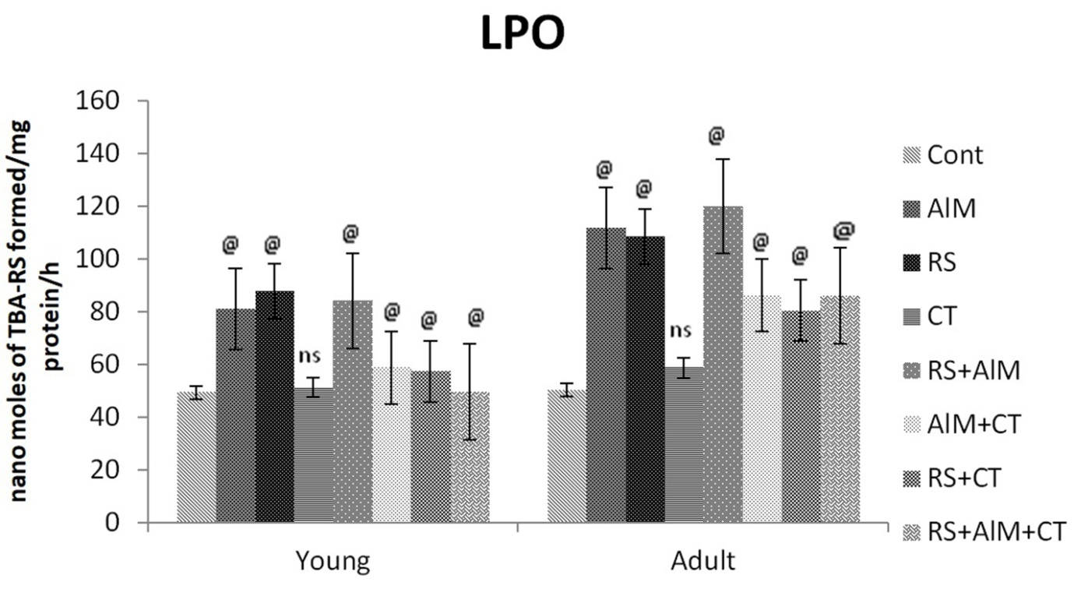
Figure 1. Effect of CT on TBARS levels in rat Medulla oblongata. Graph representing the effect of CT on Thiobarbituric acid reactive substance (TBA-RS) levels in brain medulla oblongata region of 3&12 months old rats exposed to AlM & RS. Each column represents the mean ± S.D. (n=6). Statistical analysis was performed by one-way ANOVA, followed by Dunnett test. The level of probability is denoted by @p <0.0001. (ns) denotes non-significant.

B. Enzymatic antioxidant status activated by Clitoria ternatea treatment
After 30-days treatment with RS (1 h/day/month) and AlM (100 mg/kg b.wt./month), significantly increased concentration of AlM and stress levels exacerbates brain oxidative damage was analyzed in the medulla oblongata of both young and adult rats comparing to the control by checking enzymatic antioxidant status. The levels of SOD, CAT and Gpx were declined significantly in medulla oblongata of both young and adult rats exposed to AlM and RS (Fig. 2, 3 & 4). This increase of oxidative stress in the medulla oblongata was significantly prevented by the administration with CT 50 mg/kg b.wt./month oral administration of CT showed increased SOD, CAT and Gpx levels similar to control. In order to identify the neuroprotective role of CT against RS and AlM induced oxidative damage, Co-administration of CT with AlM and RS exhibited remarkable enhancement in the levels of SOD, CAT and Gpx in AlM+CT, RS+CT and RS+AlM+CT groups somewhat similar to the control group. By the results, it is confirmed that CT administration showed significantly decreased level of ROS when compared with the AlM and RS treated young and adult rat medulla oblongata regions. We observed that CT showed no effect on the activities of SOD, CAT and Gpx (Fig. 2, 3 & 4).

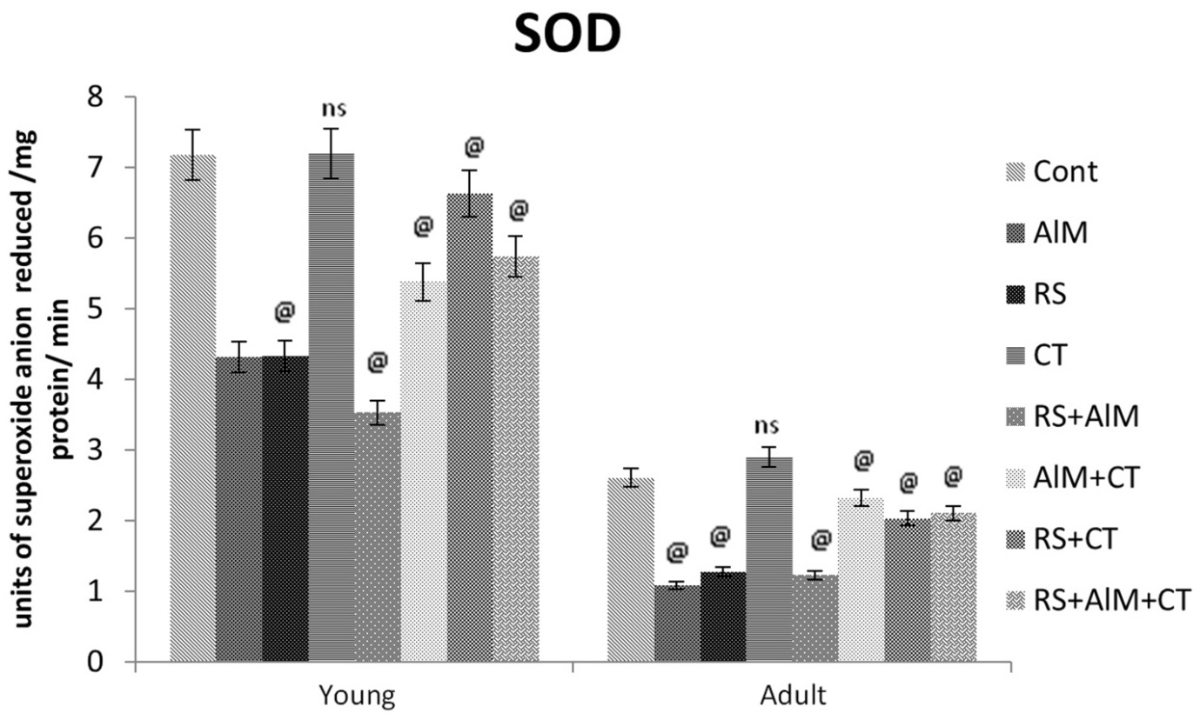
Figure 2. Effect of CT on SOD levels in rat Medulla oblongata. Graph representing the effect of CT on Superoxide dismutase (SOD) levels in brain medulla oblongata of 3&12 months old rats exposed to AlM & RS. Each column represents the mean ± S.D. (n=6). Statistical analysis was performed by one-way ANOVA, followed by Dunnett test. The level of probability is denoted by @p <0.0001. (ns) denotes non-significant.

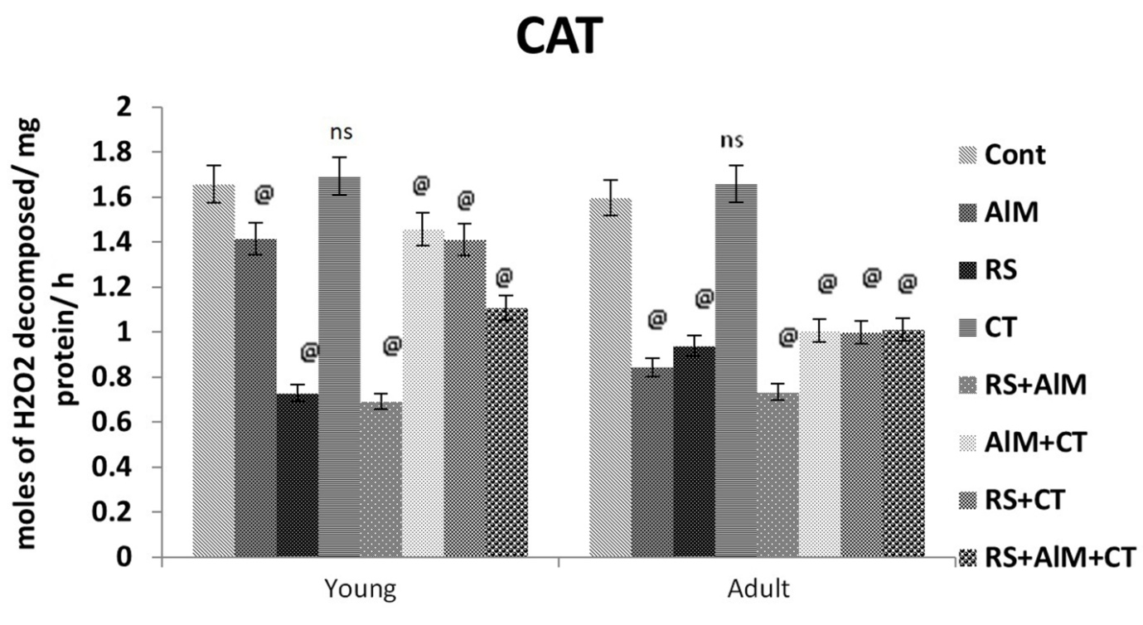
Figure 3. Effect of CT on Gpx levels in rat Medulla oblongata. Graph representing the effect of CT on glutathione peroxidase (Gpx) levels in brain medulla oblongata of 3&12 months old rats exposed to AlM & RS. Each column represents the mean ± S.D. (n=6). Statistical analysis was performed by one-way ANOVA, followed by Dunnett test. The level of probability is denoted by @p <0.0001. (ns) denotes non-significant.

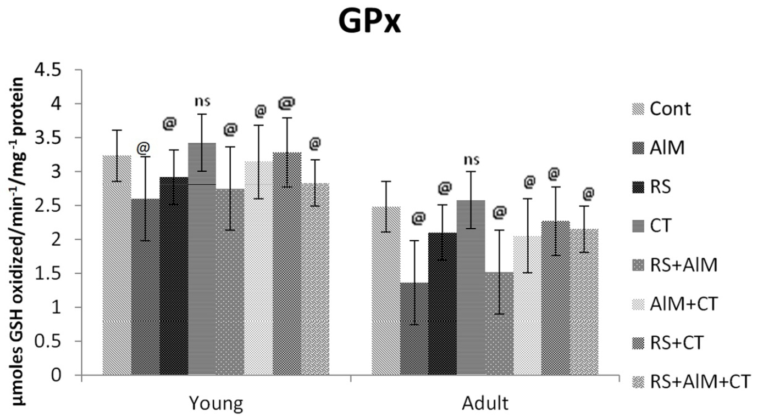
Figure 4. Effect of CT on CAT levels in rat Medulla oblongata. Graph representing the effect of CT on Catalase activity (CAT) levels in brain medulla oblongata of 3&12 months old rats exposed to AlM & RS. Each column represents the mean ± S.D. (n=6). Statistical analysis was performed by one-way ANOVA, followed by Dunnett test. The level of probability is denoted by @p <0.0001. (ns) denotes non-significant.

C. Histopathological Observations
The histopathological observations of medulla oblongata of young and adult albino rats of each experimental group revealed certain marked age-related morphological changes induced by AlM and RS as follows: AlM and RS group showed degenerative changes in neurons (DCNEU) compared to control group showing normal neuronal architecture (NEU). Control (CtL) group showed that neuron (NEU) is similar to control group. However co-administration of CtL extract along with AlM and RS to young and adult age groups AlM+CT, RS+CT, RS+AlM+CT showed marked improvement with almost normal exterior of mild degenerative changes in neuronal layer (MDCNL), similar to control group (Fig. 5 & 6).

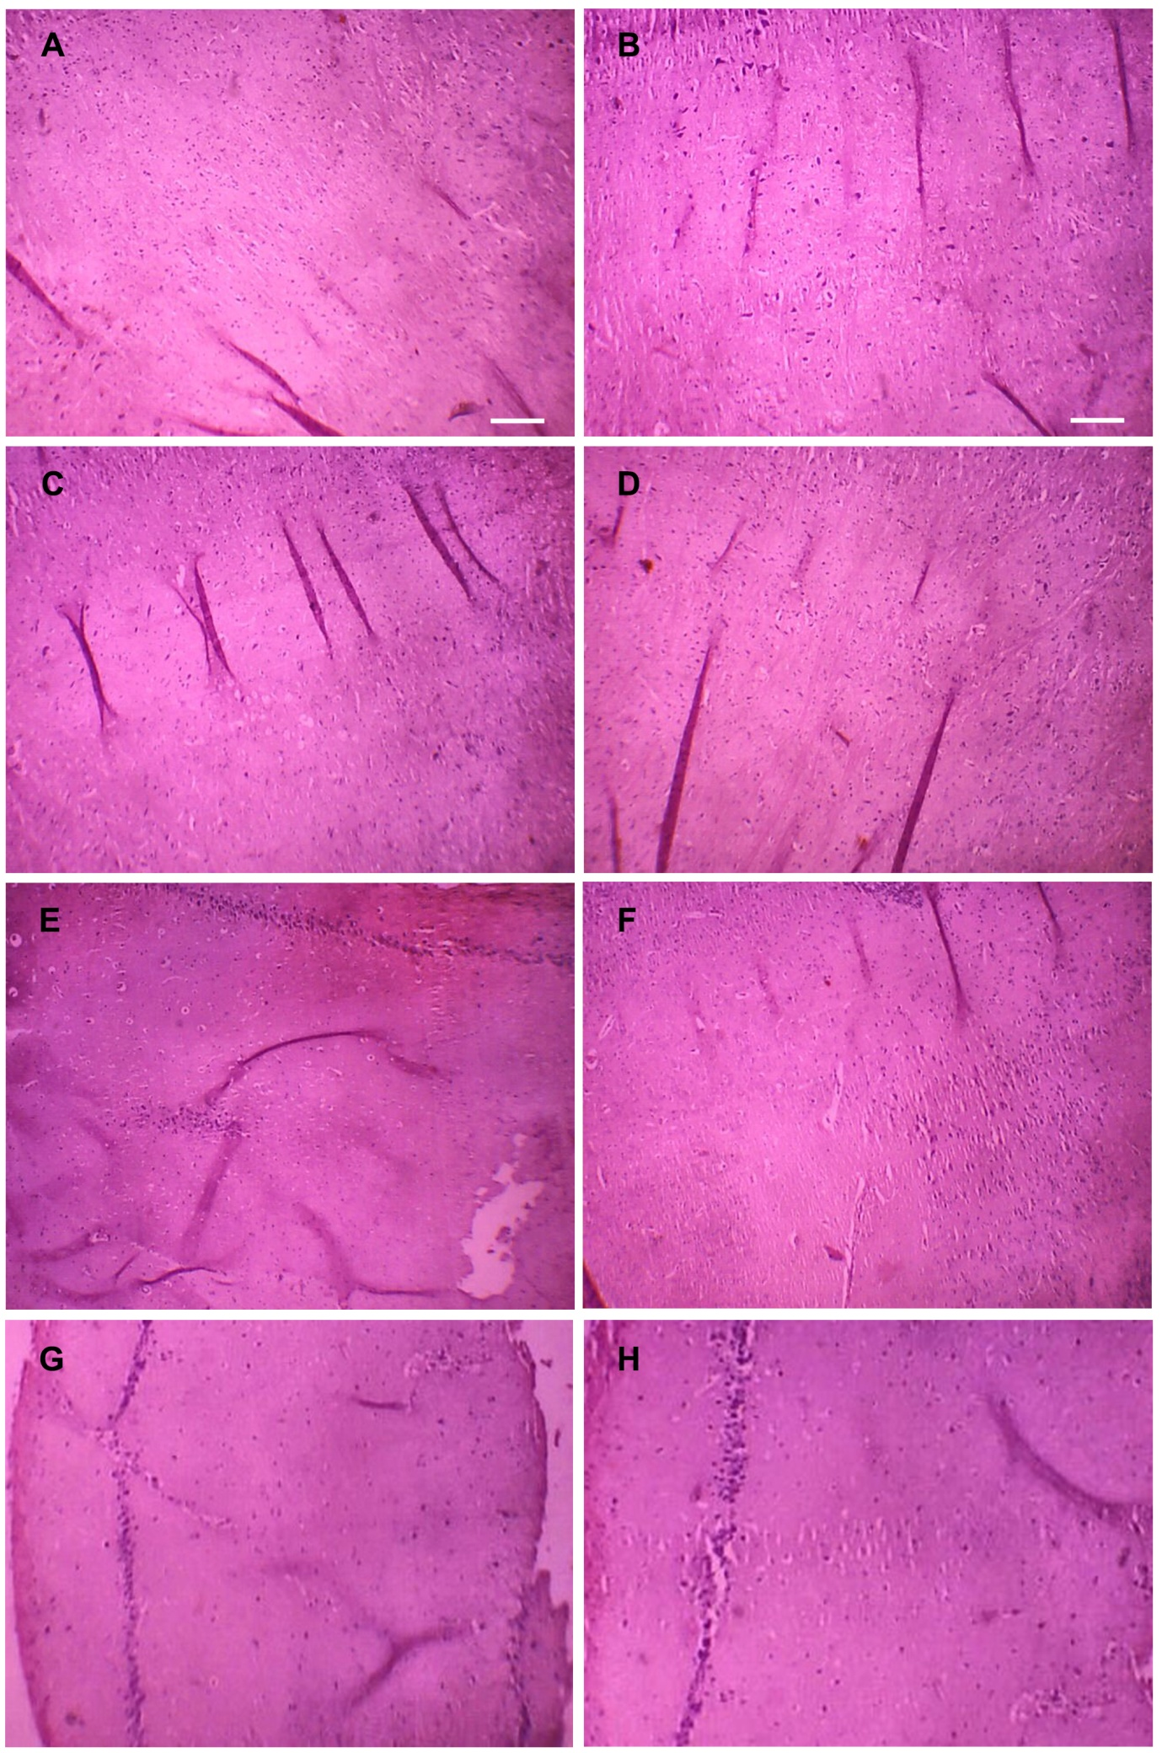
Figure 5. Effect of CT on Histopathology of young rat Medulla oblongata. Photomicrographs of Histopathology of medulla oblongata in young rats (3-months). A-control group showing normal neuronal architecture (NEU); B-aluminum and C, RS group showing degenerative changes in neurons (DCNEU); D-CT group showing neuron (NEU); E-RS+AlM showing highly degenerative changes and vacuolization; F-AlM+CT, G, RS+CT, H, RS+AlM+CT showing marked improvement with almost normal exterior of mild degenerative changes in neuronal layer (MDCNL), similar to control.

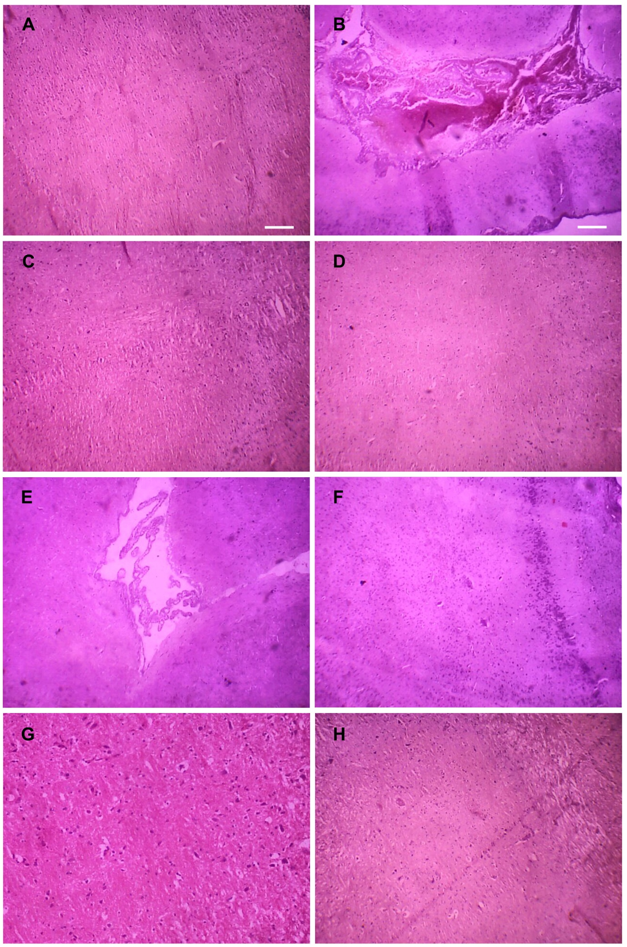
Figure 6. Effect of CT on Histopathology of adult rat Medulla oblongata. Photomicrographs of Histopathology medulla oblongata of adult rats (12-months). A-control group showing normal neuronal architecture (NEU); B-aluminum group showed vacuolization and C, RS group showing degenerative changes in neurons (DCNEU); D-CT group showing neuro (NL); E- RS+AlM showing highly degenerative changes and vacuolization; F-AlM+CT, G, RS+CT, H, RS+AlM+CT showing marked improvement with almost normal exterior of mild degenerative changes, similar to control.

IV. DISCUSSION
Psychological stress conditions and exposure to various environmental toxicants accompanies to brain aging which is characterized by increased oxidative stress and deterioration of cognitive function, including learning and memory (Papandeeou and Tsachaki, 2011). In the present investigation in order to determine the age-related neurodegeneration induced by both restraint stress (RS) exposure and environmental neurotoxicant such as aluminum maltolate (AlM) were administered to the experimental animals of young and adult male Wistar rats. Al has been reported to be involved in neurodisorders such as Alzheimer’s disease (Esparza et al., 2011). Young and adult rats that were exposed to restraint stress (RS) and aluminum maltolate (AlM) for four weeks period showed increased levels of TBA-RS as markers for lipid peroxidation (LPO) in AlM and RS treated medulla oblongata regions of young and adult rats. This exacerbates their brain oxidative damage which is more pronounced in adult rats compared to young rats. Our findings are in consonance with Dia Cheng et al., 2014 and John Sushma et al., 2014. AlM has been demonstrated to induce ROS, which subsequently attack almost all cell components including membrane lipids, producing LPO (Dai Cheng et al., 2014; John Sushma et al., 2014). The levels of TBA-RS in medulla oblongata of AlM and RS exposed young and adult rats were significantly reduced when the rats received CT leaf extract. It has been reported that CT administration reduces the TBA-RS levels in rats. The present study investigates the neuroprotective potential of Clitoria ternatea (CT) methanolic leaf extract.
The biological antioxidants play a major front line of defense against ROS in brain cells. Thus in the current study, decreased levels of enzymatic antioxidant such as SOD, CAT and GPx were observed in AlM and RS treated young and adult medulla oblongata regions. This may be due to the rise in TBA-RS levels, which is the marker for LPO and indicator of oxidative damage in both AlM and RS treated rats. SOD, CAT and GPx are the main bio-detoxifying antioxidant systems for peroxides in neurons, act as blockers of ROS and decomposes the superoxide and hydrogen peroxide in the cells to reduce the oxidative injury. Previous report of Sumathi et al. demonstrated that the aluminum dosage causes a significant decrease in SOD and CAT activities in brain regions of rat (Sumathi et al., 2013). The data obtained by the present study illustrated, that the co-administration of CT leaf extract to AlM and RS induced groups have exhibited normal antioxidant enzyme levels in young and adult rats cortex and medulla oblongata regions compared to AlM and RS alone treated rats. This may be due to its rich poly herbal formulations. The results are in agreement with Jayachitra et al., who suggested the antioxidant role of CT leaf extract in restoring the SOD, CAT and GPx levels in liver (Jayachitra et al., 2012).
Our data are in conformity with some earlier reports of Johnson et al. and Sushma et al., explained that aluminum exposure enhanced alterations in the enzymatic antioxidant defense status in association with neuronal lipid peroxidative damage (John Sushma 2014; Johnson et al., 2008). LPO exhibits serious impact on the cellular membrane fluidity and permeability, alters its receptor functions and causes loss of functional and structural development of the central nervous system (Gomez et al., 2005; Dua and Gill, 2001). Stress is one of the critical features of oxidative damage in the pathogenesis of various neurodegenerative disorders. In the current study, AlM intake and restraint stress produced an oxidative damage which is contributed to its neurotoxicity, which is in consonance with Flora et al., 2003. CT leaf extract had potentially enhanced these SOD, CAT and GPx antioxidant enzymes activity in brain by counteracting aluminum and restraint stress induced oxidative damage in rats. CT extract had already been proven as potential antioxidant by improving the antioxidant enzymes such as SOD, CAT and GPx in liver tissue of rats.
The histology observations indicated that AlM and RS-treated groups exhibited degenerative changes in medulla oblongata architecture as degenerative changes in neurons (DCNEU) compared to control group showing normal neuronal architecture (NEU) and tissue injury in both young and adult age groups of Wistar rats were identified. These results demonstrate unique attributes of histology in the screening of age-related neurotoxicity of restraint stress and aluminum in medulla oblongata of adult rats than young rats. The similar histological changes have also been reported by recent researchers upon Al induced toxic effect in the hippocampus and cortex (Dai Cheng et al., 2014). CtL group showed neuron (NEU) is similar to control group. However co-administration of CtL extract along with AlM and RS to young and adult age groups AlM+CT, RS+CT, RS+AlM+CT exhibited normal neuromorphological appearance of medulla oblongata similar to control revealed its neuroprotective role with non-toxic effect similar to control group.
Clitoria ternatea administration has revealed its tremendous neuroprotective benefits and has provided evidence against oxidative stress theory of aging and its relation with neurodisorders induced by AlM and RS. Our previous studies also revealed that co-administration of CT extract has been reduced the AlM induced neuro-oxidative damage in hippocampus (Mahalakshmi et al., 2015). Both AlM and RS are able to influence the cellular metabolism and stress related pathway in cell and ultimately brain neurodegeneration. CT administration appears to be potential therapeutic antioxidant and cholinergic interventions to treat conditions predicated by oxidative stress. Hence CT leaf extract with rich phytoconstituents can be easily incorporated into clinical trials in aging and neurodegenerative studies. Our results are in agreement wit
h Sivaprabha et al., demonstrated that, potential antioxidant effect of CT may be due to the presence of non-enzymatic antioxidant namely ascorbic acid, reduced glutathione and total carotenoids in the leaves of CT (Sivaprabha et al., 2008). It was evident that, RS and AlM caused significant oxidative damage in the present study which was observed by biochemical and histological studies in both young and adult medulla oblongata of albino rats compared to control. However, more oxidative damage was observed in adult rats compared to control. In CT administered group the alterations were not significant and the results are almost similar to control. In both CT and AlM co-administered group remarkable recovery in young and adult medulla oblongata regions with mild degenerative changes in neuronal layer.
V. CONCLUSION
From the results, we conclude that Clitoria ternatea leaf extract possess significant age-related neuroprotective activity by decreasing the free radicals damage and enhancing the activity of antioxidant enzymes with improved morphological architecture of neurons in brain medulla oblongata against stress and aluminum induced neuro-oxidative damage. Further study should focus on molecular studies to elucidate the mechanisms underlying the protective effects of Clitoria ternatea.

LIST OF ABBREVIATIONS:
Al : Aluminum
RS : Restraint Stress
CT : Clitoria ternatea
SOD : Superoxide dismutase
CAT : Catalase
GPx : Glutathione peroxidase
LPO : Lipid peroxidation
DCNEU : Degenerative changes in the neurons
CNS : Central nervous system
AD : Alzheimer’s Disease
BBB : Blood brain barrier
Cr : Chromium
Cu : Copper
ROS : Reactive oxygen species
AIM : Aluminum maltolate
TBA-RS : Thiobarbituric acid reactive substances
EDTA : Ethylenediamine tetra acetic acid
NBT : Nitro blue tetrazolium
ANOVA : One-way analysis of Variance
SD : Standard Deviation
MDCNL : Mild degenerative changes in neuronal layer
NEU : Neuronal architecture
CtL : Control

REFERENCES
[1] Abascal, K., Yarnell, E. 2004. Alzheimer’s disease: part 2-A botanical treatment plan. Altern. Complement. Ther. 10:67–72.
[2] Aebi, H. 1984. “Catalase in vitro”, Meth. Enzymol. 105:121–126.
[3] Aleisa, A.M., Alzoubi, K.H., Gerges, N.Z., Alkadhi, K.A. 2006. Chronic psychosocial stress-induced impairment of hippocampal LTP: possible role of BDNF. Neurobiol. Dis. 22:453–462.
[4] Amer Jyothi, Depak Sharma. 2006. Neuroprotective role of Bacopa monniera extract against aluminum-induced oxidative stress in the hippocampus of rat brain. Neurotoxicology. 27:451–457.
[5] Andersen, J.K. 2004. Oxidative stress in neurodegeneration: cause or consequence? Nation. Medici. 10:18–25.
[6] Bharati, P., Vasudevaraju, M., Govindaraju, A., Palanisamy, P., Sambamurti, K., Rao, K.S.J. 2008. Molecular toxicity of aluminum in relation to neurodegeneration. India. J. Medic. Res. 128:545–556.
[7] Bondy, S.C. Free radicals in neurodegenerative disease. In neurodegenerative disease. Marwah J, Teitelbaum H, eds, Prominent press, phoenix, AZ. 1998; pp: 1-23.
[8] Dai Cheng, Yu Xi, Jiankang Cao, Dongdong Cao, Yuxia M, Weibo Jiang. 2014. Protective effect of apple (Ralls) polyphenol extract against aluminum-induced cognitive impairment and oxidative damage in rat. Neuro. Toxicol. 45:111–120.
[9] Dua, R., Gill, K.D. 2001. Aluminum phosphide exposure: Implications on rat brain lipid peroxidation and antioxidant defence system. Pharmacol. Toxicol. 89:315–319.
[10] Esparza, J.L., Garcia, T., Go´mez, M. 2011. Role of deferoxamine on enzymatic stress markers in an animal model of Alzheimer’s disease after chronic aluminum exposure. Biol. Trace. Elem. Res. 141:232–245.
[11] Flohe, L., Gunzler, W.A. 1984. Methods of Enzymology. Academic Press, New York, pp. 114.
[12] Flora, S.J.S., Mehta, A., Satsangi, K., Kannan, G.M., Gupta, M. 2003. Aluminum induced oxidative stress in rat brain: response to combined administration of citric acid and HEDTA. Comp. Biochem. Physiol. Part C. 134:319–28.
[13] Friedlich, A.L., Butcher, L.L. 1994. Involvement of free oxygen radicals in β-amyloidosis: an hypothesis. Neurobiol. Aging. 15:443–455.
[14] Girish kumar gupta, Jagbir chahal, Manisha Bhatia. 2010. Clitoria ternatea (L.): Old and new aspects. J. Pharmacy. Res. 3(11): 2610–2614.
[15] Giurgea, C. 1973. The nootropic approach to the pharmacology of the integrative action of the brain. Cond. Reflex. 8:108–115.
[16] Gollen, B., Mehla, J., Gupta, P. 2018. Clitoria ternatea Linn: A Herb with Potential Pharmacological Activities: Future Prospects as Therapeutic Herbal Medicine. J Pharma Reports. 3:141.
[17] Gomez, M., Esparza, J.L., Nogues, M.R., Giralt, M,. Cabre, M., Domingo, J.L. 2005. Pro-oxidant activity of aluminum in the rat hippocampus: gene expression of antioxidant enzymes after melatonin administration. Free. Radic. Biol. Med. 38(1):104-111.
[18] Gulya, K., Rakonczay, Z., Kasa, P. 1990. Cholinotoxic effects of aluminum in rat brain. J. Neurochem. 54:1020–1026.
[19] Humason, G.L. 1972. “Animal tissue technique”, 3rd edn. Freemon, san Francisco.
[20] Jain, N.N., Ohal, C.C., Shroff, S.K., Bhutada, R.H., Somani, R.S., Kasture, V.S., Kasture, S.B. 2003. Clitoria ternatea and the CNS, Pharmacology, Biochemistry and Behaviour. 75(3):529–536.
[21] Jankord, R., Herman, J.P. 2008. Limbic regulation of hypothalamo-pituitary-adrenocortical function during acute and chronic stress. Ann. N.Y. Acad. Sci. 1148:64–73.
[22] Jayachitra, A., Sreelatha, S., Padma. P.R. 2012. Antioxidant and hepatoprotective effect of Clitoria ternatea leaf extracts by using in vivo model. Intern J Medi Aroma Plants. 2(2):323-332.
[23] John Sushma Nannepaga, Mallikarjuna Korivi, Madhavi Tirumanyam, Mahitha Bommavaram, Chia Hua Kuo. 2014. Neuroptotective effects of Bacopa monniera whole-plant extract against aluminum-induced hippocampus damage in rats: Evidence from electron microscopic images. Chin. J. Phys. 57(5):279–285.
[24] Johnson, V.J., Kim, S.H., Sharma, R.P. 2005. Aluminum-maltolate induces apoptosis and necrosis in neuro-2a cells: Potential role for p53 signaling. Toxicol. Sci. 83(2):329–339.
[25] Kamkaen, N., Wilkinson, J.M. 2009. The antioxidant activity of Clitoria ternatea flower petal extracts and eye gel, Phytother. Res. 23:1624–1625.
[26] Kawahara, M., Muramoto, K., Kabayashi, K., Mori H., Kuroda Y. 1994. Aluminum promotes the aggregation of Alzheimer’s amyloid β-protein in vitro. Biochem. Biophys. Res. Comm. 198:531–535.
[27] Lowery, O.H., Rosebrough, N.J., Farr, A.L., Randall, R.J. 1951. Protein measurement with the folin phenol reagent. J. Biol. Chem. 193:265.
[28] Mahalakshmi CHN Durga, Prathyusha D, Madhavi T, Swathi G, Sushma N John. 2015. Antioxidant role of clitoria ternatea extract against aluminum induced oxidative stress in hippocampus of albino rats. Intern J Sci Engin Res. 6:156-160.
[29] McEwen, B.S., Sapolsky, R.M. 1995. Stress and cognitive function. Curr. Opin. Neurobiol. 5(2):205–216.
[30] Misra, H.P., Fridovich, I. 1972. The role of superoxide anion in the auto-oxidation of epinephrine and a simple assay for superoxide dismutase”. J. Biol. Chem. 247(10): 3170.
[31] Montine TJ, Beal MF, Robertson D, Cudkowicz ME, Biaggioni I, O'Donnell H, Zackert WE, Roberts LJ, Morrow JD. 1999. Cerebrospinal fluid F2-isoprostanes are elevated in Huntington's disease. Neurology. 52:1104–1105.
[32] Mukherjee, P.K., Kumar, V., Houghton, P.J. 2007. Screening of Indian medicinal plants for acetylcholinesterase inhibitory activity. Phyto Therapy Res. 21:1142–1145.
[33] Mukherjee, P.K., Kumar, V., Kumar, N.S., Heinrich, M. 2008. The Ayurvedic medicine Clitoria ternatea-From traditional use to scientific assessment. J. Ethnophar. 120:291–301.
[34] Ohkawa, H., Ohishi, N., Yagi, K. 1979. Assay for lipid peroxidases in animal tissues by thiobarbituric acid reaction. Anal. Biochem. 95(2):351.
[35] Oteiza, P.I. 1993. A mechanism for the stimulatory effect of aluminum on iron induced lipid peroxidation. Arch. Biochem. Biophys. 308:374–379.
[36] Papandeeou, M.A., Maria Tsachaki Spiros Efthimiopoulos, Cordopatis P. 2011. Memory enhancing effects of saffron in aged mice are correlated with antioxidant protection. Behav. Brain Res. 219(2):197–204.
[37] Savory, J., Rao, J.K., Huang, Y., Letada, P.R., Herman, M.M. 1999. Age-related hippocampal changes in Bcl-2:Bax ratio, oxidative stress, redox-active iron and apoptosis associated with aluminum-induced neurodegeneration: increased susceptibility with aging. Neurotoxicology. 20(5):805–17.
[38] Siriporn Chamniansawat, Sukumal Chongthammakun. 2015. Inhibition of hippocampal estrogen synthesis by reactive microglia leads to down-regulation of synaptic protein expression. Neurotoxicology. 46:25–34.
[39] Smith, M.A., Harris P.L. Sayre L.M. Perry, G. 1997. Iron accumulation in Alzheimer disease is a source of redox generated free radicals. Proc. Natl. Acad. Sci. 94:9866–9868. USA88:1054010543.
[40] Sohel, R.S., Forster, M.J. 2007. Coenzyme Q, Oxidative stress and aging. Mitochondrion. 7:103–111.
[41] Srivastava, P., Raut, H.N. Puntambekar, H.M., Desai, A.C. 2012. Stability studies of crude plant material of bacopa monnieri and quantitative determination of bacopaside I and bacoside a by HPLC. Phytochem. Anal. 23:502–507.
[42] Sivaprabha, J., Supriya, J., Sumathi, S., Padma, P.R., Nirmaladevi, R., et al. 2008. A study on the levels of nonenzymic antioxidants in the leaves and flowers of Clitoria ternatea. Anc Sci Life. 27:28-32.
[43] Sumathi, T., Chandrasekar, Shobana, Varadharajan Mahalakshmi, Ramachandran Sureka, Manogaran Mabathra. 2013. Oxidative stress in brains of male rats intoxicated with aluminium and neuromodulating effect of Celastrus paniculatus alcoholic seed extract. Asian Pharm Clin Res. 6(3):80–90.
[44] Verstraeten, S.V., Nogueira, L.V., Schreier, S., Oteiza, P.I. 1997. Effect of trivalent metal ions on phase separation and membrane lipid packing: role in lipid peroxidation. Arch. Biochem. Biophys. 338:121–127.
[45] Xu, N., Majidi, V., Markesbery, W.R., Ehmann, W.D. 1992. Brain aluminum in Alzheimer’s disease using an improved GFAAS method. Neurotoxic. 13:735–744.
[46] Zafir, A., Banu, N. 2009. Modulation of in vivo oxidative status by exogenous corticosterone and restraint stress in rats. Stress. 12:167–77.
[47] Zatta, P., Ibn-Lkhayat-Idrissi, M., Zambenedetti, P., Kilyen, M., Kiss, T. 2002. In vivo and in vitro effects of aluminum on the activity of mouse brain acetylcholinesterase. Brain. Res. Bull. 59:41–45.
[48] Zheng, W., Wang, S.Y. 2001. Anti-oxidant activity and phenolic compounds in selected herbs. J. Agric. Food. Chem. 49: 5165–5170.

