**Mathematical Modeling of Vascular Blood Circulation**

Sanjeet Kumara, Bhawna Agrawalb, Subrata Rakshitc

*a Department of Mathematics Lakshmi Narain College of Technology & Science, Bhopal (M.P), India*

[*sanjeetkumarmath@gmail.com*](mailto:sanjeetkumarmath@gmail.com) *b,c Department of Mathematics,* *Rabindranath Tagore University, Bhopal, (M.P), India*

[*rakshit.subrata1983@gmail.com*](mailto:rakshit.subrata1983@gmail.com)*,* [*bhawnakhushiagrawal@gmail.com*](mailto:bhawnakhushiagrawal@gmail.com)

**Abstract**: Blood flow is the study of measuring blood pressure and determining the flow through blood vessels. The problem of blood flow has been studied for centuries, one motivation being to understand the conditions that cause hypertension. This article presents mathematical modeling of arterial blood flow derived from the Navier-Stokes equations and some assumptions. A system of nonlinear partial differential equations for blood flow and arterial cross-sectional area was obtained. Blood is non-Newtonian fluid and to model such fluid is very complicated. Even though this will make the problem much simpler, it still is valid since blood in a large vessel acts almost like a Newtonian fluid. The obtained result is very sensitive to the values of the initial state and it helps to explain the state of hypertension.

**Keywords**: Mathematical modeling, Navier-Stokes equations, Newtonian fluid, non-Newtonian fluid, arterial flow, MATLAB.

**Introduction:**

Blood flow is a study to measure blood pressure and find the flow through a blood vessel. his research is important for human health. Most studies examine blood flow in arteries and veins. One of the motives for studying circulation was to understand the conditions that can contribute to high blood pressure. Blood is a non-Newtonian fluid and modelling such a fluid is very difficult. In this problem, blood is assumed to be a Newtonian fluid. Although this makes the problem much simpler, it still holds because blood in a large vessel behaves almost like a Newtonian fluid.

**Governing equations:**

Yang, Zhang, and Asada investigated cuff-less continuous monitoring of blood pressure using a hemodynamic model. This includes the assumptions that the artery is a rectilinear, deformable, thick shell of isotropic, incompressible material with a circular cross-section and no longitudinal motions. At the same time, blood is considered an incompressible Newtonian fluid, and the flow is axially symmetric. The model approach is to use the two-dimensional Navier-Stokes equations and the continuity equation for a Newtonian and incompressible fluid in cylindrical coordinate :

 (1)

 (2)

 (3)

where, =Pressure, =density, =Kinematic viscosity,

=The components of velocity in axial (z) directions,

=The components of velocity in radial (z) directions.

For convenience**,** we define a new variable ****, which is the radial coordinate**:**  **(**4)

Where denotes the inner radius of the vessel. Assuming that is independent of the radial coordinatethen the pressure is uniform within the cross-section .   
Hence

, ,,,,,,,,, ,,,,,, ,,,, ,,,

Using simple algebra to change the variable such as:





Equation (1), (2) and (3) can be written in the new coordinate  as:

 (5)

 (6)

 (7)

An example of a hemodynamic model is the above system of equations. According to [3], Belardinelli and Cavalcanti assumed that the velocity profile in the axial direction, , would have the following formula in polynomial form:

 (8)

Despite the fact that the radial velocity profile is:

 (9)

[3] choose N =1 to simplify (8) and (9), so that

(10)

 (11)

The dynamic equations of  and , which are obtained by substituting equations (10) and (11) into equations (5) and (7), are:

 (12) (13)

Now, the cross –sectional area  and blood flow  are defined as:

 and ,

Equations (12) and (13) can be expressed in terms of  and  using these definitions:

 (14)

 (15)

By resolving the governing equations (14) and (15), the answers to the cross-sectional area of the artery and its related blood flow can now be found (15). Equations (14)–(15) form a system of nonlinear partial differential equations. Such a problem is solved using the finite difference approach. The equations will first be discretized using the first order accuracy difference formula shown below:

 and 

Where , so that the equations become difference equations:

 (16)

 (17)

Where i=1,2,3,…N .Here the pressure gradient  is kept constant and the value is prescribed. Figure -1 below displays the artery model's discretization.

L

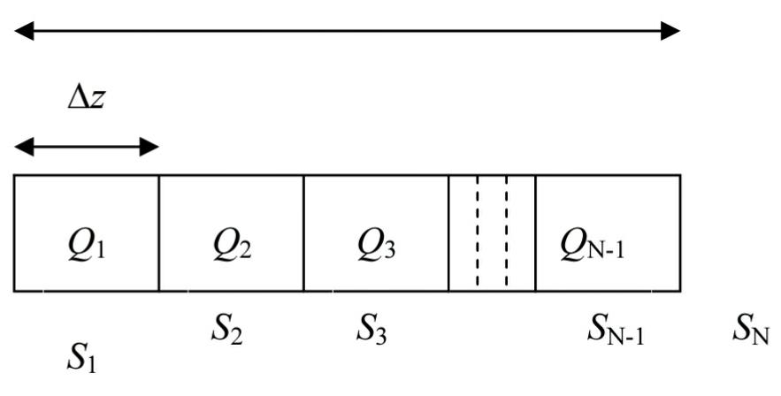

Figure 1: Discretization of the arterial model.

Since we are just interested in the local artery segment, we can linearize equation (16) to reduce the complexity of the governing equations.

 (18)

Equations (17) through (18) make up the system of equations that must now be solved, and the numerical solutions are covered in the following section.

**Numerical Method**

It is interesting to note that the difference equations (17) and (18) can be expressed using the formula ,

where,

 and



Now we use the most natural and fast habit to solve aforementioned question is by using MATLAB included function ODE45, that is established Runge-Kutta Method. The values of parameters that are required are the initial value of the blood flow,, the initial cross-sectional area, , the axial pressure gradient , the kinematic viscosity v and deity  
 for blood. The required values in normal condition can be obtained from past works in the field such as:

Initial value of  and  1 to 5.4 liter/minute [2]

Initial value of S and  to 2.0  [14]

 100 to 40 mmHg [15]

 [16]

 [16]

**Results and Discussions:**

In order to simulate the influence of the arterial cross-section on the blood flow in the artery, the parameter values ​​listed in the previous section are chosen:,  ,   and . For the sake of simplicity, we have chosen the length of the artery model to be  and the number of nodes in the system to be  . Considering only the arteries in the diastolic state, the chosen time interval is 0.2 seconds.

(A) (B)

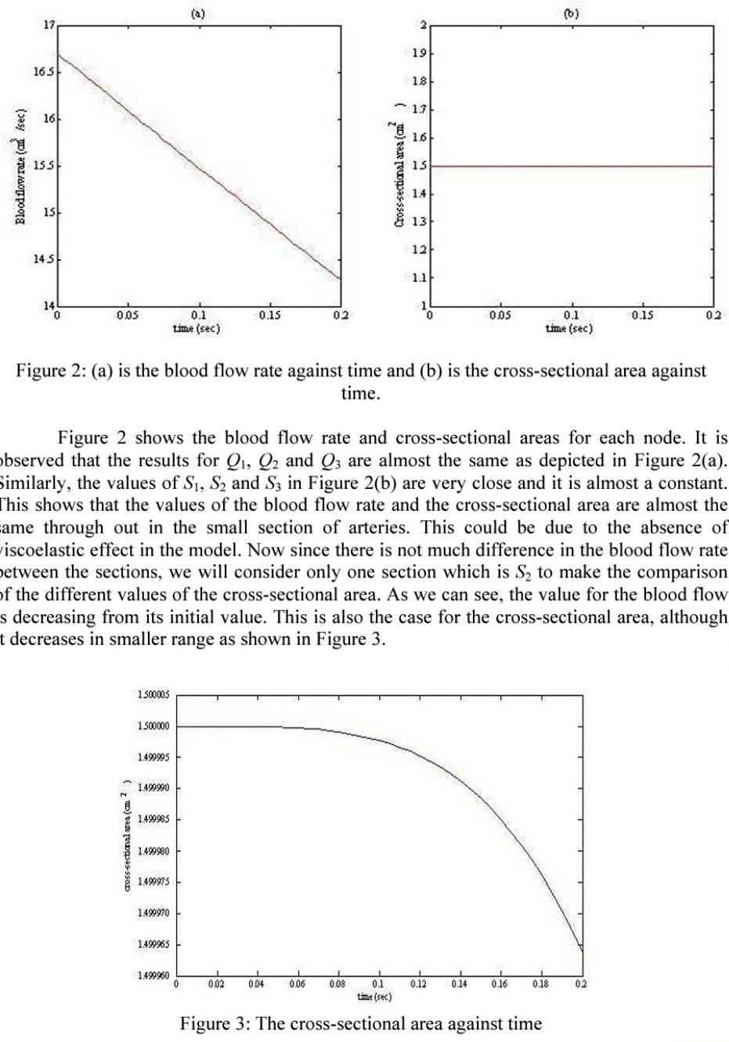

**Figure 2: (A)** is the blood flow rate against time and (B) is the cross-sectional area against time.

Now Figure 2 shows blood flow velocity and cross sections for each node. It was observed that the results for  and   were almost the same as in Figure. 2(A). Similarly, the values ​​of  and  in Figure 2(B) are very close and almost constant. This shows that the blood flow and cross section values ​​are almost the same in a small section of the arteries. This may be due to the missing viscoelastic effect in the model. Since there is not much difference in blood flow the slices, we consider only one slice, namely, to compare the different cross-sectional values. As you can see, the blood flow value decreases from the initial value. This also applies to the cross-section, which, however, decreases less, as shown in Figure 3.



**Figure 3:** The cross-sectional area against time

We have shown that blood flow in the arteries decreases linearly over time, and that this condition holds only in the diastolic state. This shows that without changing the pressure gradient value and the cross-section of the arteries, the blood flow does not change significantly over time. Figure-4 shows that with a lower cross-sectional value, blood flow decreases more slowly than under normal conditions. We then compare this result to smaller cross-sections and find that blood flow increases as the cross-sectional area decreases. This condition occurs when the cross section is between and. As more blood flows through the arteries in a smaller section, this can lead to increased pressure in the artery wall. This increases blood pressure and contributes to hypertension. That is High blood pressure (HBP) is a condition where blood pressure increases due to the fact that larger amount of blood flows through the arteries in a smaller cross-sectional area. This may cause the increasing of pressure in the artery's wall, resulting in an increased volume of blood flowing through the body.

1. (B)

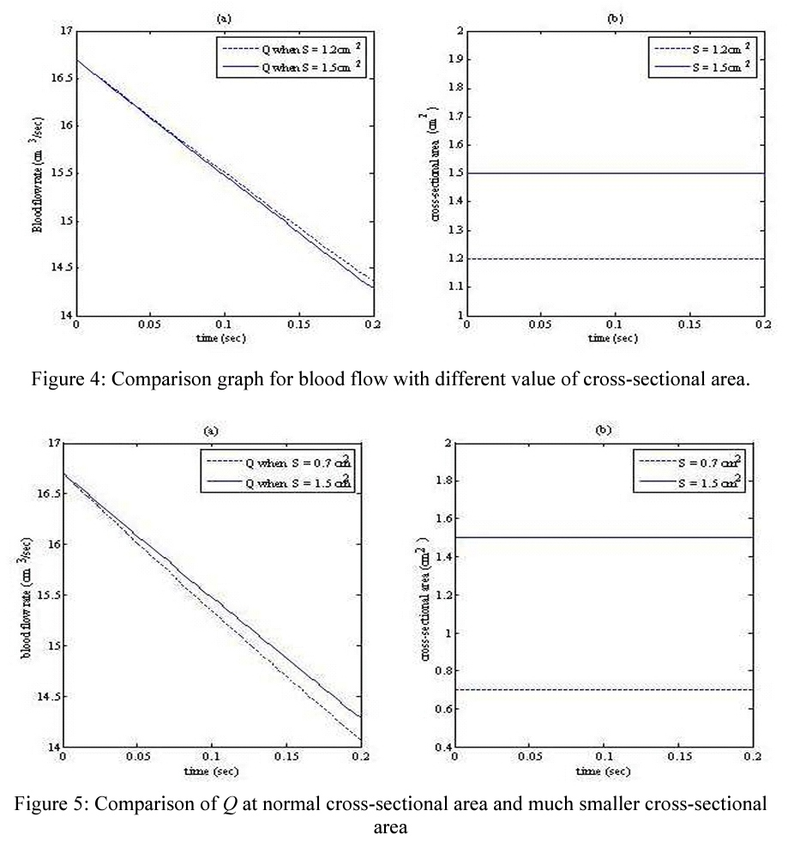

**Figure 4:** Comparison chart of blood flow at different cross-sectional values.

(A) (B)



**Figure** 5: Comparison of Q with a normal cross-sectional area and a much smaller cross- sectional area.

As shown in Figure 5 above, when the cross-sectional area value is less than , the blood flow decreases faster than normal. Pic. 6 shows the blood flow value when the cross section is in the range of to . Of course, as the cross-sectional area decreases further below, blood flow also decreases, drastic. This condition occurs when the cross-section of a person's body is too small for the blood to get through it, and this is also a dangerous condition for human. From this observation, we can say that this condition occur because the area under the person's skin is too thin and cannot be penetrated properly by the blood.

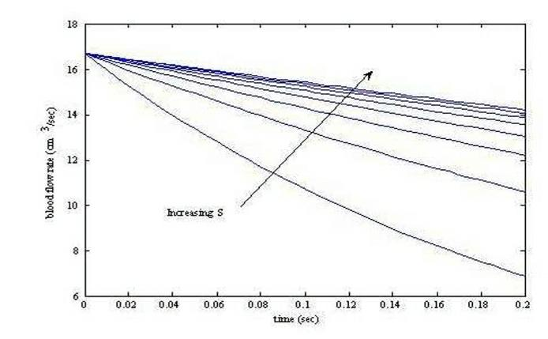

**Figure 6**: Q when cross-sectional area is in range between 0.1 cm2 to 0.8cm2

From the obtained results, it can be concluded that the cross-section plays an important role in the evenness of blood flow through the blood vessel. A small change in cross-sectional area can affect the amount of blood flow through the arteries, which can also affect blood pressure. In other words, a cross-section that is smaller than normal Size may contribute to high blood pressure or high blood pressure. When a large volume of liquid flows into a small container, pressure can build up in the container.

**Conclusion:**

In this paper, we derived a simple mathematical model that can represent blood flow in arteries. Although the model does not take into account the viscoelastic effect, the obtained results are considered reliable because based on this model we can conclude that we observe that the size of the blood vessel influences the blood flow. A small change in cross-sectional value results in a large change in blood flow.

**Reference**

1. Golden, J. F., Clark, J. W. and Stevens, P. M. Mathematical modeling of pulmonary airway dynamics, IEEE Transactions on Biomedical Engineering, 1973; 20 (6): 397-404.
2. Yang, B. H., Asada, H. H., & Zhang, Y. Cuff-less continuous monitoring of blood pressure using a hemodynamic model, The Home Automation and Healthcare Consortium-Progress Report, 1999; 2(3): 1-22.
3. Liu, Y., So, R. M. C., & Zhang, C. H. Modeling the bifurcating flow in an asymmetric human lung airway, Journal of biomechanics, 2003; 36(7): 951-959.
4. Kumar, S., Kumar, S. and Kumar, D. Oscillatory MHD flow of blood through an artery with mild stenosis, International Journal of Engineering, IJE Transactions A: Basics, 2009; 22 (2): 125-130.
5. Crosetto, P., Reymond, P., Deparis, S., Kontaxakis, D., Stergiopulos, N. and Quarteroni, A. Fluid–structure interaction simulation of aortic blood flow, Computers & Fluids, 2011; 43(1): 46-57.
6. Magder, S. Volume and its relationship to cardiac output and venous return, Critical care, 2016; 20(1): 1-11.
7. Roy, M., Sikarwar, B. S., Bhandwal, M., & Ranjan, P. Modelling of blood flow in stenosed arteries, Procedia computer science, 2017; 115: 821-830.
8. Safaei, S., Blanco, P. J., Müller, L. O., Hellevik, L. R. and Hunter, P. J. Bond graph model of cerebral circulation: toward clinically feasible systemic blood flow simulations, Frontiers in physiology, 2018; doi: 10.3389/fphys.2018.00148.
9. Kumar, S., Kumar, S., Kumar, D. Comparative study of non- Newtonian physiological blood flow through elastic stenotic artery with rigid body stenotic artery, Series on Biomechanics, 2020; 34 (4): 26-41.
10. Qohar, U. N. A., Zanna Munthe-Kaas, A., Nordbotten, J. M. and Hanson, E. A. A nonlinear multi-scale model for blood circulation in a realistic vascular system, Royal Society Open Science, 2021; 8(12): doi: 10.1098/rsos.201949
11. Figini, V., Galici, S., Russo, D., Centonze, I., Visintin, M. and Pagana, G. Improving Cuff-Less Continuous Blood Pressure Estimation with Linear Regression Analysis, Electronics, 2022; 11(9): 1442.
12. Kumar, S., Kumar, S., Kumar, D. and Kumar, A. A Two- Layered Model of Blood Flow for Stenosed Artery along with the Peripheral Layer, Series on Biomechanics, 2022; 36 (2): 181-187.
13. Agrawal, B., Kumar, S., and Rakshit, S. A Mathematical study of constrained fluid movement in the arterial system due to the formation of multiple stenosis, International Journal of Applied Research, 2022; 8 (3): 455-464.
14. Agrawal, B., Kumar, S., and Das, G. Mathematical model of blood flow through stenosed arteries with the impact of hematocrit on wall shear stress, International Journal of Applied Research, 2022; 8 (3): 439-443.
15. Zain, N. M., Ismail, Z. and Johnston, P. Numerical Analysis of Blood Flow Behaviour in a Constricted Porous Bifurcated Artery under the Influence of Magnetic Field. CFD Letters, 2023; 15(1): 39-58.
16. Xue, X., Liu, X., Gao, Z., Wang, R., Xu, L., Ghista, D. and Zhang, H. Personalized coronary blood flow model based on CT perfusion to non-invasively calculate fractional flow reserve, Computer Methods in Applied Mechanics and Engineering, 2023; 12(6): 2154. doi: 10.3390/jcm12062154
17. Shrivastava, R., Chandel, R.S., Kumar, A., Shrivastava, K. and Kumar, S. A mathematical core and peripheral layer model of blood flow through stenosed artery, International Journal of Scientific Research in Mathematical and Statistical Sciences, 2018; 5 (6): 13-20.