SAVIOURS OF EXTREMELY PRETERM BABIES-HOW FAR WE ARE!

AUTHORS
1* SANTHOSH . S , DEPARTMENT OF PHYSICIAN ASSISTANT
SCHOOL OF ALLIED HEALTH SCIENCES , VINAYAKA MISSIONS RESEARCH FOUNDATION -DU ,
SALEM , TAMILNADU, INDIA .
santhoshmscphysician@gmail.com

2..KEERTHAVARSHINI.K , DEPARTMENT OF PHYSICIAN ASSISTANT
SCHOOL OF ALLIED HEALTH SCIENCES , VINAYAKA MISSIONS RESEARCH FOUNDATION -DU ,
PUDUCHERRY , , INDIA .
keerthavarshinikannan1505@gmail.com

ABSTRACT
In 18th century, the death rate of the premature babies is very peak in counts. During that time Stephane Tarnier, who was French Obstetrician innovate the incubator for premature bay from the principle of chicken incubator. It was maintained the babies temperature to avoid the hypothermic condition of the premature babies. After several years, the early incubators was developed by the other physicians an according to the modern development from water bath to glass incubators. Its slightly reduced the rate of premature babies. After the further development of incubators, now its reached the special care unit has been innovated i.e., neonatal intensive care unit (NICU). It is completely accompanied with advanced methodology of the treatment procedures for the preterm babies such as mechanical air ventilation, oxygen administration and nasogastric feeding and so on. The death rate of the extreme preterm babies is not reduced still now even though the advancement of NICU. Recently, AWT has been introduced in 2017 Philadelphia, which is closest thing to biobag to prevent the death of extreme preterm babies. It is the entire process of ex-utero gestation. Significantly reduce the mortality & morbidity rate, but still it was in animal trials not in human trials. Expecting the clinical application of this device in future.

KEY WORDS: Preterm babies, Early incubators, Modern incubators, AWT, Biobag, EVE therapy, Ectogenesis

- INTRODUCTION

Preterm birth, before 37 weeks of gestation. It is characterized by gestational age as extreme preterm ( less than 28 weeks), very preterm (28- 32 weeks) & moderate preterm (32- 37 weeks). In 19th century the infants death rate was peak. During that period, due to the birth of preterm babies were saved by early incubators. This helps the infants to keep in warm water to maintain the womb temperature. Later, Dr. Stephane Tarnier in 1857 formulate the basic principle for the incubators, as we know them today. Infant incubators helps to sustain the preterm babies. In 2017 & 2019 two research team from US & Australia has established the Artificial Womb Technology (AWT) principle. Devices namely Ex vivo uterine environment (EVE) & Biobag, which is the treatment of extremely preterm neonates. It is complete process of Ex utero gestation helps to continue to develop the extreme preterm babies.

- SAVIOUR METHOD

Many babies died in the period of 18th century, because of hypothermia. So at that time, French Obstetrician Stephane Tarnier, who in the 1870s, invented the first premature incubator [1]. It is to warm the premature infants on the wards of Paris Maternity Hospital. This basic principle inspired him form zoo’s instrument maker, while visit to the chicken incubator display in the Paris Zoo, which is a similar device for infant care in 1880 [1].

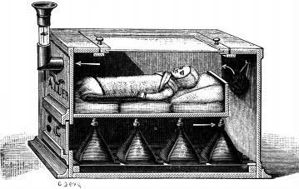

FIGURE 1: Stephane Tarnier invented incubator in 1880

Stephane Tarnier interpreted this principle by placing a hot water bottles for every 3 hours to premature infants to lower the complication of hypothermia[1]. The air ventilation enters at the base & circulates around the infants[2]. It should be noted that lowers the sudden increase of temperature than other available devices. In European Maternity Hospitals, they use the same principle by different method like laundry baskets wrapped up with blankets & hot water bottles, using metal warming tubes known as warm wannen, had been in use for more than 20 years[1]. In German, at Leipzig Maternity Hospital, Obstetrician named Carl Crede pointed out this article in 1883. But whatever criticisms, Tarnier convince his colleagues about incubators that made a huge difference among those peoples. He compared the mortality rate of premature infant before and after established the device. Lastly, he perceived that decrease a half from 66% -38%. The placing of spotlight on premature infant which may have amended nursing care or nurturing techniques, which is named as gavage feeding. It was all introduced at the same time. Hence Tarnier proclaimed that many infants that would be sorted as “small for gestational age”. But simultaneously, oddly applause those dots. After these possibilities, the Paris Municipal Board decided to speed up to set these incubators in all Maternity Hospitals[1].

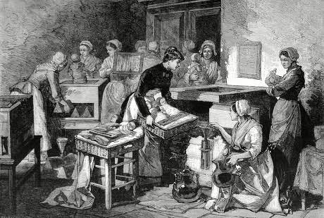

FIGURE 2: Tarnier Incubator in the Paris Maternity Hospital in 1884

On the time of 1870s, French parliamentary group captivated by the connotations of their country’s descending birth rate, which was only partly of German’s competitors. By the 1890s, through social promoters, tries to elevate their center of attention to insistence that play an active stance in facilitating the mothers to raise their healthy infants. After all these proclamations, the Paris Maternity Hospitals enhancing the foremost services called “Hospital services for weaklings” which is alternatively known as services de débiles[1]. On that time, was fully occupied in hospital wards by incubators and brought many premature infants from their homes to treating their conditions using incubators. With all of these, wet nurses made availability of breast milk for the babies apart from their mothers, with a donation of 40,000 Francs from the Paris Municipal Council in 1893 among high supposition.
After the retirement of Tarnier, the premature infants care for upcoming days cut down to Obstetricians of next generation. Beside one another, the researcher Adolph Pinard, who are primarily known as Champion of Maternal education classes which is called puericulture & French Eugenics leader, criticized the project of attempting to redeemed the premature babies lives, before the French Senate Commission of depopulation In March 1902. He became primary campaigner of maternity leave, which is the best strategy to convince a “strong and vigorous population” in the future. From that day forward, Pierre Constant Budin who was taken the position of Tarnier conflicted with figure out why babies appeared in such disastrous condition[1]. He wrote “the service de débiles served why as a mortuary depot…..a place where one transported his little infant when it was going to succumb”. So Budin connotation that was to hire the mother to the premature infant care. But, his response was to criticize the treated premature infants aside from their mother.
After that, Budin created a simple glass incubators at the bed side. The observer noted that, “The glass permits the mother to watch every movement of the poor, fragile little being”. Another observer noted that, “And thus watching him, almost minute by minute, the mother becomes attached to her baby”. This marks the revolutionize model in child care. In 1900, Budin died because of influenza virus. In United States, at the period of late 19th century, brought up to mind as the stage of professional inventor.
In 1890, Alexandre Lion, who was Physician and son of an inventor, redefined the incubator that the incubators of Tarniers. The Lion incubators were designed with a large mental equipment provide with a thermostat and an independent forced ventilation system, which is reimburse for less that flawless environment. Lion becomes entrepreneur that a physician and created so called “Incubator Charities” throughout France promoted by spectator declaration fees[1]. He endorsed his project in the press through publications. In 1896, Berlin Exposition was happened in the Lion’s profession was his inaugurating of the Kinder- brutenstalt (“child hatchery”), which is a detailed incubator premature infant show that became a huge thunderbolt outrage.

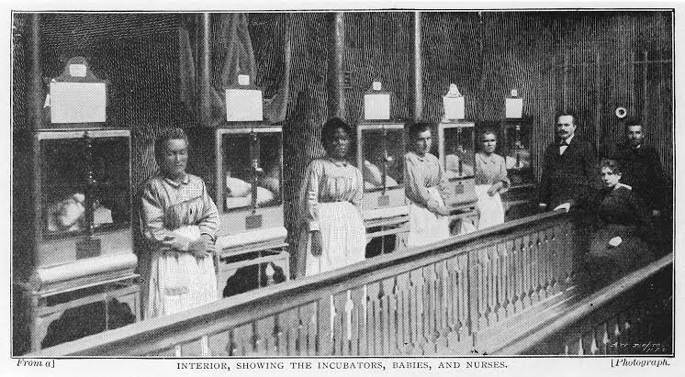

FIGURE: 3 Alexandre Lion Incubators In 1896

Afterwards the incubator show dropped in the United States, with the association of Martin Couney, who was physician and performed with Lion at the Berlin Exposition which is happened in 1896. Couney, who had before turn into American citizen, he initiated his own incubator shows in London and Pan American Exposition of 1901 in Buffalo[1]. Following this, Couney decided to display to begin everlasting incubator show at Coney Island. Later Chicago Obstetrician, named Joseph B. DeLee, who’s a son of eastern European immigrant and become one of the leaders of Obstetrics in 20th century, tries to comprise a Lion style premature incubators.
He contended that childbirth process was a pathological process, which also needs a systematic intervention. While many of the researchers strived to established a premature infant incubators in aa open pediatric ward, but DeLee doesn’t acknowledged that those incubator was not self-sufficient which needs a cornerstone to appeared in an incubator shows.

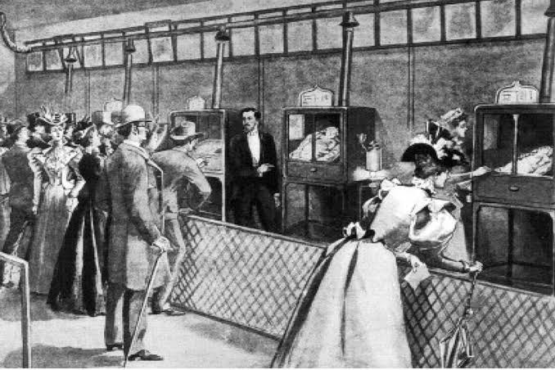

FIGURE:4 An Artificial Foster Mother : Baby Incubators At The Berlin Exposition , Display Of Lion Incubators In 1896

In 1900, DeLee initiated a premature incubator station at the Chicago Lying-in Hospital. He was capable to intubate and inflate the lungs and developed his own thermostat for his premature infant incubators. Along with, he began a transport service to brought up the premature neonates in the halfway of Chicago winter. Many middle class women started to invading the hospital especially for premature infant incubator. DeLee contributing his money for writing the articles for news papers and magazines[1]. DeLee failed on his attempt.
In 1904, at the Louisiana Purchase Exposition, DeLee incubator shows forged on the defensive and furthermore, Coney Island show was ruined by fire. Couney thought to start to with shows at Coney Island and Atlantic city. In 1917, one physician declared that, “incubators are passé, except at country fairs and sideshows”. In 1919, one review article stated that, “ the use of the incubators in becoming more and more popular”. In 1920 the United States Bureau warned mothers that, “ incubators are now generally used in hospital cases”[1]. The census was gradually decreased on the newborn period especially during the year around the First World War.
After all struggles, in 1914, Couney pursued to initiated to show at Chicago’s white city amusement park and was impressed by Julius H. Hess, who was physician. Finally, Hess’s also access into the premature infant incubator inventing world, that is to evidenced to be permanent and stated the milestone. Hess joined hands with DeLee of originate from Chicago’s Jewish community and who was the chief of Michael Reese Hospital founded by German Jewish population. In 1914, Hess developed his own version of the premature infant incubator, which containing an electrical “heated bed” that enclosed the infant containing the hot water in a metal apparatus.

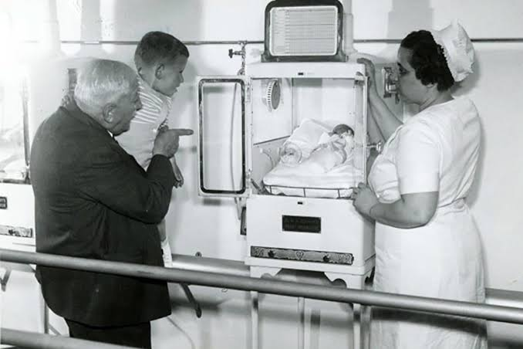

FIGURE:5 Coney Island Incubator Babies

In 1920s, Hess arised as the leading American authority before the Second World War as a result that he had established a premature infant incubator station. Later, he extended to develop the purpose of the premature infant incubator into an oxygen chamber and automobile based transport system for therapeutic methods for infants. In 1933, at the Chicago Century of Progress Exposition organized by Martin Couney and Hess. Couney shuts down his operation at Coney Island soon, afterwards defending that enhanced the hospital care had portrayed it unessentially. Now, more premature infants born in hospital with their care given by nurses directed by physicians instead of obstetricians has thus come up with to be a huge topic of the extension of neonatology to the present day

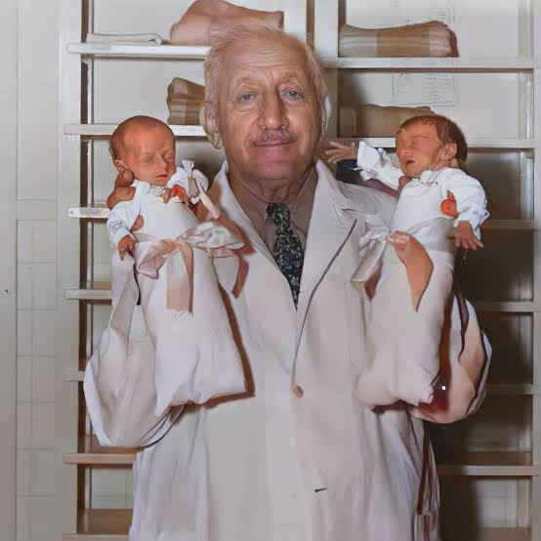

FIGURE: 6 Martin Couney Saved two premature babies by using a incubators

- THE ARTIFICIAL ENDOMETRIUM

In New York City, a researcher named Hang Chung Liu at Cornell University formulated a cell co-culture system that is a combination of epithelial and stromal cell. It is the first documented case of an artificial uterus. These experiments on embryo research were implemented in the United States and came to an end within 6 days. The artificial endometrium obtained in vitro from epithelial cells placed on a bed Matrigel[3]. Various studies have worked on artificial endometrium models and mentioned their reactions to steroid, hormones in various circumstances. The epithelial and stromal cells were arranged on Matrigel support, which provides spontaneous orientation and favourable capability to the epithelial cells. This helps in the development of new models for studying maternal embryo interactions. In 1996, in Japan, Kuwabara proclaimed attempts at preserving a developing goat in an incubator for about 3 weeks which reproduced the uterus and placenta along with both amniotic fluid and blood supply.

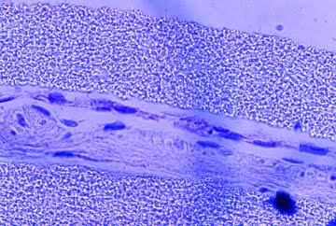

FIGURE :7 Artificial endometrium obtained in vitro from epithelial cells placed on a bed of Matrigel

- THE ARTIFICIAL PLACENTA

Through extracorporeal perfusion, the placenta has been preserved for the study of hormone metabolism, fetal and maternal responses to different pathophysiological hindrances [3]. For instance, it has been explained that the human placenta can be responsible for nutrient supply and waste product removal while connected to an artificial uterus. Several uterine transplantations resulted in failure. Because of immunosuppressive therapies, the placentation or passage of nutrients via the placenta stands as an unsettled issue in those states. By passing antibodies like immunoglobulin (IgG), the placenta may also provide immune protection to the fetus.
Premature fetal removal from the uterus by maternal means prevents their physiological blockage, allowing the three umbilical cord vessels to remain open, It’s like heparin flushing, stent placement or exchanges between maternal and fetal blood by creating an arterial bypass, which assists it, An artificial uterus and placenta connected directly to the maternal circulation [4][5]. Placental physiology is supported by a reservoir of maternal blood and helps with nutrient supply to the fetus and waste removal. So far there is consideration of another opinion, between artificial uterus and placenta would be directly connected to the maternal circulation.

- ARTIFICIAL WOMB TECHNOLOGY

In 2017, the thing that is closest to the Artificial womb was revealed by Philadelphia research team. The prototype ’BIOBAG’ was successfully created and supported with lamb fetuses on the present applicable threshold. The biobag ease the procedure of partial ectogenesis[7]. The lamb fetuses was developed in an AW, carry the fetus from the maternal womb during the gestational period part. This procedure exposes true guarantee of a future, in which redefined technology for premature neonates.
Singer and Wells contended that the biobag would come about ‘by accident’ in neonatal intensive care. During the process, a lamb fetus is already developed in uterine conditions of lamb and then carry the lamb fetus to an AW to continue developing in ex-uterine conditions. Biobag is differentiated from AWT, which means biobag is partial ectogenesis and AWT is complete ectogenesis (which means, embryo is created in-vitro fertilization that is entirely developed in AW).
The commonest and aggravating problem of NIC includes: underdeveloped lungs, respiratory and circulatory problems that causing hypotension, oxygen shortage and underdeveloped deglutition. It was mostly occur before 26 weeks[6]. These issues were corrected by mechanical ventilation, administering of oxygen supply and nasogastric feeding. Mechanical ventilation and oxygen administration for lung development which may cause damage to the lungs in neonates. Nasogastric feeding had high chance to get necrotizing enterocolitis and infection. Because there is lots of risks, so the Scientists be the option that NIC have been worn out.

- BIOBAG

The newly created AW, which able to work similar to the uterine environmental conditions to develop lamb fetuses for about 4 weeks. The biobag comprised of sealed nag to hold a lamb fetuses or premature neonates, a pump-less oxygenator circuit and umbilical cord access. The sealed bag lowers the risk of infection and prevents exposure in the outside, also the sealed bag consists of amniotic fluid, which comprised of all nutrients[6]. Cannulae was inserted into a sealed bag, which carries a nutrient and oxygen into the lamb or neonates bloodstream that plays a role like umbilical cord. Circulation is happened, that is basically according to the fetuses working of heart with the help of an oxygenator.
The biobag appropriately pretends like natural gestation in-utero. Following this, some researchers told that if in animal testing gain positive results, morbidity and mortality rate would be elevated among the human preterm neonates alone maintain to use of their AWT. For an AW procedure, some specific term gives useful transparency and error free meaning, which is known as ’Gestateling’[6]. It is a human being in the process of ex-utero gestation exercising, whether it is capable of doing so, so no dependent capacity for life. The gestateling process may occur in the future, via experimental treatment, enhance a medical reality intensifying ethico-legal argumentation in the field of obstetrics and neonatalogy.

- INTEGRAL FEATURES OF AWT

Artificial womb technology and conventional neonatal intensive care are different but both system keep the underdeveloped human. A researcher Hendricks noted, nevertheless that AWT and conventional NIC is different in nature as long as it handover more broad support. The intention of AWT is to treat a gestateling “as if it had never been born and thus needs to exercise capabilities, no independent capacity” for life. But the old incubator’s intention is to assisting what capacity for the newborn thus for exercising or initiating to exercise. If AWT were switched off or not working properly means, the underdeveloped gestateling would die just as a fetus but premature infant incubator might have chance for a little period of time to survive.
Skin-to-skin contact is less possible in AWT. Finally, AWT has some potential uses in the means of dangerous pregnancies. In some cases, pregnant mother would face a situation like threatening condition as abortion, in that type of cases, whether the women long enough to deliver a healthy baby but capturing the risk that neither mother, nor her fetus will survive[6]

- THERAPEUTICAL TRIALS

AWT is a try to artificially imitate and substitute the biological process of pregnancy or gestation and to promote the existence of humans ex-utero that don’t need to life functions to survive. AWT is an advancement of NIC[8].
Dr. Flake realized that AWT ’could establish a new standard of care subset of extremely premature infants’. The objective is to develop ’a therapeutic option’ substituting conventional mechanical ventilation that is revealed by EVE team. The researchers trust their study would advance outputs for preterm neonates. In experimental AWT, there is a lot of significant risk, like cardiac failure from circuit overload, liver dysfunction because of lack nutrient supply or brain injury and circuit malfunction because of a loss of balance between adequate and excessive nutrition. Even though, the researchers hope that this AWT would revolutionize the future of preterm care. Following this, The World Medical Association[9], British Medical Research Council[10] and United States Department for Health and Human Sciences[11], though all groups are welcoming the non-therapeutic research because of the intention is to safe of preterm babies in future.
The term ’Gestateling’ is not a neonate but it is an AW, since it is not fully born, still it is in process of gestation (human pregnancy) and is more comparable in behaviour and physically, in the matter of no capacity for independent life and no interact with fetus.
Lastly, lamb studies may possible not give essential data to establish important well-being in human. So researchers decided to do one more study with alternate animal, which is closely related, such as primates, to prove a human trials in preterm babies.

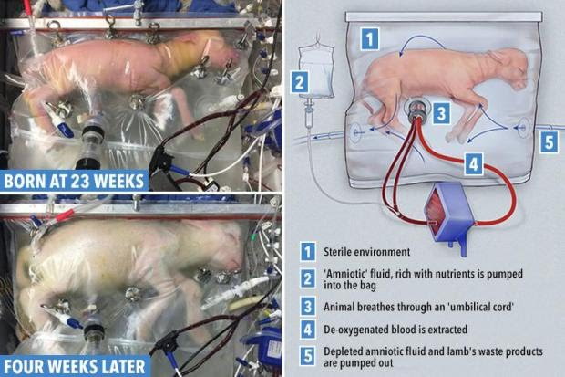

FIGURE : 8 Lamb Foetus trial was done in children hospital in Philadelphia, U.S

- NIC VS AWT

Development of the biobag was published by a US research team in the year of 2017.In early phase, this early model AW had supported lamb fetuses on the threshold of viability for 4 weeks. In the year of 2019,design named ‘EVE platform’ was published by a research team in Australia with a few comparable success. The gestateling has the ability to continue to gestate, if the devices are advanced to the conditions and functions of the human uterus. A sealed plastic bag holds artificial amniotic fluid in which the gestateling is immersed. The gestateling’s own heartbeat which is aided by an oxygenator and catheters maintains the circulation. All these studies had an impact, that contributes to continue the process of gestation ex utero that they are aiming in assisting a premature with the normal physical processes that regularly occur in the body for continuity in the outside environment.
Significant risk of deaths are caused due to prematurity, that the infants are born before 24 weeks and the usage of NIC technologies, causing infections, heart failure, and irreversible lung damage. The biobag deals with these problems[13]. All subjects from the AW were healthy and with no occurrence of heart failure or lung damage and also exhibited well developed organ. The research team concluded that the ‘potential clinical utility of a further refined EVE Therapy system to improve outcomes for extremely preterm infants’. The biobag put forward that the preparation for testing on humans will start soon.
Artificial wombs are applicable for the women who feel difficult to make a good choice about their pregnancies that are considered critical. Obstetricians and women should be directed to deliver the fetus before 37 weeks when pregnancies goes wrong. This alternative can be dangerous to pregnant woman and the fetus.
If thinking about continuing the pregnancy or either by pregnancy termination, both can result in fetal demise or preterm birth, assisted with NIC, that depends on the considerations that had to be balanced. NIC is the unit for the specialized care for premature babies that can increase the possibility of survival of the fetus, but can also bring major risks of causing death. The fetus remains undeveloped in premature delivery, also cannot survive without the help of NIC. Pregnancy termination is a final course of action, as NIC gives no assurance for the survival of the preterm. Once if the women and obstetricians decide to end a pregnancy, the fetus gets extracted from the uterus by the surgical opening of the abdomen and womb or labor induction process. These procedures put them in danger. In some circumstances, pregnancy termination can save both pregnant woman and fetus instead of continuation of pregnancy but in some cases it is difficult because it can be endangered for the pregnant woman and not for fetus and ending of pregnancy results in risks of complications. In conclusion, AWs seems less complicated than this decision making process.[12]
AWT are used as a replacement to NIC that has capability to bring finer outcomes for the fetus preterm delivered before 37 weeks. Present NIC is considered as undependable because of the restrictions and complications for the pregnant women who concern about their fetuses. Almost pregnant women want to end their pregnancies because their pregnancies are critical and remaining pregnant women prefer continuing with the pregnancy because of their concern over the complications of NIC and about their fetuses. Anyhow, AWs could get rid of all these problems. This could facilitate a different way of decision making in obstetric practice, that there is no delivery of a preterm. AWs have the ability to build up woman’s autonomy by reducing the pressure on them in the matter of taking decisions about ending of pregnancy. AWs saves the life of the pregnant women and fetuses, to set free from major risks or complications and self sacrifices.

- AWT – IN FUTURE !

Artificial reproductive technology would master the in vitro development of the human fetus. This offer the possibility of fertilizing oocytes and growing the embryo viability. This could treat for certain anomalies in utero itself. Initial attempts to develop artificial placentas were abandoned in the mid 1980s. At the same time continuous positive airway pressure system and intermittent mandatory ventilator were introduced to treat respiratory distress syndrome in premature newborns. A new system called extra uterine fetal incubation (EUFI), which used cannulation of the umbilical vein and artery that were connected to the circuit was tested on a baby goat that was ultimately extracted[3]. The research provide evidence to suggest that improving technology to our model of extracorporeal perfusion of human uterus that allows for embryo implantation that is operational. The development of an artificial human uterus using endometrial cells grown over a uterus shaped scaffolding which develops goats with artificial placenta and uterus. No experiments have done in human but experiments on lamb fetus have resulted in maintenance of life for several weeks outside the uterus.
For premature infants liquid ventilation is the next important step in treatment. Recently, a fluorocarbon liquid was developed which has the capacity to carry large amount of oxygen and carbon dioxide. By inserting the liquid in lung expands the lung sacs thus the development of liquid breathing could serve as an intermediate stage between the womb and breathing in open air.
According to the physiological approach for three reasons of AWT
- AWT put back the natural functions which made easiest to saviour of the preterms.[6]
- If the trails on humans, the technology is beyond the current viability threshold [6]
- AWT is a good replacement to NIC [6]
It is concluded that AWT carries an innovative and beneficial treatment. It is to show that experimental uses of AWT as an innovative treatment, as expansion of current NIC and therefore justifiable in the best interests of preterm neonates is imperfect. Yet, we should be cautious to avoid focusing on the possible impact of AWT while omit the issues of technology. Complete ectogenesis may not be as far of us.

REFERENCES

[1] Jeffrey P. Baker, “ The incubators and the medical discovery of the premature infant” journel of perinatology 2000;5:321-328.

[2] Budin P. The Nursling: the feeding and hygiene of premature and full term infants. Maloney WJ translator . London : Caxton 1907.

[3] Carlo Bulletti , Antonio Palagiano , Caterina Pace , Angelica Cerni, Andrea Borini And Dominique De Ziegler , “The Artificial Womb” Annals of the new York academy of sciences / volume 1221 , issue 1/ p. 124-128.

[4] Callaghan , J.C. et al 1961. “ Long term extracorporeal circulation in a development of an artificial placenta for respiratory distress of the new born” J. Surge. forum 12:215-217.

[5] Lawn. L.&R.A. Mc Cance , 1962. Ventures with an artificial placenta I. principles and preliminary results Proc . Roy.Soc.b155: 500-509 .

[6] Elizabeth Chloe Romanis, “Artificial human technology and the frontiers of human reproduction : conceptual differences and potential implications’’ Journal Of Medical Ethics 2018;44:751-755.Doi:10.1136/ Med ethics – 2018-104910.

[7]Partridge E , Davey M , Hornik M , et al . “An extra uterine system to physiologically support the extreme premature lamb”. Nat Commun 2017; 8 : 1-15.

[8] Elizabeth Chloe Romanis, “ Artificial womb technology and clinical translation : innovative treatment or medical research ?”Bioethics. 2020 may ;34:392-402 doi;10.1111/bioe.12701.Epub 2019 Nov 29.
[9] World medical association (2000). Ethical principle for medical research involving with human subjects.
[10] Medical research council (2004). Medical research involving children.
[11] U.S department for health and human services (2018). DHSS regulations.
[12] Elizabeth Chloe Romanis, “Artificial womb technology and the choice to gestate ex utero : is partial ectogenesis the business of the criminal law? Medical law review , volume 28 issue 2, spring 2020.
[13] T. Lissauer and G. Clayden (eds) , Illustrated text book of pediatrics (4th edition , Mosby Elsevier 2012) 164.

