# **Antiproliferative Activity and Molecular Docking studies of phytoconstituents from *Syzygium alternifolium* bark**

**M Lakshmi Madhuri**

Department of Pharmaceutical Chemistry

Gokaraju Rangaraju College of Pharmacy,

Hyderabad, India

[undemadhuri@gmail.com](mailto:undemadhuri@gmail.com)

**N V L Suvarchala Reddy V**

Department of Pharmacology

Gokaraju Rangaraju College of Pharmacy,

Hyderabad, India

**M Mamatha**

Department of Pharmacology

Gokaraju Rangaraju College of Pharmacy,

Hyderabad, India

**Syed Sara Afreen**

Department of Pharmaceutical Analysis

Gokaraju Rangaraju College of Pharmacy,

Hyderabad, India

**ABSTRACT**

The present study carried out to investigate the *in vitro* antimitotic activity using Allium cepa root tip assay to examine the anticancer potential of *Syzygium alternifolium*. The phytoconstituents previously determined were subjected to molecular docking studies against Bcl-2 and VEGFR-2 protein as a target receptor to support anticancer activities. Methanolic extract of *Syzygium alternifolium* showed significant antimitotic activity by decreasing rate of mitosis in comparison to water. Methotrexate (0.1 mg/mL) was used as a standard and shows the highest antimitotic activity. Thus, the selected plant displayed significant antimitotic activity by showing good inhibition. Stigmasterol and Squalene have demonstrated remarkable binding affinity towards Bcl-2 inhibitor (2W3L). Apigenin, Squalene and Kaempferol have demonstrated remarkable binding affinity towards VEGFR-2 inhibitor (2OH4) respectively.  The comprehensive analysis of both *in vitro* and *in silico* data shows that the barkof selected plantcould be a potent source of [drug](https://www.sciencedirect.com/topics/medicine-and-dentistry/chemotherapeutic-agent) and could serve as an effective therapeutic in the future.

## **Keywords:** *Syzygium alternifolium*,Antimitotic activity, Molecular docking, Bcl-2 and VEGFR-2.

1. **INTRODUCTION**

According to estimates, 9.6 million people died from cancer in 2018, making it the second-most common incidence of death in the world. Approximately one out of six fatalities worldwide are caused by cancer. About 70% of cancer deaths take place in low- as well as middle-income nations [1]. According to projections, there would be 26 million additional new cases of cancer & seventeen million deaths due to cancer each year by 2030 [2].

Nanotherapy, Low-intensity electro resonance therapy and neutron capture, are three recent advancements in the treatment of oncological disorders. Chemotherapy, surgery, and radiation therapy are still employed as well. However, each of the aforementioned techniques has a number of unfavourable side effects that are equally harmful to the patient’s wellbeing. Consequently, the development of tumour therapies based on plant-based substances and their implementation in healthcare facilities remain essential duties [3,4]. Currently, over 60 percent of medications made from natural or herbal ingredients are used to treat cancer [5,6]. Numerous edible plants, medicinal herbs, and spices are found to have primary as well as secondary metabolites that aid in the treatment of cancer, according to recent scientific investigations [7,8].

Dry deciduous habitats support *Syzygium alternifolium,* a semi-evergreen plant with numerous blossoms. In the dry areas of (Karnataka) Bangalore District, Chengalpattu and (Tamil Nadu) North Arcot Districts, Cuddapah, Chittor, and (Kurnool Districts) Andhra Pradesh, *Syzygium alternifolium* (Wight) WALP is not prevalent. To treat diabetes, ulcers of the digestive tract and duodenum, cirrhosis of the liver, infective hepatitis, hepatic enlargement, jaundice, along with other liver & gall bladder conditions, as well as diarrhoea and to minimise rheumatic aches, the various components of plant are used. Phytochemicals such tannins, phenols, glycosides, flavonoids, alkaloids, and steroids are extensively distributed in it. The antimitotic effectiveness of the extracts has been assessed using the Allium cepa assay to begin the search for plant-based medications.[[9](https://www.mdpi.com/2673-4583/3/1/137#B9-chemproc-03-00137)]. The Allium cepa root meristem assay is widely regarded as an efficient and trustworthy method for identifying environmental carcinogens and mutagens [[10](https://www.mdpi.com/2673-4583/3/1/137#B10-chemproc-03-00137),[11](https://www.mdpi.com/2673-4583/3/1/137#B11-chemproc-03-00137)].

The common onion, Allium cepa species, is the best choice for bioassays [12,13]. Additionally, it has been used extensively for the detection of the cytostatic, cytotoxic, and mutagenic effects of many substances, including those of plant-based anticancer medications [[14](https://www.mdpi.com/2673-4583/3/1/137#B14-chemproc-03-00137)].

The goal of the current investigation was to assess the antimitotic potential of aqueous extract of *Syzygium alternifolium* by using the Allium cepa root meristem model as a standard test method [15]. The effect and control were contrasted.

1. **MATERIALS AND METHODS**
2. **Plant Materials**

In the Sheshachalam highlands of Tirupati, Andhra Pradesh, India, in November 2014. The *S. alternifolium* (Wt.)  bark was gathered. Later, Tirupati University associate professor and botanist Dr. K. Madhava Chetty confirmed and taxonomically recognized the plant.

1. **Preparation of Extract**

After drying in the shade, the bark is mechanically milled into a finely ground powder. The resulting substance was sieved, maintained in a container that was airtight, and extracted for a maximum of 72 hours at 75-78°C using 70% methanol. Once extraction was complete, the solvent was eliminated using distillation. The leftover material had a dark brown hue. Prior to being placed within desiccators, the remaining materials were condensed [16].

1. ***In vitro* Antimitotic activity**

Meristematic cells of Allium cepa roots were evaluated to examine bark of *Syzygium alternifolium's* antimitotic potential using methotrexate as the reference drug [17]. Meristematic cells of Allium cepa roots, widely employed to test the antimitotic activity. Meristematic region cells undergo continuous repeated division, which resembles cancer cells division in human. As a result, Allium cepa meristematic cells can be employed to conduct a preliminary pharmacological screening for anticancer efficacy. the steps listed below were followed to carry out the antimitotic procedure [18].

**a) Roots development:**

The research project was set up in accordance with the accepted protocol. Onions that are descaled were put on glass cups filled with distilled water, housed at 24ºC in incubator for 72 hours, and allowed to grow 2-3 cm of roots. These roots were employed in subsequent steps.

**b)** **Sample Preparation for Treatment:**

* *Syzygium alternifolium* extract (10 mg/ml) as a **sample**;
* methotrexate (0.1 mg/ml) as the **standard**
* Distilled water as a **control**

**c) Treatment:** Three hours were spent, at 18 degrees Celsius, soaking developed roots in various extracts.

* **Fixation:** After cutting the root tips, they were immersed in Carnoy's Fixative for twenty-four hours at room temperature.
* **Composition of carnoy’s fixative:** Glacial acetic acid 25 ml and Ethanol 75 ml

**d) Squash preparation:**

* **Hydrolyzation:**  These roots were hydrolyzed with 1N HCl, by keeping it with HCl in oven at 60º for 10 min.
* **Staining:** Transferred root tips into 2% acetocarmine stain for 20 min.
* **To prepare a slide,** select a stain root and cut it at the tip point wherein meristematic cells are found (which gets a dark stain). Arrange a cover slip over it, inspect with a 40 X objective microscope, and count the number of cells. The following formula was used to determine the mitotic index.

$Mitotic index =\frac{(Number of dividing cells)}{Total number of cells}*$ 100

1. **MOLECULAR DOCKING STUDIES**

* **Interactions between proteins and their ligands:** The docking technique stimulations anticipate the interaction-mediated configuration of potential medicines towards their target proteins. Mcule was used to create docking simulation studies.
* **Docking simulations on Bcl-2 and VEGFR-2:** The most frequently occurring enzymes implicated in the development of cancer are Bcl-2 and also Vascular Endothelial Growth Factor Receptor-2 (VEGFR-2) [19,20]. Cancer is caused by numerous pathways that involve numerous enzymes. The BCL-2 protein family is essential for controlling apoptosis (programmed cell death) [21–24]. The cells of endothelial tissue express a tyrosine kinase target VEGFR-2 [25]. VEGFR-2 is a useful target for suppressing carcinoma cells from proliferating & metastasis that plays a significant role in anti-angiogenesis [26,27]. It consequently is important to create novel chemicals from botanical sources that have enhanced BCL-2 and VEGFR-2 protein binding abilities.

Tumour is triggered with a diverse pathways that include multiple enzymes. The most prevalent enzymes implicated in cancer formation are Bcl-2 and Vascular Endothelial Growth Factor Receptor-2 (VEGFR-2) [19,20]. The BCL-2 protein family plays a crucial role in the regulation of apoptosis (programmed cell death) [21-24]. Endothelial cells express VEGFR-2, a tyrosine kinase receptor [25]. VEGFR-2 is an essential anti-angiogenesis target that also inhibits cancer proliferation of cells and metastasis [26,27]. As a result, it is of relevance in developing and designing novel plant-based drugs with enhanced binding properties that interact with BCL-2 and VEGFR-2 proteins. As a result, the phytocompounds were employed in the molecular docking study of Bcl-2 and VEGFR-2 [28].

* **Ligand preparation:** The two-dimensional binding agents depicted by Mcule docking on the imported side of the ligand.
* **Protein preparation:** The RCSB protein bank has been utilised to obtain the x-ray crystallized components of the proteins BCL-2 (PDB ID: 2W3L) and VEGFR-2 (PDB ID: 2OH4). The discovery studio visualizer is used to retrieve the properties of the SBD site sphere.
* **Ligand docking and scoring:** Through the use of mCULE Docking's flexible glide-ligand docking, protein ligand interactions were induced. The docked compounds disclose a docking score.
* **Visualization and analysis:** The outcomes concerning the docking sites have been observed employing the discovery studio visualizer. To comprehend the binding interactions between ligands and proteins, the ligand-protein interactions are visualized. To identify best efficient docking substances, the glide score algorithm was employed. The binding is more favorable based on the lower score. Besides docked ligand poses, multiple ligand receptor interactions have been investigated.

1. **RESULTS AND DISCUSSION**

**A. *In vitro* Evaluation of Antimitotic activity *Allium cepa* root tip assay**

The bark of *Syzygium alternifolium* methanolic extract was tested for antimitotic activity using the Allium cepa root tip assay.

**Table 1. Antimitotic activity on allium cepa root tip cell using allium cepa root tip assay**

|  |  |  |  |  |
| --- | --- | --- | --- | --- |
| **S.No.** | **Different** **Solutions**  **Used for Treatment** | **% Non**  **Dividing cells** | **%**  **Dividing cells** | **Mitotic**  **Index (MI)%** |
| 1 | Water(control) | 38 | 62 | 62 ± 1.26 |
| 2 | bark of *Syzygium alternifolium* methanolic (10 mg/ml) | 52 | 48 | 48 ± 1.46 |
| 3 | Methotrexate  (0.1 mg/ml positive control) | 61 | 39 | 39 ± 0.91 |

The *Allium cepa* root tips were treated with water (control), Methotrexate and bark of *Syzygium alternifolium* methanolic extract than observed under the compound microscope. The obtained results are mentioned above.



**Figure 1. Antimitotic activity of *Syzygium alternifolium* using *Allium cepa* root tip assay**

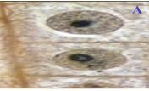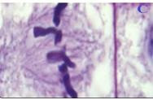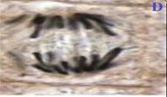

**Figure 2. Stages of onion mitotic cell division. A: interphase; B: prophase; C: metaphase; D: anaphase and E: telophase**

The mitotic index of Allium cepa root tip cells treated with water, methotrexate, and plant extract is shown in Table 1. By slowing the rate of mitosis in contrast to water, *Syzygium alternifolium* extract demonstrated considerable antimitotic efficacy. The standard drug with the strongest antimitotic activity was selected as a methotrexate (0.1 mg/mL). The chosen plant thus demonstrated strong antimitotic activity by demonstrating effective inhibition, indicating its use as a powerful antimitotic agent.

**B. Molecular Docking Investigation**

The target proteins that were downloaded from PDB were initially cleaned up by deleting unnecessary chains. We prepare and record the characteristics of spheres. Later, molecules were generated by the preparation of molecules and ligands. The docked structures were tested against the proteins 2W3L and 2OH4 after proteins were uploaded with spherical characteristics. According to docking, some of our compounds have strong affinity for the proteins Bcl-2 and VEGFR-2. The chemicals found in the *Syzygium alternifolium* bark that interact with the 2W3L and 2OH4 proteins are listed below.

**Table 3: BCL-2 (2W3L) & VEGFR-2 (2OH4) protein score of phytoconstituents from *Syzygium alternifolium***

|  |  |  |
| --- | --- | --- |
| **Compounds** | **PDB ID** | |
| **2W3L** | **2OH4** |
| 3-Hydroxy benzoic acid | -4.6 | -5.5 |
| Gentisic acid | -4.6 | -6.0 |
| Caffeic acid | -5.2 | -7.1 |
| 2,5-monoformal-1-rhamnitol | -4.5 | -6.3 |
| 4-oxo-5-phenyl pentoic acid | -5.3 | -6.9 |
| Apigenin | -6.5 | **-9.3** |
| Lutidine | -4.3 | -5.1 |
| Quercetin | **-6.6** | -7.4 |
| Kaempferol | -6.4 | **-8.9** |
| Acarbose | -6.4 | -6.3 |
| Squalene | **-7.2** | **-9.2** |
| Stigmasterol | **-7.4** | **-8.2** |
| Methotrexate | **-6.5** | **-8.6** |

The more negative the score the more favorable the binding.

**a) BCL 2 protein docking poses in *Syzygium alternifolium* (PDB ID: 2W3L)**

**.**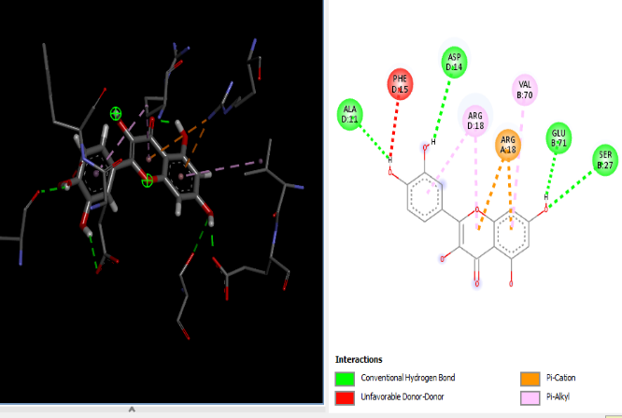 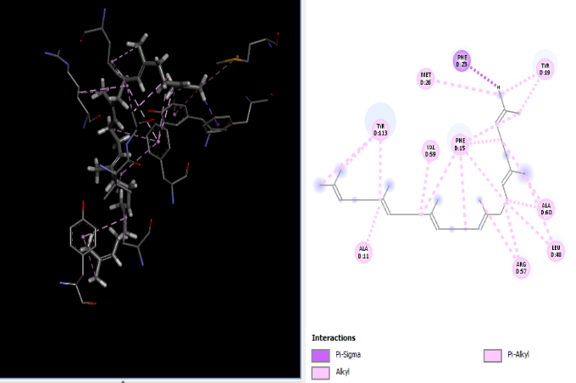

**a) Quercetin -6.6 b) Squalene -7.2**

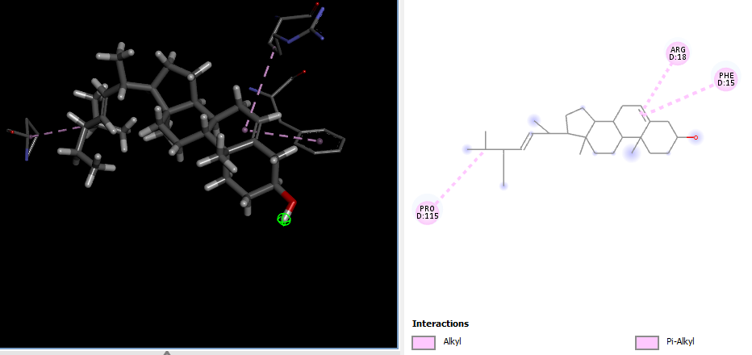 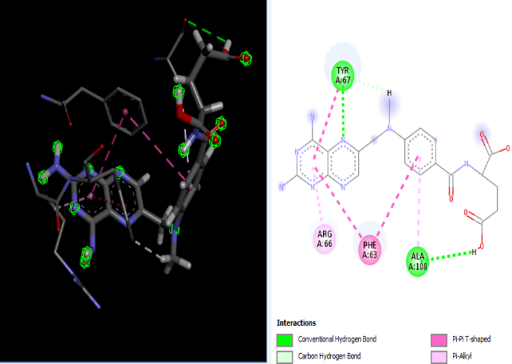

**c) Stigmasterol -7.4 d) Methotrexate -6.5**

**Figure 3: The *Syzygium alternifolium* compounds protein-ligand interaction against Bcl-2**

**ii) Poses of Docking in *Syzygium alternifolium* with VEGFR 2 protien (PDB ID: 2OH4).**

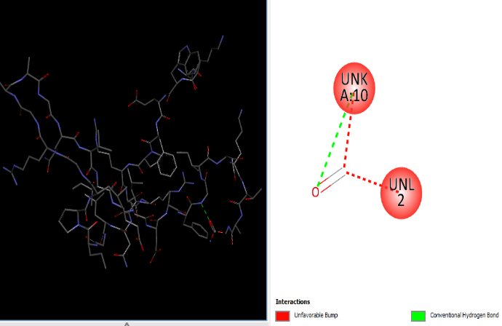

**a) Squalene -9.2 b)Kaempferol -8.9**

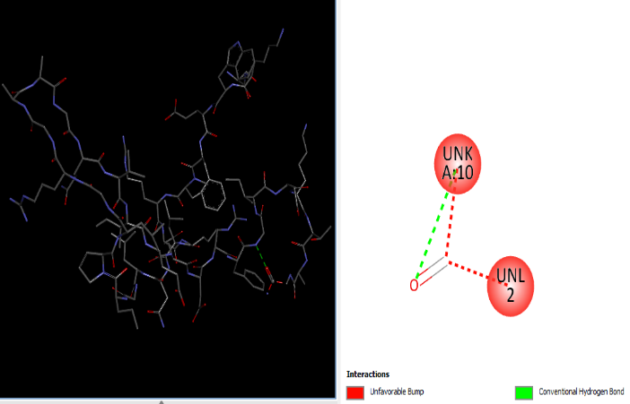

**c)) Stigmasterol -8.2 d) Methotrexate -8.6**

**Figure 4: The *Syzygium alternifolium* compounds protein-ligand interaction against VEGFR 2**

In folk medicine, *Syzygium alternifolium* has a wide range of therapeutic applications. Many researches have observed that any substance with high antioxidant qualities would also likely have anticancer effects due to the function that free radicals play in the development of cancer[29]. In light of this, the in vitro antimitotic abilities of the plant extracts were evaluated*.* An important *in vitro* assay for the discovery of anticancer drugs is the antimitotic. According to Rai et al.'s method from 2007, an antimitotic investigation was conducted using the onion root tip inhibition assay[30]. The effectiveness of the extracts in the current study's mitotic index clearly demonstrates their ability to restrict the proliferation of cancer cells either by influencing the microtubules or by promoting their production, preventing the degradation of the microtubules. As a result, the cells accumulate so many microtubules that they are unable to continue to divide and expand. Cells become stuck in mitosis as a result, and finally perish through apoptosis [31]. Cytotoxicity test via *In vitro* animal and the inhibition with the use tip of onion root experiment are both antimitotic bioassays that are quick, effective, straightforward, but sensitive [32].

In *Allium cepa* assay, bark of *Syzygium alternifolium methanolic extract* (10 mg/ml) was found to exhibit anti-mitotic action on *Allium cepa* root meristematic cell and it was indicated by decreased mitotic index after treatment. The results showed that bark of *Syzygium alternifolium methanolic extract* at a concentration of 10 mg/ml inhibited cell division in *Allium cepa* assays, which suggests that the plant may have an inhibitory effect on abnormal cell proliferation, such as that seen in cancer.

The molecular docking in this study demonstrates an essential role in foreseeing the molecular relationship of particular proteins against specific phytochemicals. This programme is widely used by the pharmaceutical industry as a powerful tool, especially when examining the relationship among structure and activity. In order to identify possible ligands, computational docking outputs involving binding affinity are often examined. Molecular docking can also be used to predict which small molecule ligands will bind to the appropriate target binding site.

Stigmasterol and Squalene have shown a remarkable affinity for binding to Bcl-2. The superior binding affinity of apigenin, squalene, kaempferol, and quercetin for VEGFR-2 has been shown. In compared to other compounds, apigenin has the greatest docking score (-9.3) for VEGFR-2. This shows that these substances are effective inhibitors of the Bcl-2 family of antiapoptotic proteins and the VEGFR-2 proteins [33].

# **CONCLUSION**

In the current study, the *in vitro* antimitotic activity of *Syzygium alternifolium* barkmethanolic extract was screened, and the *Allium cepa* root tip assay revealed decreased rate of mitosis. A molecular docking study is conducted to investigate the potential of several phytochemicals to thwart the development of cancer. Our data suggests that bioactive substances can connect with certain proteins to suppress growth factors, which in turn prevents the proliferation of cancer cells. Our research confirms the traditional medicine's stated therapeutic usage of this plant as an anticancer agent. To learn more about the precise mechanisms of action, more research is required, both *in vitro* and *in vivo.*

**CONSENT**

It is not applicable.

**ETHICAL APPROVAL**

Not applicable

**COMPETING INTERESTS**

Authors have declared that no competing interests exist.

**REFERENCES**

1. Zhang Z, Zhou L, Xie N, Nice EC, Zhang T, Cui Y, Huang C. Overcoming cancer therapeutic bottleneck by drug repurposing. Signal transduction and targeted therapy. 2020 Jul 2;5(1):113.
2. Thun MJ, DeLancey JO, Center MM, Jemal A, Ward EM. The global burden of cancer: priorities for prevention. Carcinogenesis. 2010 Jan 1;31(1):100-10.
3. Desai AG, Qazi GN, Ganju RK, El-Tamer M, Singh J, Saxena AK, Bedi YS, Taneja SC, Bhat HK. Medicinal plants and cancer chemoprevention. Curr Drug Metabol, 2008; 9:581–91.
4. Sawadogo WR, Schumacher M, Teiten MH, Dicato M, Diederich M. Traditional west African pharmacopeia, plants and derived compounds for cancer therapy. Biochem Pharmacol, 2012; 84:1225–40.
5. Majolo F. Delwing LK de Oliveira B, Marmitt DJ, BustamanteFilho IC, Goettert MI. Medicinal plants and bioactive natural compounds for cancer treatment: important advances for drug discovery. Phytochem Lett, 2019; 31:196–207.
6. Solowey E, Lichtenstein M, Sallon S, Paavilainen H, Solowey E, Lorberboum-Galski H. Evaluating medicinal plants for anticancer activity. Sci World J, 2014; 2014:721402–14.
7. Asowata-Ayodele AM, Afolayan AJ, Otunola GA. Ethnobotanical survey of culinary herbs and spices used in the traditional medicinal system of Nkonkobe Municipality, Eastern Cape, South Africa. S Afr J Bot, 2016; 104:69–75
8. Deng Y, Guo Z, Zeng Z, Wang Z. Studies on the pharmacological effects of saffron (Crocus sativus L.) a review. Zhongguo Zhong Yao Za Zhi, 2002; 27:565–8.
9. Levan, A., 1951, January. Chemically induced chromosome reactions in Allium cepa and Vicia faba. In *Cold Spring Harbor Symposia on Quantitative Biology* (Vol. 16, pp. 233-243). Cold Spring Harbor Laboratory Press.
10. Fiskesjö, G., 1985. The Allium test as a standard in environmental monitoring. *Hereditas*, *102*(1), pp.99-112.
11. Stich, H.F., Lam, P., Lo, L.W., Koropatnick, D.J. and San, R.H.C., 1975. Invitation paper: the search for relevant short term bioassays for chemical carcinogens: the tribulation of a modern sisyphus. *Canadian Journal of Genetics and Cytology*, *17*(4), pp.471-492.
12. Fonrose, X.; Ausseil, F.; Soleilhac, E.; Masson, V.; David, P. Parthenolide Inhibits Tubulin Carboxypeptidase Activity. Cancer Res. 2007, 67, 3371–3378.
13. Iwasaki, S. Antimitotic agents: Chemistry and recognition of tubulin molecule. Med. Res. Rev. 1993, 13, 183–198.
14. Mangale, S.M.; Chonde, S.G.; Raut, P.D. Use of Moringa oleifera (Drumstick) seed as Natural Absorbent and an Antimicrobial agent for Ground water Treatment. Res. J. Recent Sci. 2012, 1, 31–40.
15. Mondal, D.; Mondal, T. A Review on efficacy of Azadirachtaindica A. Juss based biopesticides: An Indian perspective. *Res. J. Recent Sci.* **2012**, *1*, 94–99.
16. Suvarchala Reddy NVLV, Priyanka AYK, Raghavendra NM. Isolation and characterization of triterpenoids from bark of *Syzygium alternifolium* (Wight) Walp. Annals of Phytomedicine. 2012;1(2):45-51.
17. Bhattacharya S, Haldar PK. Evaluation of antimitotic and genotoxic effects of the triterpenoid enriched extract from *Trichosanthes dioica*root. Am-Euras J of Toxicol Sci. 2012;4(1):20-23.
18. Periyanayagam K, Kasirajan B, Karthikeyan V, Indumathi R, Kumuda T. Vitis vinifera. L (Vitaceae) fruits towards antimitotic and antiproliferative activity in anticancer drug discovery. Innovare J Health Sci. 2013; 1(3): 32-35.
19. Li, R.; Li, Q.; Ji, Q. Molecular targeted study in tumors: From western medicine to active ingredients of traditional Chinese medicine. Biomed. Pharmacother. 2020, 121
20. Zhang, Y.; Zhang, M.; Wang, Y.; Fan, Y.; Chen, X.; Yang, Y.; Hua, Y.; Xie, W.; Lu, T.; Tang, W.; Chen, Y.; Liu, H. Protein–ligand interaction-guided discovery of novel VEGFR-2 inhibitors. J. Biomol. Struct. Dyn. 2020, 38, 2559–2574,
21. Warren, C.F.A.; Wong-Brown, M.W.; Bowden, N.A. BCL-2 family isoforms in apoptosis and cancer. Cell Death Dis. 2019, 10,
22. Ilizaliturri-Flores, I.; Correa-Basurto, J.; Bello, M.; Rosas-Trigueros, J.L.; Zamora-López, B.; BenítezCardoza, C.G.; Zamorano-Carrillo, A. Mapping the intrinsically disordered properties of the flexible loop domain of Bcl-2: a molecular dynamics simulation study. J. Mol. Model. 2016, 22,
23. Verma, S.; Singh, A.; Mishra, A. Complex disruption effect of natural polyphenols on Bcl-2-Bax: molecular dynamics simulation and essential dynamics study. J. Biomol. Struct. Dyn. 2015, 33, 1094–1106.
24. Ilizaliturri-Flores, I.; Correa-Basurto, J.; Benítez-Cardoza, C.G.; Zamorano-Carrillo, A. A study of the structural properties and thermal stability of human Bcl-2 by molecular dynamics simulations. J. Biomol. Struct. Dyn. 2014, 32, 1707–1719,
25. Vittorio, S.; Seidel, T.; Germanò, M.P.; Gitto, R.; Ielo, L.; Garon, A.; Rapisarda, A.; Pace, V.; Langer, T.; De Luca, L. A Combination of Pharmacophore and Docking‐based Virtual Screening to Discover new Tyrosinase Inhibitors. Mol. Inform. 2020, 39,
26. Goel, H.L.; Mercurio, A.M. VEGF targets the tumour cell. Nat. Rev. Cancer 2013, 13, 871–882.
27. Huang, L.; Huang, Z.; Bai, Z.; Xie, R.; Sun, L.; Lin, K. Development and strategies of VEGFR-2/KDR inhibitors. Future Med. Chem. 2012, 4, 1839–1852.
28. Reddy VNVLS, Raju GM, Sirisha S, Nikitha K. Neuropsychological Screening on Acalypha indica Whole Plant Extract. J Young Pharm. 2020;12(2) Suppl:s82-86.
29. Kaur C, Kapoor HC. Antioxidants in fruits and vegetables–the millennium’s health. International journal of food science & technology. 2001 Oct 20;36(7):703-25.
30. Rai KM, Basavaraju YB, Sadashivamurthy B. Biological assay and antimitotic activity of novel analogues of β-apopicropodophyllin. Indian J Pharm Sci 2007;69:116-8.
31. Roberge M, Cinel B, Anderson HJ, Lim L, Jiang X, Xu L, Bigg CM, Kelly MT, Andersen RJ. Cell-based screen for antimitotic agents and identification of analogues of rhizoxin, eleutherobin, and paclitaxel in natural extracts. Cancer Research. 2000 Sep 15;60(18):5052-8.
32. Babatunde B, Anabuike F. In vivo cytogenotoxicity of electronic waste leachate from Iloabuchi electronic market, Diobu, Rivers State, Nigeria on Allium cepa. Challenges 2015;6:173-87
33. Gurung AB, Ali M A, Lee J, Farah MA, Al-Anazi KM. Molecular docking and dynamics simulation study of bioactive compounds from Ficus carica L. with important anticancer drug targets. PloS one, 2021;16(7).