# Chapter-5

**Hall effects on peristaltic transport of a Johnson -Segalman fluid through a porous medium in a two-dimensional channel**

### Introduction

Despite the fact that there are a lot of models to express non-Newtonianbehaviorofthefluidshoweverinrecentyears,theJohnson-Segalmanfluidhasacquired a special class, as it includes as special cases the classical Newtonian fluidand Maxwell fluid. The Johnson-Segalman model is a viscoelastic fluid model whichwas developed to allow for nonaffine deformations by Johnson and Segalman (1977).Various researchers (Kolkka et al., 1988; Malkus et al., 1990; McLeish and Ball,1986)used this model to explain the happening of “spurt”. The term “spurt” is worn to showthe hefty increasein the volume through outfor asmall increasein the drivingpressure gradientata critical value of the pressure gradient thatis observedin theflowofnumerousnon-linearfluids.RaoandRajagopal(1999)consideredthreedistinct flows of Johnson-Segalman fluid. Contrasting most other fluid models, theJohnson-Segalman (JS) fluid permits for a non-monotonic relationship between theshear stress and the rate of strain in a shear flow for certain values of the materialparameter. Despite the fact that the JS model offers a incredibly interesting means forelucidation “spurt”, it appears more likely that the trend is because of the “stick slip”that takes place at the boundary. Peristaltic motion of a Johnson-Segalman fluid in achannelwasstudiedbyHayatetal.(2003).ElshahedandHaroun(2005)haveconsideredtheperistalticpumpingofJohnson-Segalmanfluidundereffectofamagneticfield.

The basic perception regarding MHD is the magnetic field which induces thecurrents in conductive moving fluids which in results generates the forces on the fluidand also varies the magnetic field itself. It is well known that when any conductorcomes into a magnetic field which in results creates a voltage, which is perpendicularto the current and field, this effect is known as Hall Effect. Hayat et al. (2007) haveinvestigatedtheHalleffectsonperistalticflowofaMaxwellfluidinaporousmedium.EffectsofHallandion-slipcurrentson peristaltictransportofacouplestress

fluid was analyzedby Abo-Eldahab etal. (2010). Gad (2014)has studied the effectsof Hall current on peristaltic transport with compliantwalls.Eldabe (2015)havestudied the Hall Effect on peristaltic flow of third order fluid in a porous medium withheat and mass transfer. Hall effects on the peristaltic transport of Williamson fluidthrough a porous medium with heat and mass transfer was discussed by Eldabe et al.(2016). Hall effect on the peristaltic flow of a Johnson-Segalman fluid in a channelwas investigated by Subba Narasimhudu (2017). Ranjitha and Subba Reddy (2018)haveanalyzedthe radiation effects on the peristalticflowof aWilliamsonfluidthroughaporousmediumina planarchannel.

In view of these, we studied the Hall effects on the peristaltic flow of aJohnson-Segalman fluid through a porous medium in a two- dimensional channel.The flow is studied in a wave frame of reference moving with velocity of the waveunder the assumptions of long-wavelength and low-Reynolds number. A PerturbationsolutionforsmallWeissenbergnumberisobtainedfortheaxialvelocity,axialpressuregradientandpressureriseperonewavelength.Theeffectsofvariousemergingparametersonthepressuregradientandpumpingcharacteristicsarediscussedwiththeaidofgraphs.

### MathematicalFormulation

We consider an incompressible, conducting Johnson-Segalman fluid through a

porous medium confined in a two dimensional infinite symmetric channel of width

. We employ a rectangular coordinate system withparallel to and normal to

the channel walls. Moreover, we consider an infinite wave train traveling with velocity

*c* along the channel walls. . A uniform magnetic field  applied in the transverse

direction to the flow. Fig. 5.1 shows the physical model of the problem. The symmetric

channel walls are defined as

 (5.2.1)

Here is the amplitudes of the waves, is the time andis the wavelength.

The equations governing the flow of an incompressible fluid are

 (5.2.2)

whereis the velocity field,is the body force per unit mass,is the fluid density,

is the material derivative andis the Cauchy stress tensor given by Johnson et al.

(1977).

(5.2.3)

(5.2.4)

 (5.2.5)

 (5.2.6)



Porous medium



















**Fig. 5.1**The Physical Model

The equations above include the scalar pressure *p*, the identity tensor, the dynamic

viscosities*μ* and *η*, the relaxation time *m*, the slip parameter *e* and the respective

symmetric and skew symmetric part of the velocity gradient and.

Note that, our model reduces to the Maxwell fluid model for and, and for

, it reduces to the classical Navier-Stokes fluid model.

The velocity for unsteady two-dimensional flows is defined as

 (5.2.7)

In the fixed frame the motion is unsteady, while it becomes steady in the

wave frame . The transformation from the fixed frame of reference  to

the wave frame of reference  is given by



(5.2.8)

Here *u, v* and *U, V* are the velocity components in the wave frame and in the fixed

frame, respectively.

From equations (5.3.2) - (5.3.7), we obtain, when body forces are absent, in the wave

frame:

 (5.2.9) 

(5.2.10)



(5.2.11)



(5.2.12)



 (5.2.13)



(5.2.14)

Using the following non – dimensional variables

,

 , (5.2.15)

into the equations (5.2.8) – (5.2.13), we have (after dropping the bars)

 (5.2.16)



 (5.2.17)



 (5.2.18)



 (5.2.19)



 (5.2.20)



 (5.2.21)

Under lubrication approach, neglecting the terms of order  and Re, from Equations

(5.3.17) and (5.3.18), we get

 (5.2.22)

(5.2.23)

where

 (5.2.24)

 (5.2.25)

 (5.2.26)

 (5.2.27)

From Equation (5.2.23),  is a function of  only. Therefore, using Equations

(5.2.23) – (5.2.27), the Equation (5.2.22) can be rewritten as

 (5.2.28)

Where

The corresponding non - dimensional boundary conditions are

 at 

 at  (5.2.29)

The volume flow rate in a wave frame is given by

 (5.2.30)

The flux at any axial station in the laboratory frame is

 (5.2.31)

The average volume flow rate over one wave period T (=) of the peristaltic

wave is defined as

 (5.2.32)

* 1. **Solution of the problem**

The Equation (6.2.28) is non-linear and its closed form solution is not possible. Thus,

we linearize this equation in terms of , since  is small for the type of flow

under consideration. So we expand and  as



 (5.3.1)

Substituting the above expressions in to the Equation (5.2.28) and in to the

boundary conditions (5.2.29), we obtain

**5.3.1 Equations of order **

 (5.3.2)

The corresponding boundary conditions are

at (5.3.3)

at (5.3.4)

**5.3.2 Equations of order **

 (5.3.5)

The corresponding boundary conditions are

 at  (5.3.6)

 at  (5.3.7)

**5.3.3 Solution of order **

Solving the Equation (5.3.2) by using the boundary conditions (5.3.3) and (5.3.4), we

get

 (5.3.8)

Where

and the volume flow rate  is given by

 (5.3.9)

From Equation (6.3.9), we obtain

 (5.3.10)

**5.3.4 Solution of order **

Solving the Equation (5.3.5) by using the boundary conditions (5.3.6) and (5.3.7), we

get



 (5.3.11)

and the volume flow rate  is given by



(5.3.12)

where



From Equation (5.3.12), we obtain

 (5.3.13)

Substituting Equations (5.3.10) and (5.3.13) into the second equation of (5.3.1) and

neglecting terms greater than, we get

 (5.3.14)

The dimensionless pressure rise per one wavelength in the wave frame is given by

 (5.3.15)

where .

Note that, as our results coincide with the results of Subba Narasimhudu

(2017).

**5.4. Results and Discussions**

Fig.5.2 illustrates the variation of the axial pressure gradient  with  for,

, , ,,  and . It is found that, the axial

pressure gradient decreases with increasing Weissenberg number 

The variation of the axial pressure gradient  with for ,,

, ,,  and . is illustrated in Fig. 5.3.

It is observed that, the axial pressure gradient  decreases with increasing .

Fig. 5.4 shows the variation of the axial pressure gradient  with  for,

, , ,,  and . It is noticed that, the

axial pressure gradient  increases with increasing slip parameter .

The variation of the axial pressure gradient  with for ,,

, ,,  and  is shown in Fig.5. 5. It is observed

that, the axial pressure gradient  decreases with increasing Hall parameter 

Fig.5. 6 illustrates the variation of the axial pressure gradient  with for ,

, , ,,  and . It is found that, the axial

pressure gradient  increases with an increase in Darcy number .

The variation of the axial pressure gradient  with for ,,

, ,,  and is illustrated in Fig.5.7. It is

noticed that, the axial pressure gradient  increases with increasing Hartmann

number.

Fig. 5.8 depicts the variation of the axial pressure gradient  with for ,

, , , ,and . It is found that, the

axial pressure gradient  increases with increasing amplitude ratio .

The variation of the pressure rise  with  for different values of  with,

, , , and is depicted in Fig.5. 9. It is

observed that, in the pumping region  , the  decreases with increasing

weissenberg number  and it increases in both the free-pumping and co-

pumping regions with increasing .

Fig. 5.10 shows the variation of the pressure rise  with  for different values of

with ,, , , and . It is noticed that,

in the pumping region, the  increases with increasing  and it decreases in both

the free-pumping and co-pumping regions with increasing .

The variation of the pressure rise  with  for different values of  with ,

, , , and is shown in Fig. 5.11. It is

observed that, in the pumping region  and pre-pumpingregion, the

increases with increasing , while it decreases in the co-pumpingregion

with increasing  for the chosen  .

Fig. 5.12 illustrates the variation of the pressure rise  with  for different values

ofwith , ,, , and . It is found that,

in the pumping region, the  decreases with increasing , while it increases in both

the free-pumping and co-pumping regions with increasing .

The variation of the pressure rise  with  for different values of with ,

 ,, ,  and  is shown in Fig. 5.13. It is

noticed that, in the pumping region, the  decreases with increasing , while it

increases in both the free-pumping and co-pumping regions with increasing .

Fig. 5.14 depicts the variation of the pressure rise  with  for different values of

with, ,, ,  and . It is observed

that, in the pumping region, the  increases with increasing , while it decreases

in both the free-pumping and co-pumping regions with increasing .

The variation of the pressure rise  with  for different values of with,

 ,,, , and  is depicted in Fig. 15. It

is found that, in the pumping region  and pre-pumpingregion, the

increases with increasing  while it decreases in the co-pumpingregion

with increasing  for the chosen value  .

**5.5. Conclusions**

In this chapter, we studied effect of hall on the peristaltic transport of a Johnson-

Segalman fluid through a porous medium in a two - dimensional channel under the

assumptions of long-wavelength. Perturbation solution for small Weissenberg

number is obtained for the axial velocity, axial pressure gradient and pressure rise per

one wavelength. It is found that the pressure gradient  decreases with increasing

or, whereas it increases with increasing  or . In the pumping

region, the time averaged flux  decreases with increasing  or m, whereas it

increases with increasing or. The friction force first increases and then

decreases with increasing.

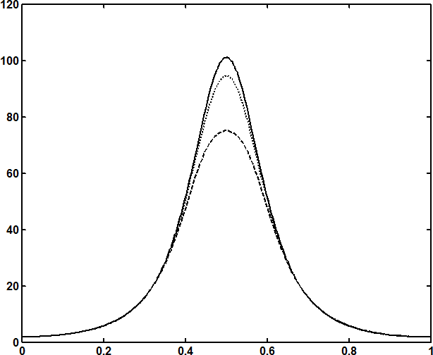

*Wi*0,0.02,0.04

*dp*

*dx*

*x*

**Fig.5.2**Thevariationoftheaxialpressuregradient*dp*

*dx*

with*Wi*for1,*e*0.5

*m*0.3,*Da*0.1,*M*1,0.6and*Q*1.

###### x

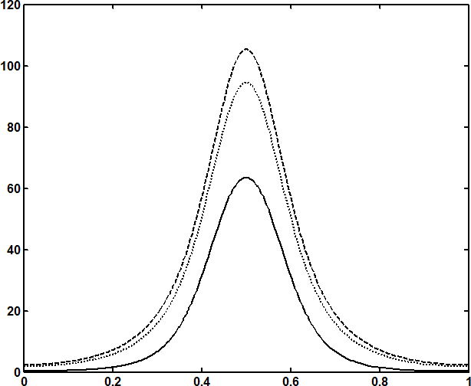

*dp*

*dx*

0,1,2

**Fig.5.3**Thevariationoftheaxialpressuregradient*dp*

*dx*

withfor*e*0.5,

*Wi*0.02,*m*0.3,

*Da*0.1,*M*1, 0.6

and*Q*1.

*dpdx*

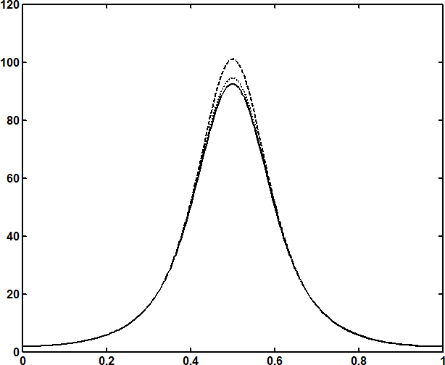

*e*1,0.5,0.1

###### x

**Fig.5.4**Thevariationoftheaxialpressuregradient*dp*

*dx*

with*e*for1,*Wi*0.02,

*m*0.3,

*Da*0.1,*M*1, 0.6

and*Q*1.

*dpdx*

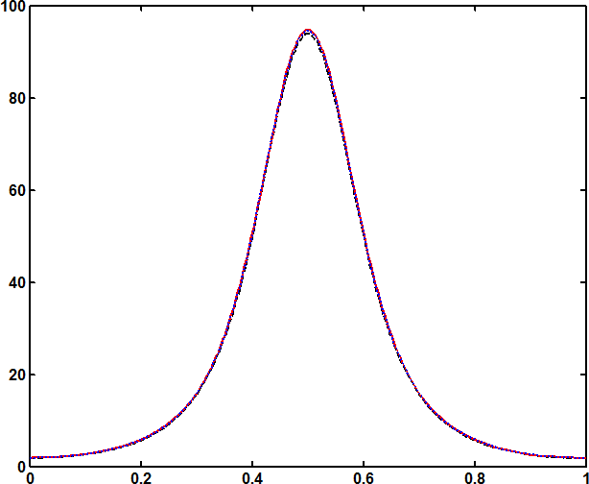

*m*0,0.3,0.8

###### x

**Fig.5.5**Thevariationoftheaxialpressuregradient*dp*

*dx*

with*m*for1,*Wi*0.02,

*e*0.5,*Da*0.1,*M*1,0.6and*Q*1.

*dpdx*

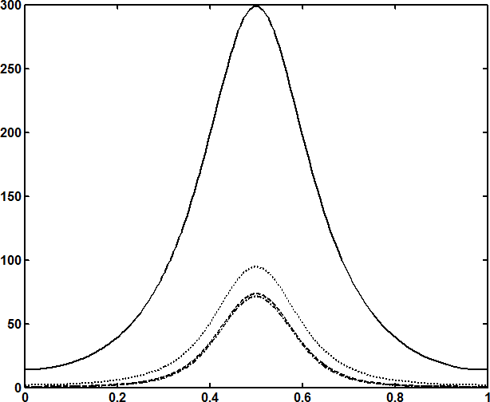

*Da* 0.01,0.1,1,10

###### x

**Fig.5.6**Thevariationoftheaxialpressuregradient*dp*

*dx*

with*Da*for1,*Wi*0.02

*e*0.5,*M*1,*m*0.3,0.6and*Q*1.

*dpdx*

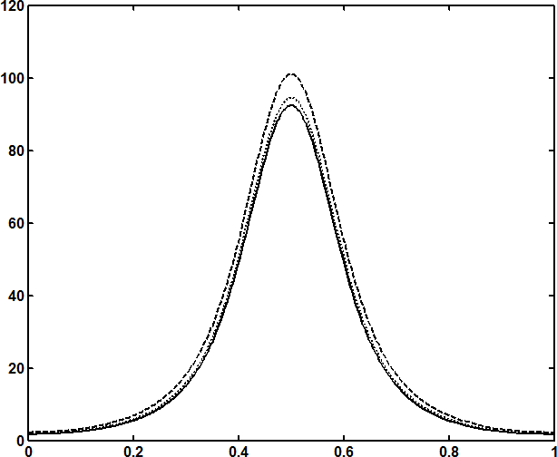

*M*2,1,0

###### x

**Fig.5.7**Thevariationoftheaxialpressuregradient*dp*

*dx*

with*M*for1,*Wi*0.02,

*e*0.5,*Da*0.1,*m*0.3,0.6and*Q*1.

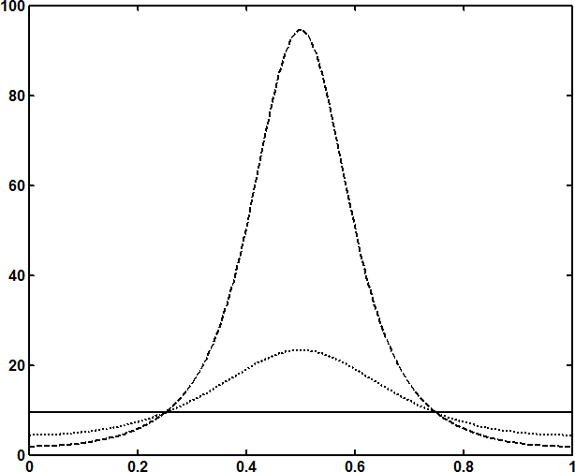

*dp*

*dx*

0.6,0.3,0

###### x

**Fig.5.8**Thevariationoftheaxialpressuregradient*dp*

*dx*

withfor1,*Wi*0.02,

*e*0.5,*Da*0.1,*m*0.3,*M*1and*Q*1.

*p*

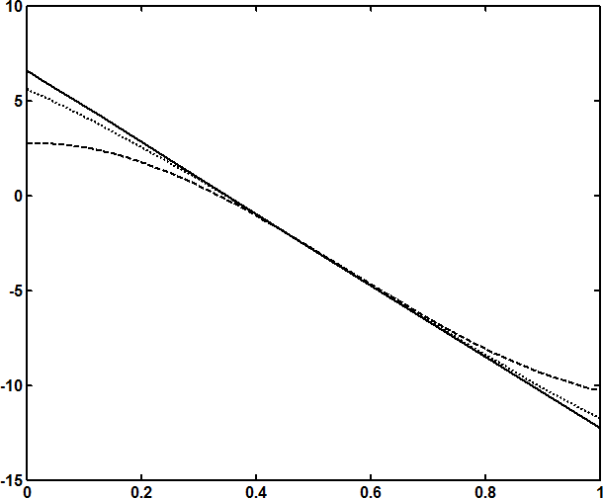

*Wi*0,0.1,0.2

**Fig.5.9**Thevariationofthepressurerise*p*

*Q*

with*Q*fordifferentvaluesof*Wi*

with1,*e*0.5,*Da*0.1,*m*0.3,*M*1and0.6.

**References**

Abo-Eldahab, E. M., Barakat, E. I. and Nowar, K. I. Effects of Hall and ion-slip currents on peristaltic transport of a couple stress fluid, International Journal of Applied Mathematics and Physics, 2 (2) (2010), 145–157.

Eldabe, N.T.M., Ahmed Y. Ghaly, A.Y., Sallam, S.N., Elagamy, K. and Younis, Y.M. Hall effect on peristaltic flow of third order fluid in a porous medium with heat and mass transfer, Journal of Applied Mathematics and Physics, 2015, 3, 1138-1150.

Eldabe, N.T., Elogail, M.A.,Elshaboury, S.M. and Hasan, A.A. Hall effects on the peristaltic transport of Williamson fluid through a porous medium with heat and mass transfer, Applied Mathematical Modeling, 40(1)(2016), 315-328.

Elshahed, M. and Haroun, M. H. Peristaltic transport of Johnson-Segalman fluid under effect of a magnetic field, Math.Probl. Eng. 6(2005), 663 – 667.

Gad, N.S. Effects of Hall current on peristaltic transport with compliant walls, Appl Math Comput. 235 (2014), 546–554.

Hayat, T. Wang, Y., Siddiqui, A. M. and Hutter K. Peristaltic motion of a Johnson-Segalman fluid in a planar channel, Mathematical Problems in Engineering, 2003 (2003),no. 1, 1-23.

Hayat, T., Ali, N. and Asghar, S. Hall effects on peristaltic flow of a Maxwell fluid in a porous medium, Physics Letters A, 363(5-6) (2007), 397–403.

Johnson JR., M.W. and Segalman, D. A model for viscoelastic fluid behavior which allows nonaffine deformation, J. Non-Newtonian Fluid Mech. 2 (1977), 255–270.

Kolkka, R.W., Malkus, D.S., Hansen, M.G., Ieriy, G.R., and Worthing, A.R. Spurt phenomenon of the Johnson–Segalman fluid and related models, J. Non-Newtonian Fluid Mech. 29 (1988), 303–335.

Malkus, D.S., Nohel, J.A., and Plohr, B.J. Dynamics of shear flows of non-Newtonian fluids, J. Comput. Phys. 87 (1990), 464–497.

Mcleish, T.C.B., and Ball, R.C. A molecular approach to the spurt effect in polymer melt flow, J. Polym. Sci. (B) 24 (1986) 1735–1745.

Ranjitha, B. and Subba Reddy, M. V. Radiation Effects on the Peristaltic flow of a Williamson fluid through a porous medium in a planar channel, JUSPS-B Vol. 30(12)(2018),121-132.

Rao, I. J. and Rajagopal, K. R. Some simple flows of a Johnson-Segalman fluid, Acta Mech. 132(1-4)(1999), , 209–219.

Subba Narasimhudu, K. “Effects of hall on peristaltic flows of conducting fluids ”, Ph D., Thesis, Rayalaseema University, (2017).

*p*

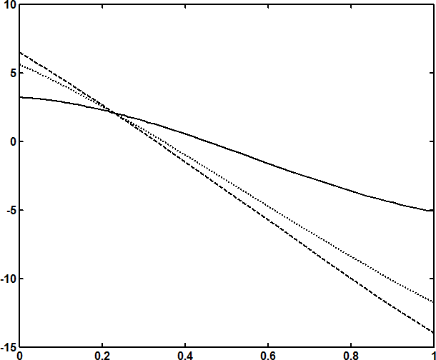

2,1,0

*Q*

**Fig.5.10**Thevariationofthepressurerise*p*with*Q*fordifferentvalues of

with*e*0.5,*Da*0.1,*Wi*0.1,*m*0.3,*M*1and0.6.

*p*

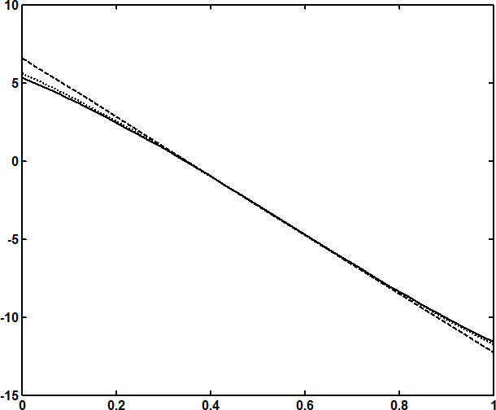

*e*1,0.5,0.1

**Fig.5.11**Thevariationofthepressurerise*p*

*Q*

with*Q*fordifferentvaluesof*e*

with1,*Da*0.1,*Wi*0.1,*m*0.3,*M*1and0.6.

*p*

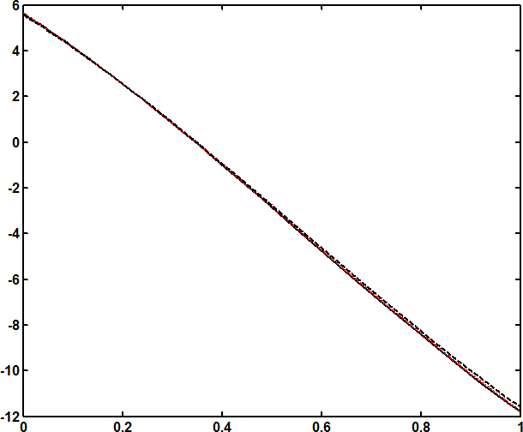

*m*0,0.3,0.8

**Fig.5.12**Thevariationofthepressurerise*p*

*Q*

with*Q*fordifferentvaluesof*m*

with1,*Da*0.1,*e*0.5,*Wi* 0.1,*M*1and0.6.

*p*

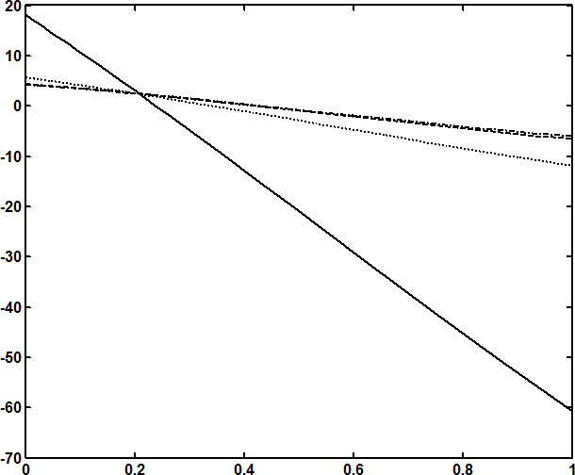

*Da* 0.01,0.1,1,10

**Fig.5.13**Thevariationofthepressurerise*p*

*Q*

with*Q*fordifferentvaluesof

*Da*with1,*M*1,*e*0.5,*Wi*0.1,*m*0.3and0.6.

*p*

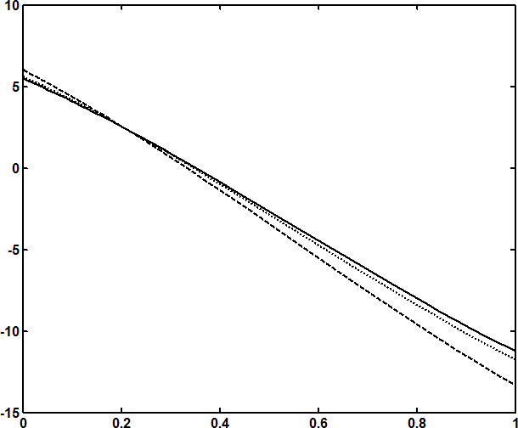

*M*2,1,0

**Fig.5.14**Thevariationofthepressurerise*p*

*Q*

with*Q*fordifferentvaluesof*M*

with1,*Da*0.1,*e*0.5,*Wi*0.1,*m*0.3and0.6.

*p*

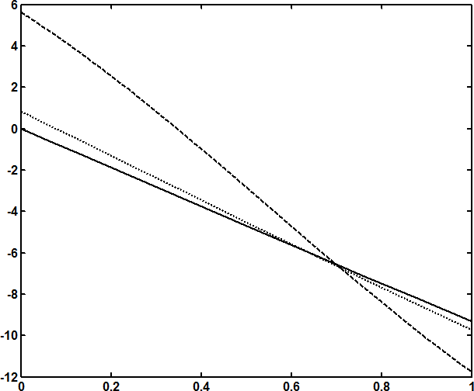

0.6,0.3,0

Q

**Fig.5.15**Thevariationofthepressurerise*p*with*Q*fordifferentvaluesof

with1,*Da*0.1,*e*0.5,*Wi*0.1,*m*0.3and*M*1