Internet of Things (IOT) in Precision Agriculture
Sushruta Boruah*
*Ph.D Scholar, Department of Agricultural Entomology, Tamil Nadu Agricultural University
Coimbatore, Tamil Nadu, India.
E-mail: sushrutaboruah277@gmail.com
Mahesh Pathak
Professor
College of Post Graduate Studies in Agricultural Sciences, (CAU)
Imphal, Manipur, India

Kasturi Sarmah
Ph.D Scholar, Department of Agricultural Entomology, Tamil Nadu Agricultural University
Coimbatore, Tamil Nadu, India
Bimal Kumar Sahoo
Ph.D Scholar, Department of Agricultural Entomology, Tamil Nadu Agricultural University
Coimbatore, Tamil Nadu, India
Professor,
Abstract
Although only a few nations have implemented precision agriculture, India's agricultural sector still need modernization with improved technology participation for improved production, distribution, and cost management. Internet of Things (IoT) sensors may provide information about agricultural areas and then act on it depending on user input. IoT development gives rise to the concept of machine-to-machine technology, which allows two machines to communicate with one another. All data that was earlier stored on a private server can now also accessible remotely on internet. Almost all businesses may benefit from the use of IoT, especially those where connection speed is not a concern. To meet the need for food, difficulties like harsh weather and accelerating climate change must be solved. With the help of IoT technology, growers and farmers will be able to increase production and minimise waste in a variety of areas, from the amount of fertiliser used to the number of trips the farm vehicles have taken.

Key words: Internet of Things; Machine-to-machine technology; Precision agriculture; IOT Sensors.

- Introduction

A farming management idea called "smart farming" aims to improve both the quantity and quality of agricultural products. Today's farmers have access to technology like GPS, soil scanning, data management, and the Internet of Things (IoT). The purpose of smart agriculture research is to provide a solid foundation for a farm management decision-support system. Population growth, climate change, and labour are all challenges that are addressed by smart agriculture. From planting and watering crops to crop health and harvesting, smart farming has received a lot of technical attention.
The Internet of Things (IoT) refers to technology and an environment that can communicate using the Internet and exchange data in real time using sensors attached to various objects [1]. Various businesses may employ IoT for big data analytics, cloud computing, etc. [2]. To date, sending and receiving information from Internet-connected devices has needed human intervention. However, IoT makes it possible for items to communicate with each other via Bluetooth, near-field communication (NFC), sensor data, and networks without the need for intervention by man [3].The IoT is a contemporary mechanism that has supplanted networked cloud applications and encompasses mechanical, electrical, and digital devices as well as people with unique IDs. A system for monitoring the agricultural field using sensors (light, humidity, temperature, soil moisture, etc.) and automating the irrigation system is created in IOT-based smart agriculture. The furthermost significant consideration of the IoT is its ability to transfer data without the help of human transmission interface. The use of Wireless Sensor Nodes (WSN) is the ideal solution to address the issue since the field is spread across a big area of farmland for agricultural or animal grazing. As they use a significant amount of electricity despite being less numerous than the sensor nodes, the actuator modules are connected to the Personal Area Network (PAN). By utilising current Local Area Network (LAN) and Internet infrastructure, this complete framework may be included into an IoT-based system.
Most developed countries are progressing with agricultural digitisation. Crop breeding, insect utilization, agricultural management, and the creation of meteorological data are all widespread practises in Japan. Farmers in the United States have access to government database for agriculture, research institutions, and libraries, as well as massive data cloud systems. The database may be used by farmers to learn about current market pricing, crop development, and emerging skills and technologies in the agricultural industry. In order to create farms with the highest yields and advantages, farmers may utilise computers to help them choose the best crops to sow, the best seasons to grow them in, and the best farming method to employ. Similar systems are available for a range of agricultural management specialisations from well-known financial management information system (FMIS) suppliers including Wisu 10 and Agrineuvos.
The Food and Agriculture Organisation (FAO) of the United Nations estimates that by 2050, there will be an additional 10 billion people on the planet, which would need a rise in agricultural production. Many scientists are conducting research to boost agricultural output to address these issues [4,5]. The agriculture sector has been able to boost productivity and distribute resources more effectively because to creative thinking and technical advancements like sensor systems and wireless sensor networks [6]. Innovative, smart farming benefits greatly from IoT [7]. Agricultural automation is made possible by IoT in agriculture, which boosts agricultural output [8, 9]. Additionally, by reducing waste, optimising processes, and building a secure food supply chain, IoT in agriculture may be utilised to increase agricultural yields [10]. Farm management [11], farm monitoring [12], livestock monitoring [13], irrigation control [14], greenhouse environmental control [15], autonomous agricultural machinery [16], and drones [17] are just a few of the aspects of agriculture where IoT can be applied. Additionally, farmers can utilise IoT technology to gather useful data that is then used to create yield maps that allow for the precision agriculture-based production of cheap, better-quality crops [18]. IoT in agriculture is depicted in Fig. 1 as a set of procedures that gather data on farm equipment, crops, livestock, and other items; create a database based on the data; analyse relevant prescriptions from key data from experts; and text message prescriptions to customers.
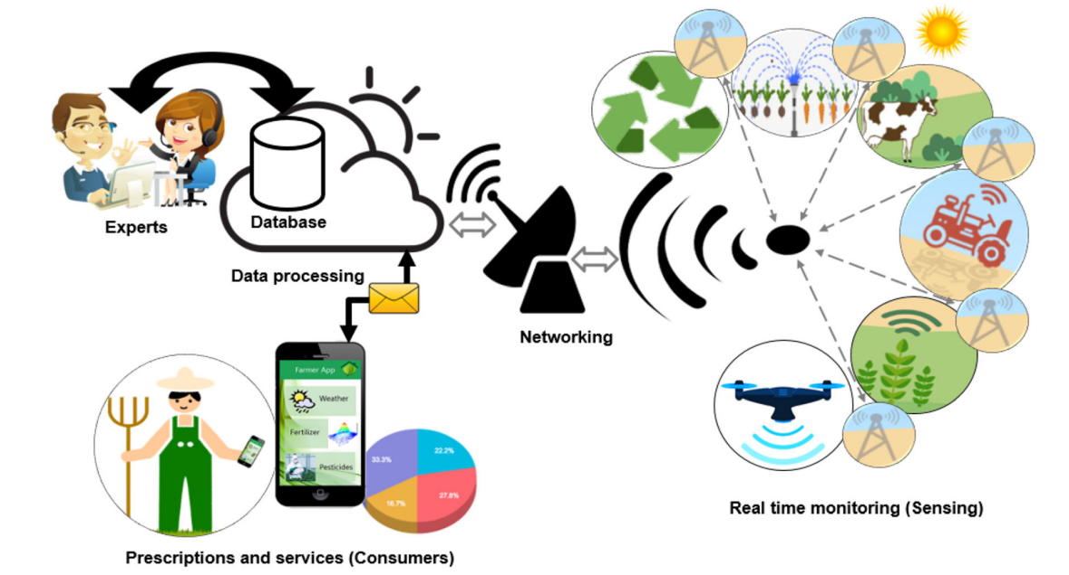
Fig1 IoT procedures in agriculture
[19]
- Applications of the Internet of Things in Agriculture

- Management System
A range of data types may now be measured more easily through recent developments in wireless sensor networks [20]. These developments have allowed IoT to address a variety of agricultural issues and enable efficient and sustainable farming [21]. As shown in Fig. 2, IoT applications in agriculture can be broadly categorised into the following four groups: (a) management system, (b)monitoring system, (c) control system and (d) unmanned machinery [22; 23].

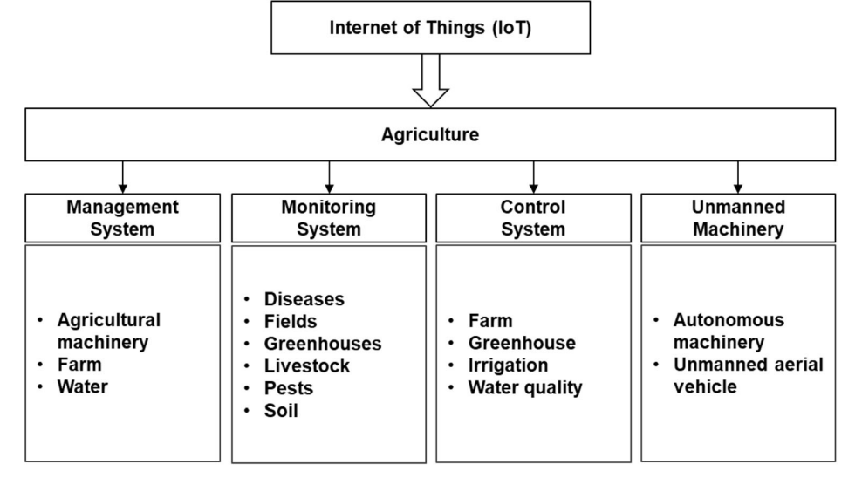
Fig 2 IoT application in agriculture, comprising of management system, monitoring system, control system, and unmanned machinery
[19]

Agricultural Machinery
IoT technology is in use in the field of conventional agricultural production to give essential facts on areas which includes management of agricultural machinery operations in real-time, and recognizing the necessities for agricultural machinery operation and control [24]. These systems permit for distant monitoring of field environments and agricultural machinery operating conditions for increasing agricultural production.

Farm
In order to help farmers make informed decisions, IoT-based farm management information systems (FMISs) was planned [25, 11]. These systems handle all data which were measured from fixed farm sensors. Using big data analysis, this system was utilised to deliver financial analysis reports to farmers as well as data collected on farm-related products such machinery, seeds, pesticides, and fertilisers. Using IoT and WebGIS, [26] proposed the creation of a precision agriculture management system (PAMS). For managing of huge agricultural producing farms, PAMS was created. In order to provide features like data collecting, retrieval, analysis, production, monitoring and administration, remote operation of production processes, and assistance for production choices, this system was developed employing advanced technologies like IoT technology and WebGIS.

Water
The multiintelligent control system (MICS) was established for the management of water resources in the agriculture sector since water shortages have gotten worse quickly [27]. The suggested system, which is based on IoT, has been utilised to manage all water resources by tracking and regulating water use and reservoir water levels. Water management in the agricultural sector has been satisfactorily addressed by the system, which has also been shown to save up to 60% of water.

- Monitoring System

Diseases
An IoT-based cognitive monitoring system for early plant disease forecasting was created [28]. In addition to providing environmental monitoring data to maintain an ideal environment for crop cultivation, the monitoring system was also used to forecast conditions that would cause an epidemic to break out using environmental sensor data. This system was created to send users warning messages and was equipped with artificial intelligence and prediction algorithms that mimicked the capability of human experts to make decisions. A multicontext fusion network (MCFN)-based automated system for the agricultural IoT was proposed [29] to identify crop disease in the wild. The system was created for actual crop simulations using the deep learning MCFN system, which was inspired by the utility of agricultural IoT.

Field
Field monitoring can be used in agriculture to control crop-growing conditions and boost crop quality and output. Field monitoring can be used in agriculture to control crop-growing conditions and boost crop quality and output.
IoT applications for agriculture using inexpensive sensors and networks often include field monitoring. An intelligent system for monitoring agricultural fields that measures soil temperature and humidity has been presented [30]. For future data analysis, which may be used to field management, the data gathered using this method is stored in the cloud. According to a framework that includes a monitoring module and the knowledge management (KM) basis, the use of field monitoring and agricultural automation has been suggested [31]. A more effective use of water resources and reduced labour costs were made possible by this approach.

Greenhouse
Environmental elements that impact plant quality and production in greenhouses include temperature and humidity. Farmers may maximise crop yield with the help of continuous monitoring of these environmental factors. For instance, traditional techniques to monitor greenhouse environmental conditions and the growth of Phalaenopsis have limited resolution, demand a lot of labour, take a long time, and lack automation. An IoT-based system to track the environmental parameters of an orchid greenhouse and the growth condition of Phalaenopsis was suggested as a solution to these issues [15]. The proposed system combines a wireless imaging platform with an environmental monitoring system based on the Internet of Things to measure environmental conditions in an orchid greenhouse and the development of orchid leaves in real time.

Livestock
Monitoring systems have been employed in agriculture to gather data on several animal species, including cows [32] and poultry [33]. Motion sensors have been used to create the Moocall system, which keeps track of pregnant cows' movements [32]. This technique was created to notify farmers through SMS text two hours before a cow gives birth, and it was utilised to lower the calf mortality rate. According to Moocall, the system's accuracy is above 95% and the fatality rate at calving was diminished by 7%. Precision livestock farming (PLF) is a framework for general management that includes monitoring, data analysis, decision-making, control, and Intervention of diverse cattle [34]. PLF systems can improve decision-making by decreasing the need for manual observations and may be used to facilitate human decision-making by drastically cutting down on the time and effort needed to handle animals, these operations may be automated.

Pest
An autonomous early warning system was suggested [35] to stop the recurrence of pests like the large Oriental fruit fly Bactrocera dorsalis (Hendel). The overuse of chemical pesticides by farmers was lessened using this technique. It also included three crucial parts: wireless monitoring nodes (WMN), a remote-sensing information gateway (RSIG), and a host control platform (HCP), as well as two wireless communication protocols, ZigBee and GSM. In order to preserve farms and the future security of food supply, the proposed research included a real-time warning system that would alert system administrators and government authorities via the GSM platform when important events were about to occur.

Soil
Maintaining a healthy soil environment for crops is crucial since it directly influences their ability to develop. An IoT-centred intelligent soil observation system for agricultural output has been created [37]. In this system, the soil was monitored using a variety of sensors, including pH, temperature, and humidity sensors, and the user received the gathered information on the soil environment via mobile apps. Using this method, judgements about spraying pesticides and irrigation systems may be made. IoT centred fertilizer system was introduced which monitors soil nutrients; analyze the requisite quantity of fertilizer, and subsequent sprays of fertilizer by use of a control system.

- Control System

IoT is utilised in agricultural system to regulate resources including irrigation, water quality, and the environment of farms and greenhouse [37]. Control systems in agriculture is utilised in particular to sustain ideal growth environments so as farms' high quality produce can thrive.

Farm
A agricultural production control system that uses IoT technology has been created [38]. The control system was utilised on the farm to operate the actuators and collect data using autonomous sensing devices. Light dependent resistors (LDRs) and light emitting diodes (LEDs) is being used to create IoT centred systems using NPK sensors [39]. By monitoring and analysing the nutrients present in soil, the system guides farmers on the amount of fertiliser needed at regular intervals.

Greenhouse
It was observed the environmental variables of an IoT-based greenhouse and examined the temperature and relative humidity displaying the maximum growth rate [15]. They then designed a control system to keep the greenhouse's environment at the ideal temperature and humidity. In order to effectively communicate between the sensor and the controller in the greenhouse, a wireless sensor node was created that complies with the communication interface standard [40]. They also analysed the data transmission speed in relation to the distance. The data rate was 100% up to a distance of 25 metres between the wireless sensor node and controller, which were built to interact wirelessly using Bluetooth.

Irrigation
Precision agriculture makes use of irrigation based on IoT to efficiently utilise water [41]. According to the water content of the soil based on real-time, an autonomous sprinkler system was created [42]. This technique was employed to keep a particular level of water by regulating the sprinkler in conformity with the moisture data on the soil's composition which was determined by an IoT in real-time without a user. Additionally, IoT features has been used which uses automatic sprinklers to avoid wasting more water and plant mortality by remotely operating sprinklers starting from every location in the globe based on weather forecasting records.

Quality of water
In order to cleanse urban wastewater and reuse it for agricultural uses, smart systems based on IoT which manage water quality on the basis of pH have been created [43]. The suggested remedy allowed for the maintenance of water quality within the set requirements, allowing for the recycling and subsequent use of municipal wastewater for agricultural uses.

- Unmanned Machinery

Autonomous Machinery
IoT is being used to agricultural machinery owing to recent advancements in wireless communication technology, which have also sped up the creation of completely autonomous tractors. A number of agricultural devices are linked to one another via communicating and sharing data. To reproduce the steering angle and speed of the primary tractor for concurrent operation, for instance, numerous tractors can be connected and interact with one another [31]. Machine Sync systems provide direct communication between tractors and combines as well as other systems, enhancing crop harvesting efficiency and precision.
Equipment can follow real crop rows thanks to AutoTrac Vision, minimising crop damage and increasing productivity. To prevent crop damage and provide complete exposure for fertiliser application and other actions, the AutoTrac RowSense technology is employed.

Unmanned aerial vehicle

Precision agriculture has helped to advance agriculture beyond its traditional agricultural practises by use to IoT-based unmanned aerial vehicles (UAVs) [17]. UAV use in agriculture is anticipated to rise steadily since they may be used for a diversity of activities such as providing irrigation, fertilisation, insecticide use, weed management, plant growth observation, disease control, and field-level phenotyping [44]. In addition to being used to analyse pest and disease epidemics in crops based on photos of fields taken by using spectral cameras, an IoT-based, low-altitude remote-sensing technology for UAVs has been widely deployed for environmental monitoring of farmland areas [45]. Additionally, thermal or heat-seeking cameras mounted to UAVs (or drones) may be used to monitor plant and crop thermal characteristics, spot dangerous wild animals near farms, and keep an eye on illnesses, plants, and water shortages[46].

- Limitations

While the Iot has the potentiality to transform agriculture and bring significant benefits to farmers and the farming industry as a whole, it also has some limitations. Some of the limitations are:

- Cost
Implementing IoT can be costly, particularly for marginal to small farmers due to lack of adequate financial resources to invest in the necessary infrastructure and technology.

- Connectivity
Many rural areas, where agriculture is prevalent, suffer from poor internet connectivity. IoT devices require a stable and reliable internet connection to function optimally and lack of connectivity can hinder its effectiveness.
- Power Supply

In order to function, IoT devices need a constant power source. It can be difficult to keep the devices' power sources reliable in rural areas with little access to electricity.

- Data privacy and security

IoT devices gather and send a tonne of data, including private information about agricultural operations, livestock, and crops. It is crucial to protect the safety and confidentiality of this data since any compromise might have serious repercussions for farmers and the agriculture sector.

- Technical knowledge and skills

Technical expertise are necessary for the efficient use of IoT in agriculture. For some farmers, the necessity for training to learn how to use and manage IoT devices might be a hurdle.

- Maintenance and support

For IoT devices to function properly, it needs timely maintenance and upgrades. Breakdowns or malfunctions might interfere with agricultural operations if they are not properly supported and maintained.

- Weather factors

Since agricultural settings are often outside, IoT devices are subjected to challenging weather conditions such high temperatures, humidity, and dust. The performance and longevity of the devices may be impacted by certain circumstances.

- Conclusion

In brief, IoT in agriculture may advance monitoring and sensing of production, which includes usage of farm resources, animal behaviour, crop development, and food processing. Furthermore, IoT aids in getting a clear vision of specific farm issues, for instance how the environment and weather influence the development of weeds, pests, and diseases, among other things. IoT has recently been extensively used in a number of agricultural technology areas. By choosing a sensor and network, based on factors including sensor range, power consumption, and cost while taking the IoT operating environment into account, a farmer may achieve the high effectiveness and low cost of agricultural production. A reliable network and data security should also be assured, and an IoT device should be safeguarded when used in harsh outdoors agricultural conditions. IoT is anticipated to minimise a number of current issues in agriculture and allow improved quality and production. Additionally, IoT has the potential to raise agricultural revenue by lowering labour costs and material costs.

- References

[1] Borgia, E. (2014). The internet of things vision: key features, applications and open issues. Computer Communications, 54, 1–31. https://doi. org/10.1016/j.comcom.2014.09.008.
[2] Baseca, C. C., Sendra, S., Lloret, J., and Tomas, J. (2019). A smart decision system for digital farming. Agronomy, 9(5), 216. https://doi.org/10. 3390/agronomy9050216.
[3] Gubbi, J., Buyya, R., Marusic, S., and Palaniswami, M. (2013). Internet of Things (IoT): a vision, architectural elements, and future directions. Future Generation Computer Systems, 29(7), 1645–1660. https:// doi.org/10.1016/j.future.2013.01.010.
[4] Dhall, R., and Agrawal, H. (2018). An improved energy efficient duty cycling algorithm for IoT based precision agriculture. Procedia Computer Science, 141, 135–142.
[5] Verdouw, C., Sundmaeker, H., Tekinerdogan, B., Conzon, D., and Montanaro, T. (2019). Architecture framework of IoT-based food and farm systems: a multiple case study. Computers and Electronics in Agriculture, 165, 104939.
[6] Ray, P. P. (2016). A survey of IoT cloud platforms. Future Computing and Informatics Journal, 1(1–2), 35–46
[7] Ande, P., and Rojatkar, D. (2017). A survey: application of IoT. International Research Journal of Engineering and Technology, 4(10), 347–350.
[8] Lee, M., Hwang, J., and Yoe, H. (2013). Agricultural production system based on IoT. In: 2013 IEEE 16th International Conference on Computational Science and Engineering, pp. 833–837, Sydney, Australia: IEEE.
[9] Bu, F., and Wang, X. (2019). A smart agriculture IoT system based on deep reinforcement learning. Future Generation Computer Systems, 99, 500–507.
[10] Huang, A. (2016). Transforming the agricultural industry
[11] Köksal, Ö., and Tekinerdogan, B. (2019). Architecture design approach for IoT-based farm management information systems. Precision Agriculture, 20(5), 926–958
[12] Muangprathub, J., Boonnam, N., Kajornkasirat, S., Lekbangpong, N., Wanichsombat, A., and Nillaor, P. (2019). IoT and agriculture data analysis for smart farm. Computers and Electronics in Agriculture, 156, 467–474.
[13] Pan, L., Xu, M., Xi, L., and Hao, Y. (2016). Research of livestock farming IoT system based on RESTful web services. In: 2016 5th International Conference on Computer Science and Network Technology (ICCSNT), pp. 113–116, Changchun, China: IEEE
[14] Nawandar, N. K., and Satpute, V. R. (2019). IoT based low cost and intelligent module for smart irrigation system. Computers and Electronics in Agriculture, 162, 979–990
[15] Liao, M. S., Chen, S. F., Chou, C. Y., Chen, H. Y., Yeh, S. H., Chang, Y. C., and Jiang, J. A. (2017). On precisely relating the growth of Phalaenopsis leaves to greenhouse environmental factors by using an IoT-based monitoring system. Computers and Electronics in Agriculture, 136, 125–139.
[16] Reid, J., Moorehead, S., Foessel, A., and Sanchez, J. (2016). Autonomous driving in agriculture leading to autonomous worksite solutions. SAE technical paper 2016-01-8006.
[17] Boursianis, A. D., Papadopoulou, M. S., Diamantoulakis, P., LiopaTsakalidi, A., Barouchas, P., Salahas, G., et al. (2020). Internet of Things (IoT) and agricultural unmanned aerial vehicles (UAVs) in smart farming: a comprehensive review. Internet of Things, 100187.
[18] Ravindra, S. (2018). IoT applications in agriculture
[19] Kim, W. S., Lee, W. S., and Kim, Y. J. (2020). A review of the applications of the internet of things (IoT) for agricultural automation. Journal of Biosystems Engineering, 45, 385-400.
[20] Glaroudis, D., Iossifides, A., and Chatzimisios, P. (2020). Survey, comparison and research challenges of IoT application protocols for smart farming. Computer Networks, 168, 107037.
[21] Antony, A. P., Leith, K., Jolley, C., Lu, J., and Sweeney, D. J. (2020). A review of practice and implementation of the Internet of Things (IoT) for smallholder agriculture. Sustainability, 12(9), 3750
[22] Aqeel-ur-Rehman, A., Abbasi, A. Z., Islam, N., and Shaikh, Z. A. (2014). A review of wireless sensors and networks' applications in agriculture. Computer Standards and Interfaces, 36(2), 263–270.
[23] Talavera, J. M., Tobón, L. E., Gómez, J. A., Culman, M. A., Aranda, J. M., Parra, D. T., Quiroz, L. A., Hoyos, A., and Garreta, L. E. (2017). Review of IoT applications in agro-industrial and environmental fields. Computers and Electronics in Agriculture, 142, 283–297.
[24] Li, C., Tang, Y., Wang, M., and Zhao, X. (2018). Agricultural machinery information collection and operation based on data platform. In: 2018 IEEE International Conference of Safety Produce Informatization (IICSPI), pp. 472–475, Chongqing, China: IEEE
[25] Paraforos, D. S., Vassiliadis, V., Kortenbruck, D., Stamkopoulos, K., Ziogas, V., Sapounas, A. A., and Griepentrog, H. W. (2016). A farm management information system using future internet technologies. IFAC-PapersOnLine, 49(16), 324–329
[26] Ye, J., Chen, B., Liu, Q., and Fang, Y. (2013). A precision agriculture management system based on Internet of Things and WebGIS. In: 2013 21st International Conference on Geoinformatics, pp. 1–5, Kaifend, China: IEEE.
[27] Hadipour, M., Derakhshandeh, J. F., and Shiran, M. A. (2020). An experimental setup of multi-intelligent control system (MICS) of water management using the Internet of Things (IoT). ISA Transactions, 96, 309–326.
[28] Khattab, A., Habib, S. E., Ismail, H., Zayan, S., Fahmy, Y., and Khairy, M. M. (2019). An IoT-based cognitive monitoring system for early plant disease forecast. Computers and Electronics in Agriculture, 166, 105028
[29] Zhao, Y., Liu, L., Xie, C., Wang, R., Wang, F., Bu, Y., and Zhang, S. (2020). An effective automatic system deployed in agricultural Internet of Things using multi-context fusion network towards crop disease recognition in the wild. Applied Soft Computing, 89, 106128.
[30] AshifuddinMondal, M., and Rehena, Z. (2018). IoT based intelligent agriculture field monitoring system. In: 2018 8th International Conference on Cloud Computing, Data Science & Engineering (Confluence), pp. 625–629, Noida, India: IEEE.
[31] Mohanraj, I., Ashokumar, K., and Naren, J. (2016). Field monitoring and automation using IOT in agriculture domain. Procedia Computer Science, 93, 931–939.
[32] Guerra, M. (2017). 3 ways the IoT revolutionizes farming
[33] Li, H., Wang, H., Yin, W., Li, Y., Qian, Y., and Hu, F. (2015). Development of a remote monitoring system for henhouse environment based on IoT technology. Future Internet, 7(3), 329–341
[34] Wolfert, S., Ge, L., Verdouw, C., and Bogaardt, M. J. (2017). Big data in smart farming–a review. Agricultural Systems, 153, 69–80
Dholu, M., & Ghodinde, K. A. (2018, May). Internet of things (iot) for precision agriculture application. In 2018 2nd International conference on trends in electronics and informatics (ICOEI) (pp. 339-342). IEEE.
[35] Liao, M. S., Chuang, C. L., Lin, T. S., Chen, C. P., Zheng, X. Y., Chen, P. T., Liao, K. C., and Jiang, J. A. (2012). Development of an autonomous early warning system for Bactrocera dorsalis (Hendel) outbreaks in remote fruit orchards. Computers and Electronics in Agriculture, 88, 1–12
[36] Ananthi, N., Divya, J., Divya, M., and Janani, V. (2017). IoT based smart soil monitoring system for agricultural production. In: 2017 IEEE Technological Innovations in ICT for Agriculture and Rural Development (TIAR), pp. 209–214, Chennai, India: IEEE.
[37] Giri, A., Dutta, S., and Neogy, S. (2016). Enabling agricultural automation to optimize utilization of water, fertilizer and insecticides by implementing Internet of Things (IoT). In: 2016 International Conference on Information Technology (InCITe)-The Next Generation IT Summit on the Theme-Internet of Things: Connect your Worlds, pp. 125–131, Noida, India: IEEE.
[38] Marković, D., Koprivica, R., Pešović, U., and Randić, S. (2015). Application of IoT in monitoring and controlling agricultural production. Acta Agriculturae Serbica, 20(40), 145–153.
[39] Lavanya, G., Rani, C., and Ganeshkumar, P. (2018). An automated low cost IoT based Fertilizer Intimation System for smart agriculture. In An automated low cost IoT based fertilizer intimation system for smart agriculture. Sustainable Computing: Informatics and Systems
[40] Park, S. H., Park, T., Park, H. D., Jung, D. H., and Kim, J. Y. (2019). Development of wireless sensor node and controller complying with communication Interface standard for smart farming. Journal of Biosystems Engineering, 44, 41–45. https://doi.org/10.1007/ s42853-019-00001-5.
[41] Goap, A., Sharma, D., Shukla, A., and Krishna, C. R. (2018). An IoT based smart irrigation management system using machine learning and open source technologies. Computers and Electronics in Agriculture, 155, 41–49.
[42] Chowdhury, B. S., and Raghukiran, N. (2017). Autonomous sprinkler system with Internet of Things. International Journal of Applied Engineering Research, 12(16), 5430–5432
[43] Khatri, N., Sharma, A., Khatri, K. K., and Sharma, G. D. (2018). An IoTbased innovative real-time pH monitoring and control of municipal wastewater for agriculture and gardening. In A. K. Somani, S. Srivastava, A. Mundra, & S. Rawat (Eds.), Proceedings of first international conference on smart system, innovations and computing (pp. 353–362). Singapore: Springer Singapore
[44] Mukherjee, A., Misra, S., Sukrutha, A., and Raghuwanshi, N. S. (2020). Distributed aerial processing for IoT-based edge UAV swarms in smart farming. Computer Networks, 167, 107038.
[45] Gao, D., Sun, Q., Hu, B., and Zhang, S. (2020). A framework for agricultural pest and disease monitoring based on internet-of-things and unmanned aerial vehicles. Sensors, 20(5), 1487.
[46] Saha, A. K., Saha, J., Ray, R., Sircar, S., Dutta, S., Chattopadhyay, S. P., et al. (2018). IOT-based drone for improvement of crop quality in agricultural field. In: 2018 IEEE 8th Annual Computing and Communication Workshop and Conference (CCWC), pp. 612– 615, Las Vegas, NV: IEEE

-------------------------------------------

