Smart Coatings in the Paint and Coatings Industry and Future Trends
Funda Demir ^{1,}*, Gülden Polat ^{1,}*
¹*Kalekim Construction Chemicals Co.; fundademir@kale.com.tr, guldenpolat@kale.com.tr

Abstract: Technological and scientific developments pave the way for new developments in the field of coating as it affects many areas of life. While coatings are mostly used for physical protection and decorative purposes, a variety of functional smart coatings have emerged with these technological and scientific developments. Smart coatings can be defined as coatings that respond automatically to external mechanical, chemical, or physical stimuli. The variety and usage areas of smart coatings, which provide benefits such as energy saving, longer lifespan, and safer structures, are increasing over time. In this study, smart and functional coatings are defined, the research for the smart coatings market is summarized and the functions and working principles of various smart coatings are examined.
Keywords: Paints and coatings industry, Futuristic trends for coatings, Smart coatings, Smart trends

- Introduction
The paint and coating industry is a continuously developing and renewing sector due to the ever-changing lifestyle and quality understanding of the modern world. This rapid change allows emerging new trends in the field of paint and coating. Smart coatings, which are practical and functional structures with various features that can react according to changing conditions, are one of the newest trends in this field. Studies on smart coatings and their applications constitute the trends of the future.
The term "Smart coatings" refers to the concept of a coating that can dynamically change its properties in response to a stimulus in the environment. These external stimuli can be in the form of a physical interaction such as mechanical force, temperature, pressure, magnetic field, electric field or electromagnetic radiation, or changes in ambient conditions such as pH or chemical composition [1].
Factors such as good performance characteristics, long service life, low cost and efficiency are important during a new product development process. As a concept, smart coatings aim to reduce manual intervention and inspection time, thereby increasing the efficiency of the system [2]. In addition, these products will bring functionality to paints and coatings that traditionally show protective and decorative features [3]. For this reason, the interest in this topic is increasing. The smart, functional and protective properties of smart coatings are grouped by Mohamed A. F. A. et al. and these properties are shown schematically in Figure 1 [4].

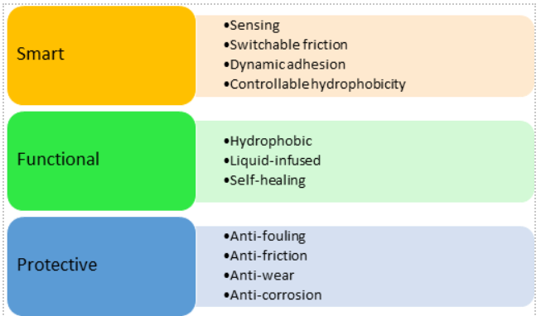

Figure 1. Properties of smart coatings [4]
The article published by R. Lewarchik in 2020 explains the research report on smart coatings by Transparency Market Research. The report states that the global smart paint market is expected to expand at a compound annual growth rate of 29.8% between 2017 and 2025, and to reach $1 billion by 2024 [3].
Current developments and future trends about smart coatings in various areas such as antimicrobial, anti-corrosive, superhydrophobic, thermochromic, intumescent, self-cleaning, self-healing coatings are discussed in this article.

- Functionalities of Smart Coatings
Smart coatings show functional properties and different response mechanisms for different stimuli. The stimuli are examined in 4 groups as chemical, electrochemical, physical, and mechanical. In this section, these functional groups and properties are outlined [5].
  - Anti-corrosive coatings
According to the ISO 8044-1986 standard, “Corrosion is the physic-chemical interaction between a metal and its environment, which results in changes in the properties of the metal and which may often lead to impairment of the function of the metal, the environment, or the technical system of which these form a part”.
Until the latest legislation was introduced by REACH (Registration, Evaluation, Authorization and restriction of Chemicals), classical anti-corrosive coating systems relied on the use of chromate-rich surface treatments and/or chromate-based primers and pigments.
However, new regulations prohibit the use of hexavalent chromium in all sectors except aviation and space applications. This new decision has accelerated research on the use of smart coating applications in anti-corrosive systems [6].
Figure 2 shows the smart coating mechanism with anti-corrosive properties.

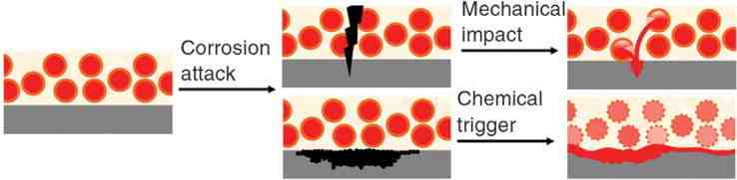

Figure 2. The mechanism of anticorrosive smart coatings [7].
Converting these systems into sustainable processes which show water-based, isocyanate-free, low volatile organic compounds (VOCs) and self-healing properties are among the future trends of smart coatings.
Two basic strategies are followed in the studies carried out for the application of smart coating applications to the anti-corrosive coating system. These strategies are described below:
1.Encapsulation: Encapsulate of functional active species in carriers.
2.Manipulation of the coating matrix composition: In order to inclusion of functional groups [6].
Development of smart coatings with anti-corrosive properties is one of the important issues that many studies have been carried out on.

  - Self-Healing Coatings
Coatings that can renew and partially or completely regenerate themselves are called self-healing coatings. Similar to the regenerative abilities of the human body, these coatings possess the capacity to self-repair fissures and structural flaws. Two main types of self-healing coating mechanisms are autonomous healing mechanisms and non- autonomous healing mechanisms.
Self-healing via microcapsules is the most popular method for autonomous healing mechanisms. In this method, with the cracking of the coating, the encapsulated healing agents are released from the microcapsules, fill the crack and provide repairing. Figure 3 shows the optical visual and SEM images of self-healing coatings. This method is also used for anti-corrosion effect. However, due to the fact that microcapsules cannot be reused, the healing capacity of this method is lower than other methods.
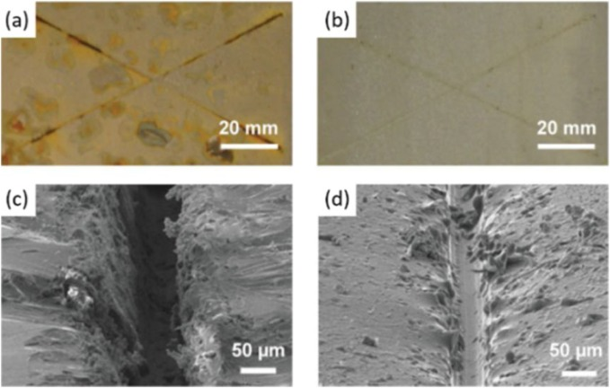

Figure 3. The optical visual and SEM images of self-healing coatings [8].
Self-healing based on dynamic bonds and shape memory polymers are two main examples of non- autonomous healing mechanisms. For both methods an external stimulus, such as heat or light, is required. Unlike microcapsules, theoretically the healing capacity of the coating is unlimited in these methods.
Self-healing coatings are mostly used in electronics, aircraft and automobiles. Although self-healing coatings are not widely used yet due to their high cost and adverse effects on the durability performance of the product, studies are continuing to overcome these limitations [8,9].

  - Self-Cleaning Coatings
Smart coatings with self-cleaning feature are divided into two parts as hydrophobic and hydrophilic. Hydrophobic coatings are also named lotus effect coatings. The working principles are based on the surface tension of the coating forming tightly bound spherical droplets of water that roll off the surface and wash the dirt away.
The working principle of hydrophilic coatings is based on the degradation of organic dirtiness on the surface by a photocatalytic reaction when exposed to sunlight.
These coatings are also used to reduce organic compounds such as nitrous oxide (NOx), sulfuric oxides (SOx), and Volatile Organic Compounds (VOCs) which are in contact with surface. In this self-cleaning mechanism, TiO₂ is used as the catalytic surface for the reaction triggered by sunlight.
These coatings can be used to prevent facade pollution of buildings or to improve air quality in crowded cities [10].

  - Chromogenic Coatings
Coatings that can change color reversibly depending on various external stimuli are called chromogenic coatings. Photochromic, thermochromic, piezochromic, electrochromic, chemochromic coatings are the main types of chromogenic coatings. The most common types are photochromic, triggered by UV or visible light and thermochromic, triggered by the heat. Figure 4 shows chromogenic materials that are classified according to stimulus types [11].
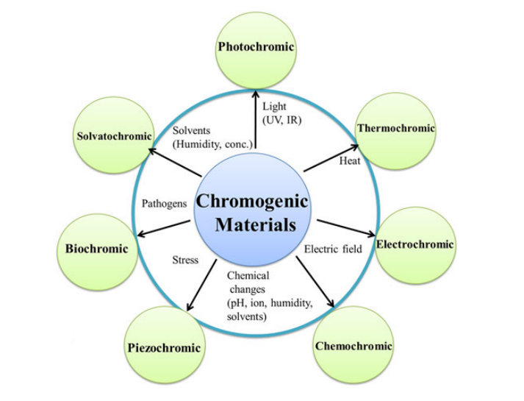
Figure 4. Chromogenic materials classified according to stimulus types [11].

The utilization of photochromic and thermochromic coatings for energy conservation is becoming prevalent. Additionally, thermochromic coatings are used as a safety measure. These coatings, which work as an indicator for temperature change, are used in cooking appliances and many areas of industry [1, 12].

  - Icephobic Coatings
Icephopic coatings are smart coatings that find application area in the aerospace sector, power transmission lines, and wind turbine systems. They have two different working principles: resisting the formation of ice by providing weak adhesion or facilitating the melting of the ice formed on the surface. The hydrophobicity of the surface is very important for these coatings since some superhydrophobic surfaces may increase ice adhesion. The low surface polarity and surface structure of superhydrophobic coatings significantly affect ice adhesion to the surface based on contact angle.
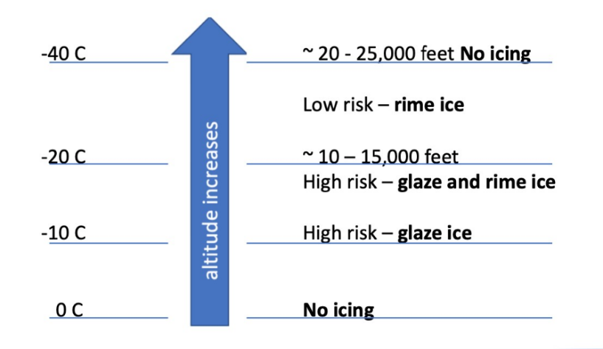

Figure 5. The relationship between altitude, temperature and icing [3].

The temperature of the environment also has a significant effect on surface icing. Figure 5 shows the temperature-icing relationship. Within the scope of smart coatings, reducing the freezing point of surfaces by using icephobic coatings are also studied.
Other methods include oil addition to decrease surface tension or using additives to increase the degree of supercooling required for ice nucleation to occur [3].

  - Environmentally Sensing Coatings
These coating types, which respond to changes in ambient conditions, can be used in many different application areas. For example, pH sensitive paints can be used for corrosion detection. Similarly, using an additive based on Rhodamine B, which can respond to both a decrease in pH and Fe⁺⁺⁺ ions, in epoxy coatings is one of the methods developed to detect corrosion on metal surfaces.
Coatings that have been modified to sensing colonization of viruses and bacteria on surfaces are another example of environmentally sensing coatings [3].

  - Antimicrobial Coatings
Antimicrobial coatings encompass a collection of intelligent coatings that acquire antimicrobial characteristics by the incorporation of diverse additives into their composition. Silver-containing materials dispersed in various binders or materials which are absorbed on porous surfaces to provide slow release and improve longevity, give antimicrobial properties to coatings. Quaternary ammonium salts are another additive that is used effectively against viruses and fungi. Antimicrobial coatings are used in a wide variety of coating areas applied to hospitals, kitchens, public toilets, door handles, transportation vehicles etc. [3].
  - VOC Capturing Coating
The rise in indoor sedentary behavior in contemporary society has led to a corresponding increase in research efforts aimed at enhancing air quality. The matter at hand pertains to a particular concern necessitating the use of paint and coating substances, as well as novel technologies aimed at the elimination of volatile organic compounds (VOCs). The subject matter under consideration pertains to the domains of physical and chemical phenomena. The adsorption method is considered the most appropriate technique for the elimination of volatile organic compounds (VOCs). Adsorption is a favorable process for interior paints due to its occurrence at ambient circumstances without the need for additional energy expenditure. Commercially available dyes with the ability to absorb certain volatile organic compounds (VOCs) are currently limited in quantity [13].
  - Other smart coatings
In this section, smart coating properties, usage areas and effects not mentioned in the previous sections are examined and summarized in Table 1.

Table 1. Function, effect and usage area of some smart coatings [14]
Function | Raw Materials | Effect | Usage Area
Various color characteristics, shade. | Oxides (TiO₂, Fe₂O₃, Fe₃O₄, SiO₂, Cr₂O₃, ZnO), Carbon black | Increasing pigment effects, fading resistance, stabilization of pigment and filler | Hobby paints or Consumer goods (furniture), Construction, Automotive
Self-Assembly | Various polymer structures | Self-healing surfaces | Automotive, cosmetics
Scratch resistance | Oxides, SiO₂ (synthetic amorphous silica), Al₂O₃ | Improved scratch resistance | Consumer goods (furniture, parquet flooring), Construction, Automotive
Intumescent, Fire Retardant | Melamine, Ammonium polyphosphate, carbon source, SiO₂ | In exceeding temperatures, a heat insulating carbon foam layer is created. | Construction, protection of different surfaces against fire
Wood preservation | Nano-clay | Nano-clay coatings delay the fading of wood. | Wood preservation
Ultraviolet protection, Infrared reflective or Infrared absorbing | TiO₂, ZnO, iron oxide pigments (transparent, needle-shaped), CeO₂ | Ultraviolet resistance, blocking of Infrared and visible light | Construction (facades), wood preservation

3. Conclusion
In this article, smart coatings and their properties that constitute the trends of the future in paint and coating industry is explained.
The main approach targeted in smart coatings is to show various properties such as self-healing, anti-microbial / anti-corrosive properties, self-cleaning, in addition to protection, which is the main purpose of general coating materials.
Part of “2. Functionalities of Smart Coatings” describes the properties of smart coatings in detail. The incorporation of these properties into the structures of coatings requires multidisciplinary engineering approaches. For this reason, it is among the topics of great interest by the scientific world.
However, improved properties of smart coatings also cause higher costs in comparison to traditional coatings. Therefore, although smart properties are desired, the cost of the coating should be taken into account. Considerations for smart coating design are listed below;
- Costs of raw materials
- Cost of final product
- Life time of coating
- Efficiency of the smart functionality
- Durability of the smart functionality
- Health and safety
- Surface protection [15]
With all these, smart coatings which can be applied in a wide variety of areas will be the most preferred products of the future.

References
- S.Rossi, M.Simeoni, A. Quaranta, Behavior of chromogenic pigments and influence of binder in organic smart coatings, Dyes Pigm., 184 (2021) 108879, https://doi.org/10.1016/j.dyepig.2020.108879
- K. Yadav, A. Kumar, Introduction of smart coatings in various directions, Antiviral and Antimicrobial Smart Coatings, Fundamentals and Applications, (2023) 219-238 (Chapter) https://doi.org/10.1016/B978-0-323-99291-6.00017-7
- Smart Coatings - The Intelligent Choice - Prospector Knowledge Center (ulprospector.com) received at 26.08.2023
- A.F.A Mohamed, A.A. Elhamy, N.Elaraby, Smart Coating; a Comparative Study of the Economic Feasibility of Employing Self-Healing and Self-Cleaning Coating as an Alternative to Ordinary Coating for Buildings, March 2019, 11th International Conference on Nano Technology in Construction "Green & Sustainable Construction", Egypt
- V.S. Kathavate, P.P. Deshpande, Smart Coatings, Fundamentals, Developments and Application, 1 (2022) https://doi.org/10.1201/9781003200635
- M.F. Montemor, Functional and smart coatings for corrosion protection: A review of recent advances, Surf. Coat. Technol., 258 (2014) 17-37. https://doi.org/10.1016/j.surfcoat.2014.06.031
- D.V. Andreeva, D.G. Shchukin, (2008). Smart self-repairing protective coatings. Mater. 11-10 (2008) 24–30. doi:10.1016/s1369-7021(08)70204-9.
- F. Zhang, P. Ju, M. Pan, D. Zhang, Y. Huang, G. Li, X. Li, Self-healing mechanisms in smart protective coatings: A review, Corros. Sci. 144 (2018) 74-88. https://doi.org/10.1016/j.corsci.2018.08.005.
- I. I. Udoh , H. Shi , E. F. Daniel, J. Li, S. Gu, F. Liu, E. H. Han, Active anticorrosion and self-healing coatings: A review with focus on multi-action smart coating strategies, J. Mater. Sci. Technol. 116 (2022) 224-237. https://doi.org/10.1016/j.jmst.2021.11.042.
- The smart coatings opportunity - Polymers Paint Colour Journal; https://www.polymerspaintcolourjournal.com/the-smart-coatings-opportunity/ received at 26.08.2023.
- K. Sadeghi, J.Y. Yoon, J. Seo, Chromogenic Polymers and Their Packaging Applications: A Review. Polym. Rev. 60-3 (2019) 1–51. doi:10.1080/15583724.2019.1676775.
- L. Civan, S. Kurama, E.Ayas, Chromogenic materials classified according to stimuli types, Duzce Uni. J. Sci. Technol. 6 (2018) 582-592.
- N. Karamahmut Mermer, N. Ugur, F. Kuzgun, B. Bakar, F. İnceoğlu, E. Unlu Pinar, Evolution of coalescent agent-free ultra-low VOC paint with formaldehyde capturing properties, Atmos. Pollut. Res. 14, 8 (2023) 101812. https://doi.org/10.1016/j.apr.2023.101812
- S. B. Ulaeto, R. Rajan, J. K. Pancrecious, T. P. D. Rajan, B. C. Pai, Developments in smart anticorrosive coatings with multifunctional characteristics, Prog. Org. Coat. 111 (2017) 294–314. https://doi.org/10.1016/j.porgcoat.2017.06.013
- I. P. Geelen, Smart Coatings Getting Smarter, Special Chem. (2021) https://coatings.specialchem.com/tech-library/article/smart-and-functional-coatings-getting-smarter, Received at 26.08.2023

