**Breaking the outer layer of the “virus (Covid-19)” with the help of electrical stimulation and protect the Human body against virus (Covid-19) infection.**

**Dr. Mamataben Soni, Dr. Bhavinkumar Soni**

**GRAPHICAL ABSTRACT**

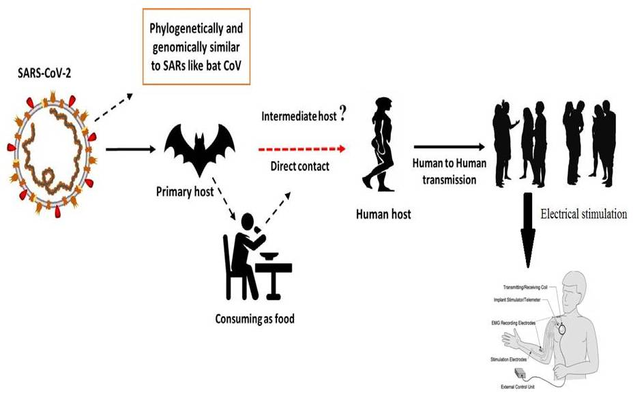

**KEY WORDS**

Electrical stimulation, Covid-19, Current, Voltage, SARS-CoV, MERS-CoV,

**INTRODUCTION**

Corona viruses are part of the Corona virus family of the order Nidovirales. The name Corona is derived from the crown-shaped spikes on the outer surface of the virus; hence the name Corona virus. Corona viruses are small (Diameter 65-125 nm) and contain a nucleocapsid of 26-32kbs (see Fig. 1). Corona viruses are divided into alpha (a) subgroup, beta (b) subgroup, gamma (c) subgroup, and delta (d) subgroup. SARS-CoV causes acute lung injury (ALI). ARDS causes acute respiratory distress syndrome (ARDS). H5N1 Influenza A causes acute respiratory distress. H1N1 2009 causes acute respiratory distress (ARDS) caused by corona virus. Middle East Respiratory Syndrome Corona virus causes acute respiratory failure (ARDS) which can lead to lung failure and death. It was thought that corona virus was primarily an animal-borne virus until 2002 when the world witnessed the world-wide outbreak of severe acute respiratory syndrome (SARS) in Guangdong (China) due to corona virus [Zhong et al., 2003]. Just 10 years later, another major corona virus, MERS-CoV, caused an outbreak in the Middle East [Wang et al., 2013].

A new corona virus has killed more than 18,000 people and infected more than 70,000 in China’s fast-growing commercial hub Wuhan in the first 50 days of the outbreak. The corona virus has been identified as part of the corona virus b family. Chinese researchers named the virus Wuhan corona virus or 2019 novel corona virus (2019-n Cov). The International Committee on the Taxonomy of Viruses (ICTV) has classified the corona virus as a SARS-CoV- 2 virus and the disease as a COVID-19. [Cui et al, 2019; Lai et al., 2019;WHO 2020]. SRAS-CoV has infected 8098 cases with a 9% mortality rate in 26 countries as of this writing while new corona virus (2019) has infected 120,000 cases with 2.9% mortality rate in 109 countries. The above table shows the transmission rate of SARS-Co virus is higher than that of SRAS-CoV-2 virus. This could be due to the genetic recombination of the S protein in the RBD region of SARS virus, which may have enhanced the transmission capacity of SARS CoV-2 virus.

**Figure:1.** The structure of the respiratory illness caused by the human corona virus History of the electrical stimulation therapy use in various “diseases”

One of the problems in this case relates to the use of Black Boxes and Magnetic Pulse Generators for blood electrification. They claim that these devices can treat infections like viruses, bacteria and yeast as well as diseases like cancer. These claims have a long history in scientific literature. Lyman and colleagues reported in 1990 that the delivery of 50-100 microamperes direct current through blood infected with the Aids virus inactivated the virus and stopped viral proliferation (Lyman et al., 1990). The study was published in the Journal of Apioids on 14 March 1991. The paper was presented at the 1st International Symposium (AIDS conference) on Combination Therapy in Washington, D.C.

Antibacterial have revolutionized the treatment of bacterial infections and dramatically reduced mortality due to microbial diseases over the past few decades. However, widespread use of antibacterial agents has caused bacteria to develop resistance to antibacterial agents. This poses a serious threat to the treatment options for bacterial infections (Castro et al., 2002; Silveira et al.,2006). Bacteria classified as part of the genera *enterobacter* and *staphylococcus aureus*, are prominent in the global landscape of bacterial resistance, and the drugs employed to control them are frequently ineffective, making them difficult to treat. (Martins et al.,2012).*Enterobacter* are Gram-Negative, facultative, anaerobic Bacilli. *Enterobacter* are a group of Gram-positive, anaerobic bacteria that have evolved as opportunistic infections in critical care units (CCUs) where they are able to develop β-lactam(Regli et al., 2015).

The higher the gene expression of the *Enterobacter* Amp-C, the more resistant the bacteria are to certain antibiotics (e.g., cefalozporin-resistant) and there have been reports of infections caused by bacteria that produce carbapenems (Tuon et al., 2015). *Staphylococcus aureus*, on the other hand, is gram-positive *cocci* bacteria found in healthy people's skin and nasal passages; it is the predominant etiological agent of skin infections due to its capacity to compromise the skin barrier's integrity. *S. aureus* infections can be fatal, causing pneumonia, meningitis, endocarditis, septicemia, and even systemic infections. Furthermore, infections caused by this agent have a high morbidity and mortality rate in both hospital and home-based cases (Martins et al.,2012).

Because of its resistance to antibiotics, this bacterium has become one of the leading causes of hospital infections and has become a global health threat (Almeida et al., 2007; Zavadinack et al., 2001). Resistant bacteria, viruses and parasites have *S. aureus* caused a number of hospital and community-acquired infections since treatment-resistant infections were first identified in the 1950s (Barradas et al., 1997In reality, *S aureus*-induced discolored skin infections are very common in general practice and in the emergency department (Sukumaran et al.,2016). Antimicrobial drug resistance is also one of the most important determinants of disease epidemiology, leading to an increase in the incidence and mortality of diseases that were once thought to be controllable (Barradas et al., 1997). Due to the high importance of microbial resistance development and the need to avoid hospital and non-Hospital infections, new bacteriostatic, and bactericidal drugs are needed to improve the treatment of sick patients. One possible solution is high frequency equipment (HFE). HFE generates alternating current (high voltage low intensity). Its vacuum or gas glass electrode conducts current and ionizes air molecules, resulting in fluorescence. The physiological effects observed are caused by the synthesis (O3) of ozone (O2) by the current generated spark when it passes the electrode. The equipment also heats up by creating an electric field. Local peripheral vasodilatation improves blood flow and increases oxygenation (Martins et al.,2012;Korelo et al., 2013). The device is used by physiotherapists, aestheticians, and dermatologists to treat skin conditions, as an anesthetic, as an anti-inflammatory and, most importantly, to expedite cyclic processes (Martins et al.,2012;Korelo et al., 2013; Sa HP et al., 2010).

When O3 is exposed to the skin, it undergoes oxidative metabolism, resulting in the conversion of molecular oxygen (O2) to atomic oxygen (O). The mechanism of action of O3 on bacteria is based on its action on the bacterial membrane. O3 interferes with the activity of enzymes, decreases cell permeability and initiates the oxidation of amino acid and nucleic acid, resulting in bacterial death (Martins et al.,2012;Korelo et al., 2013; Oliveira et al., 2011). In this regard, this study assessed the bactericidal activity of HFE in typical *S. aureus* and *E. aerogenes* strains many times and at varying intensities, as well as the sensitivity of this electrotherapeutic resource on these bacteria.

Figure 2a illustrates the bacterial growth of *E. aerogene* after irradiation for 30 seconds, 60 seconds, 90 seconds, 120 seconds and 180 seconds at 6, 8 and 10 mA high flux fractions (HFEs). Compared to the controls, the 6 mA spark did not have any bactericidal effect. However, a significant reduction in bacterial growth occurred at the 8 mA level at the 120 and 180 second intervals, and at the 10 mA level, the reduction was already confirmed at the 30 second interval. However, the total inhibition of bacterial growth at the 180 second interval was only 10 mA.

At all intensities evaluated, *S. aureus* growth was severely reduced; however, no bacterial growth was seen after 120 and 180 seconds at 6 mA. When the flashing intensity was increased to 8 and 10 mA, microbe growth was reduced after just 30 seconds of irradiation, implying that the higher the intensity, the shorter the time necessary for the equipment to provide a bactericidal effect (Figure 2 b.).

|  |  |
| --- | --- |
|  |  |
| **Figure: 2a.** The antibacterial activity of high frequency equipment at different time intervals (seconds) on the growth of an average culture of *E. aerogenes.*  **Notes:** Results are presented as mean±standard error of mean. Results are presented as a single-sided, one-way analysis of variance (ANOVA) followed by a Tukey post-hoc analysis. * p<0.05 compared to control. | **Figure: 2b.** The antimicrobial properties of high frequency equipment in relation to the growth of a standardized culture of *S. aureus* at various time intervals (seconds).  **Notes:** Results are presented as Mean standard ± error of mean. One-way ANOVA was used and Tukey post hoc analysis was conducted. * p0.01 vs. control. # p<0.05 vs. 6mA in 30 seconds. |

**DISCUSSION**

Electrical stimulation devices, in our opinion, have a solid basis for usage in the treatment of numerous disorders. Like cancer, AIDS, Herpes and many more. So here, we discuss that current Global epidemic covid-19 were spread on the earth. For this epidemic covid-19 we also use this method and break the outer surface of the corona virus and burst its cell. Use of this method to stop the replication of cell. In some case electrical stimulation can suppress the activity of cell.

**ACKNOWLEDGEMENT**

We will gratitude **Evellyn Claudia Wietzikoski Lovato and his team** who published research article on **“High frequency equipment promotes antibacterial effects dependent on intensity and exposure time”** its published in journal **Clinical, Cosmetic and Investigational Dermatology** in **2018**. This article helps the analysis of result in my review article.

**REFERENCES**

* Almeida MC, Simoes MJS, Raddi MSG. [Ocorrencia de infeccao urinaria em pacientes de um hospital universitario]. *Revista de Ciências Farmacêuticas Básica e Aplicada*. 2007;28(2):215–217. Portuguese.
* Barradas RC. [O desafio das doencas emergentes e a revalorizacao da epidemiologia descritiva]. *Revista Saúde Pública*. 1997;31(5):531–537. Portuguese.
* Castro MS, Pilger D, Ferreira MBC, Kopittke L. [Tendencias na utilizacao de antimicrobianos em um hospital universitario, 1990–1996.] *Revista Saúde Pública*. 2002;36(5):553–558. Portuguese.
* Cui J, Li F, Shi Z-L. Origin and evolution of pathogenic corona viruses. Nat Rev Microbiol 2019;17(3):181–92.
* Korelo RIG, Oliveira JJJ, Souza RSA, Hullek RF, Fernandes LC. Gerador de alta frequencia como recurso para tratamento de ulceras por pressao: estudo piloto. *Fisioter Mov*. 2013;26(4):715–724.
* Lai C-C, Shih T-P, Ko W-C, Tang H-J, Hsueh P-R. Severe acute respiratory syndrome coronavirus 2 (SARS-CoV-2) and corona virus disease-2019 (COVID- 19): the epidemic and the challenges. Int J Antimicrob Agents 2020;105924.
* Lyman WD, et al. Lab Test Results of HIV inactivation by electric current: Reporting Inactivation of AIDS Virus by Electric Current. First International Symposium on Combination Therapies in Washington DC on March 14th, 1991.
* Martins A, Silva JT, Graciola L, et al. [Efeito bactericida do gerador de alta frequencia na cultura de *Staphylococcus aureus*]. *Fisioterapia e Pesquisa*. 2012;19(2):153–157. Portuguese.
* Oliveira LMN. [Utilizacao do ozonio atraves do aparelho de alta frequencia no tratamento da ulcera por pressao]. *Revista Brasileira de Ciências da Saúde.* 2011;9(30):41–46. Portuguese.
* Organization WH. Laboratory testing for coronavirus disease 2019 (COVID-19) in suspected human cases: interim guidance, 2 March 2020. World Health Organization, 2020.
* Regli AD, Pages JM. *Enterobacter aerogenes* and *Enterobacter cloacae*: versatile bacterial pathogens confronting antibiotic treatment. *Front Microbiol*. 2015;6:392.

1. Sa HP, Nunes HM, Santo LAE, et al. [Estudo comparativo da acao do laser GaAIInP e do gerador de alta frequencia no tratamento de feridas cutaneas em ratos: estudo experimental]. *ConScientiae Saúde*. 2010;9(3):360–366. Latin.
2. Silveira GP, Nome F, Gesser JC, et al. [Estrategias utilizadas no combate a resistencia bacteriana]. *Revista Química Nova*. 2006;29(4):844–855. Portuguese.
3. Sukumaran V. Bacterial skin and soft tissue infections. *Aust Prescr*. 2016;39(5):159–163.
4. Tuon FF, Scharf C, Rocha JL, Cieslinsk J, Becker GN, Arend LN. KPC-producing *Enterobacter aerogenes* infection. *Braz J Infect Dis*. 2015;19(3):324–327.
5. Wang N, Shi X, Jiang L, Zhang S, Wang D, Tong P, et al. Structure of MERS-CoV spike receptor-binding domain complexed with human receptor DPP4. Cell Res 2013;23(8):986.
6. Zavadinack MN, Herreiro F, Bandeira COP, et al. *Staphylococcus aureus*: incidencia e resistencia antimicrobiana em abcessos cutaneos de origem comunitaria. *Acta Scientiarum*. 2001;23(3):709–712.
7. Zhong N, Zheng B, Li Y, Poon L, Xie Z, Chan K, et al. Epidemiology and cause of severe acute respiratory syndrome (SARS) in Guangdong, People’s Republic of China, in February, 2003. The Lancet 2003;362(9393):1353–8.