Discrimination of Inter-turn Fault from Magnetizing Inrush Current in Transformer: A Wavelet Transform Approach

P. R. Bharambe Dr. S. S. Jadhao Dr. S. R. Paraskar

Assistant Professor Associate Professor Professor & Head

Department of Electrical Engineering Department of Electrical Engineering Department of Electrical Engineering

Shri Sant Gajanan Maharaj College of Engineering Shri Sant Gajanan Maharaj College of Engineering Shri Sant Gajanan Maharaj College of Engineering

Shegaon. (M.S.), India Shegaon. (M.S.), India Shegaon. (M.S.), India

Abstract: To distinguish the magnetizing inrush current and internal fault accurately & quickly is a crucial issue in the transformer protection. .. This paper describes a novel and simple technique to discriminate the magnetizing inrush current and inter-turn fault using the wavelet transform avoiding rigorous mathematics. This method is independent of setting any threshold for discrimination amongst these, and capable of detecting interturn short circuit involving few turns also, which is otherwise very difficult to detect. With a thorough explanation of the proposed criterion, practical results for the specially constructed transformer are shown. The difference between the two-peak amplitudes of wavelet coefficients in a given band is used to build a discriminating function for feature extraction. This differentiation will help in the creation of an automatic detection system that will provide information to anticipate the failure in advance and allow the appropriate corrective actions to be made to decrease downtime and avoid outages.

*Keywords:* Inter-turn fault, Magnetizing inrush current, wavelet transform

I. INTRODUCTION

The transformer, an important part of electric power systems, is crucial to the power system's secure operation. Due to its straightforward operating principle and sensitivity, differential protection has long served as the transformer's primary method of protection [1],[16]. How to distinguish a magnetising inrush from an internal failure, nevertheless, is a key differential protection problem. The traditional method uses the second harmonic component of differential currents to limit the differential relay's operation so as to prevent tripping during conditions of magnetising inrush. [2].

It is commonly known that this strategy falls short in various ways when it comes to protecting modern power transformers. High performance relays are also necessary for the modern power system, particularly in terms of operating speed. The peaked wave characteristics of the transformer core's asymmetric saturation are also present in the magnetising inrush. These features enable a new field of investigation for increasing the relays' working speed by identifying magnetising inrush [15].

The power industry is becoming more and more regulated in the modern world. There is fierce competition because there are more utilities providing power. Customers want a "Good quality" of electric supply. Therefore, it is crucial in this situation to reduce the frequency and length of unwelcome distribution transformer outages.

Since the second harmonic component may also be introduced during an internal fault due to a variety of other factors, such as current transformer saturation or the presence of a shunt capacitor, it is no longer possible to distinguish between an internal fault and a magnetising inrush current by looking for the presence of a second harmonic component in the inrush current [2],[10].

Transformer inductance during saturation, flux derived from the voltage integral, and differential current are examples of earlier work on transformer protection. Fuzzy logic and ANN are two recent methodologies that have been utilised. Additionally, a few methods have been used to detect internal defects and the magnetising inrush [16],[8]. For this, a system based on microprocessors and modal analysis was deployed as a tool. In [16], the discriminating factor is the active power coming into the transformer, which is nearly zero in the event of energization.

A wavelet-based system is employed in [11]. For the study and feature extraction of power system transients, a wavelet-based signal processing technique is useful [2]. There have been reports of the technique's use in data compression, protection, study of power quality issues, fault detection, and power quality assessment.

An innovative wavelet-based technique is put out in Paper [11] to detect inrush current from internal problems and identify it. The asymmetrical magnetization that is unique to the inrush is described by the second harmonic component. The wavelet transform idea is first applied. It is described how wavelets' ability to have multiple resolutions in time and frequency allows for accurate transient component time location while also preserving data on the fundamental frequency and its lower order harmonics, making it easier to spot transformer inrush currents. Using a data window smaller than half a power frequency cycle, the approach extracts the wavelet components present in the line currents to detect inrush currents. The findings demonstrate that the suggested method can provide the desired responses and can be applied as a quick, accurate way to distinguish between inrush magnetising and power frequency issues.

In this study, a wavelet-based method for identifying inrush current and differentiating it from internal defects is devised. The data from the controlled studies were gathered in the lab using a specially constructed single-phase transformer. A wide range of potential failure scenarios on the transformer's primary and secondary windings were purposefully introduced in these controlled testing. For reaching the goal, a schematic algorithm is created; the suggested scheme does not call for any threshold settings.

# II. WAVELET TRANSFORM

The wavelet transforms associated with fast electromagnetic transients are typically non-periodic signals, which contain both high-frequency oscillations and localized impulses superimposed on the power frequency and its harmonics. The entire frequency spectrum may be impacted if signals are altered in a specific localised time instant. The short-time Fourier transform (STFT) is employed to lessen the impact of non-periodic signals on the DFT. It presupposes local periodicity within an ongoing time window of translation.. The process for implementing a Discrete Wavelet Transform is shown in Fig. 1, where S represents the original signal and LPF and HPF stand for low-pass and high-pass filters, respectively. An initial signal is split into two portions, each with a frequency bandwidth of half, and delivered to the LPF and HPF in the first step. The output of the LPF is then further reduced by halving the frequency bandwidth before being delivered to the second stage. This process is repeated until the signal has been divided into its component parts to the predetermined level. According to Nyquist's theorem, the original signal could only contain frequencies up to Fs/2 Hz if it were sampled at Fs Hz. The first detail, number 1, would show this frequency at the high pass filter's output; similarly, detail 2, number 2, and so on, would show the band of frequencies between Fs/4 and Fs/8. The frequency levels of the wavelet function coefficients are shown in Table I. In this research, the sampling frequency is assumed to be 10 kHz.

## Table I: Frequency levels of Wavelet Functions Coefficients

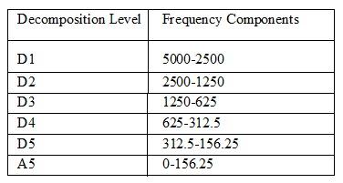

### 

### Fig. 1. Implementation of DWT

# 

# Fig. 2: Different behavior of fault and inrush current

# III. PROPOSED METHOD

Figure 2's waveform of the inrush differential current makes it obvious that its initial slope is less than that of the fault differential current, which grows after lowering initially. High frequency components are present when the slope has a high value. These characteristics are depending on the different types of current and transformer parameters and are independent of the associated power supply. The initial slope of the differential current owing to fault and that due to magnetising inrush current differ significantly from one another, and this difference has been utilised to distinguish between inter-turn fault and magnetising inrush current. According to the suggested approach for internal fault (in one scenario, an inter-turn short circuit), the high frequency's initial amplitude is high and then it gradually drops. Therefore, as illustrated in Figure 3, high frequency components are recorded in the first two levels, D1 and D2. In contrast, in an inrush current, the high frequency component's initial amplitude is lower and then grows. Therefore, nothing can be seen at the first two levels, D1 and D2, whereas at D3 (see Fig. 4), a significant amplitude can be noticed.



Fig. 3: Illustration of Wavelet decomposition of fault Current



Fig. 4: Illustration of Wavelet decomposition of inrush Current

# IV. EXPERIMENT SETUP

A specially constructed 220V/220V, 2KVA, 50Hz, single-phase transformer with externally accessible taps on both the primary and secondary to introduce faults is used in the experiment setup. There are 272 turns between windings.

The secondary's load is made up of Induction motor and static components.

The voltage and current readings were recorded using Tektronix Instruments' data acquisition card. 10,000 samples per second was the sample rate used to record these signals.

On the custom-built transformer, several inrush current and inter turn short circuit events were staged by changing the parameters, which drastically altered the properties of these currents. The voltage angle at the time of switching and the residual core flow are these parameters. The effects of the number of shorted turns on the primary or secondary, and load conditions are taken into account when staging various inter turn short circuit instances.

The custom-built transformer was used for the ensuing the following tests.

1. The primary current was measured in an unloaded state to ensure good health.

2. By keeping four percent (10 turns) of the primary turns short-circuited while under load, the transformer was powered up and differential current was acquired.

3. The identical process was carried out again for secondary winding short circuits.

On the specially made transformer, the suggested algorithm was put to the test. The experiment setup is depicted in Fig. 5

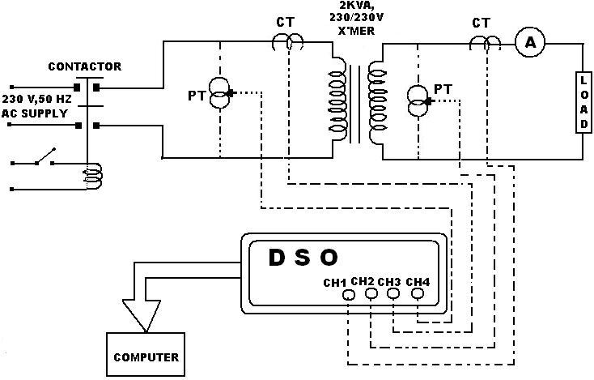

Fig.5: Experimental Setup

#### V. RESULT AND DISCUSSION

Figure 6 displays the differential current (labelled "Signal") caused by an inter-turn short circuit in a primary winding with a 4% winding that is close to neutral, together with their specific coefficients from Wavelet Transform up to D5 level. In this case, the desired wavelet coefficients are obtained using the daub- 4-mother wavelet.

The detailed coefficients of levels 1 to 5 of decomposition are shown in this image as d1 through d5, with level 5's estimated coefficients shown as a5. The absolute value of d5 is displayed at the bottom of this figure. Below is a full explanation and interpretation of Figure 6:

1. The figure's 'Signal' represents the original differential current signal that was recorded using the data acquisition technology previously mentioned. The fault starts at sample number 39 (about), and it is indicated in the graphic as "x." The first negative differential current peak, indicated by 'Y' in the picture, is seen at sample number 50.
2. Peaking of the wavelet coefficient is seen in decomposition level 'd1', roughly from samples 39 to 64. The magnitude of these oscillations then starts to decay.
3. At the 'd2' level, the sudden shifts in the signal during samples 39 to 64 are more clearly visible, and sample number 45 has the highest positive peak.
4. In 'd3' level, high frequency components that were present in d2 are filtered off. The apex of the waveform was once more seen at sample number 45.
5. At the d4 level, sample 39 exhibits the first positive peak with a magnitude of 0.3571 while sample 50 exhibits the first negative peak with a magnitude of -0.3651. This is a close representation of the 'x'-'y' curve.
6. The first positive peak in the d5 level is seen at sample 39 and has a magnitude of 0.4041, while the first negative peak is seen at sample 59 and has a value of -0.5657. The slopes of faults and inrush currents can therefore be measured precisely at the d5 level.

As a result, the first two successive peak values following the fault moment are the best approximations for the initial slope changes in the fault and inrush current, taking the absolute value of |d5| as indicated in the figure.

Consequently, the following can be used to select the discriminating function for fault and inrush current:

$ΔM\left\{d5\right\}=\left\{First Peak after fault initiation\right\}-\left\{Second Peak after fault initiation\right\}$ (1)

$ΔM\left\{d5\right\}=A-B$ (2)

Hence, for inrush current ΔM < 0 and for fault current ΔM > 0.

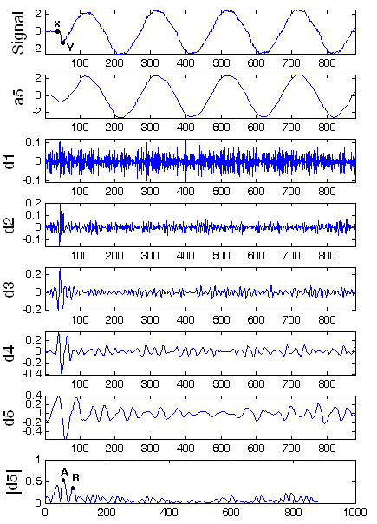

Fig. 6: Wavelet decomposition of differential current for fault in primary winding

Figure 7 displays the wavelet decomposition of the differential current measured during the interturn fault of the secondary winding's 10 turns. Similar high frequency components were seen in primary winding faults.

For high initial slope of fault current, high frequency components were seen at decomposition level d1-d4. As was previously discussed, as the fault develops, the slope of the fault current gradually diminishes. High frequency components with large amplitudes at the time of the fault and fading trends afterwards are clearly discernible from time-frequency localization in the d1-d3 levels.

Filtration of this high frequency up to the d5 level produces some really intriguing fault and inrush current discrimination criteria. The bottom of this illustration displays the coefficients of the d5 waveform's absolute value. The first two peaks after the disturbance in this have amplitudes A and B. The figure shows that for the inter-turn fault, A>B. The quarter cycle can be used to issue commands in the event of an A>B journey. Typically, the characteristics required for diagnosis appear in the high frequency range rather than the lower frequency range.

Figure makes clear that the wavelet coefficients in D5 have bigger amplitudes than those in D1 through D4. Many wavelets were tested as analysis wavelets, but Daubechies 4 (Db4) ultimately provided reassuring and distinctive properties.

The size of the two successive peaks A and B likewise exhibits the same relationship, namely, A>B.

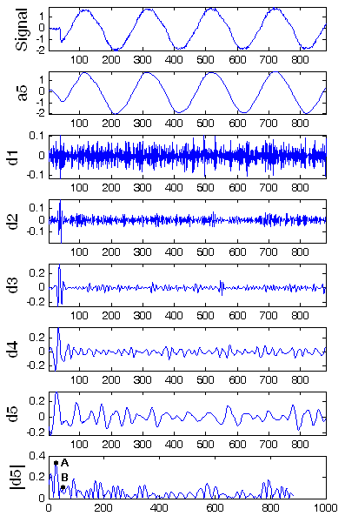

Fig. 7: Wavelet decomposition of differential current for fault in secondary winding

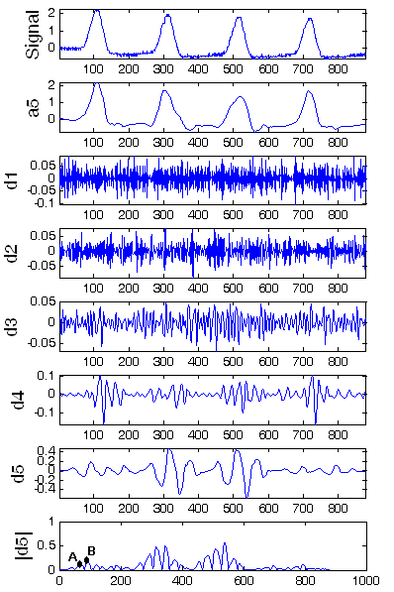

Fig. 8: Wavelet decomposition of differential current during Inrush

Despite having a similar amplitude, inrush current differs from fault current in behaviour or features. Low slope inrush current begins and increases quickly after. In fig. 8, this trait is illustrated. The signal for the acquired inrush current is divided into five levels. As was the case with the inter-turn fault, there was no peaking at the initial instant in the d1-d2 level. However, because high slope follows low slope in inrush current, high frequency oscillations can be observed in these levels. As a result, in contrast to the preceding situation, repeated oscillations are reported at the d4 level that match the steep inrush current slope. The consecutive peaks A and B can be found from the d5 and |d5| and compared. It should be observed that A > B for inrush.

In line with the prior discussion, the proposed technique does not call for a threshold value to distinguish between the transformer's magnetizing inrush and inter-turn failures. The following is a presentation of the discrimination algorithm:

1. Under the aforementioned events, measure the differential current with an acceptable sample frequency.

2. Use the MRA method to get the discrete wavelet transform up to the fifth level of decomposition.

3. Obtain |d5|

4. Discover |d5|'s first two peak values, A and B.

5. Determine M=A-B.

6. If M is negative, inrush current is present.

7. If M is positive value, it is fault condition and will sound an alarm or trip signal.

The wavelet decompositions of fault and inrush currents at various switching instants are shown in Figures 9 and 10.

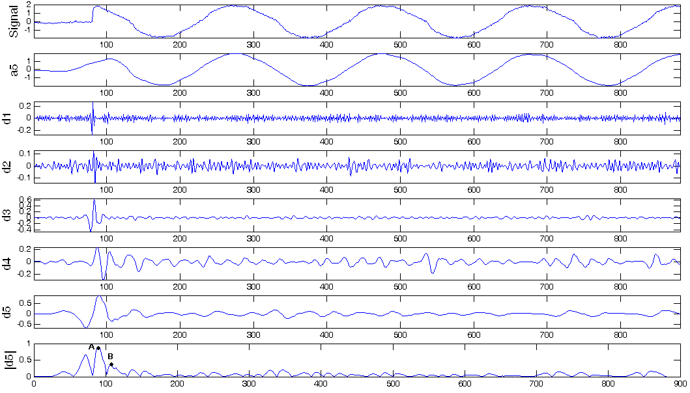

Fig. 9: Wavelet decomposition of differential current during fault

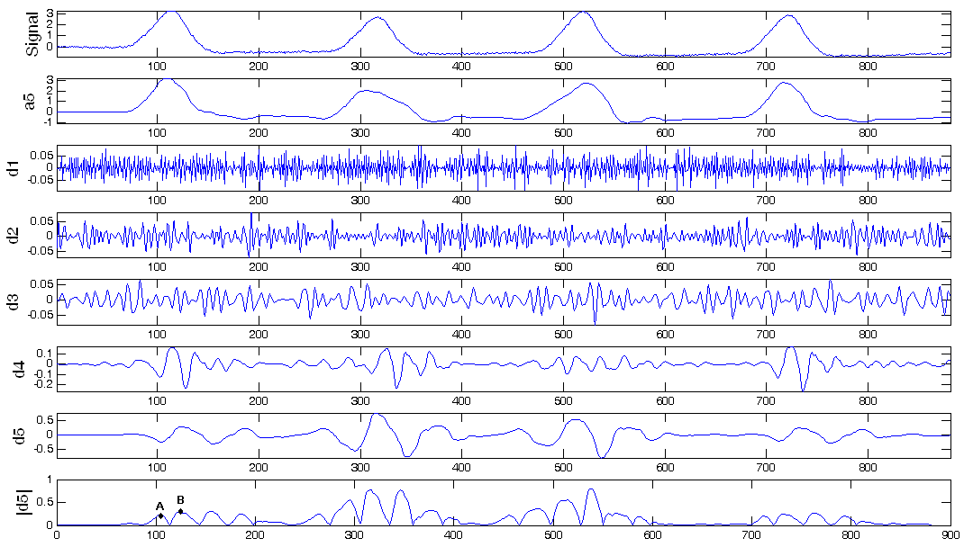

Fig. 10: Wavelet decomposition of inrush current

**VI. CONCLUSION**

This work introduces a new method that distinguishes between the inter-turn fault and the magnetising inrush current. Wavelet coefficients served as the algorithm's discriminating function. To differentiate the situations under study, two peaks at the |d5| level immediately following the fault moment are used. Since the criteria for this algorithm compare the two peaks, no threshold adjustments are required. The proposed method is thoroughly detailed and shown to be effective using a custom-built transformer.

#### VII. REFERENCES

1. Karen L Butter-pury & Mustafa bagriyanik, “Characterization of transients in Xmer using DWT” IEEE Transactions on power system, Vol.18 No.2 may 2003.
2. Jawed Faiz, “A Novel Wavelet-based algorithm of internal faults” from magnetizing inrush currents in power transformers.” IEEE Transactions on power delivery, Vol.21 No.4 Oct 2006.
3. Karen L Butter-pury, “Identifying Transformer Incipient Events fir maintaining Distribution system reliability” Proceedings of the 36th Hawai International Conference on system sciences 2003.
4. M.A.Rahman and B Jeyarurya “A state of art reviews of transformer protection algorithm, “IEEE Transactions on power delivery, Vol.3 PP 534-544 Apr-1988.
5. P.M.Anderson, Power system protection. Piscataway NJ: IEEE press 1999.
6. H.Wang and K.L.Butter “Modelling transformers with internal incipient faults.” IEEE Transactions on power delivery, Vol.17 PP 500-509 Apr-2002.
7. P.L.Mao and R.K Agrawal, “A wavelet transform based logic method for discrimination between internal faults and inrush currents in power transformers,” Electrical Power and Energy system,” Vol.22 PP 389 – 395, 2000.
8. P.L.Mao and R.K.Agrawal “A novel approach to the classification of the transient phenomena’s in power transformers using combine wavelet transform and neural network, “IEEE Transactions on power delivery, Vol.16 No.4 PP 654-660 Oct 2001.
9. Y.Y.Hong and C.W.Wang, “Switching detection / classification using discrete wavelet transform and self organizing mapping network “ IEEE Transactions on power delivery, Vol.20 No.2pt II PP 1662 – 1668 APR – 2005.
10. S.A.Saleh and M.A.Rahman , “Modelling and protection of three phase power transformer using wavelet packet transform” IEEE Transactions on power delivery, Vol.20 No.2pt II PP 1273 – 1282 APR – 2005.
11. O.A.S.Yousef, “A wavelet based technique for discrimination between faults and magnetizing inrush currents in transformer” IEEE Transactions on power delivery, Vol.18 No.1 PP 170 – 176 Jan – 2003.
12. C.K.Chui, ed: Wavelets: - A tutorial in theory and application academic Press. Inc. 1992.
13. G.Kaiser, A Friendly guide to wavelets, Birk base 1994.
14. S Mallat, “A theory for multi resolution signal decomposition: the wavelet representation,” IEEE Transactions on power Anal and much Intel, Vol.111 PP 674 – 693 Jul 1989.
15. Benteng He,Xuesong Zhang,and Zhiqian Q.Bo “A New Method to Identify Inrush Current Based on Error Estimation “. IEEE Transactions on power delivery, Vol .21, NO 3 JULY 2006.
16. Y. Kukaki, “Power differential method for discrimination between fault and magnetizing inrush current in transformer” IEEE Transactions on power delivery, Vol .12,pp1109-115, JULY 1997.