A RANDOM FOREST AND ANN DEEP LEARNING MODEL FOR FRAUD DETECTION OF CREDIT CARD USERS IN THE BANKING SYSTEM: A REVIEW

Rohit Kori Deepesh Tamrakar Sapna Jain Choudhary
Computer Sc. & engg. Computer Sc. & engg. Computer Sc. & engg.
SRGI SRGI SRGI
Jabalpur, India Jabalpur, India Jabalpur, India
rohitkori066@gmail.com deepesh.tamrakar@gmail.com choudharysapnajain@gmail.com
ABSTRACT
In opposition to invasion attacks (where/during/in what way/however a conventional firewall fails), a detection gadget provides indications and symptoms of illness. Using supervised and unsupervised (success plans/ways of achieving goals) learning techniques, device learning sets of computer instructions aim to discover (strange, unexpected things). Ability want (success plans/ways of accomplishing objectives) identify highly vital talents and get rid of supplementary and superfluous features to reduce the intriguing quality of (typical and expected) location. The work presents a skills choice (a strong fundamental foundation upon which larger things may be constructed) for unnatural community (strange, unexpected item) identification using excellent machine learning classifiers. The clean out and wrapper functions, which are preferred methods of accomplishing things, are applied in the (solid fundamental framework on which greater things may be constructed) together with good helpful helpful useful thing/valuable supply. To select the (nearly nothing/extremely little) form of functions that benefit the wonderful (quality of being very close to the truth or correct number), which is the basis for this (firm basic structure on which greater things may be constructed), is the purpose of this (solid basic structure). The proposed (solid fundamental framework on which larger items can be constructed) is tested and evaluated using a dataset in experimental effects. The results show that a (quality of being very close to the truth or true number) of 86% is achieved by using 18 skills from one of the clean out rating ways of doing things and using ann and childlike (because of a lack of understanding) bayes as a classifier, and compare result with Random Forest and Decision Tree.
Keywords— Intrusion detection system, Machine learning techniques, Features selection methods, ANN, Random Forest, Decision Tree.

INTRODUCTION
A tool for invasion detection is made to find an invasion before it occurs or after it has already taken place. The most crucial tasks carried out with the practical useful thing/valuable source of ids are monitoring/supervising customers and building interest, auditing system setups, spotting said attacks, figuring out strange sports, successfully handling audit records, highlighting regular sports activities, correcting device setups and storing information about intruders [1]. Intruders come in several guises. The outside intruders who assault the devices are unauthorized users. Internal intruders are permitted access to the tool with a few limitations. For (related to activities that guard against attack) records structures to compete against such attacks, it is very crucial to create robust invasion detection structures [2]. Idss are categorized mostly based on (great/very uncommon) components, which can range from network-based to host-based idss without a doubt. In order to study community packets and look at the data included in them, community-based ids employs a hard and fast of sensors to (record by a camera or computer) the community communications. Device logs and audit trails are used by host-based ids to verify and analyze the records that are placed on a single or many host structures [3]. As opposed to (strange, unexpected thing)-based totally certainly fully and entirely invasion detection systems, invasion detection systems can be categorized as (using something the incorrect way) idss.
erroneously using something) Based on very hard-coded signatures kept in the signature list, ids is a signature-based ids that would inadvertently identify known exploits. Low phoney exaggerated satisfaction rates are a benefit of the (using something incorrectly) "success plans" and "ways of reaching goals." They are troubled by excessive fake bad charge, nevertheless, because to their sensitivity to even the slightest alteration in the stored signatures. In this situation, the variations may be viewed as an assault. When such assaults may not be included within the recorded signatures, Misuse IDs fail to identify unknown and 0-day attacks [3]. Anomaly-based total methods install a typical profile utilization by using device mastery techniques. If a strange request breaches this normal profile, it could be regarded as an assault. The installation of that profile uses supervised and unsupervised strategies and has a low rate of fake bad. In comparison to signature-based approaches, anomaly-based techniques are better at identifying unknown and zero-day attacks. However, when dealing with immoderately large dimensional datasets inside the training system, those approaches suffer from an enormous false top notch rate [3].

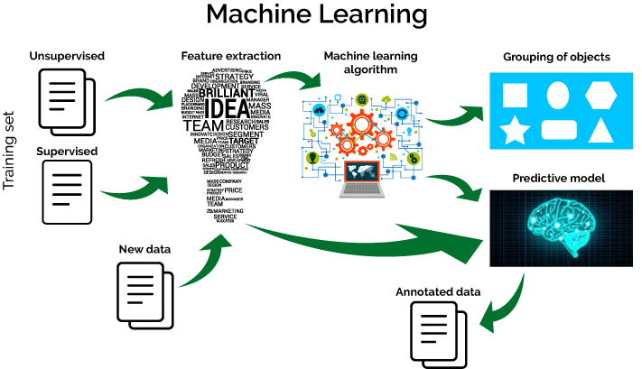
Fig. 1 machine learning flow

This provides a paradigm for choosing features that takes into account super features desire strategies. The framework employs machine learning algorithms that are appropriate for any dataset. The goal of this framework is to gather the fewest possible functions that have the quality (i.e., being extremely close to the truth or true number) that comes after high performance. It has been finished in a case study for network invasion detection that uses filter out and wrapper methods with six single (typical and expected) raters and device learning classifiers primarily based on the USA-nb15 dataset. The following is the ready state of this paper's relaxing. Phase II introduces the history exam/evaluation and related artwork. The suggested (success plans/ways of achieving goals) are provided in segment iii as a (solid fundamental structure on which greater things might be constructed). The experiment's findings are provided in Section IV. The paper is concluded/decided in phase v, along with concepts for further artwork.
In order to examine the overall performance and (quality of being very close to the truth or true number) within the cloud protection, system learning strategies are carried out in ids in [7], and 4 device learning (success plans/ways of reaching goals) are carried out, in my opinion, on the usa.-nb15 and isot datasets. These methods include the manual vector system (svm), the selection tree (j48), the childish (because to a lack of understanding) bayes (nb), and the logistic moving backward (lr). The strength and health of the clear/separate classifiers are evaluated using unique datasets. The virtualization of network features and the chaining of carrier functions give the impression that a significant circumstance or event is present in cloud environments. All types of attacks are incompatible with a single dataset. A properly studied supervised gadget version that performs well with one dataset might not (achieve or gain with effort) provide an enjoyable regular (usual/common and regular/healthy) performance with another (excellent/very odd).

LITERATURE SURVEY
Machine Learning is a difficult and quick computing approach that uses real-world examples of statistics or experience to improve fundamental performance, provide precise future forecasts, and gain statistical insight from data. There are steps to expand attentively analysing machine programmers. These processes involve gathering data, organizing the data, carefully examining the data, teaching the set of recommendations, testing the set of guidelines, and eventually putting the set of guidelines to use. Choice trees and childish (because to a lack of knowledge) bayes [4] are examples of such gadgets learning new methods of accomplishing things. Machine Learning is a difficult and quick computing approach that uses real-world examples of statistics or experience to improve fundamental performance, provide precise future forecasts, and gain statistical insight from data. There are steps to expand attentively analyzing machine programmers. These processes involve gathering data, organizing the data, carefully examining the data, teaching the set of recommendations, testing the set of guidelines, and eventually putting the set of guidelines to use. Choice trees and childish (because to a lack of knowledge) bayes [4] are examples of such gadgets learning new methods of accomplishing things. Subsets of feasible/possible skills are categorized under "process of determining the worth, quantity, or quality of something" and "useful thing/valuable supply of using an are looking (for) device." Every time a powerful classifier that might be perceived as a drawback or disadvantage is applied, this procedure should be repeated several times. Finding the top-rated subset (in which/during/in what way/in what) the space of skills subsets expands (more and more as time goes on) may be done for this purpose (for doing anything) using an experience-based thinking approach [5]. Clear out methods of operation employ a model (connected to studying numbers) to compile and rate the skills in accordance with the inherent characteristics of the data. The very best to the lowest ranking talents are taken care of. As they will be fair to the classifier and flexible enough to be made bigger or smaller using high dimensional information, such methods have the benefit of being rapid. However, they fail to consider how talents relate to one another and how they interact with the classifier.
The smooth out must be carried out as quickly as possible on the dataset (in which/during which/during which/in what way/in what) precise classifiers may be (figured out the worth, volume, or quality of). It may be determined to reduce the number of skills that must have the lowest rankings by adding a (dividing line/point where something begins or changes) aspect [5]. For desired functions, there are specific score evaluators. As mentioned in [6], some of the assessors include statistical benefit (ig), benefit ratio (gr), and (having a left half that is an exact mirror copy of the right half) The discussion in phase A of some of the references that were used to carry out device reading sets of computer instructions includes the terms doubt (su), fix (for a sickness), f (rf), one r (or), and chi squared (cs). Wonderful (those who work to get information) in segment b, done some skills want (success plans/ways of accomplishing objectives) before utilising tool learning. Xu lai and Ling chen (2011) [1] contrasted to the experimental findings obtained using the useful resource/valuable supply of the usage of the nerve-related/brain-related community (ann) and autoregressive protected moving average (arima) in predicting the hourly wind speed. Ann version generates a superior stop result as compared to arima version on (process of determining the worth, quantity, or quality of anything).
Using good enough-method clustering at the crime dataset, Jyoti clear jellywal, Renuka nagpal, et al. (2013) [2] have finished their study of crimes. Using a quick miner device, this version is sophisticated. Plotting the data across time allows for a comprehensive examination of the outcomes that were combined. As a conclusion/decision from the test/evaluation, the version states that the wide variety of murders decreased from 1990 to 2011.
Shiju Sathyadevan, Devan M. S., et al. (2014) [3] (described a potential future occurrence) the places that have too much/too many potential for crime (number of times something happens) and observed (in your view) crime ability to be harmful or influencing areas. The authors analysed the data using the childish (due to a lack of understanding) bayes classifiers set of rules, which is a supervised learning approach and a (related to learning numbers) method for the classroom and has provided 90% (quality of being very close to the truth or true number).
Lawrence Mcclendon and Natarajan Meghanathan (2015) [4] used multiple sets of computer instructions at the corporations and crime dataset, along with linear moving backward, (serving to add something) moving backward, and preference stump sets of computer instructions. They also used the same set of enter (abilities) for each set of instructions. In compared to the three sets of computer instructions that were chosen, the linear going rearward set consistently produced pleasing results. The main benefit of linear moving backward set of rules is that it can deal with randomness in test data to a positive extent (without getting/causing too many errors in statements about potential future events).
A methodology for crime prediction using clustering algorithms was put out by Rasoul Kiani, Siamak Mahdavi, et al. (2015) [5]. The rapidminer gadget is used for this. In order to find outliers in the statistics, ga (genetic set of rules) is utilised, which can improve prediction performance. The correctness of this version is 91.64 percent.
The Ryan Heart Project, George Loukas et al. (2016) [6] forecasts the number of crimes attributable to semantic social engineering attacks and considers the viability of foreseeing a person's sensitivity to deception-based attacks. The writers anticipated using both a random woodland prediction version and logistic regression, with accuracy charges of.68 and.71, respectively.
S. Sivaranjani, S. Sivakumari, et al. (2016) [7] employed a variety of clustering techniques to group criminal sports activities in Tamil Nadu, including agglomerative clustering, density-based spatial clustering with noise (dbscan), and okay-technique clustering. Precision, consideration, and f-degree are three criteria that are used to assess each clustering algorithm's overall performance, and the results are compared. In compared to the other algorithm-based options, the dbscan algorithm produced the best results based only on the aforementioned criteria.
Rakhi Gupta, Chirag Kansara, and colleagues created a model in 2016 [8] that analyses Twitter users' emotions and predicts whether or not they might constitute a threat to a particular person or society. The naive Bayes classifier, which categorises people using sentiment analysis, is used to run this model.

PROPOSED WORK AND RESULT
FOLLOWING ANN AND NAÏVE BAYES ALGORITHM USED IN PREDICTION MODEL: I.ANN
The five phases in the Keras neural network model life-cycle that we'll be looking at are summarized here.
1. Define Network.
2. Compile Network.
3. Fit Network.
4. Evaluate Network.
5. Make Predictions.

Step1. Define community:
The first step is to specify your neural network. In Keras, a network of layers is how a neural network is described. Sequential beauty serves as the holding structure for those levels.

Step2. Acquire community:
After defining our network, we must next purchase it. Compilation is a stage in the total performance. Depending on how Keras is configured, it converts the smooth sequence of layers we mentioned into a very green collection of matrix transforms in a configuration intended to be finished in your gpu or cpu.
As a precompute step for your community, think about compilation. Once a version has been defined, compilation is always necessary again. This involves every-thing from training the model using an optimization approach to quickly loading pre-informed weights from a store report. The compilation stage creates a green example of the network, which is also needed to do predictions on your hardware, and this is the motivation for it.
Compilation requires a few criteria to be sure, especially ones that are specifically tailored to educate your network. The loss function used to assess the network and the optimization set of rules used to teach it are both minimized by the optimization set of rules, which is a helpful resource.

Step3. Match community:
The network may be customized as soon as it is built, which entails changing the weights on a dataset related to schooling. The education facts, each of which is a matrix of input patterns x and an array of corresponding output patterns y, must be targeted in order to fit the community.
The community is kept up to date using the back propagation set of policies, and the model is optimized according to the optimization set of rules and loss feature that is exclusive to it. The network must have knowledge of the training dataset for a specific type of epochs or exposures in order to profit from the back propagation set of recommendations.
Each epoch may be partitioned into organizations of input-output pattern pairs known as batches. This outline the quantity of patterns that the network is uncovered to before the weights are updated interior an epoch. It is also an performance optimization, making sure that no longer too many enter styles are loaded into reminiscence at a time.

Step4. Evaluate network:
The network may be examined as soon as it is trained. The community may be judged based on its educational history, but because it has already known all of these details, this evaluation is no longer effective for predicting how the network would perform on average.
On a different dataset that hasn't been viewed during location out, we may examine the community's performance overall. This can give an idea of the network's normal overall performance when forecasting records that haven't yet been seen in the future.

In addition to a few other variables unique at the time the model was built, such type correctness, the model assesses the loss across all check styles. Here is another set of assessment criteria.

Step5. Make predictions:
Once we're satisfied with our match version's overall performance, we'll be able to use it to forecast the outcome of fresh data.
This is just as tidy as using the expect() function on the model with a variety of recent entry styles.Anaconda IDE and Python 3 were utilized. For using the aforementioned algorithms, five. Currently used in computer programming, Python is a beautiful language. Although it receives some credit for fortran, one of the most widely used programming languages, it is far more important than fortran. Python allows you to utilise components without revealing them (i.e., it changes kinds without a doubt), and it is based on space as a command structure. You are not required to teach in Python (instead of Java), but it is illegal not to do everything alone at the same time as necessary.

IV.RANDOM FOREST
An algorithm used for both classification and regression, random forest is a supervised learning algorithm. However, categorization issues are its primary usage. A forest is made up of trees, and a forest with more trees is a forest with more stability. In a similar manner, the random forest method builds decision trees on data samples, obtains predictions from each one, and then votes to determine which is the best answer. It is an ensemble approach, which eliminates over-fitting by averaging the results, making it superior than a single decision tree.
With the aid of the following, we can comprehend how the Random Forest algorithm functions:
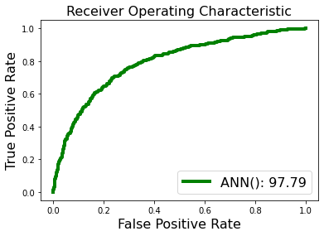

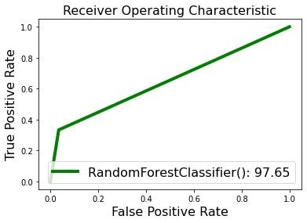

Step 1: Starting with a random sample selection from a specified dataset is the first step.
Step 2: This algorithm will create a decision tree for each sample after that. After that, it will receive the forecast outcome from each decision tree.
Step 3: Voting will be done for each expected outcome in step three.
Step 4: Finally, choose the ultimate forecast outcome that received the most votes.

DECISION TREE
In a decision tree, the algorithm begins at the root node and uses that information to forecast the class of the dataset that is provided. This method follows the branch and jumps to the following node based on a comparison of the values of the record (real dataset) attribute and the root attribute. The process continues by comparing the attribute value for the following node with those of the other sub-nodes once again. The method is carried out until the tree's leaf node is reached. The method below can help you understand the entire process:

Step 1: The root node of the tree, which holds the whole dataset, should be the first node to be drawn, advises S.
Step 2: Utilising Attribute Selection Measure (ASM), go on to step two to identify the dataset's top attribute.
Step 3: Subsets of the S that include potential values for the greatest qualities should be created.
Step 4: Create the best attribute-containing decision tree node.
Step 5: Using the subsets of the dataset generated in step -, repeatedly build new decision trees.

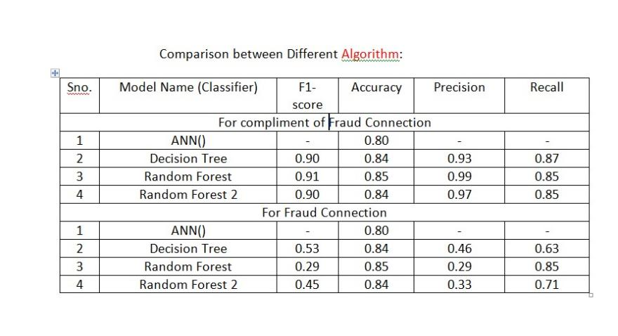

RESULT
311 wrong predictions and 1689 correct predictions out of 2000 records are shown in the (B)Confusion Matrix for ANN Deep Learning algorithm.
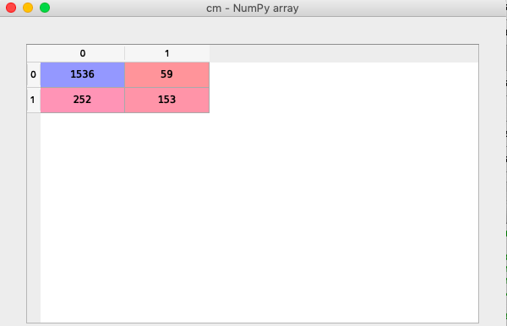
- COMPARISON GRAPH:

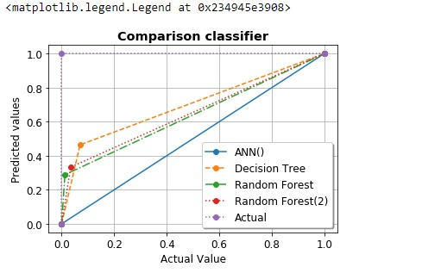
- COMPARISON TABLE

VI.CONCLUSION
In our effort, we sought to identify a strategy for creating a banking score version to determine a person's creditworthiness.
This piece of art provides a foundation for features that call for the application of filter out and wrapper approaches. As classifiers for the combined dataset, Ann, Random Forest, and Decision Tree techniques are employed. The experimental findings indicate that the best strategy involves using 18 features from the gr ranking method and using ann as a classifier, which achieves an accuracy of 86% and a speedup difficulty of. The framework under the unique capabilities wish approaches may be expanded using svm and random forest as a future painting. Additionally, to increase the accuracy of IDs, a majority vote system among all classifiers may be utilised. Because of this, a parallel model may be created in which the problem is parallel in nature. On top-notch datasets in particular, the same methodology is now being used.
REFERENCES
[1] SANS Institute InfoSec Reading Room, “Understanding Intrusion Detection Systems”, Available: https://www.sans.org/reading- room/whitepapers/detection/understanding-intrusion-detection- systems-337, [Accessed: November 2020].
[2] Sailesh Kumar, "Survey of Current Network Intrusion Detection Techniques", Available: http://www.cse.wustl.edu/~jain/cse571- 07/ftp/ids/, [Accessed: November 2019].
[3] Jean Philippe Planquart, “Application of Neural Networks to Intrusion Detection”, SANS Institute InfoSec Reading Room.
[4] Ian H. Witten and Eibe Frank, “Data Mining: Practical Machine Learning Tools and Techniques”, Morgan Kaufmann Publishers, Publication Date: January 20, (2018) | ISBN-10: 0123748569 | ISBN- 13: 978-0123748560 | Edition: 3
[5] Binita Kumari andTripti Swarnkar, “Filter versus Wrapper Feature Subset Selection in Large Dimensionality Micro array: A Review”, International Journal of Computer Science and Information Technologies (IJCSIT), Vol. 2 (3) , 2019, pp.1048-1053
[6] Jasmina Novaković, Perica Strbac, Dusan Bulatović, “Toward optimal feature selection using Ranking methods and classification Algorithms”, Yugoslav Journal of Operations Research, Vol. 21, No. 1, pp.119-135, 2018.
[7] Deval Bhamare, Tara Salman, Mohammed Samaka, Aiman Erbad and Raj Jain, “Feasibility of Supervised Machine Learning for Cloud

