IMPACT OF CONSERVATION AGRICULTURE IN RURAL SECTORS
Ms. Madhusri Pramanik¹, Mr. Soham Bachaspati² , Dr. Bhabani Prasad Mondal³, Dr. Swarnali Duary⁴, Mr. Sagar Banik⁵, Dr. Sourav Roy⁶
Assistant Professor, Department of Agriculture, Brainware University, Barasat, Kolkata.
Email: map.ag@brainwareuniversity.ac.in
ABSTRACT
Conventional tillage (CT) agriculture is a traditional farming practice that involves mechanically turning over the soil to prepare it for planting crops. While it has been widely practiced for many years, it is increasingly recognized as negatively impacting the environment, economics, and soil health. Conservation Agriculture is an approach to farming that seeks to improve crop productivity and agricultural systems' sustainability by adhering to three core principles: minimal soil disturbance, retaining crop residues on the surface, and crop rotation. When combined with suitable approaches to crop and soil management, conservation agriculture systems have been recognized as sustainable, enduring strategies to tackle the depletion of natural resources and the deterioration of environmental conditions within the agricultural industry. CA typically improves soil health and overall crop sustainability though its impact on crop productivity depending on local factors and management practices. Conservation agriculture presents a novel method for attaining sustainable agricultural productivity and is a significant step towards transitioning to sustainable farming practices. Nevertheless, weed control, herbicide resistance, and weed shift pose significant challenges in residue-retained fields.
Despite these challenges, CA offers several advantages, including increased water infiltration, reduced soil loss and runoff, and decreased transport of nitrate and phosphorus into water bodies, which curtails water body eutrophication. Additionally, CA is seen as a component of climate-smart agriculture due to its reduced time to seed/plant the next crop, minimal soil disturbance, and decreased fossil fuel consumption, which can help mitigate climate change.
Conservation agriculture possesses the capability to capture soil carbon, stimulate soil biodiversity, decrease greenhouse gas emissions, and make a contribution to mitigating climate change. However, not all experiments show consistently positive outcomes, indicating the need for a multidisciplinary approach to understand and address the site-specific complexities of CA systems.
INTRODUCTION
By 2050, in order to fulfill the worldwide need for food, agricultural output should be increased by 70%, employing methods and approaches that are scientifically valid, ecologically sustainable, and socially acceptable (FAO, 2009). Regions facing challenges of insufficient food availability due to environmental degradation and limited strategies for managing extreme weather events will experience decreased productivity, resulting in heightened instability within agricultural communities and across various production systems, including crops, forestry, livestock, and fisheries. The majority of cultivated soils in India have a soil organic carbon (SOC) concentration below 5 g kg−1, whereas untouched virgin soils typically exhibit levels ranging from 15 to 20 g kg−1 (Bhattacharyya et al., 2000). This difference contributes to soil degradation, primarily caused by extensive soil tillage, the burning of crop residues, and the adoption of intensive monoculture farming practices over several decades. Over time, there has been a consistent decrease in the response ratio (measured in kg of grain per kg of nutrient) for food grain crops in irrigated regions of India. The Green Revolution enhanced the productivity of rice-wheat systems within the Indo-Gangetic Plains (IGP) of South Asia, leading these nations to achieve food grain self-sufficiency. Nevertheless, the intensified agricultural practices have resulted in the exhaustion of the natural resource foundation (Gupta & Seth, 2007; Benbi, 2018). Moreover, the constrained time window between rice harvesting and the subsequent wheat sowing, along with the mechanized rice harvesting process, presents a significant hurdle for farmers in effectively managing the excess rice residues in a sustainable manner, particularly in the North-western Indo-Gangetic Plains (Lohan et al., 2018; Sarkar et al., 2018).
The rice-wheat (RW) cropping system holds significant importance for the livelihoods of a substantial population in South Asia, covering an area of 13.5 million hectares (Ladha et al., 2003). Nonetheless, the viability of these RW production systems has become a notable issue within the area, linked to aspects such as the lowering of groundwater levels, unchanging or decreasing productivity, and diminished economic benefits (Kumar et al., 2018).
Extensive plowing, the elimination of crop residues, and reduced variety in crops have played a crucial role in driving the transition from conventional farming to Conservation Agriculture (Sangar & Abrol, 2005).
Management practices in agricultural lands significantly contribute to global changes by affecting carbon (C) and nitrogen (N) cycles, as well as emissions of greenhouse gases. This factor notably influences the characteristics of agricultural soils (Smith et al., 2016).
Conservation agriculture (CA) is a method of ecological farming aimed at achieving sustainable and economically feasible improvements in agricultural systems. It does so by implementing three interconnected principles derived from locally developed methods: Limited soil disruption, continuous soil coverage, and diverse crop rotations (Dang, 2019).
Conservation Agriculture (CA) can modify soil quality attributes concerning physical, chemical, and biological characteristics, distinguishing it from conventional tillage (CT) methods (Basavanneppa et al., 2017; Yadav et al., 2017). Enhanced bio-physico-chemical soil quality subsequently impacts the services provided by ecosystems and the sustainability of crop production systems. This is achieved by offsetting the effects of climate variability through the creation of greater carbon sequestration reservoirs within the soil (Yadav et al., 2017). Conservation agriculture serves as an efficient approach that promotes an agricultural production system characterized by heightened soil microbial activity.
Conservation agriculture can also influence the functional variety of soil microorganisms, which play a vital role in enhancing soil quality, crop yield, and numerous ecosystem services (Yadav et al., 2017). In comparison to conventional tillage, conservation tillage methods typically lead to enhancements in soil organic matter levels, the capacity of soil to hold available water for plants, soil structure formation, and the ability of soil to transmit water. Additionally, these practices also improve the infiltration properties and the rate of saturated hydraulic conductivity in the soil (Bhattacharyya et al., 2008). The water retention capacity of conventionally tilled soil surpasses that of the conventional tillage approach, and the level of soil moisture is influenced by both the tillage method and the depth from which the soil sample is extracted. Furthermore, conservation tillage results in soil compaction, which has an impact on crop yield. The soil's gravimetric water content at various depths is greater in conservation tillage compared to conventional tillage (Kosutic et al., 2000).
The adoption of Conservation Agriculture (CA) has seen notable growth in Asia, accounting for approximately 13.9 million hectares (7.7%) or roughly 4.1% of the region's total cropland. Presently, Conservation Agriculture (CA) is being employed on approximately 180 million hectares of cultivable land worldwide, constituting around 12.6% of total cropland, and this practice is being adopted in over 50 countries. Conservation Agriculture (CA) systems are highly versatile and can be effectively applied in various ecological contexts (Jat et al., 2014a). In India, CA is practiced on an area covering 1.5 million hectares. Tillage methods and the retention of crop residues have the potential to impact the soil microclimate, the breakdown and distribution of crop residue, and the processes of nutrient mineralization and immobilization (Cheng et al., 2017). Such alterations can in turn bring about changes in soil microbial biomass (SMB) and the structure of the microbial community (Johnson & Hoyt, 1999). Hence, the practices employed in managing cropland can significantly influence microbial activity, the speed at which organic matter is broken down, and consequently, the cycling of soil carbon (C) and nitrogen (N).
Concept of Conservation Agriculture
Conservation agriculture rests upon three fundamental principles: maintaining continuous soil cover, minimizing soil disturbance, and implementing crop rotation.
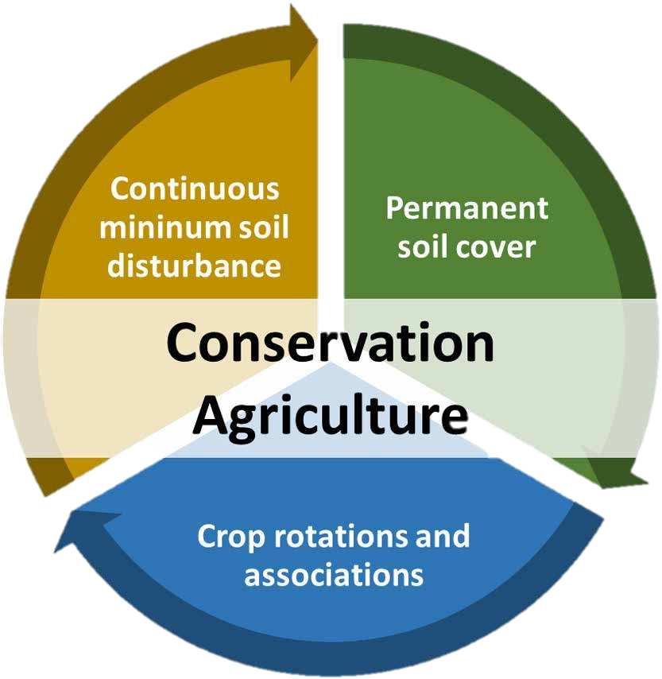
Fig 1. Principles of Conservation Agriculture
- Permanent or semi-permanent organic soil cover
Conservation agriculture entails the upkeep of an enduring or semi-permanent organic soil covering. This covering can involve actively growing crops or decomposing mulch. Its dual role involves providing a physical shield against elements like sunlight, rain, and wind, and also nurturing the soil's living organisms. The influence of surface residues on water preservation illustrates how the relationship among surface residues, enhanced water penetration, and evaporation prompted the adoption of CT following the Dust Bowl crisis of the 1930s. Subsequent research has undeniably demonstrated the importance of surface residues in conserving soil moisture and reducing both wind and water erosion.
The impact of crop residues and management techniques on soil quality, soil nitrogen dynamics and recovery, and crop output were reviewed by Kumar and Goh (2000). According to the review, agricultural residues from cultivated crops have a major impact on crop productivity due to their effects on the physical, chemical, and biological activities of the soil as well as the quality of the water and soil. Agricultural scientists work to maximize the favourable benefits, which can be both good and bad. A cover crop, along with the resulting mulch or remains of the previous crop, aids in minimizing the growth of weeds by creating a competitive environment. This prevents weed seeds from receiving the necessary light for sprouting. Additionally, there are observations that suggest cereal plant residues have allelopathic characteristics, meaning they can hinder the germination of weed seeds on the soil surface. This has been documented in studies by Jung et al. (2004) and Hobbs et al. (2008). When used in conjunction with no-till (NT) farming, cover crops exhibit a more significant influence on the accumulation of organic matter in the upper soil layer. This phenomenon has been documented in research by Roldan et al. (2003), Alvear et al. (2005), Diekow et al. (2005), Madari et al. (2005), and Riley et al. (2005). Mulch also contributes to the nutrient recycling process by interacting with underground biological agents and serving as a food source for microbial communities. This role is particularly beneficial when employing legume cover crops. Cover crops promote biological soil cultivation as their roots penetrate into the ground, and the upper layer of mulch provides nourishment, nutrients, and energy to subterranean worms, arthropods, and microorganisms, which also participate in soil cultivation through biological means. In zero-tillage approaches, compaction mitigation can be achieved by employing biological agents such as earthworms and cover crops with deep roots. While extensive research investigates the impact of agricultural residues on soil properties when they're burned, mixed in, or taken away, there is notably less available data concerning the effects of surface-retained mulch.
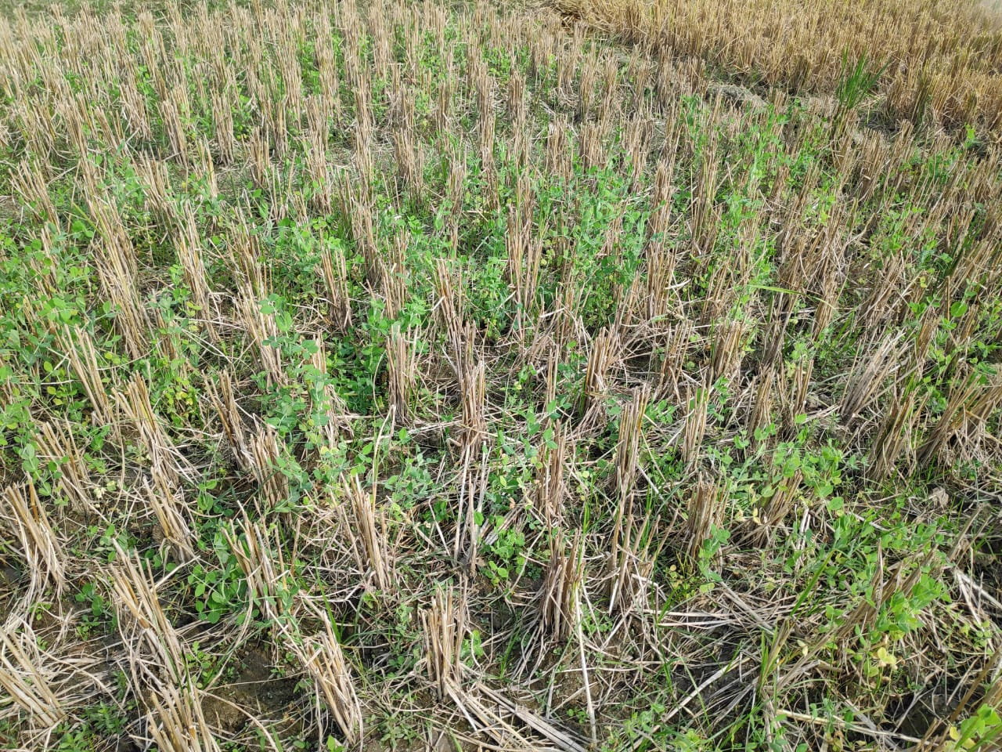
Fig. 2 Permanent organic soil cover (Rice residue mulching)
- Continuous Minimum soil disturbance
The core principle of CA is minimising soil disturbance, which seeks to enhance soil physical and chemical qualities, minimise compaction, water loss, and erosion, and establish adequate crop stands. This can be accomplished via stubble mulching, minimal tillage, and zero tillage practices. No-tillage and direct seeding are considered to cause the least amount of soil disturbance. The disturbed area must not be wider than 15 cm or 25% of the cropped area, whichever is smaller. Tillage consumes time that may be spent on other productive farming tasks or employment. The utilization of tractors for ploughing consumes significant amounts of fossil fuels, resulting in increased costs. Additionally, this practice contributes to the emission of greenhouse gases, primarily carbon dioxide (CO2), thereby contributing to global warming. Tillage systems reliant on animals incur notable expenses due to the year-long responsibility of caring for and feeding a pair of animals. Moreover, animals emit methane, a potent greenhouse gas that has 21 times the global warming impact of carbon dioxide (according to Grace et al., 2003). With zero-tillage, a crop can be established more quickly. The duration required for ploughing could potentially lead to delays in crop planting, resulting in reduced potential yields (Hobbs & Gupta 2003). Zero tillage practices enable timely crop planting by reducing turnaround time, subsequently increasing yields without elevating input expenses. Research has shown that adopting zero tillage and maintaining consistent soil cover lead to the buildup of organic carbon in the uppermost soil layers (Lal 2005). No-tillage is a potential tactic to preserve or even boost soil C and N stocks since it minimizes SOM losses (Bayer et al., 2000). Even though tillage can help to relieve some of the pressure caused by compaction, it also contributes significantly to it, especially when a tractor is used repeatedly to prepare the seedbed or keep a clear fallow. With zero-tillage, compaction is greatly reduced by a significant reduction in the number of passes over the ground. 'Controlling in-field traffic' is now included as a CA component on the FAO CA website. Field traffic is controlled by following fixed tracks. In addition to planting in permanent beds, this can also be done utilizing ridge-till techniques (Sayre & Hobbs, 2004). Utilizing permanent residue cover in zero-till systems, even under higher bulk density conditions, led to increased water infiltration compared to conventional tillage methods (Shaver et al., 2002; Sayre & Hobbs, 2004). Researchers postulated that the persistent adoption of reduced, shallow, and zero-tillage methods might necessitate transitioning to short-term conventional tillage to address soil-related issues. Nevertheless, Logsdon and Karlen (2004) demonstrated that bulk density (BD) is not a reliable indicator and affirmed that farmers do not need to be concerned about heightened compaction when transitioning from conventional tillage (TT) to no-till (NT) practices on deep loess soils in the United States. Leake (2003) discusses the impact of tillage on soil diseases and provides instances of the numerous diseases that are impacted. In his conclusion, he acknowledged that healthy soil with a high microbial diversity plays a role by acting as an antagonist to soil pathogens and concluded that the effect of tillage on diseases is uncertain. Additionally, he recommended that NT farmers modify their disease management by changes in sowing date, rotation, and cultivars with resistance to assist in shifting the benefit of the illness to the crop.
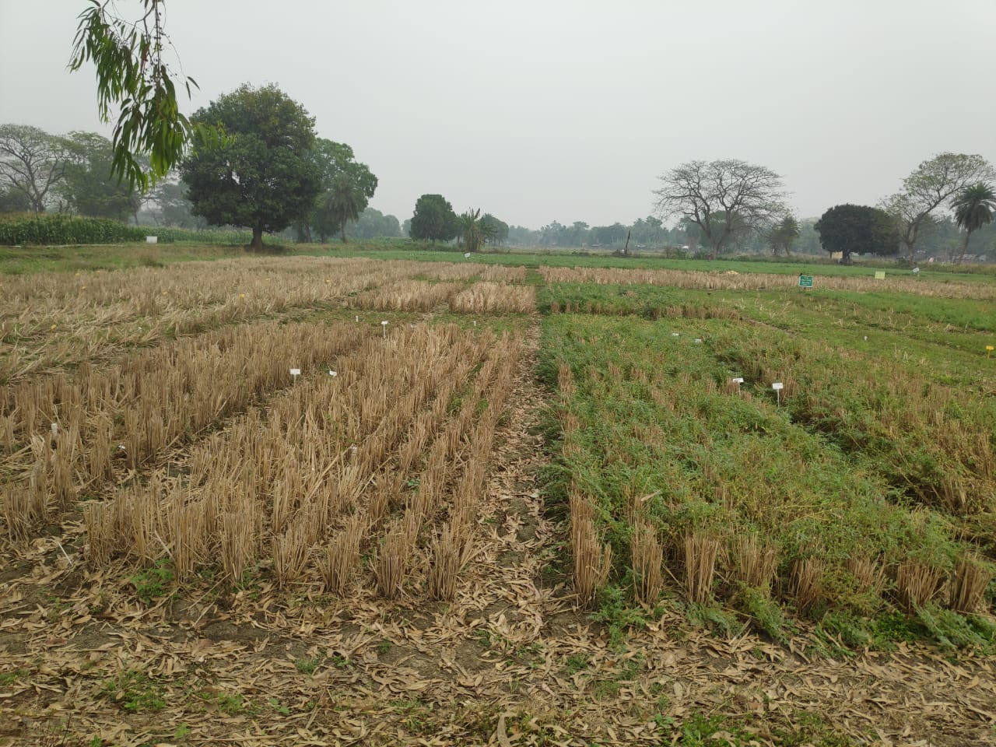
Fig. 3 Minimum soil disturbance (Zero tillage)
- Crop Rotations and Associations
Crop rotation is an age-old agricultural practice involving the sequential cultivation of multiple crops on the same piece of land in a recurring pattern. Crop rotation brings about various economic and ecological benefits as well. This practice aids in both sustainable soil and farm management by disturbing insect life cycles and enhancing soil fertility through the introduction of supplementary nutrients. Crop rotations enhance soil fertility, safeguard the ecosystem, control weeds, diseases, and pests, while also expanding the range of crops and markets available (Baldwin, 2006). Particularly in dry and semi-dry climate zones where agricultural cropping is extensive, the utilization of crop rotation alongside a no-till approach can significantly enhance soil structure and promote water preservation (Lal, 2015). As stated by Calegari et al., (2010), over a period of 19 years, the combination of winter cover crop root systems and the consistent avoidance of soil disruption under no-till practices resulted in greater soil aggregation (>2.00 mm) compared to both fallow periods and conventional tillage methods.
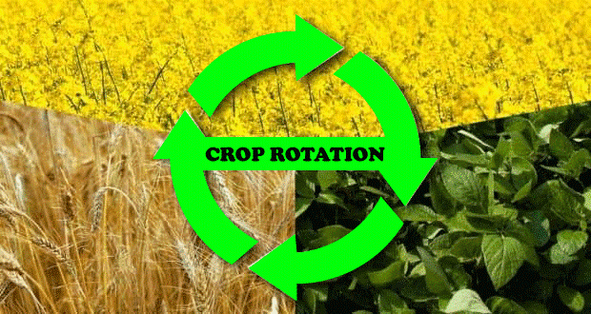
Adoption of CA: Contributing Factors
In the context of the rice-wheat (RW) system, conventional-till (CT) agriculture presents challenges such as reduced efficiency of input utilization, decreased farm income due to increased labor and fuel expenses, diminishing groundwater levels, and the impact of shifting climatic conditions. These issues are likely to be amplified by the anticipated risks associated with the deterioration of natural resources and the impacts of climate change (Kakraliya et al., 2018). The primary factors driving the adoption of Conservation Agriculture (CA) include:
- Changing climate
Climate change has significantly impacted agriculture and other production systems in the Indian subcontinent due to fluctuations in weather, temperature changes, and precipitation patterns, leading to alterations in crop seasons. These outcomes ultimately influence various facets of crop cultivation, the agricultural ecosystem, the cycling of nutrients, and, in the end, food security (Sharma et al., 2015). As per the fourth assessment report by the Intergovernmental Panel on Climate Change (IPCC, 2007), if greenhouse gas emissions persist at or above present levels, it is anticipa the global climate system is anticipated toficant alterations throughout the twenty-first century. These changes include a rise in temperature of roughly 0.2°C per decade. The increase in temperature impacts the survival and population dynamics of pests and accelerates the process of nutrient mineralization and the efficiency of fertilizer use. Two crop models (WTGROWS and INFOCROP) have forecasted a reduction in rice productivity by 0.75 tons per hectare with an increase of 2 degrees Celsius in average air temperature. According to a simulation study, it was observed that a temperature rises of 1°C resulted in a decline of 3–9% in grain yield (Zhao et al., 2017) and a 10% elevation in the demand for irrigation water for rice and wheat (Sivakumar & Stefanski, 2011). Management systems based on Conservation Agriculture (CA) can enhance resilience and address the adverse impacts of climate change by implementing adaptive strategies (Sharma et al., 2015).
- Degradation of innate resources
The RW system's extensive tillage-based farming in western IGP has resulted in issues like - deterioration of natural or innate resources (soil, biodiversity and water). Groundwater was overused by 50 per cent in Haryana and 75 per cent in Punjab, due to the excessive groundwater pumping used to irrigate these crops (Humphreys et al., 2010). Due to the repetitive RW system, the groundwater table in this area fell by roughly 0.50 m per year between 1993 and 2003. Continuous RW cultivation promotes nutrient imbalance, excessive soil nutrient mining, and organic matter loss. Furthermore, it influences the variety of plant and animal life in the area, a vital factor for maintaining ecosystem stability. (Choudhary et al., 2018b).
- Insufficient diversity in crop
Commencing with the nutrient imbalance and ending with a high danger of disease and pest infestation, the monoculture has many drawbacks To maintain fertility of soil, productivity of crop, and income of the farmers, The region should transition from cultivating rice to growing more profitable crops (Jat et al., 2018c). Maize can substitute rice due to its higher productivity and profitability, while also requiring 90 per cent lesser irrigation water. (Kumar et al., 2018). As rice necessitates significant water usage, leading to pumping from the freshwater aquifer in the western IGP, the groundwater's salinity has risen with increasing depth. Rotating crops of grains and pulses helped to preserve the soil's quality as well preserve the soil's quality, microbiology and fauna (Choudhary et al., 2018b).
- Abiotic and biological stress
The Green Revolution enhanced the production of cereal crops and altered the agricultural landscape in the IGP of India. Due to altered agricultural patterns and resource demands, biotic pressures, including weeds, insects, pests, and diseases, also got worse during the same period. A weed named Phalaris minor was simultaneously introduced into the wheat crop, and the weed flora changed as a result of enhanced fertilizer application, irrigation capabilities, and dwarf types of the rice and wheat crops. Farmers must find new and efficient pesticides every three years because the plant has grown to be highly resistant to the regularly used herbicides over time (Sharma et al., 2015).
- Ineffective crop residue management
In IGP, it is common practice to harvest rice and wheat with combine harvesters, leaving behind significant amounts (up to 9 t ha1) of plant left overs. For the majority part of the area, preparing the fields for in time wheat planting includes the step of incinerating leftover rice materials and then tilling the land. The combustion of agricultural remains leads to the depletion of essential plant nutrients (complete carbon, 80 per cent nitrogen, 25 per cent phosphorus, 50 per cent sulphur, and 20 per cent potassium), which has an adverse consequence on the biological and physicochemical qualities related to soil. Burning leftovers releases a substantial amount of GHGs and carbonaceous aerosols. For instance, according to estimates from Lohan et al. (2018), Burning agricultural remains leads to the yearly emission of 379 teragrams of carbon-dioxide, 23 teragrams of carbon monooxide, 0.68 teragrams of methane, 0.96 teragrams of Nitrous oxide, and 0.10 teragrams of sulphur dioxide. In the RW system, crop residues can be managed with CA-based management techniques employing a Turbo seeder (multi-crop planting device) and coupled (a device that combines harvesting, threshing, and cleaning into a single function) with a spreader. Agricultural remains constitute the primary origin of organic material and an indirect source of renewable energy because they enrich the soil content and Establishing optimal conditions to support the stability of agricultural ecosystems by cultivating a favourable microclimate. (Jat et al., 2019a; Jat et al., 2020a, 2020b). Carbon accounts for nearly 40 per cent of the entire dry biomass.
- Energy use and labour shortages
In the South Asian Indo-Gangetic Plain (IGP), agricultural sustainability is jeopardized by a trifecta of issues: declining natural resources, reduced farm profitability, and energy shortages. Within the critical phases of crop production—namely, sowing or transplanting and harvesting—a significant challenge faced by farmers of Indo-Gangetic Plain stems from labour shortages. This scarcity is primarily attributed to a decreased migration of agricultural workers from the eastern region of India. The energy and fuel demand for traditional plowing in rice cultivation is five times greater compared to the energy required for cultivating directly-seeded rice (DSR) and zero-tillage (ZT) maize (Gathala et al., 2013). Within conservation agriculture (CA) systems, the primary contributor to the overall energy input is crop residues, accounting for the largest portion (approximately 76 per cent). On the other hand, in cereal systems based on conventional tillage (CT), the application of fertilizers (an exhaustible energy source) constitutes around 43 per cent of the energy input (Jat et al., 2020a, 2020b). There is a significant need for a suitable rice seeding method, such as dry/wet direct-seeded rice (DSR) within a conservation agriculture framework. This requirement stems from the goals of minimizing the labour-intensive nature of rice planting, addressing shortages in labour, reducing usage of energy, and mitigating the negative impact of puddling on soil structure. This method is particularly crucial for implementation across a wider geographical area (Kamboj et al., 2012).
Technology and Procedures based on CA
The combination and incorporation of technologies rooted in conservation agriculture (CA), along with their interplay with available farm resources, serve as promising approaches to establish a robust system aimed at attaining sustainability in crop cultivation systems. The following are the scalable and inventive technologies based on conservation agriculture (CA) that significantly influence the preservation of resources (such as crop residue, nutrient , energy and water) within the Rice-Wheat (RW) system of the Indo-Gangetic Plain (IGP): -
I Management of Residue
A vital element of sustainable farming practices is the permanent crop cover and recycling of agricultural leftovers. An issue arises when a crop is sown while existence of crop left overs from a previous crop. Nevertheless, different types of zero-till seed-cum-fertilizer drill/ planters was created, such as the rotary-disc drill, Turbo Seeder and Happy Seeder, enabling the direct sowing of seeds even when surface residues are present (both loose and firmly anchored, up to a maximum of 10 tons per hectare). These devices are highly helpful for suppressing weeds, maintaining soil temperature, and managing crop leftovers to preserve moisture and nutrients. In dryland ecosystems, the capacity to utilize crop residues within the context of conservation agriculture is constrained by lower biomass productivity and conflicting uses of crop wastes. In arid environments, where a single crop is grown each year in the ecosystem, the Central Research Institute for Dryland Agriculture (CRIDA) which is located in Hyderabad, has demonstrated that by placing crop residues over the soil surface, a second crop may be raised with leftover soil moisture. According to the Ministry of New and Renewable Energy (MNRE, 2009), nearly 500 Mt of crop leftovers are produced in a year. The highest amount of residues is produced by cereals (352 Metric Ton), followed by fibres (66 Metric Ton), oilseeds (29 Metric Ton), pulses (13 Metric Ton), and sugarcane (12 Metric Ton). The production of cereal crop residue is such in ascending order - West Bengal (33 Metric Ton), Punjab (44 Metric Ton) and Uttar Pradesh (53 Metric Ton). The RW system accounts for 84% of all agricultural residue burning in India, with alternative crop rotations accounting for the other 16% (Singh & Panigrahy, 2011). In Punjab, wheat and rice leftovers are burned in-situ on a yearly basis at a rate of 20 million tonnes (54% of the total), resulting in the loss of 8 MT of carbon, 105 tonnes of nitrogen, and S (Yadvinder Singh et al., 2015). Crop left over management techniques that are economical and farmer-friendly have a major influence on water conservation by decreasing both runoff and losses due to evaporation (Yadvinder Singh et al., 2010).
II Zero-till (ZT) Technology
In both large-scale and small-scale farming systems, zero tillage is a basis of CA. Zero till, also known as no-tillage and direct drilling, is a tillage process in which seeds and nutrients are sown directly into the stubble of the previous crop using low-disturbance seeding techniques. Reduced erosion, higher crop yields that bring much crop left over to the soil surface, fluctuations in the process of incorporating and breaking down organic matter in the soil - all contribute to a gradual increase in the organic material present in the uppermost layers of untilled soil. Because of less biological oxidation than conventionally tilled soils, an organic mulch gradually forms on the soil surface. Eventually, this organic mulch turns into stable soil organic matter. Zero tillage is effective at reducing many detrimental on-farm and off-site consequences of conventional tillage.
According to research conducted by Erenstein and Laxmi (2008), the adoption of zero tillage in the cropping system which is cereal based was found to advance planting time, hence expanding the window of winter for cool season crops and assist to prevent crops from experiencing terminal heat stress. If wheat is sown one month earlier than usual, ZT provides for quicker wheat germination and reduces the population of the pesky weed Phalaris minor by 68–80% (Sharma et al., 2015). According to the findings of a chain of tests conducted in IGP, conservational agriculture based management increases crop yield by 15% while lowering production costs by 30%, resulting in a 25% increase in farmers' income. Farmers' Participatory Trials (no. 40) showed the overall expenses associated with cultivating zero tillage associated wheat with and without residue retention was 23% less than the CT method, this was credited to a reduction in tillage expenses and water used for irrigation (Aryal et al., 2015b). Farmer adoption studies provide compelling proof that zero tillage (ZT) wheat leads to a minimum of 10 per cent reduction in irrigation water usage (equivalent to around 20-30 mm) compared to conventional tillage (CT) techniques. Additionally, yields are frequently slightly elevated by 5 per cent, resulting in increased net earnings and advantages for the farmers.
Table 1. The prospective advantages of the primary conservation agriculture (CA) techniques or practices in contrast to traditional methods. [Jat (2014)].
CA technologies | Advantages compared to customary/traditional methods.
Laser Land Levelling (LLL) | Diminish greenhouse gas emissions, expand cultivable land area, and enhance crop productivity.
Zero tillage (ZT) | Decreased water usage, carbon capture, comparable or greater yield and boosted earnings, diminished fuel usage, decreased greenhouse gas emissions, enhanced heat stress tolerance.
Direct seeding of rice (DSR) | Saving 20-30% of irrigation water, time efficiency, improved post-harvest field condition, increased depth of root growth, heightened resilience to water and heat stress, cutting down methane (CH4) release by 50-60%.
Alternate Wetting and Drying in rice (AWD) | Lowers CH4 discharge by an average of 45-50% when contrasted with continuous flooding, diminishes irrigation demand by 15-20%.
Crop Diversification | Optimal utilization of natural assets (water, soil, and energy), heightened earnings, elevated nutritional stability, preserved soil richness, decreased vulnerability.
Permanent Bed Planting (PB) | Reduced water consumption, enhanced drainage, improved residue handling, minimized crop lodging, and increased resilience to water scarcity.
SPAD and Leaf Colour Chart (LCC) | Decreases the need for nitrogen fertilizer, minimizes nitrogen loss and environmental contamination, and lowers emissions of N2O.
Nitrification inhibitors | Enhance nitrogen utilization efficiency, curtail nitrogen loss, and mitigate environmental pollution.
Green Seeker | Fine-tune the necessary nitrogen fertilizer, diminish nitrogen loss and environmental impact, and lower nitrate leaching.
Nutrient Expert-decision Support tool | Fine-tune nutrient requirements, curtail nutrient losses and environmental impact, and minimize greenhouse gas emissions.
Crop Residue Management / Mulching | Regulates soil temperature and moisture levels, enhances soil health, mitigates soil erosion, minimizes evaporation losses while preserving soil moisture, boosts carbon sequestration, prevents burning and lowers environmental impact, enhances heat stress resilience, and decreases weed proliferation.
Micro Irrigation System | Enhances efficiency in water and nutrient utilization, diminishes greenhouse gas emissions, and boosts both crop and water productivity.

III Crop rotations
In the earlier cropping pattern, prior to the Green Revolution era, the study region displayed significant diversity with crops such as wheat, rice, fodder, cotton, maize, pulses, pearl millet, oilseeds, sugarcane, and more. Crop diversification is a consequence of the interplay between physical and non-physical elements in the environment (Sohal, 2003). Within the RW domain, the concept of crop diversification is aimed at expanding production-related activities of various crops in a particular area, thus providing a broader spectrum of choices within the agricultural production system and also reducing risks. On average, introducing leguminous crops into cereal systems (RW/MW) resulted in a notable 18% increase in system productivity and a 15% rise in net returns (Choudhary et al., 2018a). According to Kumar et al. (2018), Conservation Agriculture (CA)-based rice-wheat-mungbean systems led to an 11% enhancement in system productivity and a 24% increase in profitability, while requiring 28% less irrigation water and 25% less energy compared to conventional RW systems or traditional farming practices (yielding 12.3 Mg ha−1; using 2650 mm ha−1 irrigation water; earning INR 85,800 ha−1; consuming 79.2 GJ ha−1 energy). This transition also led to a 23% reduction in the potential for global warming (1.5 Mg CO2eq yr−1). Jat et al. (2019d, 2020a, 2020b) also reported similar outcomes through the incorporation of mungbean into the RW/MW system.
IV Laser Land Leveling (LLL)
Due to rough soil surfaces, inadequacy in water availability, poor interaction between nutrients and water supply, and improper distribution of salt and soil moisture have a significant impact on emergence of seedling, establishment of crop, crop uniformity and geometry, and lastly crop yield. Aryal et al. (2015) found that uneven fields and poor farm design result in significant (20–25%) irrigation water loss during application at the farm. This picture is more prominent in fields of rice. Effective land levelling reduced irrigation time by 20–30%, improved establishment of crop, increased arable area (roughly by 3-5%), and saved water (20–30%) (Jat et al., 2009). After the land was levelled using a laser land leveller, a 10–30% enlarge in crop yield was noted (Aryal et al., 2015a).
V Permanent Bed Planting (PBP)
Bed planting typically reduces labour consumption and irrigation water use without reducing crop output (Gathala et al., 2011; Hobbs and Gupta, 2000; Ladha et al., 2009). The permanent bed planting method was created to increase output while lowering costs and conserving resources (Lichter et al., 2008). For better rainfall collection and conservation, permanent raised beds are able to maintain a permanent soil cover (Govaerts et al., 2005; Govaerts et al., 2007). Saving irrigation water and weeding are two benefits of permanent raised bed planting over traditional zero tillage (ZT with flat planting).
In the western Indo-Gangetic Plain (IGP), transitioning from traditional rice cultivation to less water-dependent crops like maize through Conservation Agriculture (CA) practices is necessary for fostering sustainable intensification (Jat et al., 2018c, 2019d). Maize, being sensitive to water availability, is cultivated on permanent beds (PBs). The adoption of permanent raised beds originally emerged as a solution to water management challenges, addressing issues related to excessive water impacting crop production or providing irrigation in semi-arid and arid regions (Bhushan et al., 2008; Connor et al., 2003; Gathala et al., 2011; Govaerts et al., 2005; Sayre & Hobbs, 2004). Permanent beds offer several benefits such as controlled machinery movement, reduced compaction in furrow bottoms, decreased seeding rates compared to conventional systems, and decreased risk of crop lodging (Sayre & Moreno-Ramos, 1997). This practice leads to water savings of over 30% compared to flat systems (Jat et al., 2015). Under the maize-wheat-mungbean system, implementing permanent beds resulted in system productivity, water use efficiency (WUE), and net returns increasing by 28.2–30.7%, 27.8–31.0%, and 36.8–40.5% respectively compared to conventional tillage (CT) (Jat et al., 2018c).
VI Micro Irrigation Systems
Micro-irrigation is an efficient irrigation method where narrow tubes deliver water directly to the plant's base, either through emitters (drip irrigation) or by dispersing water in various directions via water jets (sprinklers). This technique conserves valuable resources such as water and fertilizers. The advantages of micro-irrigation encompass: (1) cost reduction through water and energy savings; (2) enhanced efficiency in utilizing water and fertilizers; (3) suppression of weed growth and salinity issues; (4) innovative fertilizer application methods like fertigation. Drip and sprinkler systems can save up to about 60% (Sidhu et al., 2019) and 48% of irrigation water, respectively, when compared to flood-puddled transplanted rice cultivation. Subsurface drip irrigation (SDI) focuses on delivering water and nutrients directly to the plant's root zone, promoting optimal moisture and nutrient availability. Systems incorporating Conservation Agriculture (CA) with SDI displayed 3% and 11% higher average system productivity in rice-wheat (RW) and maize-wheat (MW) systems respectively, over a two-year period, when contrasted with their respective conventional tillage (CT) systems (Jat et al., 2018b, 2019d). In CA-based cereal systems with SDI, nitrogen fertilizer use was reduced by 20% and the efficiency of nitrogen utilization increased by 47% compared to CT-based systems using flood irrigation (Jat et al., 2019d).
VII Smart Seeding System (DSR-direct seeded rice)
Puddle transplanting is favored by the availability of ample water and low wages, while direct-seeded rice (DSR) is supported by high wages and limited water availability, as observed by Pandey & Velasco (2005). Within the Indian Indo-Gangetic Plain (IGP), growing scarcities of water, energy, and labor push farmers toward adopting Conservation Tillage (CT) and Zero Till Direct-Seeded Rice (ZTDSR) practices. In the IGP region, DSR has demonstrated comparable or even higher yields, along with increased profitability and water conservation (around 25%) compared to transplanted rice (Choudhary et al., 2018a; Kamboj et al., 2012; Kumar et al., 2018), with greater advantages seen in the case of scented or basmati rice (Jat et al., 2019c). DSR has proven to be a viable economical alternative to puddled transplanted rice (PTR), leading to production cost reductions of 11–17%, requiring 25–30% less irrigation water for similar yield levels (Kumar et al., 2018), and resulting in savings of INR 5000/- in terms of fuel and labor expenses (Gathala et al., 2013).
VIII Site-Specific Nutrient Management (SSNM)
Fertilizer recommendations within Indo-Gangetic Plains (IGPs) typically rely on generalized crop response data spanning extensive geographic regions, disregarding the inherent nutrient provision capabilities of the soils. This approach results in instances of under-fertilization in certain areas and over-fertilization in others, as highlighted by Jat et al. (2016). Such a scenario leads to poor nutrient use efficiency, diminished profits, and an upsurge in environmental challenges. Within cereal systems, strategies like the Leaf Colour Chart (LCC), GreenSeeker, and Decision Support Tool- Nutrient Expert® (NE) are employed for site-specific nutrient management (SSNM). However, the application of SSNM is limited due to its knowledge-intensive nature, constraining its implementation on a larger scale (Jat et al., 2016). Notably, the adoption of Conservation Agriculture (CA)-based management practices in the maize-wheat (MW) system led to considerable savings in nitrogen (N) and potassium (K) fertilizers, approximately 30% and 50% respectively, after four years of continuous cultivation (Jat et al., 2018a).
Conclusion:
As a holistic system approach, CA-based cropping conserves natural resources, produces more at a lower cost, improves soil health, promotes timely planting, reduces environmental pollution, and reduces climate change effects. CA also increases topsoil organic carbon storage compared to intensive agriculture. Carbon sequestration, greenhouse gas reduction, and water regulation can mitigate climate change. Not all studies show that CA improves ecosystem sustainability. Cropping systems, climate, soil type, and land management approaches can affect experiment duration. Thus, understanding soil–climate-management-dependent CA demands a multidisciplinary approach.
REFERENCES
Alvear, M., Rosas, A., Rouanet, J. L., & Borie, F. (2005). Effects of three soil tillage systems on some biological activities in an Ultisol from southern Chile. Soil and Tillage Research, 82(2), 195-202. (doi:10.1016/j.still.2004.06.002)
Baldwin, K. R. (2006). Crop rotations on organic farms. Center for environmental farming systems, 16.
Basavanneppa, M. A., Gaddi, A. K., Chittapur, B. M., Biradar, D. P. and Basavarajappa, R. (2017). Yield maximization through resource conservation technologies under maize-chickpea cropping system in vertisols of Tunga Bhadra Command Project Area of Karnataka. Res. Crops 18 : 225-31
Benbi, D. K. (2018). Carbon footprint and agricultural sustainability nexus in an intensively cultivated region of Indo-Gangetic Plains. Sci. Total Environ. 644, 611–623. doi: 10.1016/j.scitotenv.2018.07.018
Bhattacharyya, R., Kundu, S., Pandey, S. C., Singh, K. P., & Gupta, H. S. (2008). Tillage and irrigation effects on crop yields and soil properties under the rice–wheat system in the Indian Himalayas. Agricultural water management, 95(9), 993-1002.
Bhattacharyya, T., Pal, D. K., Mandal, C., & Velayutham, M. (2000). Organic carbon stock in Indian soils and their geographical distribution. Current Science, 79, 655–660. https://www.jstor. org/stable/24105084
Calegari, A., Rheinheimer, D. D. S., Tourdonnet, S. D., Tessier, D., Hargrove, W. L., Ralisch, R., ... & Tavares Filho, J. (2010, August). Effect of soil management and crop rotation on physical properties in a long term experiment in Southern Brazil. In Proceediings Proceedings of the 19th World Congress of Soil Science, Brisbane, Australia, 2010..
Cheng, Y., Wang, J., Wang, J., Chang, S.X., & Wang, S., (2017). The quality and quantity of exogenous organic carbon input control microbial NO3 − immobilization: a metaanalysis. Soil Biology and Biochemistry 115, 357–363. https://doi.org/10.1016/j. soilbio.2017.09.006
Choudhary, M., Datta, A., Jat, H. S., Yadav, A. K., Gathala, M. K., Sapkota, T. B., Das, A. K., Sharma, P. C., Jat, M. L., Singh, R., & Ladha, J. K. (2018b). Changes in soil biology under conservation agriculture based sustainable intensification of cereal systems in Indo-Gangetic plains. Geoderma, 313, 193–204. https://doi.org/10.1016/j.geoderma.2017.10.041
Dang, Y. (2019). Special Issue “Conservation Agriculture”. https://www.mdpi.com/ journal/ agriculture/special_issues/ conservation_agriculture.
Diekow, J., Mielniczuk, J., Knicker, H., Bayer, C., Dick, D. P., & Kögel-Knabner, I. (2005). Soil C and N stocks as affected by cropping systems and nitrogen fertilisation in a southern Brazil Acrisol managed under no-tillage for 17 years. Soil and Tillage Research, 81(1), 87-95. (doi:10.1016/j.still.2004.05.003)
FAO. (2009). How to feed the world in 2050. FAO CA website. http://www.fao.org/wsfs/forum2050
Gathala, M. K., Ladha, J. K., Saharawat, Y. S., Kumar, V., Kumar, V., & Sharma, P. K. (2011). Effect of tillage and crop establishment methods on physical properties of a medium‐textured soil under a seven‐year rice− wheat rotation. Soil Science Society of America Journal, 75(5), 1851-1862.
Govaerts, B., Sayre, K. D., & Deckers, J. (2005). Stable high yields with zero tillage and permanent bed planting?. Field crops research, 94(1), 33-42.
Govaerts, B., Sayre, K. D., Lichter, K., Dendooven, L., & Deckers, J. (2007). Influence of permanent raised bed planting and residue management on physical and chemical soil quality in rain fed maize/wheat systems. Plant and Soil, 291, 39-54.
Grace, P. R., Harrington, L., Jain, M. C., & Philip Robertson, G. (2003). Long‐Term Sustainability of the Tropical and Subtropical Rice–Wheat System: An Environmental Perspective. Improving the Productivity and Sustainability of Rice‐Wheat Systems: Issues and Impacts, 65, 27-43.
Gupta, R., and Seth, A. (2007). A review of resource conserving technologies for sustainable management of the rice–wheat cropping systems of the Indo-Gangetic plains (IGP). Crop Prot. 26, 436–447. doi: 10.1016/j.cropro.2006.04.030
Hobbs, P. R., & Gupta, R. K. (2000, February). Sustainable resource management in intensively cultivated irrigated rice–wheat cropping systems of the Indo-Gangetic Plains of South Asia: Strategies and options. In International Conference on Managing Natural Resources for Sustainable Production in 21st Century (pp. 14-18).
Hobbs, P. R., & Gupta, R. K. (2003). Resource‐Conserving Technologies for Wheat in the Rice–Wheat System. Improving the Productivity and Sustainability of Rice‐Wheat Systems: Issues and Impacts, 65, 149-171.
Hobbs, P. R., Sayre, K., & Gupta, R. (2008). The role of conservation agriculture in sustainable agriculture. Philosophical Transactions of the Royal Society B: Biological Sciences, 363(1491), 543-555.
Humphreys, E., Kukal, S. S., Christen, E. W., Hira, G. S., BalwinderSingh, Sudhir-Yadav, & Sharma, R. K. (2010). Halting the groundwater decline in North-west India – which crop technologies will be winners? Advances in Agronomy, 109, 155– 217. https://doi.org/10.1016/B978-0-12-385040-9.00005-0
IPCC. (2007). Summary for policymakers. In M. L. Parry, O. F. Canziani, J. P. Palutikof, P. J. van der Linden, & C. E. Hanson (Eds.), Climate change 2007: Impacts, adaptation and Vulnerability. Contribution of Working Group II to the Fourth Assessment Report of the Intergovernmental Panel on Climate Change (pp. 7–22). Cambridge University Press.
Jat, M. L., Singh, B., & Gerard, B. (2014a). Nutrient management and Use efficiency in wheat systems of South Asia. Advances in Agronomy, 125, 171–259. https://doi.org/10.1016/B978-0- 12-800137-0.00005-4
Jat, R. D., Jat, H. S., Nanwal, R. K., Yadav, A. K., Bana, A., Choudhary, K. M., Kakraliya, S. K., Sutaliya, J. M., Sapkota, T. B., & Jat, M. L. (2018c). Conservation agriculture and precision nutrient management practices in maize-wheat system: Effects on crop and water productivity and economic profitability. Field Crops Research, 222, 111–120. https://doi.org/10.1016/j.fcr. 2018.03.025
Jat, R. D., Jat, H. S., Nanwal, R. K., Yadav, A. K., Bana, A., Choudhary, K. M., Kakraliya, S. K., Sutaliya, J. M., Sapkota, T. B., & Jat, M. L. (2018c). Conservation agriculture and precision nutrient management practices in maize-wheat system: Effects on crop and water productivity and economic profitability. Field Crops Research, 222, 111–120. https://doi.org/10.1016/j.fcr. 2018.03.025
Johnson, A., Hoyt, G., 1999. Changes to the soil environment under conservation tillage. HortTechnology 9, 380–393.
Jung, W. S., Kim, K. H., Ahn, J. K., Hahn, S. J., & Chung, I. M. (2004). Allelopathic potential of rice (Oryza sativa L.) residues against Echinochloa crus-galli. Crop protection, 23(3), 211-218. (doi:10.1016/j.cropro.2003.08.019)
Kakraliya, S. K., Jat, H. S., Singh, I., Sapkota, T. B., Singh, L. K., Sutaliya, J. M., Sharma, P. C., Jat, R. D., Choudhary, M., Lopez-Ridaura, S., & Jat, M. L. (2018). Performance of portfolios of climate smart agriculture practices in a rice-wheat system of western IndoGangetic plains. Agricultural Water Management, 202, 122– 133. https://doi.org/10.1016/j.agwat.2018.02.020
Kosutic, S., Filipovic, D. and Gospodaric, Z. (2000). Comparison of different soil tillage system in maize and winter wheat production. In Proceedings of 99 International Conferences on Agricultural Engineering, China.
Kumar, K., & Goh, K. M. (1999). Crop residues and management practices: effects on soil quality, soil nitrogen dynamics, crop yield, and nitrogen recovery. Advances in agronomy, 68, 197-319.
Kumar, V., Jat, H. S., Sharma, P. C., Balwinder-Singh, Gathala, M. K., Malik, R. K., Kamboj, B. R., Yadav, A. K., Ladha, J. K., Anitha Raman, Sharma, D. K., & McDonald, A. (2018). Can productivity and profitability be enhanced in intensively managed cereal systems while reducing the environmental footprint of production? Assessing sustainable intensification options in the breadbasket of India. Agriculture, ecosystems and. Environment, 252, 132–147. https://doi.org/10.1016/j.agee. 2017.10.006
Kumar, V., Jat, H. S., Sharma, P. C., Balwinder-Singh, Gathala, M. K., Malik, R. K., Kamboj, B. R., Yadav, A. K., Ladha, J. K., Anitha Raman, Sharma, D. K., & McDonald, A. (2018). Can productivity and profitability be enhanced in intensively managed cereal systems while reducing the environmental footprint of production? Assessing sustainable intensification options in the breadbasket of India. Agriculture, ecosystems and. Environment, 252, 132–147. https://doi.org/10.1016/j.agee. 2017.10.006
Ladha, J. K., Dawe, D., Pathak, H., Padre, A. T., Yadav, R. L., Singh, B., & Hobbs, P. R. (2003). How extensive are yield declines in long-term rice-wheat experiments in Asia? Field Crops Research, 81(2-3), 159–180. https://doi.org/10.1016/S0378- 4290(02)00219-8
Ladha, J. K., Kumar, V., Alam, M. M., Sharma, S., Gathala, M., Chandna, P., ... & Balasubramanian, V. (2009). Integrating crop and resource management technologies for enhanced productivity, profitability, and sustainability of the rice-wheat system in South Asia. Integrated crop and resource management in the rice–wheat system of South Asia, 69-108.
Lal, R. (2006). Enhancing crop yields in the developing countries through restoration of the soil organic carbon pool in agricultural lands. Land degradation & development, 17(2), 197-209. (doi:10.1002/ldr.696)
Lal, R. (2015). A system approach to conservation agriculture. Journal of Soil and Water Conservation, 70(4), 82A-88A.
Lal, R. (2006). Enhancing crop yields in the developing countries through restoration of the soil organic carbon pool in agricultural lands. Land degradation & development, 17(2), 197-209.
Leake, A. R. (2003) Integrated pest management for conservation agriculture. In Conservation agriculture: environment, farmers experiences, innovations, socio-economy, policy (eds L. Garcia-Torres, J. Benites, A. Martinez-Vilela & A. Holgado-Cabrera), pp. 271–279. Dordrecht, The Netherlands; Boston, Germany; London, UK: Kluwer Academia Publishers.
Lichter, K., Govaerts, B., Six, J., Sayre, K. D., Deckers, J., & Dendooven, L. (2008). Aggregation and C and N contents of soil organic matter fractions in a permanent raised-bed planting system in the Highlands of Central Mexico. Plant and Soil, 305, 237-252.
Logsdon, S. D., & Karlen, D. L. (2004). Bulk density as a soil quality indicator during conversion to no-tillage. Soil and Tillage Research, 78(2), 143-149.
Lohan, S. K., Jat, H. S., Yadav, A. K., Sidhu, H. S., Jat, M. L., Choudhary, M., ... & Sharma, P. C. (2018). Burning issues of paddy residue management in north-west states of India. Renewable and Sustainable Energy Reviews, 81, 693-706. doi: 10.1016/j.rser.2017.08.057
Madari, B., Machado, P. L., Torres, E., de Andrade, A. G., & Valencia, L. I. (2005). No tillage and crop rotation effects on soil aggregation and organic carbon in a Rhodic Ferralsol from southern Brazil. Soil and Tillage Research, 80(1-2), 185-200. (doi:10.1016/j.still.2004.03.006)
Riley, H. C. F., Bleken, M. A., Abrahamsen, S., Bergjord, A. K., & Bakken, A. K. (2005). Effects of alternative tillage systems on soil quality and yield of spring cereals on silty clay loam and sandy loam soils in the cool, wet climate of central Norway. Soil and Tillage Research, 80(1-2), 79-93. (doi:10.1016/ j.still.2004.03.005)
Roldan, A., Caravaca, F., Hernández, M. T., Garcıa, C., Sánchez-Brito, C., Velasquez, M., & Tiscareno, M. (2003). No-tillage, crop residue additions, and legume cover cropping effects on soil quality characteristics under maize in Patzcuaro watershed (Mexico). Soil and Tillage Research, 72(1), 65-73. (doi:10.1016/S0167-1987(03)00051-5)
Sangar, S., & Abrol, I. P. (2005). Conservation agriculture for transition to sustainable agriculture. Current Science, 88, 686–687
Sarkar, S., Singh, R. P., and Chauhan, A. (2018). Crop residue burning in northern India: increasing threat to greater India. J. Geophys. Res. Atmos. 123, 6920–6934. doi: 10.1029/2018JD028428
Sayre, K. D., & Hobbs, P. R. (2004). The raised-bed system of cultivation for irrigated production conditions. Sustainable agriculture and the rice-wheat system, 337-355.
Sharma, P. C., Jat, H. S., Kumar, V., Gathala, M. K., Datta, A., Yaduvanshi, N. P. S., ... & McDonald, A. (2015). Sustainabl e intensification opportunities under current and future cereal systems of North-Wes t India. technical bulletin: CSSRI/Karnal/2015/4. ICAR-central soil salinity researc h institute, Karnal, Haryana. India, 46.
Sivakumar, M. V. K., & Stefanski, R. (2011). Climate change in South Asia. In R. Lal, M. V. K. Sivakumar, S. M. A. Faiz, A. H. M. M. Rahman, & K. R. Islam (Eds.), Climate change and food security in South Asia (pp. 13–28). Springer Science+Business Media B.V.
Smith, P., House, J.I., Bustamante, M., Sobocká, J., Harper, R., Pan, G., West, P.C., Clark, J.M., Adhya, T., Rumpel, C., Paustian, K., Kuikman, P., Cotrufo, M.F., Elliott, J.A., McDowell, R., Griffiths, R.I., Asakawa, S., Bondeau, A., Jain, A.K., Meersmans, J., Pugh, T.A.M., 2016. Global change pressures on soils from land use and management. Global Change Biology 22, 1008–1028. http://dx.doi.org/10.1111/gcb.13068
Yadav, M. R., Parihar, C. M., Kumar, R., Yadav, R. K., Jat, S. L., Singh, A. K., ... & Jat, M. L. (2017). Conservation agriculture and soil quality–an overview. Int. J. Curr. Microbiol. Appl. Sci, 6, 1-28.
Zhao, C., Liu, B., Piao, S., Wang, X., Lobell, D. B., Huang, Y., Huang, M., Yao, Y., Bassu, S., Ciais, P., & Durand, J. L. (2017). Temperature increase reduces global yields of major crops in four independent estimates. Proceedings of the National Academy of Sciences, 114(35), 9326–9331. https://doi.org/10. 1073/pnas.1701762114

