NEOTRIC PERIOPERATIVE CARE: FUTURE DIRECTIONS

AUTHORS
1. GOVARATHANAVISHNU S, DEPARTMENT OF OPEARATION THEATRE TECHNOLOGY
SCHOOL OF ALLIED HEALTH SCIENCES, VINAYAKA MISSIONS RESEARCH FOUNDATION -DU,
AVMC & H, PUDUCHERRY, INDIA
gv3013670@gmail.com

2.MANCI V, DEPARTMENT OF OPEARATION THEATRE TECHNOLOGY
SCHOOL OF ALLIED HEALTH SCIENCES, VINAYAKA MISSIONS RESEARCH FOUNDATION -DU,
AVMC & H, PUDUCHERRY, INDIA
vmaci9994@gmail.com

ABSTRACT

The care provided to patients undergoing major surgery has significantly changed as a result of modern perioperative medicine. The goal of anesthesia and surgical practice has been to lessen physiological insult and the surgical stress response. Reduced length of stay, morbidity, expenses, and improved outcomes have resulted from the creation of standardized enhanced recovery programs in conjunction with minimally invasive surgical procedures. The improved recovery after surgery (ERAS) society and its national chapters offer a way for experts in the area to exchange best practices and create evidence-based recommendations. According to research, maintaining compliance as well as ERAS's effectiveness and sustainability face ongoing issues. Additionally, there is a growing demand for comprehensive geriatric assessments of frailer individuals and increasingly individualized care plans. ongoing gathering of results and processes. Continuously gathering outcome and process data in conjunction with machine learning is a potentially effective technique to create personalized care pathways and maximize each person's level of recovery and quality of life.

KEY WORDS: Peri operative, ERAS, Surgery.

I.INTRODUCTION

In the past twenty-five years, the specialty of perioperative medicine has undergone a change because to significant advancements in anesthetic and surgical technique. Along with this, practically every surgical specialty has abandoned conventional care methods in favor of improved recovery programs. We have covered current practice, sources of conflict, and prospective methods for advancement in this field as we explored the rise of modern perioperative care in this paper.

II. PERI OPERATIVE MEDICINE

The term "perioperative" is derived from the Greek word "peri," which means "around" or "surrounding." Therefore, perioperative care involves all the phases surrounding the surgical procedure, including preoperative assessment, intraoperative management, and postoperative recovery
Perioperative care, also known as perioperative medicine or perioperative management, refers to the comprehensive and coordinated healthcare provided to patients undergoing surgery. This care encompasses the period starting from the decision to undergo surgery the patient's complete recovery from the procedure. The details given below in figure :1
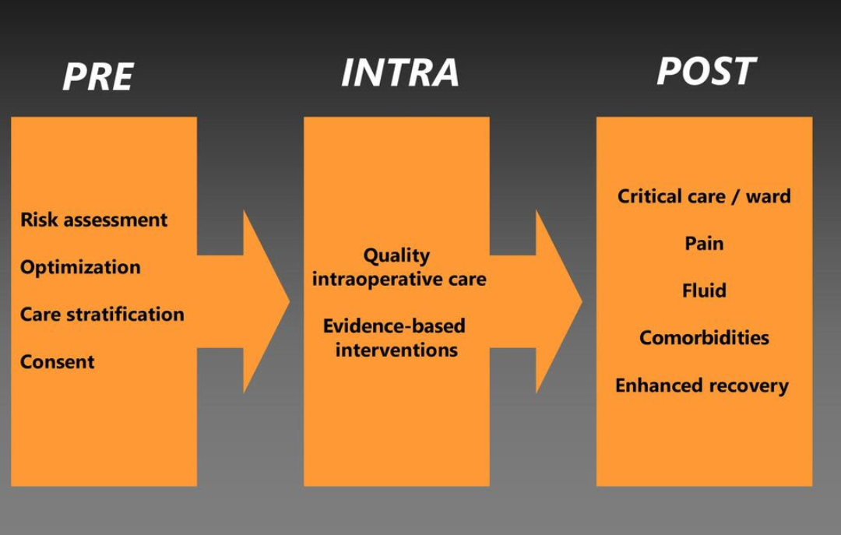
FIGURE 1: PERI OPERATIVE CARE

III. KEY COMPONENTS FOR PERI OPERATIVE CARE

The key components of perioperative care include:
- Preoperative Assessment: A thorough evaluation of the patient's medical history, current health status, and any co-existing medical conditions to assess surgical risks and plan for appropriate management.
- Preoperative Optimization: The process of preparing the patient's physical and mental health to ensure they are in the best possible condition before surgery, which may involve medication adjustments, lifestyle modifications, and addressing any potential issues.
- Intraoperative Management: This stage involves the administration of anaesthesia, the performance of the surgical procedure by the surgical team, and the monitoring of the patient's vital signs and responses during surgery.
- Postoperative Care: After the surgery, the patient is closely monitored in the recovery room or intensive care unit (ICU) as necessary. The focus is on managing pain, preventing complications, and ensuring a smooth transition to the next phase of recovery.
- Post-Discharge Follow-up: Continuation of care after the patient leaves the healthcare facility, which may involve outpatient visits, rehabilitation, or home healthcare services as needed.

IV. ADVANCES IN PERIOPERATIVE CARE

In past decades, patients had a limited understanding of what to anticipate after major surgery. Long-term fasting, vigorous bowel preparation, nasogastric decompression, bed rest, and prolong convalescence were frequent features of perioperative care. Henrik Kehlet's research on the physiological stress response and organ failure after surgery helped to usher in a paradigm change in the 1990s. He postulated that this was a significant contributor to complications after surgery and that coordinated attempts to block this reaction would enhance the efficacy of the treatment.[1][2].
Initial mobilization and the reintroduction of nutrition following surgery, together with multimodal analgesia and localized anesthetic methods, were pioneered by Kehlet and others. They reported that by using this method, the hospital stay for an elective colectomy was reduced from 10 to 2 days [3], [4]. A new era of "fast track surgery" with quick postoperative recovery began to set in as an outcome, made practicable by several types of evidence-based therapies provided by a multidisciplinary team.

V. ERAS (ENHANCED RECOVERY AFTER SURGERY)

The history of Enhanced Recovery After Surgery (ERAS) dates back to the 1990s when a few pioneering surgeons and anesthesiologists recognized the need for a more comprehensive and evidence-based approach to perioperative care. Traditional surgical practices often involved prolonged fasting, bowel preparation, and the routine use of opioids for pain management, which resulted in increased patient discomfort, longer hospital stays, and higher rates of complications. The roots of ERAS can be traced back to the concept of "fast-track" surgery introduced by surgeon Henrik Kehlet in the early 1990s. Dr. Kehlet, along with anesthesiologist Olle Ljungqvist, observed that certain perioperative practices could be modified to promote better outcomes and quicker recovery for patients. They recognized the importance of optimizing the body's response to surgery and reducing the stress of the surgical process on the patient.

In 2001, the ERAS Society was formed to further develop and promote the principles of enhanced recovery. The society brought together healthcare professionals from various disciplines, including surgeons, anesthesiologists, nurses, and nutritionists, to collaborate and share their experiences and research findings. As ERAS programs gained traction, they began to expand beyond specific surgical specialties, incorporating elements from various fields of medicine. The principles of ERAS are now applied to a wide range of surgical procedures, including colorectal surgery, orthopedic surgery, urological surgery, gynecological surgery, and more.

The implementation of ERAS involves the development of comprehensive perioperative care protocols that are tailored to each surgical procedure. These protocols are based on the best available evidence from clinical research and aim to standardize care while allowing for individual patient considerations. Over the years, numerous studies have demonstrated the effectiveness of ERAS in improving patient outcomes. ERAS programs have been shown to reduce postoperative complications, decrease hospital stays, lower healthcare costs, and enhance patient satisfaction.

As the field of perioperative care continues to evolve, ERAS principles remain at the forefront of modern surgical practice. Ongoing research and advancements in medical knowledge will likely lead to further refinements and improvements in ERAS protocols, ultimately benefiting patients worldwide by providing safer, more effective, and patient-centered surgical care.

VI. KEY COMPONENTS OF ERAS (ENHANCED RECOVERY AFTER SURGERY)

Key components of an ERAS program typically include:
- Preoperative Patient Education: Patients are informed about what to expect before, during, and after surgery. They receive information on the importance of early mobilization, nutrition, and other factors that can positively influence recovery.
- Preoperative Nutritional Optimization: Patients are encouraged to follow specific nutritional guidelines to improve their nutritional status before surgery, which can help reduce the risk of complications and promote healing.
- Preoperative Fasting: ERAS guidelines often allow for clear fluids up to two hours before surgery and carbohydrate-rich drinks up to two hours before anaesthesia to reduce fasting time and improve patient well-being.
- Multimodal Analgesia: A combination of pain management techniques is used to minimize postoperative pain, which may include the use of local anaesthesia, nerve blocks, and non-opioid pain medications.
- Early Mobilization: Patients are encouraged to begin walking and moving as soon as possible after surgery to reduce the risk of complications and improve overall recovery.
- Avoidance of Unnecessary Tubes and Drains: ERAS programs focus on minimizing the use of catheters and drains, as early removal can aid in recovery and reduce the risk of infection.
- Postoperative Nutrition: Patients are encouraged to resume eating and drinking as soon as possible after surgery to support the body's healing process.
- Postoperative Care: ERAS protocols emphasize close monitoring of patients, early detection of complications, and timely interventions to address any issues that arise during the recovery phase.

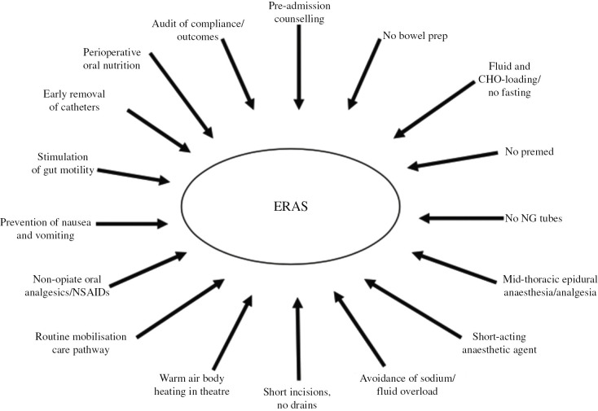

FIGURE 2: Key Components for Enhanced Recovery After Surgery [5]

VII. EVOLUTION

The dogmas of traditional perioperative care were all contested by ERAS, but it must continue to develop or run the risk of becoming dogmatic in its own right. The most recent study findings as well as cutting-edge surgical techniques and technological advancements must be considered by ERAS. Improved recovery programs have already started to have an impact on the treatment of emergency general surgery patients [6], [7], and children [8]. As surgeon experience with these operations increases, the utilization of robotic surgery [9], [10], trans anal [11], and other minimally invasive techniques is anticipated to change the surgical insult and patient recovery.

VIII. HOW ERAS WORKS
ERAS works:
- Preoperative Optimization: Before surgery, patients are thoroughly assessed, and any underlying medical conditions are optimized. This may include managing chronic diseases, quitting smoking, and ensuring that the patient is in the best possible condition for surgery.
- Patient Education: Patients are educated about the upcoming surgery, what to expect during their hospital stay, and how they can actively participate in their recovery. Education helps reduce anxiety and promotes patient engagement in the process.
- Nutrition: Patients receive nutritional guidance to ensure they are well-nourished before surgery. Good nutrition helps improve healing and reduces the risk of complications.
- Fasting: ERAS protocols often recommend shorter fasting periods before surgery to reduce dehydration and metabolic stress.
- Minimally Invasive Techniques: Whenever possible, minimally invasive surgical techniques are used, as they result in less tissue trauma and quicker recovery.
- Anesthesia: ERAS involves a specialized anesthesia approach, which may include avoiding certain medications that can cause postoperative side effects, using regional anesthesia techniques for pain management, and individualizing anesthesia to each patient's needs.
- Pain Management: ERAS emphasizes effective pain management to minimize discomfort after surgery. This may involve using a combination of medications and regional anesthesia techniques to reduce the need for opioid painkillers.
- Early Mobilization: Patients are encouraged to get up and move as soon as possible after surgery. Early mobilization helps prevent complications like deep vein thrombosis (DVT) and improves overall recovery.
- Fluid Management: ERAS protocols use personalized fluid management strategies to avoid fluid overload while maintaining adequate hydration.
- Postoperative Nutrition: Patients are encouraged to resume oral intake as soon as possible after surgery, and they may be provided with easily digestible foods and nutritional supplements.
- Multimodal Care: ERAS programs often involve a team-based approach, including surgeons, anesthesiologists, nurses, and other healthcare professionals working together to implement the ERAS protocols effectively.
- Monitoring and Auditing: The success of ERAS programs is often assessed through continuous monitoring and auditing of patient outcomes. Any areas of improvement are identified, and protocols are updated accordingly.

IX.FUTURE DIRECTION IN PERIOPERATIVE CARE

Interest in digital technological solutions and automated care procedures has increased as a result of the expanding complexity of perioperative care and the requirement for increasingly individualized and custom routes. Future perioperative care is projected to be significantly influenced by digital technology, and several developments that are pertinent to improved recovery programs have been looked into. Mobile non-invasive sensors calibrated to recognize postoperative cardiac issues, lifestyle change and preoperative optimization apps, objective nociceptive assessments, activity trackers to follow postoperative ambulatory recovery [12].

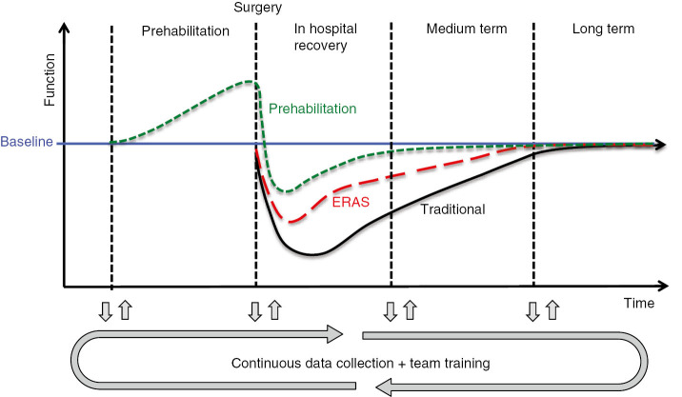
FIGURE 3 :Model of the effect of prehabilitation and ERAS on functional recovery

Perioperative medicine is a growing and evolving field that place patient outcome at its core.The challenge going forward will be innovation and development of services with in the current economic constraints.

REFERENCES

[1] Kehlet H The stress response to surgery: release mechanisms and the modifying effect of pain relief. Acta Chir Scand Suppl 1989;550:22–8.

[2] Kehlet H Multimodal approach to control postoperative pathophysiology and rehabilitation. Br J Anaesth 1997;78:606–17.

[3] Bardram L, Funch-Jensen P, Jensen P, Kehlet H, Crawford M Recovery after laparoscopic colonic surgery with epidural analgesia, and early oral nutrition and mobilisation. Lancet 1995;345:76-4.
[4] Kehlet H, Mogensen T Hospital stay of 2 days after open sigmoidectomy with a multimodal rehabilitation programme. Br J Surg 1999;86:227–30
[5]Fearon KC, Ljungqvist O, Von Meyenfeldt M, Revhaug A, Dejong CH, Lassen K, et al. Enhanced recovery after surgery: a consensus review of clinical care for patients undergoing colonic resection. Clin Nutr 2005;24:466–77.
[6] Roulin D, Blanc C, Muradbegovic M, Hahnloser D, Demartines N, Hübner M Enhanced recovery pathway for urgent colectomy. World J Surg 2014;38:2153–9.
[7] Quiney N, Aggarwal G, Scott M, Dickinson M Survival after emergency general surgery: What can we learn from enhanced recovery programmes?. World J Surg 2016;40:1283–7.
[8] Short HL, Heiss KF, Burch K, Travers C, Edney J, Venable C, et al. Implementation of an enhanced recovery protocol in pediatric colorectal surgery. J Pediatr Surg 2018;53:688–92.
[9] Polat F, Willems LH, Dogan K, Rosman C The oncological and surgical safety of robot-assisted surgery in colorectal cancer: outcomes of a longitudinal prospective cohort study. Surg Endosc 2019;33:3644–55.
[10] Perez RE, Schwaitzberg SD Robotic surgery: finding value in 2019 and beyond. Ann Laparosc Endosc Surg 2019;4:51.
[11] Deijen CL, Velthuis S, Tsai A, Mavroveli S, de Lange-de Klerk ES, Sietses C, et al. COLOR III: a multicentre randomised clinical trial comparing transanal TME versus laparoscopic TME for mid and low rectal cancer. Surg Endosc 2016;30:3210–5.
[12] Michard F, Gan TJ, Kehlet H Digital innovations and emerging technologies for enhanced recovery programmes. Br J Anaesth 2017;119:31–9.

