FUTURISTIC TRENDS IN NURSING

The use of Artificial Intelligence is Streamlining Patient care delivery May replace nursing care Services:-

Introduction:
Nowadays, artificial intelligence (AI) is seen as a game changer. Artificial intelligence seems to be ready to transform the world and the way people live and work.
Nurses who want to advance in their careers need to be open to learning about and understanding new technology and they should participate in the development and implementation of technology to ensure that it is going to help improve patient care while maintaining safety standards. With AI, nurses may be able to personalize patient came through the following.
- Monitoring population health.
- Pinpointing the best patient outcomes.
- Administering treatments optimized for each patient.
- Finding evidence that pertains to the individual patient.

The use of artificial intelligence (AI) is streaming patient care delivery AI and machine learning allow providers to collect & analyze vast amounts of health data to guide decision making. While the aging patient population and staffing. Shortages are important trends directly affecting the nursing industry, other trends are likewise shaping its future.

Terminologies:
- Artificial Intelligence: is a field which combines computer science and robust datasets to enable problem solving.
- Patient care delivery: The services provided by nurses and other health care professionals and technologies in the health service.
- Trends: Change or movement in a particular direction it also denote general direction and tendencies especially of events, opinions or movements in a particular direction.

Definition:
Futuristic trends in nursing: is defines as the “art of using the latest technology and science to promote quality of life as defined by patients and families throughout their life experiences form birth to end of life
(or)
Futuristic nursing in 1987, followed by their shorter version in 2002. Nursing encompasses autonomous and collaborative care of individual of all ages, families, groups and communities, sick well in all settings.
International Council nurses (1987)

“Sister Elizabeth Davis” defines nursing is a dynamic profession undergoing change every moment. “We are in a new place, we are not on the edge of the old place. We are not pursing the envelope, we are totally a new envelops. So the rule have changed ever fundamental premise old way of thinking is no longer applies”.

Artificial Intelligence in health care:
Health care organizations are using AI solution to inform decisions and improve experiences with data. AI is being used for all the there classical medical tasks: diagnosis, prognosis and therapy but mostly in the era of medical diagnosis generally, the medical diagnosis cycle involves observation and examination of the patient, collection of patient data, interpretation of the data using the elemi cioans knowledge and experience and then formulation of a diagnostic and a therapeutic plan by the physician. It we can compare the medical diagnostic cycle to the concept of an intelligent agent system the physician is the intelligent agent, the patient data is the input and the diagnosis is the output.
There are several methods, through which AI systems can replicate the diagnostic cycle and assist. clinicians with medical diagnosis. One approach is the use of export systems.
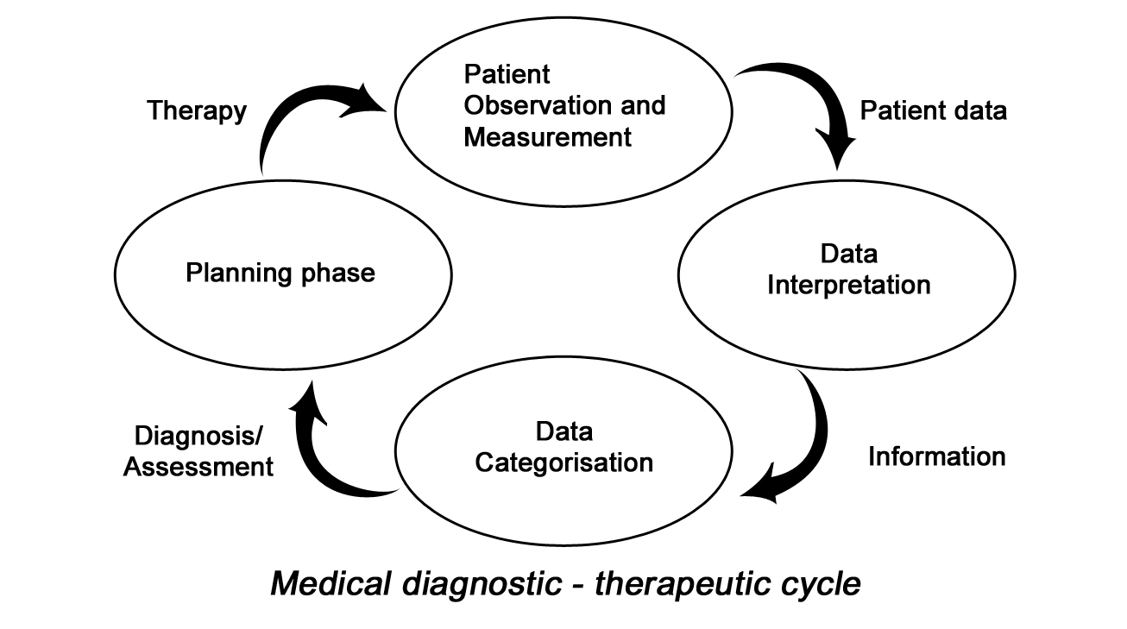

The success of the expert system relies on the explicit representation of the knowledge area in the form of rules. The cone of the expert system is the inference engine, which transforms the inputs in to actionable outputs.

Types of AI relevance to health care:
Artificial intelligence is not one technology, But rather a collection of them. Most of these technologies have immediate relevance to the health care field. Some specific AI technologies of high importance to health care are defined and described below.
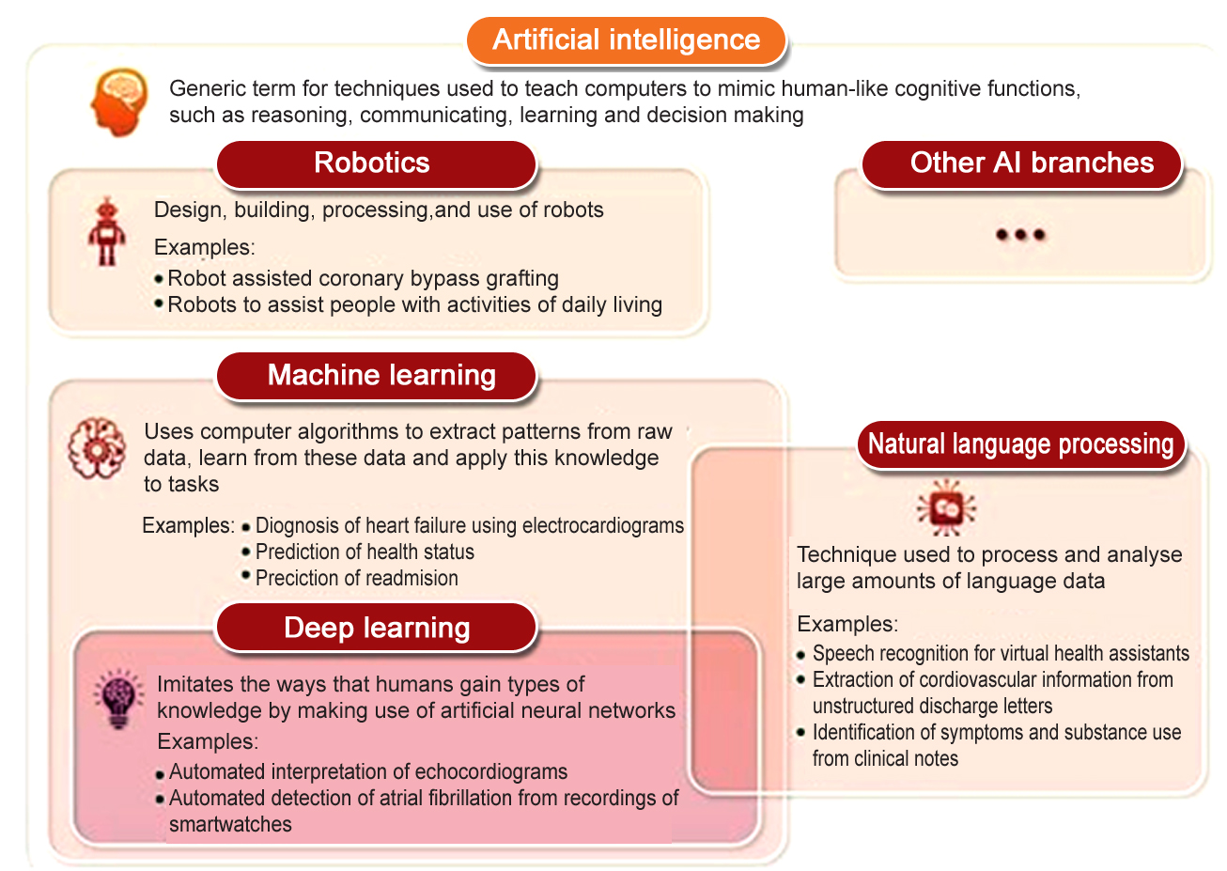

- Machine Learning: It is a branch of artificial intelligence that uses algorithm to examine previous data, current information and interaction. This analysis helps to predict the most ideal treatment for patients. It also plays a key role in optimizing and streamlining health care procedures and administration. Data annotators are one of the important aspects of ML. It helps to take CT and MRI, Scans and marks tumour cells more accurately. It helps resolving the asynchrony between a mechanical ventilator and the patient’s own breathing reflexes which can cause stress & complicating recovery.

- Natural Processing Language: It is the process of understanding and interpreting text or language by a machine. NLP can help analyze patient’s medical records and give suggestions to improve the quality of methods used and prepare better results of the patients. The common use of NLP in artificial intelligence involves understanding and clarifying medical records. When the machine understands what the user is trying to communicate, then it works accordingly.

- Physical Robots: Physical Robots are a popular type of AI used in the medical field. Initially scientists designed robots for delivering hospital supplies. However, improved version of robots are available today. Such robots can collaborate with human and can be easily given training for doing particular tasks. They are:
- AI that generates data, robotics provides touchable outcomes or realize physical tasks.
- AI & Robotics use knowledge and patient data for various tasks such as:
  - Diagnosis
  - Planning of Surgeries
  - Monitoring of patent Physical and mental wellness..
  - Basic physical interventions to improve patient independence during physical or mental deterioration.
  - Robotics can be used in a patients home (e.g. for monitoring of vital signs.)
  - Shorter term care settings include inpatient hospitals, palliative care settings include inpatient Psychiatric facilities.
- Home care Robots: Robots that provide assistance to elderly or sick persons have been the focus of research and development for several decades. Particularly in Japan due to the country’s large aging population with above average longevity. “Elder care robots” can be deployed at home, where they will help alleviate a severe shortage of nurses and specialized workers. Which cannot be easily addressed through the hiring of foreign help given the language barrier.

- Robotic process Automation: This technology in AI has been developed mainly for administrative purposes. Robotic process automation is in expensive when compared with other types of artificial intelligence. In health care RPA is used to record early authorizations. Updating patients medical records and billing. By using RPA hospital can reduce the manual dependency of each process, which in turn reduces the risk of human error and increases accuracy, thereby Nurse administrator works are minimized in following ways:

- Prior Insurance Authorization: Approval of coverage for special tests or authorization for treatment are requested electrically including the cost to the patient, and the response is communicate via auto generated email.

- Cost Estimates: Patient are made aware of the cost of procedures and treatments upfront, and payment plans and collection efforts are automated, as well.

- Insurance Verification & Benefits of approval: RPA track and request approval for patients as appointments are made, attended or cancelled.

- Claims Management and Accounts Receivable: RPA, using bots and AI technology is used to manage claims processing workflow. It recover funds without repetitive manual intervention.

Artificial Intelligence in Nursing
- Practical implementation in clinical settings:
Artificial intelligence (AI) comprises many healthcare technologies transforming nurses roles and enhancing patient care. AI typically refers to the ability of computers to independently convert data in to knowledge to guide decisions or autonomous actions.

Nursing AI tools include clinical decision support, mobile health and sensor based technologies and voice assistants and robotics.

- Clinical decision support: It is the tool enhance nurses ability to make clinical decisions. AI based clinical decision support includes automatically generated nursing diagnosis fall risk prediction and guided decision to prevent catheter associated urinary tract infections.
AI’s potential in decision support includes helping nurses advocate for patients and identify care gaps and challenges.

- Mobile Health and Sensor Based Technologies:
Mobile health and sensor based technologies provide opportunities to reshape a nurses ability to deliver care and monitor patients. Mobile health technologies help manage chronic illness by receiving and sending data directly between patients and providers, creating a comprehensial picture of the dynamic static of patients health in their everyday environments.
Sensor based technologies, when placed in the home or hospital environment and used in combination, help nurses compose text and multimedia messages (for sharing photos and videos), Measure body movement, and collect weight, movement, and environmental (temperature, light sound, air quality) data.
These technologies can be used across the care continuum, following patients as they transition from inpatient to outpatient care.

- Voice Assistants and Robotics:
Voice assistants may have future in EHR applications, collecting patient data in the home and delivering interventions to augment care.

For example: A nurse uses Alexa to remind older adults to take their medication and measure their blood pressure. Alexa then records patient data in the EHR for the nurse to review. For older adults and patients with certain disabilities, such as poor eyesight, these tods may be especially useful given their voce based interaction. The benefit of voice assistants depends on nurse involvement in technology selection and its application in practice and patient care.

As Robotics technology advance. It’s being used to provide care companions and create remote controlled tools, such as telephone robots (where a nurse can drive a wheeled robot using a voice and video application), to deliver came hospitals increasingly use tele presence robots to augment face to face patient care.

Advantages are limited & reduced contaminated diseases by using robots & voice assistants.
- Reduce the time nurses spend per visit on data collection & documentation.
- Robots with arms that nurses can drive remotely to manipulate items in the environment, such as pressing in fusion pump buttons and assisting with feeding medication delivery.

Implementing Artificial Intelligence in Nursing
Researchers have been leveraging AI for several decades, but its use in practice remains relatively new. When nurses implement AI, such as clinical decision tools, they can process large amounts of data quickly to identify risks, recommend interventions, and streamline workflow. However, for AI to truly transform nursing practice, limitations must be addressed with input from nurses

There is no perfect science to implementing AI in nursing – success will require considering the right tools for your organisation. Engagement with nurses who will use the tools, and involvement in its implementation and evaluation.

All in health care covers a wide range of assistance to health systems and workers, but what are the specific benefits and downfalls of its adoption?

Pros of using Artificial Intelligence in health care:
- Due to the advent of AI in medicine, there has been quite a list of benefits that this has garnered both professionals and patients.
Real time access to information:
- One strongest suits of AI in health care is its ability to deliver data in meal time. This allows faster diagnosis based on results which ultimately contribute greatly towards the recovery or treatment plan of patients.

Streamlining Tasks: By setting appointments, translating clinical information and transferring and tracing patient records and medical histories. AI in health care has greatly aided in streamlining tasks.

Cost efficient and resourceful: As AI replaces tedious human tasks with advanced algorithms the expenses of hospitals can be reduced by a big fraction.

Research ability: More than just providing real time data, AI can also integrate other sources of information based on research that can be of great use for analysing diseases.

Cons of using AI in health care:
AI in health care has marked how technology can also give back to those in the hard science, such as medical. Hence are some of the reason why:

Require Human Oversight:
- Because AI is not perfect, running them will still require human oversight and surveillance.
- Robotic technologies that aid in surgeries, for example, have no sense of empathy and will operate merely on their program.

Might create Social Baises:
Certain compatibility issues also arise when it comes to specific mobile platforms and devices which definitely doesn’t take into account what all are capable of having.

Might Replace Human Employees:
AI can do most of the mental and tedious human labour in health care, there is a risk of possibly no longer needing specific employees within the hospital as their jobs can be replaced by AI.

Possible Security Risks:
The most obvious and direct weakness of AI in health are is that it can bring about a security by each with data privacy.

The future impact of AI in nursing

AI has the potential to benefit clinical and patients by helping nurses to improve their efficiency and quality care. AI technology is emerging as a partner with nursing to rapidly synthesise information, complete work, assist with clinical decision and improve patient outcomes. Individually each of these emerging technology officers tremendous opportunity to improve care. Combining these solutions and educating nurses on how to best interact with machines will open unlimited solution for efficiency, capacity, quality and healthcare transformation in the future.

Implementing AI in nursing comes with some challenges, however, as it continues to develop, nurses will play a key role in helping health care organisations implement and adopt to this technology transformation.

Conclusion:
Undoubtedly, AI is transforming healthcare and the nurses role in care delivery. AI applications might greatly influence nursing practices. To ensure that his new era aligns with core nursing values and that new applications are relevant to clinical practices, health care workers and patients should be placed in key positions in the development of Artificial Intelligence in health technologies.

1.Book Reference:
1. Beam AI, kohane is, Translating artificial intelligence into clinical care. Jama 2016, 316(22):2368-9
2. Sandeep Reddy (2018) Text book of use of artificial intelligence in health care delivery
2. Web Reference :
- http://www.forseemed.com Artificial intelligence (AI) in healthcare & hospitals 2023
- http://www.intelligence.com Artificial intelligence in health care. AI applications & uses 2023
- http://www.ibm.com What is artificial intelligence in health care 2023
- http://www.consultantad.clevalandclinic.org.com How artificial intelligence is partenering with nursing to provide care 2022
- http://www.openaccessgovernment.org.com What are two pros and of implementing AI in health care, 2022
- https://www.managedoutsource.com main types of AI-2021

