FROM PRINT TO PIXEL: ANALYSIS OF PERCEPTION OF GEN – Z TOWARDS SUSTAINABILITY IN PRINT AND ONLINE NEWS FORMATS

Authors:
¹ Prof. Vijay Tandon, Director of PGDM and International Programs, Department of Marketing, Universal Business School, Karjat, Raigad, Maharashtra, 410201.
Email address: vijay.tandon@ubs.org.in
² Ms. Devanshi Nema, MBA, Universal Business School, Karjat, Raigad, Maharashtra, 410201.
Email address: devanshi.nema@ubs.org.in
³ Mr. Ajay Kumar Saini, MBA, Universal Business School, Karjat, Raigad, Maharashtra, 410201.
Email address: ajay.saini@ubs.org.in

ABSTRACT
The study aimed to investigate the reading habits of Gen-Z towards newspapers and e-newspapers in relation to sustainability. It surveyed 200 Gen-Z individuals aged 18-26 to determine their reading preferences, news interests, and feelings about reading newspapers on screens. The results showed that e-newspapers are becoming increasingly popular among Gen-Z, mainly driven by accessibility and convenience rather than environmental concerns. The study suggests that the newspaper industry should embrace environmentally friendly methods and educate Gen-Z on the negative impact of print media on the environment. The findings also indicate that although Gen-Z may lack knowledge about sustainability, they are keen to support sustainable initiatives by the newspaper industry. Thus, newspaper publishers are encouraged to use social media and other avenues to inform Gen-Z about their efforts to promote sustainability. Overall, the study provides insights into the reading habits and preferences of Gen-Z and can assist newspaper publishers and policymakers in developing long-term plans to meet the changing requirements of younger generations.
Key Words: Environment friendly, Sustainability, Newspaper, E-Newspaper, Youth, perception

- INTRODUCTION

Newspapers have a rich and varied history that dates back hundreds of years, changing along with societal norms, political developments, and technological advancements. When handwritten news sheets first appeared in Europe in the early 17th century, the history of newspapers officially began. These news sheets covered a range of topics including politics, business, and entertainment and were typically delivered by couriers or posted in public locations. The Oxford Gazette was the first printed newspaper in England, followed by other periodicals such as The London Gazette and The Spectator. These early publications served as a voice for the ruling elite and were frequently subject to strict government censorship.
As literacy rates rose in the 18th and 19th centuries, newspapers gained influence and circulation increased dramatically with the invention of the steam-powered printing press in the early 19th century. By the turn of the 20th century, newspapers had become a crucial source of information for Gen - Z worldwide, covering topics ranging from sports, entertainment, and lifestyle to local, national, and international news. Wire services like the Associated Press and Reuters allowed for even quicker news distribution, enabling newspapers to cover breaking events as they happened.
However, the emergence of television and the internet in the latter part of the 20th century posed new challenges for the newspaper industry. As readers shifted to online news sources, the circulation of many newspapers declined as they struggled to adapt to the digital age.
Newspapers have traditionally been an essential source of news and information, providing valuable journalistic analysis and opinions on a wide range of topics such as politics, sports, crime, and celebrity news. However, the production and distribution of traditional newspapers have a significant impact on the environment, contributing to deforestation and climate change. E-newspapers, published electronically, offer a more sustainable alternative to traditional print newspapers. They can be accessed through the internet and use all its resources, including hypertext, hyperlinks, images, and classified ads. Although e-newspapers typically require a subscription to access their content, they are available in various formats, including regular print publications, publications with additional or complementary material, or publications that are only available online.
Despite the benefits of e-newspapers, their adoption among the younger generation is uncertain. Some may prefer the tactile experience of reading a physical newspaper, while others may face challenges transitioning to digital modes, such as the availability of electronic devices or the shift in the reading experience. However, as younger generations become more environmentally conscious, e-newspapers are becoming increasingly popular.
By encouraging the use of e-newspapers, we can lessen the negative environmental effects associated with the manufacturing and distribution of conventional newspapers, helping to preserve the environment and advance sustainability. Although newspapers are an essential part of our everyday lives, it is important to consider how they affect the environment and explore alternatives like e-newspapers. By doing this, we can take advantage of journalism's benefits while simultaneously helping to build a more sustainable future.
Deforestation is a serious issue that affects everyone, with estimates suggesting anywhere from 4 billion to 8 billion trees used for paper every year. This means that a tree is cut down every 2.5 seconds, releasing 28 million metric tons of CO2 into the atmosphere. People are also losing their natural resources, including clean water and air, to make room for human activities. Printing and writing are 26% of global CO2 emissions.
The authors of the research paper will proceed to discuss the literature review, research gap, objectives of the study, research methodology, data collection, and analysis including the interpretation of primary data. The study will also examine future possibilities and provide a conclusion. The paper will end with a reference section.

- LITERATURE REVIEW

If audience demand and market forces alone are insufficient to supply this public benefit, can direct and indirect intervention be modified to effectively finance the production of independent, original, and professionally produced excellent journalism? current intervention techniques, like government funding for public service media and Direct and indirect funding for private sector media is frequently intended to support the dissemination of news and information and is frequently linked to traditional platforms like print and television. It identifies three fundamental trends in the way news and media are changing: the shift to a more digital environment with an increase in attention-grabbing competition, the growing significance of big tech companies in news distribution, and the emergence of a highly competitive media environment where internet users have access to an increasing amount of information, a variety of technologically advanced devices, and new ways to participate. (Council of Europe Report, 2016)

The digital revolution has had a detrimental impact on the newspaper industry, with traditional publications losing readers, going out of business, firing staff, spinning off, closing, and turning online-only. The newspaper industry is under pressure financially, so it's critical to have an optimal supply chain design to meet the goal of timely delivery at the lowest possible cost. This study examines how the newspaper industry's business models, business climate, and techniques for branding and promotion have changed. As the size and makeup of the audience affect the value of the news media to advertisers, it is difficult to identify which edition of the newspaper is more economically lucrative for the business in India. (L.Hemalatha, 2020)

A newspaper is a periodical or serial publication that is published on a regular basis and typically includes news, commentary, features, and advertising. It is now available online as well as in print editions due to the development of information communication technologies. Online newspapers are published and read via the Internet or World Wide Web, while print newspapers are created in hard copies using ink and paper. The popularity of online newspapers and magazines is due to Gen - Z's enthusiasm for new technology and desire to ride the new wave. Print news is facing problems as media technologies become more stunning and effective at disseminating information. For more accessible and speedy news, most newspapers have embraced the Internet. (Wisdom O. Anyim, Ph. D, 2021)

Trust in news is falling, with much of the public, especially younger age groups, increasingly turning away from it. The 2022 Reuters Institute Digital News Report found that consumption of traditional news media declined in nearly all the countries surveyed, with online and social consumption of news not making up for it. The proportion of news consumers who say they "avoid news" has risen sharply across countries, with the report describing the phenomenon as "selective avoidance". Reasons for this aversion include being put off by the repetitiveness of the news agenda, being worn out by the news, and not trusting it. (The Hindu, 2022)

The focus group shared that presently they did not see any threat so long as the newspapers reinvent and innovate. India is a large country with huge disparities. In the Indian context, there are several means of mass communication which have been instrumental in bridging the communication gap between Gen - Z that contributes to the air of awareness in a society. The newspaper industry stands out as an influential body which contributes to the development of the nation. Daily newspapers provide huge contribution towards the economic and industrial development of a country. Indian daily newspaper is the order of the morning for eager news hungry readers across the country. The country's general economic development is a direct outcome of the increase in newspaper circulation, which motivates it to reach new heights. (Dr. Rusha Mudga, Prof. (Dr.) Pooja Rana, 2020)

In its paper titled "The Future of News in India," the Vidhi Institute for Legal Policy explores potential legislative reform strategies and suggests a course of action for sustaining reputable print journalism in India. To prevent news from being lost to the sands of time, any policy reform being explored to maintain news for the public good must be deliberative, inclusive, and engage journalists, the news industry, and civil society. The print news industry is suffering from a serious malaise, and its business models are struggling to survive in a society that is becoming more and more at ease with tossing the newspaper to the side. (Aniruddh Nigam, 2020)

India's transition to a media landscape dominated by digital, mobile, and platforms is quickening, with more than 400,000 Indians going online for the first time as the price war in mobile makes smartphones and data accessible. The fast shift to digital has already had a significant impact on English-language print media, with declining circulation revenues and flat advertising growth predicted. The future of Indian newspapers depends on reaching the two-thirds of the country's population who are under the age of 35. While Indian newspapers are making investments in their digital operations, many are trailing behind and provide clickbait and shovel ware on their websites. Although print is currently India's second-largest advertising medium, digital is expected to surpass print in 2021. Indian newspapers must create more appealing digital products and organisations that can be maintained by their online enterprises in order to assure a sustainable digital future. (Nielsen, 2019)

Given that the library subscribes to online news sources that are made accessible to users, the growing usage of the World Wide Web at universities is an essential part of information communication technologies. The emergence of online news is one of the problems that new technologies have presented to print newspapers in the twenty-first century. The results showed that both print and online newspapers are trustworthy and reputable, and that more readers prefer the online version of the newspaper than its print equivalent. The university library of Rhema University in Nigeria served as the setting for this study, which looked at readers' perceptions and preferences for both print and online publications. Also, users said that accessibility is what decides whether they prefer print newspapers or online newspapers, and that online newspapers have a higher readership than print newspapers. Due to the availability, of newspaper publications online as well as in print editions, this has had a considerable impact on users' reading preferences. (Anyim, 2021)

The distinctions between newspapers' print and online versions were studied in this research article. It was discovered that whereas images were more prevalent in e-paper, news pieces were more prevalent in print. Also, it was discovered that more than 80% of the news articles and images on the newspaper's main page are also available online. The research paper's main finding was that most of the material was the same in both online and offline forms, but that e-paper photos and videos were more prevalent than print versions in both newspapers, drawing Gen Z readers' interest there more than in print media. (Dr. Bharat Dhiman, 2022)

The distinctions between newspapers' print and online versions were studied in this research article. It was discovered that whereas images were more prevalent in e-paper, news pieces were more prevalent in print. Also, it was discovered that more than 80% of the news articles and images on the newspaper's main page are also available online. The research paper's main finding was that most of the material was the same in both online and offline forms, but that e-paper photos and videos were more prevalent than print versions in both newspapers, drawing Gen Z readers' interest there more than in print media. (Bharucha, 2017)

Globally, there are two major changes in how Gen - Z consume news: the rise of news audiences who access journalism via their phones and mobile devices, and the rise of news consumers who read or watch news on social media platforms like Facebook, YouTube, Snapchat, WhatsApp, or Twitter. This paper provides evidence that these two trends are global phenomena that are not limited to the US or a small number of economies. With Buzzfeed, a US startup, collecting $70 million in venture capital funding and fast expanding to a monthly reach, this has had a significant impact on how journalism is produced. Buzzfeed was founded on the premise that news will predominantly be disseminated through social networks. The company is an expert in determining how news is disseminated on social media platforms as well as which journalistic styles perform best on the real-time social web. (Reuters Institute and University of Oxford, 2015)

With the United States re-joining the Paris Agreement and the Environmental Protection Agency taking action to limit greenhouse gas emissions, climate, energy, and environmental policy have received renewed federal attention during Joe Biden's presidency. Climate, energy, and environmental policy have received renewed government attention during Joe Biden's presidency as a result of the United States re-joining the Paris Agreement and the Environmental Protection Agency taking measures to reduce greenhouse gas emissions. (ALEC TYSON, 2021)

The Millennial generation and Generation Z (those born since 1997) have been significantly impacted by the coronavirus pandemic (those born between 1981 and 1996). For many people, it has been a financial catastrophe, yet unlike the Great Recession, it started out strongly. Gen Z is leading the environmental revolution because they have learnt to do less, spend less, and waste less. Gen Z consumers are most likely to pay 10% extra on sustainable products, according to consumer research on retail fashion companies. Generation Z is most likely to base purchases on values and principles, thus companies must be genuine to safeguard the safety of both employees and customers. (Petro, Gen Z Is Emerging As The Sustainability Generation, 2021)

Studies comparing the environmental effects of printed and electronic newspapers have shown that the printed version uses more energy, emits more greenhouse gases, and has additional negative effects than the electronic newspaper read on a tablet. Reduce subscriptions to unread newspapers or magazines and share paper books with others to create more sustainable reading habits. It was discovered that reading a print edition of a newspaper had a lesser environmental impact than reading an online version for a dedicated newspaper reader who reads for at least 30 minutes each day. The printing and delivery of the print edition, however, were not taken into consideration in this study. (Åsa Moberg a b d, 2010)

- RESEARCH GAP

Based on the provided search results, it appears that none of the papers directly address the topic of the use of paper in newspapers and related issues of sustainability. Some of the papers, however, do touch on the broader topic of digitalization and its impact on the newspaper industry. Researchers may need to look for industry journals or academic papers specifically focused on media or sustainability to effectively investigate the topic of paper use and sustainability in newspapers. Alternatively, original research or surveys may be required to collect data on the subject.

- OBJECTIVES OF STUDY

- To examine how often and which newspapers Gen - Z prefer to read.
- To know that newspaper industry must place a strong emphasis on the need for green practises and youth education in order to better fulfil the changing needs of the Gen - Z generation in terms of reading habits and sustainability.
- To know if Gen Z prefers online newspaper reading and whether it saves paper and is better for the environment.

- RESEARCH METHODOLOGY

In order to gather the data for this research study, which is based on both primary and secondary research, there was also information evaluated and gathered from several research articles. A structured questionnaire is prepared and circulated and survey approach is chosen for the study. This approach was chosen considering the characteristics of the respondents, who are print media subscribers and college Gen - Z. For the study, a formal questionnaire was created. The survey's purpose was taken into consideration when creating the questions. A questionnaire was distributed to a sample size of 500 people, and approximately 200 people responded.

- COLLECTION OF DATA AND DATA ANALYSIS

- Interpretation

The researcher has compiled all the information obtained through the Questionnaire during the research process since analysis of the results and discussion are essential components of a research project. The raw data was organised, systematised, and collated into several tables before analysis. Here are how the study's results are interpreted:
By conducting this survey, we have discovered that approximately 70% of young people prefer reading newspapers, while approximately 30% do not partake in reading newspapers.
Most respondents prefer reading newspapers online rather than in print, according to this graph. Among the various news reading apps used by Gen-Z, Inshorts is the most popular, followed by The Hindu, TOI, and other similar apps.
Because of their convenience, accessibility, and personalised features, news reading apps like Inshorts, The Hindu, and TOI are the most preferred way for Gen-Z to consume news. This shift towards mobile news consumption reflects the younger generation's changing habits and preferences, emphasising the importance of adapting to digital platforms in order to remain relevant and engaged with younger audiences.
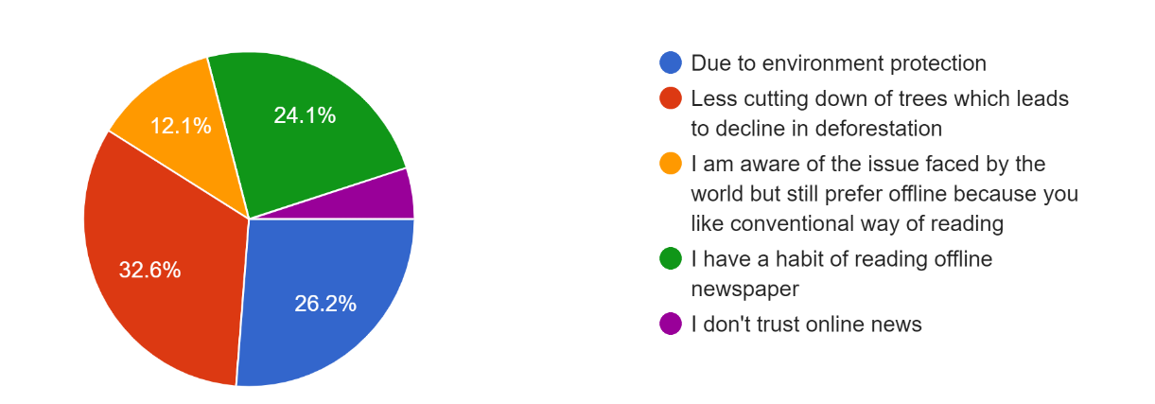

According to the survey, Generation Z is increasingly adopting sustainable practises, with approximately 60% of respondents preferring to read newspapers online in order to reduce the number of trees cut down and protect the environment. In contrast, approximately 36% of people still prefer to consume news offline, while 5% do not trust online news.
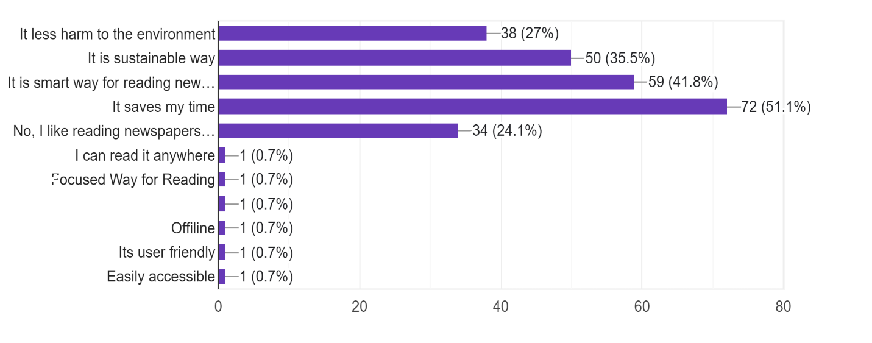
According to the survey, Generation Z prefers to read newspapers digitally due to the time savings and the perception that it is a smart and environmentally sustainable way of consuming news. Without the need for physical copies or time-consuming browsing, digital platforms provide quick and easy access to news content. Furthermore, younger readers prioritise sustainability, and digital platforms provide a more environmentally friendly way to consume news than traditional print media. These findings emphasise the significance of adapting to digital platforms in order to meet the changing needs and preferences of younger readers while also addressing environmental concerns.
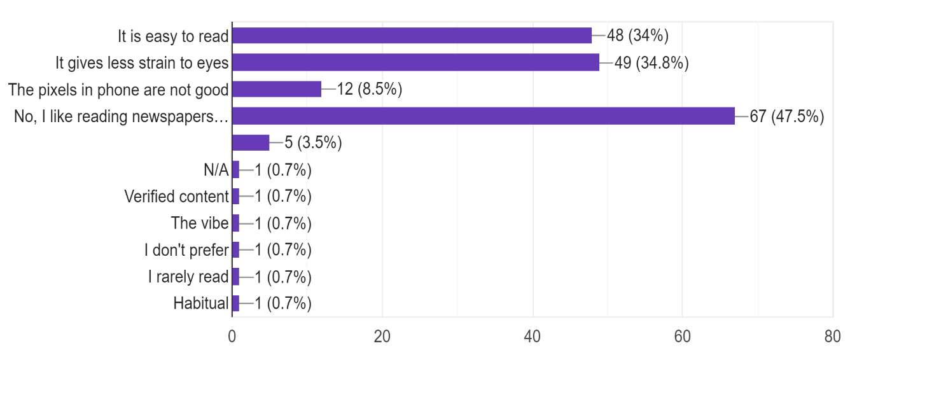
While many younger readers prefer digital modes of news consumption, a sizable portion of the population (40%, according to the survey) prefers the offline mode. Some of the reasons given for this preference include a perceived ease of reading news from a physical newspaper and less strain on the eyes. Despite the advantages of digital platforms, such as accessibility and sustainability, some people prefer the tactile experience of reading a newspaper because it is more enjoyable or convenient. To ensure a diverse readership and cater to a variety of preferences, publishers must recognise and accommodate both digital and offline readers.
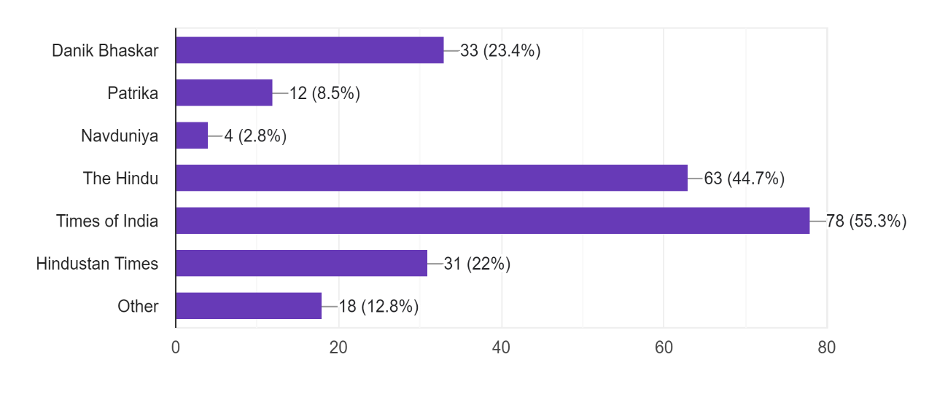
According to the survey results, the Times of India is the most widely read newspaper among respondents, with approximately 55% citing it as their preferred publication. The Hindu was close behind, with approximately 45% of readers preferring it as their preferred newspaper. Dainik Bhaskar was also mentioned by roughly 23% of respondents, indicating its readership. These findings are useful for publishers and marketers who want to understand readership trends and preferences, and they can help guide strategies for targeting specific audiences and increasing readership.
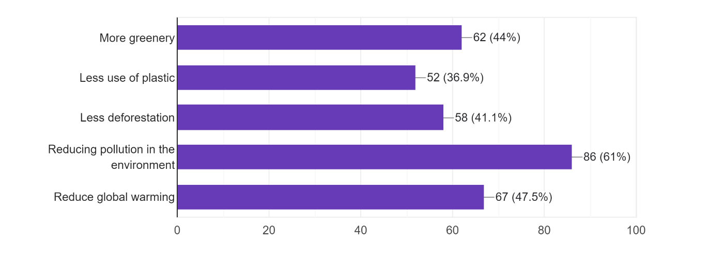
According to the Gen – Z people sustainability means reducing pollution to the environment which reduce global warming and focuses on less deforestation in the environment with less use of plastic.
Approximately 64% of respondents believe that print newspapers are harmful to the environment because they involve deforestation, which causes soil erosion and disrupts the rain cycle. And 36% believe it is not harmful to the environment because there are many other major issues related to pollution that are more harmful to the environment and thus require more attention and awareness than this issue.

- RESULTS AND DISCUSSION

Based on the available data, it can be concluded that there is a significant shift in news consumption patterns among younger generations towards digital platforms. This trend is primarily driven by factors such as convenience, accessibility, and sustainability. In contrast, traditional print media is still preferred by a considerable portion of the population, citing reasons such as ease of reading and less eye strain.
The Times of India is currently the most widely read newspaper in India, followed closely by The Hindu and Dainik Bhaskar. Online news consumption is the preferred mode of accessing news for 84% of respondents, followed by social media, television, and print. The most popular social media platforms for finding news were WhatsApp and YouTube.
The increasing use of digital devices for news consumption is evident among college students, with 88% reporting using digital devices to access news content. This trend is also reflected in the rising revenues of the online book and paper industry, projected to reach $18.5 billion by 2025.
The negative environmental impact of paper consumption is also a significant concern, with the EPA estimating that 12-24 trees are cut down every day to make one ton of newspapers. Additionally, over 15 billion trees are taken down every year, highlighting the need for sustainable news consumption practices.
Overall, the data suggests that publishers and marketers must adapt to changing reader preferences while also addressing environmental concerns. As Gen-Z becomes the dominant consumer group, it is essential to provide options for both digital and offline consumption and develop strategies that cater to the diverse needs of readership.

- FUTURE POSSIBILITIES AND CONCLUSION

- FUTURE POSSIBILITIES

Through this research it can be concluded that Gen – z is moving towards digitalization so the newspaper industry also must adapt with the changing environment. The newspaper industry is struggling to keep readers and remain relevant as the globe continues to embrace digitalization. To help the newspaper industry adjust to these developments, consider the following marketing ideas:
- Marketing to Gen Z Digital Strategies for Newspapers – To attract and retain Gen - z readers, the newspaper industry can adapt marketing strategies to embrace digitalization, create engaging content, and embrace environmentally friendly practises.
- Green News and Sustainable Practices for a Better Tomorrow - The newspaper industry can reduce its carbon footprint by adopting eco-friendly practices such as reducing paper usage, utilizing digital platforms, and embracing sustainable business models.
- Newspapers can concentrate on serving audiences rather than attempting to compete with digital news providers. This may involve in-depth local news coverage or a focus on a particular demographic, like elders or young professionals.
- Less expensive distribution: Digital distribution can be more affordable than conventional print distribution. By switching to digital platforms, newspapers can save money on printing, paper, and distribution expenses.
- Sustainability: Compared to print media, digital channels are more environmentally friendly. Lowering paper use and transportation emissions can lessen a newspaper's carbon impact and support sustainability initiatives.
- Analytics: Newspapers can obtain analytics through digital platforms to learn more about their readership. This can contain information on reader demographics, tastes, and levels of involvement, which can help guide editorial choices and marketing plans.
- Offer Opportunity for Experimentation and Innovation - Newspapers can diversify their content offerings by using technology, such as creating interactive articles or virtual reality experiences. This can help them attract younger readers and differentiate themselves from competitors, as well as provide new revenue streams through digital advertising and subscriptions.

- CONCLUSION

This research paper provides useful insights into Gen-attitudes Zs towards sustainability in print and online news formats. According to the study, younger generations prefer online news formats because of their convenience, accessibility, and perceived sustainability benefits. However, a sizable proportion of the population still prefers print media, citing factors such as tactile experience and ease of reading. The findings also show that environmental consciousness is important in Gen-Z news consumption habits, with a sizable proportion expressing concerns about the environmental impact of their preferred news format. As a result, in order to remain relevant and appealing to younger generations, the newspaper industry must embrace digitalization and incorporate sustainability into their marketing efforts. Incorporating sustainability into digital marketing strategies can be an effective way to engage younger readers who are concerned about environmental issues. Publishers, for example, can use social media and email marketing to highlight their commitment to sustainability and highlight eco-friendly initiatives. They can also promote digital subscriptions as a more environmentally friendly alternative to print media, emphasising the environmental benefits of less paper waste. Transitioning to digital formats can also have significant sustainability benefits for the newspaper industry. When compared to print media, digital platforms use less paper, ink, and energy, making them a more environmentally friendly option. Publishers can reduce their environmental footprint and appeal to environmentally conscious readers by investing in digital infrastructure and promoting online news consumption. Overall, this study emphasises the importance of the newspaper industry adapting to changing consumer preferences while also addressing environmental concerns through a focus on sustainability in both print and digital formats.

REFERENCES
ALEC TYSON, B. K. (2021, May 26). Gen Z, Millennials Stand Out for Climate Change Activism, Social Media Engagement With Issue. Pew Research Centre. https://www.pewresearch.org/science/2021/05/26/gen-z-millennials-stand-out-for-climate-change-activism-social-media-engagement-with-issue/
Aniruddh Nigam. (2020). Future Of News: What May Save India's Flailing Print Journalism In Digital Age. Outlook. https://www.outlookindia.com/website/story/opinion-future-of-news-what-may-save-flailing-print-journalism-in-digital-age/355897
Anyim, W. O. (2021, December). Readers’ Perception and Preferences for Online and Print Readers’ Perception and Preferences for Online and Print Newspapers in the University Library Newspapers in the University Library. https://www.researchgate.net/publication/356871979_Readers'_Perception_and_Preferences_for_Online_and_Print_Newspapers_in_the_University_Library
Åsa Moberg a b d, M. J. (2010, April 3). Printed and tablet e-paper newspaper from an environmental perspective — A screening life cycle assessment. https://www.sciencedirect.com/science/article/abs/pii/S0195925509000936
Basuroy, T. (2022, July 13). Value of newspaper revenue across India from 2018 to 2021, with estimates until 2024. https://www.statista.com/statistics/830131/india-newspaper-revenue/
Bharucha, D. J. (2017, January 1). An Analysis of Newspaper Reading Patterns Among the Youth. https://www.researchgate.net/publication/324798122_An_Analysis_of_Newspaper_Reading_Patterns_Among_the_Youth
Council of Europe Report. (2016). Challenges and opportunities for news media and journalism in an increasingly digital, mobile,and social media environment. https://rm.coe.int/16806c0385
Dr. Bharat Dhiman, A. P. (2022, October). A Comparatively study of content in Print and Online Newspaper in India . https://www.researchgate.net/publication/364621749_A_Comparatively_study_of_content_in_Print_and_Online_Newspaper_in_India
Dr. Rusha Mudga, Prof. (Dr.) Pooja Rana. (2020). FUTURE OF PRINT AND E-NEWSPAPER IN INDIA: A CRITIQUE. https://doi.org/10.36713/epra4457
Jagodic, G. (n.d.). Ideas. The Impact of Media on Consumers’ Environmental Behaviour: https://ideas.repec.org/a/isv/jouijm/v5y2015i2p263-281.html
Kilgore, G. (2023, January 20). How Many Trees Cut Down Each Year or in 2023? The Deforestation Crisis Explained. https://8billiontrees.com/trees/how-many-trees-cut-down-each-year/
KNIGHT FOUNDATION. (2023, February 15). KNIGHT FOUNDATION. STUDY OFFERS NEW INSIGHTS ON WHY AMERICANS’ TRUST IN NEWS CONTINUES TO DECLINE: https://knightfoundation.org/press/releases/gallup-knight-study-offers-new-insights-on-why-americans-trust-in-news-continues-to-decline/
L.Hemalatha. (2020). Dynamics of Business Models of Newspaper Industry. https://www.scribd.com/document/428440346/15112018-a-5
Nielsen, R. K. (2019, September 18). The future of India’s newspapers has to be digital – and it has to be now. https://scroll.in/article/937657/the-future-of-indias-newspapers-has-to-be-digital-and-it-has-to-be-now#:~:text=Years%20of%20non%2Dstop%20growth,lose%20what%20independence%20they%20have.
Petro, G. (2021, April 30). https://www.forbes.com/sites/gregpetro/2021/04/30/gen-z-is-emerging-as-the-sustainability-generation/?sh=17ded8348699
Petro, G. (2021, April 30). Gen Z Is Emerging As The Sustainability Generation. https://www.forbes.com/sites/gregpetro/2021/04/30/gen-z-is-emerging-as-the-sustainability-generation/?sh=6b7f60486995
Pew Research Centre. (2021, April 7). Pew Research Centre. https://www.pewresearch.org/internet/2021/04/07/social-media-use-in-2021/
Reuters Institute and University of Oxford. (2015). The Rise of Mobile and Social News – and What it Means for Journalism.
Statista Research Department. (2022, June). Statista Research Department. https://www.statista.com/outlook/dmo/digital-advertising/worldwide
Statista Research Department. (2023, January 25). Statista. https://www.statista.com/statistics/270319/consumption-of-paper-and-cardboard-since-2006/
The Hindu. (2022, June 15). Youth avoiding news, says Reuters study. The Hindu. https://www.thehindu.com/news/national/youth-avoiding-news-says-reuters-study/article65527704.ece
U.S. Enivronmental protection Act (EPA). (2021). Wastes - Resource Conservation - Common Wastes & Materials - Paper Recycling. https://archive.epa.gov/wastes/conserve/materials/paper/web/html/index-2.html
Wisdom O. Anyim, Ph. D. (2021, December). Readers’ Perception and Preferences for Online and Print Newspapers in the University Library Newspapers in the University Library. https://digitalcommons.unl.edu/cgi/viewcontent.cgi?article=12437&context=libphilprac

