Tree habitat heterogeneity and its utilization pattern by Bird community at Pakke Tiger Reserve, Arunachal Pradesh
Anurag Vishwakarma¹, Awadhesh Kumar², Rakesh Basnett³
^{1,2,3} Wildlife Resource & Conservation Lab, Department of Forestry, North Eastern Regional Institute of Science and Technology (Deemed to be University), Nirjuli 791109, Itanagar, Arunachal Pradesh, India

Keywords: Avifauna, habitat heterogeneity, Pakke Tiger Reserve

In the pursuit of comprehending the ecology of the tropical avian community and enhancing conservation endeavors, it becomes imperative to delve into the functional transformations occurring across diverse habitats, including lowland forests, bamboo enclaves, and riverine ecosystems. These modifications assume paramount importance in elucidating the adjustments within the ecosystem services provided by avian species. Indeed, habitats stand as quintessential ecosystems that cater to a wide spectrum of bird species, accommodating their varied feeding behaviors, whether terrestrial or aerial. Nestled within the intricate tapestry of landscapes lies the Pakke Tiger Reserve, an entity stratified by the convergence of myriad elements: diminutive river catchment regions, bamboo-rich habitats, and enclaves characterized as classified forests. Situated within the geographical coordinates of 92⁰ 7.5' to 92⁰ 22' E longitude and 26⁰ 3.7' E to 27⁰ 16.2' N latitude, this reserve spans a substantial expanse, encompassing 861.95 square kilometres within the Pakke Kessang district of Arunachal Pradesh. The principal aim of this endeavour was to meticulously monitor and ascertain the density, diversity, and abundance of avian species residing within the stratified habitat of the Pakke Tiger Reserve. To achieve this, the point count distance sampling method was judiciously employed to estimate the avian population across selected habitats, namely riverine, bamboo, and forested regions. Through a meticulous assessment at pre-designated point counts, it became evident that the forested habitat reigned supreme in dominance, followed by the riverine and bamboo environs. The forested habitat emerged as a repository of botanical richness, boasting a profusion of tree species, numbering an impressive 53. By contrast, the riverine habitat harbored 35 tree species, while the bamboo habitat exhibited a more modest assortment with a mere ten species. When it came to avian biodiversity, it was the forested expanse that claimed pre-eminence, hosting a total of 169 distinct bird species. Following closely, the bamboo habitat accommodated 123 avian species, while the riverine habitat provided a home to 120 such species. Further investigation involved the scrutiny of seven key tree variables to fathom the intricate interplay between tree species and the richness of bird species. The findings unequivocally pointed towards a positive correlation between these variables. The dependent variable displayed significant sensitivity to the overall independent variables, as evidenced by the statistical analysis (F6,14=2.89, p=0.05). This substantiated the assertion that all independent variables under consideration held the potential to significantly augment the richness of bird species. The prevalence of forests as the preferred habitat for avian inhabitants can be attributed to the multifarious ways in which various bird species exploit the verticality of trees for activities ranging from foraging to courtship, mating, and nesting. This intricate relationship between avifauna and their arboreal abodes underscores the profound significance of the forested landscapes within the Pakke Tiger Reserve.

- Introduction
The diversity of avian species serves as a pivotal biological indicator, affording a comprehensive assessment of the overall quality of terrestrial and aquatic habitats (Chamberlain et al., 2005; Rotenberry & Wiens, 2009; Mistry & Mukherjee, 2015). Primarily, forests emerge as the most vital sanctuaries for avian life, accommodating approximately 75% of all avifauna species, while only 45% have successfully adapted to human-altered environments (Birdlife International, 2018). Avifauna manifests a predilection for specific habitats, though some demonstrate adaptability to multiple habitat types. Nonetheless, relentless alterations in land use have compelled the displacement of many avian species from their native abodes (Burgess et al., 2002).
The ability to take flight proves invaluable to avian survival, permitting them to migrate between habitats during adverse environmental conditions or unfavorable seasons. Birds constitute a prominent and integral component of ecosystems, occupying various trophic levels within the intricate web of food chains, ranging from consumers to predators (Bideberi, 2013). Their susceptibility to human-induced habitat changes and modifications (Raman et al., 1998; Lohr et al., 2002) renders them valuable indicators of biodiversity and environmental health. Birds play multifaceted roles in ecosystems, including plant pollination, seed dispersal, and pest control (Hadley et al., 2012; Ramchandra, 2013).
In most instances, plant communities within habitats exert significant influence over the distribution, abundance, and diversity of birds. The configuration of a forest community is closely intertwined with various functional aspects of the forest, such as the creation of distinct microclimates, tree growth patterns, and the promotion of community stability (O’Hara et al., 1996; Chen et al., 1997). For instance, Tews et al. (2004) observed that the composition and structure of plant communities significantly impacted bird species diversity. Spatially heterogeneous forests can accommodate a greater array of species, including those with specialized microhabitat requirements (Atwell et al., 2008), providing essential conditions for breeding, roosting, and foraging. The complexity of vertical vegetation structure correlates with the abundance of both insect and avian species inhabiting a specific forested area (Berg & Part, 1994). Consequently, structurally intricate forests offer a richer diversity of conditions compared to less diverse counterparts, owing to the wider range of microhabitats and vegetation they encompass
The astute discernment exhibited by these avian communities underscores their potential as surrogate indicators for the assessment of habitat conditions across various structural, regional, and landscape scales, as expounded by Canterbury et al. (2000), Lindenmayer et al. (2000), and O'Connell et al. (2000). To illustrate, nectarivorous avian species assume a pivotal role in the pollination of dependent plant species, thus facilitating the exchange of genetic material across disparate regions. Likewise, frugivorous avian species engage in the consumption and dissemination of seeds, enhancing germination rates and fostering genetic interchanges between distinct geographical areas. Furthermore, their contribution extends to the repopulation and restoration of disrupted ecosystems. Insectivorous avian species, conversely, function as natural regulators of insect populations, offering a viable alternative to chemical pesticides by mitigating plant damage, a factor of substantial economic import, as elucidated by Sekercioğlu et al. (2004). The degradation of habitat caused by non-essential and unfavourable practices pressed upon anthropogenically is a significant factor in eliminating bird community populations (Palmer et al., 2004; Sidra et al., 2013). Fragmentation in the habitats is one of the results of anthropogenic factors causing the loss of species and, further unchecked, leading to species extinction (Subramanya, 1996).
Numerous preceding inquiries have endeavoured to discern the connections between avian species diversity and attributes intrinsic to their habitats, notably encompassing aspects of vegetation structure and heterogeneity (MacArthur & MacArthur, 1961; Wilson, 1974; Roth, 1976; James & Wamer, 1982). Avian fauna, considered steadfast indicators of habitat quality, have been observed to react to modifications in their respective habitats in multifarious ways (Raman et al., 1998; Chettri et al., 2001). Their responsiveness is underpinned by their acute sensitivity to habitat structure, as expounded by MacArthur and MacArthur (1961), and their representation of diverse trophic groups, as elucidated by Steele et al. (1984). The distribution patterns of numerous avian communities are intricately intertwined with factors such as habitat fragmentation and other habitat-related parameters, serving as mirrors reflecting inter-specific dynamics and population trends associated with the habitat itself (O’Connell et al., 2000).

- STUDY AREA AND METHODS
- Study area
Arunachal Pradesh, positioned within the geographical coordinates of 26º28’ to 29º30’ N and 91º30’ to 97º30’ E, covering an extensive 83,743 square kilometers in the northeastern part of India, lies within the Eastern Himalayan biodiversity hotspot. To the east, it converges with the Indo-Malayan biodiversity hotspot, creating a unique juncture of ecological significance. Within the boundaries of this state, one encounters 13 Wildlife Sanctuaries, 1 Orchid Sanctuary, and 2 National Parks, collectively spanning an area of 9,488.48 square kilometers. This region assumes paramount importance in the realm of biology, given its abundant flora and fauna, situated within the Oriental and Indo-Malayan Realms. It has earned recognition as a biodiversity hotspot, a distinction accorded to it by Myers in 1990. The climatic conditions in this area exhibit a subtropical character, marked by cold temperatures from November to March. Rainfall graces the region during the southwest monsoon season from May to September, as well as during the northeast monsoon season from November to April. During the summer months, temperatures can climb to 30°C, while in winter, they plummet to a chilly 2°C. The topography of the Pakke Tiger Reserve (PTR) undulates with hills, creating a picturesque landscape. Altitudinal variations extend from 150 to 2040 meters above mean sea level. As a result, PTR finds itself embraced by contiguous forests, undulating terrain, and hills that encircle most of its perimeter, with higher elevations adorning its northern confines. In terms of vegetation, PTR boasts the Assam Valley type (2B/C1); it houses tropical semi-evergreen forests that flourish with a profusion of trees, woody lianas, and climbers, meticulously categorized by Champion and Seth in 1968. These lush, semi-evergreen forests dominate the lower plains and foothills, while subtropical, broadleaved, evergreen forests, dense and luxuriant, thrive at elevations ranging from 900 to 1,800 meters above sea level.
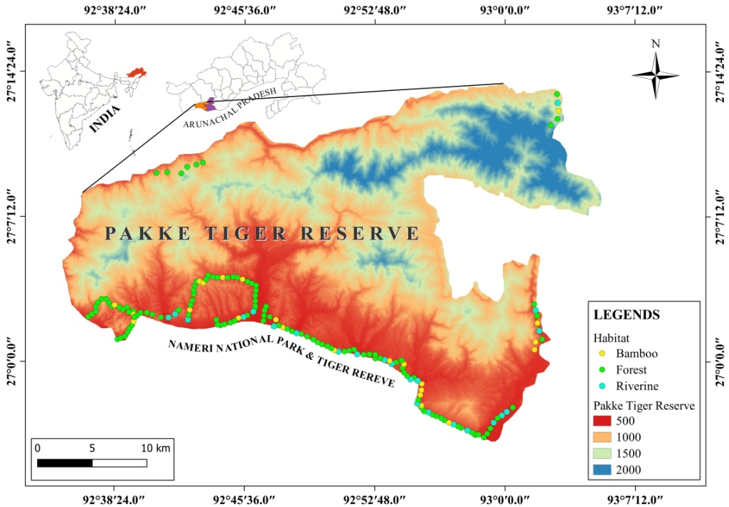
Figure 1. Study area map with sampling points in selected habitats.
- Methodology
The present study was carried out for two consecutive years from 2020 to 2021 on two major seasonal bases: pre-monsoon and post-monsoon season. The study locale was partitioned into three primary habitat classifications, contingent upon the presence of avian species. A systematic field survey was carried out using the point count distance sampling method (Bibby et al., 1992) to estimate the species diversity and population attributes of avifauna found across different selected habitat types. The point count distance sampling method is widely used to estimate biological populations' diversity, density and abundance. A total of 164 sampling points were laid in the entire landscape in selected habitat types (Forest; 109 points, Bamboo; 25 points, and Riverine; 30 points)
The quadrate sampling method as described by (Schemnitz, 1980) was used to assess the habitat structure and community characteristics of the trees found in the selected habitats of study site. Quadrates were placed in each point station or sampling points by considering the species-area richness curve in relatively leveled areas in selected habitats (viz. Forest, Riverine, bamboo dominated forest) (Photo plate 1) comprising the entire representative avian census area of PTR. Quadrate size of 10m X 10m was used the study of tree layer. In each quadrate, number of tree species and their individual, tree height, tree canopy cover using vertical-point intercept (Jennings et al., 1999) and Girth at Breast Height (GBH) in 1.37 m above from the ground was recorded.

Photo plate 1. Selected habitat types for estimating avian speices and their population
FOREST HABITAT
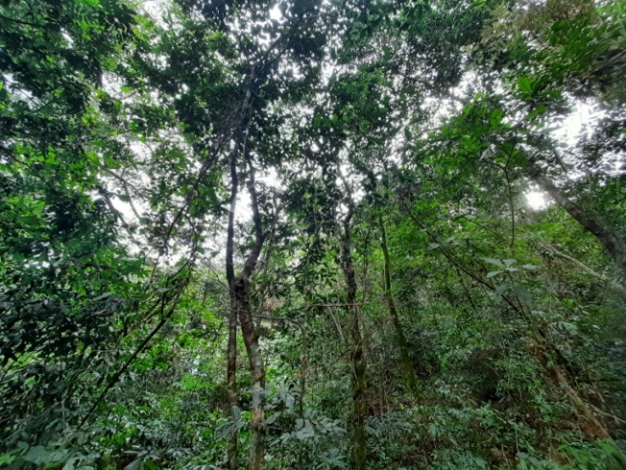 | 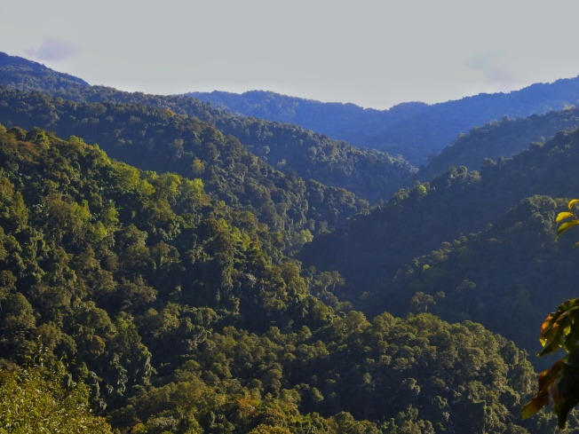
RIVERINE HABITAT
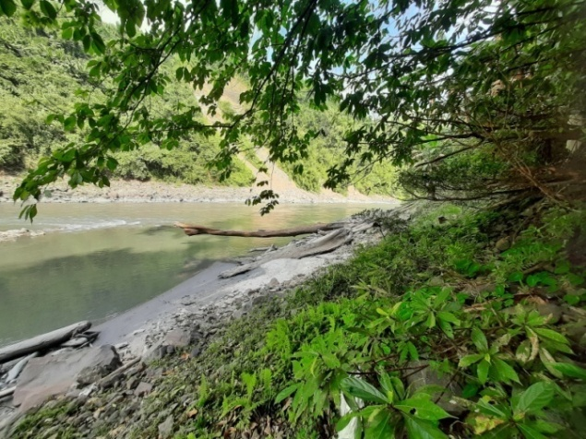 | 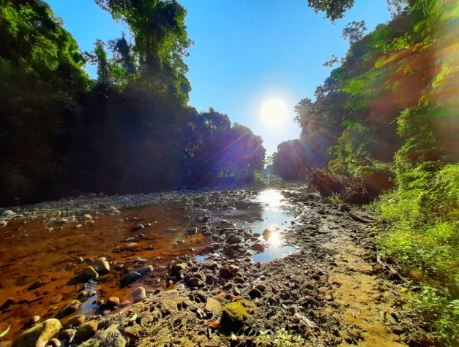
BAMBOO HABITAT
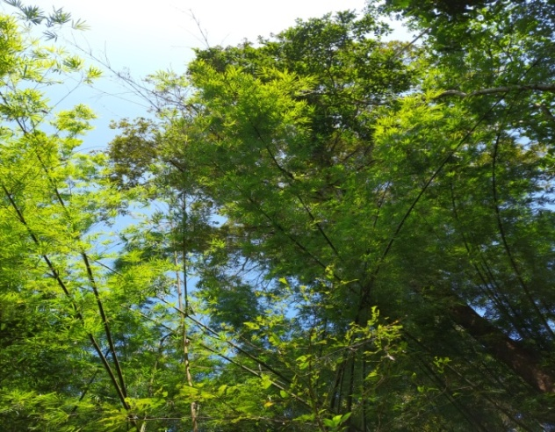 | 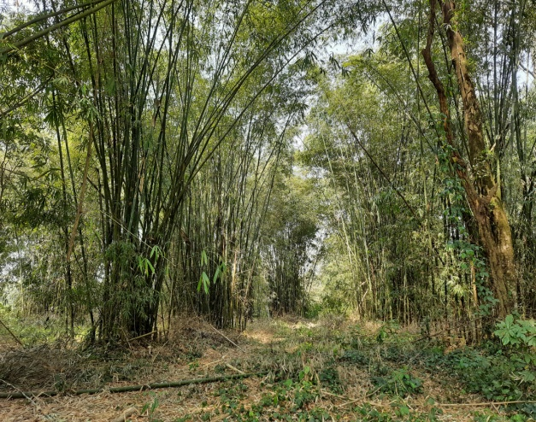
- RESULT
Overall 67 species of trees from 34 families were recorded during the study periods. The highest number of trees species with individuals was recorded in forest habitat (53 species, 426 individuals (4.35±0.84)), followed by riverine (35 species, 117 individual (1.6±0.34)) and least in bamboo habitat (10 species, 65 individual (0.23±0.07)). Family Malvaceae (9.5%, n=6) was recorded as the dominating family, followed by Meliaceae, Moraceae (7.9%, n=5 each), Burseraceae, Elaeocarpaceae, Fabaceae, Lauraceae, Magnoliaceae (6.3%, n=4 each), Achariaceae, Lythraceae, Phyllanthaceae, (3.2%, n=2 each), and rest of the family comprises only one individual of the species (1.49%, n=1 each).
The result reveals that the species richness of bird was found dominant in the forest habitat (169 species), followed by bamboo (123 species) and riverine (120), while 72 species shared all three habitats. However, when compared with two different habitats, it was found that forest and bamboo habitat had 98 common species, and forest and riverine habitat had 97 common species riverine and bamboo habitats had 80 common species (Fig. 2).
Riverine
(120)
Forest
(169)
Bamboo
(123)
98
80
97
72
Figure 2. Vein diagram showing the common bird species shared two different habitats.

- Seasonal variation in diversity indices of avifauna in selected habitats
Based on the selected habitats, species richness was recorded highest during post-monsoon season of the second year in forest habitats and lowest during pre-monsoon season of first year in riverine habitats because during post-monsoon many migratory bird species coming to the Pakke Tiger Reserve as many bird species follow the Pakke river for migration such as Black-necked Stork, Ibis Bill, Common Merganser etc. Shannon diversity index (H) was highest during post-monsoon season of second year in forest habitat (3.93), whereas it was lowest during post-monsoon season of the first year in riverine habitat (3.32). Simpson diversity index results revealed that the highest diversity during post-monsoon season of second year in bamboo habitats (0.97) and lowest during pre-monsoon season of first year in forest habitats (0.92). Dominance was highest (0.078) during pre-monsoon season of first year in forest habitats and lowest (0.031) during post-monsoon season of the second year in the bamboo habitat. The species evenness was recorded the highest (0.65) during post-monsoon season in the second year and lowest (0.24) during pre-monsoon in the first year (Table 1).

Table 1. Variation in diversity indices in different habitats
 | Habitat | Dominance | Simpson | Shannon | Evenness
Pre-monsoon 2020 | Bamboo | 0.063 | 0.94 | 3.56 | 0.42
 | Forest | 0.078 | 0.92 | 3.39 | 0.24
 | Riverine | 0.053 | 0.95 | 3.47 | 0.50
Post-monsoon 2020 | Bamboo | 0.040 | 0.96 | 3.64 | 0.57
 | Forest | 0.075 | 0.93 | 3.55 | 0.27
 | Riverine | 0.073 | 0.93 | 3.32 | 0.40
Pre-monsoon 2021 | Bamboo | 0.054 | 0.95 | 3.43 | 0.45
 | Forest | 0.066 | 0.93 | 3.61 | 0.28
 | Riverine | 0.057 | 0.94 | 3.52 | 0.48
Post-monsoon 2021 | Bamboo | 0.031 | 0.97 | 3.80 | 0.65
 | Forest | 0.042 | 0.96 | 3.93 | 0.39
 | Riverine | 0.044 | 0.96 | 3.68 | 0.53

- Seasonal variation in density of birds in selected habitat
The highest group density recorded during pre-monsoon season of first year in the bamboo habitat (71.47±10.89/km²) and the lowest during pre-monsoon season of the second year in the riverine habitat (27.065±3.42/km²). Whereas the highest individual density was recorded in the pre-monsoon season of first year in bamboo habitat (516.78±78.83/km²) and the lowest in the pre-monsoon of second year in riverine habitat (274.25±34.81/km²) (Table 2). Overall, detection probability was a maximum (85.3%) in the second year of pre-monsoon season in riverine habitat and minimum (38.7%) in the first year of pre-monsoon in Bamboo.
In bamboo habitat, detection probability was lowest in pre-monsoon season of the first year and highest in post-monsoon season of first year (Table 2), whereas in the forest habitat lowest detection probability was recorded in pre-monsoon season of the first year and highest in the post-monsoon season of the second year with respect to radial distance (Table 2). In case of riverine habitat bird detection probability was the highest in the pre-monsoon season of second year and lowest in post-monsoon season of first year with respect to radial distance (Table 2).
Table 2. Seasonal variation of bird species detection probability, density of cluster, density, effective density radius, and encounter rate in selected habitats
Season | Habitat | DP | ER | DS | D | EDR
Pre-Monsoon 2020 | Bamboo | 38.7 | 61.2 | 71.47±10.89 | 516.78±78.83 | 21.18±1.0
 | Forest | 52.2 | 47.4 | 57.72±4.05 | 413.77±29.05 | 21.66±0.54
 | Riverine | 65.9 | 33.8 | 42.28±5.56 | 337.83±44.55 | 23.49±1.25
Post-Monsoon 2020 | Bamboo | 77.2 | 21.6 | 60.79±7.06 | 424.16±49.58 | 21.24±1.09
 | Forest | 61.0 | 38.6 | 55.43±3.49 | 430.81±27.26 | 23.22±0.57
 | Riverine | 65.0 | 34.4 | 46.61±5.95 | 363±46.54 | 22.98±1.18
Pre-Monsoon 2021 | Bamboo | 65.1 | 34.6 | 54.69±6.97 | 429.24±54.8 | 23.54±1.22
 | Forest | 65.7 | 33.8 | 55.61± 3.31 | 432.81±25.88 | 23.73±0.57
 | Riverine | 85.3 | 14.0 | 27.06±3.42 | 274.25±34.81 | 31.31±1.83
Post-Monsoon 2021 | Bamboo | 73.6 | 24.8 | 55.79±6.69 | 394.99±47.77 | 22.91±1.18
 | Forest | 68.1 | 31.2 | 56.69±3.27 | 448.66±26.01 | 23.87±0.57
 | Riverine | 81.0 | 18.2 | 35.9±4.22 | 332.51±39.25 | 28.04±1.49
DP= Detection probability, DS= Density of cluster (Number/km²), D= Density of individual (Number/km²), EDR= Effective density radius (m), ER= Encounter rate (individual/km)

Correlation analysis was carried out between seven habitat variables and bird species richness. Findings of the present study revealed a strong positive correlation between the number of tree individuals with the number of bird species and a number of bird individuals. Whereas GBH and height showed a negative correlation with the number of bird species and number of bird species individuals (Table 3).
Table 3. Correlation matrix between habitat variables and bird species and individuals
Variable | Tree_  Species | Tree_Ind | GBH | Height | Crown_  cover | Bird_  species | Bird_Ind
Tree_Species | 1
Tree_Ind | 0.885 | 1
GBH | -0.792 | -0.417 | 1
Height | -0.641 | -0.211 | 0.976 | 1
Crown_cover | 0.892 | 1.00** | -0.430 | -0.224 | 1
Bird_species | 0.855 | 0.998* | -0.360 | -0.150 | 0.997* | 1
Bird_Ind | 0.820 | 0.992 | -0.300 | -0.087 | 0.990 | 0.998* | 1
** Correlation 0.01 level (2-tailed)
* Correlation 0.05 level (2-tailed)

Principal component analysis (PCA) was carried out on seven standardized habitat variables (Fig. 3) and resulted in the extraction of principal components (Eigenvalues greater than 1) that collectively explained 74.23% of the total variation in the habitat variables. The study reveals that the relationship between avifauna species richness and habitat patterns/structure addresses the effects of habitat variables on avian species richness and distribution patterns (Fig. 3).
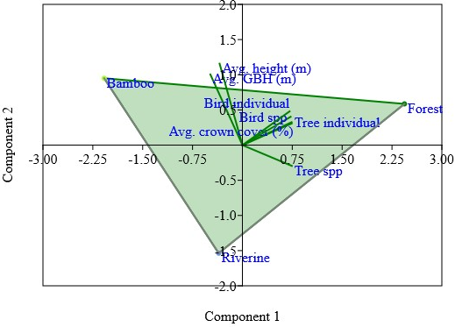
Figure 3. Principle component analysis showing interaction between all the dependent and independent variables.

Birds are dependent on trees for various activity such as nesting, feeding, roosting and foraging. So five variables of trees were taken to understand bird dependency on tree species. The hypothesis tested tree species, tree individual, tree crown cover, GBH and height carries a significant impact on bird species richness. These results clearly direct the positive effect of the overall independent variables. The dependant variable (bird species richness) was showing significant impact with overall independent variables, F_{6,14}=2.89, p=0.05, which indicates that the all-independent variables can play a significant role in increasing bird species richness (Table 4). The hypothesis tested proves that with low numbers of tree bird population will decrease because they are fully dependent on tree species.
Table 4. Descriptive results of one-way ANOVA
Source of Variation | SS | df | MS | F | P-value | F crit
Between Groups | 31142362.59 | 6 | 5190393.76 | 2.88698 | 0.047884 | 2.847726
Within Groups | 25170075.16 | 14 | 1797862.51
Total | 56312437.74 | 20
*SS- sum of square, df- degree of freedom, MS- mean square, F crit - F critical

- Discussion
Bird species mainly depend on trees for nesting, feeding and foraging. The present study maximized sampling points in the forest habitat because of the low detection of species in the dense forest compared to the bamboo and riverine habitat. Consequently, maximum bird species were recorded in the forest habitat, followed by the riverine and bamboo habitat. In the present study, Tetrameles nudiflora was the dominant tree species in the forest habitat, which is used by hornbills and many other birds for nesting, such as woodpeckers, mynas, barbet, roller birds & parakeets. Tetrameles Nudiflora is flowering and fruiting from March to May (Page et al., 2022) and provides a foraging place for many seasonal birds.
On the other hand, Duabanga grandiflora is dominated in riverine and bamboo habitats. This tree is used as camaflouge hide by green colour birds and birds of prey and used for nesting and foraging activities by small bird species. The presence of avian species in specific trees is contingent upon the particular attributes of these trees, including their height, canopy surface, crown density, and the presence of flowers and berries (Zwarts et al., 2015). Forest-dwelling birds typically make their habitat selection for breeding based on the overarching vegetational characteristics (Hilden, 1965; Klopfer & Hailman, 1965; James, 1971; Robinson & Holmes, 1982; Smith & Shugart, 1987). James (1971) coined the term "niche gestalt" to describe the characteristic vegetational profile associated with the breeding territories of individual species. The concept of the niche gestalt has proven to be invaluable in the field of avian ecology, as it can be easily quantified using straightforward measures of vegetation structure and synthesized through the application of multivariate statistical techniques (James, 1971; Capen, 1981).
In the current scholarly investigation, it is worth noting that the preeminent assemblage of avian species was documented within the forested habitats. This occurrence may be attributed to the characteristic conduct of avian denizens of the forest, who diligently safeguard their breeding territories, thus ensuring the availability of propitious nesting sites (Martin, 1971; Zimmerman, 1971; Calder, 1973), bountiful foraging grounds (Partridge, 1976), and an abundance of prey (Miller, 1931; Howell, 1952; Stenger & Falls, 1959; Cody, 1968). Consequently, it becomes apparent that the term "habitat" encompasses a broader spectrum of niche dimensions, including trophic relationships, and can be construed as a foundational wellspring of resources for avian species dwelling in forested environs, aligning with the principles elucidated by Grinnell (1917) and Hutchinson (1957).
It is noteworthy that avian creatures' reliance on their surroundings extends beyond the realm of mere survival necessities, encompassing a psychological affinity for specific landscapes (Von Haartman, 1948; Bergman, 1946; Fabricius, 1951). Furthermore, it is imperative to acknowledge that each plant species exhibits distinct phenological patterns, intricately influenced by climatic factors and evolutionary processes (Silva et al., 2011). These phenological events, in turn, wield a pivotal influence in determining the reproductive success of flora (Carvalho & Sartori, 2015).
The drastic change in the phonological condition of the particular region could be attributed to climate change or periodic drought, flood, or genetic factors affecting the avifauna species.

REFERENCES
[1] A. Berg, and T. Pärt, “Abundance of breeding farmland birds on arable and set aside fields at forest edges. Ecography, Vol. 17(2), pp. 147-152, 1994.
[2] A.M. Ramchandra, (2013). Diversity and richness of bird species in newly formed habitats of Chandoli National Park in Western Ghats, Maharashtra State, India. Biodiversity Journal, Vol. 4 (1), pp. 235-242, 2013.
[3] B.B.Steele, R.L. Bayn Jr, and C.V. Grant, “Environmental monitoring using populations of birds and small mammals: analyses of sampling effort,” Biological Conservation, Vol. 30(2), pp. 157-172, 1984.
[4] BirdLife International, “State of the world’s birds: taking the pulse of the planet. Cambridge, UK: BirdLife International,” https://www.birdlife.org/papers-reports/state-of-the-worlds-birds, 2018.
[5] Ç.H. Şekercioğlu, G.C. Daily, and P.R. Ehrlich, “Ecosystem consequences of bird declines” Proceedings of the National Academy of Sciences, Vol. 101(52), pp. 18042-18047, 2004.
[6] C.J., Bibby, N.J. Collar, M.J. Crosby, M.F. Heath, C. Imboden, T.H. Johnson, and S.J. Thirgood, “Putting biodiversity on the map: priority areas for global conservation,” International Council for Bird Preservation, Cambridge, United Kingdom, 1992, pp. 90.
[7] D.B. Lindenmayer, C.R. Margules, and D.B. Botkin, “Indicators of biodiversity for ecologically sustainable forest management,” Conservation biology, Vol. 14(4), pp. 941-950, 2000.
[8] D.E. (Ed.) Capen, “The use of multivariate statistics in studies of wildlife habitat (Vol. 87). Rocky Mountain Forest and Range Experiment Station, Forest Service, US Department of Agriculture, Vol. 87, pp. 249, 1981.
[9] D.E. Chamberlain, J.A. Vickery, D.E. Glue, R.A. Robinson, G.J. Conway, R.J.W. Woodburn, and A.R. Cannon, “Annual and seasonal trends in the use of garden feeders by birds in winter,” Ibis, Vol. 147, pp. 563-575, 2005.
[10] E. Fabricius, “Some experiments on imprinting phenomena in ducks,” Proceedings of the Tenth International Ornithological Congress, Vol. 10, pp. 375-379, 1951.
[11] F.C. James, (1971),” Ordinations of habitat relationships among breeding birds,” The Wilson Bulletin, Vol. 83(3), pp. 215-236, 1971.
[12] F.C. James, and N.O. Wamer, “Relationships between temperate forest bird communities and vegetation structure,” Ecology, Vol. 63(1), pp. 159-171, 1982.
[13] F.S. Carvalho, and A.L. Sartori, “Reproductive phenology and seed dispersal syndromes of woody species in the Brazilian Chac,”. Journal of Vegetation Science, Vol. 26(2), pp. 302-311, 2015.
[14] G. Bergman, “Der Steinwalzer, Arenaria i. interpres L., in seiner Beziehung zur Umwelt,” Acta zoologica Fennica, Vol. 47, pp. 1-143, 1946.
[15] G. Bideberi, “Diversity, distribution and abundance of avifauna in respect to habitat types: a case study of Kilakala and Bigwa, Morogoro Tanzania,” (Doctoral dissertation, Sokoine University of Agriculture), 2013, pp. 53.
[16] G.E. Canterbury, T.E. Martin, D.R. Petit, L.J. Petit, and D.F. Bradford, “Bird communities and habitat as ecological indicators of forest condition in regional monitoring,” Conservation Biology, Vol. 14(2), pp. 544-558, 2000.
[17] G.E. Hutchinson, “Concluding remarks. Cold Spring Harbor Symp,” Quantitative Biology, Vol. 22, pp. 415-427, 1957.
[18] H.G. Champion, and S.K. Seth, A revised survey of the forest types of India, Government of India Press, New Delhi, 1968, pp. 404.
[19] I.A. Silva, D.M. da Silva, G.H. de Carvalho, and M.A. Batalha, “Reproductive phenology of Brazilian savannas and riparian forests: Environmental and phylogenetic issues,” Annals of Forest Science, Vol. 68(7), pp. 1207–1215, 2011.
[20] J. Grinnell, “The niche-relationships of the California thrasher,” Auk, Vol. 34, pp. 427-433, 1917.
[21] J. Mistry, and A. Mukherjee, “Status and threats of waterbirds in Ahiran Lake, Murshidabad, West Bengal, India,” International Journal of Plant, Animal and Environmental Sciences, Vol. 5, pp. 59-64, 2015.
[22] J. Stenger, and J.B. Falls, “The utilized territory of the ovenbird,” Wilson Bulliton, Vol. 71, pp. 125, 1959.
[23] J. Tews, U. Brose, V. Grimm, K. Tielbörger, M.C. Wichmann, M. Schwager, and F. Jeltsch, “Animal species diversity driven by habitat heterogeneity/diversity: The importance of keystone structures,” Journal of Biogeography, Vol. 31(1), pp. 79–92, 2004.
[24] J.L. Zimmerman, “The territory and its density-dependent effect in Spiza amnericania,” The Auk, Vol. 88(3), pp. 591-612, 1971.
[25] J.T. Rotenberry, and J.A. Wiens, “Habitat relations of shrub steppe birds: a 20-year retrospective habitat” The Condor, Vol. 111, pp. 401-413, 2009.
[26] J.W. Wilson, “Analytical zoogeography of North American mammals,” Evolution, Vol. 28(1), pp. 124-140, 1974.
[27] K.L. O'Hara, P.A. Latham, P. Hessburg, and B.G. Smith, “A structural classification for inland northwest forest vegetation. Western Journal of Applied Forestry,” Vol. 11, pp. 97-102, 1996.
[28] L. Zwarts, R.G. Bijlsma, J. van der Kamp, M. Sikkema, and E. Wymenga, “Moreau’s Paradox reversed, or why insectivorous birds reach high densities in savanna trees,” Ardea, Vol. 103, pp. 123–144, 2015.
[29] M. Palmer, E. Bernhardt, E. Chornesky, S. Collins, A. Dobson, C. Duke, and M. Turner, “Ecology for a crowded planet, Science,” Vol. 304(5675), pp. 1251-1252, 2004.
[30] M.L. Cody, “On the methods of resource division in grassland bird communities,” The American Naturalist, Vol. 102(924), pp. 107-147, 1968.
[31] N. Burgess, N. Doggart, and J.C. Lovett, “The Uluguru Mountains of eastern Tanzania: the effect of forest loss on biodiversity,” Oryx, Vol. 36(2), pp. 140-152, 2002.
[32] N. Chettri, E. Sharma, and D.C. Deb, “Bird community structure along a trekking corridor of Sikkim Himalaya: a conservation perspective,” Biological Conservation, Vol. 102(1), pp. 1-16, 2001.
[33] N. Myers, “The biodiversity challenge: expanded hot-spots analysis,” Environmentalist, Vol. 10(4), pp. 243-256, 1990.
[34] N. Page, A. Datta, and B. Basu, Trees of Arunachal Pradesh: A field guide, Nature Conservation Foundation, 2022, pp. 591.
[35] O. Hildén, “Habitat selection in birds: a review. In Annales Zoologici Fennici Finnish Zoological and Botanical Publishing Board,” Vol. 2(1), pp. 53-7, 1965.
[36] P.H. Klopfer, and J.P. Hailman, “Habitat selection in birds,” Advances in the Study of Behavior, Vol. 1, pp. 279-303, 1965.
[37] R.C. Atwell, L.A. Schulte, and B.J. Palik, “Songbird response to experimental retention harvesting in red pine (Pinus resinosa) forests,” Forest Ecology and Management, Volume 255(10), pp. 3621-3631, 2008.
[38] R.H. MacArthur, and J.W. MacArthur, “On bird species diversity,” Ecology, Vol. 42, pp. 594-598, 1961.
[39] R.R. Roth, “Spatial heterogeneity and bird species diversity,” Ecology, Vol. 57(4), pp. 773-782, 1976.
[40] R.S. Black, “Social and economic impacts of tourist lodges on local communities: Case studies from Rwanda and Botswana,” Institute for Land, Water and Society, Charles Sturt University, Albury-Wodonga,”. Report to the African Wildlife Foundation, 2015, pp. 114.
[41] S. Sidra, Z. Ali, and M.N. Chaudhry, “Avian diversity at new campus of Punjab University in relation to land use change,” Pakistan Journal of Zoology, Vol. 45(4), pp. 1069-1082, 2013.
[42] S. Subramanya, “Distribution, status and conservation of Indian heronries,” Journal of the Bombay Natural History Society, Vol. 93(3), pp. 459-486, 1996.
[43] S.B. Jennings, N.D. Brown, and D. Sheil, “Assessing forest canopies and understory illumination: canopy closure, canopy cover and other measures,” Forestry, Vol. 72(1), pp. 59- 73, 1999.
[44] S.D. Schemnitz, Wildlife management techniques manual, Fourth edition: The Wildlife Society Bethesda, Md.,1980 pp. 686.
[45] S.G. Martin, Polygyny in the bobolink: habitat quality and the adaptive complex. Ph.D. Thesis, Oregon State University, Corvallis, 1971.
[46] S.J.K. Hadley, A.S. Hadley, and M. Betts, “Acoustic classification of multiple simultaneous bird species: A multi- Instance multi- label approach,” Journal of Acoustical Society of America, Vol. 131(6), pp. 4640- 4650, 2012.
[47] S.K. Robinson, and R.T. Holmes, “Foraging behavior of forest birds: the relationships among search tactics, diet, and habitat structure,” Ecology, Vol. 63(6), pp. 1918-1931, 1982.
[48] S.M. Lohr, S.A. Gauthreaux, and J.C. Kilgo, “Importance of coarse woody debris to avian communities in loblolly pine forests,” Conservation Biology, Vol. 16(3), pp. 767-777, 2002.
[49] T.J. O'Connell, L.E. Jackson, and R.P. Brooks, “Bird guilds as indicators of ecological condition in the central Appalachians,” Ecological Applications, Vol. 10(6), pp. 1706-1721, 2000.
[50] T.M. Smith, and H.H. Shugart, “Territory size variation in the ovenbird: the role of habitat structure,” Ecology, Vol. 68(3), pp. 695-704, 1987.
[51] T.R. Howell, “Natural history and differentiation in the yellow-bellied sapsuckmer,” Condor, Vol. 54, pp. 237-282, 1952.
[52] T.R. Raman, G.S. Rawat, and A.J.T. Johnsingh, “Recovery of tropical rainforest avifauna in relation to vegetation succession following shifting cultivation in Mizoram, north‐east India,” Journal of Applied Ecology, Vol. 35(2), pp. 214-231, 1998.
[53] Von Haartman, L. (1948). Eine Methode zum vergleichenden Studium der optischen Wahrnehmungsfähigkeit höherer Tiere. Behaviour, Vol. 1(1), pp. 35-55.
[54] W.A. Calder, “Microhabitat selection during nesting of hummingbirds on the Rocky Mountains,” Ecology, Vol. 54. Pp. 127-134, 1973.
[55] Z.S. Chen, C.F. Hsieh, F.Y. Jiang, T.H. Hsieh, and I.F. Sun, “Relations of soil properties to topography and vegetation in a subtropical rain forest in southern Taiwan.” Plant Ecology, Vol. 132(2), pp. 229-241, 1997.

Appendix 1. Checklist of Tree species of Pakke Tiger Reserve with their abundance in selected habitat
S. N. | Tree species | Family | Forest | Riverine | Bamboo
1. | Gynocardia odorata R. Br. | Achariaceae | 0 | 1 | 0
2. | Saurauia roxburghii Wall. | Actinidiaceae | 0 | 1 | 0
3. | Liquidambar excelsa (Noronha) Oken | Altingiaceae | 0 | 3 | 0
4. | Litsea glutinosa (Lour.) C.B. Rob. | Altingiaceae | 1 | 0 | 0
5. | Rhus chinensis Mill. | Anacardiaceae | 1 | 0 | 0
6. | Polyalthia simiarum (Buch. Ham. ex Hook.f. & Thomson) Hook.f. &Thomson | Annonaceae | 2 | 0 | 0
7. | Brassaiopsis glomerulata (Blume) Regel | Araliaceae | 2 | 0 | 0
8. | Livistona jenkinsiana Griff. | Arecaceae | 3 | 1 | 0
9. | Stereospermum chelonoides (L. fil.) DC. | Bignoniaceae | 4 | 4 | 0
10. | Ehretia acuminata R. Br. | Boraginaceae | 1 | 0 | 0
11. | Canarium resiniferum Bruce ex King | Burseraceae | 23 | 2 | 0
12. | Canarium strictum Roxb. | Burseraceae | 3 | 0 | 0
13. | Garuga floribunda Decne. | Burseraceae | 0 | 2 | 0
14. | Garuga pinnata Roxb. | Burseraceae | 1 | 0 | 0
15. | Mesua ferrea L. | Calophyllaceae | 2 | 0 | 0
16. | Crateva religiosa G. Forst. | Capparaceae | 5 | 0 | 0
17. | Terminalia myriocarpa Van Heurck & Mull. Arg. | Combretaceae | 7 | 11 | 3
18. | Dillenia indica L. | Dilleniaceae | 14 | 8 | 1
19. | Dipterocapus retusus Blume | Dipterocarpaceae | 0 | 1 | 0
20. | Elaeocarpus aristatus Roxb. | Elaeocarpaceae | 6 | 4 | 0
21. | Elaeocarpus robustus Roxb. | Elaeocarpaceae | 0 | 1 | 0
22. | Sloanea sterculiacea (Benth.) Rehder & E. H. Wilson | Elaeocarpaceae | 2 | 1 | 0
23. | Glochidion assamicum (Mull. Arg.) Hook.f. | Euphorbiaceae | 1 | 0 | 0
24. | Macaranga denticulata (Blume) Mull. Arg. | Euphorbiaceae | 2 | 3 | 0
25. | Albizia procera (Roxb.)Benth. | Fabaceae | 5 | 1 | 2
26. | Bauhinia purpurea L. | Fabaceae | 1 | 0 | 0
27. | Bauhinia racemosa L. | Fabaceae | 5 | 0 | 0
28. | Bauhinia variegata L. | Fabaceae | 3 | 3 | 0
29. | Altingia excelsa Noronha | Hamamelidaceae | 7 | 6 | 0
30. | Gmelina arborea Roxb.ex Sm. | Lamiaceae | 1 | 0 | 0
31. | Beilschmiedia assamica Meisn. | Lauraceae | 1 | 0 | 0
32. | Cinnamomum bejolghota (Buch. Ham.) Sweet | Lauraceae | 1 | 0 | 0
33. | Phoebe attenuata (Nees) Nees | Lauraceae | 3 | 0 | 0
34. | Phoebe cooperiana P.C. Kanjilal & Das | Lauraceae | 2 | 0 | 0
35. | Duabanga grandiflora (Roxb. Ex DC.) Walp. | Lythraceae | 11 | 15 | 2
36. | Lagerstroemia parviflora Roxb. | Lythraceae | 2 | 3 | 0
37. | Magnolia champaca (L.) Baill. ex Pierre | Magnoliaceae | 2 | 0 | 0
38. | Magnolia hodgsonii (Hook.f. & Thomson) | Magnoliaceae | 30 | 3 | 0
39. | Michelia oblonga Wall. ex Hook.f. & Thomson | Magnoliaceae | 0 | 1 | 0
40. | Bombax Ceiba L. | Malvaceae | 1 | 0 | 0
41. | Pterospermum acerifolium (L.) Willd. | Malvaceae | 20 | 1 | 2
42. | Sterculia lanceolata Cav. | Malvaceae | 0 | 1 | 0
43. | Sterculia villosa Roxb. ex Sm. | Malvaceae | 1 | 0 | 0
44. | Sterculia alata Roxb. | Malvaceae | 4 | 3 | 0
45. | Sterculia hamiltonii (Kuntze) Adelb. | Malvaceae | 2 | 0 | 0
46. | Aglaia spectabilis (Miq) S.S.Jain & Bennet | Meliaceae | 14 | 4 | 0
47. | Amoora wallichi King | Meliaceae | 0 | 1 | 0
48. | Chukrasia tabularis A. Juss | Meliaceae | 1 | 1 | 0
49. | Dysolxylum gotadhora (Buch. Ham.) Mabb. | Meliaceae | 22 | 2 | 1
50. | Aglaia sp. Lour. | Meliaceae | 2 | 0 | 0
51. | Artocarpus chaplasha Roxb. | Moraceae | 4 | 0 | 0
52. | Ficus auriculata L. | Moraceae | 0 | 1 | 0
53. | Ficus Benghalensis L. | Moraceae | 1 | 0 | 0
54. | Ficus religiosa L. | Moraceae | 1 | 0 | 0
55. | Ficus sp | Moraceae | 3 | 3 | 0
56. | Horsfieldia kingii (Hook. F.) Warb. | Myristicaceae | 1 | 3 | 0
57. | Syzygium spp. | Myrtaceae | 2 | 9 | 2
58. | Chionanthus macrophyllus (Wall. Ex G. Don) Blume | Oleaceae | 1 | 0 | 0
59. | Baccaurea ramiflora Lour. | Phyllanthaceae | 2 | 0 | 0
60. | Bridelia retusa(L.) A. Juss. | Phyllanthaceae | 1 | 0 | 0
61. | Micromelum integerrimum (Roxb. ex DC) Wight & Arn. ex M.Roem. | Rutaceae | 1 | 0 | 0
62. | Meliosma pinnata (Roxb.) Walp. ssp. barbulata (Cufod.) Beus. | Sabiaceae | 1 | 0 | 0
63. | Ailanthus grandis Prain | Simaroubaceae | 5 | 1 | 0
64. | Tetrameles nudiflora R. Br. | Tetramelaceae | 33 | 4 | 1
65. | Elaeocarpus obtusifolius Merr. | Tiliaceae | 0 | 0 | 1
66. | Dendrocnide sinuata (Blume) Chew | Urticaceae | 5 | 0 | 0
67. | Laportea crenulata Gaud. | Urticaceae | 1 | 0 | 0

