IIP ID : IIPER1680583741
11. Purpose Driven Business
Dr.Rajinder Shriram Aurora

11.0 Introduction:
Every business entity is started for attaining some pre-conceived purpose. Its aim is to pursue and attain this purpose so that all the stakeholders benefit as a result of the activity undertaken by the entity. We are required to ascertain an answer a simple question in this regard “What is a purpose-driven company?" Through this simple question, we try to describe the organizations activities and products it manufactures the benefits it offers to the society and provide some steps that can be taken to promote the main purpose of the entity and attain them comfortably. In this chapter we make an attempt to understand the concept and other related issues encountered by the entity.
11.2 Meaning of Purpose Driven Business:
A purpose-driven company is an entity that effectively integrates a social or political or commercial message or vision framed to define its activities and work. The company's beliefs regarding the issue that can influence its policies, goals, daily work procedures and interactions with customers and other stakeholders. For Example, a company may decide to donate a certain percentage of all sales to a cause it cares about. A Purpose-driven company can integrate the beliefs into employee policies such as benefits, volunteer opportunities or continuing education sessions. Like Nihar Hair Oil producers have a purpose that 50% of their earnings would be spent on Girl Education. This is one small purpose for the very existence of the business organization.
The purpose-driven company is becoming being discussed increasingly in today’s set up because it permits the company to combine its financial gains and human qualities effectively and this helps the entity to become realistically future-oriented and drive its growth.

11.3 What is a purpose-driven company?
In order to understand what a purpose driven company in its true perspective one should first distinguish between business, vision, and purpose. All three terms actually exist within the company itself.
A Vision refers to the organization's image of the future and highlights the direction that the company wishes to take by anticipating this same future. The question one needs to ask is What?
The company's activity should correspond to the work or activities it undertakes on a daily basis and the means that are added to achieve the decided vision. The question one needs to ask is How?
The fact is these two factors can change and evolve according to factors such as management decisions; competition, etc. play an important role in evolving the organization to the next level.
The purpose is to understand the reasons why an organization exists and it’s the motivations that move it forward. It, therefore, refers to the ethical aspect and pursued values of the company. These are timeless because they remain the same regardless of changes that occur within and around the organization. The common question asked here is Why?

11.4 What do Purpose driven entities try to do and attain in reality?
A purpose driven organization, strive hard to include all the strategies that are adopted by them to indicate and reflect the main ideals for which the entity actually exists in the market. Some of these ideals can be stated clearly and methodically as:
- Willingly donating a portion of their revenue for a relevant social cause like the example of Nihar Hair oil discussed above and for other philanthropic activities.
- Offering employees enhanced financial support such as tuition fees reimbursement or family medical benefits. This is done by most Indian entities like TATA group, Reliance Group, Adani Group, etc. These benefits that is so critical for their well-being
- Focusing on the consumer education that are surrounded by critical topics that take care of the entire organizational growth and benefits
- The organizations should do lobbying to the politicians for support in relevant legislature issues so that the business environment gets friendly for them. .
- The aim of these organizations should be to offer a solid platform for various activists or leaders to share their relevant perspectives openly.
- They should take a pledge to minimize corporate or industrial impacts in the future so that such organizations do not face any hurdles in its progress.
- To successfully integrate all ideals into product manufacturing and distribution that could satisfy the stakeholder’s needs.
- Creating customer policies that align with the organizational ideals and help it succeed in all respects.
- Providing continuing education and awareness on various social issues and policy that are
utterly beneficial for the employees and other stakeholders.

11.5 The Emergence of the purpose-driven company Status:
Every mission-driven enterprise is not new but has got genuinely conceptualized and originated in the U.S. in the 21st century and subsequently the thoughts spread to other countries. Since 2010, it has been a "purpose" driven activity stated in the company's articles of association and accordingly pursued to indicate the company is committed to achieve the vision and mission successfully.

11.6 The principle of every purpose-driven company: They commonly pursued principles include the following:
(i) Although the exact definition of a purpose-driven company may vary slightly from one country to another or one state to another, the term generally refers to organizations that aim to reconcile their economic performance with the general interest of the society.
(ii) Beyond its long pursued profit-making purposes, the purpose-driven organization wants to be relevant and helpful for every social and environmental goal. It aims at making profit and also contributes to something more splendidly and deeply centered on the welfare of human beings. This clearly states and highlights its purpose and does not hesitate to encourage people to act alongside it so that the visions are not lost sight of by the company.
(iii) Being a company with a mission, tries to go far beyond a simple initiative so that the organizational focus is not last and it does not loss its focus. It is about trying to fully integrate the purpose in question, that aims at infusing it into every action, product/service, and stakeholder of the proposed organization. In fact it should be so deeply included that it looks like a part of their DNA.

11.7 Why the purpose-driven companies are becoming important, relevant and critical in the modern environment

A global study reflects this:
A study done by Ernst and Young and the Said Business School at Oxford University concluded that all the public conversations, its importance and relevance of purpose increased five-fold in a short span of between 1995 and 2014. If one goes through the details one finds the numbers speak for themselves.
The Communications agency Zeno undertook and conducted a global study on purpose-driven businesses in 2020 that was termed and identified as the 2020 Zeno Strength of Purpose. It contained a panel of around 8,000 consumers from eight countries. The results were found to be pretty compelling and they show that the companies with a mission are highly valued by the public. The same details are stated herein under:
- 4 times more consumers have expressed their desire to buy from mission-based companies.
- Further it was found that consumers are 6 times more likely to protect the purpose-driven company in case of a mis-step or public criticism made against these entities.
- They are 4.5 times more likely to advocate the mission-driven company and recommend it to friends and family for their requirements.
- They are again 4.1 times more likely to trust a purpose-driven company under normal circumstances.
11.8 Public Enthusiasm towards purpose Driven Business:
Some reasons for the growing public enthusiasm towards public driven business include:

Increasing trend of Lack of Trust:
It has been a common observation in this regard that, there has been an increasing and growing loss of consumer trust in the businesses and customers feel the business do not share all the facts and are just exiting for taking them for a ride and misleading them in every aspect. They feel this is particularly true for the new generation that looks for values to hold on to the entity and not just their products/ services to buy. But they explore and try t understand their vision and the purpose they intend to pursue in the long-run.

Increasing awareness levels on various Social Issues:
The prevalent social inequalities and salary gaps between the top management and other employees are increasing unabated in all types of business entities across the globe. The top level is constantly working for their betterment and do not worry about their subordinates compensation. They give an arrogant reason difference in skills, experience and expertise. On many occasion the qualification factor is overlooked. Here the consumers want to invest in companies that have a social impact and are fair and respectful of human and prevailing working conditions within themselves. It is obvious that the employees prefer and demand a balance and fairness in remuneration and prefer that the entity recognizes and gives them their fair value.

Sustainability:
Frequent climate changes are increasingly affecting the consciousness of the employees and consumers. Many consumers appreciate the fact that businesses often impact the environment adversely and never try to act at their level by turning the companies towards making investment in sustainable development. This is done only when the country passes a law and makes it legally mandatory and start imposes penalty for damaging the environment.
- Adoption of unfair business practices:
It is commonly noticed that business adopt unfair and unethical business practices that benefit only the company and ignores the interest of other stakeholders, creating a dissatisfaction for the entity. Issues like good quality input resulting in good quality outputs, lack of punishment for use of unethical business practices, increasing number of sexual harassment cases, punish the non guilty and acquitting the guilty is a common observation. This creates a lot of frustration in the mind of the stakeholder who feel they are not getting a fair treatment.

11.9 How the purpose contributes to the success of the company:

It is important to understand how the concept of Purpose driven organization contributes to the success of the company in the long run. While trying to understand this aspect the following points strike a chord between what the companies do and what the stakeholders expect from the entity. The purpose in short acts as a true catalyst for the company and it positively impacts several levels and activities within the organization and influences the stakeholders too.

Employee motivation:
A purpose-driven organization surely motivates the employees and increases their engagement by playing on the need and sense to belongingness to the entity and on the personal desire to participate in the entity as a whole. This results in the members of such an organization to collaborate by following a common objective and values that speak to their ideas about the organization in general.
Such companies’ helps in uniting its teams, to make workers understand that their work is important for it and this makes a big difference in the result attained by the organization and its wok culture. It is this type of momentum that leads the employees to achieve the collective goals and to give the best performance to the entity.

Better branding:
Every organization strives to have a good and positive brand image for itself. A purpose-driven brand inspires positive feelings through its values, actions, and attainment of the anticipated social and environmental objectives. The change in which it participates enhances the image and perception about the company. This in turn acts as a magnet that quite naturally attracts the trust of consumers and the employees around it. The biggest take away from this is its ability to attract new talent looking for fair and inspiring organizations.

Improved reputation in the eyes of the customers:
Consumers should be increasingly informed about the products/services they buy and the about the organizations itself. This paves the way for o positive and good image of the entity in their eyes and helps to increase the trust for it and the idea goes and travels further.
The company that has a good and open mission statement that helps it successfully meet the needs of consumers’ transparency, quality, fairness, and respect for the environment and pursue effective consumers’ practices enjoys a good reputation in the eyes of the customers. This too adds to the competitive advantage enjoyed by the company and helps it to consolidates its customer relationship by creating real value for them.

Better financial performance of the company shown:
According to a research from the Harvard Business Review Analytic Services and the Ernst and Young Beacon Institute, 58% of organizations that put their purpose first are successful in growing by more than 10%. The survey defined organizational purpose as “an apparitional reason for being one that inspires and provides a call to action for an organization, its partners and stakeholders and provides benefit to both the local and global society.” Most executives believe that purpose does matter.
- Eighty-nine percent of executives surveyed said a strong sense of collective purpose drives employee satisfaction;
- 84 percent said it can affect an organization’s ability to transform, and 80 percent said it helps increase customer loyalty
- But only a minority said their company currently runs in a purpose-driven way.
- Forty-six percent said their company has a strong sense of purpose while another 44 percent said their company is trying to develop one.
A further analyses of the survey indicated that that
- 90 percent of executives surveyed said their company understands the importance and need for being purpose drive entity but said that only
- 46 percent said it informs their strategic and operational decision-making to all the stakeholders. This survey suggested that purpose is a powerful though extremely underutilized and under expressed tool for the company.
- In the end analysis of the research indicated that a purpose-driven organization is able to generate more profit. The reasons identified for this included:
- Feel more motivated and therefore productive. They are extremely fearless in getting out there and taking initiative, and showing their creativity in the work they do.
- The teams are more united and act as a single force to nourish the company's sense of purpose and help it grow unabated.
- The managers and senior executives are better at decision-making and implementing the action plans that look more aligned with the mission and best practices to be followed. It also ensures that the task becomes part of every employee’s everyday life and their sense of commitment and attaining the purpose increases.
- Last but not the least, from an external point of view, the positive image of the company with a mission brings in more loyal customers, who do not hesitate to invest in its products/services of the entity and show a greater commitment towards the company.

11.10 Things to be done to become a purpose-driven company:

Attaining the decided purpose is a big and challenging task for the company. Company needs to organize the right men and material which can help it reach their proposed destination with a stipulated time frame and resources.

Unless the company and its top level is aware of the mission and vision of the company and other relevant resources and in puts needed for reaching the targeted goal, nothing is possible to be attained for reaching the goals.

In fact failure to understand these requirements is t he main reason for companies to fail in the plans and not be able to reach the destination. Some of the most important elements of this s process are to be clearly understood such as the environmental factors that can influence the decision taken and the extent of competition prevalent in the market. In simple words understanding the elements of PESTEL are crucial for the company’s success. This in fact is the insurance against failure that needs to be taken.

In view of this the following factors need to be considered by the company for becoming a successful purpose driven company.

1. Understanding the role that business leaders and managers need to play in a Purpose-driven Enterprise:
The CEO and other senior managers play a crucial role in every entity. They are responsible for giving the much needed impetus to the entity. They should ensure that for the organization to succeed they must be able to bring together the mission and vision and based on these they should decide on the strategy, orientations, and indicators that the company needs to set up. The top level thus shows the path the company needs to tread to reach its planned destination. It is the directors and managers who actually ensure to transmit the reason for the employees to be able to work for the company, it is they who inspire them, and get them on board with the organizational mission. Thereafter they successfully guide their teams to the right path and in the right direction for the execution of daily task and objectives they need to follow for meeting the guidelines and goals set by senior management. For this every Front-line manager and supervisor’s needs to value the employees' work in the assigned field, make them part. The essence of Role clarity is not limited to one’s own role in the organization. It also includes his colleagues’ role & cross functional role. Conventionally HR briefs job description to the new recruits during orientation. But that is not sufficient. The Talent Managers need to make the new recruit realize about his role over his on the job training. The functional leader needs to educate the new recruit about different dimensions of his role. He must define how the role fits into the larger picture and how it intersects with other functions. Role clarity facilitates work alignment in a team. It enhances process efficacy and cross functional dependency. Role clarity is the most important step which can facilitate Operational efficiency and Organizational effectiveness. It is in fact clearly outlining the key tasks, responsibilities and expectations in every position descriptions. Have clear reporting lines when workers have a single immediate supervisor and ensure workers understand them clearly through the organizational chart that needs to be displayed and explained to them. . Ensure workers understand who is doing what.
The role of each member is depicted in the figure given below.

Fig. 1 The role of each member in the Purpose driven company
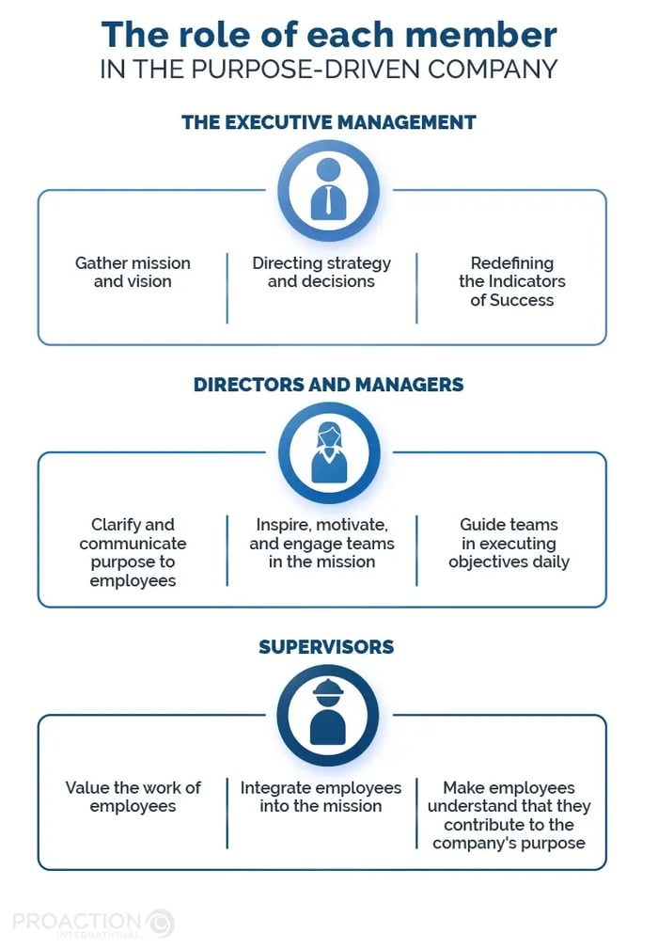
Source: Proaction
02. Define the role of the employees in the process:
It is imperative for the employyes to understand their role in the entire acticity wee. If the ir role is clearly understood execution becomes easier and quick. The employyees will require little guidance and direction.So a purpose driven organisation shoud ensure that every body in the execution chain undestands well what is their role. This clarity will save cost and time of the organisation and ensure all activities get effectively executed. Role clarity is a an essence in the entire process and orgasational teams are well aware of the missions and vision being pusued.So going of th track is jst not possible.
03. Effective Team Work:
Another important point in such process is having effective ad excellent teak work so that the teams look in sync and executethe entire plan as guided with the schedule given. Effective team work is an essential element of organisational success. In short we can sat that ccollaboration is the essence of teamwork. It ensures that everyone involved in the activity is clear about the team goals, their individual roles, as well as each other's roles across interdependent functions. It also ensures that everyone takes accountability not only for the performance of their own roles, but every other role, every other interdependent function, and ultimately the attained customer experience. This is similar to saying that the theatre process where different functions require for a totally different skill sets - light and sound, sets, props, costumes, makeup, acting, direction, but everyone has absolute clarity of the play (the goal), and the perceptive awareness that unless the audience (customer) gets up and applauds at the end of the play, no role, no performance, no function, has been worth it, has truly served its purpose.
04.Regular Monitoring, reporting evaluation and Results analusis are needed::
1. These are different terms but all put together work as the heart and soul of organizational performance. Let us evaluate each one to get clarity of purpose.
(i) Monitoring means a continuing function that aims primarily to provide the main stakeholders of an ongoing programs or projects with very clear and timely indications of progress or lack thereof in the achievement of program goals or project objectives. While monitoring is done mainly by persons involved in managing a program or project, evaluation is done by persons who have not been involved in it directly
(ii) Reporting implies a systematic and timely provision of essential information used as a basis for subsequent decision-making required at appropriate management levels. It is the most integral part of the monitoring function as it justifies the need and importance of monitoring.
(iii) Evaluation is a time-bound exercise undertaken by entities to assess systematically and objectively the relevance, performance and success of ongoing and completed programs and projects.
(iv)Results are a broad term that is used to refer to the effects and outcomes of the programs or project. The terms outputs, outcomes and impact describe more precisely and accurately the different types of result possibly attained I the activity.
Organisations should also make sure that the perforance get evaluated and reported at rtegular intervals. So that every person in the organisation is aware of the contribution being made by him in the activity.
05.Taking relevant corrective actions to prevent deviations:
This is another important element of all organisational processesand programs. The main urpose of this step is to ensure timely and appropriate corrective actions and preventive actions are initiated to include route cause analysis for resolving deviations seen, if any. This would include identification of its cause, understanding its impact on the results and thus helps to prevent its occurrence in future leading to failure of the program or process. Nee needs to remember that corrective actions and preventive actions together constitute a combination of ideas and tools to prevent and correct deviations.

11.11 Critical points for integrating purpose into the organization
- The purpose and objectives listed out must be authentic, sincere, and specific to your organization and its mission and vision and thus the values being pursued. They must appear to be meaningful to all the stakeholders within the organization and also to customers of the entity. It is crucial to a company that should ensure that the mission is completely transparent about all its actions and products and services.

- Every corporate purpose must be very clearly defined and explained so that the company is able to align every decision to it. The fact of the matter is to make sure that all actions and decisions must be consistent and in tune with the mission being pursued.

- The organization must set up a clear purpose. It should ask every person working for the entity how the program will make a difference through the products/services it will offer. The organization should ensure that its values, culture, priorities, and direction for the future need to be clearly defined. The entire process should deal with the manner to be adopted to resolve and solve a problem and steps needed to improve things in the entity. These are the critical points that allow the implementation of a precise and successful strategy.

- According to Ashley Grice the CEO of BCG Bright House who talks about mission-driven companies in a discussion, he stresses on that the organizational purpose is naturally uncomfortable and unsustainable. This is because it involves part idealism, part realism, requires solid buoyancy, alteration, patience, and a strong will to attain the decided mission. Once the company sets the goal, it can take years to merge with the business entirely. Efforts should continue unabated ad in a committed manner.

11.12 The challenges of the purpose-driven brand:
  - There is an utter difference between wanting to do certain things and actually doing them. Unfortunately, it is seen that many companies decide to set a mission and a reason for it being implemented but must implement it in their overall strategy. It is often observed that they often fail miserably to implement it successfully.
  - The main problem here is certainly due for the ability of the senior management and managers to cultivate a clear purpose daily, to integrate it into the corporate culture fully, and to make it a standard norm that needs to be honestly and effectively pursued. However, combining long-term economic profit for the common good and environmental awareness is the real challenge facing such businesses while executing any program.
  - A purpose-driven company is not just a focused title but it actually represents a state of the mind, a way of being and acting within and outside the framework of its proposed activities planned.
  - The fact of the matter is it needs to become the whole and sole identity of the organization. It implies a profound transformation of such companies as al entities are not necessarily the master of the qualities and skills needed to become a purpose driven entity. Every person needs to understand and approach the issue with an firm hand and try to coach and train to all the leaders that includes both executives and managers on it as and when the need is felt.
  - It is very critical for the entity to become a mission-based company as it is always possible and advisable to draw inspiration from this model to review the organizational priorities and goals, while giving it a more human and sustainable cheerful face to make it beneficial to all the Stakeholders.

11.13 Conclusion:

Thus to conclude one can say that a purpose-driven company is one that has a clear and shared vision surrounding a relevant social issue and it promotes and advances it through various customer, product /services and favorable employee policies and strategies. Working at a purpose-driven organization can allow the entity to complete impactful work that aligns with a company's ideals.

References:
- https://www.ey.com
- https://www.linkedin.com/pulse
- www. proactioninternational.com
- https://assets.ey.com/
- https://2112consulting.co.uk/
- https://blog.proactioninternational.com/

