Customization of Generic Selection Software and Auto Generation of Reports
Dr. P.G.Naik  Department of Computer Studies,  CSIBER, Kolhapur  India | Dr. G.R.Naik  Department of Mechanical Engineering,  KIT’s College of Engineering,  Kolhapur, India
Abstract:
Teaching pedagogy has undergone a revolutionary change over the years. Programme Educational Outcomes, Programme Specific Outcomes, Course Outcomes and Programme Outcomes define the Outcome Based Education (OBE) System in which the learning outcomes for different courses are pre-defined and the academic curriculum and content delivery is planned to meet those objectives. The academic curriculum supporting OBE is Choice Based Credit System (CBCS) in which the whole curriculum is segregated into different components targeting the holistic development of a learner. One of the components is Generic Elective course which enables the learner to select a course beyond the academic curriculum and the one offered by an external department. Currently, the selection is restricted to institute level. A learner can select any course offered by another department, other than the department in which the admission is sought. Since the activity is carried out at institute level, some sort of planning and automated computerized system is desirable to avoid any sort of chaos and confusion among the students. Due to the limited availability of human resource a sealing of 120 is declared for each GE course and the selection is on first come first serve basis. The authors have designed and developed a web based generic course selection software for the purpose which is operational for the last several years. As the curriculum undergoes a modification either structurally or content wise, as GE and class coordinators change, rules evolve, the software requires some sort of customization to incorporate the changes. Further, different reports are to be generated for GE coordinators, class coordinators and consolidated reports. As of now, the report generation was carried out manually which is a time consuming process. To account for this the authors have automated the report generation process by implementing the relevant APIs in business logic tier. The reports are exported by the system in Excel format.

Keywords:
Application Programming Interface, Choice Based Credit System, Generic Elective, Software Customization, Outcome Based Education, Ability Enhancement Course.

- INTRODUCTION
A Generic Elective (GE) is an inter-disciplinary course under Choice Based Credit System (CBCS). CBCS pattern focuses on the holistic development of the learners. Apart from the depth on core courses, skill based education is imparted through Discipline Specific Elective (DSE), Ability Enhancement Courses (AEC) and Ability Enhancement Core Courses (AECC). This course is provided to students to allow them to gain a chance at availing a comprehensive education. An elective course chosen generally from an unrelated discipline/subject, with an intention to seek exposure to other discipline/subject. The Generic Elective has equal credit as that of core paper. A core course offered in a discipline/subject may be treated as an elective by another discipline/subject. The student has to study one GE in each semester of the Programme. The Institute offers GE Selection based on First-Come-First-Serve basis.

- Departments in CSIBER and Different Programmes Launched by Various Departments
Currently CSIBER has five distinct departments listed below:
- Department of Commerce and Management
- Department of Computer Studies
- Economics Department
- Environment Management
- Social Work Department

Total 12 programmes are run by the above five departments:
- MCA
- MSc (CS)
- M.Sc.(CS in Cyber Security)
- MBA (General)
- MBA (BA)
- MBA (BFS)
- MBA (Environment Management)
- MSc (Environment and Safety)
- MSW
- MA (Counselling and Guidance)
- MSc (QE)
- MCom

- Scope of the System:
- The proposed system should incorporate the following functionalities:
- The system should be operable by end users of diverse roles and responsibilities.
- The system should be flexible enough to incorporate the new roles on the need basis.
- In the current system, the following roles are identified:
- Admin
- Director
- G.E. Coordinator
- Class Coordinator
- Student
- The system should maintain a logical relationship between the following entities:
      - Programme, Year, Semester, G.E. Subjects
      - Student Registration, G.E. Selection
- The system should avoid duplication of registration process.
- The system should avoid duplication of GE selection process.
- The system should keep track of live count of students for each GE subject at the time of GE selection process
- Allocation process of specific GE subject should stop, when student count reaches to maximum capacity
- The system should operate for both mobile and Desktop/Laptop
- The system should take care of the following tasks as depicted in the following table:

Task | Description
Transaction control | The atomic transactions in different logical transactions should be committed or rolled back as a single unit.
Concurrency Control | Proper locking mechanism should be in place to avoid data inconsistency.
Role based  authentication | The task should be accessible and should be performed only by the person who is authorized to do so.
Time triggered menu options. | The menu options should dynamically appear and persist for the specified period of time.

- To generate the required informative reports. The system should generate the requisite reports for Director, GE coordinator, Class coordinator. The list of reports along with the roles permitted to access it is shown below:
- GE coordinator Registration Report (Director)
- Class coordinator Registration Report (Director)
- Student Registration Report (Director, Class coordinator)
- Programme-wise GE Allocation Report (Director, Class coordinator)
- Programme-wise GE Non-Allocation Report (Director, Class coordinator)
- Subject-wise GE Allocation Report (Director, GE coordinator)
- Subject -wise GE Non-Allocation Report (Director, GE coordinator)
- System Objectives:
- To develop Online System for GE selection.
- To maintain transparency in GE selection process.
- To reduce human intervention in the process.
- Relevance to Professional or Academic Field
Generic Elective (GE) gives exposure to a new discipline/subject and prepare them to look for interdisciplinary research

- Tools and Techniques Employed
Different tools and techniques employed in the implementation of the model are listed below:
  - The proposed system will be implemented employing an open source technology in a cost-effective manner using PHP and MySQL
  - XAMPP stack will be utilized for execution of Apache server hosting web app and MySQL server hosting the database.
  - The system will be hosted on an internet server, so that student can go through the registration and selection process from anywhere.
  - Advanced web technology employed in the system development include
❖AJAX for improving application performance
❖ JQuery for improving User Interface and User Experience.
- The project employs bootstrap technology to handle devices of disparate display sizes.

- System Testing
The system should be tested
  - For different browsers, Mozilla and Chrome in particular, due to their highest market share.
  - For different display sizes.
  - For Concurrency
  - Allocation process of specific GE subject should stop, when student count reaches to maximum capacity
  - Proper validation mechanism should be in place in order to reduce runtime errors, if any.
- Research Approach or Methodology
The different modules employed in the project are listed below:
1. Department Master
2. Programme Master Module
3. Student Master Module
4. Registration Module
5. User Authentication Module
6. Class coordinator
7. GE coordinator
8. Generic Electives Module
9. Generic Allocation Module
H. Expected Outcomes:
- Student should be able to successfully register with the system.
- Student should be able to get access to syllabi of different generic elective subjects offered by other departments.
- Student should be able to select only the generic elective subjects offered by other departments.
- Class coordinator should be able to view the list of registered students of the class.
- GE coordinator should be able to view the list of students of different departments who have opted the GE subject.
- The GE selection link should be activated only in the specified period of time.
- At the time of GE selection, the availability status of different GE subjects should be visually displayed to a student.
- Literature Review
There is exhaustive work and a plethora of research papers on the analytical study and the implications of CBCS on higher education system. An exhaustive analytical study has been performed on the CBCS system focusing on its objective to eliminate rote learning and memorization leading to an innovative education system (Saharish 2009, Kelkar et.al. 2014, Biswas 2018, Saha 2021). Although CBCS sounds elegant on paper there are several obstacles to its practical implementation of CBCS. The problems and prospects of implementing CBCS at the UG level are highlighted by Tanmoy Saha (Saha 2021). More attention and discussion are required for the problems and prospects of CBCS to fulfil its objectives. To cater to the needs of ease in course selection, the current paper provides guidelines for the design and implementation of a generic web-based system for course selection which is generic and can be applied to any course category. Zhang et.al. have carried out a comprehensive study to examine the availability of OBE in Guangdong Ocean University. Their empirical study has proofed the teaching pedagogy based on Obasim E indeed facilitates the melioration in communication skills of undergraduates(Zhang 2019), Asim et.al. have carried out a comprehensive review to address the major factors that impact student learning outcomes. Their study suggested five important factors from the literature that impact student learning outcomes including, assessment strategies, learning objectives based on level of complexity, student preferred learning styles, English language competency and Employer requirements (Asim 2020). To achieve the goals of OBE the guidelines are provided by six knowledge levels of Bloom’s taxonomy, Programme Educational Outcomes, Programme Specific Outcomes, Course Outcomes and Programme outcomes. To gain the attributes detailed for outcome based totally schooling via NBA right overview techniques are required, due to the fact assessment of the graduate attributes plays a key position in coaching gaining knowledge of system to enhance the device and to improve the overall performance of college students. (Devasis P 2021, Nazeer 2021).
III. Conceptual System Design
- Module Dependency Diagram
The dependencies existing between different modules is shown Figure 1.
Figure 1. Dependency Between Different Modules of the GE Software
- Application Architecture
The prototype model given above will be implemented in PHP with MySQL as backend. The multi-tier application architecture employed is shown in Figure 2(a) & 2(b)
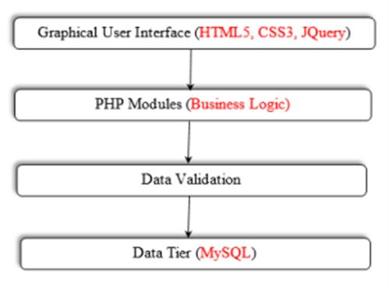
Figure 2(a) Multi-Tier Application Architecture.
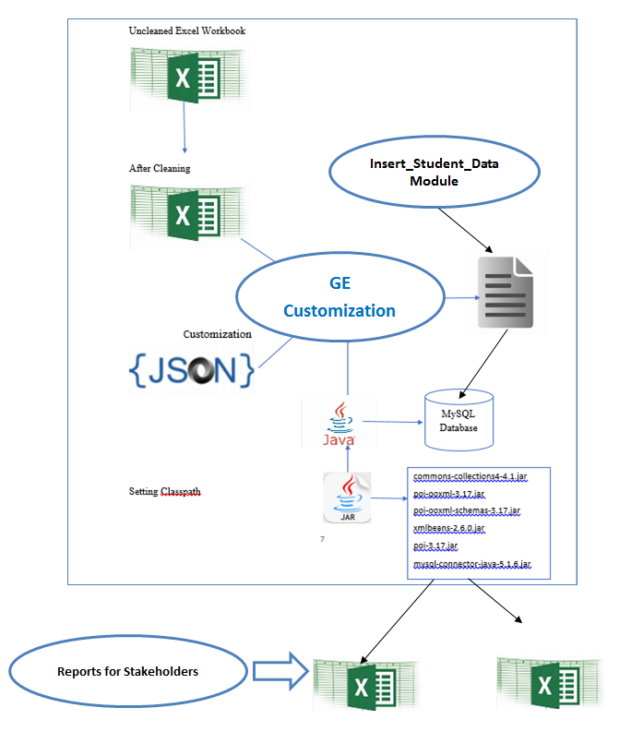
Figure 2(b) Multi-Layered Application Architecture.
- Use Case Diagram
The dynamic behaviour of the system is depicted in the form of a use case diagram in Figure 3 comprising of the following actors:
- Admin
- Director
- GE Coordinator
- Class Coordiator
- Student
The various functionalities and the tasks performed by different actors is summarized in Figure 3.
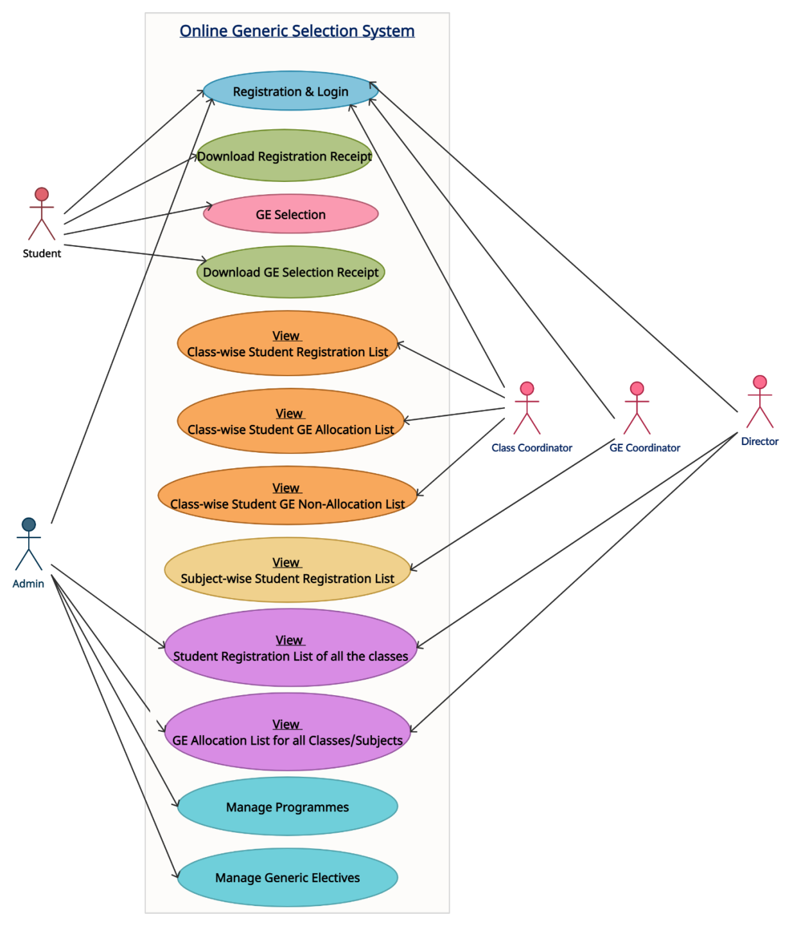
Figure 3. Use Case Diagram
- Generic Database Structure
The structure of ‘Generic’ database is depicted in Figure 4.
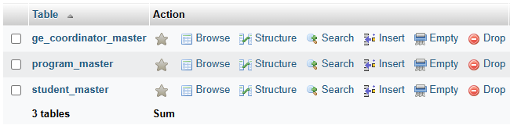
Figure 4. Structure of ‘Generic’ Database
The structure of different tables present in ‘Generic’ database is shown in Figure 5.
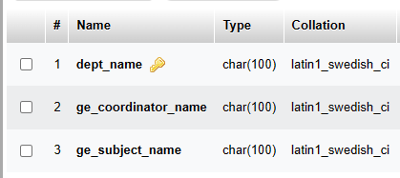 | 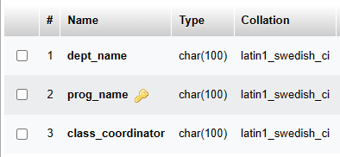
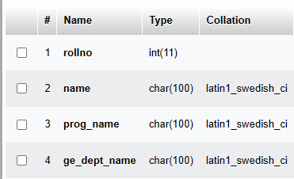
Figure 5. Structure of Tables in ‘Generic’ Database
Table Creation Commands
create database generic;
use generic;
create table student_master(rollno int, name char(100), prog_name char(100), ge_dept_name char(100));
create table program_master(dept_name char(100), prog_name char(100));
insert into program_master values('Department of Computer Studies', 'MCA');
insert into program_master values('Department of Computer Studies', 'MSc (CS)');
insert into program_master values('Department of Computer Studies', 'MSc (CS in Cyber Security)');
create table ge_coordinator_master(dept_name char(100), ge_coordinator_name char(100));
insert into ge_coordinator_master values('Department of Computer Studies', 'Sneh Nagaokar');
insert into ge_coordinator_master values('Department of Commerce and Management', 'Viraj Jadhav');
insert into ge_coordinator_master values('Economics Department', 'Kishor Kumar');
insert into ge_coordinator_master values('Environment Management', 'Rachana Ingavale');
insert into ge_coordinator_master values('Social Work Department', 'Suresh Apte');

IV. Generic Elective Software Customization
- Generic Elective Software Folder Structure on Server
The structure of Generic Elective micro site on Go Daddy server is shown in Figures 6(a) – 6(d).
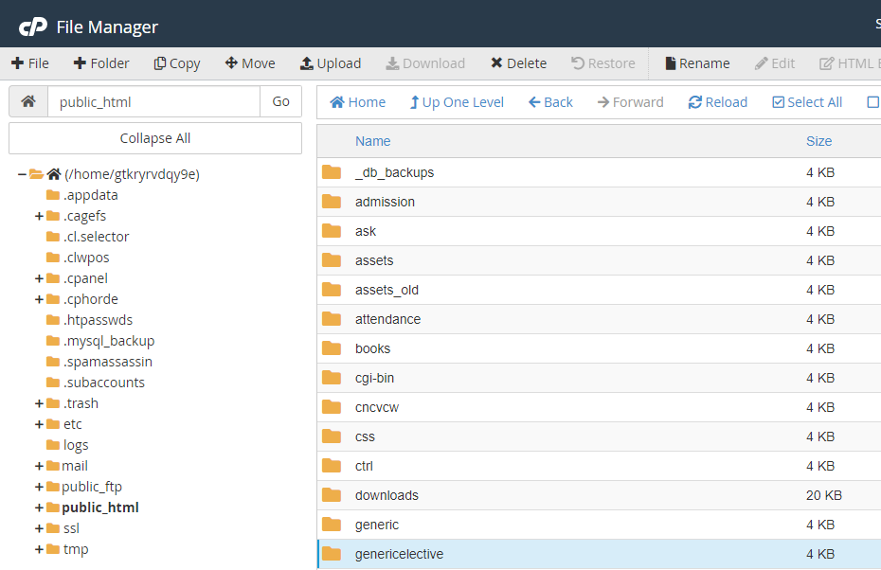
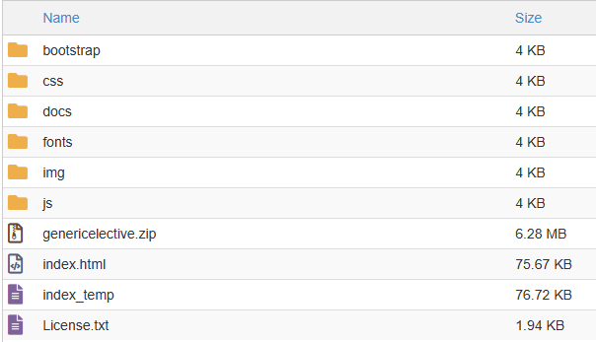

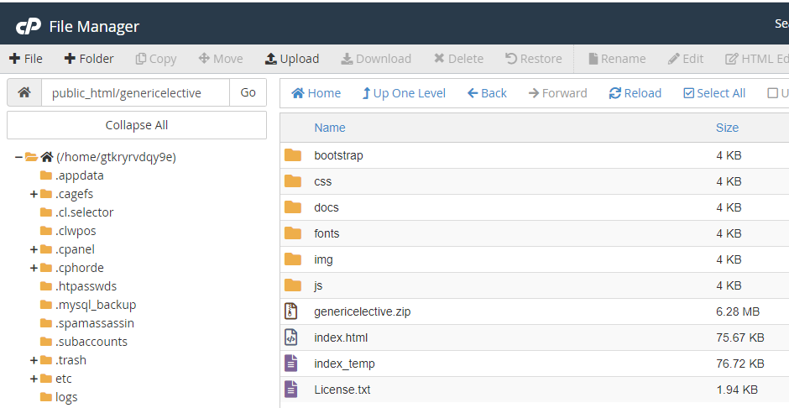

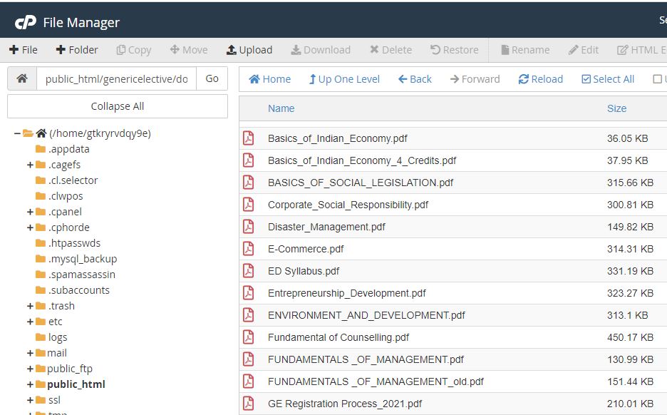
Figure 6(a) – 6(d) Generic Elective Software Folder Structure on Server

- genericelective/img/assets Folder Structure
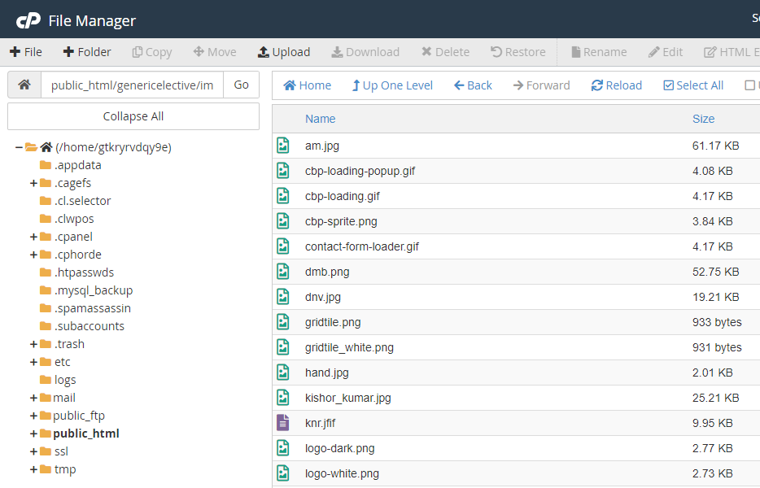

/img/portfolio/fullsize Folder Structure
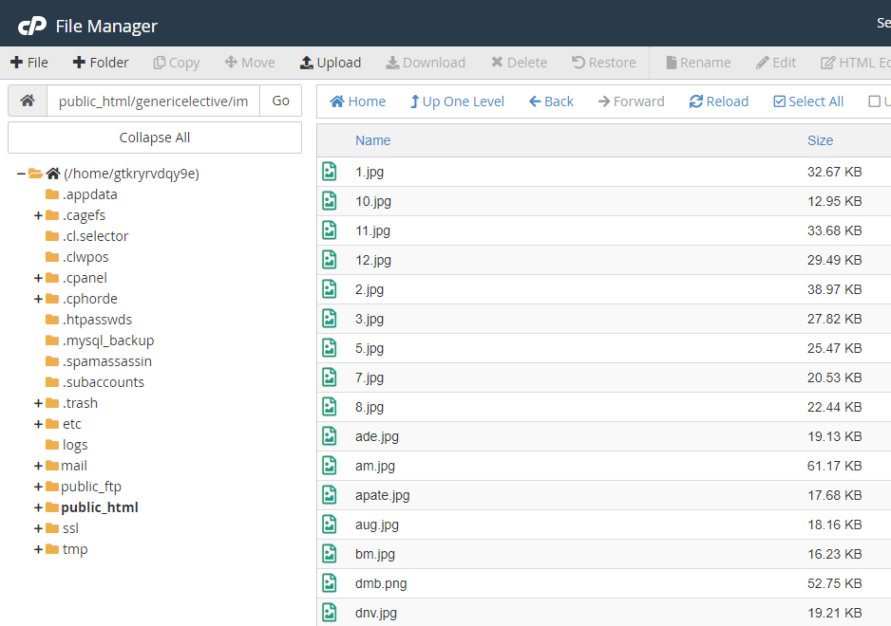

B. Files Used in the Project
As a precautionary measure towards application’s efficiency, the execution load is properly distributed between the client and the server. The GE course selection process is performed on the server side while the report generation logic is delegated to the client. The different files used in the project are depicted in Table 1.

Table 1. Different Files Used in GE Software Project.
Sr.No | File Name | Tier | Location | Description
1. | index.html | Presentation | /genericelective (Server) | Home Page
2. | *.pdf | Presentation | /genericelective/docs (Server) | Generic Elective Syllabi of five departments.
3. | *.jpg | Presentation | /genericelective/img/assets (Server)
4. | InsertStudentData.java | Business Logic | d:/genericelective/ (Client) | Parsing Excel file and inserting student information in MySQL database
5. | WriteGECoordinatorReport.java | Business Logic | d:/genericelective/ (Client) | Generates GE Coordinator reports and exports as Excel workbooks in ‘ge_coordinator_reports’ folder.
6. | WriteClassCoordinatorReport.java | Business Logic | d:/genericelective/ (Client) | Generates Class Coordinator reports and exports as Excel workbook with the name ‘class_coordinator_consolidated_report.xls’.

- Customizing index.html
Uploading the GE Course Syllabi on Server.
The current syllabi of GE courses offered by different departments are uploaded in the /genericelective/docs folder in PDF format and are available on the home page for reference as shown in Figure 7.
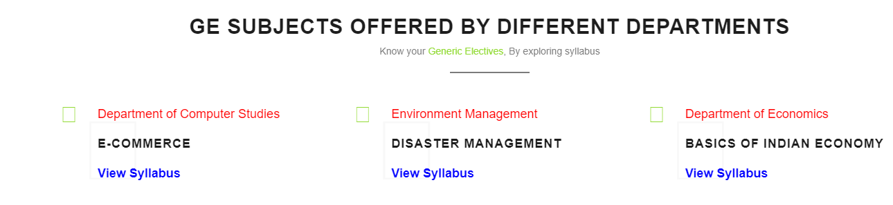
Figure 7. GE Course Syllabi Displayed on the Home Page for Reference.
The customization of index.html page for inserting the link to GE course syllabus is shown below:
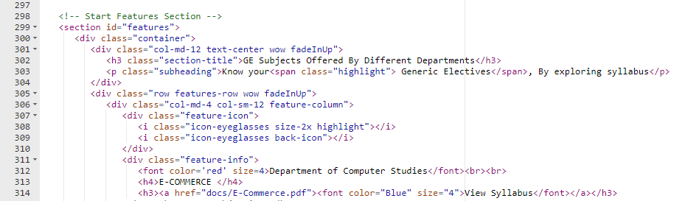

The next section consists of links to the important documents pertaining to GE user manual and document containing GE selection guidelines as shown in Figure 8.
Figure 8. Links to Important Documents

The customization of index.html page for inserting the link to important documents displayed above is shown below:
The next section contains the slide showing the names of the GE elective courses offered by different departments along with the cut-off info.
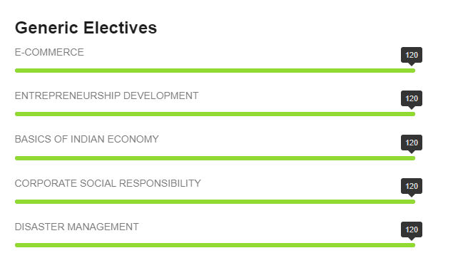
The structure of Google form for GE course selection along with its settings is shown in Figure 9(a) – 9(b).
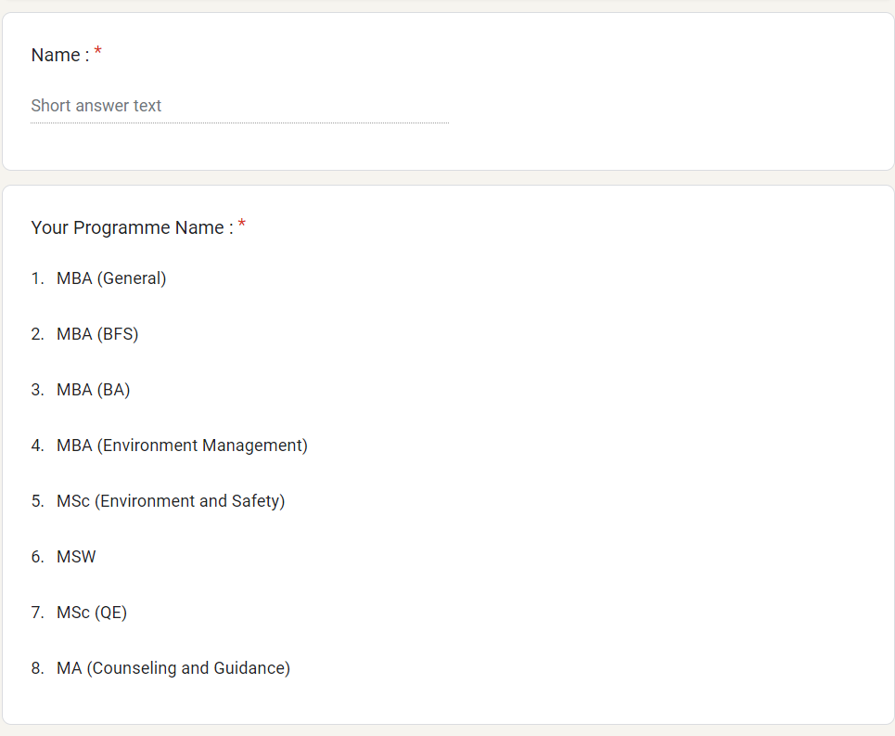
Figure 9(a) Google Form for GE Course Selection
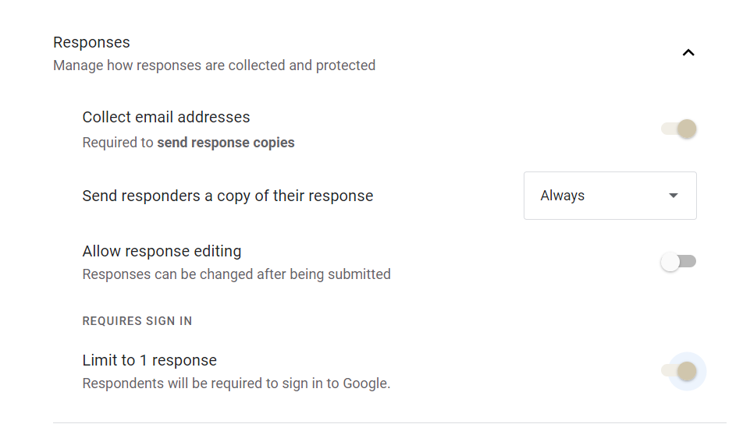
Figure 9(b). GE Course Selection Form Customization

The unique identifier associated with the form is shown below:

Due to the limited availability of human resource a sealing of 120 is declared for each GE course and the selection is on first come first serve basis. To automatically turn off the responses when the cut-off is reached a script is implemented and is associated with the trigger which is automatically executed on form submission. The scrip editor can be launched by clicking on three ellipsis on the upper right corner of the form.
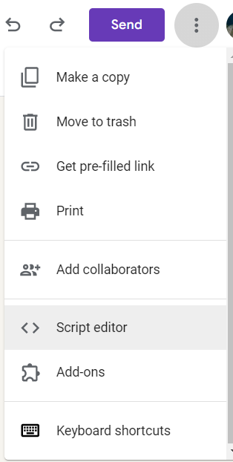
The Google script to automatically turn off the responses when the cut-off is reached is shown below:
function submit() {
var form = FormApp.openById('1s-1WqEUGIeVfDvFvoeUfoFP9nZ0KnZswBW90YJ7WjU');
var formResponses = form.getResponses();
var num_responses=formResponses.length;
if (num_responses > 120){
form.setAcceptingResponses(false);
}
}

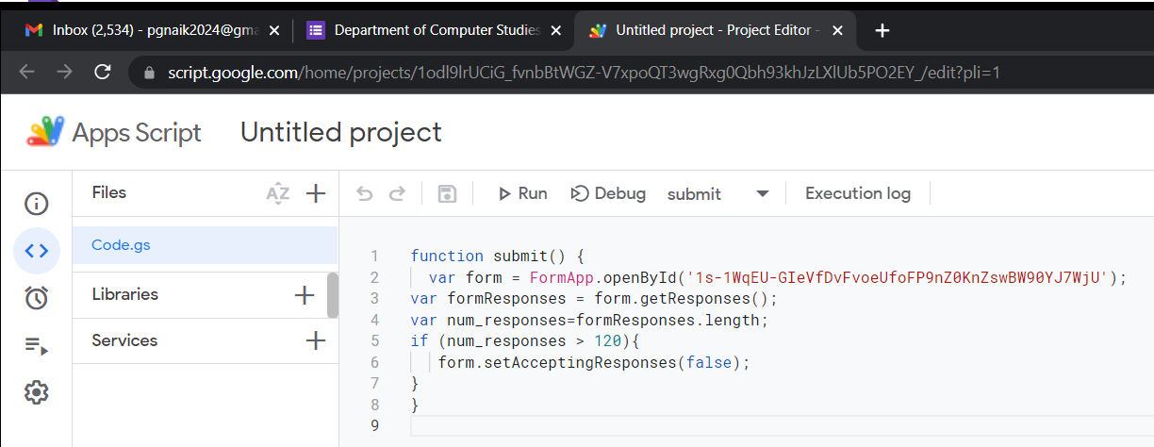

Associating the submit() function with the form_submit Trigger.
To associating the submit() function with the form_submit trigger, click on the ‘triggers’ menu option I the left menu show in Figure 10.
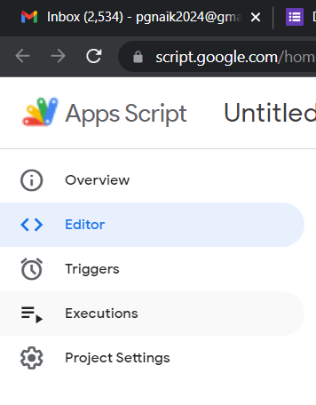
Figure 10. Structure of Left Menu
In the resulting dialog, select ‘submit’ for function to run option and ‘on form submit’ for event type.
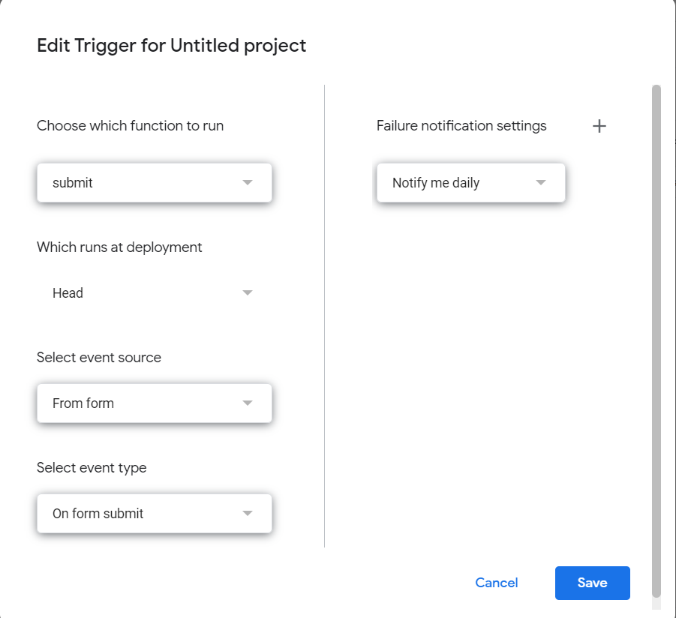
Click on ‘Save’ button and the trigger is created as shown in Figure 11.
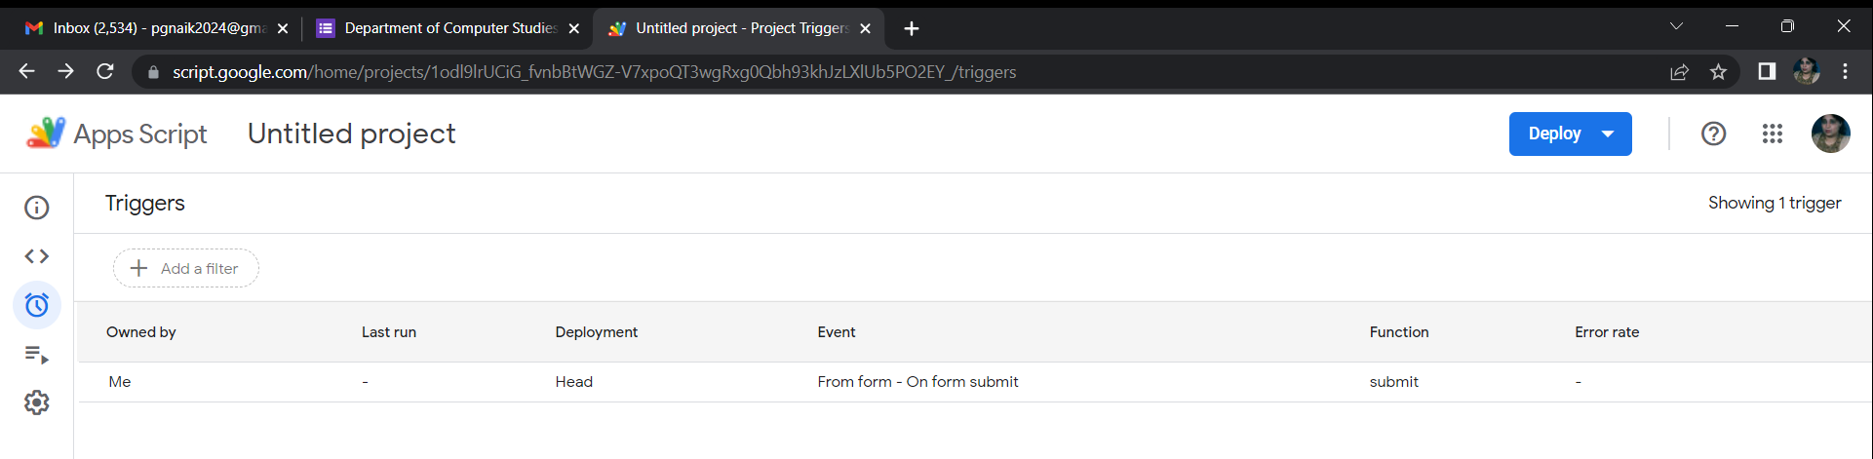
Figure 11. Creation of Trigger for form submit event.
D. Auto Generation of Reports
Reports for GE Coordinators
The GE report generation process is automated by implementing the relevant APIs in business logic tier. The reports are exported by the system in Excel format. The different JAR files required for the implementation of business logic are shown below:
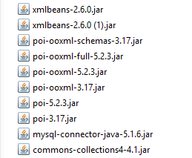

The folder ‘response_sheets’ contains the five Google response sheets in Excel 97 format.
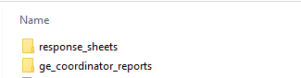

The structure of the folder ‘response_sheets’ is shown in Figure 12.
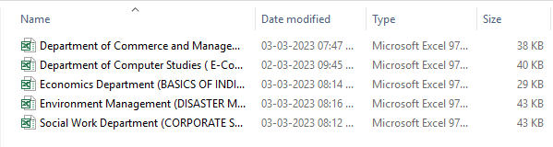
Figure 12. Google Response Sheets Residing in ‘response_sheets’ Folder.

Format of Worksheet Containing Responses is shown in Figure 13.
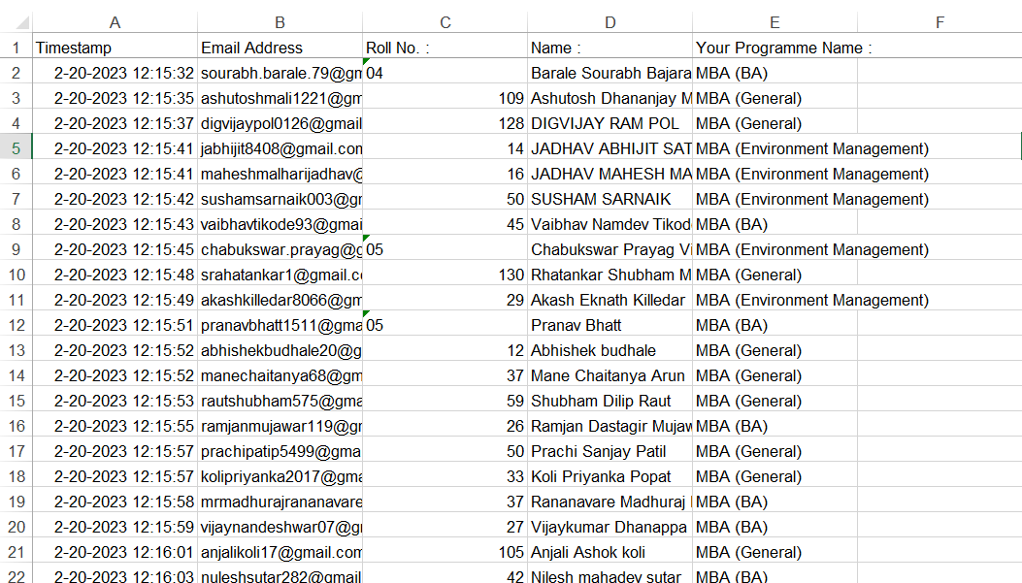
Figure 13. Format of Google Worksheet Responses
Data Cleaning
To generate the reports for GE coordinator the following tasks are executed:
- Timestamp and Email Address Columns are deleted.
- The Excel spreadsheet is sorted on Programme Name.
- The header ‘GE Selection Report (E-Commerce)’ is printed.
- The footer containing the following information is printed.
  - Total No. of Students
  - Name of GE Coordinator
  - Print ‘Prepared by Department of Computer Studies’.
On execution of business logic the reports for the GE coordinators are auto generated and are saved in the folder ‘ge_coordinaor_reports’ as shown in Figure 14. The naming convention used for file is as follows:
<Department Name>_<GE Coordinator Name>
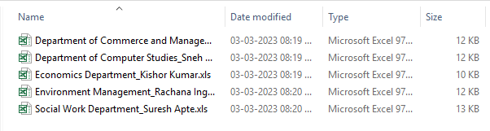
Figure 14. GE Coordinator Reports Residing in ‘ge_coordinator_reports’ Folder.

Format of the GE Coordinator Report
The format of GE coordinator report is shown in Figure 15.
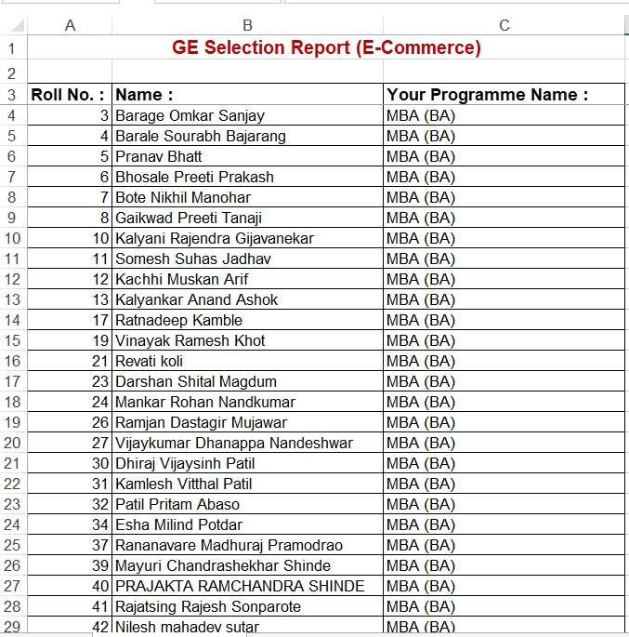

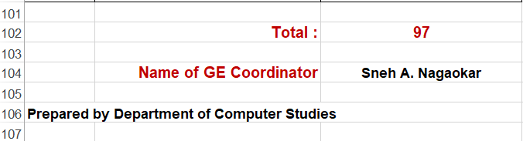
Figure 15. Format of GE Coordinator Report for E-Commerce

4.2 Reports for the Class Coordinators
Format of the Report for class coordinator is shown in Figure 16.
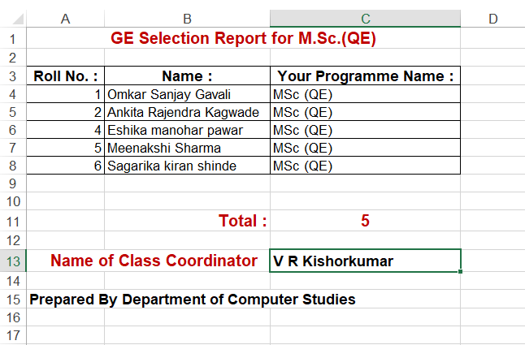
Figure 16. Format of the Report for class coordinator

In the Excel workbook each tab contains the programme name.
To generate the reports for Class coordinator the following tasks are executed:
- Create consolidated Excel worksheet by merging all the responses containing the following columns:
Roll No : , Name : and Your Programme Name : columns.
- Print total no. of responses.
- Custom sort on the following fields
  - Your Programme Name
  - Roll No
- Copy different programmes to different worksheets
- Print the header ‘GE Selection Report M.Sc. (QE)’
- Print footer containing the following information
  - Total No. of Students
  - Name of Class Coordinator
  - Print ‘Prepared by Department of Computer Studies’.
on each worksheet.

V. Experimental Results and Discussions
The system designed and implemented above is deployed on GoDaddy server as a micro site where the institute’s website is hosted. To launch the micro site, click on the link given below for online GE selection process:
http://www.siberindia.edu.in/genericElective
The home page of the site is displayed as shown in Figure 17.
Figure 17. Home Page of GE Selection Micro Site

The menu hosted by the system is shown in Figure 18.

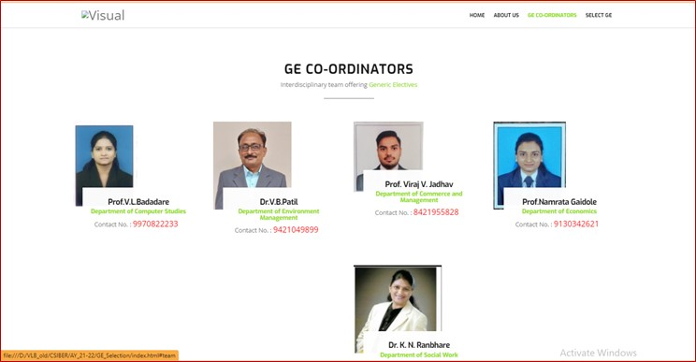
Figure 18. Menu System of Generic Selection Micro Site

Click on ‘View Syllabus’, to get detailed syllabus of concerned GE subject .
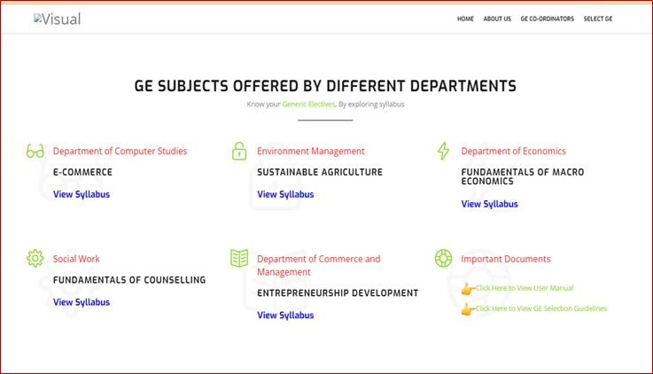

Figure depicts the E-Commerce course curriculum launched by department of Computer Studies.
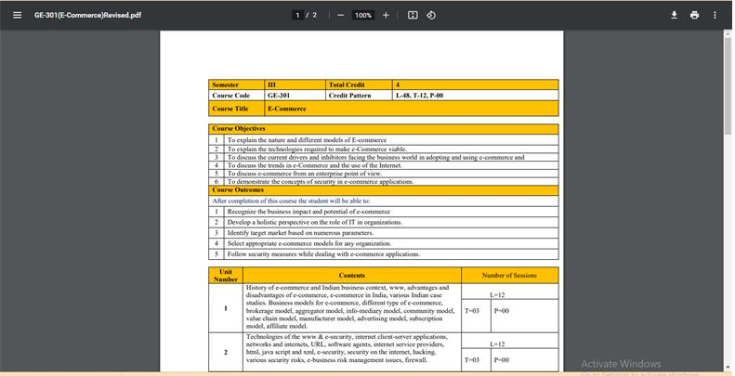
Figure 19. E-Commerce Course Curriculum Launched By Department of Computer Studies.
The links to the important documents (User Manual and GE Selection Guidelines) are provided which can be accessed by clicking the appropriate link.
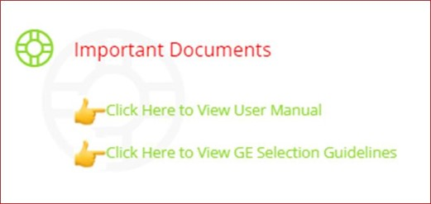

Click on ‘Select GE’ tab to navigate to GE selection section
In the first part GE selection section, you will find details of Class-coordinators to whom you
In GE Selection section, Scroll down to select GE subjects

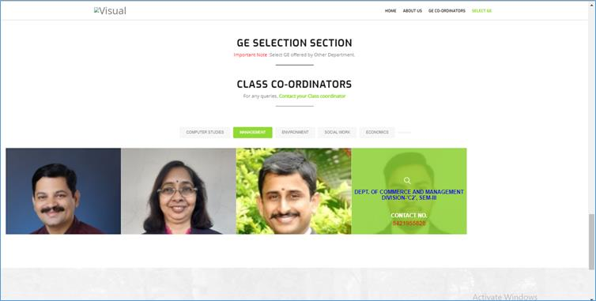

To Select your Generic Elective, click on the link provided along with subject name
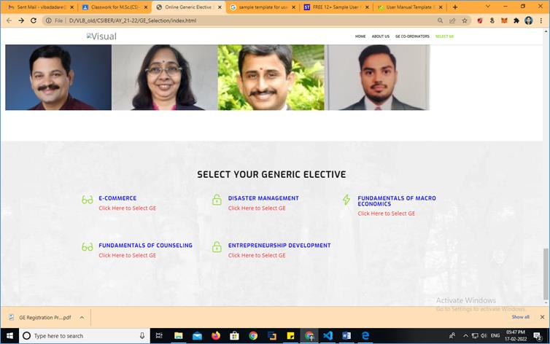

After clicking on the link, you will navigate to Google form
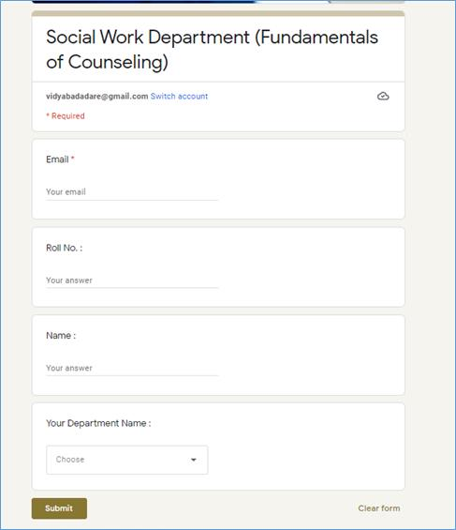

You are required to fill the form with correct email-id, Roll no., Your Full name and Your Department name
The automated reports generated by the system are shown below:
Sample GE Coordinator Report
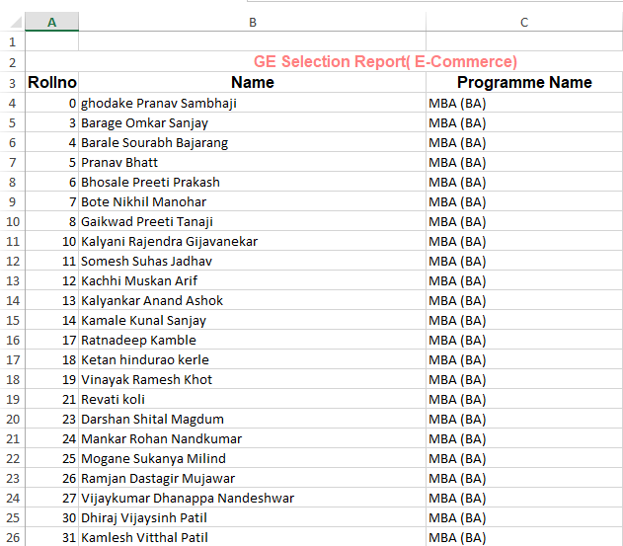

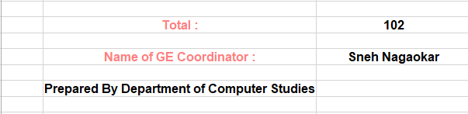

Sample Class Coordinator Reports
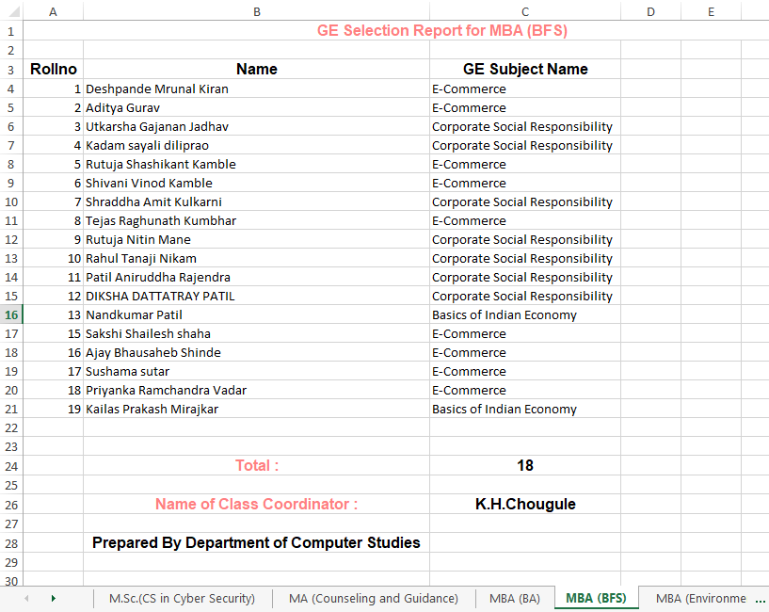
The Excel report showing the programmewise count of students who have selected GE course is shown below:
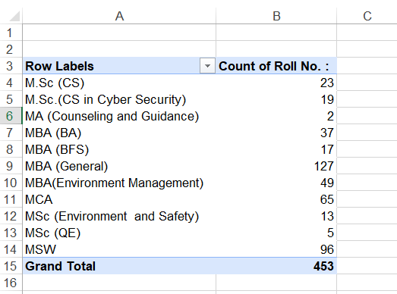
The pivot table showing the no. of students from different programmes selecting different GE courses is shown below:
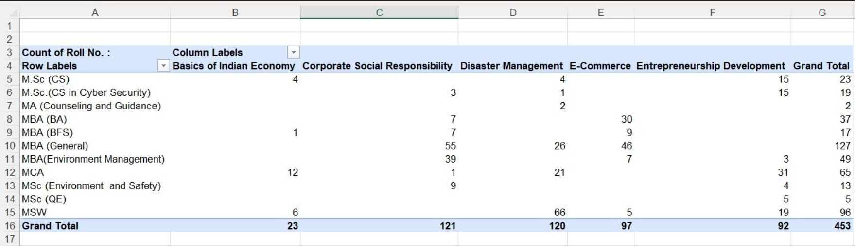

IV Conclusion and Scope for Future Work
The authors have designed and developed a web based generic course selection software which is operational for the last several years. The load distribution between the client and the server, scalable N-tier Micro Service architecture are incorporated as performance measures. Due to the limited availability of human resource a sealing of 120 is declared for each GE course and the selection is on first come first serve basis. As the curriculum undergoes a modification either structurally or content wise, as GE and class coordinators change, rules evolve, the software requires some sort of customization to incorporate the changes. In the current research authors have implemented the APIs in the business logic tier for the auto customization of GE software and the auto generation of reports for different stake holders. Different reports are required to be generated for GE coordinators, class coordinators and consolidated reports for general purpose. As of now, the report generation was carried out manually which is a time consuming process. To account for this the authors have automated the report generation process by implementing the relevant APIs in business logic tier. The reports are exported by the system in Excel format. The future work focuses on exporting the reports in various formats such as MS-Word, Excel etc. GMail integration and WhatsApp integration for creating groups and for auto sending of messages are some future enhancements which are due.

REFERENCES
- UGC guidelines on adoption of Choice Based Credit System (2023). IARE (no date). Available at:https://www.iare.ac.in/sites/default/files/
UGC_GUIDELINES_ON_ADOPTION_OF_CHOICE_BASED_CREDIT_SYSTEM.pdf (Accessed: January 13, 2023).
- Minimum course curriculum for undergraduate courses under Choice Based Credit System (2023). Available at: https://ugc.ac.in/pdfnews/8023719_Guidelines-for-CBCS.pdf (Accessed: January 13, 2023).
http://www.du.ac.in/du/uploads/Guidelines/UGC_credit_Guidelines.pdf.
- UGC News (2015). Instructional Template for Facilitating Implementation of Choice Based Credit System (CBCS). Retrieved February 13, 2020, from
https://www.ugc.ac.in/pdfnews/4426331_InstructionalTemplate.pdf
- Aithal, P. S., & Kumar, P. M. S. (2016). ‘Analysis of Choice Based Credit System in Higher Education’. International Journal of Engineering Research and Modern Education (IJERME), vol. 1, no. 1, pp. 278- 284.
- B. Saharish (2009), ‘Special issue on Evaluation System: Implementing UGC-mandated Reforms in Higher Education’, University News, vol. 47, no. 45, pp. 39-40.
- Kelkar A.S. and Ravishankar L. (2014). ‘Choice-based credit system: An academic reform in higher education’, University News, vol.51, no. 08.
- Biswas S. (2018). International Journal of Research and Analytical Reviews, vol. 5, no. 3, pp. 1362-1368.
- Saha T. (2021). International Journal of Science and Research, vol. 10, no. 1, pp. 871-874.
- https://www.ugc.ac.in/pdfnews/2758387_English-Generic_Elective-NEW.pdf
- Guangya Zhang, Lingli FanLingli Fan, ‘Research on the Effectiveness of Outcome-Based Education in the Workplace Communication Curriculum of Undergraduates’, Conference: Proceedings of the 2019 3rd International Conference on Education, Economics and Management Research (ICEEMR 2019), DOI: 10.2991/assehr.k.191221.058
- Hafiz Muhmmad Asim, Anthony Vaz, Ashfaq Ahmed & Samreen Sadiq, International Education Studies; Vol. 14, No. 2; 2021 ISSN 1913-9020 E-ISSN 1913-9039, Published by Canadian Center of Science and Education, doi:10.5539/ies.v14n2p1
- Devasis Pradhan, ‘Effectiveness of Outcome Based Education (OBE) toward
Empowering the Students Performance in an Engineering Course’, Journal of
Advances in Education and Philosophy
- Dr. S K. Nazeer, N. Kiran Kumar, Vishnu Vardhan, K Rohini, K Sarathchandra, A Chandra Sekhar, INTERNATIONAL
JOURNAL OF ENGINEERING RESEARCH & TECHNOLOGY (IJERT), vol. 9, No. 8, ISSN (Online) : 2278-0181

