Prognosticative model for mapping ionospeheric disturbance in IRNSS data

Manaswini R 1st Research scholar, Dept of ECE Jain Deemed-to-be University kanakapura road, Jakkasandra, post Bengaluru, Karnataka 562112, India. And Assitant Professor Dept of ECE, School of Engineering Technology Presidency univerty Itigalpura Rajanakunte yelahanka Bangalore 560064 manaswikrishna20@gmail.com
Raju G Professor, Dept of ECE Jain Deemed-to-be University kanakapura road, Jakkasandra, post-Bengaluru, Karnataka 562112, India

ABSTRACT
One of ISRO's key projects is the Indian regional navigation satellite system, which will principally focus on offering accurate, precise position and time data. The Earth's ionosphere is a significant layer that influences the electromagnetic signals sent and received between a satellite and a user, introducing inaccuracy into location determination. The amount of total electron content will increase as the ionosphere-induced delay increases, and vice versa. More mistake in position determination will be indicated by an increase in Iono delay and total electron concentration. These variables will be estimated by an IRNSS receiver prediction model that is currently being used. Using IRNSS real-time data, the fluctuation of the ionosphere over the Bangalore region is studied using data from several days. The research takes into account the accuracy-determining characteristic known as DOP dilution of precision, which has declined as the number of satellites grew, indicating better accuracy of IRNSS.

Keywords—Indian regional navigation system, ionosphere delay.

INTRODUCTION

Real-time timing and accurate location are made possible via the Global Navigation Satellite System (GNSS), a constellation of satellites. Indian Space Research Organization (ISRO) launched one of these navigation systems, the Indian Regional Navigation Satellite System (IRNSS). When assessing a GNSS system's performance, a number of factors are taken into account, including the accuracy of the position that is determined and its availability in real-time, the speed of position determination at a specific receiver location, the integrity, which refers to the system's capacity to operate effectively in unusual circumstances or in real-world settings, the system's capacity for uninterrupted operation, and the system's capability to provide services. IRNSS satellite signals tend to shift when they pass through a dynamic ionosphere because the signal's refractive index varies and influences how it propagates. The system that receives the data so records a propagation delay. Due to the signal's properties changing as it travels through the ionospheric layer, the signal delay affects range and phase. The total delay of the satellite signal relies on the frequency electron density. Group delay, phase delay, refraction, and dispersion are examples of propagation effects that are caused by fluctuations in the ionospheric TEC. In order to map the ionospheric time delay of GNSS signals, TEC must be precisely measured. When compared to the ratio of the L5 and S1 signals for the IRNSS (S1/L5 = 2.19), which contains signals with the L1, L2, and L5 frequencies, the resulting ratios for GPS are L1/L2 = 1.28 and L1/L5 = 1.34, both of which are much less than the ratio of the L5 and S1 signals for GPS. When S1 and L5 frequency signals are utilised, the accuracy of TEC measurements is increased since it is feasible to properly estimate the TEC when the frequency ratios are higher than average.

METHODOLOGY

The Indian Space Research Organization's SAC (Space Applications Centre) in Ahmedabad, which has donated the receiver that can receive data from GPS and IRNSS satellites, and Jain University have inked an MOU. In addition to data from GPS signals in the L1 C/A frequency band, it is intended to receive data from IRNSS signals at the L5 and S1 frequency bands. A laptop for storage and display, an Ethernet connection to connect the laptop and the receiver, a power supply, and a receiver unit are all included in the apparatus. To minimise the impacts of multipath, the antenna is mounted on the roof without any obstructions. The data that was received by the receiver in raw data format is displayed and stored on the laptop Both RINEX (Receiver Independent Exchange Format) and NMEA (National Marine Electronic Association) types of data may be received by the receiver. Comma-separated value (CSV) files matching to the obtained raw data are also given. These CSV files include information about the satellite, the user's location, numerous aspects of satellite data, and pertinent computations. This research explores features that are affected by ionospheric fluctuations and develops an automated methodology to quickly estimate VTEC and TEC. The TEC content of a given region may be determined using a number of different methods. The ionosphere's delay is computed for the observed TEC values in the study area using both L5 and S1 frequency signals. For a thorough examination, all available satellite data is taken into account, and the relevant TEC values are computed. Dual frequency receivers like IRNSS receivers, which offer both L5 and S1 frequency, may determine the total electron content using a technique called code TEC measurement. When determining the total electron energy, the pseudo-range values established by both frequencies at a certain moment are taken into consideration. Since it is impossible to determine the satellite's precise location, pseudo-range is employed to calculate its distance from the user. To determine a position properly, four satellite signals must be acquired. The pseudo ranges may be calculated by dividing the amount of time it takes for signals to travel from a satellite to a receiver by the speed of light.

RESULT AND ANAKYSIS

The studies and research findings make use of information from the receiver at Bangalore's Jain University. A few examples of dates that are taken into account and that have a stronger influence on the ionosphere during high solar flare circumstances are provided. The dates were chosen based on their availability in the database, and after additional investigation and processing, they were further refined. About 120 charts, including plots of combined values of several satellite parameter values, are produced by the ionospheric effect detection module. A few important data are provided that lend credence to the identification of the ionospheric disturbance.

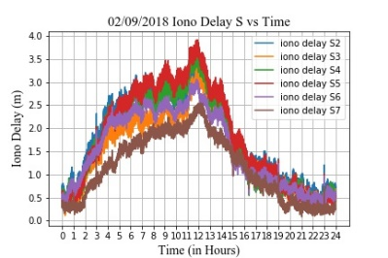

Figure 1: The graph indicates the iono delay experienced by all satellites on 2/09/2018 for S band frequency.

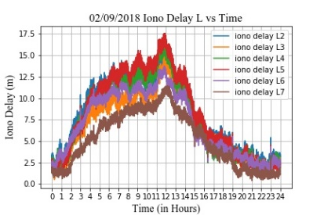

Figure 2: The graph indicates the iono delay experienced by all satellites on 2/09/2018 for L band frequency.

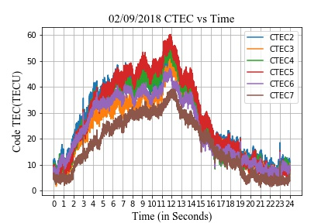
Figure 3: The graph indicates the CTEC experienced by all satellites on 2/09/2018 for L band frequency.

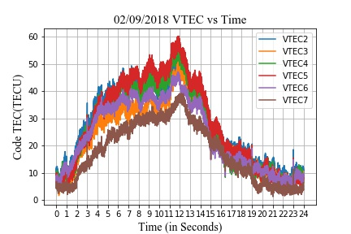
Figure 4: The graph indicates the VTEC experienced by all satellites on 2/09/2018 for L band frequency.

ACKNOWLEDGEMENT

The IGS receiver device that the ISRO Space Application Centre Ahmedabad (SAC) installed at Jain University Bangalore provided the data for the study's research endeavor. The authors would like to express their gratitude to ISRO SAC Ahmedabad for making it possible to complete the space weather-related and IRNSS performance-related tests.

REFERENCES

- Aa, E., Zhang, S.-R., Erickson, P. J., Coster, A. J., Goncharenko, L. P., Varney, R. H., & Eastes, R. (2021). Salient Midlatitude Ionosphere-Thermosphere Disturbances Associated With SAPS During a Minor but Geo-Effective Storm at Deep Solar Minimum. Journal of Geophysical Research: Space Physics, 126(7), e29509. https://doi.org/10.1029/2021JA029509
- Real-time (Quicklook) Dst index, World Data Center for Geomagnetism, Kyoto. https://wdc.kugi.kyotou.ac.jp/dst_realtime/index.html. Accessed on 20th April 2022.

- Space Weather Prediction Center, National Oceanic and Atmospheric Administration. https://www.swpc.noaa.gov/phenomena/f107-cm-radio emissions. Accessed on 15th April, 2022.
- Aa, E., Zhang, S.-R., Wang, W., Erickson, P. J., Qian, L., Eastes, R., et al. (2022). Pronounced Suppression and X-Pattern Merging of Equatorial Ionization Anomalies After the 2022 Tonga Volcano Eruption. Journal of Geophysical Research: Space Physics, 127(6), e2022JA030527. https://doi.org/10.1029/2022JA030527
- Aa, E., Zou, S., Eastes, R., Karan, D. K., Zhang, S.-R., Erickson, P. J., & Coster, A. J. (2020). Coordinated
- Desai MV, Shah SN (2020) An observational review on influence of intense geomagnetic storm on positional accuracy of NavIC/IRNSS system. IETE Tech Rev 37(3):281–295. https://doi.org/10.1080/02564602.2019.1599739
- Ratnam, D. V., T. R. Vishnu, and P. B. S. Harsha, “Ionospheric gradients estimation and analysis of S-band navigation signals for NAVIC system,” IEEE Access, Vol. 6, 2018 pp66954–66962.
- M. Ravi Kumar, M. Sridhar, D. Venkata Ratnam, P. Babu Sree Harsha, S. Navya Sri, “Estimation of ionospheric gradients and vertical total electron content using dual-frequency NAVIC measurements,” Astrophys Space Science, 2019 pp. 1-9. https://doi.org/10.1007/s10509-019-3535-y
- Abe, O. E., X. Otero Villamide, C. Paparini, S. M. Radicella, and B. Nava, “Analysis of a grid ionospheric vertical delay and its bounding errors over West African sub-Saharan region,” J. Atmos. Solar-Terrestrial Phys., Vol. 154, 67–74, Feb. 2017, doi: 10.1016/j.jastp.2016.12.015.
- Jiang, H., Z. Wang, J. An, J. Liu, N. Wang, and H. Li, “Influence of spatial gradients on ionospheric mapping using thin layer models,” GPS Solut., Vol. 22, No. 1, Jan. 2018, doi: 10.1007/s10291-017- 0671-0.
- T. Biswas, P. Banerjee, “Testing the conformity of GPS and IRNSS in terms of ionospheric delay and position errors,” 5th International Conference on Signal Processing and Integrated Networks, 2018, pp. 159-163.
- M. Ravi Kumar, M. Sridhar, D. Venkata Ratnam, P. Babu Sree Harsha, S. Navya Sri, “Estimation of ionospheric gradients and vertical total electron content using dual-frequency NAVIC measurements,” Astrophys Space Science, 2019 pp. 1-9.
- Abe, O. E., X. Otero Villamide, C. Paparini, S. M. Radicella, and B. Nava, “Analysis of a grid ionospheric vertical delay and its bounding errors over West African sub-Saharan region,” J. Atmos. Solar-Terrestrial Phys., Vol. 154, 2017, pp67–74
- Interface control document (icd) of distress alert transmitter - second generation (dat-sg) 2nd ed., Indian Space Research Organization., ISRO, India, 2019, pp. 1-30.
- K.Ramulamma, K.C.T.Swamy “Estimation and Analysis of IRNSS Satellites Differential Code Biases using Real Data,” International Journal of Recent Technology and Engineering Vol-8 Issue-3, 2019, pp.740-743
- Shivani Sinha, Ritika Mathur, Sharat Chand Bharadwaj, Anurag Vidyarthi, B S Jassal, A K Shukla, “Estimation and Smoothing of TEC from NavIC Dual Frequency Data,” 4th International Conference on Computing Communication and Automation, 2018, pp. 1-5.
- D. Venkata Ratnam, J. R. K. Kumar Dabbakuti, N. V. V. N. J. Sri Lakshmi “Improvement of Indian-Regional Klobuchar Ionospheric Model Parameters for Single-Frequency GNSS Users,” IEEE Geoscience and Remote Sensing Letters, Vol. 15, pp.971-975, 2018.

