A STUDY ON RECRUITMENT AND SELECTION PROCESS AT SKILL DEVELOPMENT INSTITUTE, WITH SPECIAL REFERENCE TO GUWAHATI.

Arpita Patowary Anchal Kumari Gupta Suman Agarwal
MBA, 1st Semester MBA,3rd Semester Assistant Professor &TPO
Nerim Group of Institutions Nerim Group of Institutions Nerim Group of Institutions
Guwahati, Assam Guwahati, Assam Guwahati, Assam
arpitapatowary003@gmail.com

ABSTRACT

PURPOSE: The study is conducted with the intention to understand the recruitment and selection process in skill development institute of Guwahati by looking into the steps being followed to analyze the efficiency of the process.

METHODOLOGY: It is a descriptive study that is conducted in the Skilled Development Institution of the Guwahati Assam for a sample size of 50 employees working in the organization. The data that is needed for the purpose of the research study is collected by asking close ended questions through structured questionnaires. The data collected is analyzed using graphs, tables, charts.

FINDINGS: It can be found from the report that the recruitment and selection process that is conducted at the Skill Development Institute is very adequate and satisfactory. After proceeding with advertisement process various test like aptitude and a round of interview is conducted in the recruitment and selection process.

PRACTICAL IMPLICATIONS: The presented research study will help the various skill development institute to design better process or strategies for implication of recruitment and selection; this will contribute to the existing field of literature and help future researchers to gain insight in the field.

KEYWORDS: Recruitment & Selection, Skill Development Institute, Guwahati.

INTRODUCTION

Employees are the vital spark and heart of any organization. Without the presence of employees no organization can function towards achieving its own goals. Even in the era of technology, human is considered as lifeblood for this particular reason. For an organization to achieve its goals it is important to acquire eligible employees and this is only possible if a good and an efficient recruitment and selection practice is carried out by the organization. And this search for a proper candidate that fits the required position of the organization comes under the process of recruitment and selection.
It is important to conduct well and organized recruitment and selection practices because it will further add in acquiring the right fit for the right job. Recruitment is about identifying vacancies and attracting large number of candidates, and selection is about making the choice and differentiating between candidates those who will fit the organization and those who will not fit the organization, it is a choice to select the one that will be able to meet the need of the firm.

LITERATURE REVIEW

Recruitment:

Recruitment is among the primary functions of Human Resource Department. It is one of the most important and structural elements of the Human Resource, and is a necessary step in assuring a better performance of the organization. Recruitment starts with creating a fierce recruitment policy [2;6]. Recruitment is an integral step that attracts the most important and required boon for the organization namely the “people” [8].It is one of the first recognized associations of the candidates with the organization and this interaction does play a pivotal role for the better functioning of the organization [15].Recruitment refers to the process that captivates and creates an accumulation of the huge number of the candidates to apply for the employment in an organization select the most suitable candidates amongst them [4; 19],is vital for an organization to have good quality and talented people to achieve the overall goals of the organization [17] and this can only be accomplished through the process of Recruitment. One of the most important objectives of the recruitment process is to hire people who have the capabilities to meet up the requirements of the jobs in the organization [8]. This process is considered of utmost importance because it brings people to the organization, who will ultimately contribute in achieving the goals of the firm, and work towards achieving the vision [13].
The process of Recruitment is carried out with an accurate insight because it is the very process that will impact the overall performance of the organization. Along with that, it will help in the retention process also, as eligible candidates are selected, which eventually reduces the turnover rate [5]. According to [11], recruitment further helps in achieving a competitive work culture in all type of organization be it public or private sector organization. Thus, it is one of the most significant processes for the human resource department which prove its point and outcome in the long run of the business operation [7].
SOURCES OF RECRUITMENT
The sources of recruitment can be broadly categorized under two factors:
- Internal Sources of Recruitment:
Internal sources of recruitment is the process where candidates are selected from within the organization for accomplishing the new requirements of the organization [10; 14].Some of the various internal sources are:

Promotions:

Promotion is generally about providing a higher rank to an existing employee based on the improvement in their performance.
It is one of the most well-known internal sources [3], where existing employees are assigned a higher position in the organization along with higher sense of accountability and responsibility and benefits [10]. A person with the required knowledge who already is associated with organization is given a new position [14].

Transfer:

Transfer is the act where an employee is moved to a different location to proceed with work within the same organization. There is no necessary up gradation of rank and responsibility occurs in transfer [14]. Transfer is the most important internal sources of requirement that is prevalent in the various organizations [10;3].

Employee Referrals:

Employee Referral is way to attract or be aware of new prospects through the already existing employees of the organization. It is a process of connecting with prospects via the current employee [10].

Hiring of Former Employees:

Hiring of Former employees where retires employees [10], or employees that voluntarily left the organization comes back to work. In case of the retired employees, it is generally taken into consideration when their job roles are not able to be fulfilled [14]. This source of recruitment has its pros and cons.
- External Source Of Recruitment :
External source of recruitment is the process of hiring new candidates from outside the organization [14] to fill the requirement of the organization [10].Some of the various external sources are:

Advertisement:

Advertisement is one of the most frequently used method that is mostly used by the organizations in the today’s date [3;16]. Organization’s publishes about their vacancies in the organization through the media and to attract newer and quality candidates [10].
The mode of advertisement is used because it is able to attract larger number of candidates when compared with any other mode or source of recruitment process [14].
- Hiring agencies :
Hiring agencies acts as a mediator or a middleman between employees and the organization to meet the need of the firm and fill the vacancies. Organization reduces the steps and obstacles for both the aspirant employee and the organization [10]. These agencies act as an agent for the organization and also charge some amount for the service that the agencies deliver [14].
- Campus recruitment :
Campus recruitment is a source where quality students from the colleges or universities are hired from the campus itself. The universities gives the organization the opportunities to hire their students for the job opportunity. Campus recruitment is generally organized for the end semester students who can join the organization once the degree is completed [14]. It is one of the most famously used source of recruitment for a major section of organization in the era [10].

Labour union:

Labour union further plays an important role in the recruitment process. Unions can help the employers to acquire new staff in the organization [10].

Unemployed workers generally contacts with the trade union to get employment and thus trade union also helps them attain it [19]

Selection:

Selection is the subsequent step preceding the recruitment process. Selection process is focused on the appointing or picking the most eligible qualified or compatible candidates amongst the accumulated group of the candidates [4; 9].According to [1] recruitment is one of the substantial process that plays the most significant role in achieving the competitive advantage among the various competition.
The main objective of the selection procedure is to match between the requirement of the job to the quality of the candidate [10] and gather the prevalent information about the candidates so that the best can be selected for the job. The organization here foresees the potentials and the secureness of the candidate to provide the best of its performance to the organization [18].
The steps of selection may vary from organization to organization. Some of the known steps of selection procedures are mentioned below:
- Preliminary Interview: It is one the most initial steps in the process of selection. It helps the organization to shortlist the candidates from the larger group and reduce or remove the candidates that do not match the requirement of the organization, this elimination is done with the information that is provided by the candidates in the forms that they submit while applying for the job [3].
- Selection Tests: Among the various methods of the selection process selection test can be counted as one of them.
Various different kinds of selection tests are conducted in order to identify the personality of the applicants [9].Which selection tests is conducted depends on the organization’s choice [10].
The various types of selection tests include: personality test, graphology test [10], aptitude tests etc.
- Job offer: Candidates that passes the above steps, are selected and given an offer to join the job. Job offer is generally provided in the written format which states the various legal procedures , code of conduct, and the description about the work [10], the benefits to be provided , the salary to be received, and etc, [9].

Induction: Induction is the last step in the selection process. Candidates that gets through all the above steps and passes the requirement is given an induction. It involves giving the new employees about the information about the firm [18; 9]

- STATEMENT OF PROBLEM

In any field, human is the most important factor that plays the most significant roles in the upliftment of the overall organization .`Human’ is attributed as a resource because it is the human force that can make all the other resources in the field yield the best positive result. Recruitment and selection are such factor that helps to acquire these human resources that can help the growth. Despite of the well-known importance of recruitment and selection process, a very negligible amount of research has been carried out about as of date. Researchers like [12 &15] has stated about the importance of the process but to state in particular information about the recruitment and selection process in the Skill Development Institutions of the Guwahati is minimal.
Recruitment and selection as an HR activity that has proved its potential at its best. In that regard it has become important to have more insights about the various aspects of it. It is important to conduct more in-depth research about this topic so more information is gathered and the necessary gap can be fulfilled. Thus, a study on Recruitment and Selection in the Skilled Development Institute is undertaken.

OBJECTIVE OF THE STUDY

- To know the recruitment and selection process in Skill development Institute.
- To know the steps of the selection process followed in Skill development Institute.
- To analyze the efficiency of the recruitment and selection.

- METHODOLOGY

It is a descriptive study that is conducted in the Skilled Development Institution of the Guwahati for a sample size of 50 employees working in the organization. Descriptive Research is aimed at light on the current issues through a process of data collection that enables them to describe the situation completely. In its essence, descriptive research studies are used to describe the characteristics of a sample population.
The required data for the research study is collected by asking close ended questions through structured questionnaires.
The data collected is analyzed using graphs, tables, charts.

DATA ANALYSIS AND INTERPRETATION
- What is the major source of recruitment?
OPINIONS | NO. OF RESPONDENTS | PERCENTAGE
INTERNAL SOURCES | 5 | 10%
EXTERNAL SOURCES | 45 | 90%
TOTAL | 50 | 100
TABLE NO.1

ANALYSIS
According to the survey, 90% of the employees think that the major source of recruitment at Skill development Institute is through external sources while 10% of the employees think the major source of recruitment takes place through Internal sources.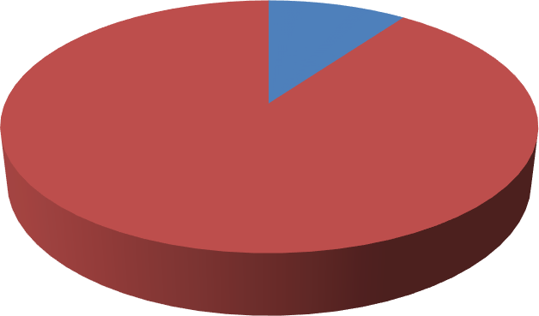
NO. OF RESPONDENTS
10%
INTERNAL SOURCES
EXTERNAL SOURCES
90%

GRAPH 1
INTERPRETATION:
From the above pie chart, it can be interpreted that the majority of the employees working at Skill development Institute think that the major source of recruitment is the external sources.

Do you think the organization prefers referred candidates?
OPTIONS | NO. OF RESPONDENTS | PERCENTAGE
HIGHLY AGREE | 3 | 6%
AGREE | 15 | 30%
DISAGREE | 13 | 26%
HIGHLYDISAGREE | 19 | 38%
TOTAL | 50 | 100%
TABLE NO:-2

ANALYSIS
- According to the survey, 38% of the employees highly disagree that the organization prefers referred candidates.
- While 30 % of employees agree that the organization prefers referred candidates.
- 26% of the employees disagree that the organization prefers referred candidates.
- 6% of the employees highly agree with the question.

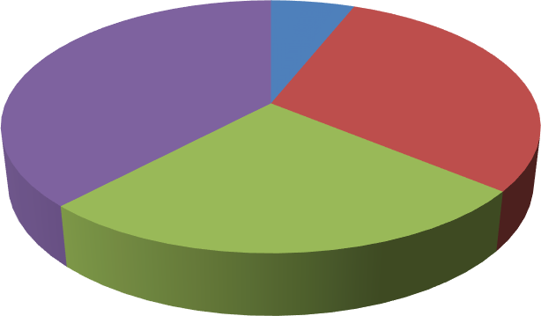
NO. OF RESPONDENTS
6%
38%
30%
26%
HIGHLY AGREE
AGREE
DISAGREE
HIGHLY DISAGREE
GRAPH NO:-2

INTERPRETATION
From the above pie chart, it is interpreted that the majority of the employees highly disagree that the organization prefers referred candidates.

Does the organization clearly define the requirement and eligibility criteria?
OPTIONS | NO. OF RESPONDENTS | PERCENTAGE
HIGHLY AGREE | 9 | 18%
AGREE | 29 | 58%
DISAGREE | 8 | 16%
HIGHLY DISAGREE | 4 | 8%
TOTAL | 50 | 100%
TABLE NO:-3

ANALYSIS
- 58% of the employee agrees that the organization clearly defines the requirement and eligibility.
- 18% of the employee highly agrees.
- 16% of the employee disagrees.
- 8% of the employees highly disagree

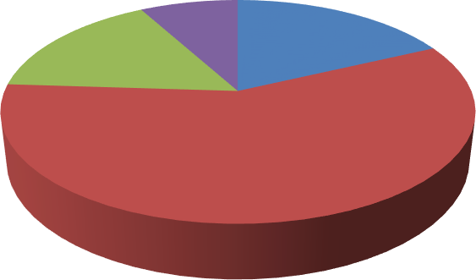
NO. OF RESPONDENTS
8%
18%
16%
58%
HIGHLY AGREE
AGREE
DISAGREE
HIGHLY DISAGREE
GRAPH NO:-3

INTERPRETATION
From the above pie chart, it can be clearly interpreted that the majority of the employees think that the organization clearly defines the requirement and eligibility criteria.

Do you think academic marks play an important role in the recruitment process?
OPTIONS | NO. OF RESPONDENTS | PERCENTAGE
HIGHLY AGREE | 17 | 34%
AGREE | 28 | 56%
DISAGREE | 4 | 8%
HIGHLY DISAGREE | 1 | 2
TOTAL | 50 | 100%
TABLE NO:-4

ANALYSIS
- 56%the employees agree that the academic marks play an important role in the recruitment process.
- 34% of the employees highly agree.
- 8% of the employees disagree.
- 2% of the employees strongly disagree.

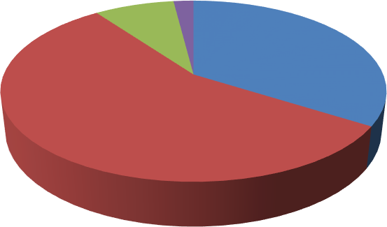
NO. OF RESPONDENTS
2%
8%
34%
HIGHLY AGREE
AGREE
56%
DISAGREE
HIGHLY DISAGREE
GRAPH NO:-4

INTERPRETATION
From the above pie chart, it can be interpreted that the majority of the employees agree that academic marks play an important role in the recruitment process at Skill development Institute.

Does the organization conduct an induction /orientation process?
OPTIONS | NO.OF RESPONDENTS | PERCENTAGE
YES | 14 | 28%
NO | 36 | 72%
TOTAL | 50 | 100%
TABLE NO:-5

ANALYSIS
- 72% of the employees said no, to the question that if the organization conducts orientation and induction procedure
- 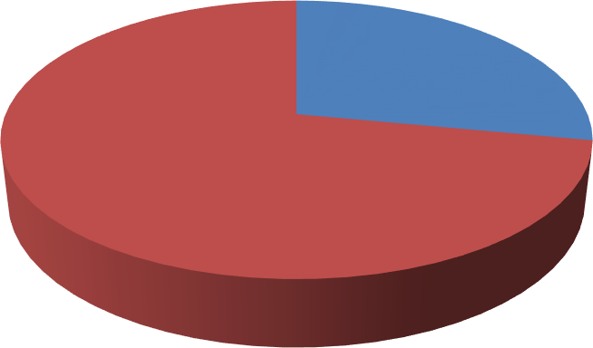28% of the employees said yes that the organization conducts orientation and induction procedures.
NO.OF RESPONDENTS
28%
YES
72%
NO
GRAPH: 5

INTERPRETATION
From the above pie chart, it can be clearly interpreted that the majority of the employees said that the organization does not conduct orientation and induction procedures.

Is the organization doing timely recruitment?
OPTIONS | NO. OF RESPONDENTS | PERCENTAGE
AGREE | 26 | 52%
HIGHLY AGREE | 13 | 26%
DISAGREE | 11 | 22%
HIGHLY DISAGREE | 0 | 0%
TOTAL | 50 | 100%
TABLE NO:-6

ANALYSIS
- 52% of the employees agree that the organization is doing timely recruitment.
- 26% highly agree.
- 22% disagree with the question.
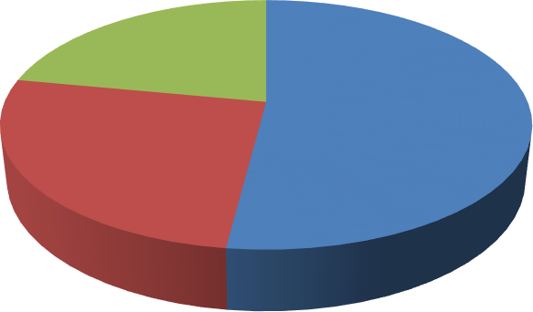
NO. OF RESPONDENTS
0%

22%
52%
26%
AGREE
HIGHLY AGREE DISAGREE HIGHLY DISAGREE
GRAPH NO:-6

INTERPRETATION
From the above pie chart, it can be clearly interpreted that the majority of the employees agreed that the organization does timely recruitment.

- What is the type of recruitment test conducted at Skill development Institute?
OPTIONS | NO. OF RESPONDENTS | PERCENTAGE
APTITUDE TESTS | 22 | 44%
GENERAL INTELLIGENCE TEST | 16 | 32%
PSYCHOMETRIC TEST | 0 | 0%
OTHERS | 12 | 24%
TOTAL | 50 | 100%
TABLE NO:-7

ANALYSIS
- 44% of the employees chose that aptitude test is conducted as a recruitment test
- 32% chose the general intelligence test.
- 24% chose the option of other.

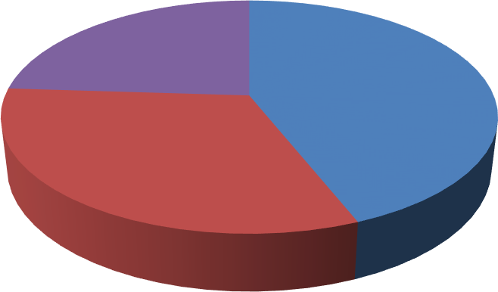
NO. OF RESPONDENTS
24%
0%
44%
32%
APTITUDE TESTS
GENERAL INTELLIGENCE TEST PSYCHOMETRIC TEST
OTHERS
GRAPH NO:-7

INTERPRETATION
From the above pie chart, it can be clearly interpreted that the majority of the employees chose the aptitude test as the test that is conducted in the recruitment process.

How many rounds of interviews are conducted?
OPTIONS | NO. OF RESPONDENTS | PERCENTAGE
ONE | 12 | 24%
TWO | 30 | 60%
THREE | 8 | 16%
MORE THAN THREE | 0 | 0
TOTAL | 50 | 100
TABLE NO:-8

ANALYSIS
- 60% of the employees chose that two rounds of an interview are conducted.
- 24% chose one round of interviews.
- 16%chose three rounds of interviews.

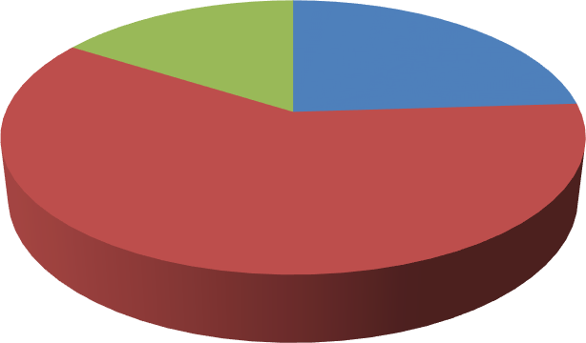
NO. OF RESPONDENTS
0%
16%
24%
60%
ONE
TWO
THREE
MORE THAN THREE
GRAPH NO:-8

INTERPRETATION
From the above pie chart, it can be clearly interpreted that the majority of the employees chose that two rounds of interview are conducted.

What are the types of interview conducted?
OPTIONS | NO. OF RESPONDENTS | PERCENTAGE
PANEL INTERVIEW | 39 | 78%
GROUP INTERVIEW | 11 | 22%
STRESS INTERVIEW | 0 | 0%
OTHERS | 0 | 0%
TOTAL | 50 | 100
TABLE NO:-9

ANALYSIS
- 78% of the employees chose that the panel interview is conducted.
- 22% chose group interviews.

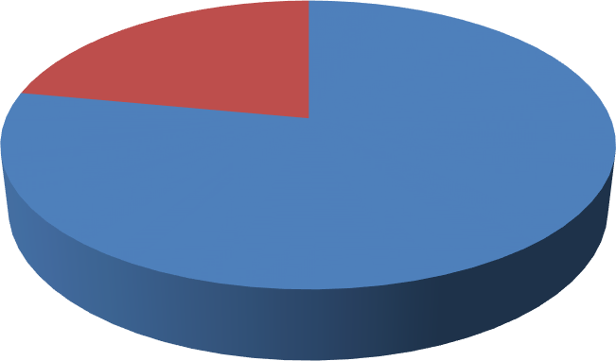
NO. OF RESPONDENTS

0%
22%
78%
PANEL INTERVIEW
GROUP INTERVIEW STRESS INTERVIEW OTHERS
GRAPH NO:-9

INTERPRETATION
From the above pie chart, it can be clearly interpreted that the majority of the employees chose that panel interview as the type of interview that is conducted at Skill development Institute.

Rate the effectiveness of the selection processes?
OPTIONS | NO. OF RESPONDENTS | PERCENTAGE
GOOD | 23 | 46%
AVERAGE | 11 | 22%
NEUTRAL | 15 | 30%
BAD | 1 | 2%
TOTAL | 50 | 100%
TABLE NO:-10

ANALYSIS
- 46% of the employees rated the effectiveness of the selection process as good.
- 30% have a neutral perspective on it.
- 22% rated it as average.
- 2% rated it as bad.

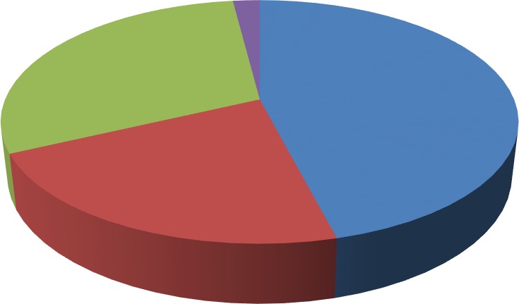
NO. OF RESPONDENTS
2%
30%
46%
GOOD
AVERAGE NEUTRAL
22%
BAD
GRAPH NO:-10

INTERPRETATION
From the above pie chart, it can be clearly interpreted that the majority of the employees think that the effectiveness of the selection process is good.

Do you think Skill development Institute prefers experienced candidates in the selection process?
OPTIONS | NO. OF RESPONDENTS | PERCENTAGE
STRONGLY AGREE | 12 | 24%
AGREE | 28 | 56%
DISAGREE | 6 | 12%
STRONGLY DISAGREE | 4 | 8%
TOTAL | 50 | 100%
TABLE NO:-11

ANALYSIS
- 56% of the employees think that Skill development Institute prefers experienced candidates.
- 24% of the employees highly agreed.
- 12% of the employees disagreed.
- 8% of the employees strongly disagreed.

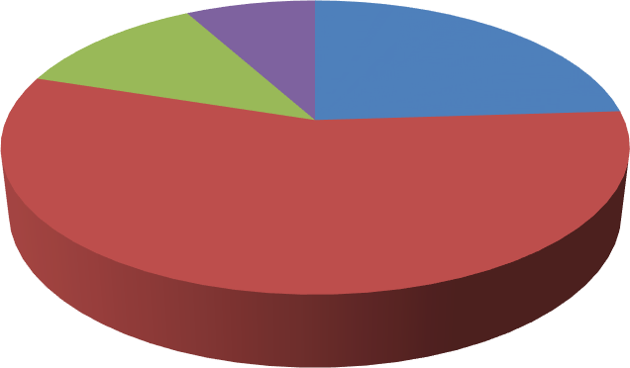
NO. OF RESPONDENTS
0%
8%
12%
24%
STRONGLY AGREE
AGREE DISAGREE
STRONGLY DISAGREE
56%
GRAPH NO:-11

INTERPRETATION
From the above pie chart, it can be clearly interpreted that the majority of the employees agreed that the Skill development Institute prefers experienced candidates.

Do you feel Skill development Institute is using satisfactory methods to conduct the interviews?
OPTIONS | NO. OF RESPONDENTS | PERCENTAGE
AGREE | 28 | 56%
HIGHLY AGREE | 4 | 8%
NEUTRAL | 10 | 20%
DISAGREE | 6 | 12%
STRONGLY DISAGREE | 2 | 4%
TOTAL | 50 | 100%
TABLE NO:-12

ANALYSIS
- 56%of the employees agree that the organization is using satisfactory method to conduct the interviews.
- 20% of the employees are neutral.
- 12%of the employees disagree.
- 8% of the employees highly agree.
- 4%highly disagrees

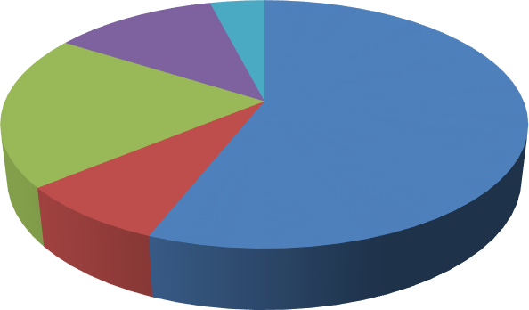
NO. OF RESPONDENTS
12%
4%
20%
56%
8%
AGREE
HIGHLY AGREE NEUTRAL DISAGREE
STRONGLY DISAGREE
GRAPH NO:-12

INTERPRETATION
From the above pie chart, it can be clearly interpreted that the majority of the employees feel that the organization is using satisfactory methods to conduct the interviews.

Are you satisfied with the recruitment and selection process through which you are selected?
OPTIONS | NO. OF RESPONDENTS | PERCENTAGE
YES | 38 | 76%
NO | 12 | 24%
TOTAL | 50 | 100%
TABLE NO:-13

ANALYSIS
- 76% of the employees are satisfied with the recruitment and selection process through which they got selected.
- 24% of the employees are not satisfied.
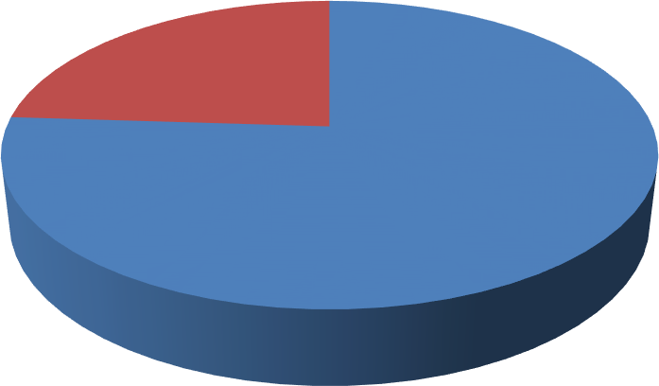
NO. OF RESPONDENTS
24%
76%
YES
NO
GRAPH NO:-13

INTERPRETATION
From the above pie chart, it can be clearly interpreted that the majority of the employees are satisfied with the recruitment and selection process through which they got selected.

- How will you rate the recruitment and selection process in Skill development Institute?
OPTIONS | NO OF RESPONDENTS | PERCENTAGE
EXCELLENT | 4 | 8%
GOOD | 30 | 60%
AVERAGE | 12 | 24%
BELOW AVERAGE | 4 | 8%
TOTAL | 50 | 100%
TABLE: 14

ANALYSIS
  - 60%of the employees feel that the recruitment and selection process is good.
  - 24% rated it to be average.
  - 8%rated it as excellent.
  - 8%rated it as below average.

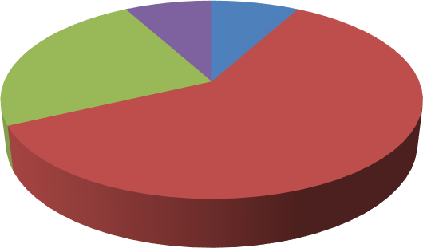
NO OF RESPONDENTS
8% 8%
24%
EXCELLENT
GOOD
60%
AVERAGE
BELOW AVERAGE
GRAPH: 14

INTERPRETATION
From the above pie chart, it can be clearly interpreted that the majority of the employees think that the recruitment and selection process is good.

How do you rate the performance of the HR department in the recruitment and selection process?

OPTIONS | NO. OF RESPONDENTS | PERCENTAGE
EXCELLENT | 8 | 16%
GOOD | 22 | 44%
ADEQUATE | 14 | 28%
POOR | 6 | 12%
TOTAL | 50 | 100%
TABLE: 15

ANALYSIS
  - 44% of the employees rated the performance of HR in the recruitment and selection process as good.
  - 28% rated as adequate.
  - 16%rated as excellent.
  - 12%rated as poor.

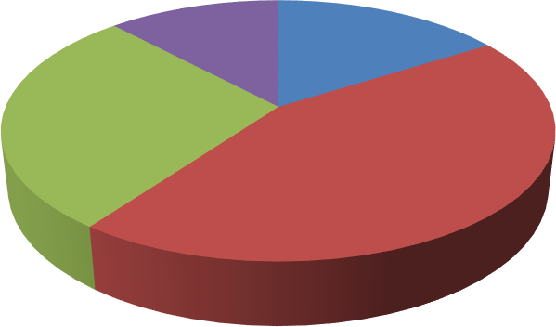
NO. OF RESPONDENTS
12%
16%
28%
EXCELLENT
GOOD
44%
ADEQUATE
POOR
GRAPH: 15

INTERPRETATION
From the above pie chart, it can be clearly interpreted that the majority of the employees think that the performance of HR in the recruitment and selection process is good.

FINDINGS
MAJOR FINDINGS OF THE STUDY:
- From question no.1, it has been found, that 90% of the employees think that the major source of recruitment at the institute is done through external sources while 10% of the employees think the major source of recruitment at institute is taken place through Internal sources. Hence, it can be said that the majority of the employees at institute think that the major source of recruitment is through external sources.
- From question no.2, it has been found that 38% of the employees highly disagree that the organization prefers referred candidates. While 30 % of employees agree that the organization prefers referred candidates. On the other hand, 26% of the employees disagree that the organization prefers referred candidates and 6% of the employees highly agree with the question. Hence, it can be said that the majority of the employees highly disagree that the organization prefers referred candidates.
- From question no.3, it has been found that 58% of the employees agree that the organization clearly defines the requirement and eligibility while 18% of the employee highly agrees with this.16% of the employee disagrees and 8% of the employees chose to highly disagree. Hence, it can be said that the majority of the employees think that the organization clearly defines the requirement and eligibility criteria.
- From question no.4, it has been found that 56%the employees agree that the academic marks play an important role in the recruitment process while 34% of the employees highly agree also 8% of the employees disagree and 2% of the employees strongly disagree. Hence, it can be said that the majority of the employees agree that the academic mark plays an important role in the recruitment and selection process.
- From question no.5, it has been found that 72% of the employees said no, to the question, does the organization conducts orientation and induction procedures? While the rest 28% of the employees said yes that the organization conducts orientation and induction procedures .Hence, it can be said that the majority of the employees said the organization does not conduct orientation and induction procedures.
- From question no.6, it has been found that 52% of the employees agree that the organization is doing timely recruitment while 26% chose to highly agree and the rest of the 22% disagrees with the question. Hence, it can be said that the majority of the employees agree that the organization does timely recruitment.
- From question no.7, it has been found that 44% of the employees chose the aptitude test as the test that is conducted as a recruitment test while 32% chose the general intelligence test and the rest of the 24% chose the option of other. Hence, it can be said that the majority of the employees chose the aptitude test as the test that is conducted in the recruitment process.
- From question no.8, it has been found that 60% of the employees say that two rounds of the interview are conducted for selecting a candidate while 24% chose that only one round of interview and the rest 16%chose three rounds of interview. Hence, it can be said that the majority of the employees say that a total of two rounds of interviews are conducted before selecting a candidate.
- From question no.9, it has been found that 78% of the employees chose the panel interview conducted and 22% chose the group interview. Hence it can be said that the majority of the employees chose the panel interview as the type of interview that is conducted at Skill development Institute.
- From question no.10, it has been found that 46% of the employees rated the effectiveness of the selection process as good while 30% has a neutral perspective on the question. 22% rated it as average and only 2% rated it as bad. Hence it can be said that the majority of the employees think that the effectiveness of the selection process is good.
- From question no.11, it has been found that 56% of the employees think that Skill development Institute prefers experienced candidates while 24% of the employees highly agreed.12% of the employees disagreed and 8% of the employees strongly disagreed. Hence it can be said that the majority of the employees agreed that the I Skill development Institute IE prefers referred candidates.
- From question no.12, it has been found that 56% of the employees agree that the organization is using a satisfactory method to conduct the interviews while 20% of the employees are neutral. 12%of the employees disagree and 8% of the employees highly agree, and only 4% highly disagree. Hence it can be stated that the majority of the employees feel that the organization is using satisfactory methods to conduct interviews.
- From question no.13, it has been found that 76% of the employees are satisfied with the recruitment and selection process through which they got selected while the rest 24% of the employees are not satisfied. Hence it can be said that the majority of the employees are satisfied with the recruitment and selection process.
- From question no.14, it has been found that 60%of the employees feel that the recruitment and selection process is good. 24% rated it to be average while 8%rated it as excellent and 8%rated it as below average. Hence it can be said that the majority of the employees think that the recruitment and selection process at skill development institute is good.
- From question no.15, it has been found that 44% of the employees rated the performance of HR in the recruitment and selection process as good. 28% rated as adequate. 16%rated as excellent and the remaining 12%rated as poor. Hence it can be said that the majority of the employees think that the performance of HR in the recruitment and selection process is good.
A few of the suggestions which may aid as a help to bring improvement in the Recruitment and Selection process.
- Giving opportunities to freshers: The organization can give opportunities to freshers and candidates with less experience but required qualifications.
Advantage: Recruiting freshers with required qualifications can bring a change. Fresher’s can bring new ideas and liveliness along with them, which can prove beneficial to the organization.
  - Mixed interview methods: It is blend of both structured and unstructured interviews. In this type of interview, both determined questions and spontaneous questions are asked. Advantage: It helps in getting an in-depth analysis of the applicants.

FUTURE SCOPE OF THE STUDY
This project talks about the Recruitment and selection that is followed at SKILL DEVELOPMENT INSTITUTE. This study brings forward a detailed report of the practices through which the recruitment and selection process is carried out in the organization. It also shows the efficiency of the recruitment and selection process followed in SKILL DEVELOPMENT INSTITUTE

LIMITATIONS OF THE STUDY
- Respondents were mostly in hurry and busy with their own works due to which they might not have responded truly and accurately to all the questions.
- Respondents were lacking attentiveness in providing the information that was required to conduct the analysis.

SUGGESTIONS AND CONCLUSION
A few of the suggestions which may aid as a help to bring improvement in the process are:
- Giving opportunities to freshers: The organization can give opportunities to freshers and candidates with less experience but required qualifications.
Advantage: Recruiting freshers with required qualifications can bring a change. Fresher’s can bring new ideas and liveliness along with them, which can prove beneficial to the organization.
  - Mixed interview methods: It is blend of both structured and unstructured interviews. In this type of interview, both determined questions and spontaneous questions are asked.
Advantage: It helps in getting an in-depth analysis of the applicants.

Conclusion

The recruitment and selection process is one of the most important parts of any organization because an organization cannot function without its employees. It is only through an adequate recruitment and selection process that an organization can acquire eligible candidates for better performance. It can be found from the report that the recruitment and selection process that is conducted at the Skill Development Institute is somewhat satisfactory. However, there are some changes which can be implemented. When we come down to the recruitment process specifically, it can be seen from the opinions of the employees collected through the questionnaire that the recruitment process is not the best but is overall at a good level. In terms of defining the eligibility criteria, it provides a generic criterion. The criteria provided are clear but can be made a little more specific with the requirement and eligibility. While looking at the selection process it can be seen from the data collected that the employees are not quite happy with the selection process and thus there can be some improvement in the selection process. The organization can introduce different methods of interview for the process of evaluating the candidates and selecting them. At an overall level, the effectiveness of the recruitment and selection process that is followed is satisfactory to the employees working; however, there is always a scope for improvement in every possible aspect of work in general.

REFERENCES:

JOURNALS:
[1]Abbasi, S. G., Tahir, M. S., Abbas, M., &Shabbir, M. S. (2022). Examining the relationship between recruitment & selection practices and business growth: An exploratory study. Journal of Public Affairs, 22(2), e2438.
[2]AbdallaHamza, P., Jabbar Othman, B., Gardi, B., Sorguli, S., Mahmood Aziz, H., Ali Ahmed, S., ...& Anwar, G. (c. Recruitment and selection: The relationship between recruitment and selection with organizational performance. Hamza, PA, Othman, BJ, Gardi, B., Sorguli, S., Aziz, HM, Ahmed, SA, Sabir, BY, Ismael, NB, Ali, BJ, Anwar, G.(2021). Recruitment and Selection: The Relationship between Recruitment and Selection with Organizational Performance.
[3]Anand, V. V., Shanthanlakshmi, M., Srinivasan, G. U., Arunkumar, V., Icewarya, G., Nandhu, S., &Kamatchi, S. M. (2018). A study on effectiveness of recruitment organizational support in ITes. International Journal of Pure and Applied Mathematics, 119(7), 2755-2764.
[4]Anosh, M., Hamad, N., &Batool, A. (2014). Impact of Recruitment and selection of HR Department Practices. European Journal of Business and Management, 6(31), 200-205.
[5]Breaugh, J. A. (2013). Employee recruitment. Annual review of psychology, 64, 389-416
[6]Compton, R. L. (2009). Effective recruitment and selection practices. CCH Australia Limited.
[7]Dany, F., & Torchy, V. (2017). Recruitment and selection in Europe Policies, practices and methods 1. In Policy and practice in European human resource management (pp. 68-88). Routledge.
[8]Garner, E. (2012). Recruitment and selection. Bookboon
[9]Gusdorf, M. L. (2008). Recruitment and selection: Hiring the right person. USA: Society for Human Resource Management, 1-14
[10]Karim, M. M., Bhuiyan, M. Y. A., Nath, S. K. D., &Latif, W. B. (2021). Conceptual Framework of Recruitment and Selection Process. International Journal of Business and Social Research, 11(02), 18-25.
[11]Louw, G. J. (2013). Exploring recruitment and selection trends in the Eastern Cape. SA Journal of Human Resource Management, 11(1), 1-10.
[12]Muscalu, E. (2015). Sources of human resources recruitment organization. Land Forces Academy Review, 20(3), 351.
[13]Omisore, B. O., &Okofu, B. I. (2014). Staff recruitment and selection process in the Nigerian public service: what is to be done. International Journal of Human Resource Studies, 4(3), 280-293.
[14]Otoo, I. C., Assuming, J., &Agyei, P. M. (2018). Effectiveness of recruitment and selection practices in public sector higher education institutions: Evidence from Ghana. European scientific journal, 14(13), 199-214.
[15]Searle, R. H., & Al-Sharif, R. (2018). Recruitment and selection. In Human Resource Management (pp. 215-237). Routledge.
[16]Tyagi, P. K., & Gupta, S. K. (2019). Recruitment and Selection Process in Travel Trade Organisations of Chandigarh: An Evaluation. Journal of Emerging Technologies and Innovative Research, 6(3), 787-794.
[17]Wolniak, R. (2018). Methods of recruitment and selection of employees on the example of the automotive industry. ZeszytyNaukowe. Organizacja i Zarządzanie/PolitechnikaŚląska.
[18]Yaseen, A. (2015). Recruitment and selection process of higher education sector and its impact on organizational outcomes. International Journal of Human Resource Studies, 5(4), 79-94.
[19]Zinyemba, A. Z. (2014). The challenges of recruitment and selection of employees in Zimbabwean companies. international Journal of science and research, 3(1), 29- 33.
WEBSITES:

[20]https://www.yourarticlelibrary.com/hrm/recruitment-hrm/recruitment-of-employees-top-15- external-sources/75384

ANNEXURES

QUESTIONNAIRE FOR RESPONDENTS

Please read all the questions carefully and tick the answer that best suits you and fill up the blanks where required.
Name (optional): Gender:

- What is the major source of recruitment in the organization?
  - Internal Sources
  - External Sources
  - Through Advertisement
  - Others
- Do you think the organization prefers referred candidates?
  - Agree
  - Highly agree
  - Disagree
  - Highly disagree
- Does the organization clearly define the requirement and eligibility criteria?
  - Agree
  - Highly agree
  - Disagree
  - Highly Disagree
- Do you think academic marks play an important role in the recruitment process?
  - Highly Agree
  - Agree
  - Disagree
  - Highly disagree
- Does the organization conduct orientation and induction procedures?
  - Yes
  - No
- Is the organization doing timely recruitment?
  - Agree
  - Highly agree
  - Disagree
  - Highly disagree
- What are the types of recruitment tests conducted?
  - Aptitude Test
  - General Intelligence test
  - Psychometric test
  - Others
- How many rounds of interviews are conducted before selecting a candidate?
- One
- Two
- Three
- More than three
- What are the types of interviews conducted?
- Panel interview
- Group interview
- Stress interview
- Others
- Rate the effectiveness of the selection process?
  - Good
  - Average
  - Neutral
  - Below average
  - Bad
- Do you think your organization prefers experienced candidate in the selection process?
  - Strongly Agree
  - Agree
  - Disagree
  - Strongly Disagree
- Do you feel your organizationis using satisfactory methods to conduct the interviews?
  - Agree
  - Highly Agree
  - Neutral
  - Disagree
  - Highly Disagree
- Are you satisfied with the recruitment and selection process through which you are selected?
  - Yes
  - No
- How will you rate the recruitment and selection process in your organization?
  - Excellent
  - Good
  - Average
  - Below average
- How would you rate the performance of the HR department in the recruitment and selection process?

  - Excellent
  - Good
  - Adequate
  - Poor

Thank You for your precious time!!!

