Revolutionary Drowsy Driver Detection System Using IoT-Enabled Smart Anti-Sleep Glasses

JANAKI GAMDHAM
Electrical and Electronics Engineering
Swarnandhra college of engineering and technology
Narsapur, INDIA
Janakigandham5005@gmail.com

ABSTRACT

Utilizing Arduino and some simple electrical; components, make anti-sleep glasses. Anytime the driver nods off while operating the car, this glass sounds an alarm. Since sleeping on wheels can occasionally be dangerous, it may result in fatal accidents. Therefore, we may utilize this device to inform the driver when the driver he feels sleepy to avoid accidents-related outcomes. Their anti-sleeping glasses are made to sense the sleepy eyes of the person which rescues him/her from the malicious situation. So let’s find out how to construct some basic anti-sleep glasses on your own.

INTRODUCTION

This project's foundation is an infrared sensor, which serves as its brain. Now let's look at the IR sensor. A typical infrared sensor is depicted in the image; it consists of a transmitter infrared LED, a photodiode, an op-amplifier IC, and a potentiometer. The photodiode is positioned such that it is not directly exposed to IR rays, just next to the IR LED. The photodiode is IR radiation sensitive. Its anode is connected to the non-inverting input of the Opp- amplifier, which is likewise pulled down by the 10-kilo ohm resistor, and its cathode is connected to the positive voltage or 5 volts. A potentiometer is used in IR sensors to adjust the sensor's sensitivity distance; it is connected to the Opp-inverting amplifier's input. When an item passes in front of an IR LED, the IR rays are reflected and received by the photodiode. As a result of this change in IR radiation, the voltage at the anode changes, and this change in the anode voltage depends on the amount of IR radiation received by the photodiode. The anode voltage will alter more in proportion to the amount of IR radiation received. The IR Sensor's output is derived from the Opp-output amplifier. By turning the potentiometer on the sensor, we can change the sensitivity distance. When we turn the potentiometer, we are setting a threshold voltage for the Opp-non-inverting amplifier's input. The voltage on the non-inverting input, or +ve voltage from the photodiode, is advanced and produces a positive pulse at the output of the Opp-amplifier, or output of the sensor, whenever the voltage on the non-inverting input exceeds the threshold value.
Check out the attached circuit schematic for an example of an IR sensor. 3 Let's look at the project's primary circuit schematic. I attached an IR sensor to the Arduino Pro Mini board by connecting the sensor's VCC to the board's VCC, ground to the board's ground, and the sensor's output to Analog Pin One (A1) on the board. For alerting, I utilized a 5-volt buzzer and a vibrator motor from the previous cell phone. The buzzer and vibrator motor were linked in parallel, and an all-purpose N-P-N transistor (BC547) was used to power both devices. The buzzer and vibrator motor's negative pin is connected to the transistor's collector's emitter, which is connected to the ground. Additionally linked to the Arduino Pro Mini's VCC are the positive terminals of the buzzer and vibrator. Through a 4.7-kilo ohm resistor, the base of the transistor was linked to pin D3 of the Arduino Pro Mini.

- BLOCK DIAGRAM:
The block diagram of the anti-sleep glasses is seen in the image above. It comprises components like an Arduino Nano, an IR sensor, spectacles, a buzzer of 5 volts, an SPST switch, a battery of 9 volts, and jumper wires.

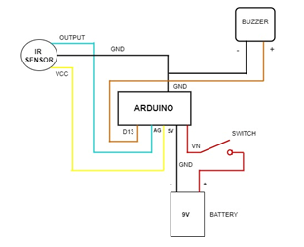
Fig1: Block Diagram
COMPONENTS REQUIRED
IR SENSOR:
IR technology serves a variety of functions in both daily life and other sectors. For instance, TVs employ an IR sensor to decipher the signals sent by a remote control. The key advantages of IR sensors are their low power consumption, straightforward construction, and practical functionality. The human eye is not capable of seeing IR waves. The visible and microwave portions of the electromagnetic spectrum contain IR radiation. These waves typically have wavelengths between 0.7 m and 1000 m. The near-infrared, mid-infrared, and far-infrared spectrums may be separated into these three categories. The near-infrared zone has wavelengths between 0.75 and 3 m, the mid-infrared region has wavelengths between 3 and 6 m, and the far infrared sector has wavelengths more than 6 m. An infrared sensor may pick up on these radiations, which are undetectable to human vision. An IR LED (Light Emitting Diode) serves as the emitter, and an IR photodiode, which is sensitive to IR light of the same wavelength as that emitted by the IR LED, serves as the detector. The resistances and output voltages when IR light strikes the photodiode change proportionally to the intensity of the IR light received.
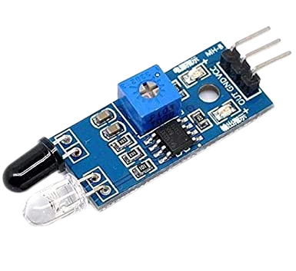
Fig2: IR SENSOR
IR SENSOR/INFRARED SENSOR:
An electrical gadget called an infrared sensor emits light to perceive certain features of its environment. An IR sensor can measure an object's heat while also spotting movement. These kinds of sensors are referred to as passive IR sensors because they do not emit infrared radiation; instead, they only measure it. Typically, all items emit some kind of heat radiation in the infrared range. One type of transmitter that generates IR radiations is the IR LED. This LED resembles a typical LED in appearance, and the radiation it produces is invisible to the human eye. An infrared transmitter is primarily used by infrared receivers to detect radiation. Photodiodes are a kind of these infrared receivers. Because they only detect IR light, IR Photodiodes are different from regular Photodiodes. Different infrared receiver types may be distinguished primarily by their voltage, wavelength, packaging, etc.
When utilized as an IR transmitter and receiver pair, the wavelength of the receiver must match that of the transmitter. Here, an IR photodiode serves as the receiver, and an IR LED as the transmitter. When utilized as an IR transmitter and receiver pair, the wavelength of the receiver must match that of the transmitter. Here, an IR photodiode serves as the receiver, and an IR LED as the transmitter. This is the basic idea behind how an IR sensor works.
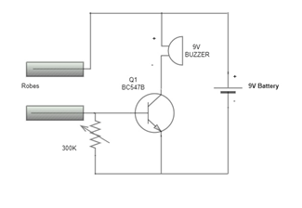
Fig IR SENSOR / INFRARED SENSOR

The following are some of the infrared sensor's benefits.
- Strong noise immunity.
- Motion is picked up whether there is light or not.
- Rust has no impact on these sensors.
- For detection, they don't have to touch anything.
- Due to the infrared radiation's directed nature, there is no data loss.
- These are smaller and more moderate in size.
- Compared to thermocouples, it reacts relatively rapidly.
- High dependability is provided by it.
SPECIFICATIONS:
- The operating voltage is 5VDC
- There are 12 mounting holes and 3.3V I/O pins.
- There is a 20-centimeter maximum range.
- The sensing range may be altered.
- a permanent ambient light sensor

BUZZER:
A beeper or buzzer, for example, might be electromechanical, piezoelectric, or mechanical in design. This mostly transforms the signal from audio to sound. It is often powered by DC voltage and used in timers, alarm clocks, printers, computers, and other electronic equipment. It may produce a variety of sounds, including alarm, music, bell, and siren, according to the varied designs.
The buzzer's pin configuration is seen below. It has two pins: a positive pin and a negative pin. The "+" sign or a longer terminal is used to indicate this is a positive terminal. The positive terminal is indicated with the '+'symbol or long terminal and is connected to the GND terminal. This terminal is supplied by 6 volts.
Fig4: Buzzer
SPECIFICATIONS:
The buzzer's specifications include the following.
- Black is the color.
- 3,300Hz is the frequency range.
- Operating temperatures vary from -20 to 60 degrees Celsius.
- Operating voltage levels range between 3V and 24V.
- The decibel level of the sound is 85dBA or 10c.
- The supply current is below 15MA
SPST SWITCH:
A Single Pole Single Throw switch serves in circuits as an on-off switch. When the switch is closed, the circuit is on. When the switch is open, the circuit is off.

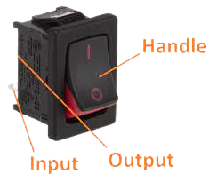
Fig5: Single pole single throw switch (SPST)

Thus, SPST switches are relatively basic in design. Circuit for a single-pole, single-throw (SPST) switch Here is an illustration of a circuit that makes use of single-pole, single-throw switches. The circuit is closed and the lamp turns on when the SPST is closed. The lamp's light is extinguished and the circuit is closed when the SPST is then opened. This demonstrates an SPST switch's fundamental structure and operation.

ARDUINO -NANO:
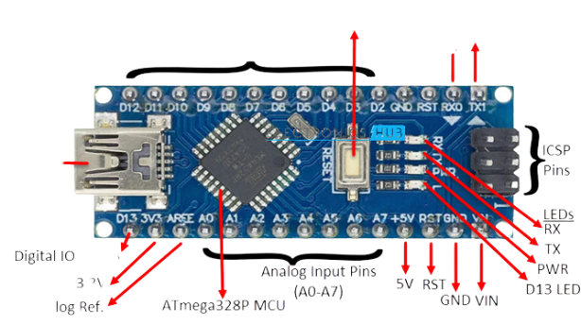
Fig6: Arduino NANO
The Arduino Nano is a compact, feature-rich, adaptable, and breadboard-friendly microcontroller board based on the ATmega328p that was created in 2008 by Arduino. cc in Italy. It has 30 male I/O headers that are arranged in a DIP30 format. There are 14 digital pins, 8 analog pins, 2 reset pins, and 6 power pins in the Arduino Nano pinout. The Arduino IDE, which can be downloaded from the official Arduino website, is used to program it. Because Arduino Nano is a scaled-down version of Arduino UNO, both devices essentially share the same functionality. The de Nevertheless, the input voltage ranges from 7 to 12V. The load connected to an Arduino Nano pins should not consume more than the device's maximum current rating of 40mA.vice has a 5V working voltage. While analog Read () is used to manage the operations of analog pins, functions like pin Mode () and digital Write () are used to control the operations of digital pins. The analog pins have a total resolution of 10 bits, measuring values between 0 and 20. A crystal oscillator with a 16 MHz frequency is included with the Arduino Nano. . With constant voltage, it is utilized to create a clock with a precise frequency.
Depending on At the mega board, flash memory can be 16KB or 32KB; for example, the Atmega168 has a 16KB flash memory whereas the Atmega328 has a 32KB flash memory. To store code, utilize flash memory. A boot loader uses the 2KB of total flash memory that is left behind. The Arduino Nano includes a 2KB SRAM memory. The EEPROM memory of the Arduino Nano is 1KB. It is programmed using the Arduino IDE, a cross-platform integrated development environment.

JUMPER WIRES:

Simply said, jumper wires are wires with connector pins at either end that can be used to connect two places without soldering. With breadboards and other prototype tools, jumper wires are frequently used to make it simple to change a circuit as required. Fairly easy. Jumper wires are actually among the most elementary things there are. Jumper wires are available in several colors, although the hues have no real significance. Thus, a red jumper wire is equivalent to a black one in theory. However, you can take advantage of the colors to distinguish between different connection kinds, such as power and ground. Male-to-male, male-to-female, and female-to-female jumper wires are the most common types. The wire's termination tip distinguishes each one from the other. While female ends do not have a protruding pin and are used to plug into items, male ends do. The most typical and often utilized jumper cables are male-to-male.
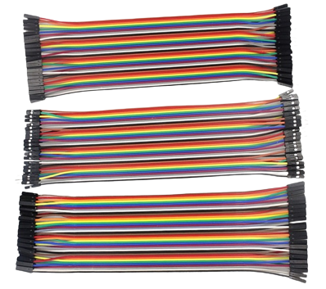
Fig7: Jumper Wires
BATTERY 9V:
The nine-volt battery, sometimes known as a 9-volt battery, is an electric battery that delivers voltage between 7.2 and 9.6 volts, depending on the technology. Various sizes and capacities of batteries are produced; one popular size is PP3, which was first used in early transistor radios. The PP3 has two polarised snap connectors on the top and is shaped like a rectangular prism with rounded sides. This type is frequently employed in numerous applications, including clocks, toys, and domestic items like smoke and gas detectors.
The primary lithium iron disulfide and lithium manganese dioxide (also referred to as CRV9), primary zinc-carbon and alkaline chemistry, primary lithium iron disulfide, nickel-cadmium, nickel-metal hydride, and lithium-ion chemistry are all frequent options for the nine-volt PP3-size battery. This type of mercury-oxide battery, which was once widely used, hasn't been produced in a long time due to its mercury concentration. This format has the designations NEDA 1604, IEC 6F22 (for zinc-carbon), or MN 1604 6LR61 (for alkaline). No of the chemistry, the size is typically referred to as PP3; this name was formerly only used for carbon-zinc or, in some countries, E or E-block. [3] The bigger 9-volt PP6, PP7, and PP9 batteries are still available. A variety of PP batteries with voltages of 4.5, 6, and 9 volts and varied capacities were produced in the past. There are a couple of additional 9-volt battery sizes available: A10 and A29
Fig8: Battery 9V

3. DESIGN AND IMPLEMENTATION

1. Let's begin by connecting the Arduino and the IR sensor.
2. Join the sensor VCC pin to the Arduino 5V, the sensor output pin to pin A1 on the Arduino, and a second sensor ground pin to pin G0 on the Arduino.
3. Let's now connect the analog pin of the buzzer to the Arduino D2 pin. the buzzer-negative pin is then connected to the Arduino's ground pin.
4. The battery's positive terminal is linked to the switch, while its negative terminal is linked to the Arduino ground pin and the switch's VCC pin.
An infrared sensor, which serves as the project's brain, is the foundation of its operation. Now let's look at the IR sensor. A common infrared sensor is depicted in the image; it consists of a transmitter infrared LED, a photo diode, an op-amplifier IC, and a potentiometer.

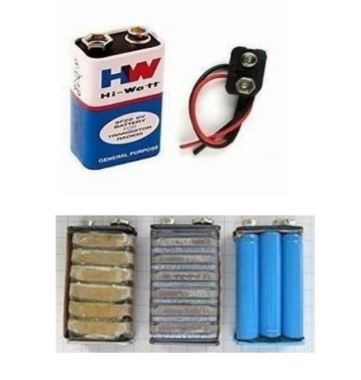
The photodiode is positioned such that it is not directly exposed to IR rays, just next to the IR LED. Photodiodes are IR radiation sensitive. Its anode is connected to the non-inverting input of the amplifier, which is likewise pulled down by the 10-kilo ohm resistor, and its cathode is connected to the positive voltage or 5 volts.
A potentiometer is used in IR sensors to adjust the sensor's sensitivity distance; it is connected to the Opp-inverting amplifier's input. The voltage at the anode changes as a result of the change in IR radiation, which is dependent on the IR radiation that the photodiode receives when an item is in front of the IR LED and reflects the IR rays to be received by the photodiode. The anode voltage will alter more in proportion to the amount of IR radiation received.
The IR Sensor's output is derived from the Opp-output. The amplifier By turning the potentiometer on the sensor, we can change the sensitivity distance. When we turn the potentiometer, we are setting a threshold voltage for the Opp-non-inverting amplifier's input. i.e., the sensor's output.

REFERENCES

- R. Jabbar, M. Shenoy, M. Kharbeche, K. Al-Khalifa, M. Krichen, and K. Barkaoui, “Driver drowsiness detection model using convolutional neural networks techniques for android application,” in 2020 IEEE International Conference on Informatics, IoT, and Enabling Technologies (ICIoT), IEEE, 2020.\G. Turan and S. Gupta, “Road accidents prevention system using drivers drowsiness detection,” International Journal of Advanced Research in Computer Engineering Technology, 2013.
- Khunpisuth, T. Chotchinasri, V. Koschakosai, and N. Hnoohom, “Driver drowsiness detection using eye-closeness detection,” in 2016 12th International Conference on Signal-Image Technology & Internet-Based Systems (SITIS), pp. 661–668, IEEE, 2016.
- S. Abraham, T. Luciya Joji, and D. Yuvaraj, “Enhancing vehicle safety with drowsiness detection and collision avoidance,” International Journal of Pure and Applied Mathematics, pages, pp. 2295–2310, 2018.
- Y. Ed-Doughmi, N. Idrissi, and Y. Hbali, “Real-time system for driver fatigue detection based on a recurrent neuronal network,” Journal of Imaging, vol. 6, no. 3, p. 8, 2020.
- A. Hayawi and J. Waleed, “Driver's drowsiness monitoring and alarming auto-system based on EOG signals,” in 2019 2nd International Conference on Engineering Technology and its Applications (IICETA), pp. 214–218, IEEE, 2019.

