“Formation of the Spheres in Aloe Vera Juice by Using Spherification Technique”
Author: Shinde Aruna.S P.V.Badadhe C.D. Ingale
Department of Chemistry, R.B.N.B.College, Shrirampur. Maharashtra 413709, India
Assistant Professor, Associate Professor Pune, Assistant Professor
Email id:- arunashinde8407@gmail.com

Abstract:
Spherification is the technique of molecular gastronomy which is used for spheres formation of liquid juices of various vegetables by using some home remedies to prevent food poisoning by it. Aloe Vera plant is used in health as well as beauty related products. It also increases the oxygen level in the human body. The leaf is composed of three layers, the 1st layer (inner) is made up of clear gel that contain 99% water, glucomannans, amino acid, lipids sterols and vitamins. The 2nd layer (middle) is of latex which is the bitter yellow sap and contains anthraquinones and glycosides. The 3rd layer (upper) is a thick layer of 15-20 cells called as rind which has protective function and synthesizes carbohydrates and proteins. Aloe vera contains important constituents such as vitamins, enzymes, salicylic acid and amino acids. Aloe Vera plant emits oxygen at day as well as at the night time.
Keywords: Spherification, Spheres, Aloe Vera, Molecular Gastronomy
Introduction:
The term ‘molecular and physical gastronomy’ was coined in 1988 by Hungarian physicist Nicholas Kurti and French physical chemist Herve. In 1992 it became the title for asset of workshops held in Erice, Italy that brought together scientists and professional cooks for discussions about the science behind current cooking preparation. After Kurti’s death in 1998, the name of the Erice workshop was changed to ‘International Workshop on Molecular Gastronomy N. Kurti’. This remained the sole director of the subsequent workshops from 1999, and continued his research in the field of molecular gastronomy at the Inra-Agro paris Tech International Centre for Molecular gastronomy, in charge of organizing the international meetings.
The technique is called Spherification and food science trend is called molecular gastronomy. The Spherification is the sub type of molecular gastronomy. The important reagents used in the Spherification process are calcium lactate and sodium alginate. Calcium lactate is a food additive that is typically added to a wide variety of food to enhance their texture and flavor. A black berry essence is prepared as coloring agent for colorless aloe vera spheres. The black berries essence is prepared by adding 20% ice sugar to 500 gm black berries with proper shaking. It is then heated in steam hot water for about 2 hrs and kept overnight in refrigerator. The black berry essence is then obtained by simple filtration. Sodium alginate derived from brown algae or seaweed is a thickening and gelling agent that forms heat stable gel in the presence of calcium. This is property helps in making gel spheres and this is known as the Spherification process. The Sperification can be a beneficial process to prepare oxygen rich food in kitchen by making use of various natural gums and hydrocolloids produced by the commercial food.
Materials: calcium lactate (pH 5.1), black berries essence, sodium alginate (pH 3-3.5), aloe vera natural extract (pH 4.5-5.5), Sodium benzoate.
1. Sodium Alginate- It has property to make gelled spheres. It is used in food industry for the production of jelly food material.
2. Calcium Lactate is commercially used to stabilize leaven food, flavor and thicken. Calcium lactate is a calcium salt of lactic acid and it has mild taste, used for reverse Spherification.
3. Aloe Vera – It is approved by the FDA as a flavoring food and as a herbal remedy.
4. Black berries essence- Addition of Black berries is not mandatory. It is used for only to give colour to the spheres.
5. Preservatives- Sodium benzoate is a common preservative in acidified foods. It kill the micro-organism which cause spoilage.

Some examples of beneficial home remedies:
1. Aloe Vera can increases amount of oxygen in human body. It also shows antibacterial, antifungal and antiviral properties.
2. Turmeric is used for relief against pain and inflammation.
3. Ginger for relief against pain and soreness.
4. Lavender for relief against migraine and anxiety.

Method:
1) In 1st bowl mix 5gm calcium lactate with Aloe Vera mixture (20 ml aloe vera in 50 ml water
2) In 2nd bowl mix 5 gm Sodium alginate with 50 ml black berry essence solution.
3) Add mixture from 1st bowl to the mixture in 2nd bowl dropwise.
4) Shift the spheres formed by dropwise addition to another bowl containing clean water
5) The fresh spheres hence formed are edible and oxygen rich.

Fig 1.1 Spherification of Aloe Vera Juice
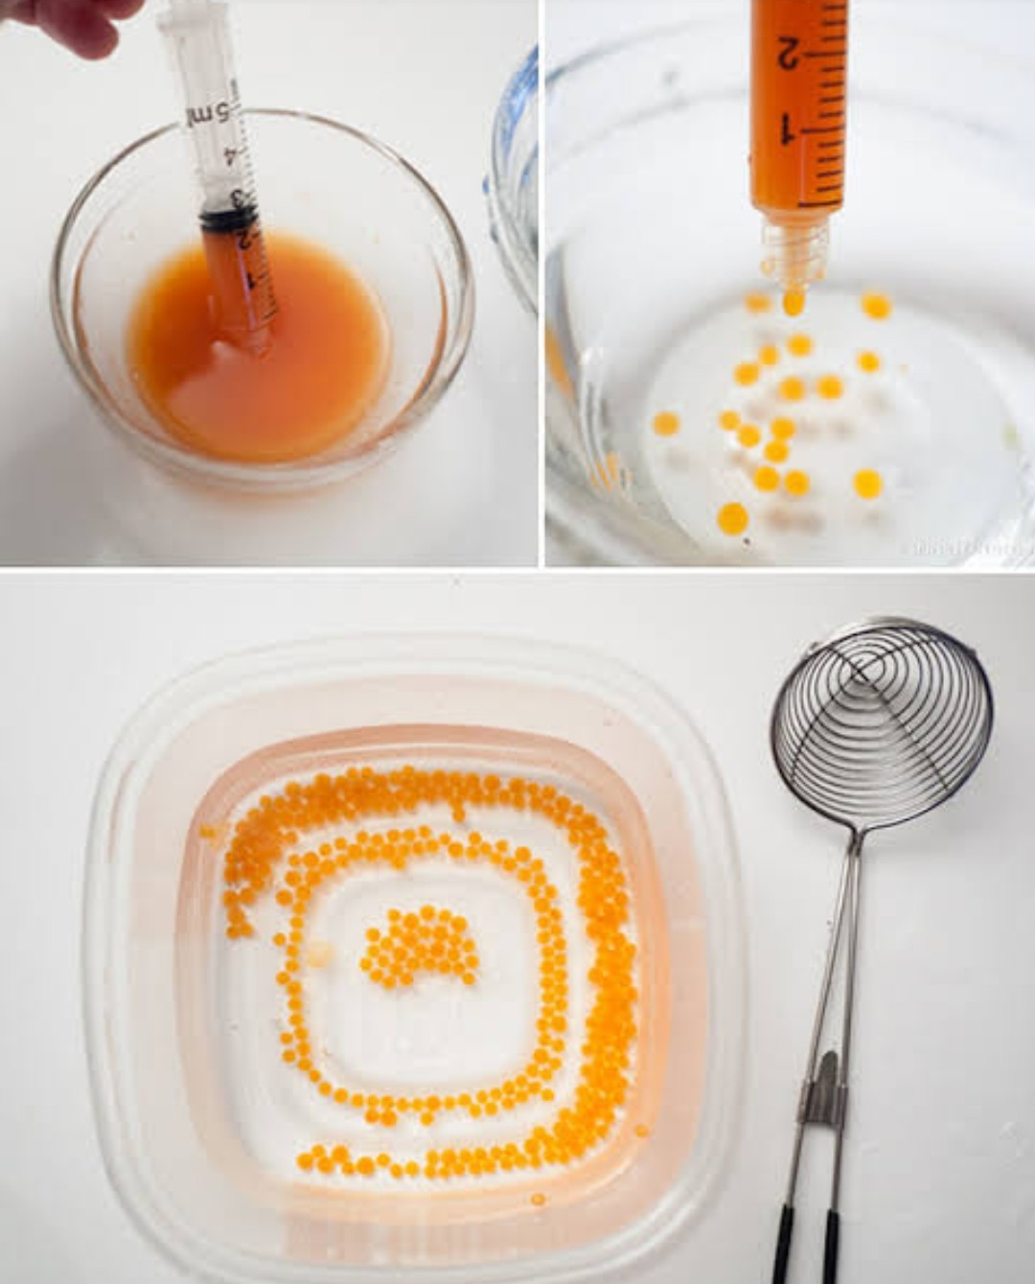

Fig 1.2 Aloe Vera Spheres
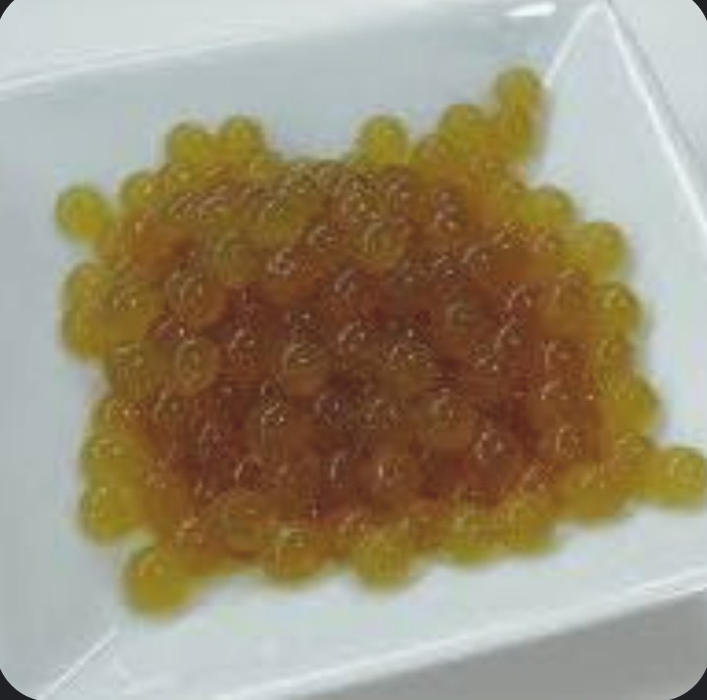

Results:
1.The Aloe Vera Juice is converted into solid spheres of different texture and is oxygen rich in nature.
2. The technique is also beneficial for the home treatment of oxygen in natural way for all human beings.
3. We can also prepare the different ayurvedic plant extract spheres.

Conclusions:
1.This is a modern style of cooking in kitchens by take advantage of home remedies and oxygen rich diet.
2. It can be beneficial for asthmatic patients and COVID- 19 Patients.

References:
1. Atherton P.Aloevera revisited.Br J Phytother1998;76-83[Google Scholar]
2. Shelton M. aloevera its chemical and therapeutic properties.Int J Dermatol 1991;30:679-
83[Pub Med] [Google Scholar]
3. Atherton.P.The essential Aloevera The action and the evidence 2nd 1997.[Google Scholar]
4. Molecular Gastronomy exploring yhe Science of Flavor.
5. H.2005. Molecular gastronomy: Exploring the science of Flavor. London: Cambridge
6. Duncan BD. Multiple-range and multiple F-test. Biometrics. 1955; 11:1-42.

7. Kohn R. Ion binding on polyuronates-alginate and pectin. Pure and Applied Chemistry. 1975;
42:371-397.

8. Lee P, Rogers MA. Effect of calcium source and exposure time on basic cavier spherification
using sodium alginate. International Journal of Gastronomy and Food Science. 2012; 1(2):96-
100.

9. Mabeau S, Fleurence J. Seaweed in food products: Biochemical and nutritional aspects. Trends in Food Science and Technology. 1993; 4:103-107.

10. Mancini F, McHugh TH. Fruit-alginate interactions in novel restructured products. Nahrung.
2000; 44:152-157.

11. Mandal S, Kumar SS, Krishnamoorthy B, Basu SK. Development and evaluation of calcium
alginate beads prepared by sequential and simultaneous methods. Brazilian Journal of
Pharmaceutical Science. 2010; 46:785-793.
12. Martinsen A, Skjak Braek G, Smidsrod O. Alginate as immobilization material: I. Correlation between chemical and physical properties of alginate beads. Biotechnology and
Bioengineering. 1989; 33:79-89.

13. Menon TV, Sajeeth CI. Formulation and evaluation of sustained release sodium alginate
microbeads of carvedilol. International Journal of Pharmaceutical Technology Research.
2013; 5:746-753.

14. Park JS, Kim DK, Lee KH, Doh DS. The diffusion characteristics of colute into the
Ca-alginate gel bead. Hwahak Konghak. 1997; 35(1):41-45.

15. Sherina VM, Santhi K, Sajeeth CI. Formulation and Evaluation of Sodium alginate
microbeads as a carrier for the controlled release of Nifedipine. International Journal of
Pharmaceutical Chemical Science. 2012; 1:699-710.

16. Silva CM, Ribeiro AJ, Figueiredo IV, Goncalves AR, Veiga FX. Alginate microspheres
prepared by internal gelation: Development and effect on insulin stability. International
Journal of Pharmaceuttics. 2006; 311(1- 2):1-10.

17. Smardel P, Bogataj M, Mrhar A. The influence of selected parameters on the size and shape
of alginate beads prepared by ionotropic gelation. Science Pharmaceutics. 2008; 76:77-89.

18. Snedecor GW, Cochran WG. Statistical Methods (17th Edn.) Ames, IA.: The Lowa State
University Press, 1987, 221-222

19. Shinde Aruna Sopan, Gaidhane Namrata Sanjay, to study the formation of flavouring juices
balls using yummy Spherification Technique. IJCRT 2020;1534-1542.
20. Wikipedia.org.
21. www.ataman-chemical.com.
22. www.phytopharmacyresearch.com
23. ijpsr.com
24. Amar Surjushe, Resham Vasani, D G Saple,ALOE VERA: A SHORT REVIEW, Indian
journal of Dermatology.

