FERMENTATION TECHNOLOGY

INTRODUCTION
Fermentation – Definition
Fermentation is an enzyme catalysed, metabolic process whereby organisms convert starch or sugar to alcohol or an acid anaerobically releasing energy. The science of fermentation is called “zymology”.
Fermentation is the process of growing Microorganisms under invitro condition there by converting feed in to a desired end product ,Fermentation technology is a field which utilises microorganisms and enzymes to produce compounds that find use in pharmaceutical, chemical, energy, material and food industries.

Process of Fermentation
Fermentation is an anaerobic biochemical process. In fermentation, the first process is the same as cellular respiration, which is the formation of pyruvic acid by glycolysis where net 2 ATP molecules are synthesised. In the next step, pyruvate is reduced to lactic acid, ethanol or other products. Here NAD+ is formed which is re-utilized back in the glycolysis process.

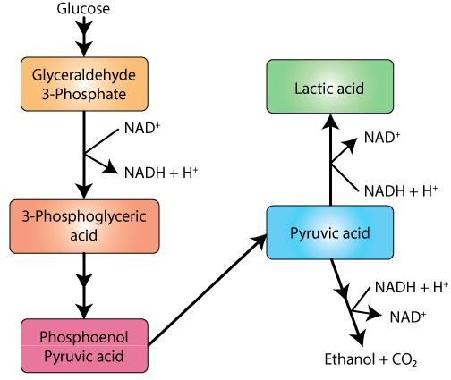

TYPES OF FERMENTATION :

Homo fermentation: only one type of product formation

Hetero fermentation: more than one product formed

Solid state Fermentation
Solid state Fermentation Is a growth of microorganisms on a Solid substrate with minimum moisture ,the moisture content of the Solid substrate medium is between 12- 80% The required water content in SSF is absorbed by the substrate in a solid matrix and offers more advantages for the growth of microorganism for the transfer of oxygen Several agricultural wastes, such as rice straw, sugarcane bagasse, wheat straw, rice hulls, and corn cobs, coconut shell are being used as substrate for SSF , Solid state Fermentation Is used in food, pharmaceutical, cosmetic, fuel and textile industries. These biomolecules are mostly metabolites generated by microorganisms grown on a solid support selected for this purpose. This technology for the culture of microorganisms is an alternative to liquid or submerged fermentation.
Antibiotics, single cell protein, polyunsaturated fatty acids (PUFAs), enzymes, organic acids, bio pesticides, biofuels, and fragrance compounds are produced using SSF as an alternative to submerged fermentation. SSF solid support is often made out of grain brans, de-oiled oil seed cakes, and other similar materials.
In such fermentation microbial growth and product formation occur at the surface layer of solid matrix example such as growth of mushroom.

Submerged fermentation
Submerged fermentation involves the cultivation of microorganisms in an enriched in liquid broth. This type of fermentation is mainly employed for industrial applications. This procedure involves growing a microorganisms in a closed container containing broth rich in nutrients with high levels of oxygen. The production medium is an important component of the submerged fermentation that is optimised according to the microbe and target molecule.

There are 3 modes in submerged fermentation:
- Batch Mode
It is a simple mode of fermentation where all the prerequisites for the process are added in a container, and nothing is added in between except air. The prerequisites include sterilisation of the fermenter and production medium and addition of inoculum. The fermenter is run in a closed manner, and the process is terminated when either the nutrient is exhausted or the target molecule has reached its maximum concentration.

Fed-batch Mode
As the name suggests, the fed-batch mode is a type of fermentation where the system is not run in a closed manner. In this mode, substrates, nutrients, or inducers are added to the system when required. This addition of products increases the productive phase of the microorganism.

Continuous Mode

In this mode, the organism is fed with fresh nutrients along with the removal of spent medium and cells so as to maintain the volume, substrate concentration, product and biomass at a constant rate.

Cycle in fermentation

- Lag phase:

Immediately after inoculation, there is no increase in the numbers of the microbial cells for some time and this period is called lag phase.

Acceleration phase:

The period when the cells just start increasing in numbers is known as acceleration phase

Log phase:

This is the time period when the cell numbers steadily increase..

Deceleration phase

The duration when the steady growth declines.

- The period in which the cell numbers decrease steadily is the death phase. This is due to death of the cells because of cessation of metabolic activity and depletion of energy re•sources. Depending upon the product required the different phases of the cell growth are maintained.

Procedure of Fermentation:

  - Depending upon the type of product required, a particular bioreactor is selected.

  - A suitable substrate in liquid media is added at a specific temperature, pH and then diluted.

  - The organism (microbe, animal/plant cell, sub-cellular organelle or enzyme) is added to it.

  - Then it is incubated at a specific temperature for the specified time.

  - The incubation may either be aerobic or anaerobic.

Bioreactors are specialized vessels designed for the growth and cultivation of microorganisms, plant and animal cells, and tissues. They are important tools in biotechnology, used for a variety of purposes such as the production of pharmaceuticals, vaccines, biofuels, and food products. Essentially, a bioreactor is a system

that provides a controlled environment for cells or microorganisms to grow and multiply. The design of a bioreactor is dependent on the type of organisms being cultivated and the intended use of the final product.
Typically, bioreactors are equipped with sensors to monitor and control factors such as temperature, pH, oxygen, and nutrient levels. They may also have mechanical agitators or impellers to ensure that the cells or microorganisms are evenly distributed throughout the reactor.

Bioreactor Working Principle
The bioreactor working principle is relatively simple, but the technology behind it is incredibly complex. As mentioned, essentially, a bioreactor is a vessel in which living cells or organisms are grown under controlled conditions to produce a particular product.
The first step in understanding how bioreactors work is to understand what they are made of. Typically, a bioreactor consists of a container, an agitator, and a means of controlling temperature, pH, and other environmental factors. The container can be made of glass or stainless steel and has ports for adding nutrients, removing waste, and monitoring the progress of the culture. The agitator is used to mix the contents of the bioreactor to ensure that all cells receive an equal supply of nutrients and oxygen.
The bioreactor working principle involves creating an environment that is conducive to the growth of the cells or organisms being cultured. For example, if you were trying to produce a particular protein using bacteria, you would need to provide them with the right nutrients, such as glucose and amino acids. You would also need to control the temperature and pH of the culture to ensure that the bacteria grow optimally.
Once you have set up the bioreactor with the right conditions, you would then inoculate it with the bacteria. Over time, the bacteria would multiply and produce the protein that you are interested in. As they do so, they will consume nutrients and produce waste products, such as carbon dioxide and lactic acid. These waste products can build up in the culture and affect its growth, so it is essential to remove them periodically.

Airlift Bioreactor

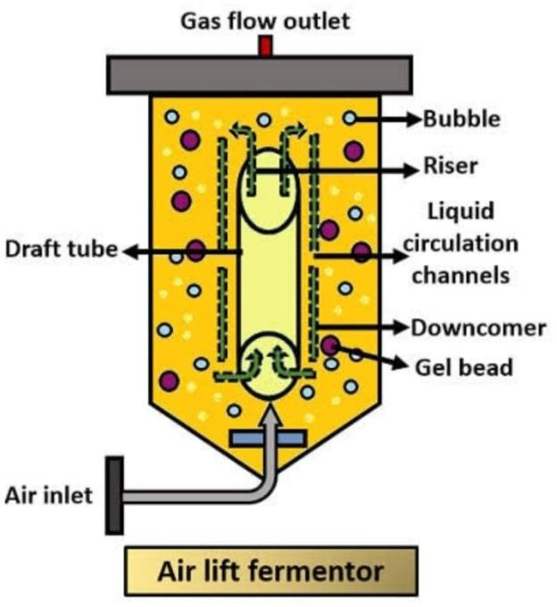

An airlift bioreactor works by stirring cultured substance using gas. Air/Gas is fed through a sparger ring into the bottom of a concentric tube, which directs the circulation of both air bubbles and liquid. At the top of the bioreactor, there is a gas separator to remove gaseous substances. Air bubbles flow upwards within the central draft tube; some of these bubbles coalesce at the top of the column and exit, while others follow the degassed liquid and circulate downward from the area outside the draft tube.

Airlift Bioreactor Applications

- Culturing sensitive organisms/cells and single-cell protein production
- Methanol productions
- Wastewater treatment
- Aerobic bioprocessing

Advantages

- Extremely energy efficient; low energy requirement
- They use a simple design
- They have no moving parts, so less maintenance is required
- Less risk of defects
- As they have no agitator shaft parts they have easier sterilization

Disadvantages

- They can be expensive to run; the greater the air pressure, the more energy is consumed
- Agitation of the bioreactor is controlled from the air supply so a greater pressure is required
- During higher pressures, a greater air throughput is needed
- When foaming happens, an inefficient break of the foam occurs
- As there are no blades, there is no bubble breaker

Bubble column bioreactors

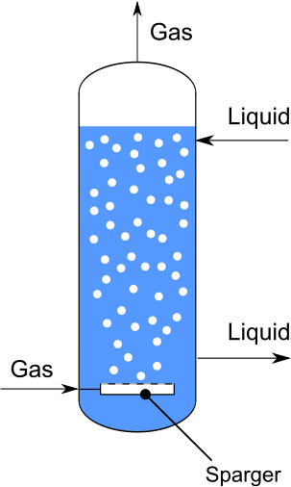

It consist of a tall vertical column filled with liquid, which is aerated from the bottom to create bubbles. These bubbles provide oxygen and mixing and aeration to the system, allowing for the growth and viability of microorganisms.

Bubble Column Bioreactor Applications
- Fermentation processes
- Producing pharmaceuticals and chemicals
- Culturing sensitive organisms/cells like plant cells
- Advantages
- Self-regulating
- Excellent heat management
- High volumetric productivity
- Good flow distribution
- Disadvantages
- Less efficient than other types of bioregulators
- They do not have a draft tube
- They are expensive to install
- They have a higher catalytic consumption than fixed-bed bioreactors

Continuous Stirred-Tank Bioreactors

Bubbles are formed by the sparger, which are then later broken down into smaller bubbles and evenly spread throughout the medium. This process continously allows the creation of a homogeneous and uniform environment inside the bioreactor.

Continuous Stirred Tank Bioreactor Applications
- Hydrocarbon-rich industrial wastewater treatments
- Pharmaceutical industry

Advantages
- Continuous operation, making them ideal for large-scale production of biotech products where consistency and efficiency are key factors
- Good temperature control, so they require minimal supervision
- The process can easily be adapted to two-phase runs
- Easy to clean
- They allow efficient gas transfer for growing cells and content mixing

Disadvantages

- They require bearings and shaft seals
- Some users have issues with foaming
- You are limited in terms of motor size, weight, and the shaft length
- They consume a lot of power because of the mechanical pressure pumps used

Fluidized Bed Bioreactors

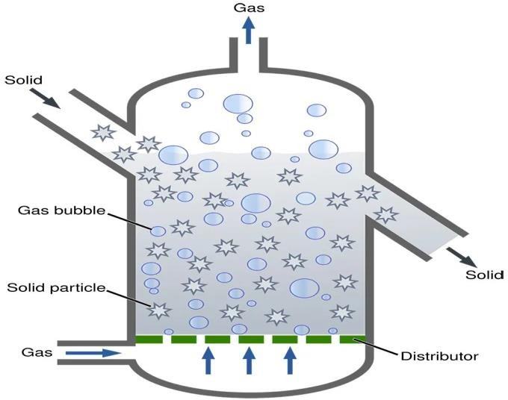

Fluidized bed reactor (FBR) is a type of reactor that can perform a wide range of multiphase chemical processes. In this reactor, a fluid (gas or liquid) is transported at high enough speeds through a solid granular material (typically a catalyst) to suspend the solid and force it to behave like a fluid. Fluidization, as a result of this process, provides a number of significant benefits to an FBR. As a result, FBRs are used in a variety of industrial settings.

Fluidized Bed Bioreactor Applications:

- Producing gasoline and other fuels
- Chemical engineering
- Food processing industries
- Bulk drying of materials
- Anaerobic and aerobic wastewater treatments

Advantages

- They can operate in a continuous state
- They use uniform temperature gradients
- Uniform particle mixing
- Small footprint

Disadvantages

- Some users face pressure loss/drop
- The reactor vessel is large
- They have specific pumping requirements

Packed Bed Bioreactors

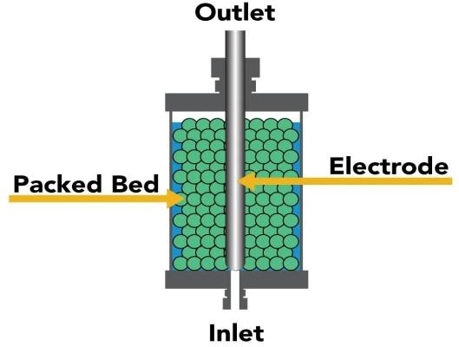

Packed bed bioreactors contain a confined bed of solid particles with biocatalysts. These solids can either consist of porous or non-porous (rigid) gels. The biocatalyst is immobilized on the solids and a medium (typically called a nutrient broth) flows constantly over it, either upward or downward. When the fluid runs upward, the velocity must not exceed the minimum fluidization velocity, which is why gravitational downward flow is preferred.

Packed Bed Bioreactor Applications
- Immobilized/particular biocatalysts
- Wastewater treatments
- Catalytic reactors; fermenters
- Can handle high-density cultures

Advantages
  - Low operating cost
  - They offer continuous operations (constant flow rate of nutrients and oxygen)
  - They have no moving mechanical parts that will wear out
  - The catalyst stays within the bioreactor
  - The design is simple and therefore they are effective at high temperatures and pressures
  - Compared to other catalytic bioreactors, packed bed bioreactors have a higher conversion per unit mass
  - They are highly versatile, so they can be adapted to a wide range of biological systems

Disadvantages
  - They are very difficult to clean
  - Unwanted heat gradients and poor temperature control
  - It is difficult to replace the catalyst

Bioreactors are essential tools in biotechnology, providing a controlled environment for the growth and cultivation of cells and microorganisms. These specialized vessels play a crucial role in the production of a wide range of products, from pharmaceuticals to biofuels.

REFERENCES
[1]. “Principles of Fermentation Technology Book” Third Edition • 2016 Authors: Peter F. Stanbury, Allan Whitaker and Stephen J. Hall
[2]. https://www.ncbi.nlm.nih.gov/pmc/articles/PMC6764775/

[3]. https://www.biologydiscussion.com/fermentation/fermentation-technology-meaning-methodology-types-and-procedure/17492

[4]. https://link.springer.com/book/10.1007/978-3-030-16230-6

[5]. https://www.slideshare.net/shashikala221977/fermentation-technology-77873936

