Biomass energy as a carbon neutral energy source: Precautions for the future use

Supriya K Salimath*⁺, Clara Manasa PA*, Ramakrishna Hegde* and Deepthi Dechamma NL*
*College of Forestry, Ponnampet, Keladi Shivappa Nayaka University of Agricultural and Horticultural Sciences, Shivamogga, Karnataka, India
*Corresponding author: supriyasalimath673@gmail.com

ABSTRACT

While recently experiencing the warmest months, Earth's temperature has risen over the past few decades. The main contributor to global climate change is an increase in greenhouse gases brought on by human activities. Finding an alternative to fossil fuels, which are the largest contributor to the negative consequences of climate change, is the fundamental objective of the worldwide effort to reduce greenhouse gas emissions. Biomass is currently garnering interest as a source of energy due to its ability to be renewed, the potential for decentralized production, and—most importantly—its carbon neutrality. People are burning more wood for fuel due to the concept of carbon neutrality rather than utilizing sustainable harvesting and replanting methods, which might have a substantial influence on the stocks of terrestrial carbon and atmospheric carbon. In comparison to continued use of fossil fuels, woody biomass has various degrees of ability to reduce human emissions in the atmosphere depending on the source of biomass employed and the time horizon taken into consideration. Forests, on the other hand, act as a net carbon source, releasing more carbon than they store and eventually raising the atmospheric concentration of CO₂Although most regulatory frameworks for renewable energy assume that burning biomass is carbon neutral, this assumption cannot be made since burning biomass emits more carbon per unit of energy than burning most fossil fuels when considered the various aspects..
Keywords: Bioenergy, Carbon neutrality, CO₂, energy
I INTRODUCTION
The earth has warmed over the past century, changing the precipitation to have drier summers, wetter winters, and more frequent heavy rains. According to the United Nations Environment Program (UNEP), the World Meteorological Organization (WMO), and the Intergovernmental Panel on Climate Change (IPCC), the average surface temperature of the globe increased by around 0.6° to 0.2°C throughout the 20th century. Although regional and short-term temperatures fluctuate across a wide range, there may appear to be little change in world temperatures overall. The main cause of the global climate change that has been seen since the middle of the 20th century is the concentration of greenhouse gases (GHGs) brought on by human activity. According to the current scenario, GHG concentrations will continue to rise indefinitely, resulting in a process of continued global warming. [1]
The only approach to ameliorate the problem in all industries, including the forestry sector, is through significant and ongoing reductions of GHGs. The forestry sector can help implement several strategies for reducing climate change. The most crucial is to increase the amount of carbon that trees remove from the atmosphere while lowering wood-related emissions.[2]
The world's top priority is lowering GHG emissions and locating a renewable energy source to replace fossil fuels. Biomass can subsidize the world's energy supply since it is a productive renewable energy source. To minimize GHG emissions, improve energy supply security, and lessen their reliance on fossil fuels, developing nations prioritize biomass. Therefore, the renewability, carbon neutrality, decentralised production capability, and role in mitigating climate change are the key reasons why biomass is gaining attention nowadays. The purpose of this chapter is to discuss the arguments for and against utilizing bioenergy as a green energy source. Based on its potential to be a carbon-neutral fuel, many scientists' arguments for using bioenergy as a strategy to slow down climate change have been reviewed in this article.

- WHAT IS BIOENERGY?
Bioenergy is power produced from renewable biological resources (biomass). It may be used to generate heat or energy that can be used to power a system. In the developing world, there is an increase in the usage of biomass-based biofuels, which are used as a feedstock for the creation of bio-energy generated either directly or indirectly from biomass. Biofuels are frequently found in solid or liquid forms, such as fuelwood, charcoal, wood pellets, and briquettes. Liquid biofuels include bioethanol and biodiesel. Wood fuel, agricultural fuels, and municipal wastes are the three types of biofuel sources. (Table 1).

Table 1. Various form of biofuels [3]
Biofuels |  | Description
Wood fuel | Direct wood fuel | Fuel generated from wood from other trees, shrubs, and woods
 | Indirect wood fuel | Mostly solid biofuels obtained from wood processing activities
 | Recovered wood fuel | The wood, which originates from socioeconomic activity outside the forest sector, is utilized directly or indirectly as fuel.
 | Wood-based fuels | Majority of liquid and gaseous biofuels obtained from woody biomass
Agrofuels | Fuel crops | Growing plants for the production of biofuels
 | Agricultural by-products | Primarily residual agricultural byproducts from crop harvesting and other types of agricultural activities
 | Animal by-products | Primarily the waste products of cattle, horses, pigs, and birds
 | Agro-industrial by-products | Several biomass components, such bagasse and rice husks, are primarily generated in the food and fibre processing sectors.
Municipal by-products | In urban societies, a variety of solid and liquid municipal biomass products are generated.
- Carbon neutrality of wood burning for energy
Global concerns about climate change and energy security have opened up new opportunities for biomass-based energy use. Biomass can play an indispensable role in reducing GHG emissions by creating diversification of the energy mix, thus, helping countries lessen their reliance on fossil fuels and aid in meeting global energy demand. Burning wood simply returns CO₂ to the atmosphere initially absorbed by the tree in its lifecycle, implicating no net release of CO_{2,} making it a carbon dioxide-neutral fuel (Fig. 1). Production of wood fuel is sustainable, provided that the trees harvested for fuel are replaced with new ones. Using wood for heating reduces carbon emissions by 90-95 percent compared to fossil fuel use. The usage of biomass can also be utilized to help developed countries comply with the Kyoto Protocol.
The climatic effects of CO₂ emitted by the burning of biomass are the same as those of CO₂ emitted by the combustion of fossil fuels. Compared to CO₂ from fossil fuels, CO₂ emitted by the burning of biomass has a range of net climatic effects. To account for regeneration, [4] proposed the idea of global warming potential (GWP). It calculates, taking into account infrared radiation absorption and air lifetime, the total potential warming effect of a pulse of GHGs over a certain time. The CO₂ GWP has assigned a ratio of 1. From a climatic standpoint, bioenergy from trees is superior to fossil fuels if the global warming potential is much below 1.0.[5]
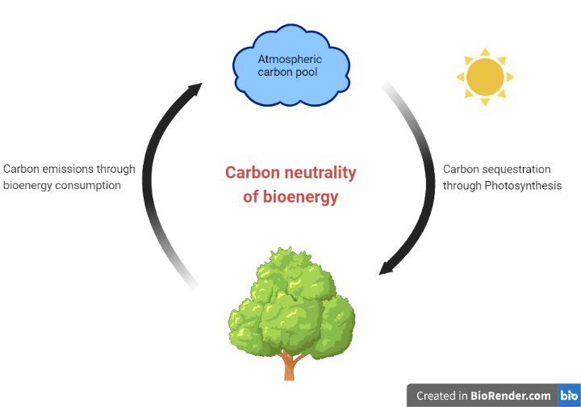

Figure 1. Carbon neutrality of bioenergy
Emissions from biomass combustion may vary with the type of wood used and the technology generated. For example, sulfur dioxide emission is considered minimal if wood is the primary energy source. In wood combustion, there is a release of CO₂ into the atmosphere. Still, through the cycle of growing trees, using wood, afforestation, and reforestation, the CO₂ is sequestered from the atmosphere. Fossil fuels required millions of years to form, but they are burnt within a few decades, and at a rate that is much quicker than the global carbon cycle can handle. Fossil fuels burn by releasing their stored carbon into the air as CO2. In contrast, burning wood is effectively carbon neutral since the CO2 generated while burning is offset by the growth of new trees. By keeping waste wood out of landfills, using wood fuel can also help to lower the release of methane.
The potential solution for preventing climate change today is to replace fossil fuel energy. It finally results in a developing market for the generation of biomass energy. Before entering this market, it is crucial to understand that the advantages of forest bioenergy depend on weighing different alternatives for forest management against a worst-case scenario, taking carbon stocks into account. Stand productivity, which is expressed by the change in silvicultural management, the prior land use, and baseline assumptions are some crucial assumptions that affect the growth of woody bioenergy through time.
According to [6], a forest may also operate as a carbon source since they produce more carbon than they store, making them a net carbon source that ultimately raises the atmospheric concentration of CO2. While certain forest biomass sources may result in decades-long increases in atmospheric GHGs, others may offer near-immediate GHG reductions. Additionally, felling affects the carbon pool dynamics in the stands. For instance, following harvesting, there will frequently be a net release of carbon from the soil layer. In addition, if the stand is not harvested, there will often be more growth and biomass buildup. In order to determine the possible climatic consequences of harvesting, it is important to compare the harvest scenario to a no-harvest approach that also includes a description of the stand's carbon dynamics.
Furthermore, two concerns lead to extra considerations. First, although emissions and regrowth for annual crops happen within a single year, there is a lag between emissions and regrowth for woody biomass. Increasing current harvest levels, for instance, in order to meet renewable energy goals without enough afforestation. Additionally, the overall carbon stock of such stands in intensively and sustainably managed forests may be smaller than in the non-bioenergy scenario. Wherever harvest rises, the biosphere's carbon reserves are burned instead, releasing CO₂ into the atmosphere.

- Precautions to use bioenergy as a carbon-neutral energy source
It is common knowledge that about half of the wood harvested from forests worldwide is used to provide energy, principally for cooking and heating, of which 17 % is turned into charcoal. The production and consumption of fuelwood and charcoal are projected to release between 1.2 and 2.4 Gt CO₂ yearly, or 2 to 7 percent of all anthropogenic emissions worldwide. These emissions are mostly caused by the burning of wood fuel, inefficient charcoal production, and unsustainable forest management. The information shown in Fig. 2 alerts people to the threat posed by a continual rise in the production of wood fuel worldwide and urges them to take the required steps to reduce CO₂ emissions from burning wood. The idea that wood fuel is carbon-neutral has prompted people to use it without proper planning for afforestation, reforestation, and using sustainable harvesting methods. This could cause significant changes in the terrestrial carbon stocks, eventually increasing the concentration of CO₂ in the atmosphere.
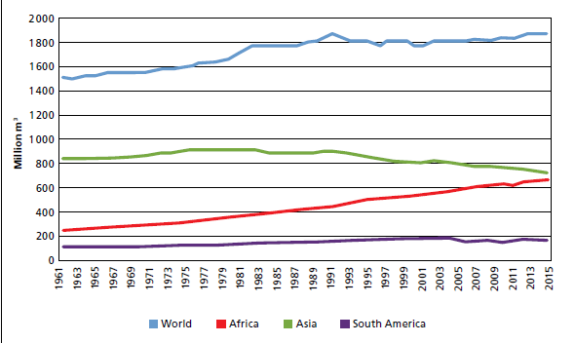
Figure 2: Wood fuel Production worldwide and by the region (Source: [7])

By reducing the forest carbon sink owing to wood harvesting, the advantages of avoiding fossil emissions through material and energy substitution are primarily lost. If time horizons of less than 100 years were taken into account, the effect of the trees as a carbon sink would be considerably more important. The global climate policy is put to the test by this trade-off: although using wood reduces fossil carbon emissions in part, further emission-reduction efforts are required to make up for the decreased forest carbon sink brought on by wood harvesting. The above is problematic since all fossil fuel emissions must be eliminated within a few decades. Before 2100, even detrimental net emissions will probably be needed globally to keep the rise in the global average temperature under 2°C. [8]
Furthermore, even if biomass is generated responsibly, the IPCC criteria do not consider biomass-based energy to be carbon neutral. Because harvesting and regrowth of bioenergy crops may result in CO2 emissions and removals at any time; land use changes brought on by biomass production may result in significant GHG fluxes as well; and there may be additional significant emissions that are estimated and reported in the sectors where they occur. For instance, direct methane and nitrous oxide emissions from the combustion of the biomass; emissions from the manufacture and usage of fertilizers and liming if either is used to grow the biomass; and emissions from the processing and transportation of the biomass Land use changes can be caused by growing crops for bioenergy, either directly by converting land to bioenergy production or indirectly by causing land use shifts elsewhere. Among these will be emissions caused by indirect land-use change inside a country. It is difficult to isolate solely those fluxes caused by indirect land-use change, though. Indirect fluctuations in terrestrial carbon stocks are difficult to model, contain significant uncertainties, are not readily visible, and are difficult to trace to a single source.
Many researchers opine that wood-burning is CO₂ neutral is irrational because biomass growth absorbs the wood-burning CO₂ and has overlooked many factors. For example, a power plant producing wood chips or a heating plant adds CO₂ to the atmosphere during the following processes:
- Addition of CO₂ in logging due to soil disturbance; vehicle transport, equipment uses, replacements and diesel burning.
- Construction of buildings for the wood-burning
- Plant organic matter and restorations and replacements, which adds CO₂
- Burning wood, which adds CO₂ at much higher rates/energy units than other fuels
- Decommissioning the plant which adds CO₂
Though it would take longer for the biomass to become harvestable, one advantageous approach would be to build the new bioenergy-designated plants on abandoned or degraded lands, which has the benefit of having a lower carbon stock value than the baseline (Fig. 3). The harvest of standing live trees, either in addition to or in place of current harvest operations for traditional wood products, is among the least preferable solutions.
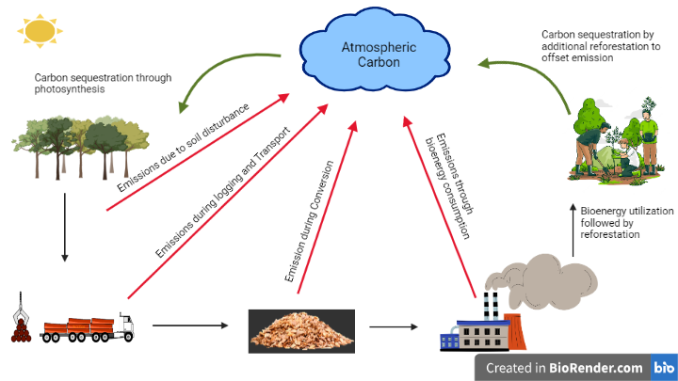
Figure 3. Schematic view of emissions during the bioenergy utilization and strategy for the sustainability

Table 2: Authors cautioning for the use of bioenergy as a carbon-neutral source.
Sl. No | Statements | Reference
 | The European Union's industries have exploited wood burning's carbon neutrality, which is the main danger to fulfilling the goals of the Paris Agreement. | [9]
 | The most unsuitable technique to combat global warming is to burn stuff (wood), a practice that involves physicians drilling holes in patients' skulls to release their demons and charging for it. | [10]
 | Depending on the source of biomass used and the time horizon taken into account, woody biomass's capacity to reduce human emissions in the atmosphere in comparison to continuous fossil fuel usage varies greatly. | [11]
 | Although it results in considerable carbon releases, cutting down old-growth forests for wood burning or growing energy crops is considered a 100 percent decrease in energy emissions. | [12]
 | For a few years to more than a century, live tree biomass from forests used for energy surpasses GHG emissions from fossil fuels when properly accounted for, and the difference can be noticeable., | [13]
 | By diminishing the forest carbon sink from wood harvesting, the advantages of avoiding fossil emissions through material and energy substitution are primarily lost. | [8]
 | Similar to burning fossil fuels, burning biomass increases the quantity of carbon in the atmosphere; harvesting biomass lowers the amount of carbon sequestered in plants and soils or diminishes carbon storage. | [14]
 | While bioenergy systems can aid in climate mitigation, it is important to carefully assess what GHG reductions are required and how the deployment of bioenergy interacts with other climate mitigation alternatives to make the most use of the finite biomass resource. | [15]
 | Within less than 100 years, the climate will reach a tipping point. The danger of climate change may eventually increase with increased usage of bioenergy from slowly expanding forests. | [5]
- Conclusions
Even though India's bioenergy sector is still in its infancy, it is important to take note of what has been learned in other nations. The use of bioenergy is a terrific way to slow down climate change, but it must be approached with caution. Although the use of wood as bioenergy has increased recently, the myth that it is carbon-neutral has concealed its true impact on climate change. This has to be properly examined, taking into consideration the contributions of all the researchers. It's also critical to realise that, in order to fully account for the emission benefits of replacing fossil fuels with bioenergy, it is also necessary to account for the forest carbon that would have remained had fossil fuels not been substituted with bioenergy. It is necessary to alter policies and objectives to promote the use of bioenergy solely from new biomass that lowers GHG emissions without displacing other ecosystem services.

REFERENCES
[1] D. Sujatha, C.N. Pandey, S.K. Nath, “ Impact of Forestry Products on Climate Change Mitigation in India,” Int J Appl Sci Technol. 4(7):97, 2014
[2] M. Matsumoto, H. Oka, Y. Mitsuda, S. Hashimoto, C.Kayo, Y.Tsunetsugu, M.Tonosaki, “ Potential Contributions Of Forestry And Wood Use To Climate Change Mitigation In Japan,” J For Res. 21(5): 211–222. 2016.
[3] FAO. Unified bioenergy terminology. Food And Agriculture Organization Of The United Nations. 2004.
[4] F. Cherubini, G.P.Peters, T.Berntsen, A.H.Strømman, E. Hertwich, “CO₂ Emissions From Biomass Combustion For Bioenergy: Atmospheric Decay And Contribution To Global Warming,” Glob Change Biol Bioenergy. 3(5): 413–426. 2011.
[5] B. Holtsmark, “ A Comparison Of The Global Warming Effects Of Wood Fuels And Fossil Fuels Taking Albedo Into Account,” Glob Change Biol Bioenergy. 7(5): 984–997. 2015.
[6] A. Bijalwan, A.Shankhwar, M.J.R. Dobriyal, P. Verma, “ Wood Is Good: A Way Forward For Climate Change Mitigation,” Int J Curr Microbiol App Sci. 6(11): 5460-5465. 2017.
[7] FAO FAOSTAT. Online Statistical Database (available at http://faostat.fao.org/). 2016.
[8] S. Soimakallio, L. Saikku, L. Valsta, K. Pingoud, “ Climate Change Mitigation Challenge for Wood Utilization-The Case of Finland,” Environ Sci Technol. 50(10): 5127−5134. 2016.
[9] P. Pearce, “Carbon Loophole: Why Is Burning Counted As Green Energy?,” Yale school of Forestry and environmental Studies. pp. 1-8. 2017.
[10] H.K. Gibbs, M. Johnston, J.A. Foley, T. Holloway, C. Monfreda, N. Ramankutt, D. Zaks, “Carbon Payback Times For Crop-Based Biofuel Expansion In The Tropics: The Effects Of Changing Yield And Technology,” Environmental Research Letters. 3(3): 034001, 2008.
[11] G. Zanchi, N. Pena, B. Bird, “Is Woody Bioenergy Carbon Neutral? A Comparative Assessment Of Emissions From Consumption Of Woody Bioenergy And Fossil Fuel,”Glob Change Biol Bioenergy. 4(6): 761-772, 2012
[12] T.D. Searchinger, S.P. Hamburg, J. Melillo, W. Chameides, P. Havlik, D.M. Kammen, G.E. Likens, et al. “Fixing A Critical Climate Accounting Error,”Science, 326(5952), pp.527-528. 2009
[13] S. B. Ter-Mikaelian, “The Role of Biomass in Achieving Climate and Energy Goals,”. Air & Waste Management Association. pp. 20-24. 2013
[14] H. Haberl, D. Sprinz, M. Bonazountas, P.Cocco, Y. Desaubies, M. Henze, et al. “ Correcting A Fundamental Error In Greenhouse Gas Accounting Related To Bioenergy.” Energy Policy. 45(6): 18–23. 2012.
[15] P. Thornley, P.Gilbert, S. Shackley, J. Hammond, “ Maximizing The Greenhouse Gas Reductions From Biomass: The Role Of Life Cycle Assessment,” Biomass Bioenergy. 81(10): 1-9. 2015.

