FUTURISTIC TRENDS IN MEDICAL SCIENCES- NEWER APPROACHES TO MANAGEMENT OF GROIN HERNIAS

AUTHORS
1.COL (DR) VIVEK UPADHYAY
MS GENERAL SURGERY
HOD MILITARY HOSPITAL, SECUNDERABAD
2.WG CDR (DR) HARSH PREET
MS, DNB GENERAL SURGERY
14 AIRFORCE HOSPITAL, HYDERABAD

INTRODUCTION
A prevalent global health issue is the occurrence of hernias, with a higher prevalence observed in developing nations. The most frequently repaired type of hernia worldwide is the inguinal hernia, which occurs in the groin area.The incidence of hernia is around 5-7% however in countries like India this prevalence of hernia is far greater amounting to a major health care burden. Inguinal hernia amount to 75% of all groin hernias.^{[1,2]}. Hence, one of the most frequently conducted surgical procedures worldwide involves the correction of groin hernias.

The term "hernia" is derived from the Latin word "rupture." It is defined as an anomalous bulging of an organ or tissue through a gap or opening in the walls that normally enclose it. These openings typically affect the abdominal wall, especially the inguinal area, although hernias can develop in different parts of the body. It is prudent that the operating surgeon must understand at which surgico-anatomical layer this hernia occurs and the other implicated surgico-anatomical layers, the boundaries of the ring and the content of the hernia.

A basic classification involves segregating hernia into reducible, irreducible and strangulated. A hernia is considered "reducible" when its contents can be returned to their normal position within the surrounding muscles. On the other hand, it is deemed "irreducible" or "incarcerated" when it cannot be returned to its normal position. When the blood supply to the hernia's contents is disturbed, strangulation is a dangerous and potentially fatal consequence.
INCIDENCE
For men, the lifetime risk of inguinal hernias is 27%, whereas for women it is 3%. Just 10% of groin hernia procedures are done on women; 90% are done on men. Inguinal hernias are five times more common than femoral hernias in terms of groin hernias. In both men and women, the indirect inguinal hernia is the most prevalent subtype of groin hernia, and indirect hernias outnumber direct hernias by a ratio of 2:1. Even though women have a higher incidence of femoral hernias compared to men, inguinal hernias still remain the most common hernia type in women. While femoral hernias are rare in men, 50% of men and 10% of women with a femoral hernia have already developed or will develop an inguinal hernia in the future.
The right side of the body experiences more inguinal hernias than the left, which can be attributed to the delayed atrophy of the processus vaginalis during fetal development. This process happens after the right testis normally descends into the scrotum more slowly than the left. As people age, they become more prone to hernias, are more likely to strangulate themselves, and require hospitalization. The most common serious hernia consequence, strangulation, affects just 1% to 3% of cases of groin hernias and is more likely in the very young and old. [.^{3,4,5]}
TYPES
In the traditional classification of inguinal hernias, they were categorized into three primary types: indirect, direct, and femoral. The primary basis for this classification was the herniation's location with respect to the surrounding anatomical structures. Indirect hernias enter through the deep inguinal ring and bulge outward lateral to the inferior epigastric vessels. Conversely, direct hernias occur within Hesselbach's triangle and press through medially to the inferior epigastric arteries.
The newer Nyhus classification has categorized hernia defects by size, location and type. They are divided into 6 types:
Type I - Internal abdominal ring normal; indirect hernia; usually occurs in newborns, children, and small adults
Type II: Internal ring enlargement without impingement on the inguinal canal floor; does not extend to the scrotum; an indirect hernia
Type IIIA Direct hernia; size is not taken into account
Type IIIB This group comprises pantaloon hernias as well as indirect sliding or scrotal hernias, which are frequently connected to extension to the direct space. An indirect hernia that has grown to the point where it is intruding against the posterior inguinal wall
Type IIIC Femoral hernia
Type IV Recurrent hernia; modifiers A–D are sometimes added, which correspond to indirect, direct, femoral, and mixed, respectively
RELEVANT SURGICAL ANATOMY
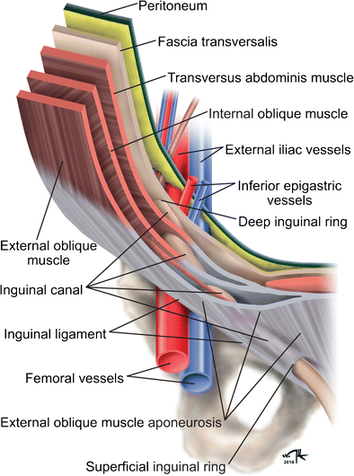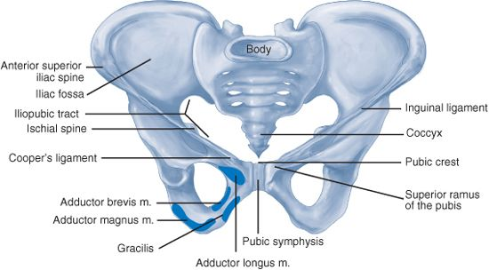
The inguinal canal is a conical area near the front of the pelvic basin that is normally 4 to 6 cm in diameter. The spermatic cord enters the deep inguinal ring, which is an aperture in the transversalis fascia, on the posterior abdominal wall, where the canal begins. The spermatic cord passes through a slit in the external oblique aponeurosis at the superficial inguinal ring, marking the end of the canal as it moves towards the medial side.
The external oblique aponeurosis forms the anterior boundary of the inguinal canal, while the internal oblique muscle borders it laterally. The transversalis fascia and transversus abdominis muscle enclose it posteriorly. The internal oblique muscle marks the inguinal canal superiorly, and it extends inferiorly to the inguinal (Poupart's) ligament. The spermatic cord, which includes the vas deferens, the pampiniform venous plexus, two nerves, three arteries, and three veins, is located within the inguinal canal. Spermatic fascia in three layers encircles this canal. Moreover, the conjoined tendon, Cooper's ligament, the iliopubic tract, and the lacunar ligament are significant nearby structures. The inferior epigastric arteries that supply the rectus abdominis are housed in the vascular space, which is located between the anterior and posterior layers of the transversalis fascia. The inferior epigastric artery begins at the external iliac artery and ends at the superior epigastric artery, which extends from the internal thoracic artery. The rectus sheath's arteries and the epigastric vein's course are parallel. Upon closer inspection, the inferior epigastric veins are situated deep within the internal inguinal ring. Among the nerves located in the inguinal area are the genitofemoral, ilioinguinal, iliohypogastric, and lateral femoral cutaneous nerves.
During laparoscopic hernia repair a study of preperitoneal anatomy led to characterization of critical anatomic areas of importance, known as the triangle of doom, the triangle of pain, and the circle of death .
The triangle of doom is delineated medially by the vas deferens and laterally by the vessels of the spermatic cord. It encompasses the external iliac vessels, deep circumflex iliac vein, femoral nerve, and genital branch of the genitofemoral nerve.
The gonadal vessels and iliopubic tract define the region that is associated with the triangle of pain. The femoral branch of the genitofemoral nerve, the femoral nerves, and the lateral femoral cutaneous nerve are among its contents.
The circle of death represents a vascular channel created by the internal iliac, common iliac, inferior epigastric, obturator, and external iliac vessels. ^{[6]}.
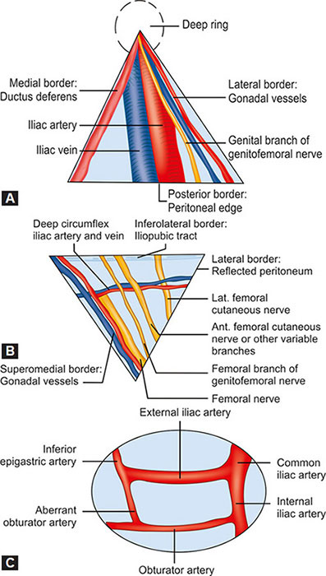
Triangle of Doom (A), Triangle of Pain(B) & Circle of Death(C)

APPROACH TO MANAGEMNT OF INGUINAL HERNIAS
Surgical intervention serves as the definitive remedy for inguinal hernias, but it may not be required for a specific group of patients. For individuals with minimal symptoms, nonoperative management is a suitable option. Opting for a nonoperative approach is the best course of action for cases of minimally symptomatic inguinal hernias. It also does not elevate the risk of hernia-related complications. Nonoperative methods, such as trusses and maintaining a recumbent position, are included in these approaches. ^{[7,8]}.
HISTORICAL OR OPEN APPROACH
Open approaches can be categorized into two main techniques: those that employ prosthetic devices to achieve a tension-free repair and those that reconstruct the inguinal floor using the body's natural tissues. Tissue-based repairs are typically recommended when the use of prosthetic materials is not advisable, such as in cases involving contamination or strangulation.
In an open approach, the procedure often begins with the exposure of the anterior inguinal region. An incision, either oblique or horizontal, is made in the groin area. Subsequently, a small incision is made in the external oblique aponeurosis, following the direction of the muscle fibers. This is then followed by lifting the flaps of the external oblique aponeurosis, dissecting the fibers of the internal oblique, and finally dissecting the lower flap to reveal the sloping edge of the inguinal ligament.
The ilioinguinal and iliohypogastric nerves, which control nerve supply, are meticulously recognized and conserved. The cord is elevated on a vascular-free plane 2 cm above the pubic symphysis after the cord structures are gently separated from the pubic tubercle. The anterolateral surface of the spermatic cord is usually where an indirect hernia is seen. An extensive examination of the inguinal canal floor is done in case of direct hernias. A femoral hernia is checked for in the preperitoneal area if it is not first apparent upon entry into the inguinal canal. Next comes the repair of the inguinal canal using either natural tissue or prosthetic materials.
TISSUE BASED HERNIORRHAPHY
Tissue-based herniorrhaphy is an acceptable approach when prosthetic materials cannot be used safely or are contraindicated. Three commonly employed approaches for hernia repair are the Bassini repair, the Shouldice repair, and the McVay repair. The Bassini repair represented a significant historical advancement in hernia repair techniques. However, its contemporary application is restricted, as modern techniques have demonstrated superior efficacy in reducing recurrence rates. The original Bassini repair technique involves the dissection of the spermatic cord, followed by the dissection of the hernia sac with high ligation, and extensive reconstruction of the floor of the inguinal canal.

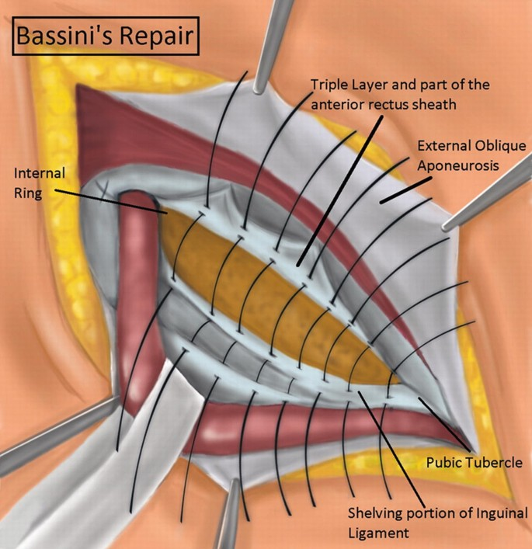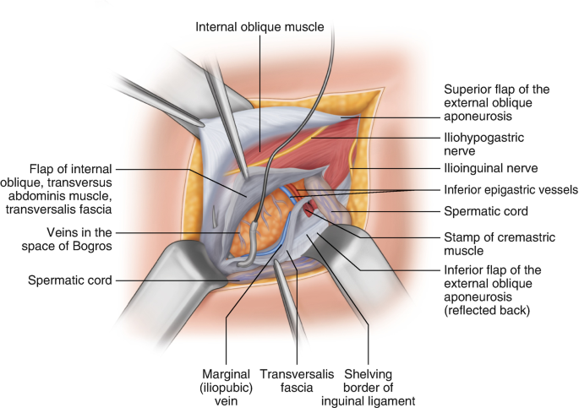
Bassini Repair Shouldice repair
The Shouldice repair procedure reaffirms the fundamental principles of the Bassini repair, emphasizing the distribution of tension across multiple layers of tissue to achieve lower recurrence ratesUsing a non-absorbable, synthetic monofilament suture, the iliopubic tract is painstakingly sutured from the pubic tubercle to the lateral border of the rectus sheath in this procedure. The margin of the inferior transversalis flap and the posterior surface of the superior flap are connected by a continuous, laterally extending suturing process. At the internal inguinal ring, the suturing process continues by returning medially and joining the shelving edge of the inguinal ligament with the edge of the superior transversalis fascia flap. At the pubic tubercle, this suture is fastened to the end of the first stitch. To connect the aponeuroses of the internal oblique and transversus abdominis with the fibers of the external oblique aponeurosis, the following suture is started at the internal inguinal ring and proceeds medially. The suture then travels laterally in the direction of the tighter internal ring, reversing its route via the same tissues.
In McVay repair A vertical incision, typically measuring 2-4 cm, is created in the anterior rectus sheath starting from the pubic tubercle. This incision plays a crucial role in reducing tension on the repair; however, it may potentially increase the risk of ventral abdominal herniation and postoperative discomfort. The superior transversalis flap is subsequently firmly secured to Cooper's ligament using either interrupted or continuous sutures. The femoral ring is blocked while the repair procedure moves laterally along Cooper's ligament. A transitional stitch is positioned adjacent to the femoral ring, firmly connecting the transversalis fascia to the inguinal ligament. Further sutures are used to attach the transversalis to the inguinal ligament, extending laterally to the internal ring.
Mcvay repair

TRANSITION TO PROSTHETIC REPAIRS
An important change in the surgical approach to inguinal hernia repair was brought about by the development of tension-free prosthetic mesh repairs. At the moment, mesh-based hernioplasty is the most often used general surgery technique.
The Lichtenstein technique Expanding the inguinal canal's area, a prosthetic mesh reinforces the inguinal floor, ensuring a low-tension repair. After dissecting the inguinal canal, the shelving edge of the inguinal ligament is revealed. The inner edge of the mesh is affixed to the anterior rectus sheath, extending approximately 1.5 - 2 cm beyond the pubic tubercle. This modification to the original Lichtenstein repair technique effectively reduces the risk of medial recurrence. ^{[9]}.
Plug and Patch Technique . This procedure is an adaptation of the Lichtenstein method in which a 3D prosthetic plug is placed into the area that was previously occupied by the hernia sac before the prosthetic mesh patch is placed over the inguinal floor. Through the internal ring, the plug is carefully positioned next to the spermatic cord. Prosthetic plugs come in a range of sizes, and an appropriate size plug is fastened to the inside ring's edges by interrupted sutures. ^{[10,11]}

Prolene Hernia System The anterior and posterior walls of the abdominal wall are strengthened with the Prolene Hernia System, often known as PHS repair. When there is an indirect hernia, the internal ring is gently removed to release the sac from the spermatic cord and reveal the preperitoneal region. When a direct hernia occurs, the preperitoneal area is carefully divided to provide room for the mesh by opening the transversalis fascia at the hernia defect. One key advantage of positioning the mesh in the preperitoneal space is that, in situations of increased intra-abdominal pressure, it causes the mesh to come into closer contact with the abdominal wall.
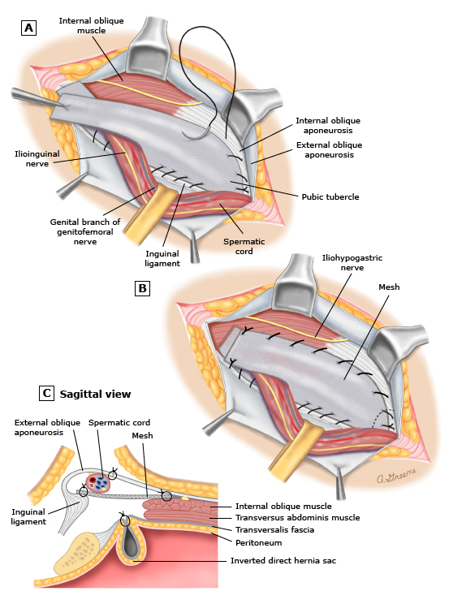
Lichtenstein technique
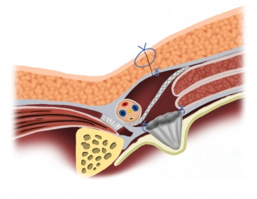
Plug and patch repair
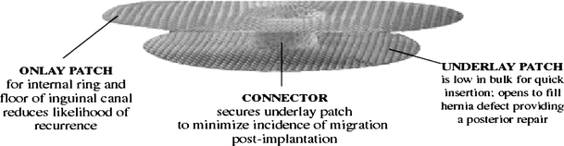
Prolene Hernia System
ADVENT OF LAPROSCOPIC TECHNIQUES
Inguinal hernias can be repaired laparoscopically using a posterior approach to reinforce the abdominal wall. The transabdominal preperitoneal (TAPP), completely extraperitoneal (TEP), and less common intraperitoneal onlay mesh (IPOM) repairs are the three primary laparoscopic techniques.
The consensus among most surgeons is that when it comes to bilateral or recurrent inguinal hernias, the laparoscopic approach is significantly better than the open approach[12]. The International Endohernia Society (IEHS) guidelines strongly suggest TEP and TAPP as preferred alternatives to the Lichtenstein repair for recurring hernias after open anterior repair; the recommendation is rated as a Grade A. ^{[13]}
Port placement in TAPP(A) & TEP(B)
The transabdominal approach(TAPP) They have the benefit of an intraperitoneal viewpoint, which is advantageous in treating big hernia defects, bilateral hernias, and scarring from prior lower abdominal procedures. It is advised to make bilateral peritoneal incisions when repairing bilateral inguinal hernias, making sure to preserve a midline bridge of tissue to prevent harm to a patent urachus. To reveal the spermatic cord, the lower margin of the incised peritoneum is pulled aside and the preperitoneum is carefully dissected. In the instance of a direct hernia, the sac is firmly fixed to Cooper's ligament in an inverted position to stop seromas or hematomas from forming. Usually, the sac associated with an indirect hernia projects anteriorly toward the spermatic cord. In these cases, the sac is picked up and raised off the cord, and the area underneath is gradually made smaller so that the mesh can be positioned there. The sac is then released from its adhesions and the cord is carefully revealed.
The mesh is subsequently rolled lengthwise and introduced through the 12-mm trocar. It is then carefully unrolled within the preperitoneal space. The prosthesis is firmly anchored in place using staples, adhesive, or tacks. The inner edge is affixed by tacking or stapling it to the soft tissue surrounding the contralateral pubic tubercle and the pubic symphysis. The lower, inner border is secured just above Cooper's ligament. Following this, the prosthesis is fastened along the upper border to the posterior rectus sheath and the transversalis fascia, approximately 2cm above the hernia defect. The final step involves closing the prosthesis by suturing, stapling, tacking, or using adhesive to seal the peritoneum.
Incision of peritoneum Entering lateral inguinal space Hernial sac dissection
Pseudosac dissection in direct hernia Mesh is rolled and inserted Smoothed out mesh
Mesh is fixed to Cooper’s Ligament Securing the superior border of mesh Peritoneal closure
Totally Extraperitoneal Procedure(TEP). The main benefit of the TEP repair is that it can reach the preperitoneal cavity without going through the intraperitoneal cavity. This method greatly lowers the possibility of causing damage to intra-abdominal organs and the formation of a port site herniation as a result of an unintentional abdominal wall defect. Similar to the TAPP technique, TEP is advised for the repair of bilateral inguinal hernias or unilateral hernias in cases when the anterior approach is difficult due to previous scarring. A small horizontal incision is made beneath the umbilicus to start the process. The subcutaneous tissue is dissected laterally along the linea alba until it reaches the level of the anterior rectus sheath. Following a gentle superolateral retraction of the rectus muscle, a dissecting balloon is inserted through the incision and directed toward the pubic symphysis. The balloon is progressively inflated to execute a blunt dissection of the preperitoneal area with the use of a 30° laparoscope. The dissecting balloon is swapped out for a 12-mm balloon trocar, and 15 mmHg of insufflation is used to produce pneumoperitoneum. Next, a 5-mm trocar is placed in the midline suprapubically, and a second trocar is placed beneath the insufflation port. After that, the patient is put in the Trendelenburg position, and the surgery is performed similarly to the TAPP technique.

The balloon is then inflated to create a working space
Preperitoneal space dissection-the balloon dissector is inserted into the preperitoneal space amd advanced to the pubic symphysis

The balloon deflated , removed and replaced with a Hasson or Balloon tip cannula. The preperitoneal working space is visualized with the laproscope and other ports are placed
Blunt graspers and gentle traction are used to reduce indirect sacs as they course with the cord structures through the internal inguinal ring

Intraperitoneal Onlay Mesh Procedure(IPOM) The IPOM procedure offers a posterior approach that eliminates the necessity for preperitoneal dissection. This procedure is particularly advantageous in situations where the anterior approach is impractical, such as in recurrent hernias that have proven resistant to other methods or in cases involving extensive preperitoneal scarring, which would present challenges for TEP or TAPP procedures. Instead of inverting the hernia sac from the preperitoneal area, this approach places a mesh directly over the hernia defect and secures it with spiral tacks or sutures.
NOVELISTIC APPROACHES TO HERNIA REPAIR

Desarda technique The Desarda technique for repairing inguinal hernias involves using adjacent live muscle tissue near the hernia site to reinforce and repair the weakened area, without the use of synthetic mesh material. A section of live muscle tissue is carefully separated from the external oblique aponeurosis while maintaining its connection and continuity with the parent muscle. This muscle strip is then affixed to the inguinal ligament below and the internal oblique muscle or aponeurosis above. By doing this, the natural muscle tissue strip covers the area of the hernia in the posterior wall of the inguinal canal. This repair technique offers several advantages, including the use of the patient's own tissue (natural tissue repair), avoidance of entry into the abdomen, minimal risk of injury to the intestines or major blood vessels, a low risk of infection or major complications, and the possibility of performing the procedure under local or regional anesthesia.^{[14,15]}
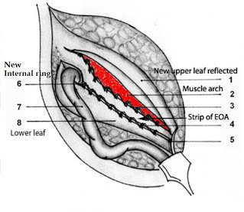
Desarda Technique
NOTES The exploration of natural orifice transluminal endoscopic surgery (NOTES) as a potential future alternative for general surgery remains ongoing. Supporters of this approach argue that it could offer benefits such as improved cosmetic outcomes, reduced pain, quicker return to regular activities, decreased complications related to port sites, and, notably, greater advantages for obese patients. However, in contrast, some surgeons believe that NOTES procedures for hernia repair may increase the risk of significant complications. Consequently, they suggest that these techniques should currently be regarded as experimental and should only be performed under strict institutional research protocols.^{[16]}

Robotic surgery The da Vinci robot's versatility has expanded significantly since receiving approval from the Food and Drug Administration in 2000[17]. Initially used for procedures like hysterectomy and prostatectomy, it is now being employed in an increasing number of general surgery operations, including Nissen fundoplication, single-site cholecystectomy, colectomy, and ventral or incisional hernia repair. Its widespread adoption is attributed to its highly magnified, three-dimensional, high-definition field of vision, computer-assisted elimination of hand tremors, and the seven degrees of freedom at the distal ends of the instruments, providing superior maneuverability [18]. Currently, many surgeons use the robot primarily for suturing the hernia defect closed and placing the mesh as an intraperitoneal onlay. This approach offers advantages such as shorter hospital stays, reduced blood loss, and lower infection rates.^{[19]}
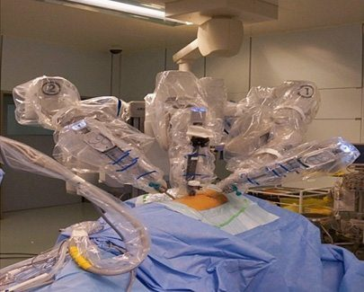
Da Vinci Robot
ADVANCEMENTS IN MESH
Mesh materials have been categorized according to their biological response and overall characteristics. These categories encompass non-absorbable and synthetic materials, non-absorbable and synthetic materials with a barrier, synthetic and partially absorbable materials, as well as combined and biological materials.
Non-absorbable and synthetic materials
Polypropylene (PP) is a non-absorbable polymer that comes in both coated and uncoated variations. However, one significant drawback is its weight, which can introduce more foreign material into the abdomen, triggering a robust inflammatory response and resulting in side effects and complications such as the development of thick scar tissue and mesh contraction, often leading to hernia recurrence as the mesh "shrinks." Recently, lightweight PP mesh has been introduced to address this issue and reduce complications associated with its higher weight.^{[20,21]}.
Polyester mesh is chosen for hernia repair primarily to enhance flexibility and prevent tissue ingrowth into the abdominal wall. Its biological response in terms of scar formation, complications, and side effects resembles that of PP mesh. It has been observed to degrade over time, especially in cases of infection, which makes it a suitable choice for hernia repair. ^{[22]}

Expanded polytetrafluoroethylene (ePTFE) Its application is typically limited to surgical scenarios where preventing visceral adhesions is the primary focus. This mesh is characterized by smaller pore sizes, which effectively prevent intestinal adhesion and hinder tissue ingrowth into the abdominal wall. As a consequence, it tends to lead to encapsulation, potentially resulting in weaker hernia repairs. Its primary benefits stem from its minimal inflammatory response and relatively lower scar density.^{[24]}
Non-absorbable and synthetic materials with a barrier

Prosthetic implants with barriers, which can be either absorbable or non-absorbable, are employed to prevent bowel adhesions when positioned intraperitoneally. The primary role of these barriers is to minimize the biological response and limit the initial adhesion of the material to the abdominal wall. This, in turn, reduces the activation of inflammatory cytokines and cells. Potential barrier materials encompass ePTFE, polyurethane, oxidized regenerated cellulose, omega-3 fatty acids, collagen, and beta-glucan. Numerous studies have demonstrated the anti-adhesive properties of these compounds, and this holds true for both physical (non-absorbable) and chemical (absorbable) barriers.^{[25,26]}

Synthetic and partially-absorbable meshes

The development of a partially absorbable mesh was primarily driven by the goal of decreasing the biomaterial's density and, consequently, reducing its inflammatory response. This was achieved while maintaining favorable intraoperative handling characteristics and long-term wound strength. Modern partially absorbable meshes are created by combining non-absorbable (PP) and absorbable materials, such as poliglecaprone 25, polyglactin 910, and Polyglycolide copolymer. The benefits of using this type of mesh material include reduced fibrosis and minimized structural alterations over time..^{[27]}

Combined Meshes

Polyester and PTFE composite meshes have been developed, with the former facilitating tissue ingrowth into the abdominal wall and the latter preventing the formation of intestinal adhesions due to variations in mesh pore sizes.

Newer biological meshes

The primary motivation behind the introduction of biological mesh was to tackle the problems pertaining to synthetic meshes and provide enhanced mechanical support and smoother tissue remodeling along the mesh scaffold. By forming a well-organized collagen network, this method aims to construct a new circulatory channel that leads to the hernia site. This is achieved by taking human or animal tissues that are rich in collagen, extracting their cellular components, and stabilizing the extracellular protein structure that is left behind. This structure promotes tissue angiogenesis and lowers the risk of infection by acting as a scaffold for collagen deposition and fibroblast infiltration. When used to contaminated and sick areas, biological meshes have demonstrated promising outcomes, particularly when they offer significant overlap. However, they do have some drawbacks, including lower tensile strength compared to synthetic prostheses, as well as variations in tissue biocompatibility and tensile strength among different biological mesh types. Notably, cross-linked graft materials within the biological mesh category tend to be more durable and less prone to failure than non-cross-linked grafts. ^{[32]}.
SUMMARY
The landscape of inguinal hernia repair is undergoing continuous transformation, driven by a combination of innovative surgical techniques and advancements in technology. These developments include the implementation of self-fixing sutureless systems, which enhance the patient experience by reducing postoperative pain. While traditional methods have achieved considerable success in the past, progress in this surgical field has largely involved refining and optimizing various intraoperative and postoperative factors to maximize both surgeon and patient satisfaction. The introduction of synthetic meshes has ushered in ongoing improvements in design and materials. Additionally, the adoption of minimally invasive surgical approaches represents another facet of progress, although their widespread success has been constrained by factors such as availability and cost-effectiveness. Consequently, a blend of conventional and modern techniques is frequently employed. The overarching goal driving these advancements is an enhancement in patient care, evidenced by a reduction in postoperative complications and, critically, a quicker return to daily activities.
REFERENCES
- Fitzgibbons RJ, Richards AT, Quinn TH. Open hernia repair. In: Souba WS, Mitchell P, Fink MP, Jurkovich GJ, Kaiser LR, et al., editors. ACS Surgery: Principles and Practice. 6th ed. Philadelphia, USA: Decker Publishing Inc; 2002. pp. 828–849.
- Ruhl CE, Everhart JE. Risk factors for inguinal hernia among adults in the US population. Am J Epidemiol. 2007;165:1154–1161.
- Gould J. Laparoscopic versus open inguinal hernia repair. Surg Clin N Am. 2008;88:1073-1081.
- Abramson JH, Gofin J, Hopp C, et al. The epidemiology of inguinal hernia. A survey in western Jerusalem. J Epidemiol Community Health. 1978;32:59.
- Rutkow IM. Epidemiologic, economic, and sociologic aspects of hernia surgery in the United States in the 1990s. Surg Clin North Am. 1998;78:941.
- Spaw AT, Ennis BW, Spaw LP. Laparoscopic hernia repair: the anatomic basis. J Laparoendosc Surg. 1991;1:269.
- Fitzgibbons RJ Jr, Giobbie-Hurder A, Gibbs JO, et al. Watchful waiting vs repair of inguinal hernia in minimally symptomatic men: a randomized clinical trial. JAMA. 2006;295:285.
- Van den Heuvel, Dwars BJ, Klassen DR, et al. Is surgical repair of an asymptomatic groin hernia appropriate? A review. Hernia. 2011;15:251-259.
- Amid PK, Shulman AG, Lichtenstein IL. Critical scrutiny of the open "tension-free" hernioplasty. Am J Surg. 1993;165:369-371.
- Gilbert AI. Sutureless repair of inguinal hernia. Am J Surg. 1992;163:331.
- Millikan KW, Cummings B, Doolas A. The Millikan modified mesh-plug hernioplasty. Arch Surg. 2003;138:525.
- Voyles CR, Hamilton BJ, Johnson WD, et al. Meta-analysis of laparoscopic inguinal hernia trials favors open hernia repair with preperitoneal mesh prosthesis. Am J Surg. 2002;184:6.
- Bittner R, Arregui ME, Bisgaard T, et al. Guidelines for laparoscopic (TAPP) and endoscopic (TEP) treatment of inguinal hernia [International Endohernia Society (IEHS)].Surg Endosc. 2011;25:2773-2843.
- Szopinski J, Dabrowiecki S,Pierscinski S,Jackowski M,Jaworski M, Szuflet Z ..Desarda Versus Lichtenstein Technique for Primary Inguinal Hernia Treatment: 3-Year Results of a Randomized Clinical Trial. World J Surg. 2012; 36(5): 984–992.
- Philipp M, Leuchter M, Lorenz R, Grambow E, Schafmayer C , Wiessner R..Quality of Life after Desarda Technique for Inguinal Hernia Repair—A Comparative Retrospective Multicenter Study of 120 Patients . J Clin Med. 2023 Feb; 12(3): 1001.
- Vorst AL, Christodoulos K, Carbonel AM ,Franz MG .Evolution and advances in laparoscopic ventral and incisional hernia repair.. World J Gastrointest Surg. 2015 Nov 27; 7(11): 293–305.
- Finnerty BM, Afaneh C, Aronova A, Fahey TJ, Zarnegar R. General surgery training and robotics: Are residents improving their skills? Surg Endosc. 2015
- Allison N, Tieu K, Snyder B, Pigazzi A, Wilson E. Technical feasibility of robot-assisted ventral hernia repair. World J Surg. 2012;36:447–452
- Warren JA, Cobb WS, Ewing J, Carbonell AM. Prospective, observational, cohort study of robotic Rives-Stoppa retrorectus incisional hernia repair. 1st World Conference on Abdominal Wall Hernia Surgery; Paper presented at: Hernia Repair 2014, Americas Hernia Society. Las Vegas, NV, March 12-15; 2015. pp. Apr 25–29; Milan, Italy.
- Cobb WS, Kercher KW, Heniford BT. The argument for lightweight polypropylene mesh in hernia repair. Surg Innov. 2005; 12: 63–69.
- Robinson TN CJ, Schoen J, Walsh MD. Surgical Endoscopy. 2005; 19: 1556–1560.
- PB Matthews BD, Pollinger HS, Backus CL, Kercher KW, Sing RF. Heniford BT. J Surg Res. 2003; 114: 126–132
- Woloson SK, Greisler HP. Biochemistry, immunology, and tissue response to prosthetic material. In: Bendavid R, Abrahamson J, Arregui ME, Flament JB, Phillips EH, et al editors Abdominal wall hernias. Principles and management. New York: Springer-Verlag; 2001; 201–207.
- McGinty JJ, Hogle NJ, McCarthy HA, Fowler DL. Comparative study of adhesion formation and abdominal wall ingrowth after laparoscopic ventral hernia repair in a porcine model using multiple types of mesh. Surg Endosc. 2005; 19: 786–790.
- Bellon JM, Garcia-Honduvilla N, Serrano N, Rodriguez M, Pascual G, Bujan J. Composite prostheses for the repair of abdominal wall defects: effect of the structure of the adhesion barrier component. Hernia. 2005; 9: 338–343
- Bellón JM, Serrano M, Rodríguez M, García Honduvilla N, Pascual G, Buján J. Composite prostheses used to repair abdominal wall defects: physical or chemical adhesion barriers?. J Biomed Mater Res B Appl Biomater. 2005; 74: 718–724.
- Wolloscheck T, Gaumann A, Terzic A, Heintz A, Junginger T, Konerding MA. Inguinal hernia: measurement of the biomechanics of the lower abdominal wall and the inguinal canal. Hernia. 2004; 8(3): 233–241
- Baldwin HS. Early embryonic vascular development. Cardiovasc Res. 1996; 31: E34–E45.
- Deprest J, De Ridder D, Roovers JP, Werbrouck E, Coremans G, Claerhout F. Medium term outcome of laparoscopic sacrocolpopexy with xenografts compared to synthetic grafts. J Urol. 2009; 182: 2362–2368.
- Bachman S, Ramshaw B. Prosthetic Material in Ventral Hernia Repair: How Do I Choose?. Surg Clin N Am. 2008; 88: 101–112.
- Earle DB, Mark LA. Prosthetic material in inguinal hernia repair: how do I choose? Surg Clin North Am. 2008;88:179.
- Smart NJ, Bloor S. Durability of biologic implants for use in hernia repair: a review. Surg Innov. 2012;19:221-229.

