Seismic Strengthening Analysis & Design (Retrofitting) of Educational Building at Nepal
Pramod K R¹
Asst.Prof Civil Engineering
pramodraghu619@gmail.com,
Sapthagiri College of Engineering, Bangalore-57

N Lakshminarasimaiah²
Professor & Head of the Civil Engineering
laknar_05@yahoo.com
APS College of engineering,
Bangalore-82

M.B. Ananthayya³
Professor & Head of the Civil Engineering
ananthayya.mb@saividya.ac.in
SVIT College of engineering, Bangalore-64

Latha M S⁴
Professor & Head of the Civil Engineering
lathamsm@yahoo.co.in
SVCE College of engineering, Bangalore-57

Abstract
Although Seismic effect can be predicted when it occurs but it is certain that when it occurs the severity of damage will be significant. Like many urban areas in developing countries, Nepal’s risk is increased significantly basically in regard to earthquake hazard. Uncontrolled development process, poor design and construction practice has further increased the seismic vulnerability. If a large earthquake hits the area, it will cause heavy loss of life and properties. So, it is highly recommended to design and construct the structure s in cities like Kathmandu with due consideration to the seismic load to minimize the structural damage and reduce the casualties when a large earthquake hits the area. n view of this, the design and detailing of the mentioned building has been conducted with due consideration of the earthquake load and its summary has been presented herewith.
I Introduction
Earthquake is one of the most dreaded natural disasters. Vibration of earth’s surface caused by waves coming from a source of disturbances inside the earth are described as earthquakes It is a natural phenomenon, which depends upon various factors. It becomes considerably destructive when it affects an ever larger concentration of material property and population. The occurrence of earthquake is frequent in Nepal. This is because Nepal lies in the Himalayan range where continental tectonic plates collide causing Indian plate to subduct with Eurasian plate. This has caused built up of tremendous strain energy causing abrupt failure of rock masses along the faults, which in their turn cause earthquakes. Nepal has already witnessed large earthquakes causing heavy loss of life and property. The earthquakes of 1934 and 1988 and April 2015(Gorkha Earthquake) are the recent ones. It is believed that the medium earthquake occurs in Nepal in every 50 years and major earthquake occurs in an interval of 100 years. It is highly expected that another major earthquake is due in near future.
Keywords- Retrofiting,Strengthening,SAP
Retrofiting design – background
The aftermath of an earth quake manisfests great devastation due to unpredicted seismic motion striking extensive damage to innumerable buildings of varying degree i.e either full or partial or sligth. This damage to Structures in its turn cause a irreparable loss of the life with a large number of casualties. As a result frightened occupants may refuse to enter the buildings unless assured of the safety of the buildings. from future earthquakes. It has been observed that majority of such earthquake damaged buildings may be safely reused, if they are converted into seismically resistant structures by employing a few retrofitting measures. This proves to be a better option catering to the economic considerations and immediate shelter problems rather than replacements of buildings. Moreover it has often been seen that retrofitting of buildings is generally more economical as compared to demolition and reconstruction even in the case of severe structural damage. Therefore, seismic retrofitting of building structures is one of the most important aspect for mitigating seismic hazard especially in earthquake-prone countries. The need of seismic retrofitting of buildings arises under two circumstances: (I) earthquake-damage buildings and (ii) earthquake-vulnerable buildings that have not yet experience severe earthquakes.
Retrofitting Strategies
Various method used for retrofitting of reinforced concrete buildings Are:
1.Structural level (or Global)Retrofit Methods
Two approaches are used for structure-level Retrofitting.
i. Conventional method
This methods of retrofitting are used to enhance the seismic resistance of existing structure by elimination or reducing the adverse effect of design. It includes
Adding Shear walls
Adding Infill walls
Adding steel bracings
ii. Non-conventional methods
This methods of retrofitting are used to reduce the horizontal seismic forces.it includes
Seismic base isolation
supplemental damping device
2.Member Level (or Local) Retrofit Methods
Approaches Used for member level retrofit methods are:
i. Jacketing/confinements
ii. Jacketing of columns
iii. Reinforced concrete jacketing
iv. Steel jacketing
v. FRP jacketing
vi.Beam jacketing
vii. Beam-column jacketing
Adopted retrofiting Strategy : Reinforced concrete jacketing
Reinforced concrete jacketing can be employed as a repair or steengthrning scheme. Damaged regions of the exeisting members should be repaired prior to their jacketing. There are two main purpose of jacketing of columns: (i) increse in the shear capacity of columns in order to accompolish a strong column-weak beam design and (ii) to improve the column's flexural strength by the longitudnal steel of the jacket made continuous through the slab system and anchored with the foundation. It is achived by passing the new longitudnal reinforcement through holes driled in slab and by placing new concrete in the beam column joints.
Details for reinforced concrete jacketing
Properties of jackets : 1. Match with the concrete of the existing structure 2. Compressive strength greater than that of existing structure by
5 N/mm^2 (50 Kg/cm^2), or at least equal to that of the existing structure.

Minimum width of jacket:
1. 10 cm for concrete cast in place and 4 cm for shotcrete
2. If possible, four-sided jacket should be used
3. Narrow gap should be provided to prevent any possible increase in flexular capacity

Minimum area of longitudinal reinforcement:
1. Spacing should not exceed six times of width of the new elements (the jacket in the case ) up to limit of 60 cm.
2. Percentage of steel in the jacket with respect to jacket area should be limited between 0.015 and 0.04
3. At least, a 12 mm bar should be used at every corner for a four-sided jacket.
Shear stress in the interfere:
chipping the concrete cover of the original member and roughening its surface may improve the bond between the old and new concrete.

Connector:
1. Connectors should be anchored in both the concrete such that it may develop at least 80% of the yeilding stress.
2. It is better to use reinforced bars anchored with epoxy resigns of grouts .
Spacing of ties: |  |  | S= | (Fy*d²)/(sqrtFck*tj)
 |  |  | Fy= | 500
 |  |  | d= | 10
 |  |  | Fck= | 25
 |  |  | tj= | 125
 |  |  | S= | 80
Provide spacing of ties 10mm dia @ 75 mm c/c.

II DESIGN DATA
1 |  |  |  | Building Type |  |  |  |  |  |  |  | : |  |  |  | Educational Building
2 |  |  |  | Type of structure |  |  |  |  |  |  |  | : |  |  |  | Frame Structure (Rigid joined Frame structure )
3 |  |  |  | No. of Storey |  |  |  |  |  |  |  | : |  |  |  | 4
4 |  |  |  | Concrete Grade |  |  |  |  |  |  |  | : |  |  |  | M 25
5 |  |  |  | Reinforcement Used |  |  |  |  |  |  |  | : |  |  |  | Fe 415 |  |  |  |  | For Existing column
 |  |  |  |  |  |  |  |  |  |  |  |  |  |  |  | Fe 500 |  |  |  |  | Retrofit Column
6 |  |  |  | Cement Used |  |  |  |  |  |  |  | : |  |  |  | Ordinary Portland Cement
7 |  |  |  | Load Taken
 |  |  |  | Class |  |  |  |  |  |  |  |  |  |  |  |  |  |  |  |  |  |  |  |  |  |  |  |  |  | 3 |  |  | kN/sqm
 |  |  |  | Kitchen, Laundaries & Laboratories |  |  |  |  |  |  |  |  |  |  |  |  |  |  |  |  |  |  |  |  |  |  |  |  |  | 2.5 |  |  | kN/sqm
 |  |  |  | Toilets & Bathrooms |  |  |  |  |  |  |  |  |  |  |  |  |  |  |  |  |  |  |  |  |  |  |  |  |  | 2 |  |  | kN/sqm
 |  |  |  | Corridore, Passage & Lobby |  |  |  |  |  |  |  |  |  |  |  |  |  |  |  |  |  |  |  |  |  |  |  |  |  | 4 |  |  | kN/sqm
 |  |  |  | Finishing Load |  |  |  |  |  |  |  |  |  |  |  |  |  |  |  |  |  |  |  |  |  |  |  |  |  | 1.5 |  |  | kN/sqm
8 |  |  |  | Design Philosophy - Limit State Design Confirming IS : 456-2000
9 |  |  |  | Analysis Software Used = |  |  |  |  |  |  |  |  |  |  |  |  |  |  |  |  | SAP 2000 |  |  |  |  |  |  |  |  | VER 16
10 |  |  |  | Earthquake Load Consideration = |  |  |  |  |  |  |  |  |  |  |  |  |  |  |  |  | IS 1893-2002
11 |  |  |  | Retrofitting Guidelines Consideration= |  |  |  |  |  |  |  |  |  |  |  |  |  |  |  |  | IS 15988-2013
 |  |  | Load Combination
 |  |  | Combination |  |  |  |  |  |  |  |  |  |  |  |  |  |  |  |  |  |  | 1 | = |  | (DL+LL)x1.5
 |  |  | Combination |  |  |  |  |  |  |  |  |  |  |  |  |  |  |  |  |  |  | 2 | = |  | (DLx1.2 + LLx1.2+ EQ1x1.2)
 |  |  | Combination |  |  |  |  |  |  |  |  |  |  |  |  |  |  |  |  |  |  | 3 | = |  | (DLx1.2 + LLx1.2+ EQ2x1.2)
 |  |  | Combination |  |  |  |  |  |  |  |  |  |  |  |  |  |  |  |  |  |  | 4 | = |  | (DLx1.2 + LLx1.2+ EQ1x-1.2)
 |  |  | Combination |  |  |  |  |  |  |  |  |  |  |  |  |  |  |  |  |  |  | 5 | = |  | (DLx1.2 + LLx1.2+ EQ2x-1.2)
 |  |  | Combination |  |  |  |  |  |  |  |  |  |  |  |  |  |  |  |  |  |  | 6 | = |  | (.9 X DL+1.5X EQ1)
 |  |  | Combination |  |  |  |  |  |  |  |  |  |  |  |  |  |  |  |  |  |  | 7 | = |  | (.9 X DL-1.5X EQ1)
 |  |  | Combination |  |  |  |  |  |  |  |  |  |  |  |  |  |  |  |  |  |  | 8 | = |  | (.9 X DL+1.5X EQ2)
 |  |  | Combination |  |  |  |  |  |  |  |  |  |  |  |  |  |  |  |  |  |  | 9 | = |  | (.9 X DL-1.5X EQ2)
 |  |  | Combination |  |  |  |  |  |  |  |  |  |  |  |  |  |  |  |  |  |  | 10 | = |  | (1.5 XDL +1.5 X EQ1)
 |  |  | Combination |  |  |  |  |  |  |  |  |  |  |  |  |  |  |  |  |  |  | 11 | = |  | (1.5 XDL -1.5 X EQ1)
 |  |  | Combination |  |  |  |  |  |  |  |  |  |  |  |  |  |  |  |  |  |  | 12 | = |  | (1.5 XDL +1.5 X EQ2)
 |  |  | Combination |  |  |  |  |  |  |  |  |  |  |  |  |  |  |  |  |  |  | 13 | = |  | (1.5 XDL -1.5 X EQ2)
 |  |  |  |  |  |  |  |  |  |  | Load Calculation
1 |  |  |  |  |  |  | A. Slab Load
 |  |  |  |  |  |  | Slab Thickness |  |  |  | 0.1 |  |  |  |  |  |  |  | 25 |  |  |  |  | 2.5
 |  |  |  |  |  |  | Floor finish |  |  |  |  |  |  |  |  |  |  |  |  |  |  |  |  | 1
 |  |  |  |  |  |  |  |  |  |  |  |  |  |  |  |  |  |  | Total |  |  |  |  | 3.5
 |  |  |  |  |  |  | B. Beam Load
 |  |  |  |  |  |  | L |  |  |  | B |  |  |  | Density |  |  |  |  |  |  |  |  | WEIGHT/M
 |  |  |  |  |  |  | 0.45 |  |  |  | 0.25 |  |  |  | 25 |  |  |  |  |  |  |  |  | 2.81
 |  |  |  |  |  |  | 0.35 |  |  |  | 0.25 |  |  |  | 25 |  |  |  |  |  |  |  |  | 2.19
 |  |  |  |  |  |  |  |  |  |  |  |  |  |  |  |  |  |  | Total |  |  |  |  | 5.00 |  |  |  |  | kN/m
 |  |  |  |  |  |  | C. Column Load
 |  |  |  |  |  |  |  |  |  |  | L |  |  |  | B |  |  |  | Density |  |  |  |  | H |  |  |  |  | WEIGHT
 |  |  |  |  |  |  | Column C1 |  |  |  | 0.3 |  |  |  | 0.3 |  |  |  | 25 |  |  |  |  | 3 |  |  |  |  | 6.75
 |  |  |  |  |  |  | Rc 500*500 |  |  |  | 0.5 |  |  |  | 0.5 |  |  |  | 25 |  |  |  |  | 3 |  |  |  |  | 18.75
 |  |  |  |  |  |  |  |  |  |  |  |  |  |  |  |  |  |  |  |  |  |  |  | Total |  |  |  |  | 25.50 |  |  | kN/m
 |  |  |  |  |  |  | B.Wall Load
 |  |  |  |  |  |  | Description |  |  |  | L |  |  |  | B |  |  |  | Density |  |  |  |  | H |  |  |  |  | WEIGHT |  |  | % of wall |  |  |  |  | Adopt
 |  |  |  |  |  |  | 4" wall |  |  |  | 1 |  |  |  | 0.138 |  |  |  | 19 |  |  |  |  | 2.655 |  |  |  |  | 6.96 |  |  | 4.87 |  |  |  |  | 5.00
 |  |  |  |  |  |  | 9" wall |  |  |  | 1 |  |  |  | 0.23 |  |  |  | 19 |  |  |  |  | 2.655 |  |  |  |  | 11.60 |  |  | 8.12 |  |  |  |  | 10.00
 |  |  |  |  |  |  |  |  |  |  | Assuming |  |  |  | 30 |  |  |  | % of Openings
III Seismic weight of the building
As per IS 1893(part I): 2002 Seismic weight of the building = dead load + percentage of imposed load
As per IS 1893(part I): 2002 clause 7.3.1 percentage of imposed load = 25
 |  | TABLE-1 Joint Reactions
 |  | TABLE: Joint Reactions
 |  | Joint |  |  |  |  |  |  |  |  |  |  |  |  |  |  | OutputCase |  |  |  |  |  |  |  |  | CaseType |  |  |  |  |  |  |  | F3
 |  | Text |  |  |  |  |  |  |  |  |  |  |  |  |  |  | Text |  |  |  |  |  |  |  |  | Text |  |  |  |  |  |  |  | KN
 |  | 262 |  |  |  |  |  |  |  |  |  |  |  |  |  |  | COMB15 |  |  |  |  |  |  |  |  | Combination |  |  |  |  |  |  |  | 150.857
 |  | 263 |  |  |  |  |  |  |  |  |  |  |  |  |  |  | COMB15 |  |  |  |  |  |  |  |  | Combination |  |  |  |  |  |  |  | 173.731
 |  | 264 |  |  |  |  |  |  |  |  |  |  |  |  |  |  | COMB15 |  |  |  |  |  |  |  |  | Combination |  |  |  |  |  |  |  | 151.955
 |  | 265 |  |  |  |  |  |  |  |  |  |  |  |  |  |  | COMB15 |  |  |  |  |  |  |  |  | Combination |  |  |  |  |  |  |  | 152.032
 |  | 266 |  |  |  |  |  |  |  |  |  |  |  |  |  |  | COMB15 |  |  |  |  |  |  |  |  | Combination |  |  |  |  |  |  |  | 152.929
 |  | 267 |  |  |  |  |  |  |  |  |  |  |  |  |  |  | COMB15 |  |  |  |  |  |  |  |  | Combination |  |  |  |  |  |  |  | 152.459
 |  | 268 |  |  |  |  |  |  |  |  |  |  |  |  |  |  | COMB15 |  |  |  |  |  |  |  |  | Combination |  |  |  |  |  |  |  | 162.617
 |  | 269 |  |  |  |  |  |  |  |  |  |  |  |  |  |  | COMB15 |  |  |  |  |  |  |  |  | Combination |  |  |  |  |  |  |  | 132.027
 |  | 270 |  |  |  |  |  |  |  |  |  |  |  |  |  |  | COMB15 |  |  |  |  |  |  |  |  | Combination |  |  |  |  |  |  |  | 423.084
 |  | 271 |  |  |  |  |  |  |  |  |  |  |  |  |  |  | COMB15 |  |  |  |  |  |  |  |  | Combination |  |  |  |  |  |  |  | 503.824
 |  | 273 |  |  |  |  |  |  |  |  |  |  |  |  |  |  | COMB15 |  |  |  |  |  |  |  |  | Combination |  |  |  |  |  |  |  | 370.319
 |  | 274 |  |  |  |  |  |  |  |  |  |  |  |  |  |  | COMB15 |  |  |  |  |  |  |  |  | Combination |  |  |  |  |  |  |  | 370.391
 |  | 275 |  |  |  |  |  |  |  |  |  |  |  |  |  |  | COMB15 |  |  |  |  |  |  |  |  | Combination |  |  |  |  |  |  |  | 428.055
 |  | 277 |  |  |  |  |  |  |  |  |  |  |  |  |  |  | COMB15 |  |  |  |  |  |  |  |  | Combination |  |  |  |  |  |  |  | 370.214
 |  | 278 |  |  |  |  |  |  |  |  |  |  |  |  |  |  | COMB15 |  |  |  |  |  |  |  |  | Combination |  |  |  |  |  |  |  | 376.429
 |  | 279 |  |  |  |  |  |  |  |  |  |  |  |  |  |  | COMB15 |  |  |  |  |  |  |  |  | Combination |  |  |  |  |  |  |  | 346.72
 |  | 280 |  |  |  |  |  |  |  |  |  |  |  |  |  |  | COMB15 |  |  |  |  |  |  |  |  | Combination |  |  |  |  |  |  |  | 372.901
 |  | 281 |  |  |  |  |  |  |  |  |  |  |  |  |  |  | COMB15 |  |  |  |  |  |  |  |  | Combination |  |  |  |  |  |  |  | 449.389
 |  | 282 |  |  |  |  |  |  |  |  |  |  |  |  |  |  | COMB15 |  |  |  |  |  |  |  |  | Combination |  |  |  |  |  |  |  | 372.133
 |  | 283 |  |  |  |  |  |  |  |  |  |  |  |  |  |  | COMB15 |  |  |  |  |  |  |  |  | Combination |  |  |  |  |  |  |  | 371.788
 |  | 284 |  |  |  |  |  |  |  |  |  |  |  |  |  |  | COMB15 |  |  |  |  |  |  |  |  | Combination |  |  |  |  |  |  |  | 429.969
 |  | 285 |  |  |  |  |  |  |  |  |  |  |  |  |  |  | COMB15 |  |  |  |  |  |  |  |  | Combination |  |  |  |  |  |  |  | 371.399
 |  | 286 |  |  |  |  |  |  |  |  |  |  |  |  |  |  | COMB15 |  |  |  |  |  |  |  |  | Combination |  |  |  |  |  |  |  | 376.105
 |  | 287 |  |  |  |  |  |  |  |  |  |  |  |  |  |  | COMB15 |  |  |  |  |  |  |  |  | Combination |  |  |  |  |  |  |  | 347.977
 |  |  |  |  |  |  |  |  |  |  |  |  |  |  |  |  |  |  |  |  |  |  |  |  |  |  |  |  |  |  |  |  |  | 7509.304
IV EARTHQUAKE LOAD CALCULATION
Lateral load distribution
Type of soil = |  |  |  |  |  |  |  |  |  | medium
Height of building (H) = |  |  |  |  |  |  |  |  |  | 12.000 |  |  | m
base dimenstion of building at the plinth level (d) in X-direction = |  |  |  |  |  |  |  |  |  |  |  |  |  |  |  |  |  |  |  |  |  |  |  |  |  |  |  | 20.60 |  |  | m
base dimenstion of building at the plinth level (d) in Y-direction = |  |  |  |  |  |  |  |  |  |  |  |  |  |  |  |  |  |  |  |  |  |  |  |  |  |  |  | 6.60 |  |  | m
Time Period in X-direction = |  |  |  |  |  |  |  |  |  |  |  |  | 0.075H ^{0.75} = |  |  |  |  |  |  |  |  | 0.484 |  |  |  |  |  | clause IS 1893:2002; 7.6.1
Time Period in Y-direction = |  |  |  |  |  |  |  |  |  |  |  |  | 0.075H ^{0.75} = |  |  |  |  |  |  |  |  | 0.484 |  |  |  |  |  | clause IS 1893:2002; 7.6.1
Sa/g (X-dir) = |  |  |  |  |  |  |  |  |  | 2.500 |  |  | Check |  |  |  |  |  |  |  |  |  |  |  |  |  |  | clause IS 1893:2002; 6.4.5
Sa/g (Y-dir) = |  |  |  |  |  |  |  |  |  | 2.500 |  |  |  |  |  |  |  |  |  |  |  |  |  |  |  |  |  | clause IS 1893:2002; 6.4.5
Zone factor (Z) = |  |  |  |  |  |  |  |  |  | 0.360 |  |  | for Zone V |  |  |  |  |  |  |  |  |  |  |  |  |  |  | clause IS 1893:2002; Table 2
Importance factor (I)= |  |  |  |  |  |  |  |  |  | 1.500
Response reduction factor (R)= |  |  |  |  |  |  |  |  |  |  |  |  | 5 |  |  |  |  | for special RCC building |  |  |  |  |  |  |  |  |  | clause IS 1893:2002; Table 7
Seismic coefficient (Ah) = (Z/2)*(I/R)*(Sa/g) = |  |  |  |  |  |  |  |  |  |  |  |  |  |  |  |  |  |  |  |  |  | 0.135 |  |  |  |  |  | clause IS 1893:2002; 6.4.2
Seismic Weight (W)= |  |  |  |  |  |  |  |  |  | 7509.304
Base Shear |  |  |  |  |  | (vb)= |  |  |  | Ah*W |  |  | 1013.756
U= |  |  |  |  |  | (T_{rem}/T_{use})^{0.5}
 |  |  |  |  |  | 0.987
Hence Taking U= |  |  |  |  |  |  |  |  |  |  |  |  | 1
Final Base Shear |  |  |  |  |  |  |  |  |  | (fvb)= |  |  | vb*U= |  |  |  |  | 1013.756
 |  |  |  |  |  |  |  |  |  |  |  |  |  |  |  |  |  |  |  |  |  |  |  |  |  |  |  |  |  |  |  |  |  |  |  |  |  |  |  |  |  |  |  |  |  |  |  |  |  |  |  | 7509.306 | 1013.756
Program Generated Base Shear along X direction |  |  |  |  |  |  |  |  |  |  |  |  |  |  |  |  |  |  |  |  |  |  |  |  |  |  |  |  |  |  |  |  |  |  |  |  |  |  |  |  |  |  |  |  |  |  |  |  |  |  |  | 7509.306 | 1013.756
Base shear Vb x = Ah X W = |  |  |  |  |  |  |  |  |  |  |  |  | 1013.756 |  |  |  |  | KN
Program Generated Base Shear along Y direction
Base shear Vb y = Ah X W = |  |  |  |  |  |  |  |  |  |  |  |  | 1013.756 |  |  |  |  | KN
 |  |  |  |  | TABLE-2 FOUNDATION LOAD
 |  |  |  |  | TABLE: Joint Reactions
 |  |  |  |  | Joint |  |  | OutputCase |  |  |  |  |  | CaseType |  |  |  |  |  | F3
 |  |  |  |  | Text |  |  | Text |  |  |  |  |  | Text |  |  |  |  |  | KN
 |  |  |  |  | 262 |  |  | COMB14 |  |  |  |  |  | Combination |  |  |  |  |  | 532.936
 |  |  |  |  | 263 |  |  | COMB14 |  |  |  |  |  | Combination |  |  |  |  |  | 556.27
 |  |  |  |  | 264 |  |  | COMB14 |  |  |  |  |  | Combination |  |  |  |  |  | 529.728
 |  |  |  |  | 265 |  |  | COMB14 |  |  |  |  |  | Combination |  |  |  |  |  | 528.937
 |  |  |  |  | 266 |  |  | COMB14 |  |  |  |  |  | Combination |  |  |  |  |  | 529.466
 |  |  |  |  | 267 |  |  | COMB14 |  |  |  |  |  | Combination |  |  |  |  |  | 532.053
 |  |  |  |  | 268 |  |  | COMB14 |  |  |  |  |  | Combination |  |  |  |  |  | 720.727
 |  |  |  |  | 269 |  |  | COMB14 |  |  |  |  |  | Combination |  |  |  |  |  | 502.435
 |  |  |  |  | 270 |  |  | COMB14 |  |  |  |  |  | Combination |  |  |  |  |  | 775.607
 |  |  |  |  | 271 |  |  | COMB14 |  |  |  |  |  | Combination |  |  |  |  |  | 877.348
 |  |  |  |  | 273 |  |  | COMB14 |  |  |  |  |  | Combination |  |  |  |  |  | 693.883
 |  |  |  |  | 274 |  |  | COMB14 |  |  |  |  |  | Combination |  |  |  |  |  | 694.938
 |  |  |  |  | 275 |  |  | COMB14 |  |  |  |  |  | Combination |  |  |  |  |  | 780.461
 |  |  |  |  | 277 |  |  | COMB14 |  |  |  |  |  | Combination |  |  |  |  |  | 696.961
 |  |  |  |  | 278 |  |  | COMB14 |  |  |  |  |  | Combination |  |  |  |  |  | 850.406
 |  |  |  |  | 279 |  |  | COMB14 |  |  |  |  |  | Combination |  |  |  |  |  | 677.006
 |  |  |  |  | 280 |  |  | COMB14 |  |  |  |  |  | Combination |  |  |  |  |  | 702.167
 |  |  |  |  | 281 |  |  | COMB14 |  |  |  |  |  | Combination |  |  |  |  |  | 809.119
 |  |  |  |  | 282 |  |  | COMB14 |  |  |  |  |  | Combination |  |  |  |  |  | 667.406
 |  |  |  |  | 283 |  |  | COMB14 |  |  |  |  |  | Combination |  |  |  |  |  | 669.071
 |  |  |  |  | 284 |  |  | COMB14 |  |  |  |  |  | Combination |  |  |  |  |  | 756.248
 |  |  |  |  | 285 |  |  | COMB14 |  |  |  |  |  | Combination |  |  |  |  |  | 667.698
 |  |  |  |  | 286 |  |  | COMB14 |  |  |  |  |  | Combination |  |  |  |  |  | 695.685
 |  |  |  |  | 287 |  |  | COMB14 |  |  |  |  |  | Combination |  |  |  |  |  | 704.81
 |  |  |  |  |  |  |  |  |  |  |  |  |  | Total |  |  |  |  |  | 16151.37

column 300*300
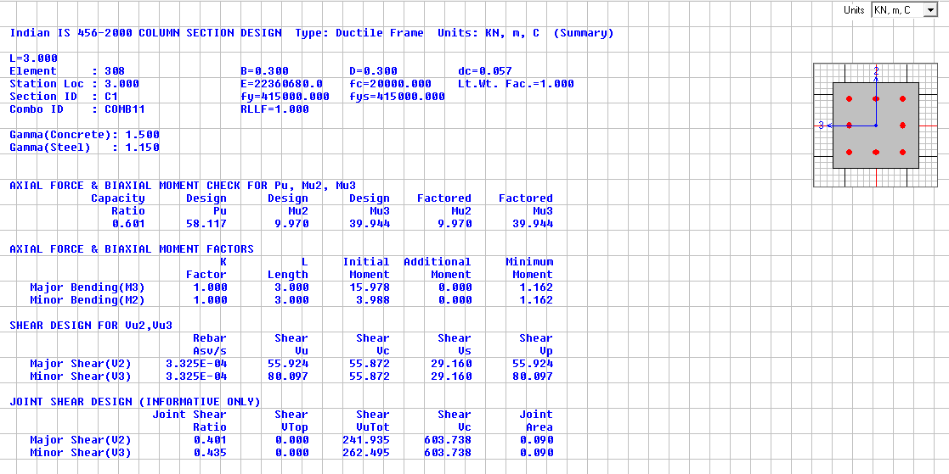
Beam design
bm 250*450
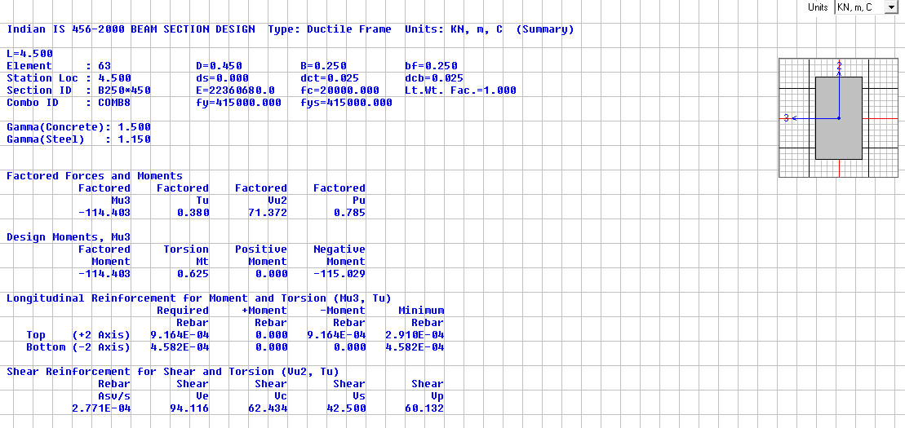

bm 250*350
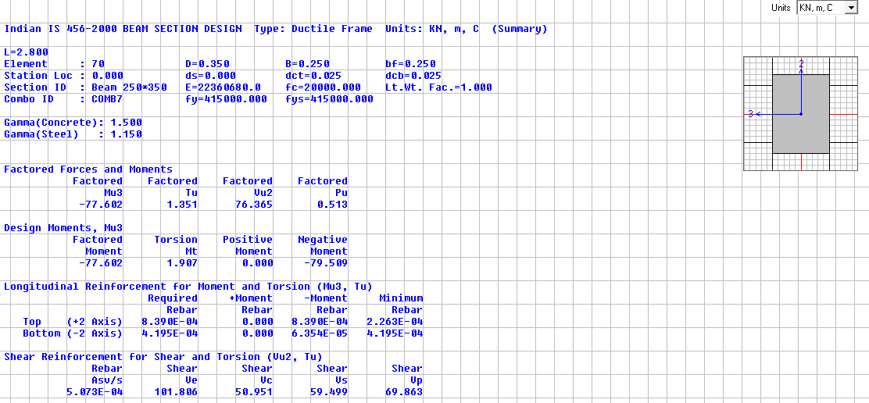
TABLE-3 Joint Reactions
TABLE: Joint Reactions
Joint | OutputCase | CaseType | F3 | Design Load | Bearing Load | Area required | Area Provided | Remarks
Text | Text | Text | KN | KN | KN/m^2 | m^2 | m^2
262 | COMB14 | Combination | 532.936 | 390.82 | 100 | 3.91 | 1.21 | micropiling Required
263 | COMB14 | Combination | 556.27 | 407.93 | 100 | 4.08 | 1.21 | micropiling Required
264 | COMB14 | Combination | 529.728 | 388.47 | 100 | 3.88 | 1.21 | micropiling Required
265 | COMB14 | Combination | 528.937 | 387.89 | 100 | 3.88 | 1.21 | micropiling Required
266 | COMB14 | Combination | 529.466 | 388.28 | 100 | 3.88 | 1.21 | micropiling Required
267 | COMB14 | Combination | 532.053 | 390.17 | 100 | 3.90 | 1.21 | micropiling Required
268 | COMB14 | Combination | 720.727 | 528.53 | 100 | 5.29 | 1.21 | micropiling Required
269 | COMB14 | Combination | 502.435 | 368.45 | 100 | 3.68 | 1.21 | micropiling Required
270 | COMB14 | Combination | 775.607 | 568.78 | 100 | 5.69 | 1.69 | micropiling Required
271 | COMB14 | Combination | 877.348 | 643.39 | 100 | 6.43 | 1.69 | micropiling Required
273 | COMB14 | Combination | 693.883 | 508.85 | 100 | 5.09 | 1.69 | micropiling Required
274 | COMB14 | Combination | 694.938 | 509.62 | 100 | 5.10 | 1.69 | micropiling Required
275 | COMB14 | Combination | 780.461 | 572.34 | 100 | 5.72 | 1.69 | micropiling Required
277 | COMB14 | Combination | 696.961 | 511.10 | 100 | 5.11 | 1.96 | micropiling Required
278 | COMB14 | Combination | 850.406 | 623.63 | 100 | 6.24 | 1.69 | micropiling Required
279 | COMB14 | Combination | 677.006 | 496.47 | 100 | 4.96 | 1.69 | micropiling Required
280 | COMB14 | Combination | 702.167 | 514.92 | 100 | 5.15 | 1.69 | micropiling Required
281 | COMB14 | Combination | 809.119 | 593.35 | 100 | 5.93 | 1.69 | micropiling Required
282 | COMB14 | Combination | 667.406 | 489.43 | 100 | 4.89 | 1.69 | micropiling Required
283 | COMB14 | Combination | 669.071 | 490.65 | 100 | 4.91 | 1.69 | micropiling Required
284 | COMB14 | Combination | 756.248 | 554.58 | 100 | 5.55 | 1.69 | micropiling Required
285 | COMB14 | Combination | 667.698 | 489.65 | 100 | 4.90 | 1.69 | micropiling Required
286 | COMB14 | Combination | 695.685 | 510.17 | 100 | 5.10 | 1.96 | micropiling Required
287 | COMB14 | Combination | 704.81 | 516.86 | 100 | 5.17 | 1.69 | micropiling Required

TABLE -3 Top Storey Deflection
TABLE: Joint Displacements
Joint | OutputCase | CaseType | U1 | Allowable deflection
Text | Text | Text | mm | mm
204 | EQX | LinStatic | 15.10 | 48
TABLE -4 Time Period
TABLE: Modal Periods And Frequencies
OutputCase | StepType | StepNum | Period
Text | Text | Unitless | Sec
MODAL | Mode | 1 | 0.466
MODAL | Mode | 2 | 0.446
MODAL | Mode | 3 | 0.405
MODAL | Mode | 4 | 0.158
MODAL | Mode | 5 | 0.156
MODAL | Mode | 6 | 0.139
MODAL | Mode | 7 | 0.085
MODAL | Mode | 8 | 0.084
MODAL | Mode | 9 | 0.076
MODAL | Mode | 10 | 0.061
MODAL | Mode | 11 | 0.057
MODAL | Mode | 12 | 0.055
TABLE -5 Drift
According to IS 1893:2002 Clause 7.11.1
TABLE: Joint Displacements |  |  |  | Inter Storey Drift | Height | Drift Limitation | Check
Joint | OutputCase | CaseType | U1 |  |  | 0.004 x H | 0.004 x H >
Text | Text | Text | mm | mm | H (m) | mm | ID
287 | EQx | LinStatic | 0.00 | 0 | 0 | 0 | PASS
35 | EQx | LinStatic | 2.56 | 2.56 | 3 | 12 | PASS
63 | EQx | LinStatic | 6.96 | 4.41 | 3 | 12 | PASS
87 | EQx | LinStatic | 11.09 | 4.12 | 3 | 12 | PASS
215 | EQx | LinStatic | 15.10 | 4.01 | 3 | 12 | PASS
TABLE -6 Joint Displacements
TABLE: Joint Displacements |  |  |  | Inter Storey Drift | Height | Drift Limitation | Check
Joint | OutputCase | CaseType | U2 |  |  | 0.004 x H | 0.004 x H >
Text | Text | Text | mm | mm | H (m) | mm | ID
287 | EQy | LinStatic | 0.00 | 0.00 | 3 | 12 | PASS
35 | EQy | LinStatic | 2.40 | 2.40 | 3 | 12 | PASS
63 | EQy | LinStatic | 6.35 | 3.95 | 3 | 12 | PASS
87 | EQy | LinStatic | 10.07 | 3.72 | 3 | 12 | PASS
215 | EQy | LinStatic | 13.86 | 3.79 | 3 | 12 | PASS

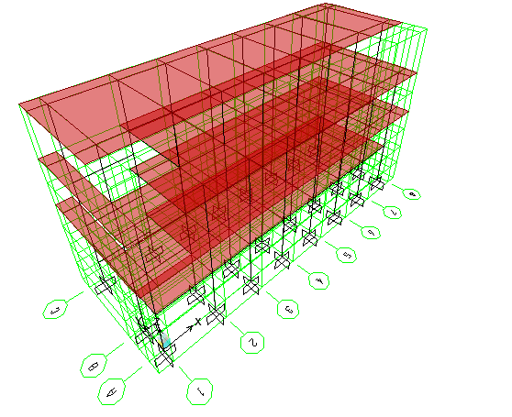
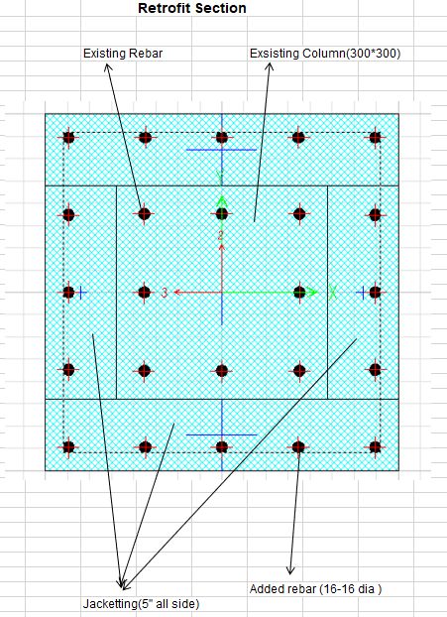
3d model in SAP
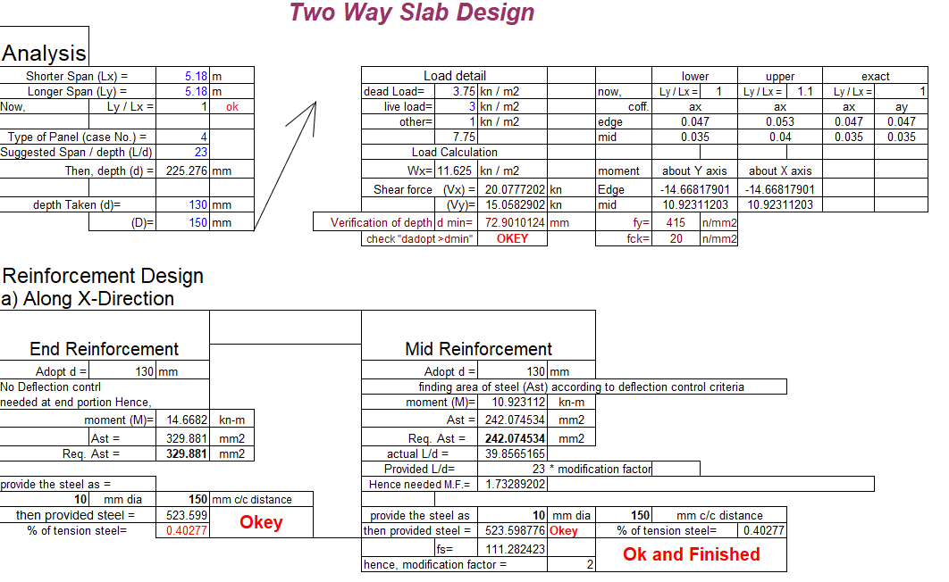
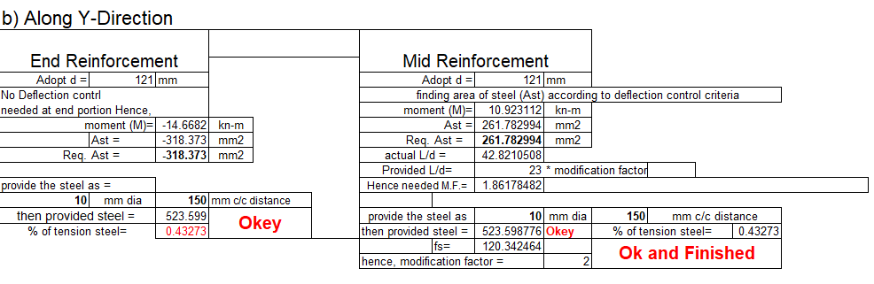
V Conclusion
The design and detailing of the mentioned building has been conducted using SAP consideration of the earthquake load in strengthening f the building and durability of the structure.
Reference
- Raza, S.; Khan, M.K.I.; Menegon, S.J.; Tsang, H.-H.; Wilson, J.L. Strengthening and Repair of Reinforced Concrete Columns by Jacketing: State-of-the-Art Review. Sustain. 2019, Vol. 11, Page 3208 2019, 11, 3208, doi:10.3390/SU11113208.
- M. Emara, M. Rizk, H. Mohamed, M. Zaghlal, Enhancement of circular RC columns using steel mesh as internal or external confinement under the influence of axial compression loading, Frat. Ed. Integrita ` Strutt. 15 (2021) 86–104.
- A. Doǧangün, Performance of reinforced concrete buildings during the May 1, 2003 bingol ¨ earthquake in Turkey, Eng. Struct. 26 (2004) 841–856.
- S.S.E. Lam, B. Wu, Y.L. Wong, Z.Y. Wang, Z.Q. Liu, C.S. Li, Drift capacity of rectangular reinforced concrete columns with low lateral confinement and high-axial load, J. Struct. Eng. 129 (2003) 733–742.
- Z.W. Shan, D.T.W. Looi, R.K.L. Su, A novel seismic strengthening method of rc columns confined by direct fastening steel plates, Eng. Struct. 218 (2020),110838.
- K.G. Vandoros, S.E. Dritsos, Concrete jacket construction detail effectiveness when strengthening RC columns, Constr. Build. Mater. 22 (2008) 264–276.
- S.-Y. Chang, T.-W. Chen, N.-C. Tran, W.-I. Liao, Seismic retroftting of RC columns with RC jackets and wing walls with different structural details, Earthq. Eng. Eng. Vib. 2014 132 13 (2014) 279–292.
- M. Deng, Y. Zhang, Cyclic loading tests of RC columns strengthened with high ductile fiber reinforced concrete jacket, Constr. Build. Mater. 153 (2017) 986–995.
- Y. Zhang, M. Deng, T. Li, Z. Dong, Strengthening of flexure-dominate RC Columns with ECC jackets: experiment and analysis, Eng. Struct. 231 (2021), 111809.
- K.M. Mahmoud, E.A. Sallam, H.M.H. Ibrahim, Behavior of partially strengthened reinforced concrete columns from two or three sides of the perimeter, Case Stud. Constr. Mater. 17 (2022), e01180

