Detection of movement over illegal water bodies and International waters using water buoys using Machine Learning in comparison with Automated Object Detection System in Marine Environment

*₁Mrs.S.Menaka, ₂Dr.C.G.Balaji,₃Mr.Ragu .G,₄Mrs.J.Juslin Sega
_{*1,2,3,4} Assistant Professor, Department of Computer Science and Engineering,SRM Institute of Science and Technology,Ramapuram,Chennai India. *₁menakas1@srmist.edu.in,*₂balajic3@srmist.edu.in,*₃ragug@srmist.edu.in,*₄juslinsj@srmist.edu.in

Abstract - Surveillance is an important job for the coastal guard and yet there is a lot of illegal movement over the restricted water bodies and international waters. Coastal guard's job is to keep a constant watch over the marine borders. Yet there are crimes like smuggling and illegal fishing taking place across the water bodies without proper notice. These acts have an impact and also the fragile marine ecosystem due to overfishing and the usage of fishing gear in prohibited areas. This paper proposes a technique that makes it easier to monitor the movement of ships and boats across borders by utilising 360-degree cameras with a clear view of the horizon. The cameras compare with the data already available to confirm and verify about the illegal movement. This prevents crimes and increases the usage of buoys, increasing the surveillance for safety from even national threats.

Keywords - Surveillance, cameras, buoys, harbour protection, marine life protection, machine learning

- INTRODUCTION

Surveillance is an important role of a water buoy, which with the help of various other sensors and cameras can help detect various movements of waves. Some sensors in them can even detect the slightest change in the wave movement. Ships and boats create a distortion in the wave movement, thus making the buoys detect movement over a particular region with a considerable large radius.Visual surveillance has been studied in the maritime area for more than a decade. Surveillance has been primarily focused on port facilities and coastal areas, using fixed cameras. This has led to the development of several functional systems and mature technology.[1] For many applications in the civilian and military sectors, the strategic problem of detecting both inshore and offshore vessels.[12] Preventing the movement of fishermen boats over the illegal movement over international waters with an alert message to the coast guard as well as the fishermen’s boat, which would prevent a lot of fishermen from going astray and restrict fishing in both international waters as well as the restricted marine areas.[16] Recently, neural network methods have revolutionised computer vision, especially with regards to visual identification tasks like object detection and picture categorization.[14] Safe vessel navigation in and near harbours and trade lanes also necessitates accurate, real-time measurement of the sea surface.[9] So it is essential for maritime surveillance to deploy ship-based video surveillance systems. As a result, video surveillance systems use automatic ship recognition technologies.[14]

II. EXISTING METHODOLOGY

Ship detection currently being used is on shore and is done manually rather than automated buoys which are faster and accurate in nature.[2] The existing smart buoys follow CNN pattern but still don't provide accurate outputs. In the realm of computer vision, there is a lot of ongoing research into the classification and recognition of vessels from cluttered imagery. Because of its complexity, coastal regions are more difficult to distinguish between different ships. Environmental conditions and vessel visual aspects complicate the classification problem.[4] Most prior study has investigated hand-crafted ship characteristics, which may not be able to discern ships with comparable outward looks. This predicament encourages us to suggest an innovative a system for recognising the type of ship using deep learning that we call a coarse-to-fine cascaded convolution neural network. (CFCCNN).[10]

III. COLLECTED DATA AND RELATED WORKS

We take a look at the current state of affairs in the area from a variety of perspectives.In section 2.1 ,we review how buoys can be used to detect boats and ships using camera visuals. In section 2.2 ,we review how the marine ecosystem is affected by excessive fishing.

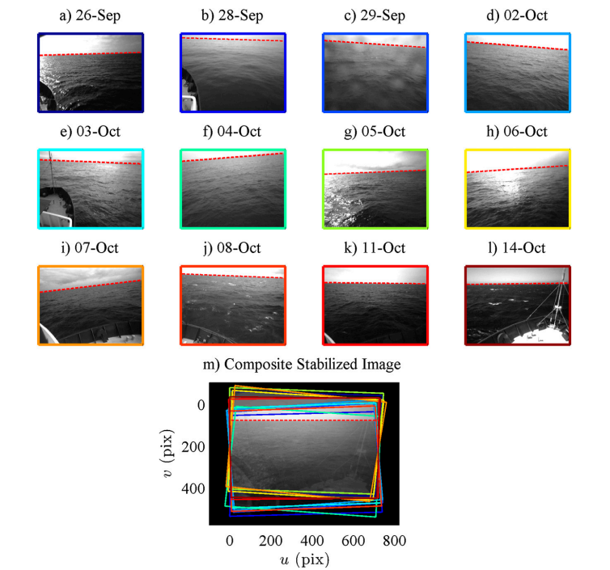

Fig. 1. Detecting movement of boats and ships using cameras attached to water buoys

In the case of buoy-based visual maritime surveillance, the camera is situated almost parallel to the ocean's surface. This type of forward-looking camera has a constrained field of view and limited resolution. As a result, the acquired data, which is from the visible spectrum, is represented using the RGB-color model. The camera can only distinguish distant objects that are just over the horizon since the focus is set to infinity. The camera lacks stabilisation and is securely fastened to its buoy platform, which is not fixed, therefore the scenery it captures is reliant on the buoy's uncontrolled motion. Because the buoy is not totally stabilised and its position cannot be predicted at any given time of day, and it can be moved along a certain radius by the waves. (2012) Fefilatyev, S., Goldgof, D., Shreve, & Lembke. utilising a camera system mounted on a buoy that is constantly moving to locate and follow ships in wide water. (1–12) Ocean Engineering, 54.

2.2. Understanding on how marine life is affected by fishing.

Active and passive fishing techniques both have an impact on benthic flora and ecosystems. Towing trawls or dredges are the primary active fishing techniques on the continental shelf. On the other hand, artisanal fisherman on tropical coasts use a variety of violent techniques include drive netting, spearing, and fishing with explosives or poisons. Passive fishing methods include using pots or traps, baited hooks on set lines, gill nets, and drift nets. Whether actively or passively fished, surface, midwater, and bottom fishing gear can have a direct impact on non-target species such birds, marine mammals, reptiles, and fish trapped as by-catch.
Additionally, fishermen's activities and equipment have a big impact on the benthic organisms that live in bottom environments. (Kaiser, M. J. & Jennings, S.,(1998). The effects of fishing on marine ecosystems. In Advances in marine biology (Vol. 34, pp. 201-352). Academic Press.)

IV. PROPOSED METHODOLOGY

The goal of this paper is to develop automated ways to detect illegal ships crossing the international borders as well as the restricted water bodies. The intrusive target can be detected and verified mainly by the following approaches: i) detection of movement through K-Means ii) Ship detection and verification using buoy horizon image capturing iii) Verifying the collected images with RCNN iv) Alerting system for trespassers and ocean guards. Using a particular type of CNN gives us a better chance of reducing the errors caused by various other CNN algorithms. And by using it along with the horizon detection method it will prove that the provided results are more effective.[11]
V. ALGORITHM

We plan to integrate the use of horizon detection algorithm along with R-CNN algorithm to help find the boats which are crossing and detect them as they do cross the buoys , this way we will have a popper knowledge on what boats are passing.This algorithm also will try to increase the efficiency of the buoys and reduce the number of wastage in energy by using solar panels and high quality batteries to store the enough energy to run the cameras through the night with grayscale vision.

We take a look at how the algorithm that the paper is proposing works. In section 5.1 ,We review how the Horizon Detection method helps increase the efficiency of the results. In section 5.2 ,we review how buoys detect objects using K-Means clustering. In section 5.3 , we review how the CNN model helps classify the different boats.

5.1. Detection and verification of ships and boats by using cameras on the buoy

Once there is a detection of change in the waveform, an alert is sent to the buoys to activate its 360 degree camera to position itself and look for the object which caused the distortion in the waves. The camera is set in a level parallel to the ocean’s surface. Since the buoy is in an uncontrollable state , the pictures taken by the camera are not very clear and often take pics which are far off and have very less resolution.The camera clicks live images , these live images are then compared with the data already present with the system.To locate probable targets, the algorithm for ship detection and localisation employs step technique. If the model is discovered to be incorrect, If the assumptions aren't met, each of those elements may either produce results for the following phase or exclude the current image frame. If assumptions are made, the frame was labelled as "intractable" when it was found to be broken. The algorithm moves on to the following frame of the series of images. [5]

The horizon detection stage of the approach is the most important one for a variety of reasons.[19] To check if the current frame adheres to the model's assumptions regarding the water and sky areas, the detected horizon line is employed. In the following stage of image registration, the horizon line is also used as a reference line for aligning the images.
Finally, since all objects of interest are presumed to be above and nearby the horizon line, the horizon line is used in the segmentation stage to reduce the search space for prospective targets. machine learning techniques—including ensemble methods—have been frequently used. In comparison to individual models, ensemble approaches integrate numerous models to get predictions that are more accurate. To boost overall performance, these techniques can make use of a variety of algorithms or tweaks to a single algorithm
[18].

The horizon-finding method may fail for one of two reasons: either it is not the strongest line in the image or it is not visible in the image.[8]

5.2. Horizon detection of object through K-Means clustering

We do cluster analysis, in general, cluster analysis is a technique for identifying collections of data called clusters. According to the presumption that these groups are disjoint, data from separate clusters differ from one another much more than data from the same cluster.[17] The k-means method is one of many algorithms that is used to solve the cluster analysis problem. K-means is a partitional clustering technique that is iterative. The k-means algorithm creates k clusters from the provided data. The clustering process is concentrated on the centroids which are present and are called cluster centres.. The user must specify the value of k, which determines the number of clusters. Because of this, k-means is not an algorithm for determining how similar or how often data may be similar, but it is a suitable approach for clustering data when the number of clusters is known in advance.

Fig. 2 Comparative analysis of sea horizon image dataset

Here we use k-means to detect the group of boat clusters such that we can classify the objects to a cluster of boats and then further classify using CNN.

5.3. Detection and classification of boats by using CNN model algorithm

Convolutional layers extract features whereas pooling layers generalise them in CNNs, which commonly alternate convolutional layers and pooling layers before fully linked layers [14]. The n filters in the convolutional layers will be of size k k q, where k is less than the input dimension and q typically vary for each kernel. The research probably suggests a novel method that combines a unified ensemble layer and deep features taken from[15] CNNs. A strategy where numerous classifiers or models are merged to create predictions is known as an ensemble layer. In order to increase the accuracy and speed of species identification, the unified ensemble layer may entail aggregating outputs from various models or merging their predictions. [13]

Effectively extracting ship region features is essential. Fast R-CNN and Faster R-CNN, however, both collect area characteristics through RoI layer pooling based on box boundaries that consistently cover an excessive amount of noise information in the ship identification job.[7]

We classify the boats using the R-CNN to what type of boat it exactly is, as this will help identify if that boat is trespassing in areas other than the unrestricted areas.

Our system is trained with those tracking data which have been collected on a daily basis by the cameras to detect and differentiate the ships, boats and other marine life which are big enough to distort waves. The system has an auto update version where all the data is automatically trained at the end of the day, such that each day every new data is learned by the system. This data would increase the existing comparisons and reduce the false alarms set off by the buoys [20].

These steps in the algorithm keep running such that the coastal guard has a constant watch on the borders as well as the preserved water bodies. If any intrusions do take place an alerting message is sent. The following architectural diagram explains how the algorithms work together.

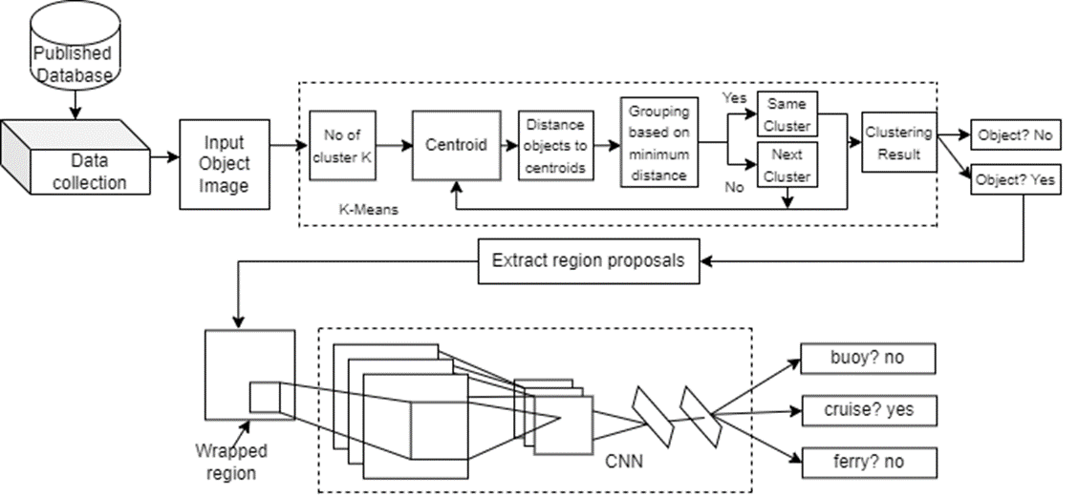

Fig. 3. Architectural diagram of comprising of the proposed algorithms

VI. PERFORMANCE EVALUATION

The goal of this part is to present the techniques for evaluating the performance of the produced algorithm and its components. The evaluated performance percentage obtained for object detection is found to be the value of 94%. Comparing it to the previous [6] horizon-finding algorithms, A manual evaluation of all 1,500 processed photos was conducted, and each was assigned to one of three categories: horizon visible and correctly identified, horizon visible but wrong, or horizon not visible. The Hough transform technique successfully recognised 94.0% of the visible horizon lines from the entire dataset.

The sun is low in the sky on clear or partly cloudy days, which causes significant glare and saturation of the scene towards the horizon. Low light in the morning or evening is a secondary effect, as are raindrops on the camera.
Fig. 4. Performance Model for horizon alignment for object detection

Identifying boats in the sea successfully is the secondary strategy. [10] However, for the following reasons, using just the conventional CNN models to do the ship type recognition assignment is challenging. First, it's possible that the object isn't a ship and that we're wasting resources trying to find some random object in the water. Second, the CNN model's training process frequently has over-fitting disadvantage as a result of the small number of input training samples, which lowers recognition performance. Our research team suggested a revolutionary Regions framework to address the aforementioned problems with Convolutional Neural Networks (R-CNN) framework for recognising ship types.

The graph 6.2 depicts the ship's performance loss model, whereas the graph 6.3 depicts the ship's performance accuracy model. In comparison, it examines and aids in the optimization of the R-CNN algorithm, if present. The distinguishing characteristics of the ships are extracted from over 1,500 photos, yielding an accuracy rating of 94.60% for the proper representation of ship type.

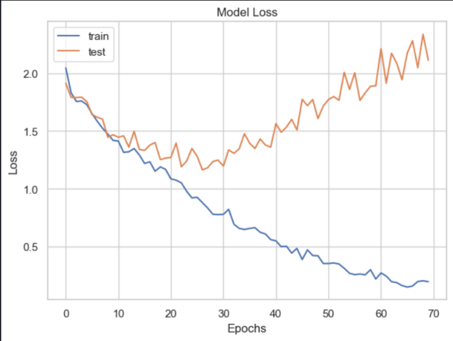

Fig. 5 Performance Model Loss for ship detection

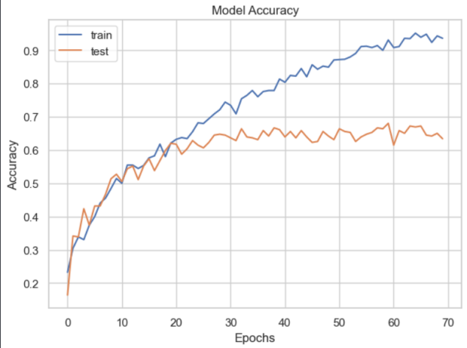

Fig. 6 Performance Model Accuracy for ship detection

VII. RESULT

This article [1] introduces novel algorithms for visual maritime surveillance at sea using a highly mobile camera. Extreme weather conditions and erratic movement are both challenges for the camera that is installed atop a buoy. The suggested technique discovers and recognises ships on the sea horizon in the camera's field of vision, and it creates images of the found objects. The tests, which used a sizable dataset of image data collected from a prototype, produced encouraging outcomes. In particular, the programme correctly identifies and tracks up to 94% of ships. A new horizon detection technique for a complex marine environment was developed in the context of ship identification, and it produces 94.00% accuracy in horizon localization and 93.60% accuracy in horizon picture detection.

The proposed algorithms are quick and well suited for long-term deployment of low-powered autonomous devices. This The horizon line surrounding the platform should not contain any shorelines or other man-made structures, according to research on visual monitoring in open waters. Future research will focus on a more challenging subject, such as tracking ships in coastal zones where the shoreline and building infrastructure are visible, and may comprise of ship profiles.

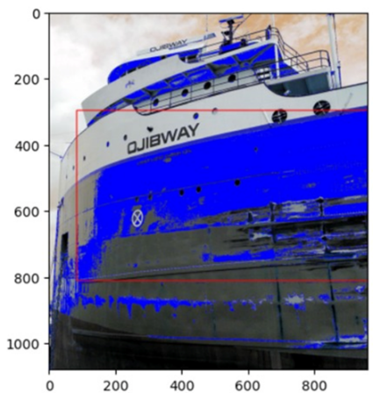

Fig. 7. Model detected object in the horizon

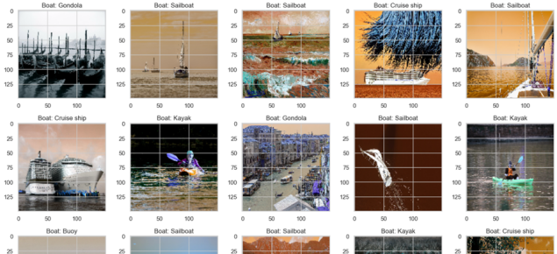

Fig. 8. Model detected type of boat in the horizon

VIII. EVALUATION OF ACCURACY

The accuracy evaluation is taken by running the model a certain number of times to try and train the model to get better as seen in Table 1 the accuracy increases significantly as the number of epochs being run by the model increases, this accuracy will potentially go to 0.9436 which is pretty high accuracy given by the R-CNN algorithm. This just proves that the algorithm chosen for this purpose of classifying ships and boats is right and has a better accuracy rate comparatively. This would decrease the loss rate as its epoch number increases.

Table 1.
Accuracy values of ship identification algorithm performance.

Epoch number | Accuracy | Loss
1 | 0.3388 | 1.755
2 | 0.3306 | 1.762
3 | 0.3740 | 1.6482
4 | 0.3998 | 1.5834
5 | 0.4404 | 1.5227

Fig. 8. Accuracy of boat detection using R-CNN

IX. CONCLUSION

The current study proposes the detection of ships in the horizon as well as the categorization of several ship classifications. [3] The findings show that the new method outperforms the prior methods. The confusion matrix is used to show the improved results after the suggested technique is trained on roughly 1500 frames of ship data. The accuracy of the study is approximately 93.60 for ship classification with simulated time 600 s and 94.00 for horizon object detection with simulated time 1.34 s. The vast data set needed to find an object and categorise the ship is handled in a major way by the proposed method. This project's prospective iteration goes beyond just using the existing algorithm, in the future we intend to develop and integrate more sub-algorithms, making the project as a whole aggregation of various other sub algorithms. Here are some future endeavours of the project are using WSN, Wireless Sensor Networks, which would detect the movement of the boats through the change in the waves of the ocean, frontend application development of the project, where the coastal guard will get an alert, about the trespassing if there is any, tracking through SARs satellite which would allow the coastal guard to know the approximate location of the illegal movement and an infrared LED along with a buzzer sound will help alert the local fishermen about the trespassing as well.
REFERENCES

- Fefilatyev, S., Goldgof, D., Shreve, M., & Lembke, C. (2012). Detection and tracking of ships in open sea with a rapidly moving buoy-mounted camera system. Ocean Engineering, 54, 1-12.
- Jennings, S., & Kaiser, M. J. (1998). The effects of fishing on marine ecosystems. In Advances in marine biology (Vol. 34, pp. 201-352). Academic Press.
- M. Kouzehgar, M. Meghjani and R. Bouffanais, "Multi-Agent Reinforcement Learning for Dynamic Ocean Monitoring by a Swarm of Buoys," Global Oceans 2020: Singapore – U.S. Gulf Coast, 2020, pp. 1-8, doi: 10.1109/IEEECONF38699.2020.9389128.
- Vishal Gupta;Monish Gupta;Parveen Singla; (2021). Ship Detection from Highly Cluttered Images Using Convolutional Neural Network . Wireless Personal Communications, (), –. doi:10.1007/s11277-021-08635-5
- Sergiy Fefilatyev; Dmitry Goldgof; Matthew Shreve; Chad Lembke (2012). Detection and tracking of ships in open sea with rapidly moving buoy-mounted camera system. , 54(none), –. doi:10.1016/j.oceaneng.2012.06.028
- Schwendeman, Michael & Thomson, Jim. (2015). A Horizon-Tracking Method for Shipboard Video Stabilization and Rectification*. Journal of Atmospheric and Oceanic Technology. 32. 164-176. 10.1175/JTECH-D-14-00047.1.
- S. Menaka, B. Shivani, S. Malavikka, B. S. Ganesh and V. Saravanan, "A Reliable and Fast Automatic Combination of Deep Features and Species Categorization Using Unified Ensemble Layer," 2022 International Conference on Data Science, Agents & Artificial Intelligence (ICDSAAI), Chennai, India, 2022, pp. 1-6, doi: 10.1109/ICDSAAI55433.2022.10028941.
- Liu, Z., Hu, J., Weng, L., & Yang, Y. (2017). Rotated region based CNN for ship detection. 2017 IEEE International Conference on Image Processing (ICIP). doi:10.1109/icip.2017.8296411
- Herselman, P. L., Baker, C. J., & de Wind, H. J. (2008). An Analysis of X-Band Calibrated Sea Clutter and Small Boat Reflectivity at Medium-to-Low Grazing Angles. International Journal of Navigation and Observation, 2008, 1–14. doi:10.1155/2008/347518
- Deepa, S., Umamageswari, A., Menaka, S. (2023). A Novel Hand Gesture Recognition for Aphonic People Using Convolutional Neural Network. In: Kannan, R.J., Thampi, S.M., Wang, SH. (eds) Computer Vision and Machine Intelligence Paradigms for SDGs. Lecture Notes in Electrical Engineering, vol 967. Springer, Singapore. https://doi.org/10.1007/978-981-19-7169-3_22.
- Porikli, F. (2006). Achieving real-time object detection and tracking under extreme conditions. Journal of Real-Time Image Processing, 1(1), 33–40. doi:10.1007/s11554-006-0011-z
- Chen, X., Yang, Y., Wang, S., Wu, H., Tang, J., Zhao, J., & Wang, Z. (2020). Ship Type Recognition via a Coarse-to-Fine Cascaded Convolution Neural Network. Journal of Navigation, 1–20. doi:10.1017/s0373463319000900
- Li, G., Song, Z., & Fu, Q. (2020). A convolutional neural network based approach to sea clutter suppression for small boat detection. Frontiers of Information Technology & Electronic Engineering, 21(10), 1504–1520. doi:10.1631/fitee.1900523
- Spagnolo, P., Filieri, F., Distante, C., Mazzeo, P. L., & D’Ambrosio, P. (2019). A new annotated dataset for boat detection and re-identification. 2019 16th IEEE International Conference on Advanced Video and Signal Based Surveillance (AVSS). doi:10.1109/avss.2019.8909831
- S. Menaka, J. Harshika, S. Philip, R. John, N. Bharathiraja and S. Murugesan, "Analysing the Accuracy of Detecting Phishing Websites using Ensemble Methods in Machine Learning," 2023 Third International Conference on Artificial Intelligence and Smart Energy (ICAIS), Coimbatore, India, 2023, pp. 1251-1256, doi: 10.1109/ICAIS56108.2023.10073834.
- Zhang, D., Liu, J., Heng, W., Ren, K., & Song, J. (2018). Transfer Learning with Convolutional Neural Networks for SAR Ship Recognition. IOP Conference Series: Materials Science and Engineering, 322, 072001. doi:10.1088/1757-899x/322/7/072001
- Rainey, K., Reeder, J. D., & Corelli, A. G. (2016). Convolution neural networks for ship type recognition. Automatic Target Recognition XXVI. doi:10.1117/12.2229366
- Ren, Y., Yang, J., Zhang, Q., & Guo, Z. (2020). Ship recognition based on Hu invariant moments and convolutional neural network for video surveillance. Multimedia Tools and Applications, 80(1), 1343–1373. doi:10.1007/s11042-020-09574-2
- Jain, U., & Hussain, M. (2021). Security mechanism for maritime territory and frontier surveillance in naval operations using wireless sensor networks. Concurrency and Computation: Practice and Experience, 33(17). doi:10.1002/cpe.6300
- Mieczyńska, M., Czarnowski, I. K-means clustering for SAT-AIS data analysis. WMU J Marit Affairs 20, 377–400 (2021). https://doi.org/10.1007/s13437-021-00241-3

