Enhancing Agricultural Resilience: Exploring the Role of Insurance and Risk Mitigation Strategies in Sustainable Farming
^{1*}Anmol Giri and ²Mita Meher
¹Assistant Professor, Department of Agricultural Economics, School of Agriculture, GIET University, Gunupur- 765022, Odisha
¹Research Scholar,, Department of Agricultural Economics, Bidhan Chandra Krishi Viswaviyalaya, Mohanpur, Nadia-741252
²Assistant Professor, Department of Agricultural Extension, School of Agriculture, GIET University, Gunupur- 765022, Odisha
²Research Scholar,, Department of Agricultural Extension, Indira Gandhi Krishi Viswaviyalaya, Raipur, Chattisgarh-492012
*Corresponding author’s mail- anmolgiri20k@gmail.com
1. Background and importance of agricultural insurance
India has a rich history of implementing various crop insurance schemes, continually improving them over time to protect the farming community from cultivation risks (Mishra 1996, Singh 2013). The introduction of traditional crop insurance in 1965 was followed by the Comprehensive Crop Insurance Scheme (CCS) in the 1980s and 1990s, weather-based insurance schemes in 2003, and the National Agricultural Crop Insurance Scheme (NAIS) in 2004, later modified as MNAIS in 2010 (Anonymous 2014). These existing crop insurance schemes determine loss estimation and indemnity payment based on weather index or crop yield index over a designated area. However, the popular NAIS and MNAIS area-yield crop insurance schemes have encountered significant limitations, including subjective crop yield measurements, inadequate coverage, and concerns regarding accuracy and transparency (Anonymous 2014). Consequently, basis risk has increased, and indemnity payments have consistently surpassed the premiums even during years of favorable weather conditions (Rao 2010, Anonymous 2014).
Approximately half of India's workforce relies directly on agriculture for their livelihood (Chand, 2017). Agriculture is inherently risky, presenting a unique scenario where the risks outweigh the rewards, particularly for smallholder farmers, due to the diverse, complex, and extensive nature of risks (Chatterjee and Oza, 2017). Globally, agriculture faces various hazards, resulting in frequent crop losses. Consequently, crop insurance has become an indispensable risk management tool in the agricultural sector (Vermeulen et al., 2012). Improved agricultural risk management stands as a significant strategy to address the current challenges of food security, income stability, and climate resilience in Indian agriculture. With mounting crop risks and limited crop insurance coverage, there exists immense potential for crop insurance in India (Murthy et al., 2021). Establishing a robust crop insurance system is crucial to mitigate the impact of covariate risks in agriculture and foster innovations and investments in the farming sector.
Pradhan Mantri Fasal Bima Yojana (PMFBY) being implemented in the country from kharif 2016, is an area-yield insurance contract that has many positive features to compensate for multiple risks during the entire life cycle of the crop season. Use of technologies viz. remote sensing, mobile and data analytics is mandatory for effective implementation of the scheme (Murthy et. al. 2021).
Table 1. Selected State-wise Number of Farmers Covered/Benefited, Area/Sum Insured, Premium and Claims under National Agricultural Insurance Scheme (NAIS) in India (Rabi 1999-2000 to Kharif 2015)
States/UTs | Number of  Farmers Covered | Area Insured (In Hectare) | (Rs. in Lakh) |  |  | Number of  Farmers Benefitted
 |  |  | Sum Insured | Premium | Total Claims
Andaman and Nicobar Islands | 4282 | 6579.18 | 2177.43 | 60.64 | 115.22 | 944
Andhra Pradesh | 30498889 | 46196802.77 | 6459243.53 | 186171.33 | 488855.21 | 6897943
Assam | 422654 | 309482.42 | 90821.88 | 2530.74 | 1687.30 | 65963
Bihar | 9271653 | 10405015.89 | 2310359.54 | 53692.51 | 306123.35 | 3277833
Chhattisgarh | 11728099 | 23376652.42 | 1481710.91 | 37696.93 | 39967.48 | 1712134
Goa | 8211 | 13440.13 | 318.12 | 5.65 | 2.36 | 702
Gujarat | 15494171 | 35190624.63 | 4930466.40 | 202671.80 | 841185.84 | 5593245
Haryana | 635778 | 769038.32 | 83496.10 | 2413.98 | 4336.39 | 129424
Himachal Pradesh | 362700 | 284370.70 | 74054.75 | 1589.93 | 1828.78 | 108562
Jammu and Kashmir | 49065 | 68994.99 | 10902.23 | 213.80 | 126.42 | 4492
Jharkhand | 6877479 | 4203916.99 | 444550.07 | 10926.64 | 52466.07 | 2188050
Karnataka | 14013046 | 22102882.88 | 1937544.06 | 56355.23 | 194943.65 | 5223118
Kerala | 461282 | 414760.68 | 87165.63 | 1881.59 | 3062.82 | 85470
Madhya Pradesh | 41258600 | 97860999.94 | 9080309.59 | 214278.05 | 536606.18 | 7684185
Maharashtra | 48347904 | 38422588.10 | 3684790.57 | 163204.61 | 473513.76 | 14970986
Manipur | 35645 | 57471.71 | 14812.25 | 368.73 | 1226.20 | 29932
Meghalaya | 35694 | 35677.99 | 7179.85 | 313.08 | 68.46 | 3600
Mizoram | 121 | 133.79 | 23.24 | 0.58 | 11.23 | 119
Odisha | 19869088 | 19360765.87 | 3575373.09 | 89740.97 | 209443.56 | 3233725
Puducherry | 41984 | 58341.54 | 11050.12 | 214.46 | 316.95 | 7269
Rajasthan | 15058674 | 31379980.35 | 1620309.00 | 45754.35 | 262165.99 | 5200566
Sikkim | 1924 | 1361.87 | 267.90 | 4.32 | 1.28 | 86
Tamil Nadu | 7349888 | 9449547.79 | 2186541.72 | 57726.61 | 296868.98 | 2840476
Telangana | 1041314 | 1208024.17 | 528333.89 | 15861.38 | 2204.19 | 53591
Tripura | 20709 | 13752.03 | 3160.11 | 87.07 | 58.31 | 3432
Uttar Pradesh | 23426012 | 31070385.59 | 3353782.49 | 68482.01 | 116937.52 | 4517617
Uttarakhand | 399156 | 372508.94 | 87097.93 | 1978.13 | 4188.31 | 119370
West Bengal | 14133404 | 6999579.84 | 1809289.61 | 84636.87 | 137087.74 | 3042985
India | 260847426 | 379633682.00 | 43875132.00 | 1298862.00 | 3975400.00 | 66995819
Source: Ministry of Agriculture & Farmers Welfare, Govt. of India. (ON1235)
2. Understanding Agricultural Risks
Agricultural risks encompass a wide range of uncertainties, including weather-related hazards, market price fluctuations, policy and regulatory changes, input availability, and environmental challenges, all of which impact the sustainability and profitability of farming operations. Although higher predicted returns are often one of the benefits for taking risk, risk necessarily implies bad outcomes, including lower yields and incomes and can potentially involve catastrophic events, such as financial bankruptcy, food insecurity, and human health issue (Wauters, et. al., 2014)
2.1. Production risks (crop failure, livestock diseases)
Production risks stem from the uncertain natural growth processes of crops and livestock, with typical sources of these risks related to weather and climate (temperature and precipitation) and pests and diseases. Other yield-limiting or yield-reducing factors are also production risks such as excessive heavy metals in soils or soil salinity.
2.2. Market Risks:
Market risks in agriculture are multifaceted and revolve around uncertainties related to prices, costs, and market access (Smith et al., 2018). Agricultural commodity prices are susceptible to volatility due to weather shocks and their impact on yields, energy price fluctuations, and asymmetric information access (Jones and Brown, 2016). Moreover, market risk stems from factors like international trade, liberalization, and protectionism, which can disrupt market access at various spatial scales (Thompson and Davis, 2019). Farmers face complex decision-making scenarios, contending with multiple risks occurring concurrently, such as weather variability, price spikes, or reduced market access (Carter and White, 2020). Successfully managing these intertwined market risks is vital for farmers' financial stability and long-term agricultural sustainability (Peterson and Smith, 2017).
2.3. Institutional Risks.
According to Harwood et al. (1999), institutional risks are related to sudden changes in the laws and rules that affect agriculture. These institutions might be formal or unofficial. Farmers have little control over the policies and regulations that the government, a formal institution, may modify at any time. The acts of informal trade partners, rural producer organisations, or shifts in social norms that have an impact on agriculture are just a few examples of informal institutions that might be sources of institutional risk. Institutions are assisting and connecting farmers more frequently, especially as agricultural produce grows more geared towards the market.
2.4. Personal Risks
Personal hazards are to issues with health or interpersonal connections that influence the farm or farm household and are unique to an individual. Some causes of personal danger include agricultural equipment injuries, family member illness or death, harmful pesticide impacts on human health, and disease transmission between livestock and humans (Tukana and Gummow, 2017). Farmers' concerns and income fluctuations are largely attributed to health risks (Dercon et al., 2005). Farmers frequently deal with the interconnectivity of institutional and personal risks. For instance, due to institutional risks posed by customary rules, a husband's death or divorce may result in the takeover of land or cattle (Meinzen-Dick et al., 2014).
2.5. Financial risks (credit, input costs, revenue)
Financial risk is defined as the increased volatility of the farm's operating cash flow as a result of the fixed financial obligations inherent in the usage of credit (Gabriel and Baker, 1980; de Mey et al., 2016). Financial risk is related to risks related to how the farm is financed. Changes in interest rates, loan availability, or credit terms are a few examples of sources of financial risk.
3. Agricultural Insurance Types and Coverage
Farmers are financially protected by agricultural insurance against output losses brought on by natural calamities including drought, excessive precipitation, hail, cold, wind, and wildlife. Agricultural insurance is a useful business risk management instrument. According to Siwedza and Shava 2020, the welfare impacts achieved from insurance payouts may include a reduction in hunger (SDG 2). As a result, among other risk management techniques, insurance is a crucial component of agricultural adaptation to climate change.
There are three types of crop insurance:
- Multiple Peril Crop Insurance:
Multi-peril crop insurance (MPCI) is structured in a way so as to protect the farmers from losses in crop production, including lower yields, caused by natural calamities or events like disease (pest and insect damage), drought, flooding, fire or destructive weather. The MPCI is purchased before the crop is planted.
- Actual Production History
The actual production history (APH) of farmers or agricultural producers is taken into account to analyse the grower’s actual yields over a period of time. Based on the APH, the farmer or agricultural producer is offered a lower or higher premium for their crop insurance.
- Crop Revenue Coverage:
Farmers’ income can be largely affected due to extremely variable crop prices. Farmers can opt for crop revenue insurance coverage to protect their earnings in case they have a low yield or the price drops.
3.1 Crop Insurance: Eligibility Criteria
Crop Insurance is compulsory for farmers who are availing crop loans from rural financial institutions (RFIs) for cultivation of their crops. They are also called as ‘loanee farmers’. Other farmers, also known as ‘non-loanee farmers’ have an option to insure their crops under the same schemes (Anonymous, 2023).

3.2 Crop insurance
Crop insurance is a type of insurance designed to lessen the financial losses farmers incur when their crops are damaged or destroyed due to different production hazards. According to research, farms that employ crop insurance have a 70% lower likelihood of farm departure and live an average of 7 years longer than farms that do not. (Kim et al. 2019
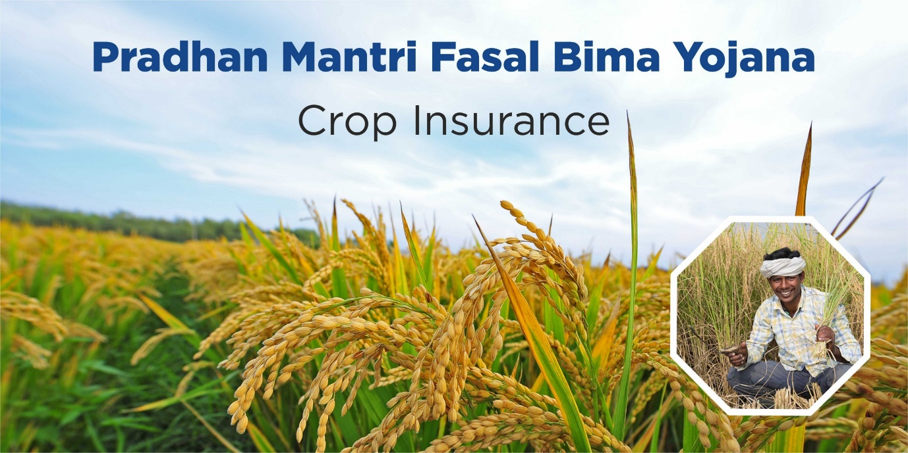
Fig. 1. Crop insurance. (Source: royalsundaram.in/business-insurance)
3.2.1. Yield-based insurance
Yield-based insurance plans offer coverage if the actual yield realised falls short of the anticipated yield. There are two kinds of insurance contracts that function based on yield;
Multiple peril agriculture insurance: When different natural occurrences like hail, wind, rain, insects, etc. lead to a loss in agricultural productivity after harvest, MPCI offers coverage. Farmers decide the amount of the produce to be covered (which might range from (50-85%) as well as the government protection rates when they engage into a contract with the insurers.
Group risk plan: While MPCI calculates the loss using the reference yield derived from the farmers' historical data, Group-Risk-Plan (GRP) does so using a county yield index. The National Agricultural Statistics Service (NASS) makes this decision. The time of payment upon claims may take longer than MPCI payments since these computations may take some time.
3.2.2. Revenue-based insurance
On the other side, revenue insurance plans offer protection from a reduction in produced revenue that might be caused by a loss of production, a change in the market price of the crops, or perhaps both.
Crop revenue coverage (CRC): It employs two different prices, namely the initial price projection and the harvest price, which is determined right prior to harvesting. The crop and the location both influence the precise timing of pricing determination.
Revenue Assurance: The farmer selects a financial amount to be covered that ranges from (65-75%) of projected income as part of revenue assurance (RA). But as farmers, you may also choose the harvest-price option, which resembles a CRC except that, unlike a CRC, it doesn't have an upward restriction on harvest-price protection. CRC/ RA_HPO will be worth more if output declines and prices rise, and vice versa.
Group revenue insurance policies (GRIPs): These policies are designed to offer protection if and when the average county revenue covered by the insurer falls below the revenue chosen by the grower.
3.2.3. Livestock insurance
During the 10th and 11th Five Year Plans, 2005–2006, 2006-07and 2007–2008, respectively, 100 chosen districts underwent a pilot programme of the government supported Livestock Insurance Scheme. From 2008 to 2009, 100 freshly chosen districts around the nation saw the system executed on a regular basis. The plan eventually became a part of the National Livestock Mission's Sub-mission on Innovation and Extension: on Livestock Development. By providing farmers with a safety net against the loss of any animals due to death, the component attempts to manage risk and uncertainty while also highlighting the advantages of livestock insurance to the general public.
Coverage: the scheme is executed in all the districts of the country from 21.05.2014. For all animals besides sheep, goats, pigs, and rabbits, the benefit of subsidies is to be limited to 5 animals per recipient per household. A "Cattle Unit" is equivalent to 10 animals, or 50 animals, in the case of sheep, goats, pigs, and rabbits. A recipient may also receive assistance if they own fewer than 5 animals or 1 cattle unit.
Fig. 2. Livestock insurance. (Source: gstsuvidhakendra.org)
Animals covered: The scope of this component includes indigenous and crossbred milch animals, pack animals (such as horses, donkeys, mules, camels, and male cattle and buffalo), and other livestock (such as goats, sheep, pigs, rabbits, yaks, mithuns etc.)
Component | Pattern of assistance
Premium rates for Normal areas  - Premium rates for one year policy - 4.5%  - Premium rates for two year policy - 8 %  - Premium rates for three year policy - 11 % | Normal areas: Central share 25%, State share 25% and Beneficiary share 50% for APL, and Central share 40%, State share 30%, and Beneficiary share 30% for BPL / SC / ST
Premium rates for NER / Himalayan states  - Premium rates for one year policy - 5.5%  - Premium rates for two year policy - 9 %  - Premium rates for three year policy - 11.5 % | NER / Himalayan states: Central share 35%, State share 25% and Beneficiary share 40% for APL, and Central share 50%, State share 30%, and Beneficiary share 20% for BPL / SC / ST

3.2.4. Weather-based insurance
A special type of weather-based insurance product called the Weather Based agricultural Insurance Scheme (WBCIS) was created to offer insurance coverage against agricultural production losses brought on by unfavourable weather events. It offers compensation for unfavourable weather conditions like frost, heat, relative humidity, excessive rainfall, etc. during Rabi and unfavourable weather conditions like deficiency and excess rainfall during Kharif. It is different from Yield guarantee insurance. In the early phases of crop growth, heavy rains may drown the crops, and in the later stages of crop growth, lodging may result. Floods on the plains might result from heavy rains in the catchments. The flooding throw off the planting schedule and harm the standing crops, which reduces or even eliminates agricultural yields and farm revenue in addition to property loss. Sunlight, temperature, wind, and hail are other meteorological factors that have an impact on crop productivity. In reality, the main enemy that farmers are unable to manage from the beginning of time has been the weather. It has been determined that fluctuations in rainfall are to blame for 50% of differences in crop output. (India Development Gateway, Varsha Bima - 2005)
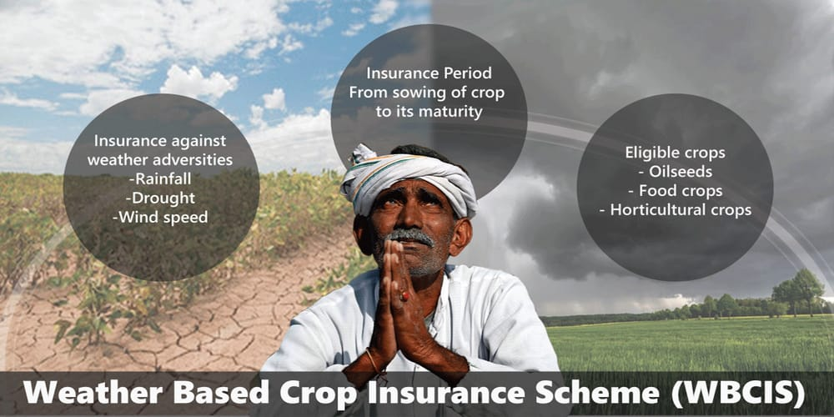
Fig. 3. Weather based crop insurance. (Source: focusagritech.com)
Coverage
Crops: Major food crops (cereals, millets, pulses) and oilseeds
Commercial/ Horticultural crops
Farmers: Everyone who farms the notified crops in the notified regions, including tenant farmers and sharecroppers, is eligible for coverage. On the insured crop, however, farmers should have insurable interest. The non-loanee farmers must provide the proper documentation, including copies of any relevant contracts or agreements and/or land records (in the case of sharecroppers or tenant farmers).
Perils: Any weather adversities which are deemed to cause Adverse Weather Incidence which leads to crop loss like,
- Rainfall – Deficit Rainfall, Excess rainfall, Unseasonal Rainfall, Rainy days, Dry-spell, Dry days
- Relative Humidity
- Temperature – High temperature (heat), Low temperature
- Wind Speed
- A combination of the above parameters
- Hailstorms, cloud-burst may also be covered as Add-on/Index-Plus products for those farmers who have already taken normal coverage under WBCIS.
Premium rates:
Sl. No | CROPS | Maximum Insurance charges payable by farmer (% of Sum Insured)
i) | Season - Kharif - Food & Oilseeds crops (all cereals, millets, & oilseeds, pulses) | 2.0% of SI or Actuarial rate, whichever is less
ii) | Season - Rabi - Food & Oilseeds crops (all cereals, millets, & oilseeds, pulses) | 1.5% of SI or Actuarial rate, whichever is less
iii) | Season - Rabi and Kharif - Annual Commercial / Annual Horticultural crops | 5% of SI or Actuarial rate, whichever is less

Various insurance companies both private and public can participate in WBCIS which are under Department of Agriculture & Cooperation (DAC) and Farmers Welfare, Government of India and selected by concerned State Government / Union Territory (UT).

3.2.5. Index-based insurance
Payments under agricultural index insurance are based on an easily quantifiable index of elements that forecast specific losses, such as rainfall or average yields. In developing nations where the fixed costs of confirming claims for a large number of small farms make traditional insurance too expensive, index insurance is appealing as a risk-management strategy.
In addition to being more expensive, adverse selection and moral hazard are two major issues with traditional insurance that are resolved by agricultural index insurance. The only farmers that get insurance are those who are more likely to incur losses, which is an example of adverse selection in agriculture. Moral hazard might occur, for instance, if insured farmers reduced their efforts or compromised output specifically in order to get an insurance benefit. Because the index is built on variables that are unaffected by a single individual, index insurance eliminates both adverse selection and moral hazard. In fact, the majority of systematic evaluations on agricultural insurance exclusively address index-based insurance. (de Leeuw et al 2014, Marr et al 2016, Vroege et al 2019, Benami et al 2021)
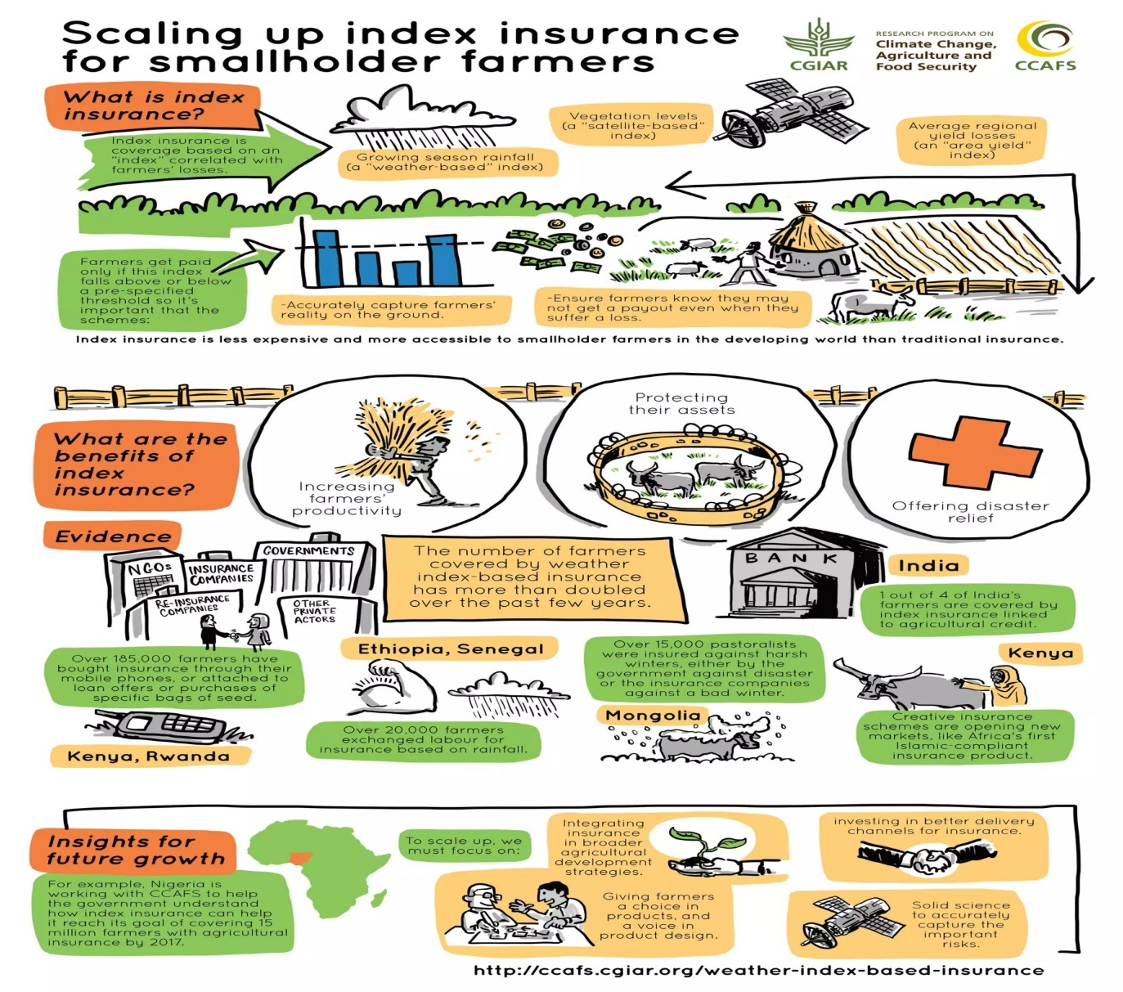
Fig. 4. Scaling up index insurance for small scale farmers (Source: inclusivebusiness.net)
4. Risk Mitigation Strategies
Decision-making is the principal activity of management. Early in the cropping season farmers must make decisions about what crops to plant, and what seeding rates and fertilizer levels to use. The yield and prices obtained will not be known with certainty for several months, or even several years in the case of perennial crops and livestock. In only a few cases are farmers certain of the outcome of their decisions. This usually occurs when the decision is easy and there is only a single outcome (Kahan, 2008).
There are different options to manage agricultural risks, agricultural insurance being one of them. Actions taken before the risk materializes are known as ex-ante measures and actions taken after the fact as ex-post. Three main approaches can be used: risk reduction (ex-ante); risk mitigation (ex-ante); and risk coping (ex-post).
- Risk reduction can occur in several ways: investments in hazard-resistant technology, such as irrigation systems and pest-resistant seed varieties, and through the diversification of income sources including off-farm employment and migration away from hazardous areas.
- Risk-mitigation activities include crop insurance and saving. While saving is a risk-retention strategy, crop insurance is a risk-transfer strategy. In the former, the amount of savings must be large enough to be prepared for worst case scenarios either through own savings or by taking savings from others (credit). In the latter, only a fraction (typically a small fraction) of the potential losses are paid as a premium to secure the right to be compensated if a risk materializes; if the risk doesn’t materialize, the premium is lost.
- Risk-coping strategies when uninsured shocks hit include selling productive assets such as land and livestock, cutting back on consumption, and reducing investments in education among others.
For example, if farmers decide to take short-term loans, they know what will occur; banks will charge them interest at a specific rate. In this case, farmers know exactly the consequences of their decisions. In most situations, however, the outcome of a decision cannot be predicted, as there is more than a single possible outcome. Farmers often find that their decisions turn out to be less than perfect because of changes that take place between the time the decision is made and the time the outcome of that decision is finalized. It may be that the outcomes themselves depend on the decisions of others and on future events that lie beyond the control of the farmer. For effective decisions to be taken, farmers must have all the necessary information regarding input prices, output prices and yields, as well as other technical data.
Crop insurance is a mechanism to protect farmers, against the uncertainties of crop production, due to natural factors, beyond farmer’s control. It is also a financial mechanism, which minimizes the uncertainty of loss in crop production, by factoring in a large number of uncertainties, which impact crop yields distributing the loss burden. In a country like India, where crop production is subjected to the vagaries of weather and large-scale damage due to the attack of pests and diseases, crop insurance assumes a very vital role
4.1 On-farm strategies
4.1.1. Crop diversification
Crop diversification provides better conditions for food security and enables farmers to grow surplus products for sale at market and thus help to obtain increased income to meet other needs related to household well-being. Crop diversification can enable farmers to gain access to national and international markets with new products, food and medicinal plants. Diversifying from the monoculture of traditional staples can have important nutritional benefits for farmers in developing countries and can support a country for becoming more selfreliant in terms of food production (Khanam et. al., 2023). Diversification can also manage price risk, on the assumption that not all products will suffer low market prices at the same time and increase the profitability of the farming community.
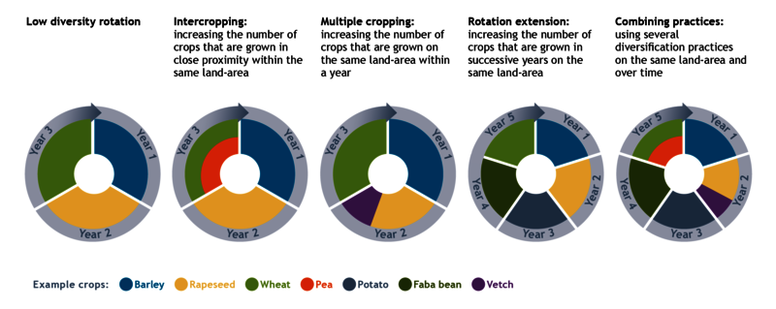
Fig. 5. Crop diversification. (Source: diverimpacts.com)
4.1.2. Irrigation and water management
Irrigation and water management play a crucial role as on-farm strategies to mitigate agricultural risks and ensure optimal crop production. With changing climate patterns and increasing water scarcity, efficient irrigation practices become essential to enhance water use efficiency and reduce water-related risks. Implementing well-designed irrigation systems, such as drip irrigation or sprinkler irrigation, allows farmers to provide water directly to the root zones of crops, minimizing wastage and ensuring precise water application. Moreover, adopting advanced technologies, like soil moisture sensors and automated irrigation scheduling, enables farmers to monitor soil moisture levels in real-time and deliver water precisely when needed (El-Nashar, 2023). By optimizing water usage and preventing under or over-irrigation, farmers can minimize crop stress, enhance crop health, and ultimately achieve higher yields. Proper water management practices, such as rainwater harvesting and water recycling, contribute to water conservation and increase resilience against droughts or irregular rainfall patterns. Emphasizing irrigation and water management as integral components of on-farm risk mitigation fosters sustainable agriculture, promotes water security, and strengthens the overall resilience of farming systems.
4.1.3. Integrated pest management
Integrated Pest Management (IPM) serves as a vital on-farm strategy to mitigate agricultural risks and ensure sustainable crop production. By combining various pest control methods, IPM offers a comprehensive approach that reduces the reliance on chemical pesticides while effectively managing pest populations. Farmers practicing IPM focus on prevention, continuously monitoring fields to detect pests early, and implementing intervention thresholds to decide when control measures are necessary. The integration of multiple approaches, including biological controls, cultural practices, mechanical methods, and judicious use of pesticides, enhances the resilience of crops against pest pressures. Additionally, understanding pest lifecycles and behaviors enables targeted and efficient pest management (Kaur & Kaur, 2020). With IPM's emphasis on reducing environmental impact and preserving natural resources, this approach contributes to long-term agricultural sustainability, making it a valuable tool in safeguarding farm productivity and farmer livelihoods.
4.1.4. Precision agriculture technologies
Precision agriculture technologies offer a cutting-edge on-farm strategy to mitigate agricultural risks and optimize farm productivity (Lowenberg-DeBoer, J, 1999). By harnessing the power of modern technologies, such as Global Positioning System (GPS), Geographic Information System (GIS), remote sensing, and data analytics, precision agriculture allows farmers to make data-driven decisions with a high degree of accuracy and efficiency. These technologies enable farmers to precisely analyze variations in soil fertility, moisture levels, and crop health across their fields, leading to targeted interventions and resource allocation. By applying the right amount of inputs, such as fertilizers, pesticides, and water, at the right time and in the right locations, farmers can minimize waste, reduce production costs, and mitigate potential environmental impacts (Monteiro, et. al., 2021).
Remote sensing technologies, such as drones and satellites, provide real-time monitoring of crops, enabling early detection of pest outbreaks, diseases, or nutrient deficiencies. As precision agriculture continues to evolve, its ability to optimize yields, enhance resource use efficiency, and adapt to climate variability positions it as a pivotal tool for achieving sustainable agriculture and managing risks associated with changing environmental conditions
4.2. Off-farm strategies
4.2.1. Futures and options contracts
Futures and options contracts serve as indispensable off-farm strategies to effectively mitigate agricultural risks and secure the financial well-being of farmers. These financial instruments enable farmers to hedge against price volatility and adverse market conditions, providing a safeguard against potential losses in crop prices. Futures contracts allow farmers to lock in a predetermined price for their agricultural commodities, ensuring a stable income regardless of market fluctuations. On the other hand, options contracts provide farmers with the right, but not the obligation, to buy or sell commodities at a specified price, offering flexibility and risk management during uncertain market conditions. By leveraging futures and options contracts, farmers can manage their price risk, preserve profit margins, and make informed decisions regarding planting, harvesting, and marketing their produce. These instruments also provide a layer of financial security, reducing the vulnerability of farmers to unexpected price swings and enhancing their ability to navigate the dynamic agricultural market landscape with greater confidence.
4.2.2. Forward contracts
Forward contracts represent a valuable off-farm strategy for farmers to effectively mitigate price risks and enhance their financial stability. These contracts allow producers to lock in a predetermined price for their agricultural commodities at a future date, irrespective of market fluctuations (Dhir, 2022). By entering into a forward contract with a buyer, farmers can secure a fixed price for their produce, thus safeguarding their revenue against potential price volatility. Forward contracts significantly reduce price risk exposure for agricultural producers, providing them with greater certainty and enabling better financial planning. Utilizing forward contracts as part of a comprehensive risk management strategy can bolster the financial resilience of farmers and contribute to the overall stability of the agricultural sector.
4.2.3. Hedging
Hedging is a powerful off-farm strategy employed by farmers and agricultural businesses to effectively mitigate various financial risks inherent in agricultural markets. Through hedging, market participants can protect themselves from adverse price movements by taking offsetting positions in derivative contracts, such as futures or options. By doing so, farmers can lock in a specific price for their produce, ensuring a stable income regardless of potential market fluctuations. Hedging acts as a valuable risk management tool, enabling farmers to shield their revenue and safeguard against unpredictable market dynamics (Haacke & Ciorciari, 2022). The ability to hedge not only provides financial security but also instils confidence in decision-making, encouraging long-term planning and investment in agricultural operations. With hedging as an integral part of their risk management strategy, farmers can navigate the uncertainties of the market landscape with greater assurance, ultimately contributing to the stability and sustainability of the agricultural sector.
4.2.4. Commodity exchanges
Commodity exchanges play a pivotal role as an off-farm strategy to effectively mitigate risk in the agricultural sector. These organized platforms facilitate the trading of agricultural commodities, allowing farmers and traders to hedge against price fluctuations and manage market risks. By participating in commodity exchange markets, farmers can lock in future prices through futures contracts, thereby ensuring a predetermined income for their produce regardless of market volatility. Commodity exchanges provide transparency and price discovery mechanisms that enable farmers to make informed decisions based on real-time market information. This risk management tool empowers farmers to protect their revenue and plan their operations with greater certainty, fostering stability and sustainability in the agricultural industry. Embracing commodity exchanges as part of a comprehensive risk mitigation strategy enables farmers to navigate the complexities of the market and secure their financial well-being in an ever-changing economic landscape.
5. Government Initiatives and Policies
Government initiatives and policies related to agricultural insurance aim to provide financial security and risk management tools to farmers, fostering the resilience and sustainability of the agricultural sector. These policies often include the implementation of crop insurance schemes, which enable farmers to mitigate the impact of crop losses caused by natural disasters, pests, and other unforeseen events. Governments may also offer subsidies and incentives to encourage farmers to participate in agricultural insurance programs, making them more accessible and affordable. Policy frameworks may be designed to improve insurance coverage and tailor insurance products to suit the diverse needs of different farming communities. By promoting the adoption of agricultural insurance, governments seek to safeguard farmers' incomes, enhance food security, and promote stability in rural economies.
5.1. Public agricultural insurance programs
Public agricultural insurance programs are government initiatives that aim to provide financial protection to farmers against various risks and uncertainties in agriculture. These programs typically offer insurance coverage for crops, livestock, and other agricultural assets, helping farmers recover from losses caused by natural disasters, adverse weather conditions, pests, diseases, and market price fluctuations. The government usually subsidizes a portion of the insurance premiums, making it more affordable for farmers, especially smallholders and those with limited resources. Public agricultural insurance programs also contribute to the overall stability of the agricultural sector, as they enable farmers to manage risk and invest in their operations with greater confidence. By reducing the financial vulnerabilities of farmers and ensuring their livelihoods are protected, these programs play a vital role in enhancing food security and supporting sustainable agricultural practices.
5.2. Subsidies and support for farmers
Subsidies and support for farmers are government initiatives and policies aimed at providing financial assistance and various forms of aid to the agricultural community. These programs are designed to promote agricultural development, ensure food security, and support rural economies. Some common types of subsidies and support for farmers include:
- Direct Income Support: Governments may provide direct payments or cash transfers to farmers to supplement their income and stabilize farm revenues. These payments can help offset low commodity prices, production costs, and income fluctuations.
- Crop Insurance Subsidies: Governments often subsidize premiums for crop insurance, making it more affordable for farmers to protect their crops against weather-related risks, pests, and diseases.
- Input Subsidies: Subsidies on agricultural inputs such as fertilizers, seeds, and pesticides aim to reduce production costs and improve farmers' access to essential resources.
- Price Support Mechanisms: Price support programs guarantee minimum prices for certain agricultural commodities, ensuring farmers receive a fair return for their produce even during market downturns.
- Infrastructure Development: Governments invest in rural infrastructure, including irrigation systems, roads, and storage facilities, to enhance agricultural productivity and market access.
- Training and Extension Services: Support is provided for agricultural training, research, and extension services to equip farmers with the latest knowledge and best practices in farming.
- Credit Support: Access to affordable credit and loans is facilitated through government-supported agricultural credit schemes, enabling farmers to invest in their operations and expand their activities.
- Subsidized Technology Adoption: Subsidies may be offered to encourage the adoption of modern agricultural technologies, such as precision farming tools and machinery, to improve productivity and efficiency.
- Market Support: Governments may establish market intervention measures, such as procurement programs and price stabilization funds, to stabilize prices and protect farmers from market volatility.
Subsidies and support for farmers play a crucial role in ensuring the sustainability of agriculture, strengthening rural livelihoods, and enhancing food security for the nation. However, the design and implementation of these programs often involve complex policy considerations to strike a balance between supporting farmers and managing fiscal constraints.
5.3 Role of government in promoting risk mitigation strategies
The government plays a crucial role in promoting risk mitigation strategies in agriculture. It establishes and supports agricultural insurance programs, providing financial protection against crop losses and price fluctuations. Disaster relief and compensation are provided to help farmers recover from natural disasters and maintain their operations. Governments invest in agricultural research and extension services to disseminate knowledge on climate-resilient practices. Market intervention measures stabilize commodity prices, and infrastructure development enhances agricultural productivity. Access to affordable credit and financial support enables farmers to invest in risk-reducing technologies. Climate-smart farming practices are promoted, and capacity-building programs equip farmers with the necessary skills. Stable and supportive policy environments foster an enabling climate for risk management in agriculture. The government's proactive involvement ensures the sector's sustainability, enhances farmer livelihoods, and strengthens food security.
6. Case Studies and Success Stories
6.1 Examples of effective agricultural insurance programs
There are several instances when governments have employed farm insurance in collaboration with the private sector to control the financial effects of climate shocks and to assist the expansion of the agriculture industry. Here are few examples (Gracelin Baskaran, Barry Maher, 2021)
6.1.1. Comprehensive Crop Insurance Scheme of India, Gujrat.
When it came to small and medium farms in India, the government intended to increase production. Poor collateral prevented these farmers from obtaining loans, which stifled investment. A public-private crop insurance programme called the Comprehensive Crop Insurance Scheme of India was started by the government in Gujarat state, using subsidised farm insurance as security for loans. Due to this, the amount of credit provided to farmers climbed from 19 to 27 percent of the total credit portfolio, increasing both its coverage and size. Though farmers in India still encounter significant challenges when trying to insure their crops, the initiative served as the model for a nationwide programme.
6.1.2. National Disaster Risk Financing Strategy, Kenya
In Kenya, providing assistance to farmers was a continual financial burden. Twelve billion dollars, or around 11% of 2011's GDP, were thought to have been lost as a result of the devastating drought that lasted from 2008 to 2011. As a part of the reaction, the government passed a National Disaster Risk Financing Strategy, which targets vulnerable farmers with an agriculture insurance programme run in collaboration with the private sector (further information can be found in this World Bank project paper). The insurance is sold to farmers as a package together with high-quality supplies. In exchange for the premium, the insurance covers damages if the rains don't come. They obtain big crops if the rain is favourable. Payments are made through mobile money, which speeds processing and makes relief assistance more transparent. It also encourages financial inclusion by giving people access to savings. By shifting part of the risk to private markets, the programme has helped more than 500,000 farmers become more resilient to financial shocks and the value chains associated with agriculture. It also helps the government avoid budgetary instability.
7. Conclusion
The adoption of effective agricultural risk mitigation strategies is critical for enhancing the resilience and sustainability of the farming sector. Farmers face a multitude of uncertainties, from production and market risks to institutional and personal hazards. To navigate these challenges, a combination of on-farm and off-farm strategies can be employed, such as crop diversification, irrigation and water management, integrated pest management, precision agriculture technologies, futures and options contracts, forward contracts, and hedging. These measures enable farmers to proactively manage risks, optimize resource use, and secure their financial well-being. Additionally, government initiatives and policies play a crucial role in promoting agricultural insurance and supporting farmers in their risk management efforts. Public-private partnerships, climate change adaptation, capacity building, and research and innovation further contribute to strengthening the sector's ability to cope with evolving challenges. By embracing a comprehensive and holistic approach to agricultural risk management, we can ensure the stability and prosperity of the farming community, enhance food security, and foster a sustainable and resilient agricultural industry for the future.
References
- Anonymous, (2023). Crop Insurance: All You Need To Know – A Complete Guide. Life and General Insurance. Available at https://www.lnginsurance.com/blog/crop-insurance-all-you-need-to-know/
- Chatterjee, A., & Oza, A. (2017). Agriculture insurance. ADB Briefs. 77: 1-8.
- Murthy C. S., Poddar M. K., Pandey V., Biswal, A., & Choudhary, K.K. (2021). Replacing CCE-yield estimates with modeled-yield estimates for crop insurance. Agricultural Sciences & Applications Group. 1: 1-21.
- Mishra, P.K. (1996) Agricultural Risk, Insurance and Income. Arabury, Vermont: Ashgate Publishing Company
- Singh, R. (2013) Agricultural livelihoods and crop insurance in India: Situation analysis & Assessment, Deutsche Gesellschaft fur Internationale Zusammenarbeit (GTZ) GmbH: New Delhi.
- Rao, K.N., Index based crop insurance, (2010) Agriculture and Agricultural Science Procedia, 1, 193-203.
- Chand, R., (2017). Doubling Farmers’ Income: Rationale, Strategy, Prospects and Action Plan. NITI Policy Paper 01/2017. National Institution for Transforming India, Government of India, New Delhi
- Khanam, R., Bhaduri D., & Nayak, A. K. (2018) Crop diversification: an important way-out for doubling farmers' income. Indian Farming. 68(01): 31–32
- Kahan, D. (2008). Managing risk in farming. Rome: Food and agriculture organization of the United Nations.
- Kaur, T., & Kaur, M. (2020). Integrated pest management: A paradigm for modern age. Pests, Weeds and Diseases in Agricultural Crop and Animal Husbandry Production. Intech Open.
- El-Nashar, W., & Elyamany, A. (2023). Adapting irrigation strategies to mitigate climate change impacts: a value engineering approach. Water Resources Management, 37(6-7), 2369-2386.
- Lowenberg-DeBoer, J. (1999). Risk management potential of precision farming technologies. Journal of Agricultural and Applied Economics, 31(2), 275-285.
- Monteiro, A., Santos, S., & Gonçalves, P. (2021). Precision agriculture for crop and livestock farming—Brief review. Animals, 11(8), 2345.
- Dhir, R. (2022) Forward Contract: How to Use It, Risks, and Example. Investopedia. Available at https://www.investopedia.com/terms/f/forwardcontract.asp
- Haacke, J., & Ciorciari, J. D. (2022). Hedging as risk management: Insights from works on alignment, riskification, and strategy. IPC Working Paper Series Number, 124, 2-44.
- Benami E, Jin Z, Carter M R, Ghosh A, Hijmans R J, Hobbs A, Kenduiywo B and Lobell D B 2021 Uniting remote sensing, crop modelling and economics for agricultural risk management Nat. Rev. Earth Environ. 2 140–59
- de Leeuw J, Vrieling A, Shee A, Atzberger C, Hadgu K M, Biradar C M, Keah H and Turvey C 2014 The potential and uptake of remote sensing in insurance: a review Remote Sens. 6 10888–912
- Gracelin Baskaran, Barry Maher. Agricultural insurance: The antidote to many economic illnesses May. 26, 2021.
- Kim, Youngjune,Jisang Yu, and Dustin L.Pendell.2019.“Effects of Crop Insurance on Farm Disinvestment and Exit Decisions.”European Review of Agricultural Economics47(1):324–47
- Marr A, Winkel A, van Asseldonk M, Lensink R and Bulte E 2016 Adoption and impact of index-insurance and credit for smallholder farmers in developing countries: a systematic review Agric. Financ. Rev. 76 94–118
- Siwedza S and Shava S 2020 Scaling up SDGs Implementation: Emerging Cases from State, Development and Private Sectors ed G Nhamo, G O A Odularu and V Mjimba (Cham: Springer International Publishing) Insurance, increasing natural disaster risks and the SDGs: a focus on Southern Africa 129–38
- Vroege W, Bucheli J, Dalhaus T, Hirschi M and Finger R 2021 Insuring crops from space: the potential of satellite-retrieved soil moisture to reduce farmers' drought risk exposure Eur. Rev. Agric. Econ. 48 266–314
- Wauters, E., Van Winsen, F., De Mey, Y., & Lauwers, L. (2014). Risk perception, attitudes towards risk and risk management: evidence and implications. Agricultural Economics, 60(9), 389-405.

