**CHAPTER–6**

**GREEN SYNTHESIS OF SILVER NANOPARTICLES USINGLEAF EXTRACT OF *SYZYGIUM AQUEUM* (WATER APPLE) ENCAPSULATED WITH POLYMER: ANTIBACTERIAL AND ANTIOXIDANTSTUDY**

**6.0 Abstract**

The versatile cost effective green synthesis method is used to synthesize polymer encapsulated silver nanoparticles. The salt of Silver nitrate (AgNO3) is used to synthesize Silver nanoparticles i.e. AgNPs. Herein, we synthesized polymer encapsulated silver nanoparticles. Polyvinyl pyrrolidone(PVP) used as encapsulated polymer material. The PVP-b-AgNPs prepared from the plant extract of water apple (*Syzygium aqueum*). The Bio synthesized PVP-silver nanoparticles are characterized using UV-visible spectroscopy,FTIR, XRD and HR-TEM, SAED. The confirmation of Silver Nanoparticles and PVP encapsulated Silver Nanoparticles are done by the UV spectroscopy. The crystallite size of PVP-b-AgNPs are calculated using XRD and the stretching vibrations of the PVP-b-AgNPs are determined using FTIR,The morphology of PVP-b-AgNPs are derived by the HR-TEM and SAED. The antimicrobial activity of b-AgNPs and PVP-b-AgNPs were tested for *B.subtilis, S.aureus S.typhi* and *E.coli*. The synthesized silver nanoparticles(AgNPs) and PVP functionalized silver nanoparticles(PVP AgNPs) exhibited remarkable antimicrobial activity. The antioxidant activity of b-AgNPs and PVP-b-AgNPs gives tremendous activity against the DPPH scavenging radical.

**Keywords:**

*Syzygium aqueum*, Biosynthesis, silver nanoparticles, encapsulation, polyvinyl pyrrolidone(PVP)

**6.1 Introduction:**

**6.1.1 Green synthesis of nanoparticles:**

Nanotechnology is playing a critical rolein many significant technologies via nanoscale structures(nanoparticles) in areas of optics, electronics, biomedicalscience, mechanics, drug-gene delivery, chemical industry,optoelectronic devices, nonlinear optical devices, catalysis,

space industries, energy science, and photoelectrochemicalapplications**[1]**.

In the last decade, biosynthesis of metal nanoparticles has emerged as a novel and dependable

method for the synthesis of nanoparticles due to a growing demand to develop eco-friendly processes in nanomaterials synthesis. Much effort has been put into the biosynthesis of metal nanoparticles by microorganisms. Klaus *et al.* fulfilled biosynthesis of silver-based single crystals at the cell poles of propagating *Pseudomonas stutzeri* AG259. Nair *et al.* attained formation of submicron crystallites of Ag, Au and Ag-Au alloy using live*Lactobacillus* strains. Li and coworkers explored synthesis of silver nanoparticles by dried *Corynebacterium sp.* SH09 and *Aeromonas sp.* SH10 isolated from gold mine. Sastry *et al.* attained synthesis of metal nanoparticles by fungi**[2-7]**.

The three foremost conditions for the synthesis of nanoparticles are the selection of green or environment-friendly solvent, a good reducing agent, and a harmless material for stabilization. For the synthesis of nanoparticles, extensive synthetic routes have been applied in which physical, chemical, and biosynthetic routes are very common. Generally, thechemical methods used are too expensive and incorporate the uses of hazardous and toxic chemicals answerable for various risks to the environment**[8]**. The biosynthetic route is a safe, biocompatible, environment- friendly green approach to synthesize nanoparticles using plants and microorganisms for biomedical applications**[9]**. This synthesis can be carried out with fungi, algae, bacteria, and plants, etc. Some parts of plants such as leaves, fruits, roots, stem, seeds have been used for the synthesis of various nanoparticles due to the presence of phytochemicals in its extract which acts like stabilization and reducing agent**[10]**.

The biological methods for the synthesis of nanomaterials include the extract from plants, bacterial, fungal species, and so forth. The synthesis of nanoparticles using various plants and their extracts can be favourable over other biological synthesis methods which involves complex procedures of maintaining microbial cultures and hence plant mediated biological synthesis is hiking importance due to its simplicity and ecofriendliness**[11]**.

In the biosynthesis of nanoparticles environmentally accepted “green chemistry” concept has been applied for the development of clean and environment-friendly nanoparticles which involves bacteria, fungi, plants, actinomycetes, etc., which is said to be “green synthesis”**[12]**.

Green synthesis of nanoparticles has many potential applications in environmental and biomedical fields. Green synthesis aims in particular at decreasing the usage of toxic chemicals. For instance, the use of biological materials such as plants is usually safe. Plants also contain reducing and capping agents. Here we present the principles of green chemistry, and plant-mediated synthesis of nanoparticles and their recent applications. Nanoparticles include gold, silver, copper, palladium, platinum, zinc oxide, and titanium dioxide**[13]**.

An environment-friendly synthesis process has been developed with the aid of *Syzygium aqueum* (water apple) leaves extract. Pulverized leaves of *Syzygium aqueum* (water apple) are mixed with a universal solvent such as water for the preparation of Pd nanoparticles supported on activated Bentonite**[14]**.

The Myrtaceae comprises about 131 genera and 5500 species that are characterized by their abundant antioxidants, mainly flavonoids, flavonols, anthocyanins, ellagitannins as well as phenolic acids**[15]**. Among its genera, *Syzygium* is a large genus that includesabout 1100 species, many of which had been taxonomically confused with the genus Eugenia**[16]**.Five species selected from *Syzygium* (*S. aqueum, S. cumini, S. jambos, S. malaccense,* and *S. samarangense*) from the leaves and stems were the best phenolic and flavonoid sources **[17-21]**.Several species belonging to the genus *Syzygium* have been extensively studied for their phytoconstituents as well as their biological activities; among them, *S. cumini, S. samarangense,* and *S. jambos*. The reported pharmacological activities includeantioxidant, antiviral, anti-diabetic and hepatoprotective properties**[22-23]**.

*Syzygium aqueum* is widely used in folk medicine. A polyphenol-rich extract fromits leaves demonstrated a plethora of substantial pharmacological properties. Theextract showed solid antioxidant properties in vitro and protected human keratinocytes(HaCaT cells) against UVA damage. The extract also reduced the elevated levelsof ALT, AST, total bilirubin (TB), total cholesterol (TC) and triglycerides (TG) inrats with acute CCl4 intoxication**[24]**.

The Water rose apple, *Syzygium aqueum*, a member of family Myrtaceae, is native to Indonesia and Malaysia but is presently widely distributed in the tropics. Several biologically active compounds have been isolated from the plant, among them, epigallocatechin, epigallocatechin gallate, vescalagin, castalagin, and samarangenins A and B**[25]**. Several plant parts have been used in folk medicine. Substantial antihyperglycaemicactivities were reported from the leaf extract and its individual components myricitrin, myrilgalone G and B, phloretin and europetin 3-O-rhamnoside from plants grown inMalaysia**[26]**.Water apple belongs to a species of brush cherry tree and is found in tropical countries. It can be harvested from the July to December, and thus it is easily utilized. Aqueous fruit extract of water apple (*Syzygium aqueum*) was used for the first time as bioreductant to synthesize stable AgNPs**[27]**.

The ultrafine size ranging from 1 to 100 nm is known to be nanoparticles (NPs). Within the list of the NPs, metal nanoparticles(MNPs) are discovered for their optical, electrical and photothermal properties**[28]**.

Nanotechnology is a rapidly growing field for producing tools using particles on the order of about a nanometer (10–9 m) in scale. Nanotechnology offers significant improvements to benefit the life sciences, healthcare, and industrial technology**[29]**. An eco-friendly process for the synthesis of metallic nanoparticles is an important step in nanotechnology. Recently, the use of eco-friendly nanotechnology for the development of selective and sensitive detection methods in the analytical and biological sciences has become increasingly important**[30-31]**.

A number of approaches are available for the synthesis of silver nanoparticles viz. a photochemical method**[32]**, thermal decomposition of silver compounds**[33]**, an electrochemical method**[34]**, and recently via a green chemistry route**[35-36]**. Apparently, many of the nanoparticles synthesis methods are expensive and selectively involve the use of hazardous chemicals. The hazardous chemicals can cause contamination on the surface of the nanoparticles similar to the adverse effects of metals in applications. Above all, the biosynthesis of nanoparticles is highly favoured on account of its environmental friendliness, and is a method which has attracted considerable attention for materials synthesis**[37]**. Plant leaves or plant seed extracts contain reducing sugars (aldoses), terpenoids, amino acids, and other organic compounds**[38]**, which are vital to cause changes in nanoparticle formation. Some of the extracts are composed of reducing agents, complexing agents and stabilizers which have an effect on the size and shape of the forming nanoparticles. In previous work, they have demonstrated that noble metal nanoparticles reduced by biomass had excellent performance for photochemical catalysis and selective hydrogenation**[39-40]**.

Plant mediated biological synthesis is hiking importance due to its simplicity and ecofriendliness**[41]**. Silver in its pure form was known to keep the microbes at bay. The antimicrobial property of silver isintensified if they are transformed into a nanoparticles, making it useful in effectively eliminating various microbes. As a natural material, silver is known to be safe to man and produce little to no allergic reactions when tested for curing various diseases**[42]**. The silver nanoparticles (AgNPs) act on a broad range of target sites both extracellular as well intracellular. In fact microbes generally have a harder time to develop resistance to silver then they do to antibiotics**[43]**.

Silver nanoparticles are among the most important nanomaterials, being used as antibacterial agents**[44]** as well as components of cosmetics, electronics, biosensors, food additives, industry, paints, and medicines**[45]**. Biological materials that have proven useful for synthesis of metal nanoparticles include *Hibiscus rosasinensis***[44]** and *Foeniculum vulgare***[46]**.

Many nanoparticles such as gold, silver, zinc oxide, iron have been synthesized very easily by adopting a green approach. The phytocompounds present in the plant extract such as polyols, terpenoids, polyphenolsare responsible for metallic ions bioreduction**[47-50]**.

Silver nanoparticles can be extracted from many medicinal plantssuch as *Saccharum officinarum***[51]**, *Helianthus annus***[52]**,*Cinamomum camphora***[53]**, *Oryza sativa***[54]**,*Aloevera***[55]**, *Capsicum annuum***[56]**, *Medicago sativa***[57]**, *Zeamays***[58]**, *Magnolia Kobus***[59]**in the biological and pharmaceutical field.

A strategic approach was developed to synthesize silver nanoparticles from AgNO3 using *Melastoma malabathricum* fruits extract. The reaction of silver ions with the organic compounds in the fruits extract proceeded smoothly at room temperature without any additional capping agent**[60]**.

Green synthesis of silver nanoparticles (AgNPs) is non-toxic and eco-friendly than commonly usedphysicochemical methods. The study focuses on synthesis, characterization, antibacterial andantioxidant activity of AgNPs synthesized using aqueous extract of *Moringa stenopetala (M.stenopetala)* leaves**[61]**.

The antimicrobial and multi-drug resistance (MDR) of human pathogens made as problematic issue which needs to discover new natural alternates to overcome this problem**[62]**. AgNPs seem to be alternative antibacterial agents to antibiotics and have the ability to overcome the bacterial resistance against antibiotics. Therefore, it is necessary to develop AgNPs as antibacterial agents. Among the several promising nanomaterials, AgNPs seem to be potential antibacterialagents due to their large surface-to-volume ratios and crystallographic surface structure**[63]**.

Novel green chemistry synthesis of silver nanoparticles(AgNPs) is introduced as a low cost, rapid and easy to use.Aqueous fruit extract of water apple (*Syzygium aqueum*) was used for the first time as bioreductant to synthesize stable AgNPs**[64-65]**.

**Figure:6.1 Synthesis of nanoparticles by plant extract:**



Modification of silver nanoparticles by polymers and surfactants revealed high microbial activity against Gram-negative and Gram-positive bacteria**[66]**.

The nanoparticles were synthesized chemically and it was stabilized by Polyvinylpyrrolidone (PVP)**[67]**. Polyvinylpyrrolidone (PVP) PVP, also known as povidone or polyvidone, is a polymer(C6H9NO)n soluble in water. PVP is composed of polymerization of monomer *N*-vinylpyrrolidone. It is light, flaky, and hygroscopic powder. It absorbs approximately40% of water by its mass. It consists of outstanding moistening properties. Hence, it makes films forming a compelling coating agent. PVP with its exclusive physico- chemical properties like solubility both in water and organic solvents, biocompatibility, chemical stability and non-toxicity makes it a potential biomaterial in many considerable medical and non-medical purposes. PVPis extensively used in various medical products, cosmetics,and haircare products. The popular uses of PVP in a pharmaceutical industry include manufacturing of drugs as a common ingredient in tablets, granules, pellets, softgelatine capsules, gels, hydrogels, films and coatings, membranes and mats of nanofibers, powders, syrups, oral or injectable solutions, coatings for medical devices,contact lenses and many others **[68-69]**.

PVP is one of the significant capping agents that havebeen utilized in nanotechnology to overcome drawbacksassociated with conventional methods of preparation ofnanoparticles such as their toxicity, size, and agglomeration.Hence, ecofriendly nanoformulations are obtainedusing PVP having more applicability **[70-71]**. In variousresearches, PVP has been employed as a capping agentaround metal nanoparticles such as Iron (Fe), silver (Ag),gold (Au), zinc (Zn), etc. **[72]**.

**6.2 Material and methods:**

**6.2.1 Plant material and chemicals**

Silver nitrate was purchased from Sigma-Aldrich. The leaves of *Syzygium aqueum* were collected from ambika nursery,Saraswati, Taluka, Dist. Patan, Gujarat, India. Analytically, all purchased chemicals have been used as, with no further purification method. Polyvinyl pyrrolidone (PVP MW 40,000) was purchased commercially and used without further purification.  Antimicrobial pathogens obtained from MTCC Chandigarh, Punjab, India Throughout the study,mili-Q System (ultra pure water) was used for the preparation of solution.

**6.2.2 Leaf extract preparation**

To begin the process of making the plant extract, we need 10g of fresh *Syzygium aqueum* leaves. The deionized water was used to thoroughly clean leaves and get rid of any bad odours. The leaves were then ground in a grinder after being dried on filter paper and compelling. Add 100 ml of ultrapure water after that. The mixture was brought to a boil by being heated to a temperature of between 600 and 700 °C. Then, the mixture was cooled and filtered with Whattman filter paper. Preliminary results show a yellowish colour. The silver nanoparticles are formed by the leaf extract solution.

**6.2.3 Synthesis of Silver Nanoparticles**

We used silver nitrate solution and*Syzygium aqueum* leaf extract as a green synthesized and boiled it for one hour at 60°C. with constant stirring**[73]**. After an hour, the mixture had transformed from a pale yellow colour to a dark brown colour. After cooling for another 20 minutes, the reaction mixture was centrifuged at 10,000 rpm for another 20 minutes at room temperature. To remove any leftover contaminants, the precipitates were cleaned with deionized water and then dried at 70–75°C for four hours.

**6.2.4 Synthesis of PVP formulated silver nanoparticles**

0.2 gm of PVP (Polyvinyl pyrrolidone) was dissolved in 100 ml of ultra pure water and stirred for 1 hr at 80°C. The leaf extract-derived AgNPs solution was then gradually supplemented with the new solution. After an hour, the colour went from dark brown to light brown. It took 15 minutes to centrifuge the reaction mixture at 6000 rpm after 10 minutes at room temperature. Using deionized water, the precipitates were washed and then dried in an oven for two hours at 70°C.

**6.2.5 Characterization of green AgNPs and PVP functionalized AgNPs**

Different instrumentation techniques were used to characterizesynthesizedb-AgNPs and PVP functionalized b-AgNPs. The synthesis of AgNPs was confirmed using a UV-visible spectrophotometer (Perkin-Elmer USA). FTIR analysis was performed in the 400–4000 cm-1 region with a resolution setting of 5 cm-1 to confirm the functional biomolecules associated with the produced b-AgNPs and PVP functionalized b-AgNPs. XRD analysis was performed to ensure purity using a Rigaku D/max 40 kV X-ray diffraction spectrometer. High resolution Transmission Electron Microscopy (HR-TEM) was used to analyze the structural morphology of the produced nanoparticles.

**6.2.6 Anti microbial activity**

Silver nanoparticles and PVP-functionalized b-AgNPs were examined for biological properties against gram-positive and gram-negative bacteria strains. Agar diffusion techniques were used to test the antimicrobial efficacy**[74]**. In the Petri dish plate, the nutritional agar medium was evenly spread, and a 10 mm diameter disc was placed in the centre of the sectioned sections. We employed 100 µL of silver nanoparticles and PVP-functionalized b-AgNPs to test the efficiency of nanoparticles. The culture medium was kept at 37°C in an aerobic atmosphere for 24 hours. The creation of zones on petri dish plates can be linked to the antimicrobial capabilities of b-AgNPs and PVP-functionalized b-AgNPs.

**6.2.7 Anti Oxidant properties**

**6.2.7.1.DPPH radical scavenging activity**

b-AgNPs and PVP-functionalized b-AgNPs were tested for anti-oxidant capabilities using the DPPH technique**[75]**. Because of its significant anti-oxidant capabilities, ascorbic acid was adopted as a standard. Ascorbic acid solutions of various concentrations (20,40,60,80,100,120 g/mL) were created for the experiment. To make DPPH, 20 mg of DPPH was weighed and dissolved in 100 ml of methanol. One millilitre of DPPH solution was mixed with one ml of b-AgNPs and PVP functionalized b-AgNPs and 1 ml of standard ascorbic acid solution, and the mixtures were incubated separately for 30 minutes. The absorbance was measured with a UV-visible spectrophotometer at 517 nm. Calculating free radical scavenging inhibition was done using the formula below.

% of Antioxidant activity = Absorbance of control – Absorbance of sample) ˣ 100

Absorbance of control

**6.2.7.2 Super oxide anion radical scavenging assay:**

Alsubki et al. discovered the radical scavenging ability of super oxide anion radicals**[76]**. By reacting with super oxide radicals formed from the phenzinemetho sulphate, NAD system, we were able to detect the NBT-induced purple formazan (NBT-induced purple formazan). It was done using this approach, in which a mixture of NBT (1 mM), NADH (1 mM), and PMS (0.1 mM) was incubated for 5 minutes at room temperature with various quantities of b-AgNPs and PVP encapsulated b-AgNPs, and the absorbance at 560 nm was determined. The percentage of inhibition was established by comparing it to a separate control number that had been previously determined. The ability to scavenge was measured using an equation.

.

Scavenging effect (%) = [(Ac-As)/Ac] X 100

Where , Ac is the absorbance of the control and As is the absorbance of the sample or standard.

**6.3 Result and discussion**

**6.3.1 b-AgNPs characterization**

The darkening of the precursor solution to a dark brown colour and the formation of brown precipitation on the inner surface of the reaction flask show that the synthesis of b-AgNPs was effective following the addition of a generous quantity of *Syzygium aqueum* leaf extract. Previous attempts to synthesize b-AgNPs using water apple (*Syzygium aqueum*) callus culture extract had similar success**[77]**. The colour of a nanoparticles is determined by the surface Plasmon resonance (SPR) of that particle**[78]**. It is shown in great detail in **Fig. 6.2** and **Fig. 6.3** how AgNPs were synthesized using *Syzygium aqueum* leaf extract.

M+M0M

Ag+Metal Ion Metal Nanoparticles Nanoparicles with

Organic Compound

**Fig. 6.2 Formation of biogenic AgNPs nanoparticles**

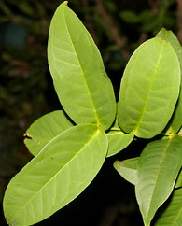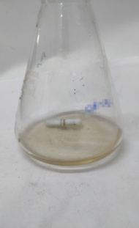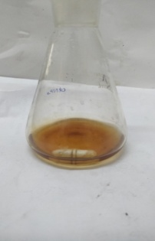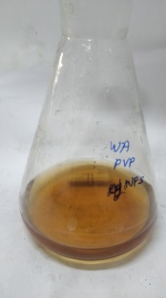

C

A

D

B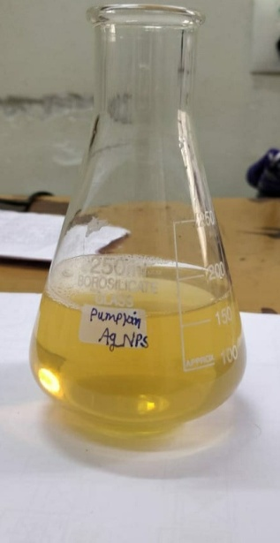

**Fig.6.3**[A] Plant Leaves of *Syzygium aqueum* , Colour change of Nanoparticles [B] At Initial time [C] After 1 hr formation of b-AgNPs [D] PVP-b-AgNPs

**6.3.2 UV-visible spectroscopy:**

The stabilizing agent method was followed by a reduction of Ag ions before the AgNPs were formed. For b-AgNPs, a 451nm band in the UV-visible spectrum was observed in the UV-visible spectrum **(Fig. 6.4 A, B, and C)**. This absorption band is due to the plasma resonance absorption of silver nanoparticles. Nanoparticles of Ag have a surface Plasmon peak of 400-500 nm**[79]**. In the synthesis of b-AgNPs, the leaf extract of *Syzygium aqueum* acts as a reducing-cum-surface capping agent.

Polymeric nanoparticles can be made in a variety of ways; depending on the application and the sort of medicine they are to contain**[80]**. These nanoparticles can be utilized in nanomedicine to encapsulate bioactive compounds. Polymer-based nanoparticles are preferred because of their ability to be used in medication delivery systems. These nanoparticles have properties such as controlled/sustained release, sub cellular size, and biocompatibility with tissues and cells**[81]**. The structural organization of nanoparticles separates them into two subgroups: nanocapsules and nanospheres**[82]**.

The surface was clearly visible in the UV-visible spectrum. The light brown colour is caused by the nanoparticles' plasmon resonance, which is encapsulated. b-AgNPs and PVP encapsulated b-AgNPs absorbance peaks range from 447 nm to 458 nm**[83]**. These findings are in line with earlier research in this area**[84]**. According to research, the SPR of most metallic compounds depends on their size and form**[85]**.



**Fig.6.4** UV –Visible Spectrum of [A] Plant Extract [B] b-AgNPs [C] PVP-b-AgNPs

**6.3.3 FTIR- Fourier transformed infrared spectroscopy:**

*Syzygium aqueum* leaf extract contains major metabolites such as vitamins, nucleic acids, proteins, and amino acids involved in the formation of b-AgNPs. In recent investigations, polysaccharides have been found to work as reducing and stabilizing agents**[86]**. When AgNPs were formed, proteins did not serve largely as reducing agents. According to certain research**[87]**, these macromolecules may play an important role in later stages of the creation of b-AgNPs, such as surface coating. Many secondary metabolites, including phenols, alkaloids, terpenoids, saponins, and so on, are effective reducing agents and can be used in all phases of b-AgNPs synthesis. FTIR spectroscopy shows the chemical behaviour of b-AgNPs and b-AgNPs encapsulated in other materials (FTIR). FTIR can also be used to determine the chemical structure of b-AgNPs and PVP-b-AgNPs. Functional groups in molecules can be identified using FTIR. Biomolecules that are involved in the creation of b-AgNPs and PVP-b-AgNPs can be studied using FTIR to discover which molecules are serving as coating or stabilizing agents**[88]**. The biomolecules responsible for the silver ions in *Syzygium aqueum* leaves aqueous extract and the capping agent that keeps biodegradable b-AgNPs stable were identified using FTIR measurements. b-AgNPs and PVP-b-AgNPs peaks were observed in the FTIR spectra **(Fig.6.5 A and B)** at 1089 cm-1, 1371 cm-1, 1632 cm-1, 2087 cm-1, 1450 cm-1, 646 cm-1, 565 cm-1, 3410 cm-1, 3138 cm-1, 1632 cm-1, 837 cm-1, while PVP-AgNPs peaks were recorded at 3402 cm-1, 3224 cm-1, 2079 cm-1, 2378 cm-1. In contrast to the biosynthesized AgNPs, the FTIR spectra of the pneumatic extract showed high peaks at 1089, 1361, 1632, 1637 cm-1 and lesser peaks at 2079, 2087, 1450, 1361, 646, 654, and 565 cm-1. Both AgNPs and PVP-AgNPs have the same C-H bonding vibrational peaks at 1371 and 1361 cm-1. The OH stretching of phenolic groups is associated with the conspicuous band attributed to 3410 and 3402 cm-1. The N-H stretching of amines was the primary cause of the 1371 and 1450 cm-1 peaks. Due to the presence of metal carbonyl stretching polymer, the bands at 1632 and 1632 cm-1 can be traced to C=O stretching **(Fig. 6.5)**. When the stretching vibrations associated with –OH and CH/CH2 groups are integrated with the aliphatic hydrocarbon group in polysachcharide, proteins, and poly phenols are molecules attached to the Ag surface, the presence of the peaks at 1632 and 1637 cm-1 was observed**[89-91]**. Analyzing the FTIR spectrum, researchers found that Ag+ ions could be reduced by the addition of oxygen and phenolic compounds could be oxidized by the addition of oxygen. b-AgNPs and polymer-capped b-AgNPs were both produced using an extract from *Syzygium aqueum* leaves as a reducing agent. The results are in line with previous studies on the topic**[92]**.

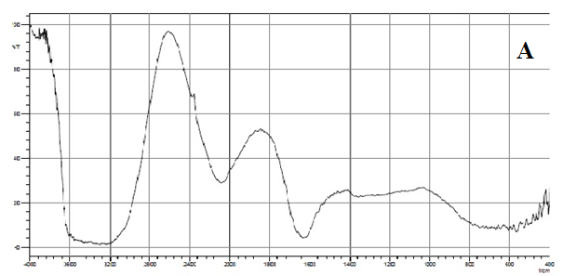

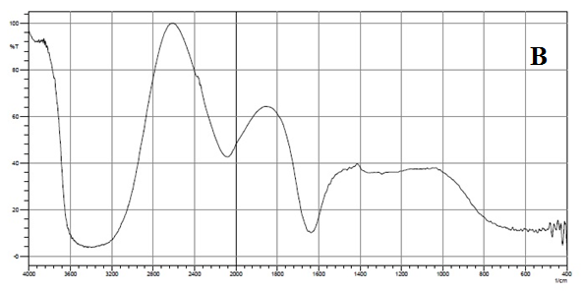

Fig. 6.5 FT- IR Spectrum of [A] AgNPs [B] PVP- AgNPs

**6.3.4 X- Ray diffraction**

Powder X-ray diffraction confirms the production of b-AgNPs and polymer-capped b-AgNPs (XRD). **Figure 6.6** shows the XRD patterns of b-AgNPs and polymeric b-AgNPs powder. Face-centered cubic (FCC) crystalline structure phase of silver is well-indexed by all diffraction peaks, which are in good accord with JCPDS file no.89-3722. At 27.740 (111), 32.170 (200), 38.090 (220), 36.2 (310), 46.23 (220), 77.410 (311), and 85.570 (322), indicative of significant diffraction peaks were detected, reflecting the FCC structure of silver. All of the peaks are in the same place, which is consistent with silver. The product's crystal structure may be seen in the XRD pattern, which has a strong peak**[93]**.

The bioconjugate between the polymer component and the formed polymer-capped b-AgNPs was modified by the PVP polymer in terms of phase change. The nearing of nanocrystal development is indicated by the significant reflection at (111)**[94]**. According to the Debye-Scherrer equation, the average crystal size of b-AgNPs generated in the bioreduction and PVP capped b-AgNPs is 17 nm.

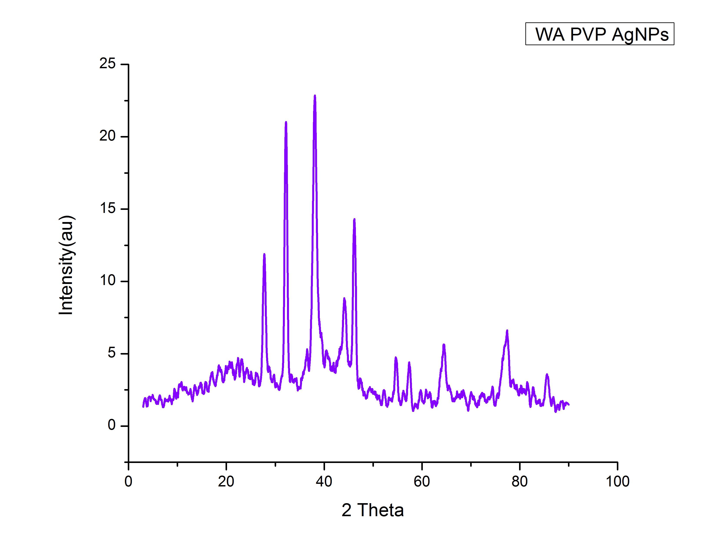

**Fig . 6.6** XRD pattern of PVP AgNPs

**6.3.5 HR-TEM Analysis**

High-resolution transmission electron microscopy (HR TEM) can all be determined using high-resolution transmission electron microscopy (HR TEM). TEM can be used to determine the precise size, shape, and morphology of produced silver nanoparticles **[95]**.

PVP-b-AgNPs that were produced in the range of 4 nm to 13 nm were captured in the high-resolution TEM picture (in line with XRD data). Spherical, well-spread, and homogeneous particles were discovered. Chemically reduced Ag ions were made zero-valent by coating them with biological molecules (extracted from *Syzygium aqueum* leaf extracts) that contain surface-bound hydroxyl groups. Particles appeared agglomerated as a result of this**[96]**.

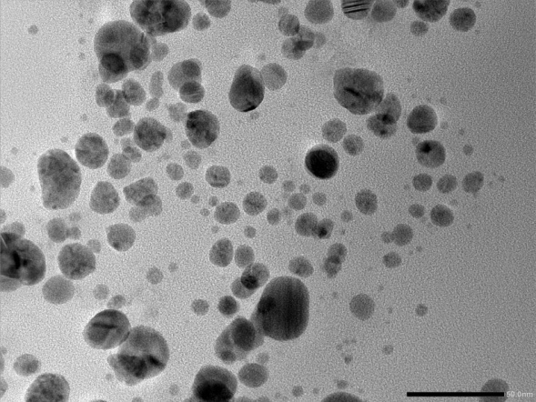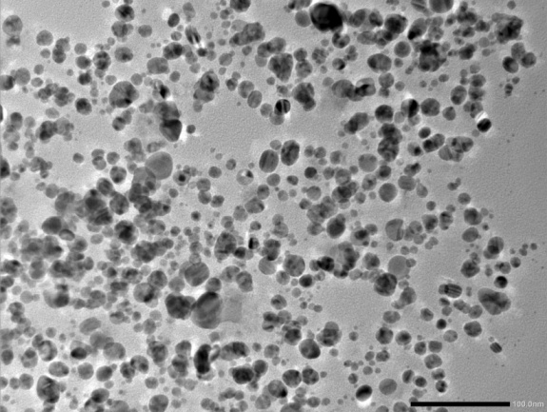

1. B.

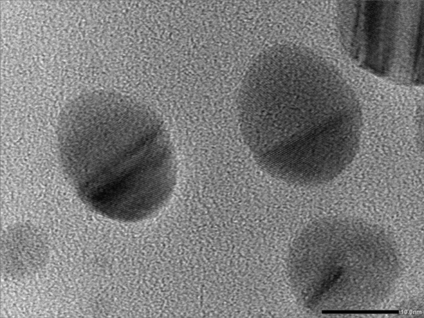

C.

**Fig. 6.7**  HR-TEM image of PVP- b-Ag NPs observed at 50 nm[A],100 nm[B],5 nm [C].

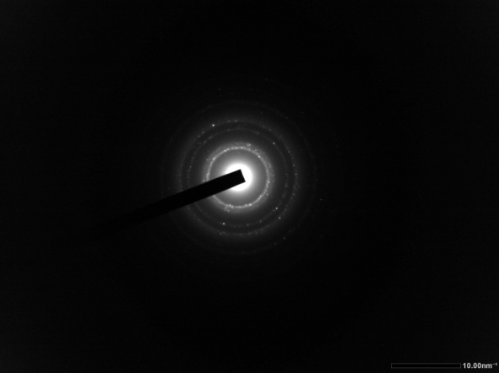

D.

**Fig. 6.7** [D] Selected area electron diffraction (SAED) pattern of PVP-b-AgNPs

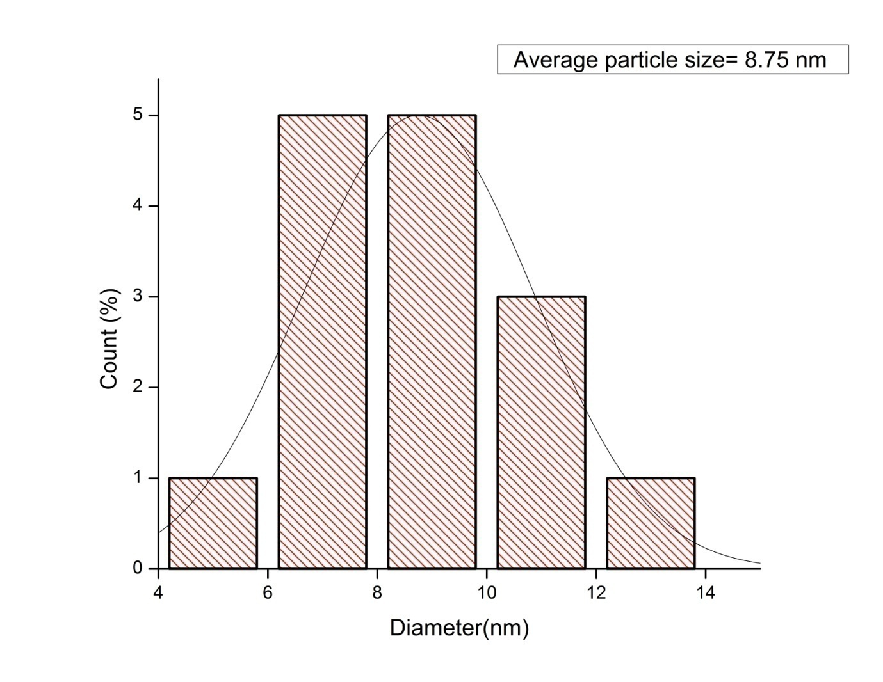

**Fig.6.8** The size distribution curves from the TEM analysis and SAED pattern of PVP functionalized b-AgNPs

The single plots in **Fig. 6.7** revealed ring patterns that were shown by the SAED pattern (D). The XRD findings are consistent with this conclusion. The TEM-derived curve for size distribution is shown in **Figure 6.8**. Particle sizes range from 8.75nm and above. Another factor that contributes to PVP–Ag nanoparticles size modification is *Syzygium aqueum* leaf extract polyphenolic compounds (components such as flavonoids and flavonols). As a result, a wide range of particle sizes are produced. Because of hydrogen interaction between hydroxide groups of diverse phenolic compounds, accumulations are produced**[97]**.

**6.3.6 Antimicrobial activity of b-AgNPs and polymeric capped b-AgNPs**

As illustrated, biogenic silver nanoparticles have proved their outstanding antibacterial activities in recent literature. Additionally, using water apple leaf extract and polymer capping, our study team created nanoparticles (19.37 nm) that were then tested on gram positive bacteria (*Salmonella typhi,E. coli*)) and gram negative bacteria (*Bacillus subtilis, Staphylococcus aureus*).

The antibacterial activity of AgNPs produced from water apple leaf extract, polymer-coated AgNPs, and extract was tested using a disc diffusion experiment in this study. The antibacterial activity of PVP-AgNPs (polymeric nanoparticles) was shown to be strong against all tested bacterial pathogens at a 100 µL concentration **(Fig. 6.9 A& B)**. Values in millimetres (mm) were obtained for the growth inhibition zones **(Table 6.1)**. As shown in table 1, the maximum zone of inhibition for *S. typhi* is around 20 mm. For*E.coli*,*B. subtilis* and *S. aureus*, the zone of inhibition was about 18 mm, 17 mm and 19 mm, respectively. It has been found that the suspension possesses antibacterial action against bacterial pathogens after it has been treated with AgNPs and PVP AgNPs nanoparticles. According to the findings, *S. typhi* was shown to be more sensitive than other pathogens. Antibacterial efficacy against gram-positive and gram-negative bacteria has long been shown with AgNPs**[98]**. As a result of the conformational changes induced by AgNPs on cell walls, which result in enhanced membrane permeability and thus bacterial cell death, PVP-AgNPs are more active**[99]**.

**Table : 6.1**

Antibacterial activity of plant extract, silver nanoparticles of *Syzygium aqueum* leaves and PVP capped silver nanoparticles.

|  |  |  |  |  |  |
| --- | --- | --- | --- | --- | --- |
| Test sample | Concentration  (In microliter) | Inhibition zone(in mm) | | | |
| *E.coli* | *Salmonella typhi* | *Bacillus subtilis* | *Staphylococcus aureus* |
| Plant extract | 100 | 15 | 18 | 15 | 15 |
| Peniciline | 100 | 13 | 16 | 14 | 16 |
| AgNPs | 100 | 17 | 18 | 16 | 18 |
| PVP-AgNPs | 100 | 18 | 20 | 17 | 19 |

Fig. 6.9A The assay of the minimum inhibition of PVP-b-AgNPs against the bacterial strains.

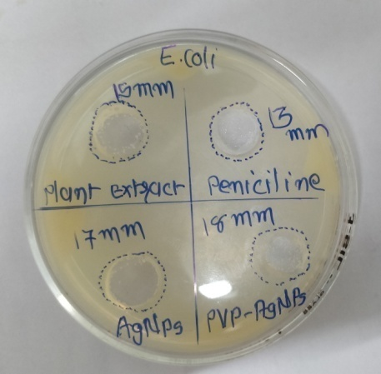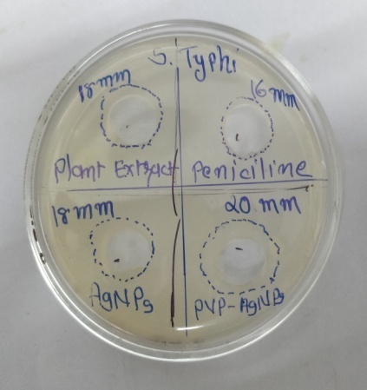

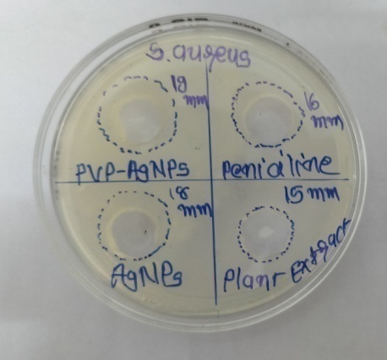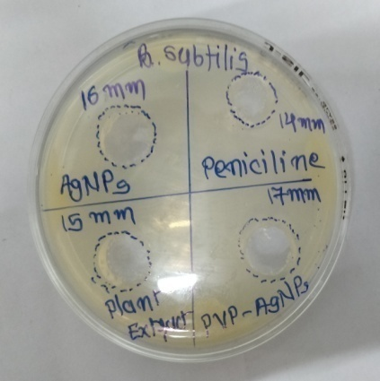

**Fig. 6.9B** Antimicrobial study of b-AgNPs And PVP-b-AgNPs against pathogenic bacteria

**6.3.7 Antioxidant properties of b-AgNPs and PVP Capping b-AgNPs**

**6.3.7.1 DPPH radical scavenging activity**

Antioxidants are known for their hydrogen-donating abilities, which allow them to scavenge DPPH. Different concentrations of b-AgNPs and PVP-capped b-AgNPs on DPPH radical scavenging activity are illustrated in **Fig. 10A**. "b-AgNPs and PVP-capped b-AgNPs have free radical scavenging properties that increase in concentration." PVP-capped b-AgNPs, on the other hand, exhibit a 52.94 percent increase in antioxidant activity at 120g/mL. In the same concentration, the standard ascorbic acid demonstrated 50.19 percent inhibition. activity of AgNPs, summarized before, allowed us to conduct our current research**[100]**.

Fig. 6.10 [A] DPPH radical scavenging activity

**6.3.7.2 Super oxide anion radical scavenging assay**

Because it is a precursor to more reactive oxygen species, the super oxide anion radical has a well-documented negative impact on living beings. It causes tissue necrosis and a wide range of illnesses, including cancer**[101]**. As can be seen in **Figure 10 B**, this study looked at the antioxidant activity of b-AgNPs, PVP-capped b-AgNPs, as well as Vitamin C. Antioxidant scavenging activity was 44.56 %, 46.32 %, and 45.41 % reduced by b-AgNPs and PVP-capped b-AgNPs at a concentration of 120 g/mL compared to Vitamin C's (45.41 percent). An increase in the concentration of nanoparticles resulted in an increase in the suppression of superoxide. b-AgNPs have been shown to have antioxidant-scavenging activities prior to this investigation **[102]**.

Fig.6.10 [B] Super oxide anion radical scavenging assay

**6.4 Conclusion:**

This study utilized organic components from *Syzygium aqueum* leaves as potential reducing and stabilizing agents for the production of AgNPs. In order to enhance the biocompatibility of b-AgNPs without the use of harmful or toxic compounds, they were functionalized with PVP. The generation of b-AgNPs and polymer b-AgNPs was confirmed using advanced characterization techniques (UV-vis, FTIR, HR-TEM, XRD). There were nano-sized b-AgNPs of 8 nm and 12 nm in the polymeric AgNPs that were synthesized and then tested.

The biomedical efficacy of the nanoparticles was evaluated using their antioxidant and antibacterial properties, respectively. It is possible that the biosynthesized b-AgNPs and PVP-capped b-AgNPs could be used as free radical scavengers in the treatment of various disorders, such as cancer. When compared to traditional antibacterial medications, PVP-b-AgNPs demonstrate greater action at lower concentrations against *E.Coli, B.subtilis, S.aureus,* and *S. typhi*, with greater sensitivity for *S. typhi* than for*E.Coli,S. aureus* and *B.subtilis*, according to our observations. Made PVP-b-AgNPs are a better choice for antibacterial drugs in the therapeutic biomedical field because they work well against infections.

**References:**

**[1].** Singh, T., Singh, A., Wang, W., Yadav, D., Kumar, A., & Singh, P. K. **(2019)**. Biosynthesized nanoparticles and its implications in agriculture. *Biological Synthesis of Nanoparticles and Their Applications*, 257-274.

**[2].**Klaus, T., Joerger, R., Olsson, E., & Granqvist, C. G. **(1999)**. Silver-based crystalline nanoparticles, microbially fabricated. *Proceedings of the National Academy of Sciences*, *96*(24), 13611-13614.

**[3].**Nair, B., & Pradeep, T. **(2002)**. Preparation of gold nanoparticles from Mirabilis jalapa flowers. *Cryst Growth Des*, *2*, 293-8.

**[4].**Zhang, H., Li, Q., Lu, Y., Sun, D., Lin, X., Deng, X., ... & Zheng, S. **(2005)**. Biosorption and bioreduction of diamine silver complex by Corynebacterium. *Journal of Chemical Technology & Biotechnology: International Research in Process, Environmental & Clean Technology*, *80*(3), 285-290.

**[5].**Mouxing, F. U., Qingbiao, L. I., Daohua, S. U. N., Yinghua, L. U., Ning, H. E., Xu, D. E. N. G., ... & Huang, J. **(2006)**. Rapid preparation process of silver nanoparticles by bioreduction and their characterizations. *Chinese Journal of Chemical Engineering*, *14*(1), 114-117.

**[6].** Mukherjee, P., Ahmad, A., Mandal, D., Senapati, S., Sainkar, S. R., Khan, M. I., ... & Sastry, M. **(2001)**. Fungus-mediated synthesis of silver nanoparticles and their immobilization in the mycelial matrix: a novel biological approach to nanoparticle synthesis. *Nano letters*, *1*(10), 515-519.

**[7].** P. Mukherjee, A. Ahmad, D. Mandal, S. Senapati, S.R. Sainkar, M.I. Khan, R. Ramani, R. Parischa, P.A.V. Kumar, M. Alam, M. Sastry, R. Kumar: Angew. Chem. Int. Ed. Vol. 40 **(2001)**, p.3585. <http://dx.doi.org/10.1002/1521-3773(20011001)40:19&lt;3585::AID> ANIE3585&gt;3.0.CO;2-K]

**[8].** Nath, D., & Banerjee, P. **(2013)**. Green nanotechnology–a new hope for medical biology. *Environmental toxicology and pharmacology*, *36*(3), 997-1014.

**[9].** Razavi, M., Salahinejad, E., Fahmy, M., Yazdimamaghani, M., Vashaee, D., & Tayebi, L. **(2015)**. Green chemical and biological synthesis of nanoparticles and their biomedical applications. *Green processes for nanotechnology*, 207-235.

**[10].** Singh, H., Du, J., Singh, P., & Yi, T. H. **(2018)**. Ecofriendly synthesis of silver and gold nanoparticles by Euphrasia officinalis leaf extract and its biomedical applications. *Artificial cells, nanomedicine, and biotechnology*, *46*(6), 1163-1170.

**[11]**. Sastry, M., Ahmad, A., Khan, M. I., & Kumar, R. **(2003)**. Biosynthesis of metal nanoparticles using fungi and actinomycete. *Current science*, 162-170.

**[12].** Pal, G., Rai, P., & Pandey, A. **(2019)**. Green synthesis of nanoparticles: A greener approach for a cleaner future. In *Green synthesis, characterization and applications of nanoparticles* (pp. 1-26). Elsevier.

**[13].** Green synthesis of nanoparticles using plant extracts: a review Sapana Jadoun1 · Rizwan Arif1 · Nirmala Kumari Jangid2 · Rajesh Kumar Meena3 Received: 19 July 2020 / Accepted: 6 August 2020 © Springer Nature Switzerland AG (2020)]

**[14].** Manjare, S. B., & Chaudhari, R. A. **(2020)**. Palladium nanoparticle-bentonite hybrid using leaves of Syzygium aqueum plant from India: Design and assessment in the catalysis of–C–C–coupling reaction. *Chemistry Africa*, *3*(2), 329-341.

**[15].** Nair, A. G. R., Krishnan, S., Ravikrishna, C., & Madhusudanan, K. P. **(1999)**. New and rare flavonol glycosides from leaves of Syzygium samarangense. *Fitoterapia*, *70*(2), 148-151.

**[16].** Wrigley, J. W., & Fagg, M. **(2013)**. *Australian native plants: cultivation, use in landscaping and propagation*. Reed New Holland.

**[17].** Saxena, M. S. J., Nema R., Sigh, D., and Gupta, A.**(2013)**. *Phytochemsitry of Medical Plants. Journal of Pharmacy and Phytochemistry*, *1*(6), 168-182.

**[18].** Chikezie, P. C., Ibegbulem, C. O., & Mbagwu, F. N. **(2015)**. Bioactive principles from medicinal plants. *Research Journal of Phytochemistry*, *9*(3), 88-115.

**[19].**Mandal, S., & Mandal, M. **(2015)**. Coriander (Coriandrum sativum L.) essential oil: Chemistry and biological activity. *Asian Pacific Journal of Tropical Biomedicine*, *5*(6), 421-428.

**[20].** Nadeem, M., Abbasi, B. H., Younas, M., Ahmad, W., & Khan, T. **(2017)**. A review of the green syntheses and anti-microbial applications of gold nanoparticles. *Green Chemistry Letters and Reviews*, *10*(4), 216-227.

**[21].** Sheela, D., & Cheenickal, M. **(2017)**. Total Phenolics and Flavonoids among The Selected Species of Syzygium, Gaertn. *Research Journal of Pharmacognosy and Phytochemistry*, *9*(2), 101-104.

**[22].** Sobeh, M., Esmat, A., Petruk, G., Abdelfattah, M. A., Dmirieh, M., Monti, D. M., ... & Wink, M. **(2018)**. Phenolic compounds from Syzygium jambos (Myrtaceae) exhibit distinct antioxidant and hepatoprotective activities in vivo. *Journal of Functional Foods*, *41*, 223-231.

**[23].** Sobeh, M., Youssef, F. S., Esmat, A., Petruk, G., El-Khatib, A. H., Monti, D. M., ... & Wink, M. **(2018)**. High resolution UPLC-MS/MS profiling of polyphenolics in the methanol extract of Syzygium samarangense leaves and its hepatoprotective activity in rats with CCl4-induced hepatic damage. *Food and Chemical Toxicology*, *113*, 145-153.

**[24].** Sobeh, M., Mahmoud, M. F., Petruk, G., Rezq, S., Ashour, M. L., Youssef, F. S., ... & Wink, M. **(2018)**. Syzygium aqueum: A polyphenol-rich leaf extract exhibits antioxidant, hepatoprotective, pain-killing and anti-inflammatory activities in animal models. *Frontiers in pharmacology*, *9*, 566.

**[25].** NONAKA, G. I., AiKo, Y., ARITAKE, K., & NISHIOKA, I. **(1992)**. Tannins and related compounds. CXIX. Samarangenins a and b, novel proanthocyanidins with doubly bonded structures, from Syzygium samarangens and S. aqueum. *Chemical and pharmaceutical bulletin*, *40*(10), 2671-2673.

**[26].** Manaharan, T., Appleton, D., Cheng, H. M., & Palanisamy, U. D. **(2012)**. Flavonoids isolated from Syzygium aqueum leaf extract as potential antihyperglycaemic agents. *Food chemistry*, *132*(4), 1802-1807.

**[27].** Firdaus, M. L., Fitriani, I., Wyantuti, S., Hartati, Y. W., Khaydarov, R., Mcalister, J. A., ... & Gamo, T. **(2017)**. Colorimetric detection of mercury (II) ion in aqueous solution using silver nanoparticles. *Analytical Sciences*, *33*(7), 831-837.

**[28].**Bhatt, K. D., Vyas, D. J., Makwana, B. A., Darjee, S. M., & Jain, V. K. **(2014)**. Highly stable water dispersible calix [4] pyrrole octa-hydrazide protected gold nanoparticles as colorimetric and fluorometric chemosensors for selective signaling of Co (II) ions. *Spectrochimica Acta Part A: Molecular and Biomolecular Spectroscopy*, *121*, 94-100.

**[29].** A. Nouailhat, “Introduction to Nanotechnology”, **(2008)**, Wiley, New York.

**[30].**Vahabi, K., & Dorcheh, S. K. **(2014)**. Biosynthesis of silver nano-particles by Trichoderma and its medical applications. In *Biotechnology and biology of Trichoderma* (pp. 393-404). Elsevier.

**[31].**Huang, J. T., Yang, X. X., Zeng, Q. L., & Wang, J. **(2013)**. A simple green route to prepare stable silver nanoparticles with pear juice and a new selective colorimetric method for detection of cysteine. *Analyst*, *138*(18), 5296-5302.

**[32].**Lin, X., Rong, F., Fu, D., & Yuan, C. **(2012)**. Enhanced photocatalytic activity of fluorine doped TiO2 by loaded with Ag for degradation of organic pollutants. *Powder technology*, *219*, 173-178.

**[33].**Navaladian, S., Viswanathan, B., Viswanath, R. P., & Varadarajan, T. K. **(2007).** Thermal decomposition as route for silver nanoparticles. *Nanoscale research letters*, *2*(1), 44-48.

**[34].**Rodriguez-Sanchez, L., Blanco, M. C., & López-Quintela, M. A. **(2000).** Electrochemical synthesis of silver nanoparticles. *The Journal of Physical Chemistry B*, *104*(41), 9683-9688.

**[35].**Lin, L., Wang, W., Huang, J., Li, Q., Sun, D., Yang, X., ... & Wang, Y. **(2010)**. Nature factory of silver nanowires: Plant-mediated synthesis using broth of Cassia fistula leaf. *Chemical Engineering Journal*, *162*(2), 852-858.

**[36].**Du, M., Zhan, G., Yang, X., Wang, H., Lin, W., Zhou, Y., ... & Li, Q. **(2011)**. Ionic liquid-enhanced immobilization of biosynthesized Au nanoparticles on TS-1 toward efficient catalysts for propylene epoxidation. *Journal of catalysis*, *283*(2), 192-201.

**[37].**Mukunthan, K. S., Elumalai, E. K., Patel, T. N., & Murty, V. R. **(2011)**. Catharanthus roseus: a natural source for the synthesis of silver nanoparticles. *Asian pacific journal of tropical biomedicine*, *1*(4), 270-274.

**[38].**Yilmaz, M., Turkdemir, H., Kilic, M. A., Bayram, E., Cicek, A., Mete, A., & Ulug, B. **(2011)**. Biosynthesis of silver nanoparticles using leaves of Stevia rebaudiana. *Materials Chemistry and Physics*, *130*(3), 1195-1202.

**[39].**Wu, X., Song, Q., Jia, L., Li, Q., Yang, C., & Lin, L. **(2012)**. Pd-Gardenia-TiO2 as a photocatalyst for H2 evolution from pure water. *International Journal of Hydrogen Energy*, *37*(1), 109-114.

**[40].**Jia, L., Zhang, Q., Li, Q., & Song, H. **(2009)**. The biosynthesis of palladium nanoparticles by antioxidants in Gardenia jasminoides Ellis: long lifetime nanocatalysts for p-nitrotoluene hydrogenation. *Nanotechnology*, *20*(38), 385601.

**[41]**. Sastry, M., Ahmad, A., Khan, M. I., & Kumar, R. **(2003)**. Biosynthesis of metal nanoparticles using fungi and actinomycete. *Current science*, 162-170.

**[42]**. Morones JR, Elechiguerra JL, Camacho A, Holt K, Kouri JB, Ramirez JT, Yacaman MJ. The bactericidal effect of silver nanoparticles. Nanotechnol., **(2005)**, 16: 2346-2353.

**[43]**. Lansdown, A. B. G., & Williams, A. **(2007)**. Bacterial resistance to silver in wound care and medical devices. *Journal of wound care*, *16*(1), 15-19.

**[44].**Philip, D. **(2010)**. Green synthesis of gold and silver nanoparticles using Hibiscus rosa sinensis. *Physica E: Low-Dimensional Systems and Nanostructures*, *42*(5), 1417-1424.

**[45].**Ahamed, M., AlSalhi, M. S., & Siddiqui, M. K. J. **(2010)**. Silver nanoparticle applications and human health. *Clinica chimica acta*, *411*(23-24), 1841-1848.

**[46].**Bonde, S. **(2011)**. A biogenic approach for green synthesis of silver nanoparticles using extract of Foeniculum vulgare and its activity against Staphylococcus aureus and Escherichia coli. *Nusantara Bioscience*, *3*(2).

**[47].** Carolin, C. F., Kumar, P. S., Saravanan, A., Joshiba, G. J., & Naushad, M. **(2017)**. Efficient techniques for the removal of toxic heavy metals from aquatic environment: A review. *Journal of environmental chemical engineering*, *5*(3), 2782-2799.

**[48].** Singh, J., Dutta, T., Kim, K. H., Rawat, M., Samddar, P., & Kumar, P. **(2018)**. ‘Green’synthesis of metals and their oxide nanoparticles: applications for environmental remediation. *Journal of nanobiotechnology*, *16*(1), 1-24.

**[49].** Ovais, M., Khalil, A. T., Islam, N. U., Ahmad, I., Ayaz, M., Saravanan, M., ... & Mukherjee, S. **(2018)**. Role of plant phytochemicals and microbial enzymes in biosynthesis of metallic nanoparticles. *Applied microbiology and biotechnology*, *102*(16), 6799-6814.

**[50].** Wang, Y., O'Connor, D., Shen, Z., Lo, I. M., Tsang, D. C., Pehkonen, S., ... & Hou, D. **(2019)**. Green synthesis of nanoparticles for the remediation of contaminated waters and soils: Constituents, synthesizing methods, and influencing factors. *Journal of Cleaner Production*, *226*, 540-549.

**[51].**Chaudhari, P. R., Masurkar, S. A., Shidore, V. B., & Kamble, S. P. **(2012)**. Biosynthesis of silver nanoparticles using Saccharum officinarum and its antimicrobial activity. *Micro & Nano Letters*, *7*(7), 646-650.

**[52].**Dubchak, S., Ogar, A., Mietelski, J. W., & Turnau, K. **(2010)**. Influence of silver and titanium nanoparticles on arbuscular mycorrhiza colonization and accumulation of radiocaesium in Helianthus annuus. *Spanish Journal of Agricultural Research*, (1), 103-108.

**[53].**Huang, J., Lin, L., Li, Q., Sun, D., Wang, Y., Lu, Y., ... & Lin, W. **(2008)**. Continuous-flow biosynthesis of silver nanoparticles by lixivium of sundried Cinnamomum camphora leaf in tubular microreactors. *Industrial & engineering chemistry research*, *47*(16), 6081-6090.

**[54].**Dar, P., Waqas, U., Hina, A., Anwar, J., Dar, A., Khan, Z., & Shafqat, T. **(2016)**. DBiogenic Synthesis, Characterization of Silver Nanoparticles Using Multani mitti (Fullers Earth), Tomato (Solanum lycopersicum) seeds, Rice Husk (Oryza sativa) and Evaluation of their Potential Antimicrobial Activity. *Journal of the Chemical Society of Pakistan*, *38*(4).

**[55].**Chandran, S. P., Chaudhary, M., Pasricha, R., Ahmad, A., & Sastry, M. **(2006)**. Synthesis of gold nanotriangles and silver nanoparticles using Aloevera plant extract. *Biotechnology progress*, *22*(2), 577-583.

**[56].**Li, S., Shen, Y., Xie, A., Yu, X., Qiu, L., Zhang, L., & Zhang, Q. **(2007)**. Green synthesis of silver nanoparticles using Capsicum annuum L. extract. *Green Chemistry*, *9*(8), 852-858.

**[57]**. Lukman, A. I., Gong, B., Marjo, C. E., Roessner, U., & Harris, A. T. **(2011)**. Facile synthesis, stabilization, and anti-bacterial performance of discrete Ag nanoparticles using Medicago sativa seed exudates. *Journal of colloid and interface science*, *353*(2), 433-444.

**[58].**Rajkumar, T., Sapi, A., Das, G., Debnath, T., Ansari, A., & Patra, J. K. **(2019)**. Biosynthesis of silver nanoparticle using extract of Zea mays (corn flour) and investigation of its cytotoxicity effect and radical scavenging potential. *Journal of Photochemistry and Photobiology B: Biology*, *193*, 1-7.

**[59].**Lee, S. H., Salunke, B. K., & Kim, B. S. **(2014)**. Sucrose density gradient centrifugation separation of gold and silver nanoparticles synthesized using Magnolia kobus plant leaf extracts. *Biotechnology and bioprocess engineering*, *19*(1), 169-174.

**[60].** SALPRIMA, Y. S., Falahudin, A., Meka, S. P., Gustian, I., & Ikram, S. **(2017)**. Melastoma malabathricum Fruit Extract-Mediated Synthesis of Silver Nanoparticles with Sensing Ability for High Concentrations of Mercury (II) Nitrate. *The Journal of Pure and Applied Chemistry Research*, *6*(3), 261.

**[61].** Mitiku, A. A., & Yilma, B. **(2017)**. Antibacterial and antioxidant activity of silver nanoparticles synthesized using aqueous extract of Moringa stenopetala leaves. *African Journal of Biotechnology*, *16*(32), 1705-1716.

**[62].** Haghighi Pak, Z., Abbaspour, H., Karimi, N., & Fattahi, A. **(2016)**. Eco-friendly synthesis and antimicrobial activity of silver nanoparticles using Dracocephalum moldavica seed extract. *Applied sciences*, *6*(3), 69.

**[63].** Zhang, X. F., Liu, Z. G., Shen, W., & Gurunathan, S. **(2016)**. Silver nanoparticles: synthesis, characterization, properties, applications, and therapeutic approaches. *International journal of molecular sciences*, *17*(9), 1534.

**[64].** Firdaus, M. L., Fitriani, I., Wyantuti, S., Hartati, Y. W., Khaydarov, R., Mcalister, J. A., ... & Gamo, T. **(2017)**. Colorimetric detection of mercury (II) ion in aqueous solution using silver nanoparticles. *Analytical Sciences*, *33*(7), 831-837.

**[65].** Functionalized Silver Nanoparticles as Colorimetric and Fluorimetric Sensor for Environmentally Toxic Mercury Ions: An Overview Nandan C. Pomal1 & Keyur D. Bhatt1 & Krunal M. Modi1 & Ajay L. Desai1 & Nihal P. Patel1 & Anita Kongor2 & Viliam Kolivoška3 Received: 4 January 2021 /Accepted: 10 February 2021]

**[66].** Sharma, V. K., Yngard, R. A., & Lin, Y. **(2009)**. Silver nanoparticles: green synthesis and their antimicrobial activities. *Advances in colloid and interface science*, *145*(1-2), 83-96.

**[67].** Balasurya, S., Syed, A., Thomas, A. M., Marraiki, N., Elgorban, A. M., Raju, L. L., ... & Khan, S. S. **(2020)**. Rapid colorimetric detection of mercury using silver nanoparticles in the presence of methionine. *Spectrochimica Acta Part A: Molecular and Biomolecular Spectroscopy*, *228*, 117712.

**[68]**. Teodorescu, M., & Bercea, M. **(2015)**. Poly (vinylpyrrolidone)–a versatile polymer for biomedical and beyond medical applications. *Polymer-Plastics Technology and Engineering*, *54*(9), 923-943.

**[69]**. Okoroh, D. O., Ozuomba, J. O., Aisida, S. O., & Asogwa, P. U. **(2019)**. Properties of zinc ferrite nanoparticles due to PVP mediation and annealing at 500 C. *Advances in nanoparticles*, *8*(02), 36.

**[70]**. Goodarz Naseri, M., Saion, E., & Khalil Zadeh, N. **(2013)**. The amazing effects and role of PVP on the crystallinity, phase composition and morphology of nickel ferrite nanoparticles prepared by thermal treatment method. *International nano letters*, *3*(1), 1-8.

**[71]**. Pandey, G., Singh, S., & Hitkari, G. **(2018)**. Synthesis and characterization of polyvinyl pyrrolidone (PVP)-coated Fe3O4 nanoparticles by chemical co-precipitation method and removal of Congo red dye by adsorption process. *International Nano Letters*, *8*(2), 111-121.

**[72]**. Ahlberg, S., Antonopulos, A., Diendorf, J., Dringen, R., Epple, M., Flöck, R., ... & Zellner, R. **(2014)**. PVP-coated, negatively charged silver nanoparticles: A multi-center study of their physicochemical characteristics, cell culture and in vivo experiments. *Beilstein journal of nanotechnology*, *5*(1), 1944-1965.

**[73].**HAMED, A. A. R., & MUSTAFA, S. E. **(2018)**. Extraction and assessment of pectin from pumpkin peels. *Asian Journal of Natural Product Biochemistry*, *16*(1), 1-7.

# [74]. N.M.Zain,AStpley. G.Sharma.CarbohydratePolymer . 112(2014) 195 – 202.Green synthesis of silver and copper nanoparticles using ascorbic acid and chitosan for antimicrobial applications

# [75].Bhakya, S., Muthukrishnan, S., Sukumaran, M., & Muthukumar, M. (2016). Biogenic synthesis of silver nanoparticles and their antioxidant and antibacterial activity. *Applied Nanoscience*, *6*(5), 755-766.

**[76].** Harsh Mistry .RashmiThakor .ChiragPatil .JitendraTrivedi .HimanshuBariya, **(2021)**Biogenically proficient synthesis and characterization of silver nanoparticles employing [marine procured fungi Aspergillusbrunneoviolaceus along with their antibacterial and antioxidative potency, BiotechnolLett ,https://doi.org/10.1007/s10529-020-03008-7.**43**, pages307–316

**[77].** Ismail, G. A., El-Sheekh, M. M., Samy, R. M., & Gheda, S. F. **(2021)**. Antimicrobial, antioxidant, and antiviral activities of biosynthesized silver nanoparticles by phycobiliprotein crude extract of the cyanobacteria Spirulina platensis and Nostoc linckia. *Bionanoscience*, *11*(2), 355-370.

**[78].**Iyer, R. I., & Panda, T. **(2018)**. Biosynthesis of gold and silver nanoparticles using extracts of callus cultures of pumpkin (Cucurbita maxima). *Journal of nanoscience and nanotechnology*, *18*(8), 5341-5353.

**[79].**Kumara Swamy, M., Sudipta, K. M., Jayanta, K., & Balasubramanya, S. **(2015)**. The green synthesis, characterization, and evaluation of the biological activities of silver nanoparticles synthesized from Leptadenia reticulata leaf extract. *Applied nanoscience*, *5*(1), 73-81.

**[80].**Wu, T., Lu, F., Wen, Q., Yu, K., Lu, B., Rong, B., ... & Lan, G. **(2018)**. Novel strategy for obtaining uniformly dispersed silver nanoparticles on soluble cotton wound dressing through carboxymethylation and in-situ reduction: antimicrobial activity and histological assessment in animal model. *Cellulose*, *25*(9), 5361-5376.

**[81].**Reis, C. P., Neufeld, R. J., Ribeiro, A. J., & Veiga, F. **(2006)**. Nanoencapsulation I. Methods for preparation of drug-loaded polymeric nanoparticles. *Nanomedicine: Nanotechnology, Biology and Medicine*, *2*(1), 8-21.

**[82].**Panyam, J., & Labhasetwar, V. **(2003)**. Biodegradable nanoparticles for drug and gene delivery to cells and tissue. *Advanced drug delivery reviews*, *55*(3), 329-347.

**[83].**Tiyaboonchai, W. **(2013)**. Chitosan nanoparticles: a promising system for drug delivery. *Naresuan University Journal: Science and Technology (NUJST)*, *11*(3), 51-66.

**[84].**Ashraf, J. M., Ansari, M. A., Khan, H. M., Alzohairy, M. A., & Choi, I. **(2016).** Green synthesis of silver nanoparticles and characterization of their inhibitory effects on AGEs formation using biophysical techniques. *Scientific reports*, *6*(1), 1-10.

**[85].** Behravan, M., Panahi, A. H., Naghizadeh, A., Ziaee, M., Mahdavi, R., & Mirzapour, A. **(2019)**. Facile green synthesis of silver nanoparticles using Berberis vulgaris leaf and root aqueous extract and its antibacterial activity. *International journal of biological macromolecules*, *124*, 148-154.

**[86].**Soylu, E., Soylu, S., & Kurt, S. **(2006)**. Antimicrobial activities of the essential oils of various plants against tomato late blight disease agent Phytophthora infestans. *Mycopathologia*, *161*(2), 119-128.

**[87].**Venkatpurwar, V., & Pokharkar, V. **(2011)**. Green synthesis of silver nanoparticles using marine polysaccharide: study of in-vitro antibacterial activity. *Materials Letters*, *65*(6), 999-1002.

**[88].**Mo, Y. Y., Tang, Y. K., Wang, S. Y., Lin, J. M., Zhang, H. B., & Luo, D. Y. **(2015)**. Green synthesis of silver nanoparticles using eucalyptus leaf extract. *Materials Letters*, *144*, 165-167.

**[89].**Rivera-Rangel, R. D., González-Muñoz, M. P., Avila-Rodriguez, M., Razo-Lazcano, T. A., & Solans, C. **(2018)**. Green synthesis of silver nanoparticles in oil-in-water microemulsion and nano-emulsion using geranium leaf aqueous extract as a reducing agent. *Colloids and Surfaces A: Physicochemical and Engineering Aspects*, *536*, 60-67.

**[90].** Philip, D. **(2011)**. Mangifera indica leaf-assisted biosynthesis of well-dispersed silver nanoparticles. *Spectrochimica Acta Part A: Molecular and Biomolecular Spectroscopy*, *78*(1), 327-331.

**[91].**Barua, S., Konwarh, R., Bhattacharya, S. S., Das, P., Devi, K. S. P., Maiti, T. K., ... & Karak, N. **(2013)**. Non-hazardous anticancerous and antibacterial colloidal ‘green’silver nanoparticles. *Colloids and Surfaces B: Biointerfaces*, *105*, 37-42.

**[92].**Mittal, A. K., Bhaumik, J., Kumar, S., & Banerjee, U. C. **(2014)**. Biosynthesis of silver nanoparticles: elucidation of prospective mechanism and therapeutic potential. *Journal of colloid and interface science*, *415*, 39-47.

**[93].**Rolim, W. R., Pelegrino, M. T., de Araújo Lima, B., Ferraz, L. S., Costa, F. N., Bernardes, J. S., ... & Seabra, A. B. **(2019)**. Green tea extract mediated biogenic synthesis of silver nanoparticles: Characterization, cytotoxicity evaluation and antibacterial activity. *Applied Surface Science*, *463*, 66-74.

**[94].**Wang, T., Jin, X., Chen, Z., Megharaj, M., & Naidu, R. **(2014)**. Green synthesis of Fe nanoparticles using eucalyptus leaf extracts for treatment of eutrophic wastewater. *Science of the total environment*, *466*, 210-213.

**[95].**Jain, N., Bhargava, A., Majumdar, S., Tarafdar, J. C., & Panwar, J. **(2011)**. Extracellular biosynthesis and characterization of silver nanoparticles using Aspergillus flavus NJP08: a mechanism perspective. *Nanoscale*, *3*(2), 635-641.

**[96].** B. Kumar , K. Smita , et al. , in: S. Ranjan, et al. (Eds.), **(2016)**Nanoscience in Food and Agriculture 2,Sustainable Agriculture Reviews, Volume 2, chapter 7 Springer International Publishin, Switzerland, , pp. 235–252. chapter 7 .

**[97].**Dibrov, P., Dzioba, J., Gosink, K. K., & Häse, C. C. **(2002)**. Chemiosmotic mechanism of antimicrobial activity of Ag+ in Vibrio cholerae. *Antimicrobial agents and chemotherapy*, *46*(8), 2668-2670.

**[98].**Kumar, B., Smita, K., & Cumbal, L. **(2016)**. Biosynthesis of silver nanoparticles using lavender leaf and their applications for catalytic, sensing, and antioxidant activities. *Nanotechnology Reviews*, *5*(6), 521-528.

**[99].**Nordberg, J., & Arnér, E. S. **(2001)**. Reactive oxygen species, antioxidants, and the mammalian thioredoxin system. *Free radical biology and medicine*, *31*(11), 1287-1312.

**[100].**Ramamurthy, C. H., & Padma, M. **(2013)**. mariya samadanam ID, Mareeswaran R, Suyavaran A, Kumar MS, et al. The extr a cellular synthesis of gold and silver nanoparticles an d their free radical scavenging and antibacterial properties. *Colloids and Surfaces B: Biointerfaces*, *102*, 808-15.

**[101].**Esmaeili, M. A., & Sonboli, A. **(2010)**. Antioxidant, free radical scavenging activities of Salvia brachyantha and its protective effect against oxidative cardiac cell injury. *Food and Chemical Toxicology*, *48*(3), 846-853.

**[102].**Liu, J., Jia, L., Kan, J., & Jin, C. H. **(2013)**. In vitro and in vivo antioxidant activity of ethanolic extract of white button mushroom (Agaricus bisporus). *Food and chemical toxicology*, *51*, 310-316.