An Overview of Circular Economy with an Emphasis on the Basel and Hong Kong Conventions of the IMO-Sustainability Approach

- Dr. A. Mathiazhagan, Professor, Department of Ship Technology, Cochin University of Science and Technology
- Mr. Aravind K.R, Assistant Professor, Department of Ship Technology, Cochin University of Science and Technology

Abstract:
The circular economy aims to change the paradigm in relation to the linear economy, by limiting the environmental impact and waste of resources, as well as increasing efficiency at all stages of the product economy. There an urgent need to redesign our extractive economy. The circular economy is a model of production and consumption, which involves sharing, leasing, reusing, repairing, refurbishing and recycling existing materials and products as long as possible. In this way, the life cycle of products is extended. Reusing and recycling products would slow down the use of natural resources, reduce landscape and habitat disruption and help to limit biodiversity loss. This paper provides a comprehensive overview of Sustainable Materials Management (SMM) through the lens of the Circular Economy (CE) paradigm, with a particular focus on the Basel and Hong Kong Conventions established by the International Maritime Organization (IMO). The paper highlights the significance of the circular economy in the marine industry and its role in addressing the challenges of waste management and resource depletion. It explores the principles of the circular economy, the relevance of the Basel and Hong Kong Conventions, and their contributions to achieving sustainable materials management in the maritime sector.

Keywords: Circular Economy; Sustainability, Sustainable Development, Life cycle model, Business strategy.

1. Introduction:
The circular economy is a system where materials never become waste and nature is regenerated. In a circular economy, products and materials are kept in circulation through processes like maintenance, reuse, refurbishment, remanufacture, recycling, and composting. The circular economy tackles climate change and other global challenges, like biodiversity loss, waste, and pollution, by decoupling economic activity from the consumption of finite resources. In our current economy, we take materials from the Earth, make products from them, and eventually throw them away as waste – the process is linear. In a circular economy, by contrast, we stop waste being produced in the first place. The circular economy includes products, infrastructure, equipment and services, and applies to every industry sector. It includes 'technical' resources (metals, minerals, fossil resources) and 'biological' resources (food, fibres, timber, etc.) Most schools of thought advocate a shift from fossil fuels to the use of renewable energy, and emphasize the role of diversity as a characteristic of resilient and sustainable systems. The maritime industry, being an essential global trade facilitator, faces unique challenges in waste management and resource conservation. The Basel and Hong Kong Conventions, established by the International Maritime Organization (IMO), play a pivotal role in regulating waste management at sea. This paper aims to provide an overview of sustainable materials management through the circular economy framework, with a specific focus on the marine industry and the IMO conventions.

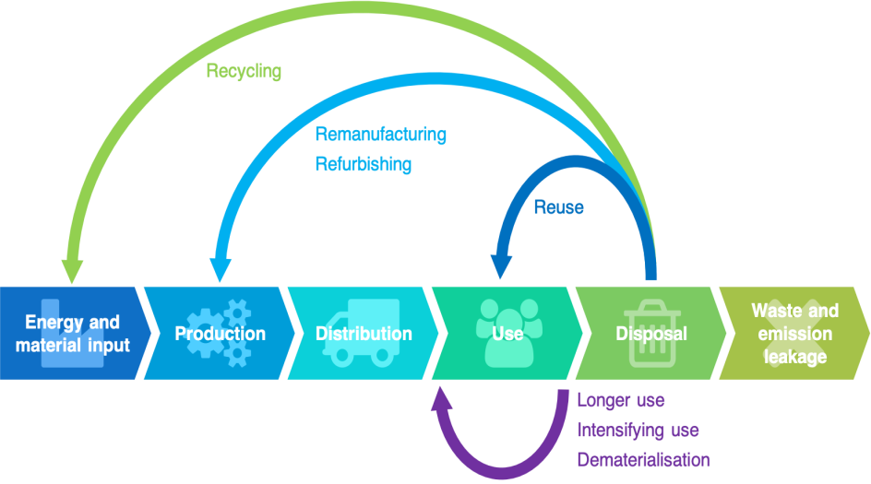

Fig. 1 Circular Economy Model (Source: ref.1)

2. Materials Life Cycle Model.

- Raw materials are first extracted from natural earthy resources through drilling ,mining, etc.
- Later-on these are subjected to purification, refining to convert them into metals, ceramics, rubber, fuel, etc.
- These primary products are further processed to obtain engineered materials like metallic alloy, glass, plastics, semi-conductors, etc.
- Now the engineered materials are shaped and heat treated to make components that are assembled into products and devices that are ready for use by society.
- During the service, products become old, outdated, break down, or may not serve the purpose efficiently. So, they are discarded. This completes the lifecycle.

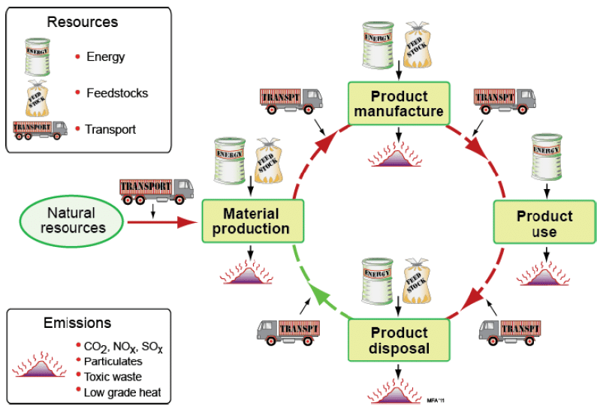

Fig.2 Life Cycle model of Materials(Source: ref.2)

Circular economy often refers to quantities of recycled materials or reduced waste, however Cradle to Cradle Design focuses on quality of products including safety for humans and environmental health. Popularized by the book Cradle to Cradle: Remaking The Way We Make Things, Cradle to Cradle Design has been widely implemented by architect William McDonough, who was introduced as the "father of the circular economy" while receiving the 2017 Fortune Award for Circular Economy Leadership in Davos during the World Economic Forum(3).The material life-cycle: material creation, product manufacture, product use, and a number of options for product disposal at the end of life. Transport is involved between the stages.

UN Environment’s Global Resources Outlook 2019, prepared by the International Resource Panel, examines the trends in natural resources and their corresponding consumption patterns since the 1970s. Its main findings are as per the below:
- The extraction and processing of materials, fuels and food contribute half of total global greenhouse gas emissions and over 90 per cent of biodiversity loss and water stress.
- Resource extraction has more than tripled since 1970, including a fivefold increase in the use of non-metallic minerals and a 45 per cent increase in fossil fuel use.
- By 2060, global material use could double to 190 billion tonnes (from 92 billion), while greenhouse gas emissions could increase by 43 per cent.
Now more than ever, unprecedented and urgent action is required by all nations” to reduce global warming, says UN Environment’s Emissions Gap Report 2018(4). “To bridge the 2030 emissions gap and ensure long-term decarbonisation, countries must also enhance their mitigation ambitions. Defined by the principles of eliminating waste, circulating materials, and regenerating nature, the circular economy proposes a new framework to move towards a resilient system that is good for business, people, and the environment. Momentum around the circular economy is evident, and has never been greater, with businesses and world leaders starting to take steps to eliminate waste and pollution, circulate products and materials, and regenerate nature. Even so, the symptoms of our linear economy are being felt, and planetary thresholds are being met sooner than we’d imagined. There’s an urgent need to move from ambition to action to see positive impact but at an accelerated pace. A change of this magnitude cannot happen without design.

3. Levels of circularity ("R" models)
In the 2010s, several models of a circular economy were developed that employed a set of steps, or levels of circularity, typically using English verbs or nouns starting with the letter "r". The first such model, known as the "Three R principle", was "Reduce, Reuse, Recycle", which can be traced back as early as the 1970s. According to Breteler (2022), the 'most comprehensive and extensive' of four compared models was the "10R principle", developed by sustainable entrepreneurship professor and former Dutch Environment Minister Jacqueline Cramer(5).

4. Circular economy principles
The circular economy encompasses a very large number of sectors of activity and can be broken down into 7 complementary patterns of production and consumption which, when combined, make sense and reinforce each other:
• Sustainable procurement: development and implementation of a responsible
purchasing policy

• Ecodesign: process of reducing the environmental impacts of a product or service

throughout its life cycle

• Industrial and territorial ecology: search for eco-industrial synergies at the scale of a

business area - the waste of one company can become the resources of another one

• Economics of functionality: collaborative economy that favours use over possession

and thus tends to sell services related to products rather than the products themselves

• Responsible consumption: rational consumption and choice of products according to

social and ecological criteria

• Extending the duration of use: through repair, reuse and repurpose

• Recycling: treatment and recovery of the materials contained in collected waste.

Like cars, all ships reach a point when it is no longer sustainable or economical to operate them. At the end of their life cycle, typically 20-30 years, most vessels are demolished or recycled. As the shipping industry works towards decarbonisation and older ships become obsolete, ship recycling is becoming part of the sector’s regulatory framework. About 90% of the world’s ship recycling activity takes place in Bangladesh, China, India, Pakistan and Turkey. In India’s Gujarat state, the Alang area alone directly employs around 60,000 people when all its yards are occupied, in addition to providing many indirect jobs. Unveiling its 2021 budget earlier this year, India’s finance ministry announced plans to double the country’s ship-recycling capacity by 2024.The steel industry is one of the top three producers of CO2 in the world. Ship recycling supplies a large quantity of scrap metal to the steel and iron industries and reduces the need to produce virgin metals to meet demand. A study commissioned by the World Bank in 2009 found that Bangladesh satisfied 50% of its steel needs from national ship recycling. The figure was around 15% for Pakistan and 5-6% for India.

5. Regulating recycling
Although ship recycling is beneficial from a life cycle point of view and provides thousands of jobs, the industry faces great challenges when it comes to occupational safety and environmental impact. As the world fleet grows, the need for ship recycling will rise, and the potential to improve and upgrade South Asia’s ship-recycling industry is huge. Now is the time to act and continue to focus on improving safe working conditions and environmental sustainability.

6. Hong Kong Convention: Safe and Environmentally Sound Ship Recycling
The Hong Kong Convention, formally known as the "International Convention for the Safe and Environmentally Sound Recycling of Ships," is an important legal framework established by the International Maritime Organization (IMO) to address the challenges associated with ship recycling. This convention is designed to ensure that the recycling of ships is carried out in a safe, environmentally friendly, and socially responsible manner. Ship recycling is a complex process that involves dismantling ships at the end of their operational lives to recover valuable materials, such as steel, and to properly manage hazardous materials on board.

6.1 Objectives and Scope
The primary objective of the Hong Kong Convention is to provide a comprehensive set of guidelines and regulations to govern all aspects of ship recycling, from shipyard practices to the management of hazardous materials. The convention aims to prevent accidents, injuries, and environmental pollution during the ship recycling process. It applies to all ships, including large commercial vessels and smaller ships that are being recycled, regardless of their flag state. This global approach ensures that ship recycling activities are conducted consistently and responsibly across international borders.

6.2 Inventory of Hazardous Materials (IHM)
Shipowners are required to develop and maintain an Inventory of Hazardous Materials (IHM) that lists all hazardous materials present on board the ship. This inventory helps ship recycling facilities identify potential risks and take necessary precautions to ensure the safety of workers and prevent environmental contamination.

7. Basel Convention: Regulating Transboundary Movements of Hazardous Waste
The Basel Convention on the Control of Transboundary Movements of Hazardous Wastes and Their Disposal is an international treaty established to address the management and control of hazardous waste, particularly when it crosses international borders. Administered by the International Maritime Organization (IMO), the convention aims to minimize the adverse environmental and health impacts associated with the generation, transportation, and disposal of hazardous wastes.

7.1 Definition of Hazardous Wastes
The convention defines hazardous wastes as wastes that are harmful to human health or the environment due to their physical, chemical, or biological properties. It includes a range of waste streams, such as industrial wastes, medical wastes, and certain types of electronic wastes

7.2 Prior Informed Consent (PIC) Procedure
The PIC procedure is a fundamental aspect of the Basel Convention. It requires that a country exporting hazardous waste obtain the prior informed consent of the country receiving the waste before the shipment takes place. This procedure ensures that the recipient country is aware of the nature of the waste, its potential risks, and its intended management methods

7.3 Environmentally Sound Management (ESM)
The Basel Convention emphasizes the importance of environmentally sound management of hazardous waste. It encourages countries to develop and implement strategies for the safe handling, transportation, treatment, and disposal of hazardous waste. ESM practices aim to minimize risks to human health and the environment.
7.4 Ban Amendment
One of the significant achievements of the Basel Convention is the Ban Amendment, which prohibits the export of hazardous waste from member countries of the Organization for Economic Cooperation and Development (OECD) to non-OECD countries. This amendment aims to prevent the transfer of hazardous waste to countries that might lack the infrastructure and capacity to manage it safely.

6. Shaping a sea-worthy circular economy
In the transitional period before the convention enters into force, it is important to use recycling yards that already comply with the convention’s requirements. Ships can be recycled more responsibly while we wait for a global commitment from governments and nations to ratify the convention. In the meantime, a vast number of guidelines and contracts have been created to help the industry. European Commission, the OECD, the International Maritime Organisation and its sister agencies, including the ILO, are among organisations that have developed extensive guidelines to facilitate responsible ship recycling. The guidelines address the development of ship-recycling plans, authorisation of facilities, the inventory of hazardous materials and working conditions, to name a few. However, if these tools and guidelines do not become mainstream and the global regulatory framework—the Hong Kong Convention—is not ratified by sufficient nations to come into force, the opportunity to further develop responsible ship recycling and thereby promote a sustainable global circular economy. There is a long way to go, but a fully sustainable ship-recycling industry is possible and within reach. The economic, occupational, social and environmental benefits are too big to be missed.

7. Circular Economy in the Marine Industry
Ships have always been recycled. The material used for building ships, in the old days wood, or nowadays steel has always been valuable. In recycling, the shipping industry is a forerunner of other industries, such as the automotive and aviation sectors. Some 95–98 % of ship materials by weight are recycled (8). However, the majority of ship demolitions take place in what can only be called horrific circumstances in Asia, where ships are pulled up on muddy beaches (beaching) (9). The demolition is dangerous, costs many lives and is very polluting. The shipping industry is in many ways defined by an ‘engineer-to-order’ environment, wherein necessary activities to deliver a product (e.g., design, engineering, manufacturing, assembly, etc.) are executed after receiving a purchase order. This method of building and designing vessels implies unique and bespoke ship designs, which makes the industry less flexible and ready for retrofitting in response to future regulation. Standardized and modular designs that can easily be retrofitted to operate on new fuel types could enable cost savings and create a competitive advantage. Furthermore, remanufacturing of used maritime components reduces energy, water, and material use by up to 90% and, when remanufactured to the same level of reliability as new components, may lower overall component costs by 50% to 80%.

8. Barriers in the maritime industry to the circular economy:

8.1 Low awareness, limited knowledge level and lack of technical expertise.
The overall maritime industry is unfamiliar with the circular economy concept, as the questionnaire shows that 25% of the participants have not heard of the circular economy before. Moreover, the participants' self-assessment shows that those who heard about the circular economy have medium knowledge on average. Low awareness of the shipyards and recycling facilities directly affects the end-of-life practices of vessels as it is reflected in dismantling methods and reverse supply chain. Currently, yards (both repair and recycle) are not aware of the potential of the items they are dismantling. Also, since the current approach does not pay attention to the quality, the equipment left for repair and reuse in the shipyards does not meet technical standards as in remanufacturing by OEMs. There is a need to improve the ship repair and recycling facility workers’ skills for removing components from end-of-life ships without damaging the core products. The quality of the items dismantled from vessels is difficult to ensure, which can increase the remanufacturing costs and the difficulty of the processes (Matsumoto and Umeda, 2011). That is directly affected by the technical capacity and capabilities of recycling yards. Furthermore, since the maritime industry lags behind in practice, maritime OEM manufacturers' remanufacture and rebuild capacities are lacking (apart from the well-known engine remanufacturers, which serve other industries as well), especially compared to other sectors such as automotive. Therefore, there are challenges related to the processes, and the know-how gap might increase the cost and lead times (10).

8.2. Regulation and certification related barriers (Classification societies, Flag authorities etc.)
The most critical barrier to the implementation is found in the regulations. The maritime industry is heavily regulated with rules, regulations, and legislation to avoid environmental damage and human health. Ships have to be registered to a Classification society, which regulates the vessel on behalf of the flag state and ensures that vessels' structures and the yard that builds (repairs or refits) the vessel comply with those rules. This is a critical part of the maritime circular economy approach as it directly affects the fate of equipment. As part of their responsibilities, class societies check the certification of every item onboard a vessel, including new, used or remanufactured items. Currently, classification societies do not favour remanufactured items in retrofitting ships and prefer new components (10). In the case of new items, the certification procedure is a standard and straightforward process, it is done by the relevant stakeholders, and generally, there are no issues here. On the other hand, the problem starts when reusing or using remanufactured equipment. This will need to be re-certified by both the classification society before it can be put on board the vessels, which creates a conflict of interest for the original equipment manufacturer and third-party remanufacturer. Classification societies are also reluctant to recertify used or remanufactured products since there is a lack of knowledge.

8.3. Long lifecycle of maritime vessels.
One of the unique aspects of the maritime industry is that the average lifespan of the vessels is longer compared to other transport modes, with an average economic life of 30 years. The maritime industry regulations occasionally amend to address the world's developments, requirements, or trends. Therefore, a good design ten years ago or a product in line with the previous regulations becomes obsolete following a requirement change. Thus, used products or remanufactured products may not satisfy current regulations. Apart from that, due to the long lifecycle, at the end-of-life stage, ship owners end up with outdated components that are no longer suitable for use within the maritime industry. Or, even if it is suitable, the equipment might not be economical to use compared to newer alternatives in terms of operating costs. However, there is only limited interest within the maritime industry for design for remanufacturing (DfRem) .

8.4. Geographic barriers to reverse supply chain and asset tracking issues.
Asian shipbuilding yards dominate the new-built market, while the scrapping market is dominated by other countries, namely Bangladesh, India, China, Pakistan and Turkey. Therefore, the production and demolition locations are entirely different, which creates the issue of the core collection. There are long distances to cover, and the present reverse supply chain is not developed enough to support 6R principles at this point. Due to the long lifecycle of vessels, poor standardisation in the industry and a vast range of materials and equipment on board, asset (and onboard equipment) tracking stands as a serious barrier. Milios et al. (2019) state that a shipping company tried to facilitate reuse and recycling effectiveness by mapping the components, but the extensive supply chain made this impossible(10). Furthermore, this wide supply chain also prohibits effective communication. These two problems cannot be overcome without an industry-wide application and collaboration.

8.5. Perception and Industry Acceptance.
Another major challenge in the maritime industry is the perception (or establishing trust in RRR products) of the users (ship-owners) or shipyards. Ship-owners and shipyards are not in favour of using remanufactured or used items for several reasons. Most ship-owners are unaware that remanufactured products come with an extended warranty time. Hence, the maritime industry's demand for RRR products is still limited. Similar parts are only used in sister vessels as spare parts, and some ship-owners buy the same engines from the endof-life step to dismantle the machine and keep it as a spare part.
9. Discussion: The implementation of Circular Economy principles in the marine industry can lead to a paradigm shift that not only addresses environmental concerns but also drives economic growth. Circular practices can reduce the reliance on virgin resources, lowering production costs and reducing the sector's carbon footprint. Furthermore, adopting a Circular Economy approach can enhance the industry's resilience by decreasing its vulnerability to resource scarcity and price fluctuations. The Basel and Hong Kong Conventions play a pivotal role in ensuring the safe and environmentally sound management of hazardous materials and waste. Their alignment with Circular Economy principles demonstrates a commitment to sustainable practices within the maritime sector. However, there is a need for increased global cooperation, capacity-building, and technology transfer to ensure effective implementation and enforcement of these conventions.
10. Future Works:
The integration of Circular Economy principles in the marine industry is an ongoing process that requires continued research and innovation. Future works in this field could focus on the following areas:

Technological Innovation: Develop advanced technologies for ship recycling, waste treatment, and materials recovery to enhance the efficiency and environmental sustainability of Circular Economy practices in the maritime sector.
Policy Frameworks: Advocate for stronger policy support and regulatory mechanisms that incentivize Circular Economy adoption in the marine industry, aligning with international conventions and agreements.
Capacity Building: Invest in training and capacity-building programs for industry professionals, policymakers, and local communities to ensure the effective implementation of Circular Economy practices and the conventions.
Lifecycle Analysis: Conduct comprehensive lifecycle analyses to assess the environmental, economic, and social impacts of Circular Economy strategies in the marine industry, helping to inform decision-making and resource allocation.

11. Conclusion:
Sustainability means proactively planning for the future to ensure the long-term viability of the mission. It is an environmental management goal shifting from preventing pollution and compliance to sustaining our resources.Circular economy would appear to be more sustainable than the current linear economic system. Reducing the resources used, and the waste created, conserves resources and helps to reduce environmental pollution. However, it is argued by some that these assumptions are simplistic; that they disregard the complexity of existing systems and their potential trade-offs. Yet, the social dimension of sustainability seems to be only marginally addressed in academic community on the circular economy. The Circular Economy, when integrated into the maritime industry through frameworks like the Basel and Hong Kong Conventions of the IMO, offers a comprehensive approach to sustainable materials management. These conventions provide the regulatory framework necessary to ensure the proper handling and disposal of waste in the maritime sector, aligning with the principles of the circular economy. The synergy between circular economy principles and IMO conventions holds great promise for achieving environmentally responsible and resource-efficient practices in the marine industry, contributing significantly to global sustainability efforts.

Reference:

1.Geissdoerfer, M., Pieroni, M.P., Pigosso, D.C. and Soufani, K. "Circular business models: A review" ). Journal of Cleaner Production. 277: 12374(2020) .
2.André Canal Marques, “Sustainability Design of Products to Engineering”, International Journal of Performability Engineering 10(6):589-604, June (2014).
3.McDonough, William; Braungart, Michael , Cradle to Cradle: Remaking the Way We Make Things. New York: North Point Press. ISBN 0865475873(2002).
4. Hsu, A.; Widerberg, O.; Weinfurter, A.; Chan, S.; Roelfsema, M.; Lütkehermöller, K. and Bakhtiari, F, UN Environment Emissions Gap Report, Bridging the emissions gap - The role of non-state and subnational actors, . Nairobi (2018).
5.Jacqueline Cramer, Building a Circular Future, Amsterdam Economic Board, Vormgeving Counter Creatives(2022)

6. Kanu Priya Jain, Hans (J.J.) Hopman, Jfj Pruyn, Critical Analysis of the Hong Kong International Convention on Ship Recycling, International Journal of Environmental, Ecological, Geological and Mining Engineering Vol:7 No:10, 2013.

7. Amy E. Moen,Breaking Basel: The elements of the Basel Convention and its application to toxic ships, Marine Policy, Volume 32, Issue 6, Pages 1053-1062(2008).

8. Sabrina Chao, Ship recycling: building a circular economy for the high seas, Economist Impact, September 16 (2020).
9. Jansson, K.: Remanufacturing & Ship Repair Possibilities, Networking and Outlook. World Remanufacturing Summit, Shanghai (2013)
10. Milios, L., Beqiri, B., Whalen, K. A. & Jelonek, S. H., Sailing towards a circular economy: Conditions for increased reuse and remanufacturing in the Scandinavian maritime sector. Journal of Cleaner Production, 225, 227-235(2019).

